Lab 1
Open-Loop and Closed-Loop
Velocity Control of DC Motor
Objective
The aim of the lab is to familiarize the students with the Modular Servo System and the students to study experimentally and compare the open-loop and closed-loop velocity control of DC motor.
Background Materials
- Lecture notes for the course Control Theory 1, Theme 1. Introduction to Control Systems, pp. 1 – 6, 13 – 15.
- General description of the Modular Servo System.
The Modular Servo System is manufactured by INTECO, a Polish company developing real-time control systems for education and research. The main concept of the Modular Servo System is to create a rapid and direct path from the control system design to hardware implementation.
The Modular Servo System (Figure 1) consists of:
- Several modules mounted at the metal rail.
- Power Interface unit.
- Specialized RT-DAC/USB2 I/O board.
- Computer system based on INTEL or AMD processor.
The Modular Servo System includes the following modules: DC motor with tachogenerator, digital encoder, inertia load, gearbox with output disk, magnetic brake, backlash module and input potentiometer. The modules are arranged in the chain and coupled with small clutches. The DC motor together with the tachogenerator opens the chain. The gearbox with the output disk closes the chain. The input potentiometer module is located outside the chain. The rotation angle of the DC motor shaft is measured using an incremental encoder. The tachogenerator is connected directly to the DC motor and generates a voltage signal proportional to the angular velocity. The load disturbances can be introduced manually by braking slightly the inertia load of the Modular Servo System.
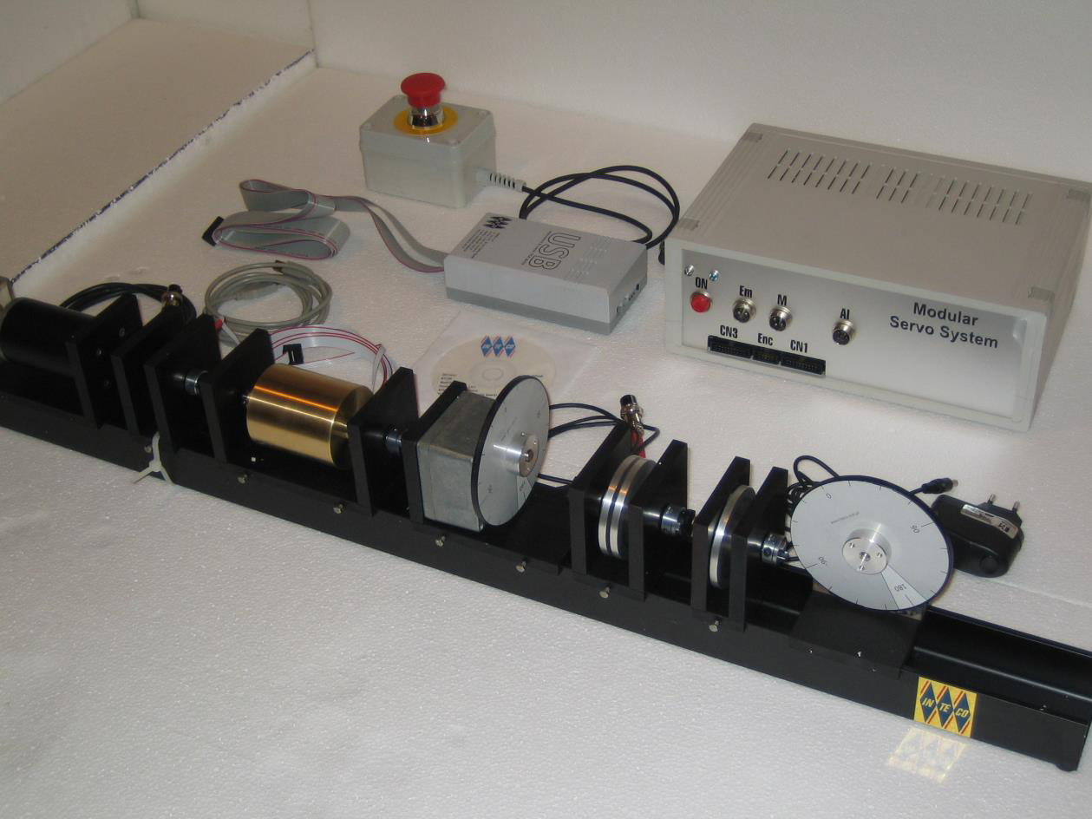
Figure 1 Modular Servo System
The Modular Servo System uses standard PC hardware platforms and Microsoft Windows operating systems. The set-up is fully integrated with MATLAB/Simulink. Real-time control algorithms can be rapidly prototyped. No C code programming is required.
The servomechanism is connected to a computer where a control algorithm is realized based on measurements of angle and angular velocity. The accuracy of measurement of velocity is 5% while the accuracy of angle measurement is 0.1%.
The armature voltage of the DC motor is controlled by PWM signal. For this reason the dimensionless control signal is the scaled input voltage, 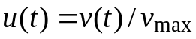. The admissible controls satisfy 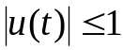| and 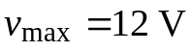.
The measurement system is based on RTDAC4/PCI acquisition board equipped with a D/A and an A/D converters.
The I/O board communicates with the power interface unit. The whole logic necessary to activate and read the encoder signals and to generate the appropriate sequence of PWM pulses to control the DC motor is configured in the Xilinx chip of the RT-DAC/PCI board. All functions of the board are accessed from the Modular Servo Toolbox which operates directly in the MATLAB/Simulink environment. The sampling time is set equal to 0.01 s.
The user has a quick access to all functions of the Modular Servo System from the Servo Control Window. It is invoked trough the command servo. The Servo Control Window includes modular servo device driver, tests, tools, simulation models and application examples.
To build the control application that operates in the real-time mode the user has to:
- Create a Simulink model of the control system which consists of the Modular Servo Device Driver and other blocks selected from the Simulink library.
- Build an executable file (in the case if it has not been done before). For this purpose select Tools/Code Generation/Build Model.
- Select the Simulation/Connect to Target option and click the Simulation/Start Real-Time Code to start the experiment.
Tasks
Task 1
A closed-loop system for control of motor angular velocity is shown in Figure 1. The control system consists of the following blocks: controller (C), power supply device (PS), DC motor (M), velocity sensor (VS), gearbox (G) and load (L). The controlled variable (motor angular velocity), the reference input and the control input are denoted by y, r and u, respectively.
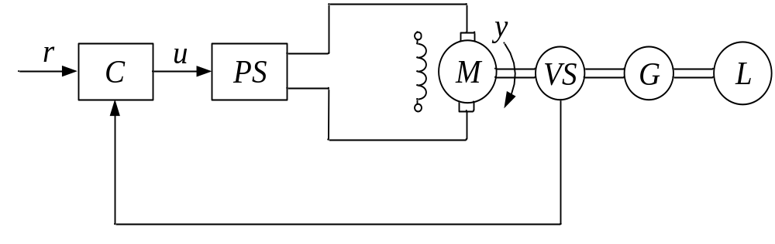
Figure 1 Closed-loop velocity control.
Study experimentally the closed-loop velocity control system using the Modular Servo System. Plot the motor angular velocity, the desired velocity and the control input.
Real-time experiments are performed using the Simulink model Lab_1_Task_1.mdl, depicted in Figure 2. Build an executable file and start experiments. Introduce the load disturbances by hand in the interval of 20 seconds from the start to 30 seconds.
Task 2
An open-loop system for control of motor angular velocity is shown in Figure 3.
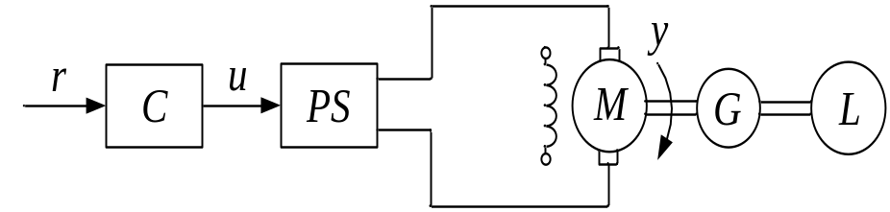
Figure 3 Open-loop velocity control.
- Study experimentally the open-loop velocity control system using the Modular Servo System. Plot the motor angular velocity, the desired velocity and the control input.
- Compare the experimental results obtained for the closed-loop velocity control and the open-loop velocity control.
Real-time experiments are performed using the Simulink model Lab_1_Task_2.mdl shown in Figure 4. Build an executable file and start experiments. Introduce the load disturbances manually as in Task 1.
Report Content
The lab report should contain the following:
- The objective of the lab.
- Formulation of the tasks.
- Experimental results.
- Discussion of the obtained results.
- Conclusion.

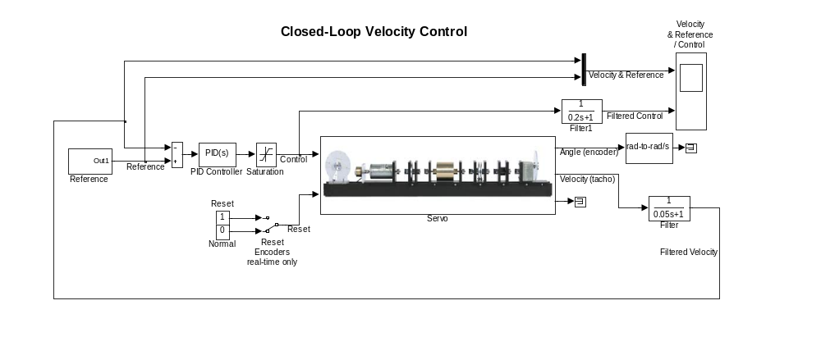
Figure 2 Real-time Simulink model for closed-loop velocity control.

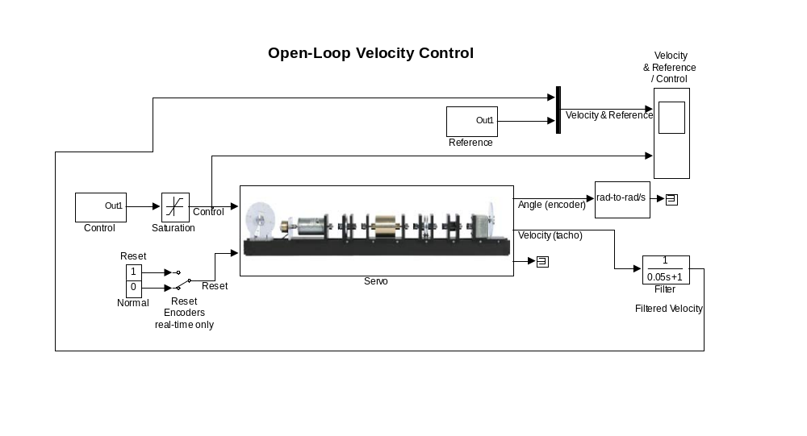
Figure 4 Real-time Simulink model for open-loop velocity control.

