Lab 2
Transfer Functions of Control Systems
Objective
The lab aims to teach the students to determine transfer functions of control systems by hand and using MATLAB.
Background Materials
- Lecture notes for the course Control Theory 1, Theme 2. Mathematical Models of Systems, pp. 9 – 21.
- MATLAB functions.
A transfer function model can be entered into the MATLAB environment using the following MATLAB command:
G = tf(num,den)
It is required to enter the numerator and denominator polynomial coefficients separately into two row vector variables num and den in the descending order of s. The variable G returned is the transfer function object.
For example, the transfer functions
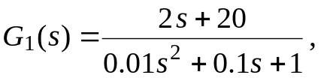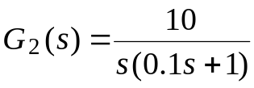
can be represented in MATLAB as
G1 = tf([2 20],[0.01 0.1 1]);
G2 = tf(10,[0.1 1 0]);
and the system objects G1 and G2 can then be used to uniquely describe the given transfer functions.
Alternatively, a transfer function given in factorized form can be entered into MATLAB by declaring the Laplace complex variable with s=tf(’s’) and the transfer function can then be specified in a mathematical way.
For example, the transfer functions 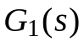 and 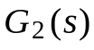 can be entered into the MATLAB workspace using the following commands:
s = tf('s');
G1 = (2*s + 20)/(0.01*s^2 + 0.1*s + 1);
G2 = 10/(s*(0.1*s + 1));
The overall transfer function of the series (cascade) connection of two blocks can be determined using the MATLAB statement
G = G1*G2
The MATLAB representation of the overall transfer function of the parallel connection of two blocks can be obtained using
G = G1 + G2
For a negative feedback connection of two blocks, one can compute the overall transfer function by using the MATLAB function feedback with the syntax
G = feedback(G1,G2)
where G1 and G2 are the transfer functions in the forward path and feedback path, respectively.
For a positive feedback connection, the overall system model can be obtained using
G = feedback(G1,G2,+1)
Tasks
Part I: Determining transfer functions of control systems
by hand
Task 1
Consider the feedback system shown in Figure 1. Determine the closed-loop transfer function 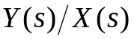.
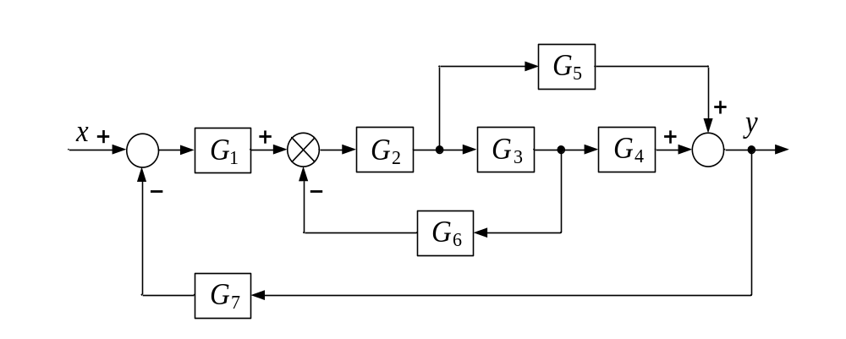
Figure 1 Block diagram of the feedback system for Task 1.
Task 2
Consider the control system model shown in Figure 2.
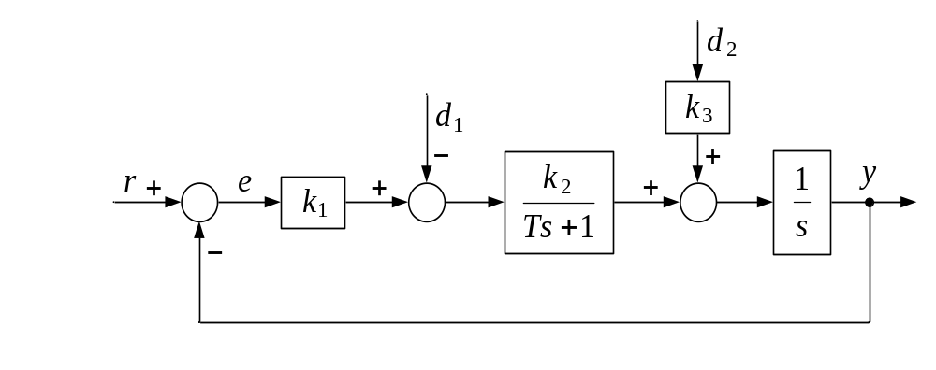
Figure 2 Block diagram of the control system for Task 2.
Find the closed-loop transfer functions:
- 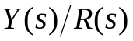, 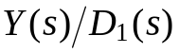, 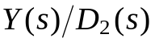,
- 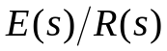, 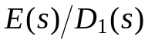, 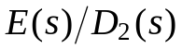.
Task 3
Block diagram of the feedback control system is shown in Figure 3. Determine the closed-loop transfer functions and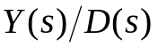.
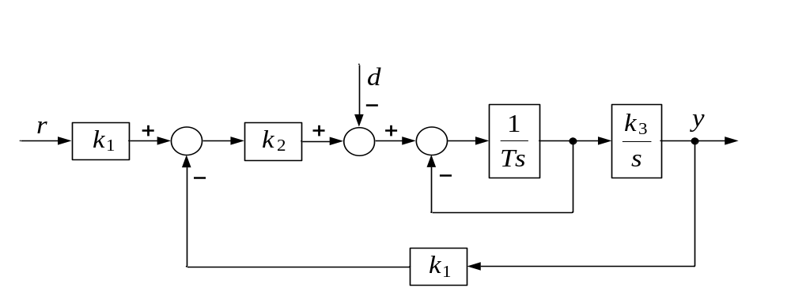
Figure 3 Block diagram of the control system for Task 3.
Task 4
Block diagram of the control system is shown in Figure 4. Determine the closed-loop transfer functions and .
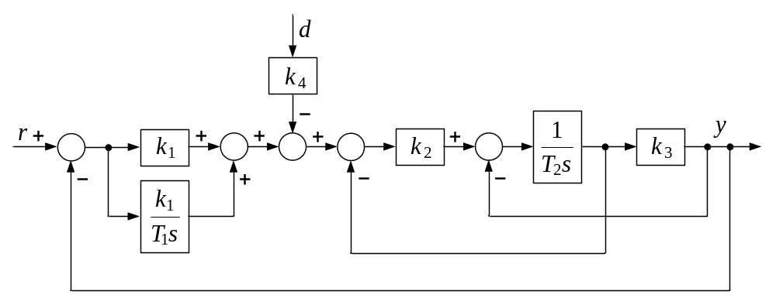
Figure 4 Block diagram of the control system for Task 4.
Task 5
Consider the control system model shown in Figure 5. Find the closed-loop characteristic equation.
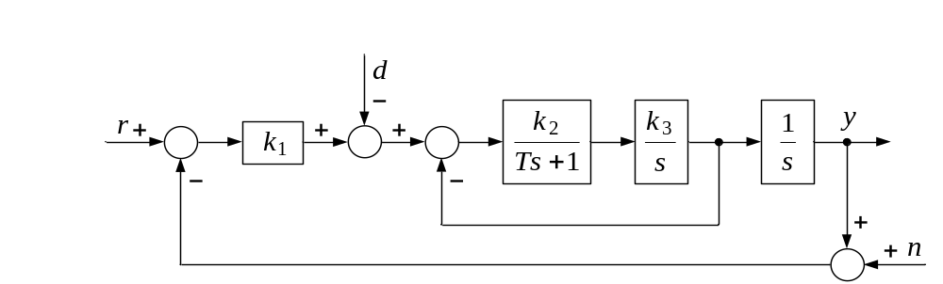
Figure 5 Block diagram of the control system for Task 5.
Part II: Determining transfer functions of control systems
using MATLAB
Task 6
Enter the following transfer functions into the MATLAB environment:
- 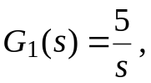
- 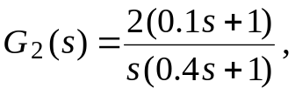
- 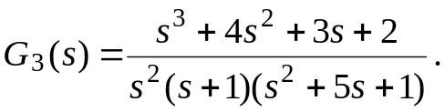
Task 7
Consider the control system model shown in Figure 6. The values of the parameters are 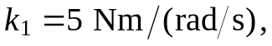 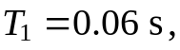 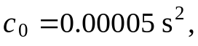 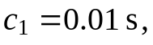 and 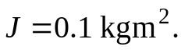 Compute the closed-loop transfer functions and .
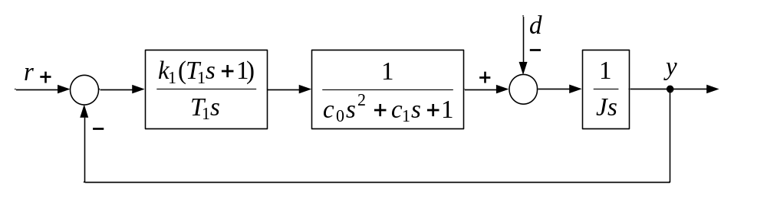
Figure 6 Block diagram of the control system for Task 7.
Task 8
Consider the temperature control system shown in Figure 7. The parameter values are 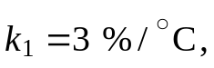 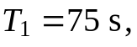 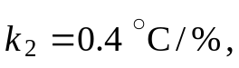 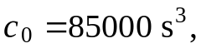 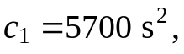 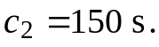 Determine the closed-loop transfer functions, , , and 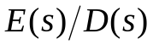.
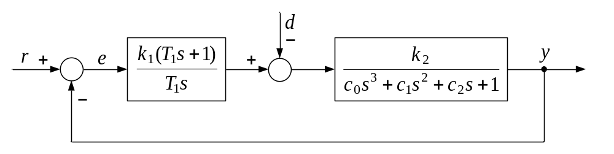
Figure 7 Block diagram of the control system for Task 8.
Task 9
Consider the control system model shown in Figure 8. Find the closed-loop transfer functions, 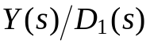, 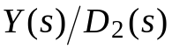 and 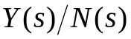.
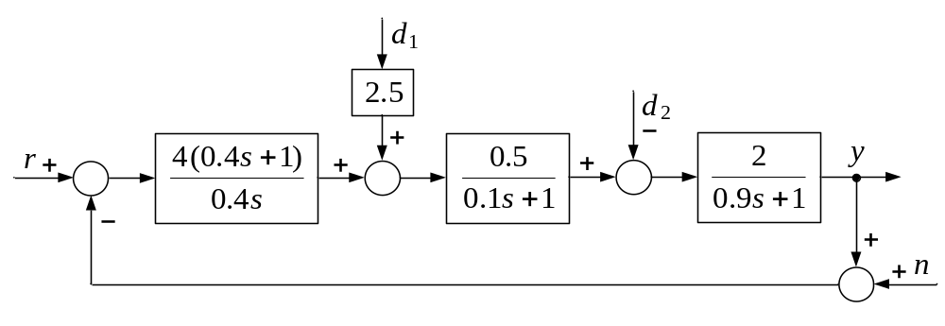
Figure 8 Block diagram of the control system for Task 9.
Report Content
The lab report should contain the following:
- The objective of the lab.
- Formulation of the tasks.
- Solutions and MATLAB commands and script-files.
- Discussion of the obtained results.
- Conclusion.

