Theme 1
Introduction to Control Systems
_______________________________________________________
1.1 Open-Loop and Closed-Loop Control
1.2 Examples of Control Systems
1.3 Control System Design
1.4 Design Examples
_______________________________________________________

1.1 Open-Loop and Closed-Loop Control
Engineering is concerned with understanding and controlling the materials and forces of nature for the benefit of humankind. Control system engineers are concerned with understanding and controlling segments of their environment, often called systems, to provide useful economic products for society. The twin goals of understanding and controlling are complementary because effective systems control requires that the systems be understood and modeled. Furthermore, control engineering must often consider the control of poorly understood systems such as chemical process systems. The present challenge to control engineers is the modeling and control of modern, complex, interrelated systems such as traffic control systems, chemical processes, and robotic systems. Simultaneously, the fortunate engineer has the opportunity to control many useful and interesting industrial automation systems. Perhaps the most characteristic quality of control engineering is the opportunity to control machines and industrial and economic processes for the benefit of society.
Control engineering is based on the foundations of feedback theory and linear system analysis, and it integrates the concepts of network theory and communication theory. Therefore control engineering is not limited to any engineering discipline but is equally applicable to aeronautical, chemical, mechanical, environmental, civil, and electrical engineering. For example, a control system often includes electrical, mechanical, and chemical components. Furthermore, as the understanding of the dynamics of business, social, and political systems increases, the ability to control these systems will also increase.
A control system is an interconnection of components forming a system configuration that will provide a desired system response. The basis for analysis of a system is the foundation provided by linear system theory, which assumes a cause-effect relationship for the components of a system. Therefore a component or process to be controlled can be represented by a block, as shown in Figure 1.1. The input-output relationship represents the cause-and-effect relationship of the process, which in turn represents a processing of the input signal to provide an output signal variable, often with a power amplification.
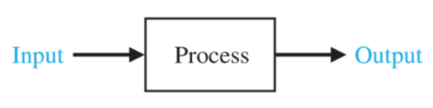
FIGURE 1.1 Process to be controlled.
An open-loop control system uses a controller and an actuator to obtain the desired response, as shown in Figure 1.2. An open-loop system is a system without feedback.
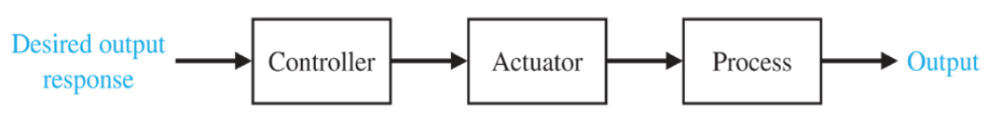
FIGURE 1.2 Open-loop control system (without feedback).
An open-loop control system utilizes an actuating device to control
the process directly without using feedback.
In contrast to an open-loop control system, a closed-loop control system utilizes an additional measure of the actual output to compare the actual output with the desired output response. The measure of the output is called the feedback signal. A simple closed-loop feedback control system is shown in Figure 1.3. A feedback control system is a control system that tends to maintain a prescribed relationship of one system variable to another by comparing functions of these variables and using the difference as a means of control. With an accurate sensor, the measured output is a good approximation of the actual output of the system.
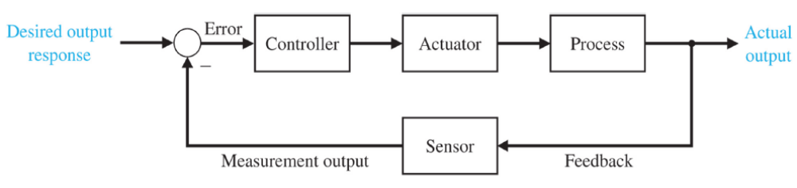
FIGURE 1.3 Closed-loop feedback control system (with feedback).
A feedback control system often uses a function of a prescribed relationship between the output and reference input to control the process. Often the difference between the output of the process under control and the reference input is amplified and used to control the process so that the difference is continually reduced. In general, the difference between the desired output and the actual output is equal to the error, which is then adjusted by the controller. The output of the controller causes the actuator to modulate the process in order to reduce the error. The sequence is such, for instance, that if a ship is heading incorrectly to the right, the rudder is actuated to direct the ship to the left. The system shown in Figure 1.3 is a negative feedback control system, because the output is subtracted from the input and the difference is used as the input signal to the controller. The feedback concept has been the foundation for control system analysis and design.
A closed-loop control system uses a measurement of the output
and feedback of this signal to compare it with
the desired output (reference or command).
As we will discuss in Chapter 3, closed-loop control has many advantages over open-loop control including the ability to reject external disturbances and improve measurement noise attenuation. We incorporate the disturbances and measurement noise in the block diagram as external inputs, as illustrated in Figure 1.4. External disturbances and measurement noise are inevitable in real-world applications and must be addressed in practical control system designs.
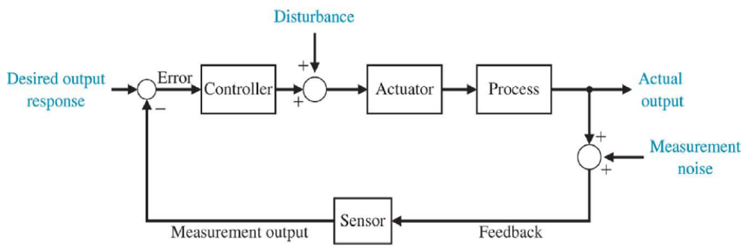
FIGURE 1.4 Closed-loop feedback system with
external disturbances and measurement noise.
The feedback systems in Figures 1.3 and 1.4 are single-loop feedback systems. Many feedback control systems contain more than one feedback loop. A common multiloop feedback control system is illustrated in Figure 1.5 with an inner loop and an outer loop. In this scenario, the inner loop has a controller and a sensor and the outer loop has a controller and sensor. However, we use the single-loop feedback system for learning about the benefits of feedback control systems since the outcomes readily extend to multiloop systems.
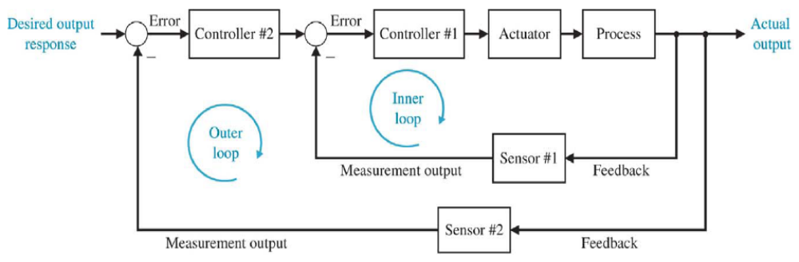
FIGURE 1.5 Multiloop feedback system with
an inner loop and an outer loop.
Due to the increasing complexity of the system under control and the interest in achieving optimum performance, the importance of control system engineering has grown. Furthermore, as the systems become more complex, the interrelationship of many controlled variables must be considered in the control
scheme. A block diagram depicting a multivariable control system is shown in Figure 1.6.
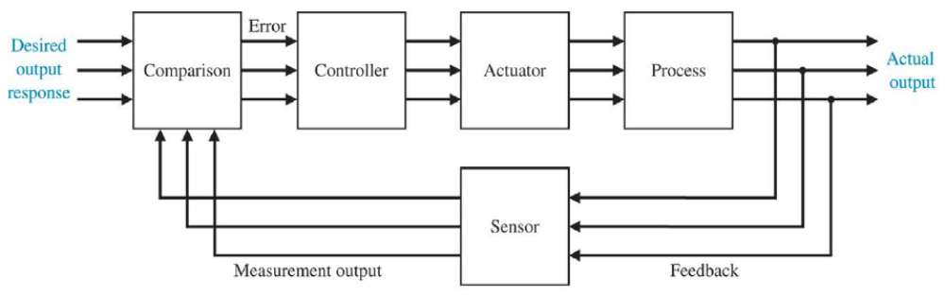
FIGURE 1.6 Multivariable control system.
The use of feedback to control a system has a fascinating history.
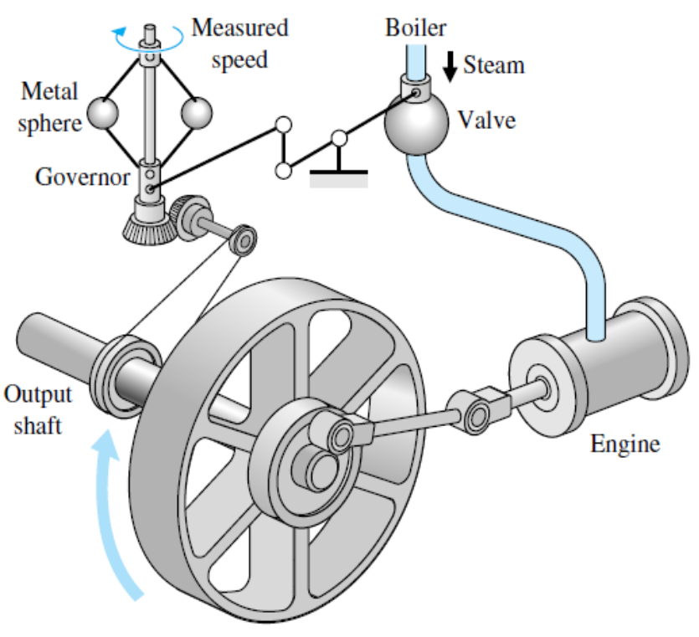
FIGURE 1.7 Watt's flyball governor.
The first automatic feedback controller used in an industrial process is generally agreed to be James Watt's flyball governor, developed in 1769 for controlling the speed of a steam engine . The all-mechanical device, shown in Figure 1.7, measured the speed of the output shaft and utilized the movement of the flyball to control the steam valve and therefore the amount of steam entering the engine. As depicted in Figure 1.7, the governor shaft axis is connected via mechanical linkages and beveled gears to the output shaft of the steam engine. As the steam engine output shaft speed increases, the ball weights rise and move away from the shaft axis and through mechanical linkages the steam valve closes and the engine slows down.
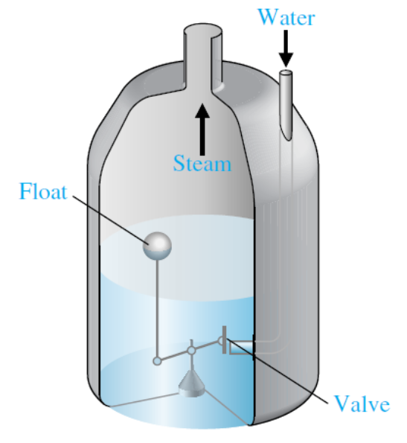
FIGURE 1.8 Water-level float regulator.
The first historical feedback system, claimed by Russia, is the water-level float regulator said to have been invented by I. Polzunov in 1765. The level regulator system is shown in Figure l.8. The float detects the water level and controls the valve that covers the water inlet in the boiler.
The next century was characterized by the development of automatic control systems through intuition and invention. Efforts to increase the accuracy of the control system led to slower attenuation of the transient oscillations and even to unstable systems. It then became imperative to develop a theory of automatic control. In 1868, J. C. Maxwell formulated a mathematical theory related to control theory using a differential equation model of a governor. Maxwell's study was concerned with the effect various system parameters had on the system performance. During the same period, I. A. Vyshnegradskii in Russia formulated a mathematical theory of regulators.
The control of an industrial process (manufacturing, production, and so on) by automatic rather than manual means is often called automation. Automation is prevalent in the chemical, electric power, paper, automobile, and steel industries, among others. The concept of automation is central to our industrial society. Automatic machines are used to increase the production of a plant per worker in order to offset rising wages and inflationary costs. Thus industries are concerned with the productivity per worker of their plants.
1.2 Examples of Control Systems
Control engineering is concerned with the analysis and design of goal-oriented systems. Therefore the mechanization of goal-oriented policies has grown into a hierarchy of goal-oriented control systems. Modern control theory is concerned with systems that have adaptive, robust, learning, and optimum qualities.
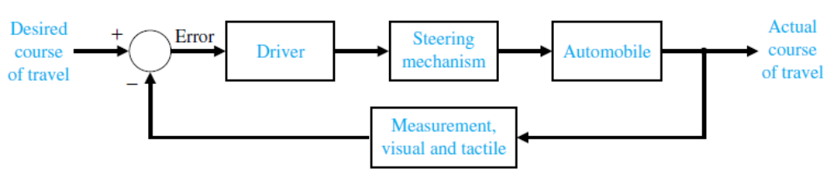
(a)
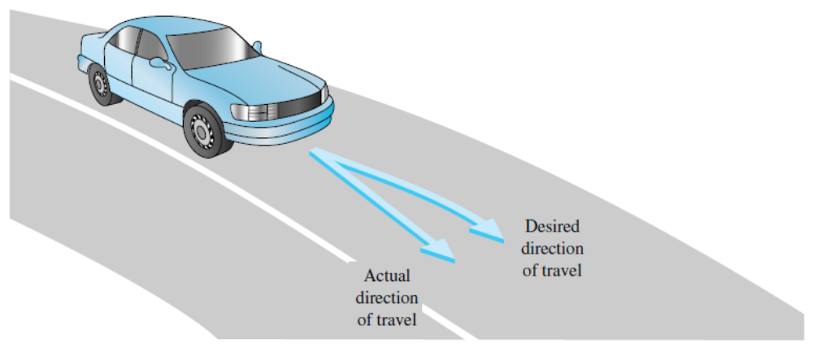
(b)
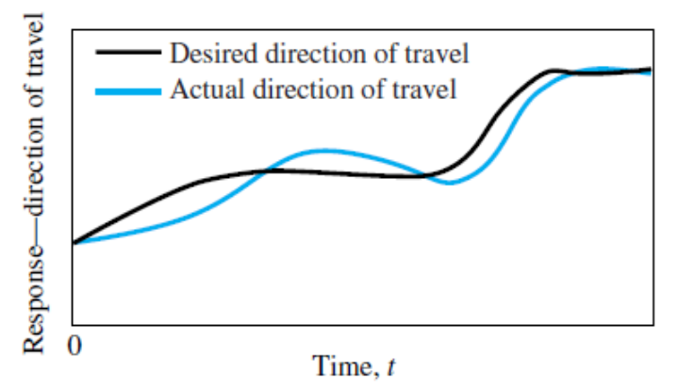
(c)
FIGURE 1.9 (a) Automobile steering control system, (b) The driver uses the
difference between the actual and the desired direction of travel to generate a controlled adjustment of the steering wheel, (c) Typical direction-of-travel response.
Feedback control is a fundamental fact of modern industry and society. Driving an automobile is a pleasant task when the auto responds rapidly to the driver's commands. Many cars have power steering and brakes, which utilize hydraulic amplifiers for amplification of the force to the brakes or the steering wheel. A simple block diagram of an automobile steering control system is shown in Figure 1.9(a). The desired course is compared with a measurement of the actual course in order to generate a measure of the error, as shown in Figure 1.9(b). This measurement is obtained by visual and tactile (body movement) feedback, as provided by the feel of the steering wheel by the hand (sensor). This feedback system is a familiar version of the steering control system in an ocean liner or the flight controls in a large airplane. A typical direction-of-travel response is shown in Figure 1.9(c).
Other familiar control systems have the same basic elements as the system shown in Figure 1.3. A refrigerator has a temperature setting or desired temperature, a thermostat to measure the actual temperature and the error, and a compressor motor for power amplification. Other examples in the home are the oven, furnace, and water heater. In industry, there are many examples, including speed controls; process temperature and pressure controls; and position, thickness, composition, and quality controls.
In its modern usage, automation can be defined as a technology that uses programmed commands to operate a given process, combined with feedback of information to determine that the commands have been properly executed. Automation is often used for processes that were previously operated by humans. When automated, the process can operate without human assistance or interference. In fact, most automated systems are capable of performing their functions with greater accuracy and precision, and in less time, than humans are able to do. A semiautomated process is one that incorporates both humans and robots. For instance, many automobile assembly line operations require cooperation between a human operator and an intelligent robot.
Feedback control systems are used extensively in industrial applications. Machines that automatically load and unload, cut, weld, or cast are used by industry to obtain accuracy, safety, economy, and productivity. The use of computers integrated with machines that perform tasks like a human worker has been foreseen by several authors. In his famous 1923 play, entitled R.U.R., Karel Capek called artificial workers robots, deriving the word from the Czech noun roboia, meaning "work." A robot is a computer-controlled machine and involves technology closely associated with automation. Industrial robotics can be defined as a particular field of automation in which the automated machine (that is, the robot) is designed to substitute for human labor. Thus robots possess certain humanlike characteristics. Today, the most common humanlike characteristic is a mechanical manipulator that is patterned somewhat after the human arm and wrist. Some devices even have anthropomorphic mechanisms, including what we might recognize as mechanical arms, wrists, and hands.
A three-axis control system for inspecting individual semiconductor wafers is shown in Figure 1.10. This system uses a specific motor to drive each axis to the desired position in the x-y-z-axis, respectively. The goal is to achieve smooth, accurate movement in each axis. This control system is an important one for the semiconductor manufacturing industry.
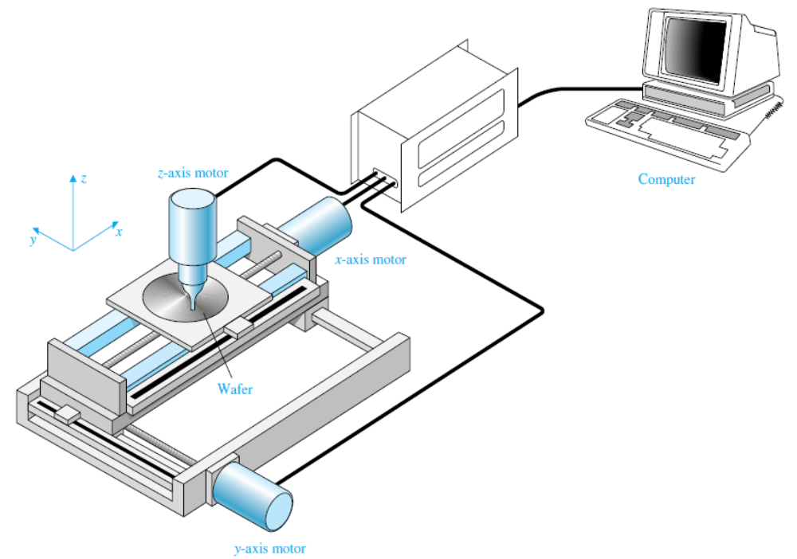
FIGURE 1.10 A three-axis control system for inspecting individual semiconductor wafers with a highly sensitive camera.
The modern, large-capacity plants, which exceed several hundred megawatts, require automatic control systems that account for the interrelationship of the process variables and optimum power production. It is common to have 90 or more manipulated variables under coordinated control. A simplified model showing several of the important control variables of a large boiler-generator system is shown in Figure 1.11. This is an example of the importance of measuring many variables, such as pressure and oxygen, to provide information to the computer for control calculations.
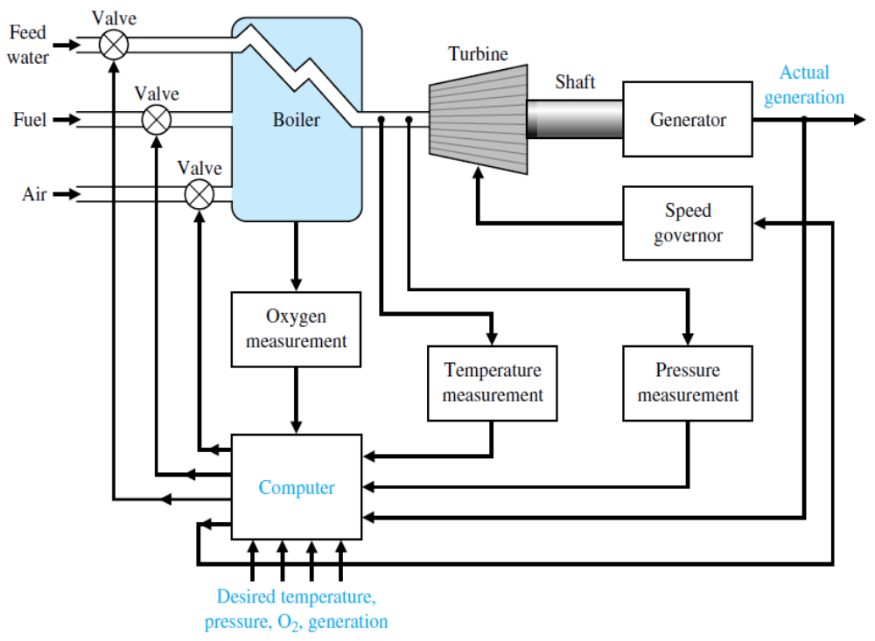
FIGURE 1.11 Coordinated control system for a boiler-generator.
The process industry has used the modern aspects of control engineering for significant and interesting applications. Another important industry, the metallurgical industry, has had considerable success in automatically controlling its processes. Very important application of control technology is in the control of the modern automobile. Control systems for suspension, steering, and engine control have been introduced. Many autos have a four-wheel-steering system, as well as an antiskid control system. In fact, in many cases, the control theory is being fully implemented.
Control systems are used to achieve (1) increased productivity and (2) improved performance of a device or system. Automation is used to improve productivity and obtain high-quality products. Automation is the automatic operation or control of a process, device, or system. We use automatic control of machines and processes to produce a product reliably and with high precision. With the demand for flexible, custom production, a need for flexible automation and robotics is growing.
The theory, practice, and application of automatic control is a large, exciting, and extremely useful engineering discipline. One can readily understand the motivation for a study of modern control systems.
1.3 Control System Design
The design of control systems is a specific example of engineering design. The goal of control engineering design is to obtain the configuration, specifications, and identification of the key parameters of a proposed system to meet an actual need. The control system design process is illustrated in Figure 1.12.
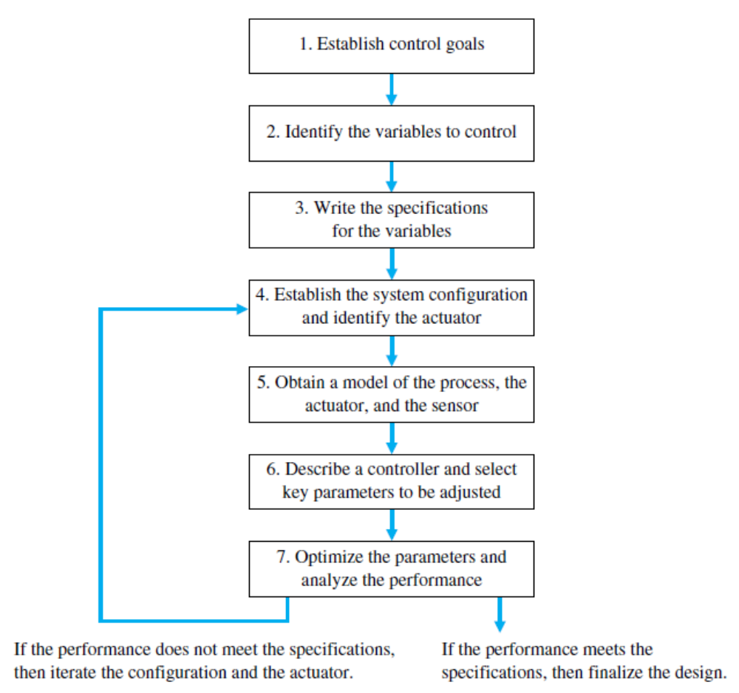
FIGURE 1.12 The control system design process.
The design process consists of seven main building blocks, which we arrange into three groups:
- Establishment of goals and variables to be controlled, and definition of specifications (metrics) against which to measure performance (blocks 1, 2, and 3);
- System definition and modeling (blocks 4 and 5);
- Control system design and integrated system simulation and analysis (blocks 6 and 7).
The first step in the design process consists of establishing the system goals. For example, we may state that our goal is to control the velocity of a motor accurately. The second step is to identify the variables that we desire to control (for example, the velocity of the motor). The third step is to write the specifications in terms of the accuracy we must attain. This required accuracy of control will then lead to the identification of a sensor to measure the controlled variable. The performance specifications will describe how the closed-loop system should perform and will include:
  - good regulation against disturbances;
  - desirable responses to commands;
  - realistic actuator signals;
  - low sensitivities;
  - robustness.
As designers, we proceed to the first attempt to configure a system that will result in the desired control performance. This system configuration will normally consist of a sensor, the process under control, an actuator, and a controller, as shown in Figure 1.3. The next step consists of identifying a candidate for the actuator. This will, of course, depend on the process, but the actuation chosen must be capable of effectively adjusting the performance of the process. For example, if we wish to control the speed of a rotating flywheel, we will select a motor as the actuator. The sensor, in this case, must be capable of accurately measuring the speed. We then obtain a model for each of these elements.
The next step is the selection of a controller to achieve the desired performance. In summary, the controller design problem is as follows: Given a model of the system to be controlled (including its sensors and actuators) and a set of design goals, find a suitable controller. As with most of engineering design, the design of a feedback control system is an iterative process. A successful designer must consider the underlying physics of the plant under control, the control design strategy, the controller design architecture (that is, what type of controller will be employed), and effective controller tuning strategies. In addition, once the design is completed, the controller is often implemented in hardware, and hence issues of interfacing with hardware can appear. When taken together, these different phases of control system design make the task of designing and implementing a control system quite challenging
The design process has been dramatically affected by the advent of powerful and inexpensive computers and effective control design and analysis software.
1.4 Design Examples
EXAMPLE 1.1 Rotating disk speed control
Many modern devices employ a rotating disk held at a constant speed. For example, a CD player requires a constant speed of rotation in spite of motor wear and variation and other component changes. Our goal is to design a system for rotating disk speed control that will ensure that the actual speed of rotation is within a specified percentage of the desired speed. We will consider a system without feedback and a system with feedback.
To obtain disk rotation, we will select a DC motor as the actuator because it provides a speed proportional to the applied motor voltage. For the input voltage to the motor, we will select an amplifier that can provide the required power.
The open-loop system (without feedback) is shown in Figure 1.13(a). This system uses a battery source to provide a voltage that is proportional to the desired speed. This voltage is amplified and applied to the motor. The block diagram of the open-loop system identifying the controller, actuator, and process is shown in Figure 1.13(b).
To obtain a feedback system, we need to select a sensor. One useful sensor is a tachometer that provides an output voltage proportional to the speed of its shaft. Thus the closed-loop feedback system takes the form shown in Fig. 1.14(a). The block diagram model of the feedback system is shown in Fig. 1.14(b). The error voltage is generated by the difference between the input voltage and the tachometer voltage.
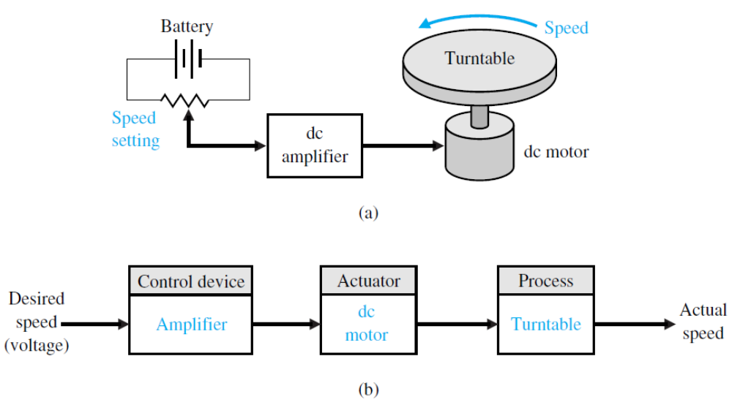
FIGURE 1.23 (a) Open-loop (without feedback) control of the speed
of a rotating disk. (b) Block diagram model.
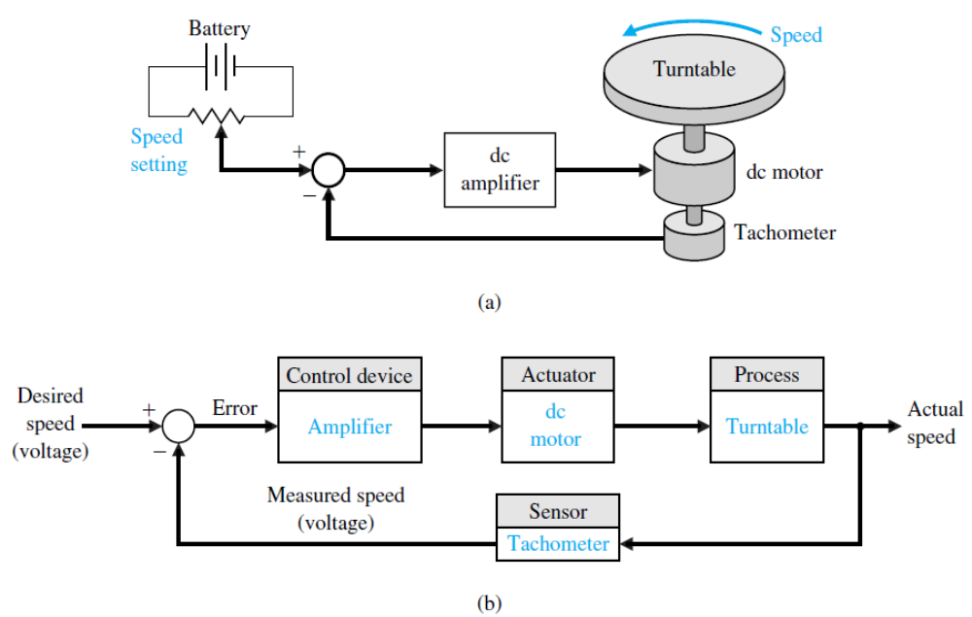
FIGURE 1.14 (a) Closed-loop control of the speed of a rotating disk.
(b) Block diagram model.
We expect the feedback system of Figure 1.14 to be superior to the open-loop system of Figure 1.13 because the feedback system will respond to errors and act to reduce them. With precision components, we could expect to reduce the error of the feedback system to one-hundredth of the error of the open-loop system.
EXAMPLE 1.2 Disk drive system
Consider the basic diagram of a disk drive shown in Fig. 1.15. The goal of the disk drive reader device is to position the reader head to read the data stored on a track on the disk. The variable to accurately control is the position of the reader head (mounted on a slider device).The disk rotates at a high speed and the head "flies" above the disk at a distance of less than 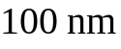. The initial specification for the position accuracy is 1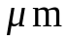. Furthermore, we plan to be able to move the head from track a to track b within 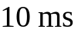, if possible.
We establish an initial system configuration as shown in Figure 1.16. This proposed closed-loop system uses a motor to actuate (move) the arm to the desired location on the disk.
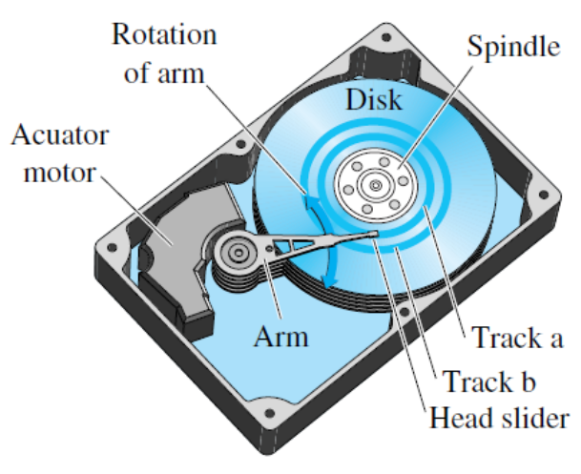
FIGURE 1.15 Diagram of a disk drive.
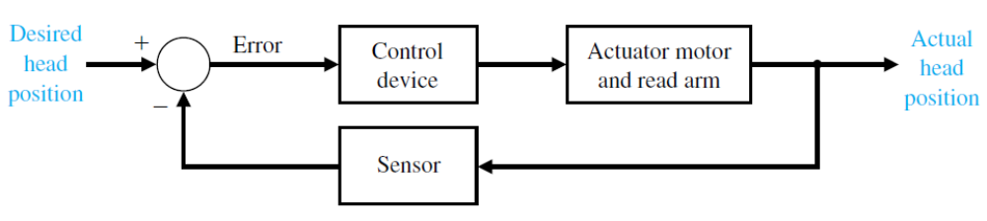
FIGURE 1.16 Closed-loop control system for disk drive.
Text:
Dorf, R. C., R. H. Bishop. Modern Control Systems, 12th Ed., Prentice Hall, Upper Saddle River, N.J., 2011.

