Theme 6
Root Locus Analysis
_______________________________________________________
6.1 Root Locus Concept
6.2 PID Controllers
_______________________________________________________

6.1 Root Locus Concept
The relative stability and the transient performance of a closed-loop control system are directly related to the location of the closed-loop roots of the characteristic equation in the s-plane. It is frequently necessary to adjust one or more system parameters in order to obtain suitable root locations. Therefore, it is worthwhile to determine how the roots of the characteristic equation of a given system migrate about the s-plane as the parameters are varied; that is, it is useful to determine the locus of roots in the s-plane as a parameter is varied.
The root locus method provides graphical information, and therefore an approximate sketch can be used to obtain qualitative information concerning the stability and performance of the system. If the root locations are not satisfactory, the necessary parameter adjustments often can be readily ascertained from the root locus.
The dynamic performance of a closed-loop control system is described by the closed-loop transfer function
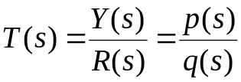, (6.1)
where 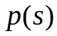 and 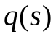 are polynomials in s.
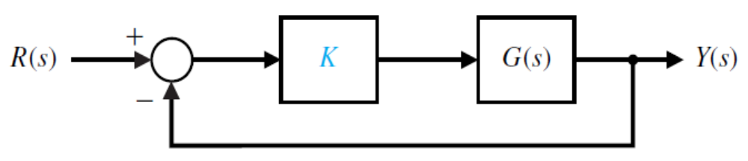
FIGURE 6.1 Closed-loop control system
with a variable parameter K.
The roots of the characteristic equation determine the modes of response of the system. In the case of the simple single loop system shown in Figure 6.1, we have the characteristic equation
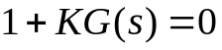, (6.2)
where 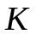 is a variable parameter and 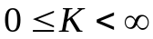. The characteristic roots of the system must satisfy Equation (6.2), where the roots lie in the s-plane. Because s is a complex variable, Equation (6.2) may be rewritten in polar form as
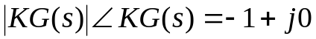, (6.3)
and therefore it is necessary that
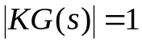
and
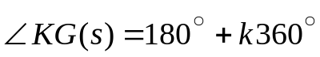, (6.4)
where 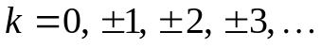.
The root locus is the path of the roots of the characteristic equation
traced out in the s-plane as a system parameter
varies from zero to infinity.
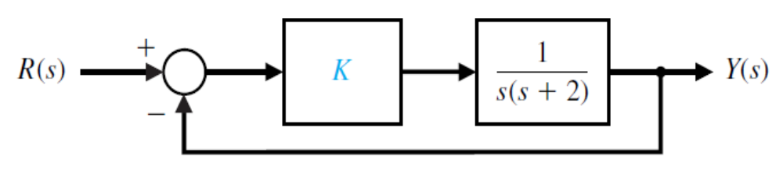
FIGURE 6.2 Unity feedback control system.
The gain K is a variable parameter.
The simple second-order system is shown in Figure 6.2. The characteristic equation representing this system is
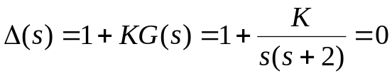,
or, alternatively,
. (6.5)
The locus of the roots as the gain K is varied is found by requiring that
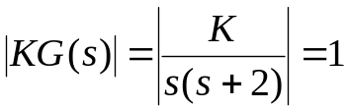 (6.6)
and
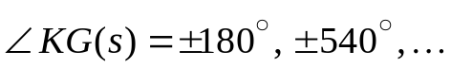. (6.7)
The gain K may be varied from zero to an infinitely large positive value. For a
second-order system, the roots are
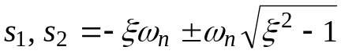, (6.8)
and for 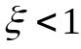, we know that 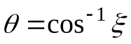.
Graphically, for two open-loop poles as shown in Figure 6.3, the locus of roots is a vertical line for 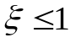 in order to satisfy the angle requirement, Equation (6.7). For example, as shown in Figure 6.4, at a root 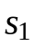 the angles are
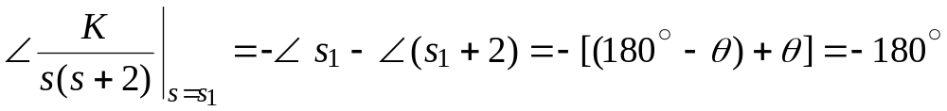. (6.9)
This angle requirement is satisfied at any point on the vertical line that is a perpendicular bisector of the line 0 to 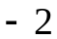. Furthermore, the gain K at the particular points is found by using Equation (6.6) as
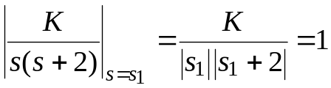, (6.10)
and thus
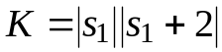, (6.11)
where 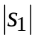 is the magnitude of the vector from the origin to , and 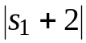 is the magnitude of the vector from to .
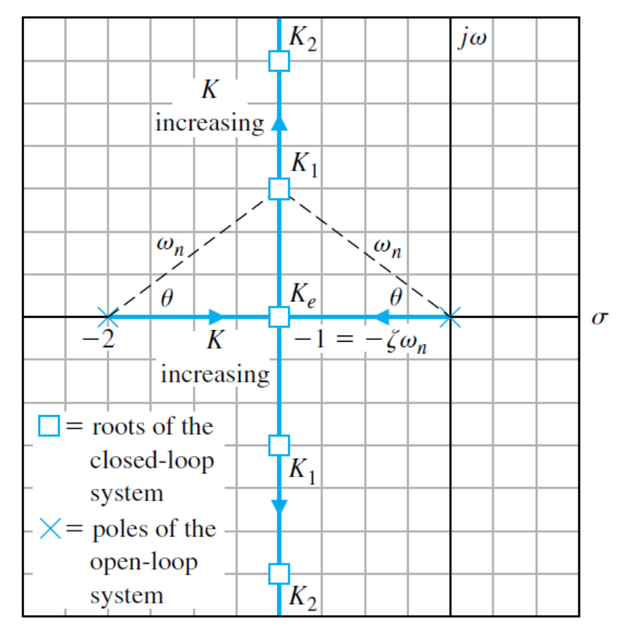
FIGURE 6.3 Root locus for a second-order system
when 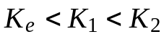.
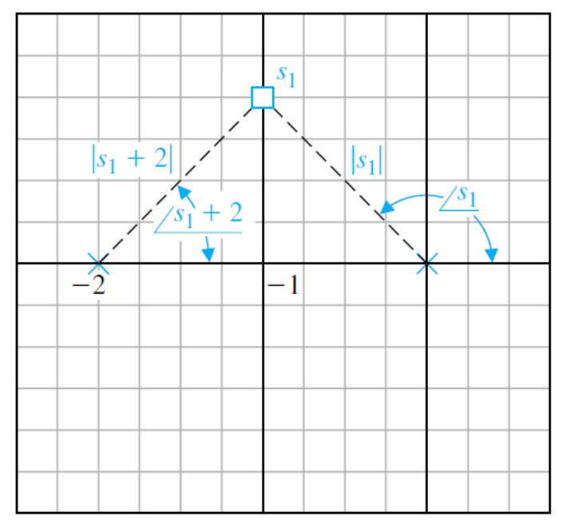
FIGURE 6.4 Evaluation of the angle and gain
at for gain 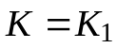.
To further illustrate the root locus procedure, let us consider the second-order system of Figure 7.5(a).
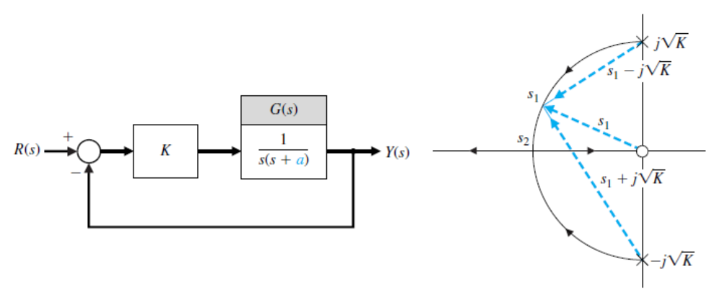
(a) (b)
FIGURE 6.5 (a) Single-loop system, (b) Root locus
as a function of the parameter 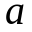, where 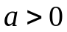.
The effect of varying the parameter can be effectively portrayed by rewriting the characteristic equation for the root locus form with as the multiplying factor in the numerator. Then the characteristic equation is
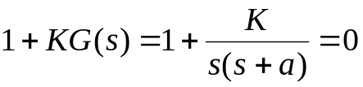,
or, alternatively,
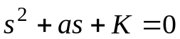.
Dividing by the factor 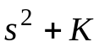, we obtain
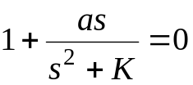. (6.12)
Then the magnitude criterion is satisfied when
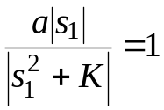 (6.13)
at the root . The angle criterion is
.
In principle, we could construct the root locus by determining the points in the s-plane that satisfy the angle criterion. The root locus for the characteristic equation in Equation (6.12) is shown in Figure 6.5(b). Specifically at the root the magnitude of the parameter a is found from Equation (6.13) as
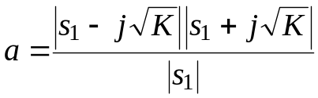. (6.14)
The roots of the system merge on the real axis at the point 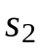 and provide a critically damped response to a step input. The parameter a has a magnitude at the critically damped roots, 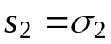, equal to
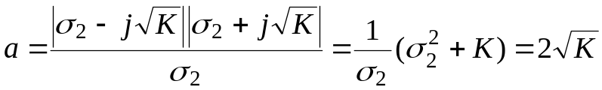, (6.15)
where 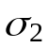 is evaluated from the s-plane vector lengths as 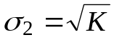. As a increases beyond the critical value, the roots are both real and distinct; one root is larger than , and one is smaller.
The complex conjugate roots near the origin of the s-plane relative to the other roots of the closed-loop system are labeled the dominant roots of the system because they represent or dominate the transient response. The relative dominance of the complex roots, in a third-order system with a pair of complex conjugate roots, is determined by the ratio of the real root to the real part of the complex roots and will result in approximate dominance for ratios exceeding 5. The concept of dominant roots is useful for estimating the response of a system, but must be used with caution and with a comprehension of the underlying assumptions.
Originally, the root locus method was developed to determine the locus of roots of the characteristic equation as the system gain, K, is varied from zero to infinity. However, the effect of other system parameters may be investigated by using the root locus method, which can be readily extended to the investigation of two or more parameters. This method of parameter design uses the root locus approach to select the values of the parameters.
6.2 PID Controllers
One form of controller widely used in industrial process control is the three-term, PID controller. This controller has a transfer function
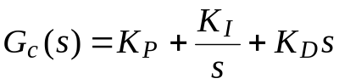. (6.16)
The equation for the output in the time domain is
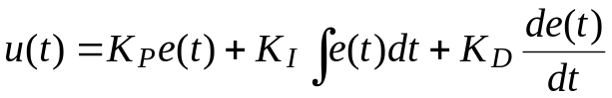. (6.17)
The three-term controller is called a PID controller because it contains a proportional, an integral, and a derivative term represented by 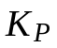, 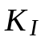, and 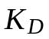, respectively. The transfer function of the derivative term is actually
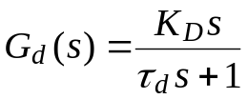,
but 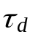 is usually much smaller than the time constants of the process itself, so it is neglected.
If we set 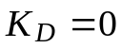, then we have the proportional plus integral (PI) controller
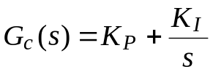. (6.18)
When 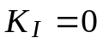, we have
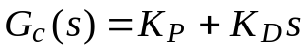, (6.19)
which is called a proportional plus derivative (PD) controller.
The PID controller can also be viewed as a cascade of the PI and the PD controllers. Consider the PI controller
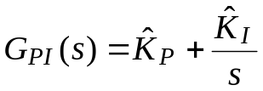 (6.20)
and the PD controller
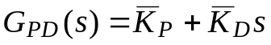, (6.21)
where 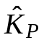 and 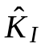 are the PI controller gains and 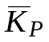 and 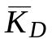 are the PD controller gains. Cascading the two controllers (that is, placing them in series) yields
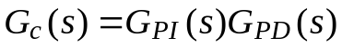
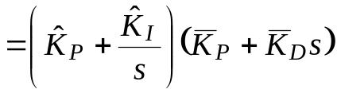
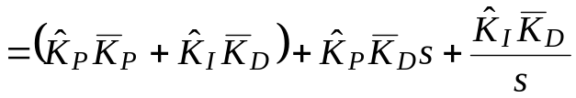
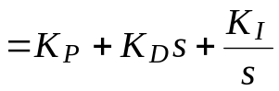, (6.22)
where we have the following relationships between the PI and PD controller gains and the PID controller gains
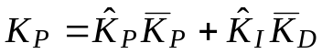
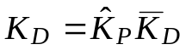 (6.23)
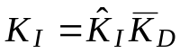.
Consider the PID controller
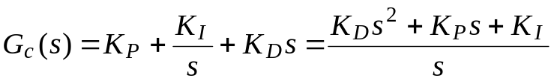
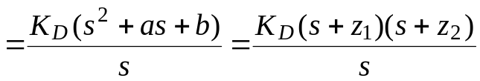, (6.24)
where 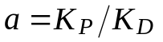 and 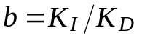. Therefore, a PID controller introduces a transfer function with one pole at the origin and two zeros that can be located anywhere in the s-plane.
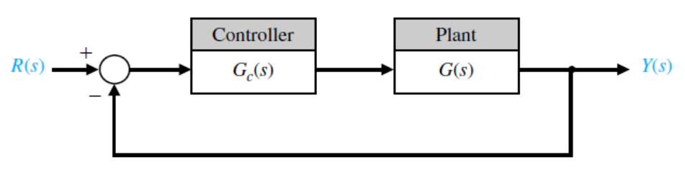
FIGURE 6.6 Closed-loop system with a controller.
Recall that a root locus begins at the poles and ends at the zeros. If we have a system, as shown in Figure 6.6, with
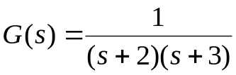, (6.25)
and we use a PID controller with complex zeros 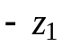 and 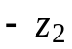, where 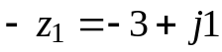 and 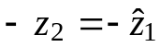, we can plot the root locus as shown in Figure 6.7.
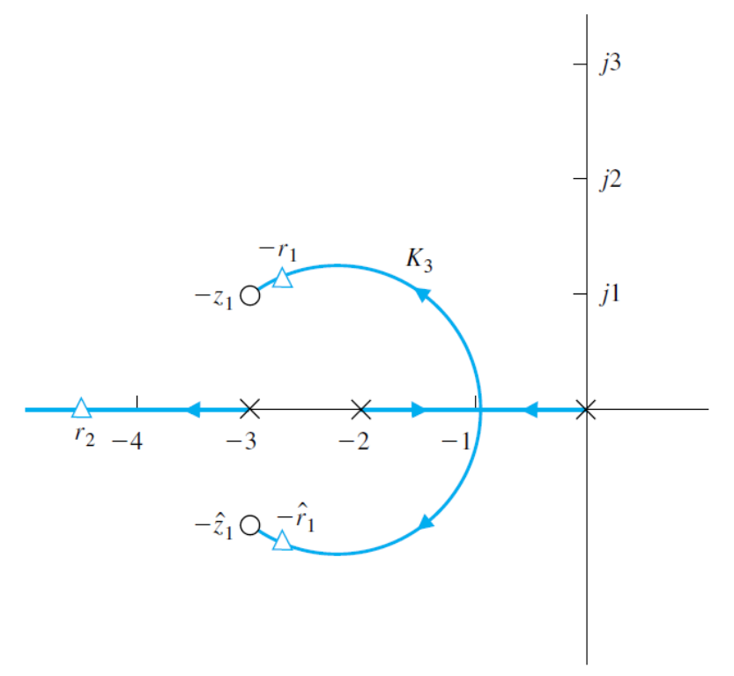
FIGURE 6.7 Root locus for plant with a PID controller
with complex zeros.
As the gain, , of the controller is increased, the complex roots approach the zeros. The closed-loop transfer function is
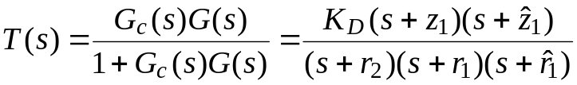. (6.26)
The response of this system will be attractive. The percent overshoot to a step will be less than 2%, and the steady-state error for a step input will be zero. The settling time will be approximately 1 second. If a shorter settling time is desired, then we select 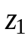 and 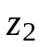 to lie further left in the left-hand s-plane and set to drive the roots near the complex zeros.
Many industrial processes are controlled using PID controllers. The popularity of PID controllers can be attributed partly to their good performance in a wide range of operating conditions and partly to their functional simplicity that allows engineers to operate them in a simple, straightforward manner. To implement the PID controller, three parameters must be determined, the proportional gain, denoted by , integral gain, denoted by , and derivative gain, denoted by .
There are many methods available to determine acceptable values of the PID gains. The process of determining the gains is often called PID tuning.
Text:
Dorf, R. C., R. H. Bishop. Modern Control Systems, 12th Ed., Prentice Hall, Upper Saddle River, N.J., 2011.

