Lab 7
Position Control of DC Motor
Objective
The aim of the lab is the students to design and study experimentally a single-loop position control system of DC motor.
Background Materials
Lecture notes for the course Control Theory 1, Theme 4. Performance of Control Systems, pp. 1 – 12, Theme 6. Root Locus Analysis, pp. 7 – 9.
Tasks
Task 1
A simple single-loop feedback system for control of motor angular position is shown in Figure 1. The control system consists of the following blocks: controller (C), power supply device (PS), DC motor (M), digital encoder (E), gearbox (G) and load (L). The controlled variable (motor angular position), the reference input and the control input are denoted by y, r and u, respectively.
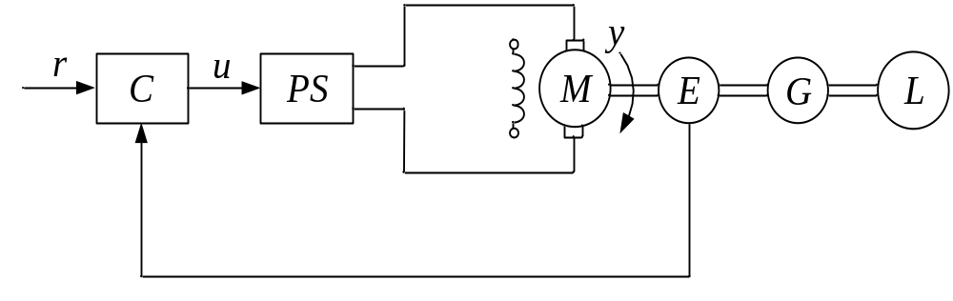
Figure 1 Position control system of DC Motor.
A simplified transfer function model of the DC motor with the power supply device has the form
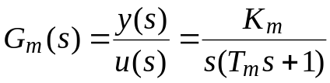.
The following values of the plant parameters are identified: 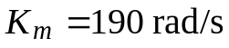, 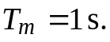
Determine the coefficients 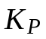 and 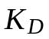 of the proportional-derivative (with derivative on output only) controller
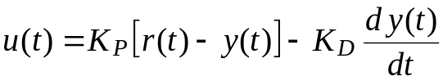
to achieve a 2 % settling time 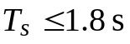 and a percent overshoot 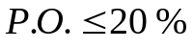 to a step reference input.
Directions:
Use the following design procedure:
- Find the closed-loop transfer function.
- Compute the desired values of parameters 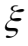 and 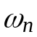 using the design specifications.
- Determine the coefficients and by comparing the closed-loop transfer function to a general second-order system.
Task 2
Use MATLAB to plot the control system response for a unit step reference input. Determine the values of settling time and percent overshoot. If the design specifications are not achieved, redesign the controller.
Task 3
Investigate experimentally the position control system designed using the Modular Servo System.
Real-time experiments are performed using the Simulink model, depicted in Figure 2.
- A goal of the control is to track a reference position which is defined as a square wave. In the Signal Generator Block in the real-time Simulink model Lab_7_Task_3_A.mdl, enter the square reference signal, amplitude equal to 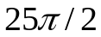 rad and frequency equal to 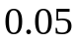 Hz. Set the determined values of the controller coefficients and . Stop time set equal to 28 s. Build an executable file and start the real-time experiment. Observe the results in the scope of the Simulink model. Repeat the experiment with the new value of the controller coefficient , compare and explain the obtained results.
- In the real-time Simulink model Lab_7_Task_3_B.mdl, enter the sine reference signal, amplitude equal to 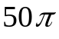 rad, frequency equal to Hz and stop time equal to 65 s. Set the determined values of the controller coefficients and . Start the real-time experiment, observe and explain the results.
Report Content
The lab report should contain the following:
- The objective of the lab.
- Formulation of the tasks.
- Controller design.
- Experimental results.
- Discussion of the obtained results.
- Conclusion.

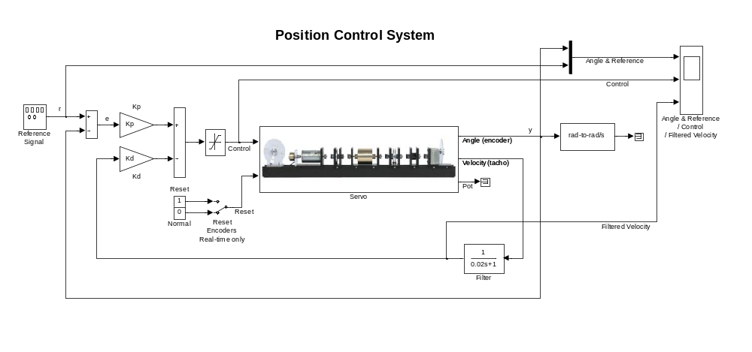
Figure 2 Simulink model for real-time position control.

