Lab № 1

Modeling Discrete-time and Nonlinear Systems with Simulink
Objective
This lab aims to teach the students to use Simulink for modeling and analyzing discrete-time and nonlinear systems.

Background Materials
Lecture notes for the course Control Theory 2, Theme 1. Introduction to Discrete-Time Control System, pp 1- 13, 140 – 141.

Simulink is a graphical extension to MATLAB for the modeling and simulation of systems. Simulink is integrated with MATLAB and data can be easily transfered between the programs. Most of the blocks needed for modeling basic systems can be found in the subfolders of the main "Simulink" folder.
The general classes of blocks available for us to modeling discrete and nonlinear systems are:
- Continuous
- Discontinuities
- Discrete
- Math: Mathematical operators
- Sinks: Used to output or display signals
- Sources: Used to generate various signals
For modeling nonlinear systems we use Discontinuities library:
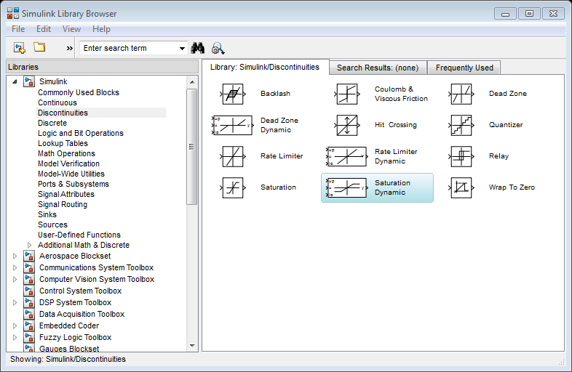
For modeling discrete-time systems we use subfolder Discrete with following elements:

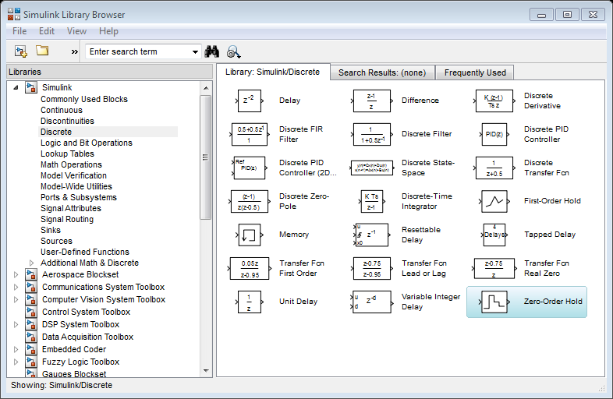

Tasks

Task 1
Draw a Simulink model of a unity negative feedback discrete-time control system including plant with pulse transfer function 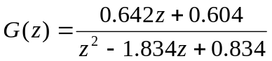 and discrete controller with pulse transfer function 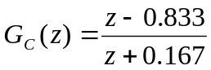. Assume that the sampling period 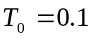 sec.
Obtain the response of the system to the unit step input.

Instruction:
1. Use block Discrete Transfer Fcn
2. Set the sampling period in all discrete blocks.
3. Simulink model of the system is shown in Figure 1.

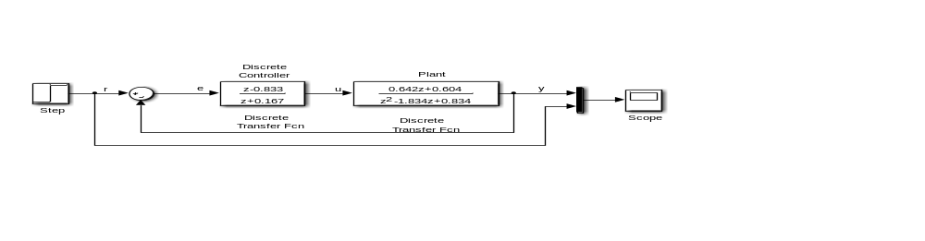
Figure 1 Simulink model for Task 1

Task 2
Consider a discrete-time control system with a state-space representation as follows:
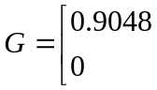. 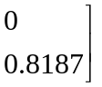; 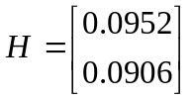; 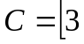 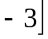; 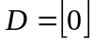.
Assume that the sampling period sec. Obtain the response of this system to a unit step input.

Instruction:
1. For this model use Discrete State-Space block from the library.
2. Set the parameters of the system as is shown in Figure 2.

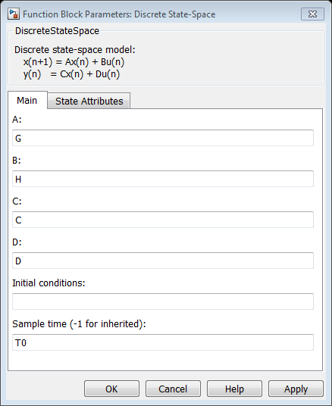
Figure 2 Function block parameters for Discrete State-Space
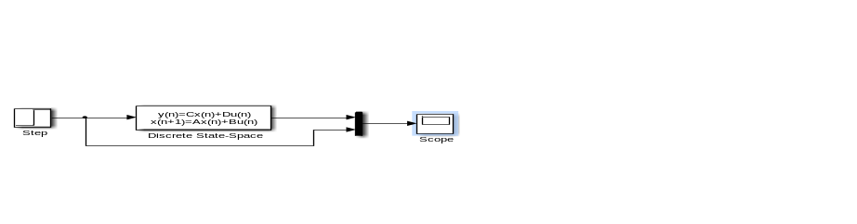
Figure 3 Simulink model for Task 2

Task 3
Consider the system from Task 1. Assume that the input of the plant is limited. Draw Simulink model, using block Saturation from Discontinuities library. Obtain the response of the system to a unit step input for two upper and lower saturation values of the block Saturation: 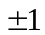 and 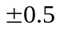.
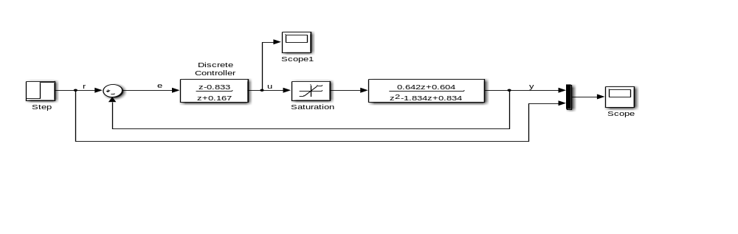
Figure 4 Simulink model for Task 3

Report Content

The lab report should contain the following:
• The objective of the lab.
• Formulation of the tasks.
• Obtained results, including MATLAB script-files, Simulink models and plots.
• Discussion of obtained results.
• Conclusions

