Theme 1

Introduction to Discrete-Time Control System

  - Introduction
  - Digital Control Systems
  - Quantizing and quantization error
  - Data acquisition, conversion, and distribution systems

1.1. Introduction
Advantages :
Computer-assisted control produces significant advantages as compared to conventional typical analog regulators. Some of these advantages are
• Great flexibility in modifying the controller’s features. Indeed, these features can easily be altered by modifying the program. In contrast, in analog control systems, changing the controller characteristics is usually a nontrivial task and quite expensive because a substitution of elements and devices is required
• Data processing is easy. Complex calculations can be performed easily and quickly. Analog controllers do not have this capability.
• They present better technical behavior in comparison to the analog control systems in terms of reliability and sensitivity to disturbances.
• They have an improved stability, a lower physical weight and, in many cases, a lower implementation cost
Types of signals.
A continuous-time signal is a signal defined over a continuous range of time. The amplitude may assume a continuous range of values or may assume only a finite number of distinct values. The process of representing a variable by a set of distinct values is called quantization, and the resulting distinct values are called quantized values.

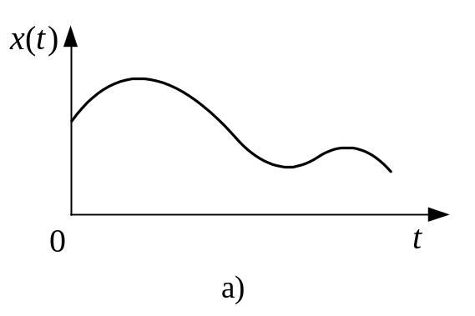

An analog signal is a signal defined over a continuous range of time whose amplitude can assume a continuous range of values. Figure 1.1(a) shows a continuous-time analog signal, and Figure 1.1(b) shows a continuous-time quantized signal (quantized in amplitude).
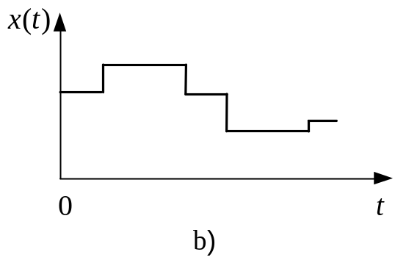

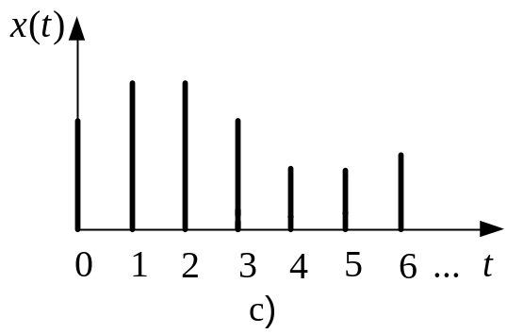A discrete-time signal is a signal defined only at discrete instants of time. In a discrete-time signal, if the amplitude can assume a continuous range of values, then the signal is called a sampled-data signal. A sampled-data signal can be generated by sampling an analog signal at discrete instants of time. It is an amplitude-modulated pulse signal. Figure 1.1(c) shows a sampled-data signal.

A digital signal is a discrete-time signal with quantized amplitude. Such a signal can be represented by a sequence of numbers. In practice, many digital signals are obtained by sampling analog signals and then quantizing them. It is the quantization that allows these analog signals to be read as finite binary words. Figure 1.1(d) depicts a digital signal. It is obviously, it is signal quantized both in amplitude and in time. The use of the digital controller requires quantization of signals both in amplitude and in time.

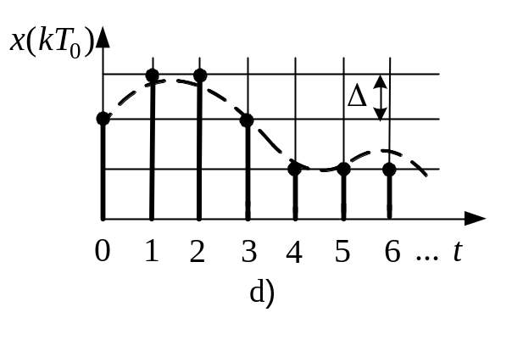

Figure 1.1: a) Continuous-time analog signal; b) continuous-time quantized signal; c) sampled-data signal; d) digital signal
A discrete-time signal can refer either to a digital signal or to a sampled-data signal. In practical usage, the terms “discrete time” and “digital” are interchanged.
Many industrial control systems include continuous-time signals, sampled-data signals, and digital signals. Therefore, in this course of lectures we use the term "discrete-time control systems" to describe the control systems that include some forms of sampled-data signals (amplitude-modulated pulse signals) and/or digital signals (signals in numerically coded form).
Discrete-time control systems. Discrete-time control systems are control systems in which one or more variables can change only at discrete instants of time. These instants, which we shall denote by 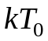 or 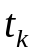 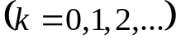, may specify the times at which some physical measurement is performed or the times at which the memory of a digital computer is read out. The discrete-time control systems considered in this course of lectures are linear and time invariant. A linear system is one in which the principle of superposition applies. A time-invariant system is that in which the properties of the system do not change with time.
Continuous-time systems may be described by differential equations. Discrete-time systems, which involve sampled-data signals or digital signals and probably continuous-time signals, may be described by difference equations.

1.2. Digital control systems
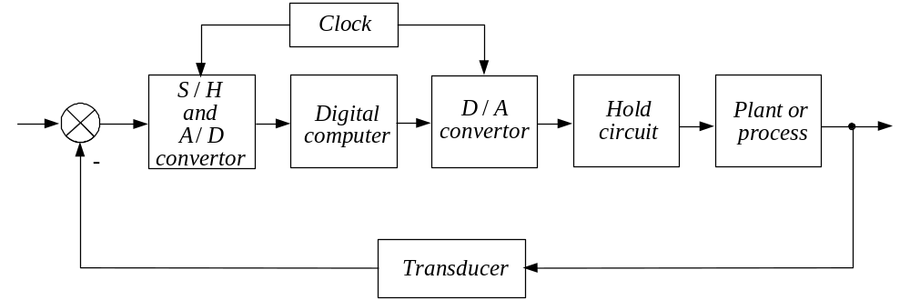

Figure 1.2. Block-diagram of a digital control system

Figure 1.2 shows a block diagram of a digital control system. The output of the plant is a continuous-time signal. The error signal is converted into digital form by the sample-and-hold (S/H) circuit and the analog-to-digital converter (A/D). The operation that transforms continuous-time signals into discrete-time data is called sampling or discretization. The conversion is done at the sampling time. The sample-and-hold circuit and analog-to-digital converter convert the continuous-time signal into a sequence of numerically coded binary words. Such an A/D conversion process is called coding or encoditig. The combination of the S/H circuit and analog-to-digital converter may be visualized as a switch that closes instantaneously at every time interval 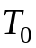 and generates a sequence of numbers in numerical code. The digital computer processes the sequences of numbers by means of an algorithm. At every sampling instant a coded number must be converted to a physical control signal, which is usually a continuous-time or analog signal. The digital-to-analog converter and the hold circuit convert the sequence of numbers in numerical code into a piecewise continuous-time signal. The operation that transforms discrete-time data into a continuous-time signal, is called data-hold. The digital-to-analog (D/A) conversion process is called decoding.

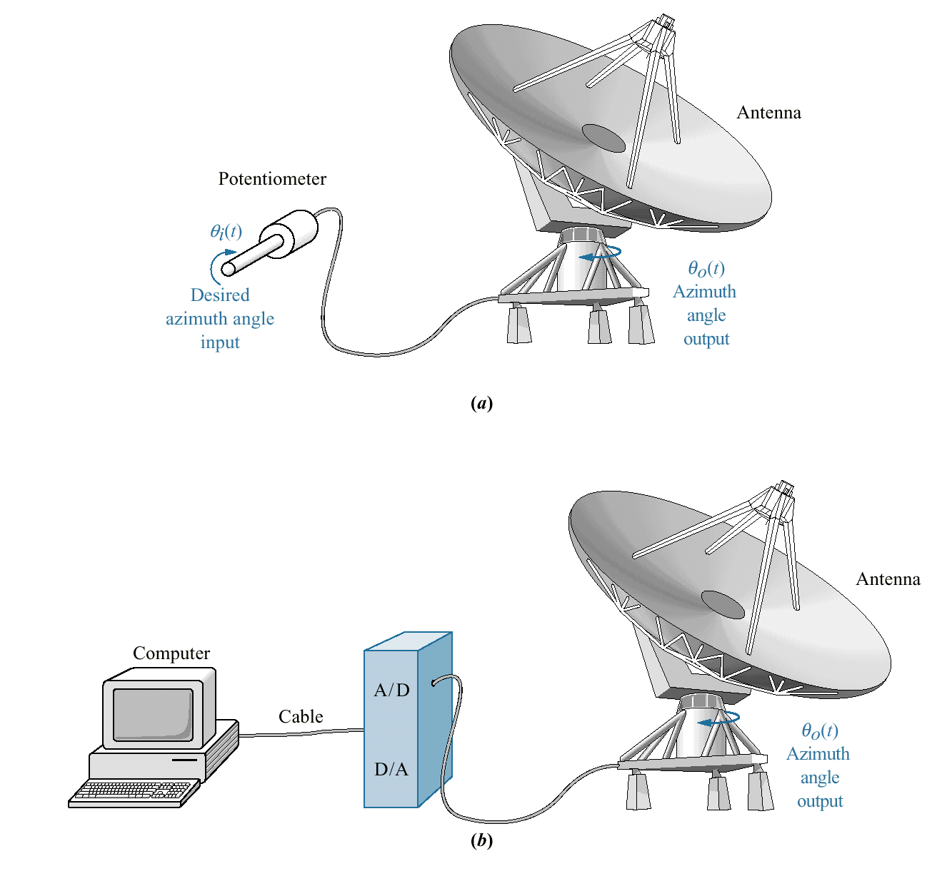

Figure 1.3. Conversion of antenna azimuth position control system from: a) analog to b) digital control system
The real-time clock in the computer synchronizes the events. The output of the hold circuit, a continuous-time signal, is fed to the plant to control its dynamics.
Figure 1.4b) shows some simplifying assumptions we have done. The power amplifier’s pole is assumed to be far enough away from the motor’s pole that we can represent the power amplifier as a pure gain equal to its dc gain of unity. Also, we have absorbed any preamplifier and potentiometer in the computer and its associated D/A converter.

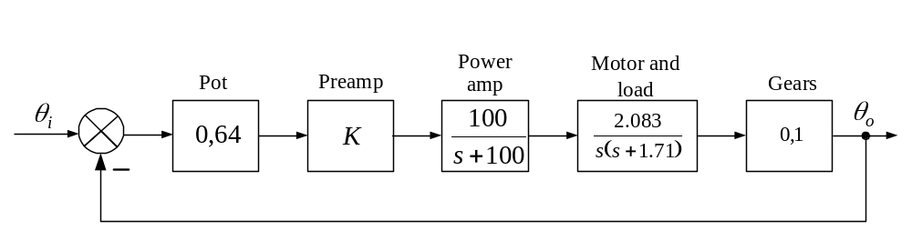

a)
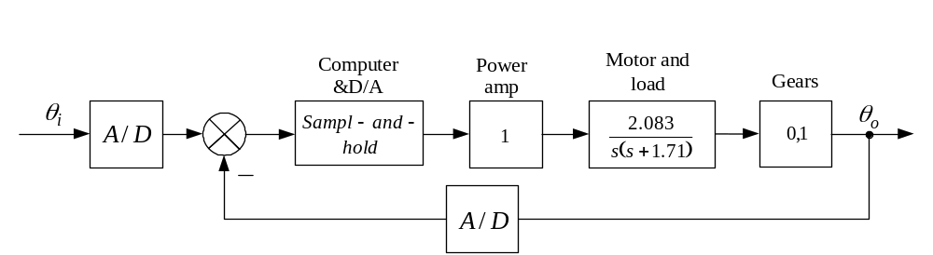

b)
Figure 1.4. Antenna control system: a) continuous implementation.
b) digital implementation

1.3. Quantizing and quantization error
Quantizing. The main functions involved in analog-to-digital conversion are sampling, amplitude quantizing and coding. The value of any sample is represented by the state nearest the actual value of the signal. This process of representing a continuous or analog signal by a finite number of discrete states is called amplitude quantization. The output state of each quantized sample is then described by a numerical code. The process of representing a sample value by a numerical code is called encoding or coding. The sampling period and quantizing levels must be determined carefully in digital control systems.
The number system used for representing digital signals is the binary number system. In this system the code group consists of n pulses each indicating either ‘on’ (1) or ‘off’ (0). In quantizing n "on-off" pulses can represent 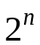 output states. The quantization level 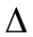 is defined as the range between two adjacent decision points and is given by
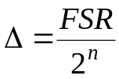,
where the 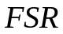 is the full-scale range.

Quantization error. There is a maximum for the number of bits n, and so there is always some error due to quantization. This quantization error varies between 0 and 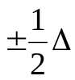, fig.1.5. The uncertainty present in the quantization process is called quantization noise. The variance of the quantization noise is an important measure of quantization error, since the variance is proportional to the average power associated with the noise. For a small quantization level , the nature of the quantization error is like that of random noise. Let assume that the quantization error 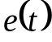 is distributed uniformly between 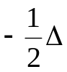 and 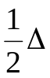, and that this error acts as a white noise. The probability distribution 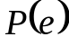 of is shown in fig.1.6, and the average value of is zero. It can be proved that the variance 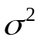 of the quantization noise is 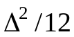. Thus, if the quantization level is small compared with the average amplitude of the input signal, then the variance of the quantization noise is one-twelfth of the square of the quantization level.
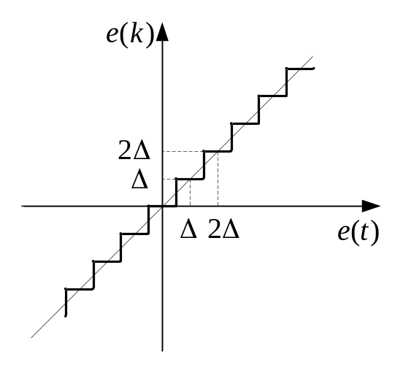
Figure 1.5. Input-output characteristics of a quantizer
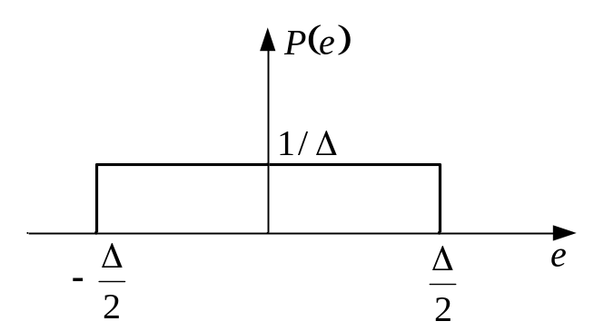
Figure 1.6. Probability distribution 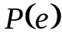 of quantization error 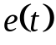

  - Data acquisition, conversion, and distribution systems
Figure l.7(a) shows a block diagram of a data-acquisition system, and Figure 1.7(b) shows a block diagram of a data-distribution system.
In the data-acquisition system the input to the system is a physical variable which is converted into an electrical signal by a suitable transducer. The amplifier performs one or more of the following functions: it amplifies the voltage output of the transducer; it converts a current signal into a voltage signal; or it buffers the signal. The low-pass filter attenuates the high-frequency signal components. The output of the low-pass filter is an analog signal. This signal is fed to the analog multiplexer. The output of the multiplexer is fed to the sample-and-hold circuit, whose output is, in turn, fed to the analog-to-digital converter. The output of the converter is the signal in digital form; it is fed to the digital controller.

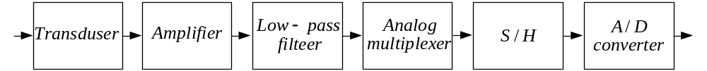

(a)

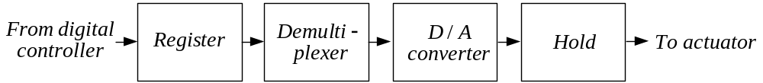

b)
Figure 1.7: a) Block diagram of a data-acquisition system; b) block diagram of a data-distribution system
As shown in Figure l.7(b), a data-distribution system consists of registers, a demultiplexer, digital-to-analog converters, and hold circuits. It converts the signal in digital form into analog form. The output of the hold circuit is fed to controls the plant.
In the following, we shall discuss sample-and-hold circuit, A/D converter and D/A converter.
Sample-and-hold circuit. A sampler in a digital system converts an analog signal into a train of amplitude-modulated pulses. The hold circuit holds the value of the sampled pulse signal over a specified period. The sample-and-hold is necessary in the A/D converter to produce a number that represents the input signal at the sampling instant.
In practice, the sampling duration is very short compared with the sampling period 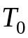 and the sampler may be considered an "ideal sampler". Figure 1.8 shows a diagram for the sample-and-hold. In Figure 1.8 the electronic switch is connected to the hold capacitor. Operational amplifier 1 is an input buffer amplifier with a high input impedance. Operational amplifier 2 is the output amplifier; it buffers the voltage on the hold capacitor. There are two modes of operation for a sample-and-hold circuit: the tracking mode and the hold mode. When the switch is closed the operating mode is the tracking mode. The charge on the capacitor in the circuit tracks the input voltage. When the switch is open, the operating mode is the hold mode and the capacitor voltage holds constant for a specified time period. Figure 1.9 shows the tracking mode and the hold mode. Switching from the tracking mode to the hold mode is not instantaneous.

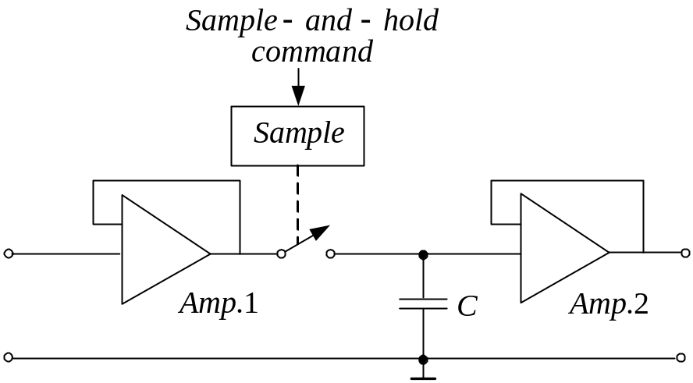

Figure 1.8. Sample-and-hold circuit

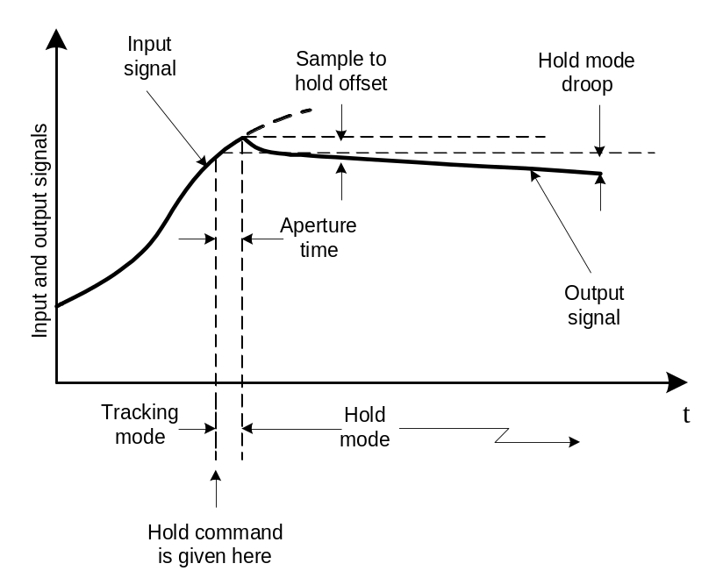

Figure 1.9. Tracking mode and hold mode
If the hold command is given while the circuit is in the tracking mode, then the circuit will stay in the tracking mode for a short while before reacting to the hold command. The time interval during which the switching takes place is called the aperture time. The output voltage during the hold mode may decrease slightly. The hold mode droop may be reduced by using a high-input-impedance output buffer amplifier. The sample-and-hold operation is controlled by a periodic clock.

Analog-to-Digital (A/D) Converters. As explained before, the process by which a sampled analog signal is quantized and converted to a binary number is called analog-to-digital conversion. In other words, the A/D converter performs the operations of sample-and-hold, quantizing, and encoding. Note that in the digital system the A/D converter sends a digital signal to the digital controller every sampling period .
The following types of the A/D circuits are used most frequently: Successive-approximation type; Integrating type; Counter type; Parallel type. Each of these types has its own advantages and disadvantages. The successive-approximation type of A/D converter is the one most frequently used. Figure 1.10 shows a schematic diagram of the successive-approximation type of A/D converter. The principle of operation of this type of A/D converter is as follows. The successive approximation register first turns on the most significant bit and compares it with the analog input. The comparator decides whether to leave the bit on or turn it off. If the analog input voltage is larger, the most significant bit is set on. The next step is to turn on bit 2 and then compare the analog input voltage with three-fourths of the maximum. After n comparisons are completed, the digital output of the successive-approximation register indicates all those bits that remain on and produces the desired digital code. Thus, this type of A/D converter sets 1 bit each clock cycle, and so it requires only n clock cycles to generate n bits, where n is the resolution of the converter in bits. The time required for the conversion is approximately 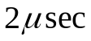 or less for a 12-bit conversion.

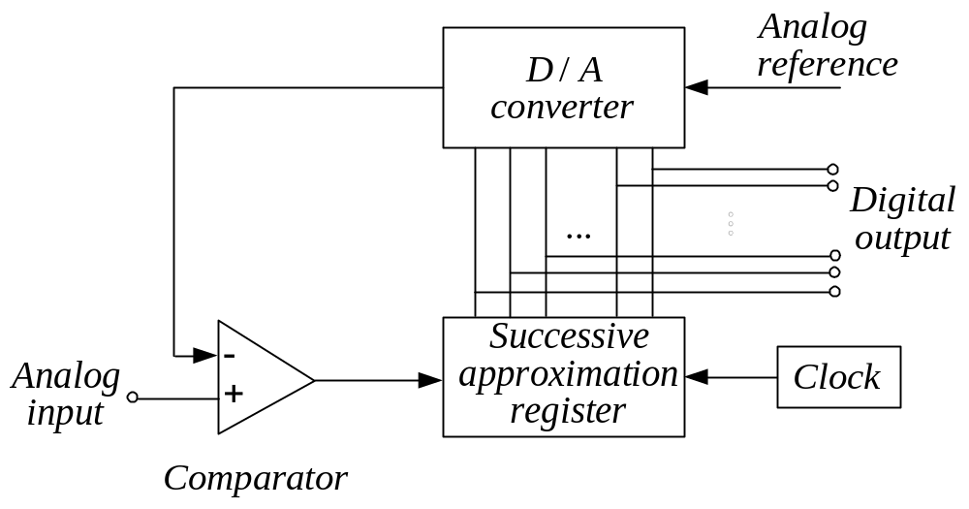

Figure 1.10. Schematic diagram of a successive-approximation-type of A/D converter

Digital to Analog (D/A) converters. A D/A converter is a device that transforms a digital input to an analog output. Two methods are commonly used for digital-to-analog conversion: the method using weighted resistors, and the method using the 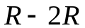 ladder network. The former is simple in circuit configuration, but its accuracy may not be very good. The latter is a little more complicated in configuration but is more accurate.
Figure 1.11 shows a schematic diagram of a D/A converter using weighted resistors. The input resistors of the operational amplifier have their resistance values weighted in a binary fashion. When the logic circuit receives binary 1, the switch connects the resistors to the reference voltage. When the logic circuit receives binary 0, the switch connects the resistor to ground. The digital-to-analog converters used in practice are of the parallel type – all bits act simultaneously upon application of a digital input.
The D/A converter generates the analog output voltage corresponding to the given digital voltage. For the D/A converter shown in Figure 1.11, if the binary number is 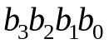, the output is
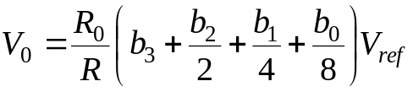.
Notice that as the number of bits is increased the range of resistor values becomes large and consequently the accuracy becomes poor.
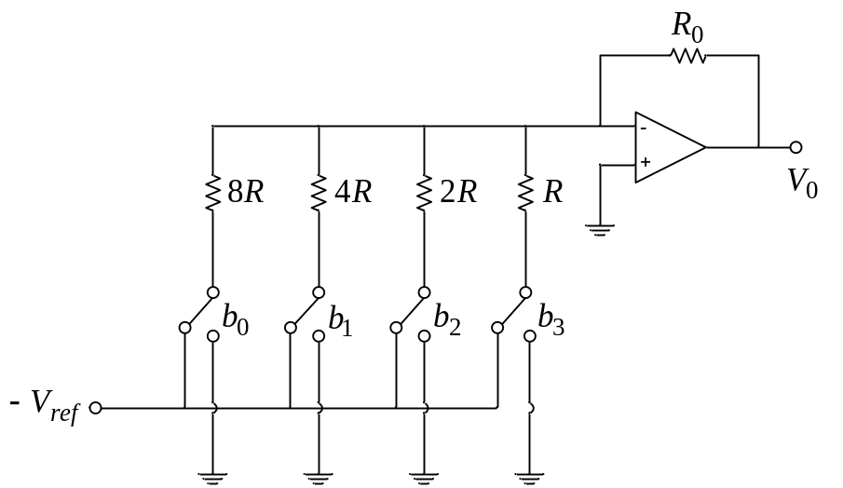

Figure 1.11. Schematic diagram of a D/A converter using weighted resistors

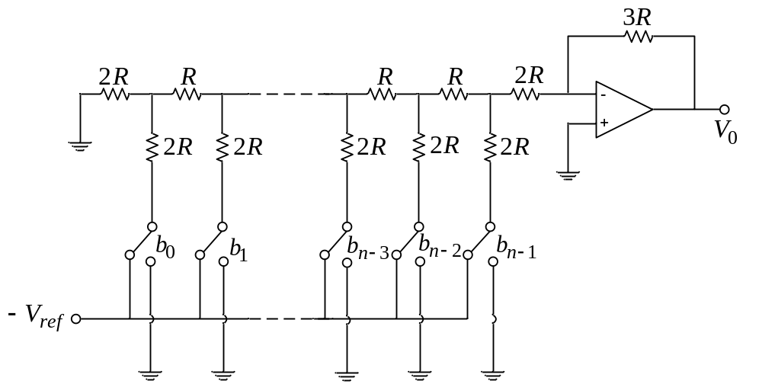
Figure 1.12. - Bit D/A converter using an 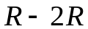 ladder circuit
Figure 1.12 shows a schematic diagram of an n-bit D/A converter using an ladder circuit. Note that with the exception of the feedback resistor all resistors involved are either 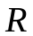 or 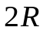. This means that a high level of accuracy can be achieved. The output voltage can be given by
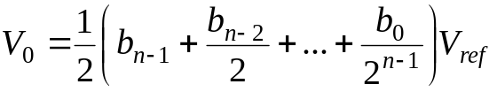.
Reconstructing the Input Signal by Hold Circuits. The function of the hold operation is to reconstruct the analog signal that has been transmitted as a train of pulse samples. The hold circuit is designed to extrapolate the output signal between successive points according to some prescribed manner. The staircase waveform of the output shown in Figure 1.13 is the simplest way to reconstruct the original input signal. The
hold circuit that produces such a staircase waveform is called a zero-order hold. Because of its simplicity, the zero-order hold is commonly used in digital control systems. More sophisticated hold circuits a higher-order hold circuits and include the first-order hold and the second-order hold. Higher-order hold circuits will generally reconstruct a signal more accurately than a zero-order hold, but with some disadvantages, as explained next.
The first-order hold retains the value of the previous sample, as well as the present one, and predicts, by extrapolation, the next sample value. This is done by generating an output slope equal to the slope of a line segment connecting previous and present samples and projecting it from the value of the present sample, as shown in Figure 1.14.
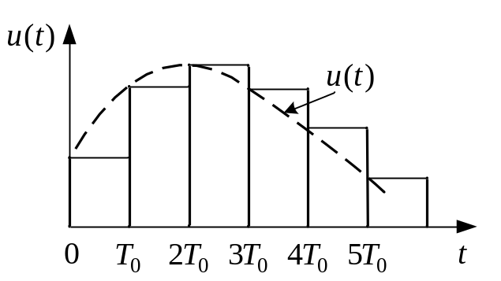
Fig.1.13. Output from a zero-order hold
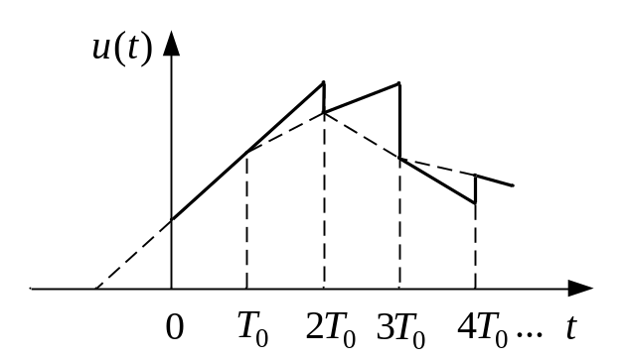
Fig.1.14. Output from a first-order hold

Text:
Ogata, K. Discrete-Time Control Systems, 2nd ed., Prentice-Hall, Upper Saddle River, N.J.
Nise, N. S.. Control System Engineering, John Wiley & Sons, M.A., 2011.

