Lab № 12

Design of a State Observer

Objective
This lab aims to teach the students to design a full-order state observer and to realize discrete-time control system with state feedback and a state observer.

Background Materials
Lecture notes for the course Control Theory 2, Theme 6. Pole Placement and Observer Design, pp 134 – 139.

Tasks

Task 1
Consider the system in lab.11. Assume that the state variables are not available for measuring.
1. Design the full-order state observer for three values of the desired poles, simulate the observer and compare state variables with the output of the plant.
2. Make a Simulink model of the observed state feedback control system.
3. Obtain the step response of the system when the initial conditions of the observer and the plant are different. Explain the results.
4. Obtain the step response when in the system there is a measurement noise.

Instruction:

1.Check the observability of the discrete-time control system. MATLAB command to obtain the observability matrix N is:
N=obsv(G,C)
2.The equation of the state observer is:
, (1)
where 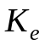is the observer feedback gain matrix. This equation can be modified as
. (2)
The design of the state observer reduces to the determination of an appropriate state observer feedback gain matrix . Once we select the desired eigenvalues (or desired characteristic equation), the observer can be designed in a way similar to the method used in the case of the pole placement. The desired characteristic equation may be chosen so that the observer responds at least four or five times faster than the closed-loop system or deadbeat response may be desired.
A MATLAB command to determine matrix K_{e} is:
K_{e}=acker(G’,C’,z₀),
where z₀ is a vector of the desired poles.

Calculate K_{e} for the following values of z_{0:}
zo1=[0.8 0.8];
zo2=[0.5+j*0.5 0.5-j*0.5];
zo3=[0 0];

For Simulink model of the observer we can use the equation (2). The block parameter of the observer is shown in Figure 1. Obtain the unit step response for three values of the Initial conditions (0, 4 and 6) of the Plant and compare the results (Figure 2).

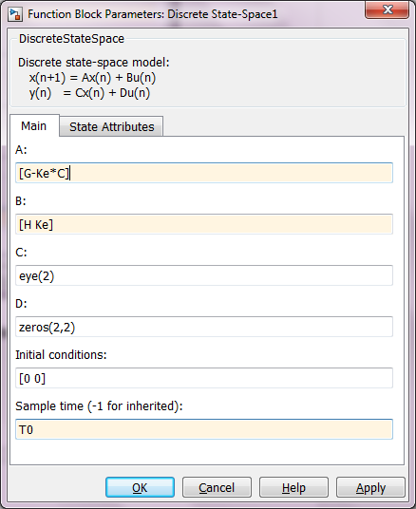

Figure 1 Function block parameters for observer

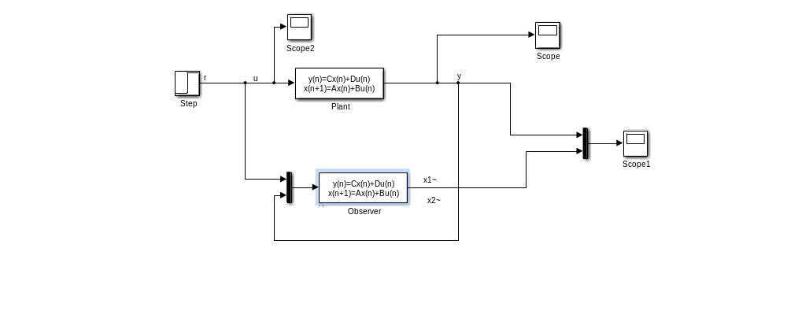
Figure 2 Block diagram to simulate and compare Plant and State observer

3.The other way to make a Simulink model of the state observer is write the observer equation as follow:
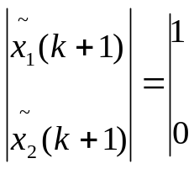 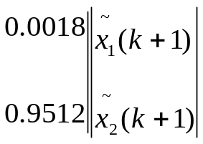+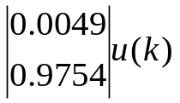+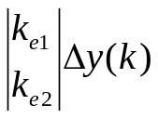.
Write equations for 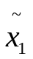 and 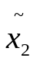 and realise them in a Simulink model (see Figure4).
Obtain the step response (r₀=10) for two values of the Initial conditions (0 and 4) of the block Discrete State-Space and Noise power=0 of the Band-Limited White Noise. (Figure 3 and Figure 4)
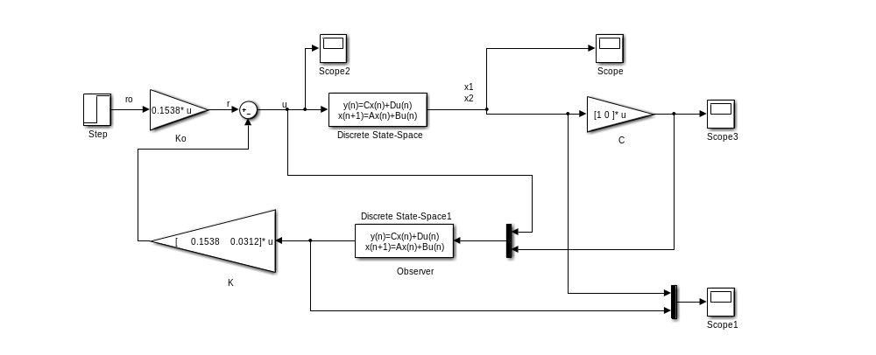

Figure 3 Simulink model of observed-state feedback control system
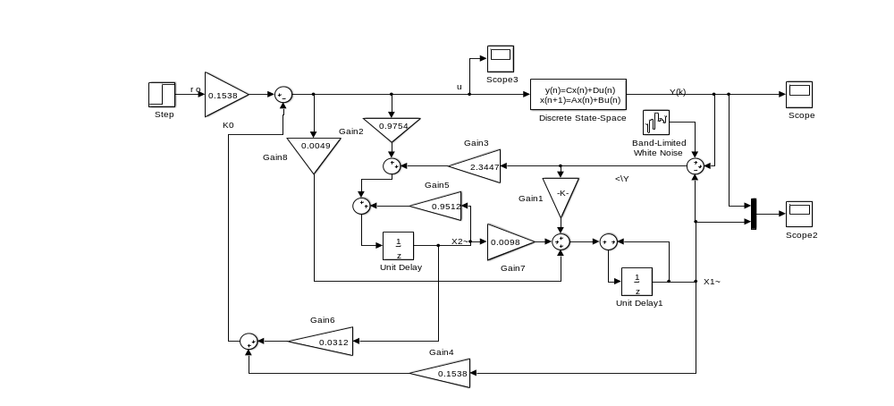

Figure 4 Simulink model of the closed-loop system with state observer and noise

4.Simulate the system for Noise power=0,01 of the Band-Limited White Noise and observe the output and state variables.

Report Content

The lab report should contain the following:
• The objective of the lab.
• Formulation of the tasks.
• Obtained results, including MATLAB script-files, Simulink models and
plots.
• Discussion of obtained results.
• Conclusion.

