Lab № 6

Stability analysis of closed-loop systems in the z-plane

Objective
This lab aims to teach the students to analyze stability of closed-loop control
systems using location of the roots of characteristic equation, the Jury test and the Routh-Hurwitz criterion.

Background Materials
Lecture notes for the course Control Theory 2, Theme 4. Design of Discrete-Time Control Systems by Conventional Methods, pp 63 – 75.

Tasks

Task 1
A closed-loop discrete–time system has a characteristic equation:
- 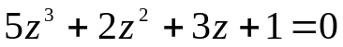
- 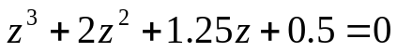
- 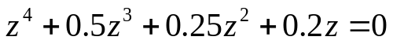
- 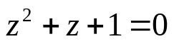
Check the stability of the system.

Instruction:

To find the roots of the characteristic equation use the MATLAB command roots.

Task 2
Determine the stability of discrete-time unity-feedback control system with open-loop pulse transfer function
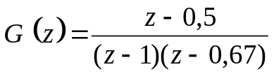.

Task 3
A discrete-time unity-feedback control system has open-loop pulse transfer function 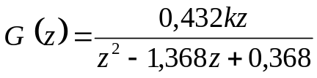.
Determine the range of the gain k for the stability of the closed-loop system, using
Routh-Hurwitz criterion.

Task 4
A discrete-time control system has the following characteristic equation
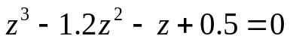.
Determine the stability of the system with Jury stability test.

Task 5
A discrete-time control system has the characteristic equation
.
Determine and plot the region of gains k₁ and k₂ for stability by using the Jury stability test.

Report Content

The lab report should contain the following:
• The objective of the lab.
• Formulation of the tasks.
• Obtained results, including MATLAB script-files, Simulink models and
plots.
• Discussion of obtained results.
• Conclusion.

