Lab № 11

Design of Closed-loop Systems via Pole Placement

Objective
This lab aims to teach the students to design discrete-time control systems using state space method via pole placement

Background Materials
Lecture notes for the course Control Theory 2, Theme 6. Pole Placement and Observer Design, pp 118 – 134.

Tasks

Task 1
Consider electromechanical control entity(plant) consisting of an electronic amplifier(EA), a DC motor, a mechanism for converting the movement(MCM) and a mechanical unit(MU) shown in Figure 1.
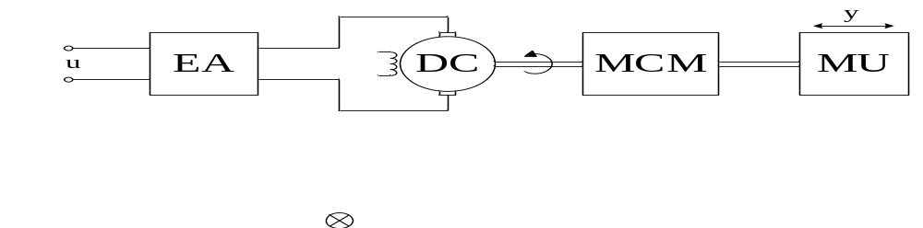
Figure 1 Functional diagram of system for Task 1

In ignoring the electromagnetic time constant of the motor and the time constant of the amplifier, the transfer function of the plant can be represented in the form:
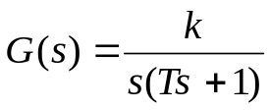,
where
-electromechanical constant T=0.2sec.
-coefficient k=20mm/V.sec.;
Output of the plant is moving y of the mechanical unit and the control action is the voltage u of the electronic amplifier. The step response of the closed-loop system should be without overshoot and the transient response specification settling time 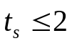sec. We assume that all state variables are measurable and available for feedback.
1. Obtain the discrete-time state-space representations of the described plant. Assume T₀=0.01sec.
2. Design a closed-loop system with matrix K feedback via pole placement.
3. Use Simulink to plot the response of y(t) to a step input r(t)=10 and to define the transient response specification settling time 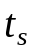. Observe changing of the state variables x₁ and x₂ and control action u for two values of K. Make conclusions.

Instruction:

The structure of a closed-loop control system is shown in Figure 2.
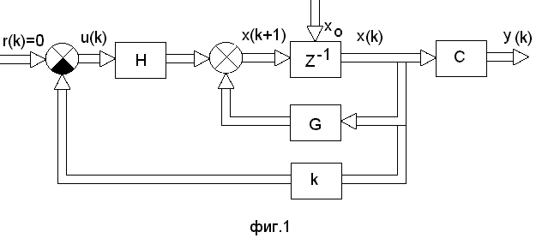
Figure 2 Closed-loop control system with u(k)= -Kx(k)

- Obtain the discrete-time state-space representations and check the
controllability. MATLAB command to obtain the controllability matrix M is:
M=ctrb(G,H).
- Select the desired closed-loop poles or the desired characteristic equation
There are no clear rules for selection of the poles of the closed-loop system. There is a relationship between the location of the poles of discrete-time control system and the type of its transient response.
If the pole z_{i} is a positive integer and z_{i}<1, an appropriate transient response is without overshot.
If the pole z_{i} is a negative integer and z_{i}<1, an appropriate transient response is oscillatory.
If the pole z_{i}=0 the response of the system is deadbeat.
For this task we recommend the following values of the poles of the closed-loop system:
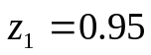, 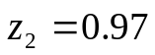.
The desired characteristic equation is:
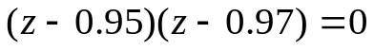.
- Determine matrix K
Characteristic equation of the designed closed-loop system is:
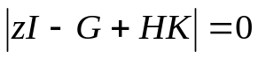.
Now equate this characteristic equation with the desired characteristic equation. By comparing the coefficients of equal powers of z obtain
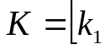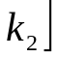.
Calculate K again for the other values of the poles:
, 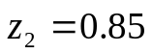.

A MATLAB commands to determine matrix K and K₀ are:

K=acker(G,H,z),
K₀=inv(C*inv(eye(2)-G+H*K)*H)
where z is vector of the desired closed-loop poles.

Simulink model of the system is shown in Figure 2. Note that in block Discrete State Space have to set for matrix C and D
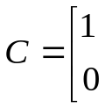 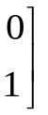, 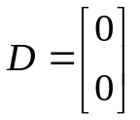.
This is necessary because we want the output of the block to be the state vector X.

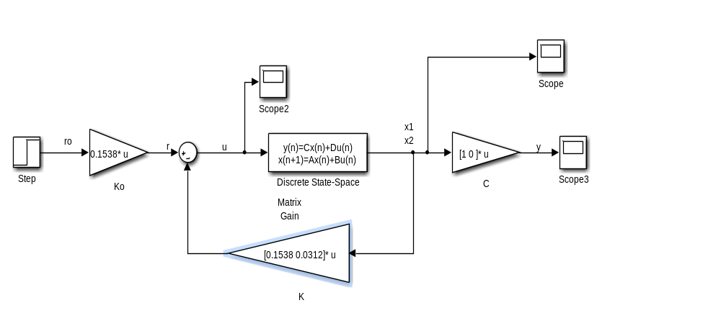
Figure 2 Simulink model of the designed system

Report Content

The lab report should contain the following:
• The objective of the lab.
• Formulation of the tasks.
• Obtained results, including MATLAB script-files, Simulink models and
plots.
• Discussion of obtained results.
• Conclusion.

