# Control Theory 1

# Report

# Lab 9

|  |  |
| --- | --- |
| Student | Murad Aliyev |
| Supervisor | Nijat Hasanov |
| Date | 04/12/2024 |

## Task 3

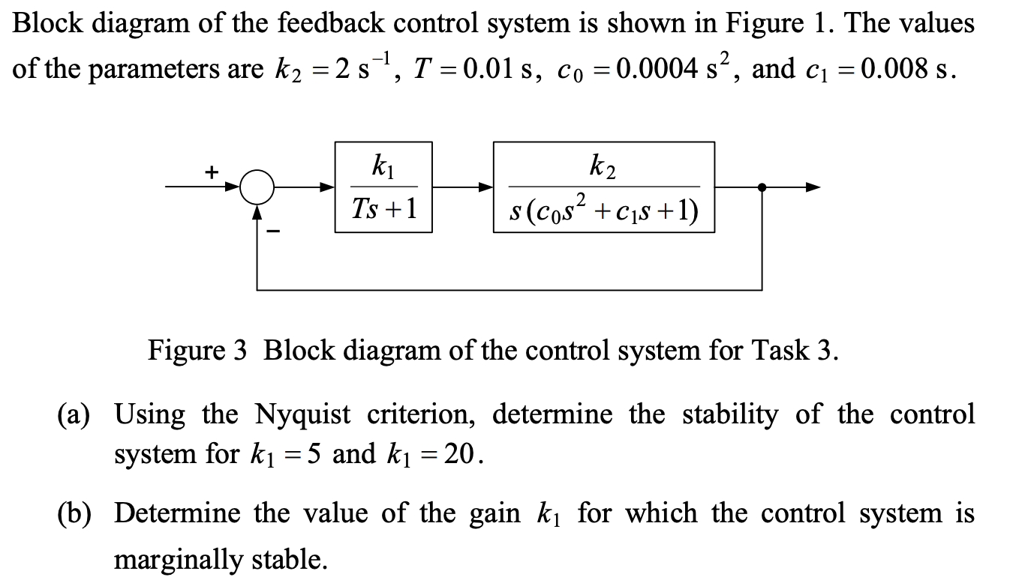

## Solution

**Task A)**

The open-loop transfer function  G(s)H(s)  of the system is:

Substitute the given parameters:

• ,

• T = 0.01s1 ,

• c0 = 0.0004s2 ,

• c1 = 0.008s.

This becomes:

Steps:

1. Determine the Nyquist plot for  k_1 = 5  and  k_1 = 20 .

2. Use the Nyquist stability criterion to check whether the closed-loop system is stable (by analyzing the encirclement of the -1 point in the Nyquist plot).

**Part (b): Marginal stability**

Marginal stability occurs when the Nyquist plot passes through -1 on the real axis, meaning:

|G(s)H(s)| = 1 \quad \text{at some frequency}.

Solve for  k_1  such that the magnitude condition is satisfied:

\left| \frac{2k_1}{(0.01j\omega + 1) \cdot j\omega \cdot (0.0004(j\omega)^2 + 0.008j\omega + 1)} \right| = 1.