Control Theory 2

Lab Report 1

by Murad Aliyev

# Task 1

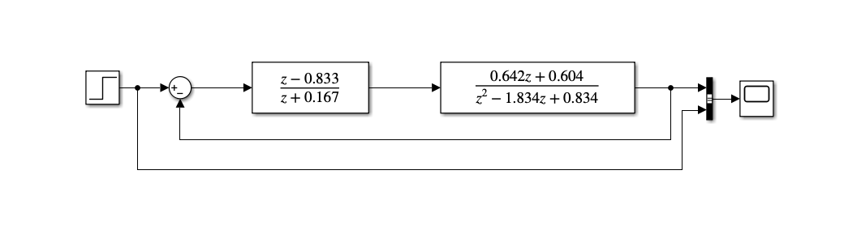

The model is built as shown. And after running the model we get the following scope results:

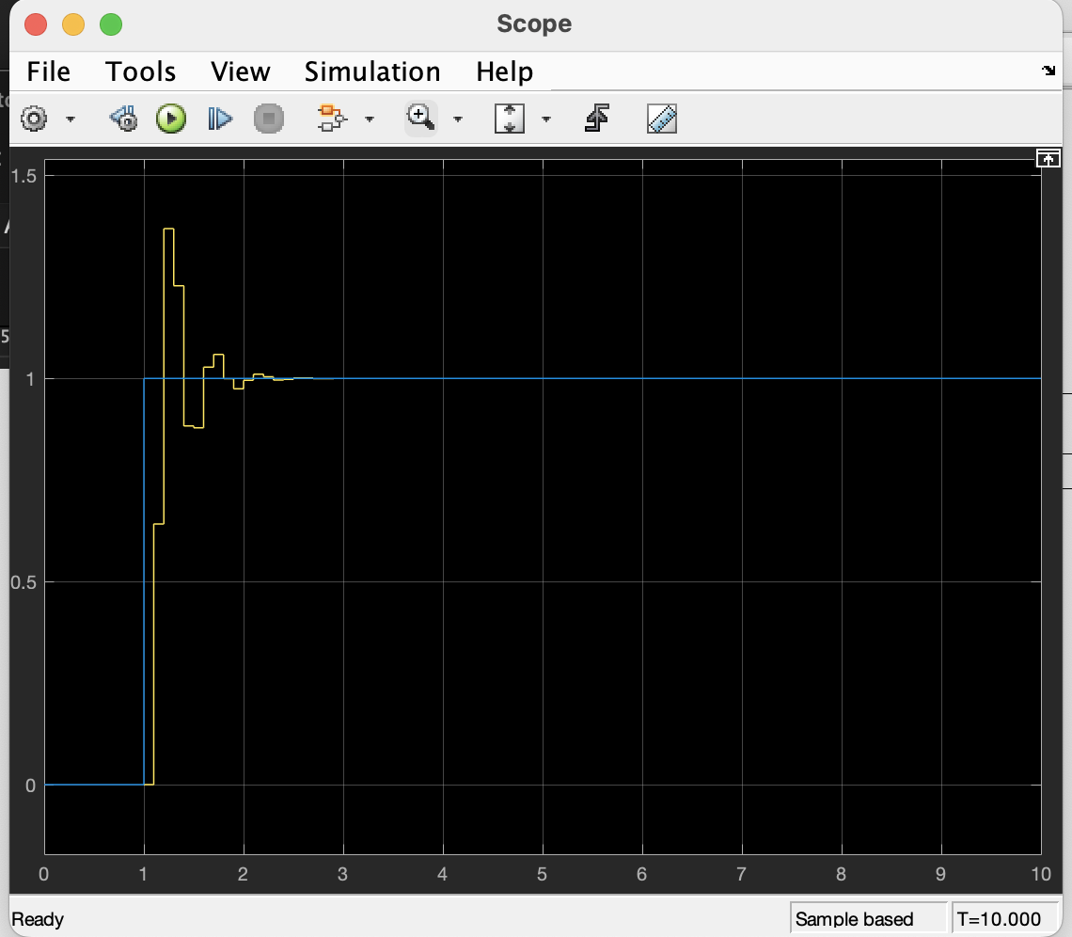

# Task 2

The task contains following variable definitions. These variables are need in the workspace so as the first step we must run this matlab file:

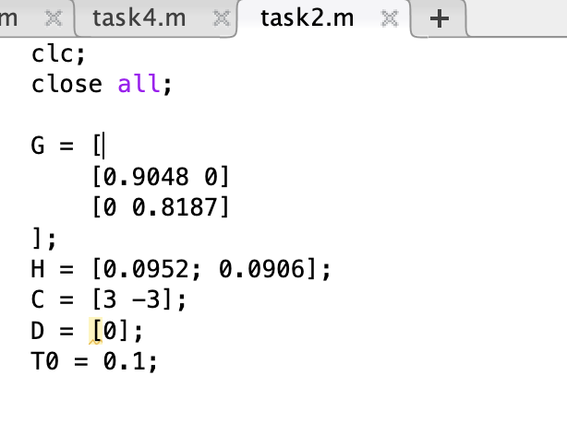

Following this we have the model structure

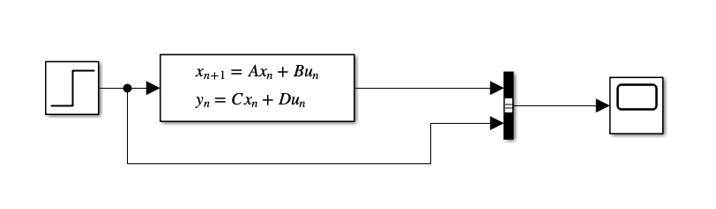

Running this model will result in the following result:

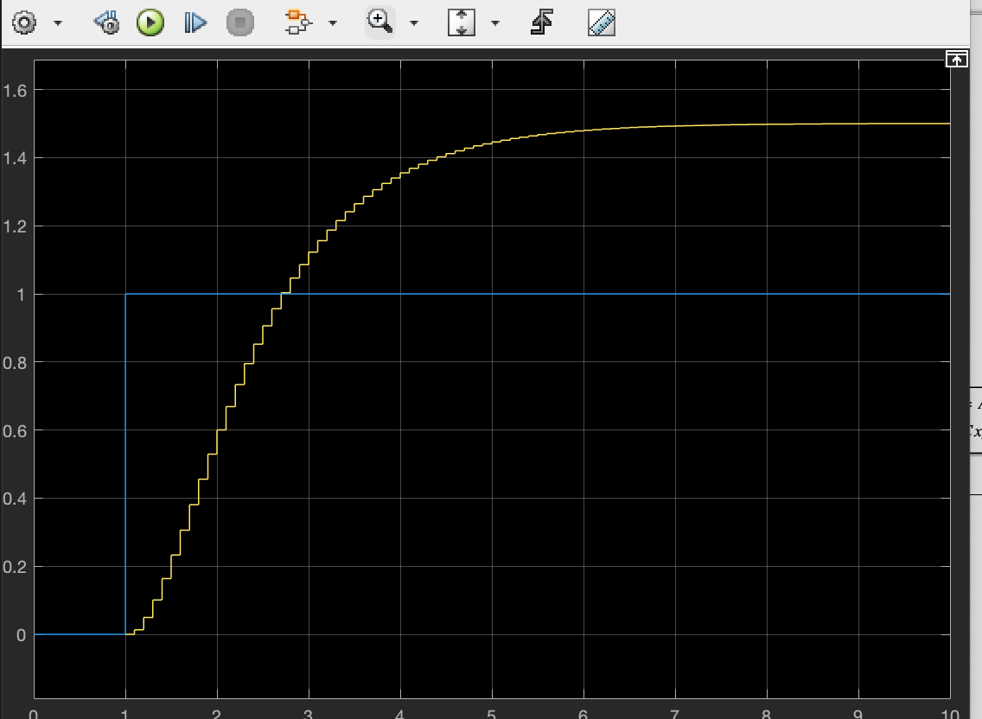

# Task 3

This task also has the same parameters we had in the first task but with some additional components.

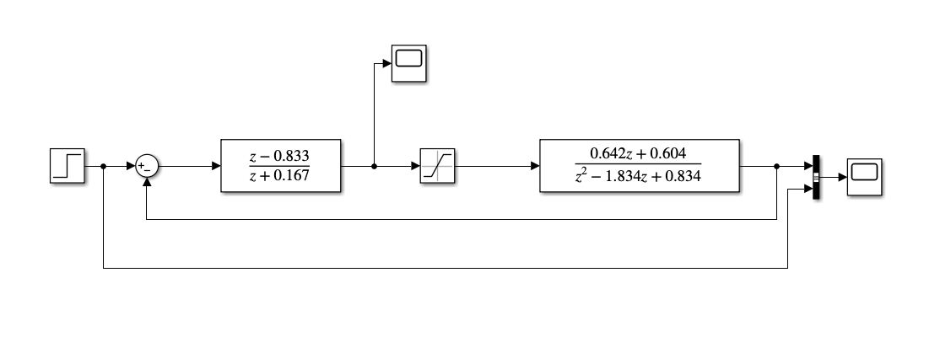

And this results in the following graph output:

