Control Theory 2

Lab Report 3

by Murad Aliyev

# Task 1

To determine the step response of the discrete-time unity-feedback closed-loop system, we need to find the closed-loop transfer function:

The closed-loop transfer function for a unity feedback system is given by:

$$T\left(z\right)=\frac{G\left(z\right)}{1+G\left(z\right)}$$

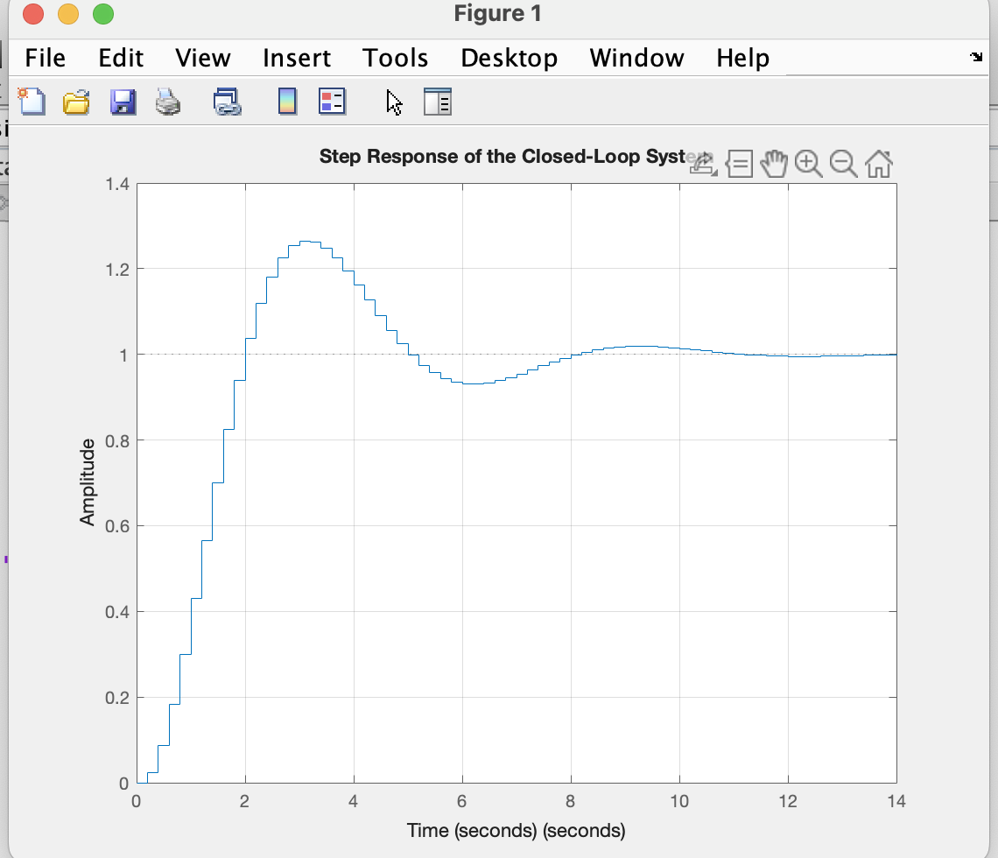

# Task 2

The obtained results show that the step response becomes more accurate and smoother when the sampling period is smaller. With finer sampling, the discrete-time system closely follows the behavior of the original continuous system. However, as the sampling period increases, the response becomes less precise, showing delays and distortions. This demonstrates that the choice of sampling time significantly affects the performance of the discrete-time control system.

