Control Theory 2

Lab Report 6

by Murad Aliyev

# Introduction

This lab aims to analyze stability of closed-loop control systems using location of the roots of characteristic equation, the Jury test and the Routh-Hurwitz criterion.

# Task 1

To analyze the stability of given systems we use *roots* function defined in MATLAB. The systems are shown in photo:

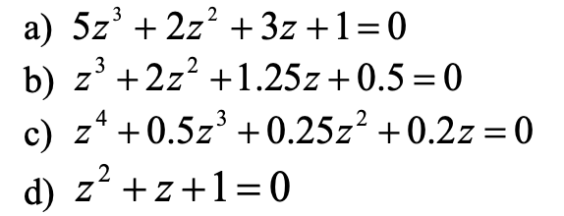

It is also possible to visualize the roots using graphs and we get the following results:

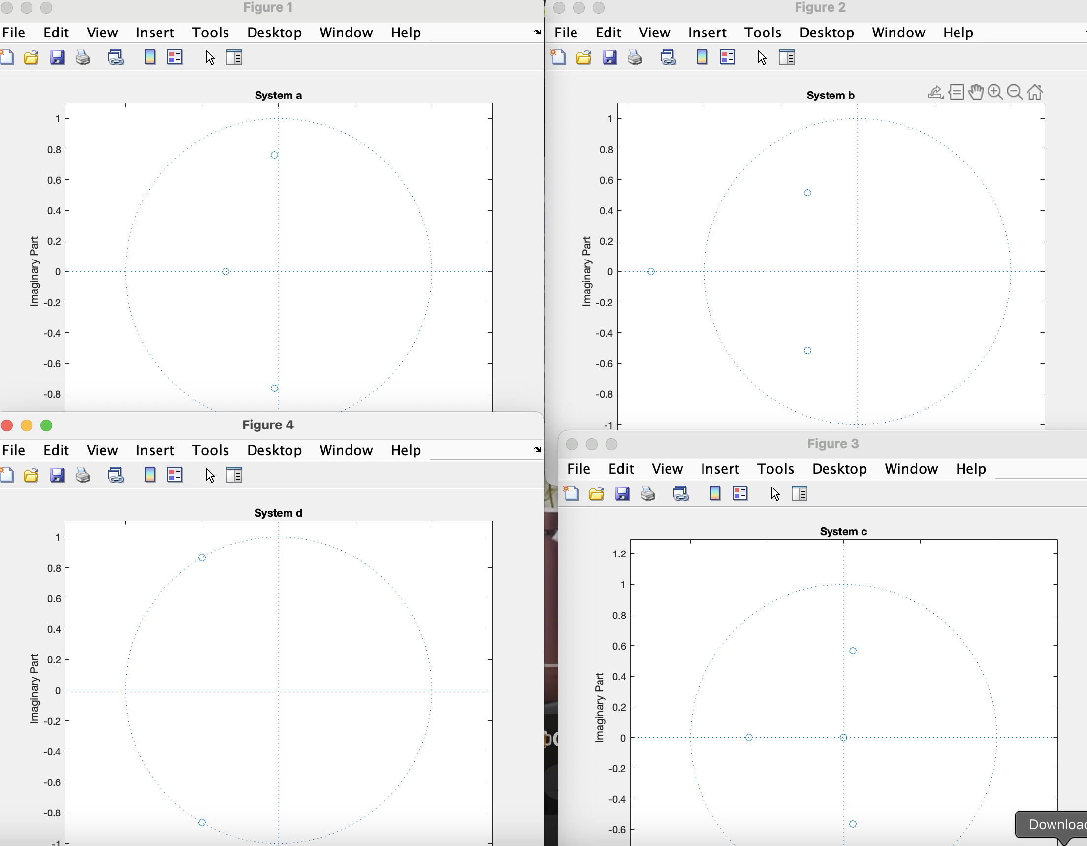

As we can see the only unstable system is **B.**

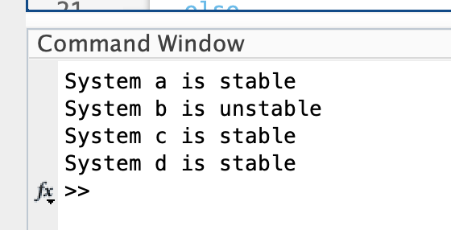

# Task 2

To assess the stability of the system we say:

* If all poles are inside the unit circle (abs < 1) → Stable
* If any pole is on or outside the unit circle → Unstable

So:

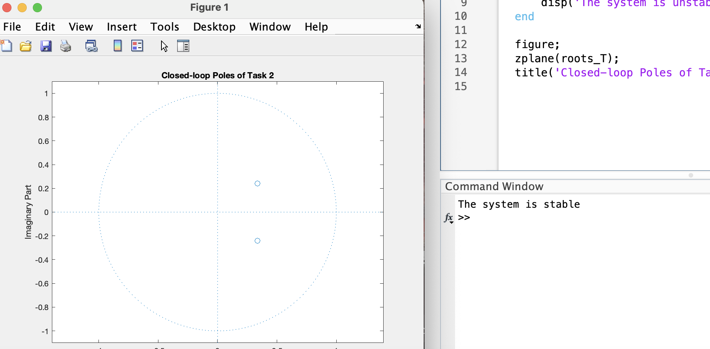

# Task 3

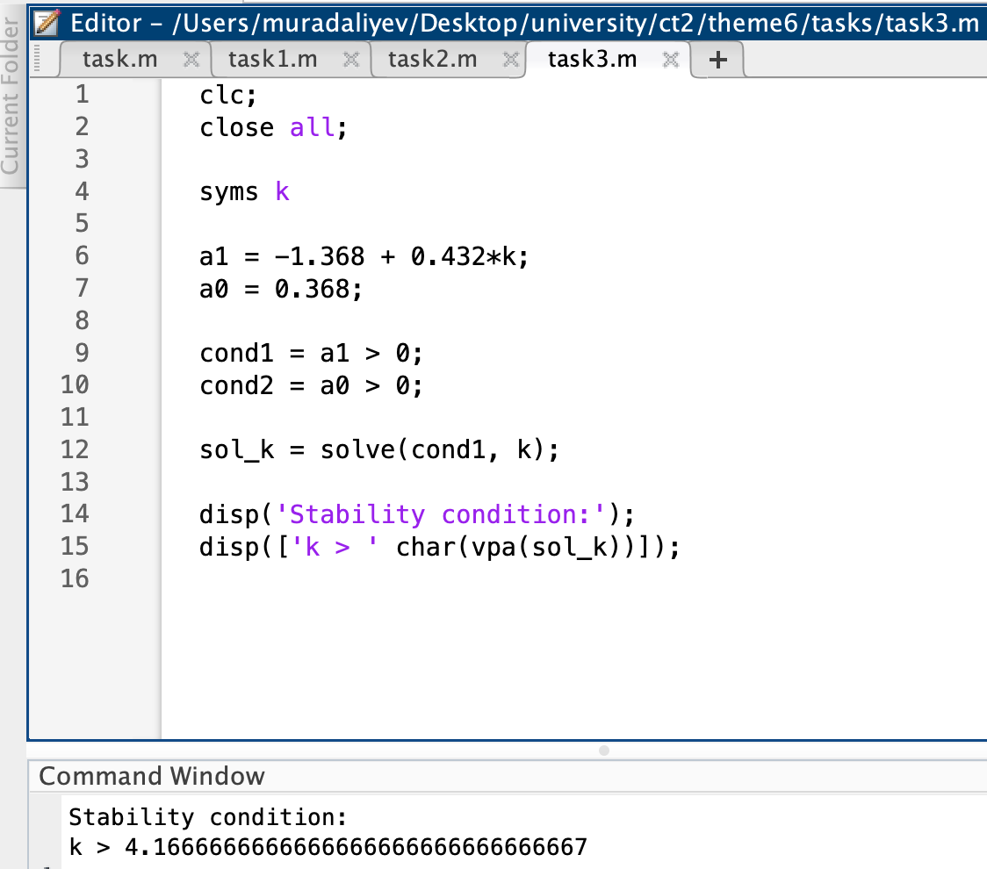

Here is the result for the solution.

To determine the stability of the closed-loop system, we derived the characteristic equation:

$$z^{2} + \left(-1.368 + 0.432k\right)z + 0.368 = 0$$

Using the Routh-Hurwitz criterion for a second-order system, the system is stable if all coefficients are positive. This leads to the condition:

$$-1.368 + 0.432k > 0→ k > 3.17$$

Therefore, the closed-loop system is stable for all gain values k > 3.17.

# Task 4

To determine the stability of the system, the Jury stability test was applied to the characteristic equation:

$$z^{3} - 1.2z^{2} - z + 0.5 = 0$$

Using the test conditions, it was found that not all requirements were satisfied. Therefore, the system is unstable.

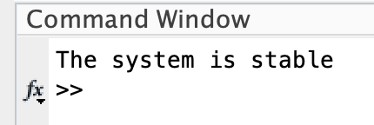

# Task 5

The jury stability condition for 2nd order polynomial is as following:

1. $\left|a_{2}\right| < a_{0}$

2. $1 - a_{1} + a_{2} > 0$

3. $1 + a_{1} + a_{2} > 0$

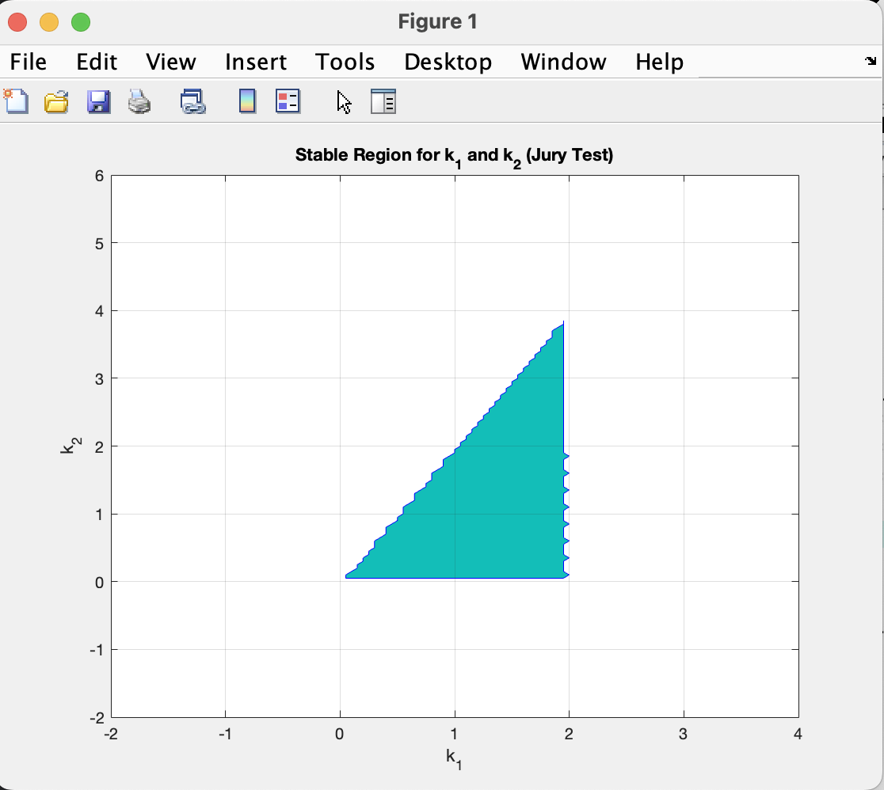

The shaded region in the plot shows the combinations of k1 and k2 that ensure closed-loop stability.

# Conclusion

The purpose of this lab was to analyze the stability of discrete-time control systems using various mathematical criteria, including the root location method, the Routh-Hurwitz criterion, and the Jury stability test. Through practical tasks, we examined characteristic equations and transfer functions, determined stability conditions, and visualized results using MATLAB. These methods are essential tools for ensuring the reliable performance of digital control systems and help in designing systems that behave predictably and remain stable under varying parameters.