**Vision Document for “Course Registration System - CRS”**

**Team members:**

*Murad Hajiyev (610691), Uuganbayar Oyun (610751), Mohamed Ibrahim (610695), Odbayar Nanjidjamts (610526)*

**1. Introduction**

Several years ago in the Computer Professional MS in CS program, there were three

entries per year and student entry numbers were 20-40 per entry. Often there was just one

elective class being offered per block and all students in an entry took the same classes in

the same sequence. Scheduling of classes and faculty was done with a relatively simple

Excel spreadsheet, and students were assigned to classes via a manual process.

As Compro has grown, we now offer 4 entries per year and there are often 100 – 130

students per entry. In some blocks, we may offer 8 or 9 elective classes, plus there are

often 3 FPP classes and 5 MPP classes offered per entry. There are several areas of

specialization for classes such as:

- Web Applications

- Data Science

- SW Design

- Networking

- Operating Systems

- Compilers

- Parallel Programming, etc.

Most faculties have one or two areas of specialization and a set of classes that they

would like to teach. In addition, they have preferences for what blocks they can teach.

Faculty needs to be able to enter their profile and be able to view their scheduled classes.

Compro students should be able to view the schedule and register for classes.

A few 500 level courses have 400 level **course prerequisites**, so the 400 level courses

should be offered for each entry in their first blocks on campus.

The 500 level classes should be provided for their later blocks on campus.

Most students take 4 elective blocks on campus.

Some U.S. resident students take 9 elective blocks on campus.

Some OPT students take 5 courses on campus.

CRS is a new software tool that will build a Compro schedule of classes with

faculty assigned to each class and will also offer a simple tool for students to register for

those classes.*

(*Note – the student registration part will be kept simple for our project. It is added for

the purposes of having a separate student register subsystem – to be explained in later.)

**2. Positioning**

**2.1 Problem Statement**

|  |  |
| --- | --- |
| The problem of | *managing the Compro schedule and allowing students to*  *register for classes* |
| Affects | *administrators, faculty, and students* |
| the impact of which is | *scheduling is complex, must be manually maintained, and*  *changed frequently* |
| a successful solution would be | *one tool which builds a Compro schedule that integrates the*  *business rules for faculty availability and courses needed by*  *students per entry. This tool will provide a Database and a*  *user interface that is easy to use for faculty, staff, and*  *students.* |

**2.2 Product Position Statement**

|  |  |
| --- | --- |
| For | *administrators, faculty, and students* |
| Who | *manages and registers course schedule.* |
| The (CRS) | *Is Course registration system* |
| That | *Allows students to register to courses, and give chance to administrators to manage courses and assign them to faculties, etc.* |
| Unlike | *Current system – excel spreadsheet* |
| Our product | *Allows students to register to courses, and give chance to administrators to manage courses and assign them to faculties through web platform.* |

**3. Stakeholder Descriptions**

**3.1 Stakeholder Summary**

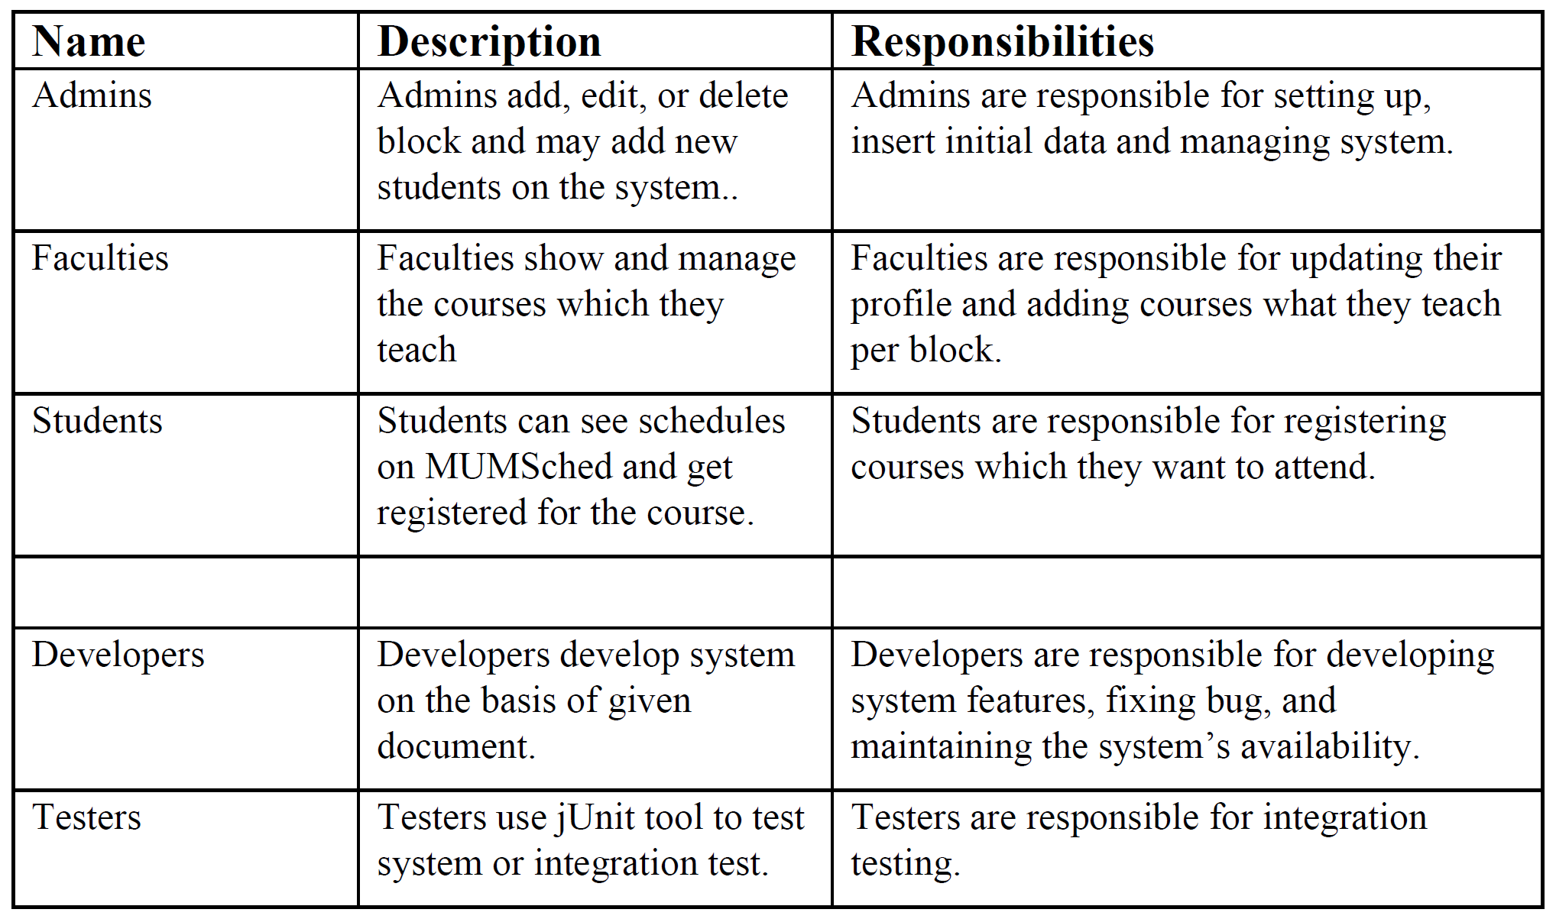

**3.2 User Environment**

It is intended for university administrators, faculty members and all students. Minimum target user count should be 100. It is changeable. The task cycle takes 1 week. Member may spend 1 day for each activity. It may change. Excel is being used right now. CRS will be used in future.

**4. Product Overview**

**4.1 Product Perspective**

It is a web based system implementing client-server model. The CRS provides simple mechanism for students to register to the courses.

The following are the main features that are included in CRS

User account: The system allows the user to create their accounts in the system and provide features of updating and viewing profiles.

Number of users being supported by the system: Though the number is precisely not mentioned but the system is able to support a large number of online users at a time.

Search: search is simply local search engine based on key words.

FAQs section: Frequently asked section contain answer of problem which CRS user frequently faced.

**4.2 Assumptions and Dependencies**

A student will take a course each block. Professor can give maximum a course per block on campus. He may teach DE course at the same time.

**4.3 Needs and Features**

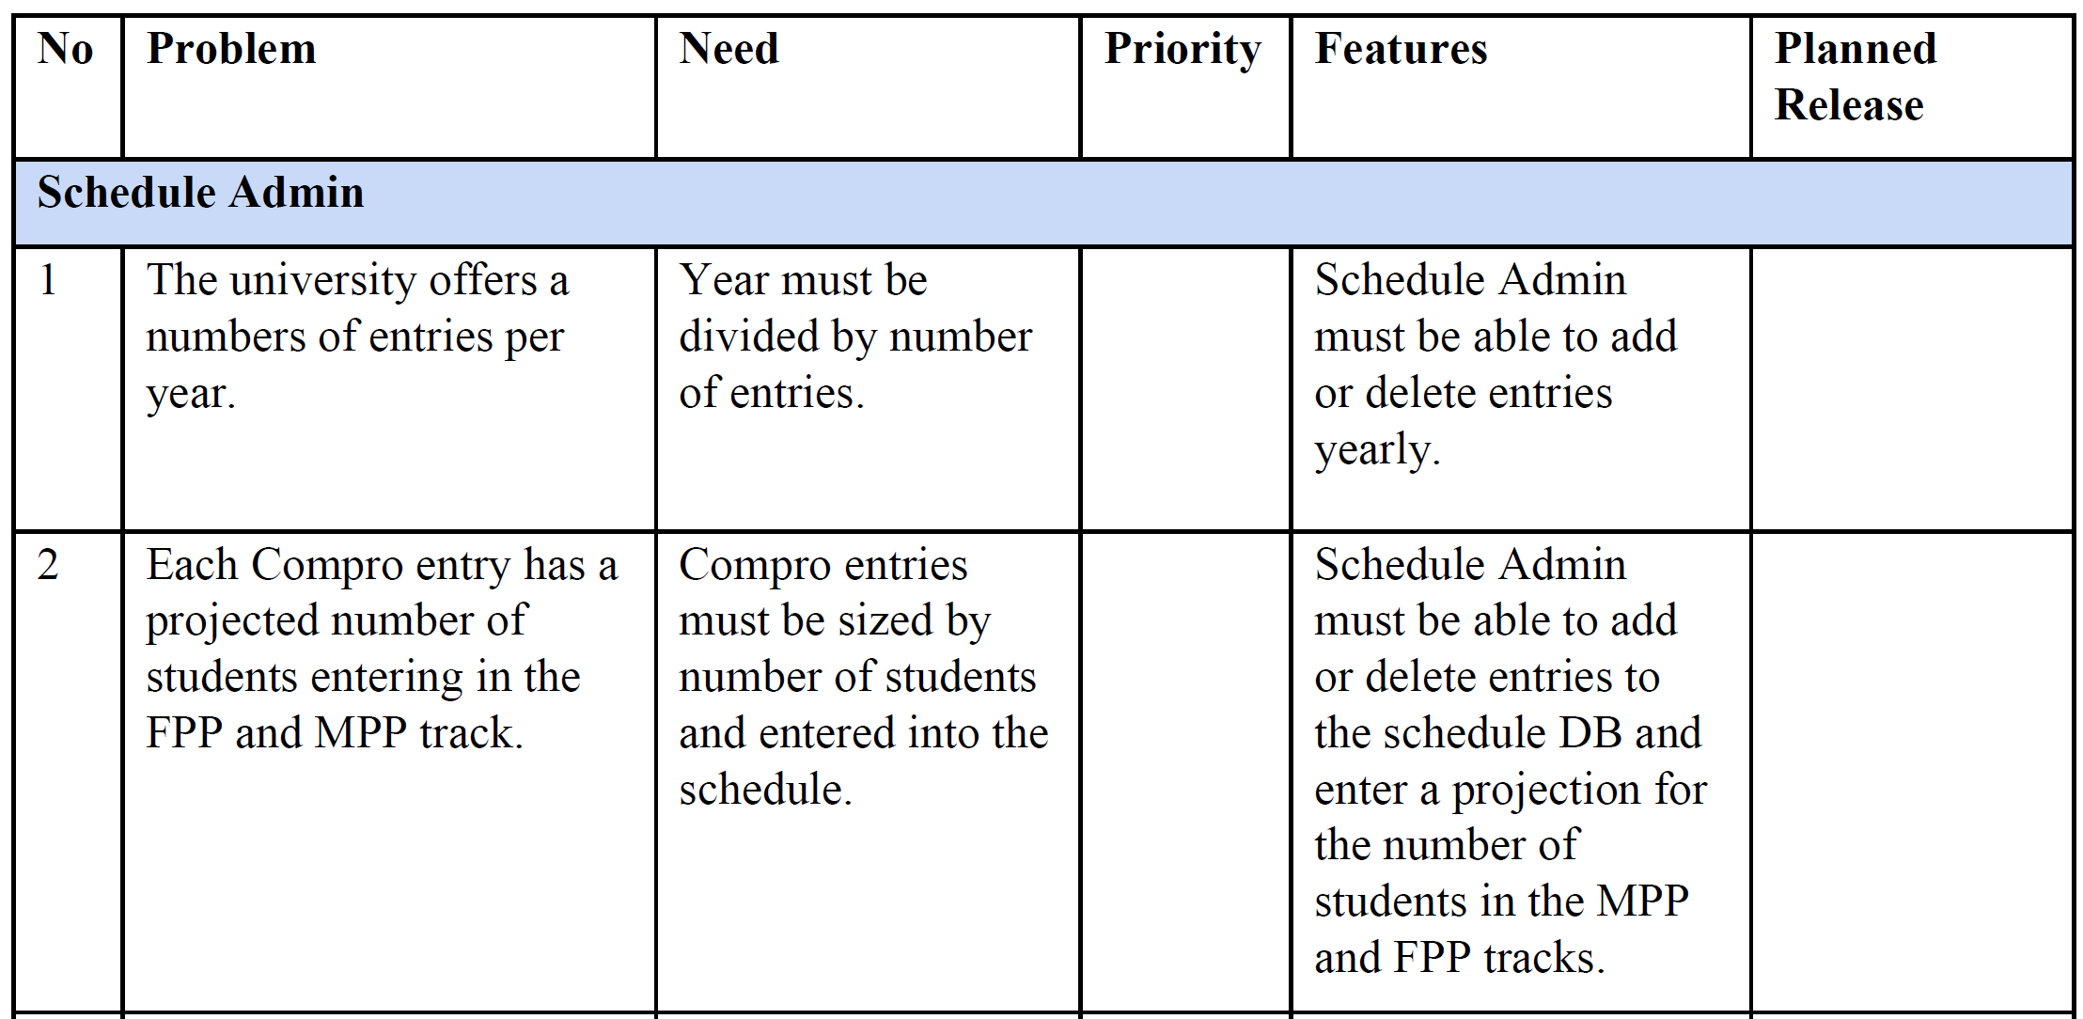

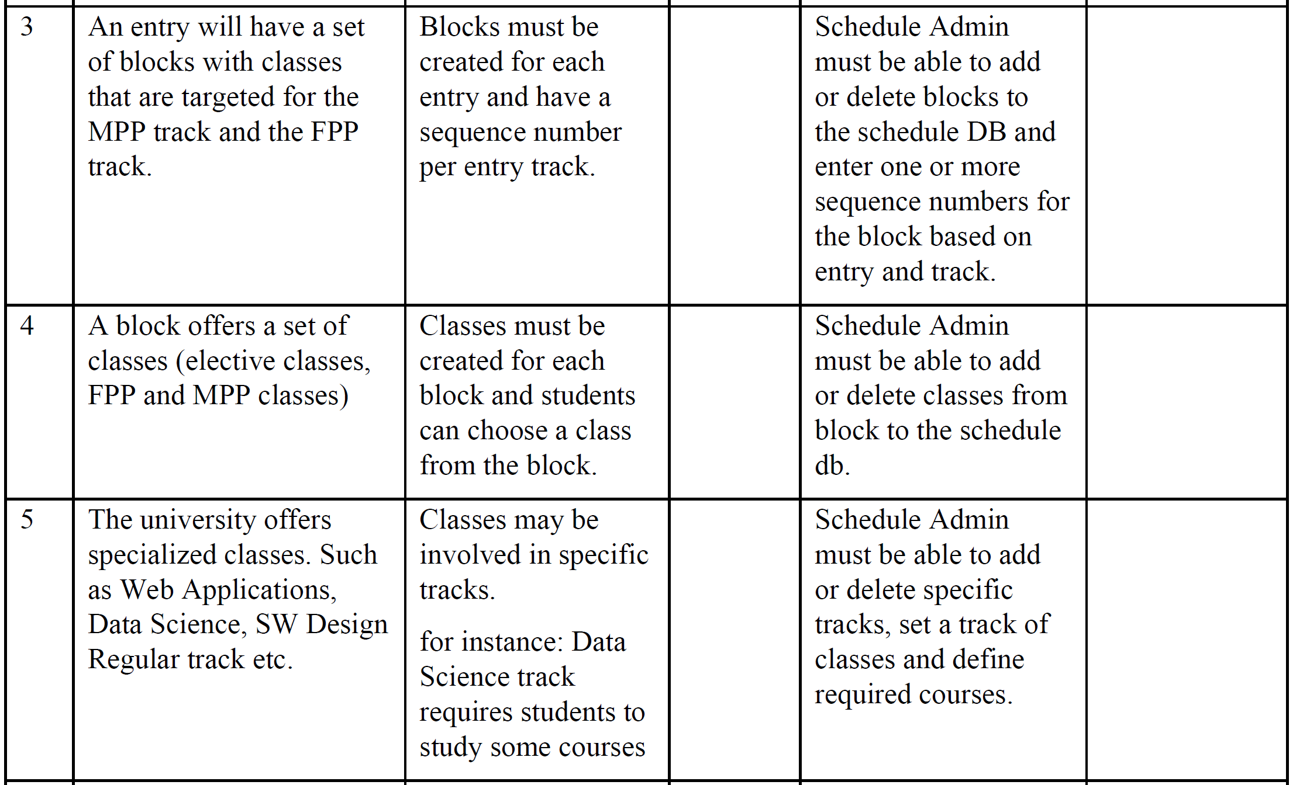

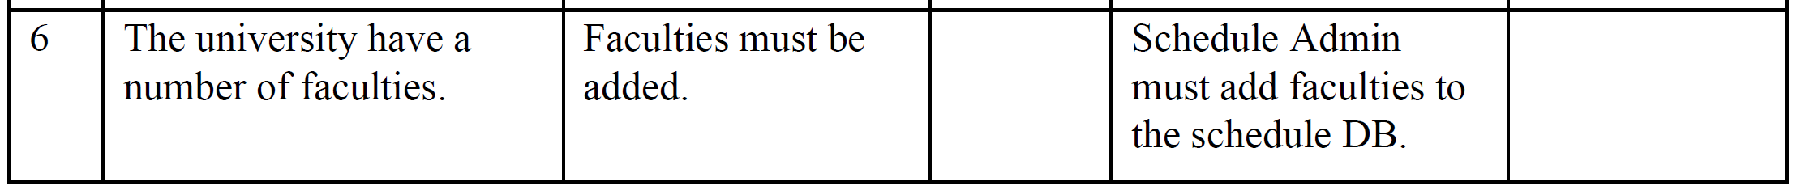

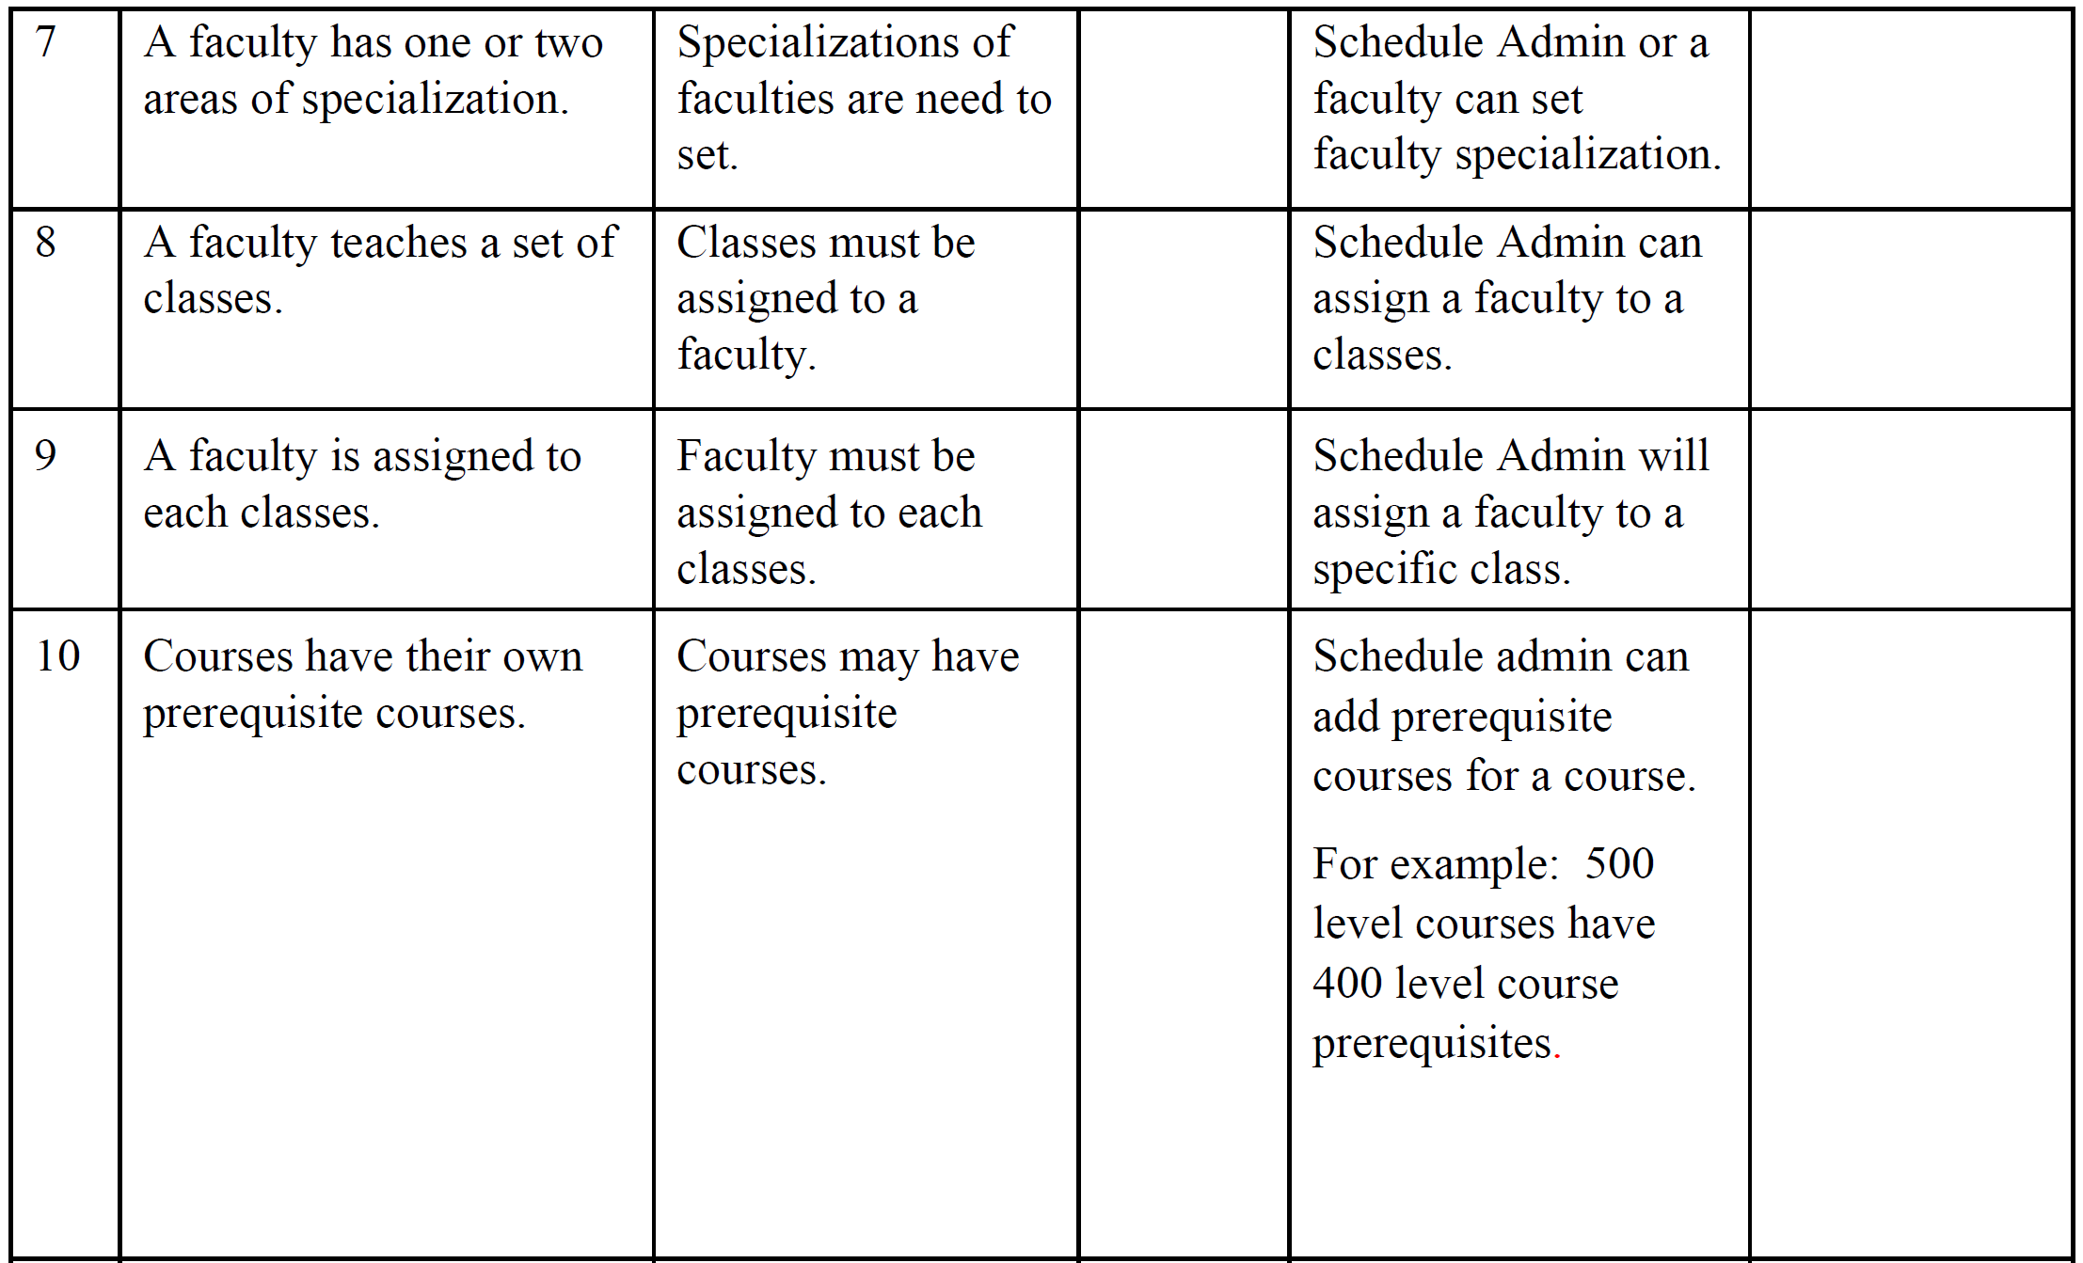

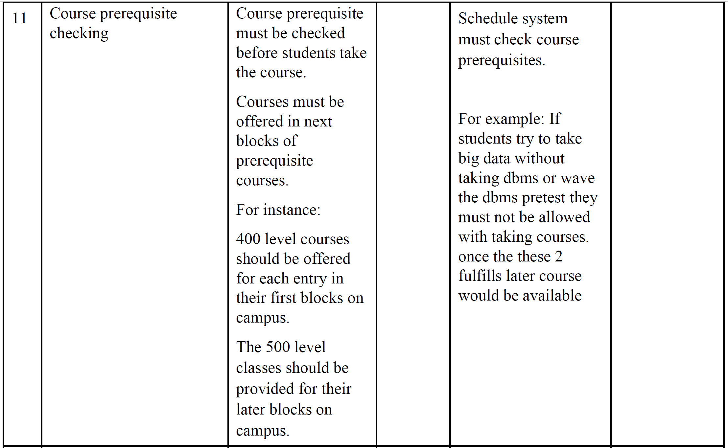

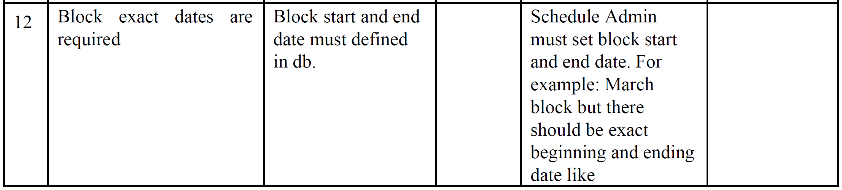

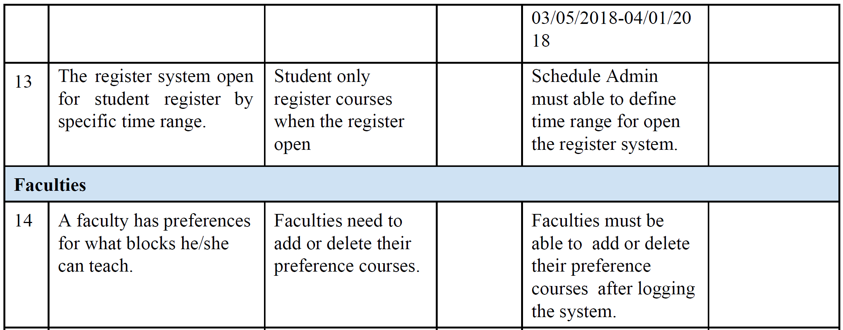

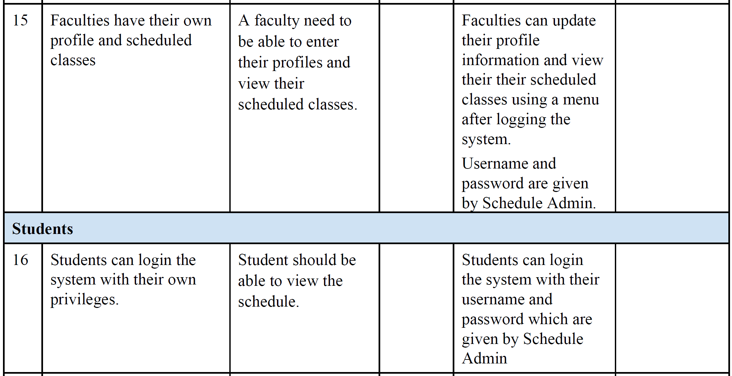

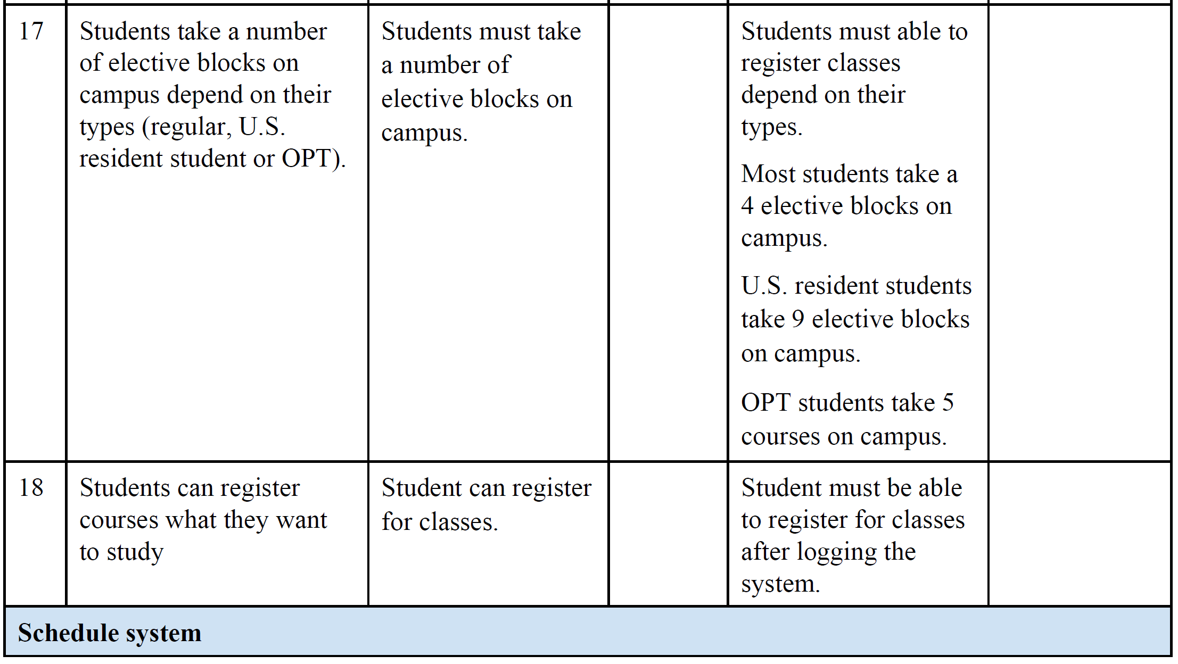

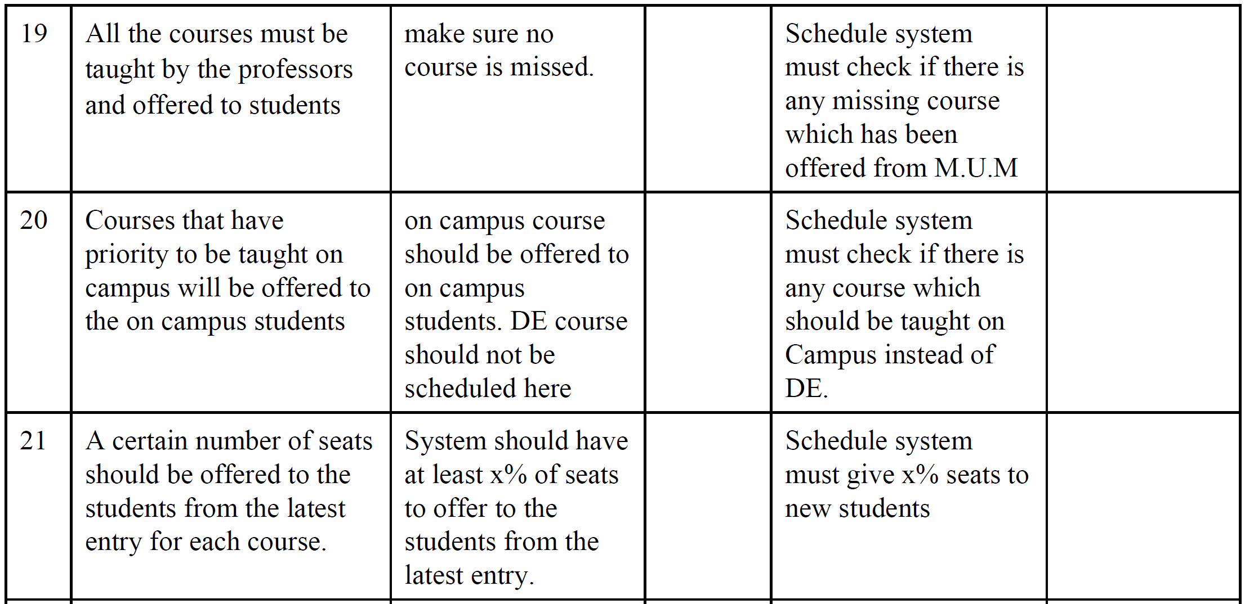

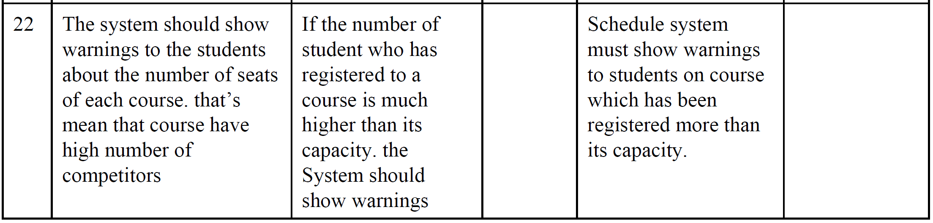

**4.4 Alternatives and Competition**

The other groups in classroom are our alternatives and competitors.

**5. Other Product Requirements**

System should be implemented using Java Spring. Relation database might be selected as Mysql or Postgresql.