Func-e

In this tutorial you will use the [func-e](https://func-e.io/" \t "_blank) CLI to run envoy.

1. Verify that func-e is installed
2. func-e --version
3. Run the *help* command to familiarize yourself with the CLI.
4. func-e help
5. Review the help for the run subcommand.

func-e run --help

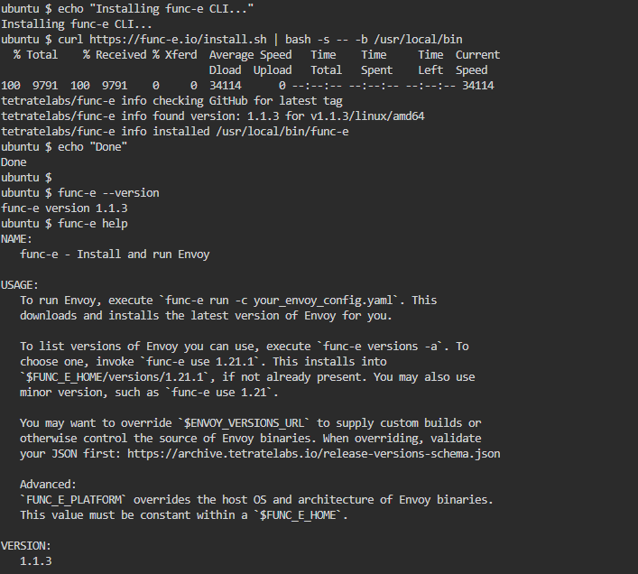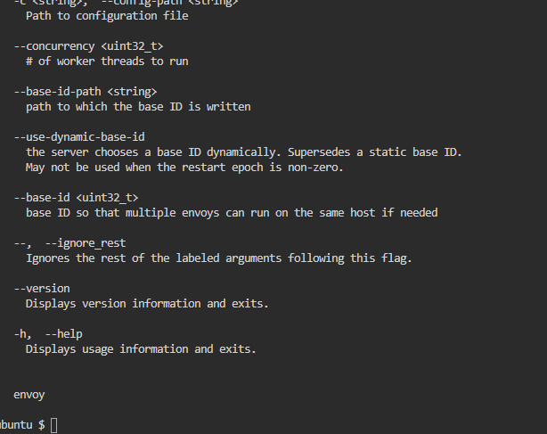

The file minimal-config.yaml is just that: it contains the minimum configuration necessary to start envoy.

1. Review the file's contents:
2. cat minimal-config.yaml

envoy will listen on port 10000, and is configured with no filters.

1. Run envoy in the background:
2. func-e run --config-path minimal-config.yaml &
3. Try to send a request to localhost:10000 :
4. curl -v localhost:10000

envoy does not yet know how to route the request.

Stop envoy: bring the process back to the foreground with fg , then press ctrl+c .