Contents
Introduction 4
Design Specification and Class Diagrams 4
Java Implementation, Use Cases, ADT Justification, and Benefits 5
Use Case Scenarios and How the System Solves the Problem 6
Error Handling Stage 7
Justification Selected Abstract Data Types 7
Benefits of Using Implementation-Independent ADTs 8
Complexity Evaluation of Implemented Algorithms and ADTs 9
Feature 1 9
Method 1: addItem 9
Method 2: dispalyItems() 10
Methode 3: searchByDescription(String keyword) 10
Feature 2 11
Method 1: addRequest(RoomRequest request) 11
Method 2: displayRequests() 11
Feature 3 12
Method 1: addEdge(int source, int destination, int weight) 12
Method 2: printGraph() 12
Method 3: dijkstra(int source, int target) 12
Feature 4 – Undo/Redo 13
Method 1: performAction(String action) 13
Method 2: undo() 13
Method 3: redo() 13
Method 4: displayHistory() 13
Feature 5 14
Method 1: register(Student student) 14
Method 2: processRegistration() 14
Method 3: showQueue() 14
Feature 6 15
Method 1: insert(Locker locker) 15
Method 2: delete(int studentId) 15
Method 4: displayInOrder() 15
Step-by-Step Illustration of Feature 3 Algorithm (Dijkstra’s Shortest Path) 17
Graph Example 17
Explanation of the Implemented Dijkstra's Algorithm 20
Step 1: Initialization 20
Step 2: Priority Queue Setup 20
Step 3: Main Loop 20
Step 4: Relaxation of Neighbors 21
Information Hiding, Encapsulation, and the Role of ADTs in Object-Oriented Programming 21
Trade-offs Between Selected ADTs and Alternative Data Structures 22
References 26

Introduction
In This report I will present the design and implementation of a campus management system developed using java. My goal if solving real world university service problems through the application of appropriate data structures and algorithms. The system has six essential features Lost & Found tracking, Room Booking, Campus Navigation, Undo/Redo history, Event Registration, and Student Locker Allocation each implemented using a suitable Abstract Data Type (ADT) such as Linked List, Stack, Queue, Binary Search Tree, and Graph. I focused on the correct use of ADTS to achieve efficient data handling, user interaction, and error handling. This report details the design specifications, java implementation, complexity evaluation, and critical reflection on the effectiveness of each chosen structure in addressing the systems functional requirements.

Design Specification and Class Diagrams
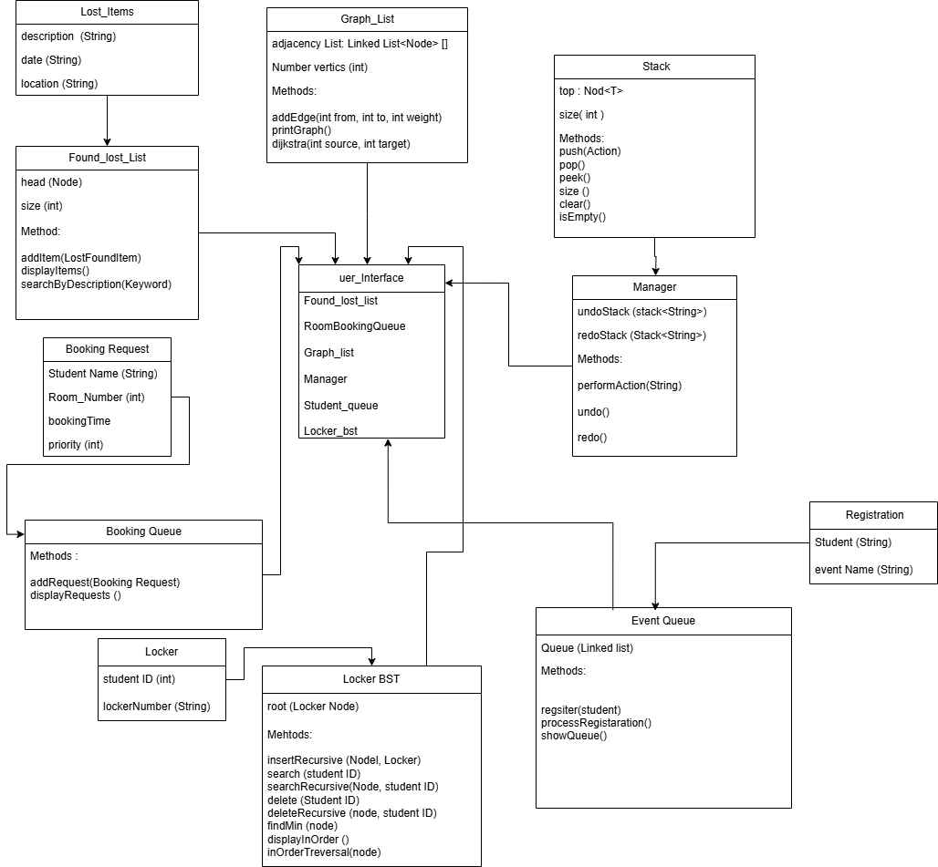
The class diagram above illustrates the architecture of the Management System and the different Abstract Data Types (ADTs) I used for each feature. Each class shows its related data structure logic and exposes only the important public methods.
Feature | ADT Used | Key Classes | Operations
1. Lost & Found Tracking | Linked List | Lost_Items, Found_lost_list | addItem(), displayItems(), searchByDescription()
2. Room Booking | Priority Queue | Booking_Request, Booking_Queue | addRequest(), displayRequests()
3. Student Orientation (Graph) | Graph | Graph_List, Node | addEdge(), dijkstra(), printGraph()
4. Undo/Redo | Stack | Stack, Manager | performAction(), undo(), redo(), clear()
5. Event Registration | Queue | Registration, Event_Queue | register(), processRegistration(), showQueue()
6. Locker Allocation | Binary Search Tree | Locker, Locker_BST | insert(), search(), delete(), displayInOrder()

Java Implementation, Use Cases, ADT Justification, and Benefits

System Architecture and Menu Implementation
I developed the system using Java programming language, and it is structured in a good way, where each feature is implemented in a separate class using its right Abstract Data Type (ADT). The main class responsible for user interaction is User_interface_code, which provides a console-based menu that allows users to utilize six services: Lost & Found tracking, Room Booking, Campus Navigation, Undo/Redo history, Event Registration, and Locker Allocation. I built the menu using a switch-case structure and imported the Scanner class to read user input. Each option in the menu triggers a specific feature class, promoting clear separation of concerns. My system error handling using try-catch blocks to manage invalid inputs and prevent crashes, ensuring smooth interaction. Overall. The design supports clean user interaction and modular feature extension.

Use Case Scenarios and How the System Solves the Problem
Feature 1 – Lost & Found Tracking (Linked List)
A student wishes to report a lost item. The user is prompted to input the description, date, and location of the item by the system. After inputting the information, the Lost_item object is instantiated and inserted into a self-contained linked list by the Found_lost_list class. This provides dynamic insertion without concerning oneself with resizing or array limits. When called, the system iterates through the list to print or search for items, which is ideal for an increasing collection of records.

Feature 2 – Room Booking (Priority Queue using Sorted Linked List)
The students place room booking requests, which are served according to priority. The system prompts the student to enter his/her name, room number, booking time, and priority level. These are encapsulated as RoomRequest objects and placed in a special list in order of priority. The RoomBookingQueue class manages this list using sorted insertion, mimicking the operation of a priority queue. This way, the system can always take up the request with the highest priority first.

Feature 3 – Student Orientation Guidance (Graph + Dijkstra)
A student requires assistance finding his/her way around campus. The system welcomes the user to input building connections (edges) and distances. After the graph is constructed, the user inputs a source and destination. The Graph_list class, which implements an adjacency list, utilizes Dijkstra's algorithm to calculate and print the shortest path between buildings. This assists students in finding their way efficiently and comprehending campus geography.

Feature 4 – Undo/Redo System (Stack)
The users can carry out actions and decide whether to undo or redo them. When an action is taken, it is pushed onto the undoStack. If the user wishes to undo, the action is popped from undoStack and pushed onto redoStack. Redo works in reverse. This is carried out by the Manager class, which employs two custom Stack objects to provide last-in-first-out (LIFO) logic in order to enable command history navigation.
Feature 5 – Event Registration (Queue)
The students are registered for events, and the system keeps them in the order received. The system uses the student name and event name and inserts them as a Student object in a custom queue that is processed by Student_queue. This is an ordered first-in-first-out (FIFO) fashion, so registrations can be processed orderly. When displaying the students, they appear in the exact order they were received.

Feature 6 – Locker Assignment (Binary Search Tree)
The university has to allocate lockers to students according to their student ID. The system can add a new locker, find a student's locker, or delete it when they graduate. These are performed on a Locker_bst with nodes ordered by student ID. The use of BST guarantees good average-case efficiency in insert, search, and delete operations even if the number of students increases.

Error Handling Stage
I deal with the error handling by using try-catch blocks to manage runtime errors such ass InputMismtachExcpetion. This ensures that unvalid inputs do not stop the program. After catching the error the system clear the scanner input and provides the user with warnings to re-enter their choice.

Justification Selected Abstract Data Types
Feature 1 – Lost & Found (Linked List)
I chose a linked list because it allows dynamic insertion and removal of items without the need to resize or shift elements. This supports efficient tracking of an unpredictable number of lost items.
Feature 2 – Room Booking (Priority Queue via Sorted Linked List)
I handled the Room request feature using a sorted linked list to simulate a priority queue, enabling the system to always access the highest-priority booking first while maintaining an ordered structure.

Feature 3 – Student Orientation Help (Graph)
A graph was selected to model campus building connections, and an adjacency list structure was used to represent the graph efficiently in memory. This works well with Dijkstra’s algorithm for finding shortest paths.
Feature 4 – Undo/Redo (Stack)
Stacks are good for undo/redo functionality due to their LIFO behavior allowing the system to reverse or re-apply the most recent user actions in the correct order.
Feature 5 – Event Registration (Queue)
A queue was used to preserve the order in which students register for events ensuring fair and sequential processing using first-in-first-out (FIFO) logic.
Feature 6 – Locker Allocation (Binary Search Tree)
A binary search tree was implemented to manage locker assignments by student ID offering efficient insertion, search, and deletion operations while maintaining sorted access.

Benefits of Using Implementation-Independent ADTs
Feature 2 – Room Booking
ADT: Priority Queue
Implementation: Sorted Linked List
Benefits:
- Sorted Insertion: The linked list allows maintaining requests in sorted priority order without requiring a separate heap.
- Simplicity: A linked list is easier to implement than a binary heap for small to medium data sizes.
- Flexibility: Changing the sorting logic (e.g., by time instead of priority) is simple using linked list traversal.

Feature 3 – Student Orientation (Graph)
ADT: Graph
Implementation: Adjacency List using Linked Lists
Benefits:
- Space Efficiency: The adjacency list uses memory only for existing edges (unlike adjacency matrix).
- Scalability: Works well for large, sparse graphs — ideal for real campus layouts.
- Fast Edge Access: Linked lists allow quickly traversing all neighbors of a node.

Feature 5 – Event Registration
ADT: Queue
Implementation: Linked List
Benefits:
- True FIFO: Linked list supports accurate first-in-first-out behavior without shifting elements.
- Efficient Memory: Memory is allocated only as needed for each student registration.
- Clear Front/Rear Control: Easy to manage queue ends for registration processing.

Complexity Evaluation of Implemented Algorithms and ADTs

Feature 1

Method 1: addItem
Node newNode = new Node(item); // O(1)
if (head == null) { // O(1)
head = newNode; // O(1)
} else {
Node temp = head; // O(1)
while (temp.next != null) { // O(n)
temp = temp.next; // O(1)
}
temp.next = newNode; // O(1)
}

-Time Complexity:
- Best Case: O(1) → if list is empty
- Worst Case: O(n) → if you append at the end of a long list
- Average Case: O(n)
Space Complexity: O(1) per operation (but O(n) total for all nodes)

Method 2: dispalyItems()
if (head == null) return; // O(1)
Node temp = head; // O(1)
while (temp != null) { // O(n)
System.out.println(...); // O(1) per node
temp = temp.next; // O(1)
}
- Time Complexity: O(n)
- Space Complexity: O(1)

Methode 3: searchByDescription(String keyword)
if (head == null) return; // O(1)
Node temp = head; // O(1)
while (temp != null) { // O(n)
temp.data.getDescription().toLowerCase(); // O(1)
desc.contains(keyword); // O(m) [m = length of desc]
temp = temp.next; // O(1)
}
-Time Complexity:
- O(n × m)
  - n = number of items
  - m = average description length
-Space Complexity: O(1)

Feature 2

Method 1: addRequest(RoomRequest request)
Node newNode = new Node(request); // O(1)
if (head == null || request.priority < head.priority) { // O(1)
newNode.next = head; // O(1)
head = newNode; // O(1)
} else {
Node current = head; // O(1)
while (current.next != null && // O(n)
current.next.data.getPriority() <= request.getPriority()) {
current = current.next; // O(1)
}
newNode.next = current.next; // O(1)
current.next = newNode; // O(1)
}

-Time Complexity:
- Best Case: O(1) → insert at the head (highest priority)
- Worst Case: O(n) → insert at the end (lowest priority)
- Average Case: O(n)
-Space Complexity: O(1) per insertion

Method 2: displayRequests()
if (head == null) return; // O(1)
Node current = head; // O(1)
while (current != null) { // O(n)
System.out.println(...); // O(1)
current = current.next; // O(1)
}
-Time Complexity: O(n)
- Space Complexity: O(1)

Feature 3

Method 1: addEdge(int source, int destination, int weight)
adjacencyList[source].add(...); // O(1)
adjacencyList[destination].add(...); // O(1)
-Time Complexity: O(1) per edge
-Space Complexity: O(1) per edge

Method 2: printGraph()
for i = 0 to numVertices: // O(V)
for each node in adjacencyList[i]: // O(Ei) per vertex (Ei: number of edges connected to vertex i)
print... // O(1)
-Time Complexity: O(V + E)
- Space Complexity: O(1)

Method 3: dijkstra(int source, int target)
Key operations:
- Initializations: O(V)
- PriorityQueue insertions: O(E log V)
- poll() from priority queue: O(log V)
- Looping through edges: O(E)
- Path reconstruction: O(V)
- Time Complexity:
- Overall: O((V + E) log V)
(Because we use a priority queue and adjacency list)
- Space Complexity: O(V) for distance, previous, visited, path

Feature 4 – Undo/Redo

Method 1: performAction(String action)
undoStack.push(action); // O(1)
redoStack.clear(); // O(1)
-Time Complexity: O(1)
-Space Complexity: O(1) (plus O(n) total for all stacked actions)

Method 2: undo()
if (undoStack.isEmpty()) // O(1)
undoStack.pop(); // O(1)
redoStack.push(action); // O(1)
-Time Complexity: O(1)
-Space Complexity: O(1)

Method 3: redo()
Same logic as undo(), reversed:
- Time Complexity: O(1)
- Space Complexity: O(1)

Method 4: displayHistory()
for (int i = undoStack.size() - 1; i >= 0; i--) {
undoStack.get(i); // O(n) per get (linked list traversal)
}

Feature 5

Method 1: register(Student student)
Node newNode = new Node(student); // O(1)
if (rear == null) { // O(1)
front = rear = newNode; // O(1)
} else {
rear.next = newNode; // O(1)
rear = newNode; // O(1)
}
-Time Complexity: O(1)
-Space Complexity: O(1) (excluding the node added)

Method 2: processRegistration()
if (front == null) return; // O(1)
System.out.println("Processing: " + front.data); // O(1)
front = front.next; // O(1)
if (front == null) rear = null; // O(1)
Time Complexity: O(1)
pace Complexity: O(1)

Method 3: showQueue()
Node temp = front;
while (temp != null) {
System.out.println(...); // O(1)
temp = temp.next; // O(1)
}
-Time Complexity: O(n)
-Space Complexity: O(1)

Feature 6

Method 1: insert(Locker locker)
- Best/Average Case: O(log n) → balanced tree
- Worst Case: O(n) → skewed tree (e.g., inserting sorted IDs)
-Time Complexity: O(log n) avg, O(n) worst
-Space Complexity: O(h) call stack (h = height of tree)

Method 2: delete(int studentId)
- Best Case: O(log n) → balanced
- Worst Case: O(n) → skewed
- Includes subtree copy operations
-Time Complexity: O(log n) avg, O(n) worst
-Space Complexity: O(h)

Method 4: displayInOrder()
- Visits all nodes once → O(n)
-Time Complexity: O(n)
-Space Complexity: O(h) (recursion stack)
Feature | ADT Used | Key Methods | Time Complexity | Space Complexity | Notes
1. Lost & Found | Linked List | addItem() | O(n) | O(1) | Appends to end of list
 |  | displayItems() | O(n) | O(1) | Linear traversal
 |  | searchByDescription() | O(n × m) | O(1) | m = avg. string length
2. Room Booking | Sorted Linked List (Priority Queue) | addRequest() | O(n) | O(1) | Inserts based on priority
 |  | displayRequests() | O(n) | O(1) | Traverses list
3. Orientation Help | Graph (Adjacency List) | addEdge() | O(1) | O(1) per edge | Adds edge bidirectionally
 |  | printGraph() | O(V + E) | O(1) | Lists all connections
 |  | dijkstra() | O((V + E) log V) | O(V) | Uses min-heap priority queue
4. Undo/Redo | Stack (Linked List) | performAction() | O(1) | O(1) | Push to undo, clear redo
 |  | undo(), redo() | O(1) | O(1) | Constant-time push/pop
 |  | displayHistory() | O(n²) | O(1) | Uses get(i) repeatedly in singly linked list
5. Event Registration | Queue (Linked List) | register() | O(1) | O(1) | Enqueue at tail
 |  | processRegistration() | O(1) | O(1) | Dequeue from front
 |  | showQueue() | O(n) | O(1) | Traverses the queue
6. Locker Allocation | Binary Search Tree | insert() | O(log n) avg / O(n) worst | O(h) | Recursive insert based on student ID
 |  | search() | O(log n) avg / O(n) worst | O(h) | Searches based on ID
 |  | delete() | O(log n) avg / O(n) worst | O(h) | Includes min replacement in subtree
 |  | displayInOrder() | O(n) | O(h) | In-order traversal for sorted output

Step-by-Step Illustration of Feature 3 Algorithm (Dijkstra’s Shortest Path)
To support new students in exploring the campus, I implemented Dijkstra’s shortest path algorithm using a graph represented by an adjacency list. Below is a step-by-step illustration of how this algorithm works in the implemented system.

Graph Example
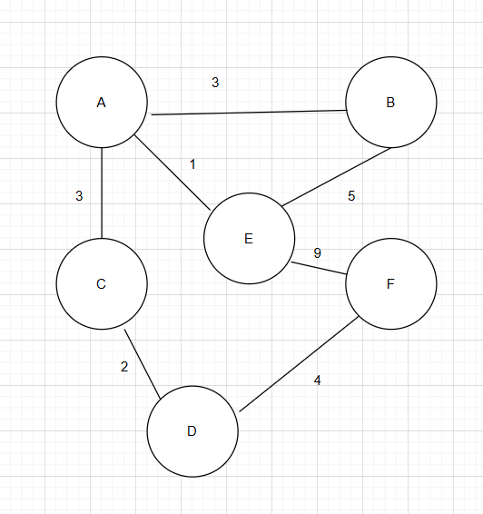
Edge | Weight
A – B | 3
A – C | 3
A – E | 1
B – E | 5
C – D | 2
D – F | 4
E – F | 9
Source: A

Step-by-Step Execution of dijkstra(A, all)
We’ll label each vertex:
A = 0
B = 1
C = 2
D = 3
E = 4
F = 5
Initial State
Vertex | Distance | Previous
A | 0 | —
B | ∞ | —
C | ∞ | —
D | ∞ | —
E | ∞ | —
F | ∞ | —
Unvisited = {A, B, C, D, E, F}

Visit A (distance 0)
Update neighbors:
B: 0 + 3 = 3
C: 0 + 3 = 3
E: 0 + 1 = 1
Vertex | Distance | Previous
A | 0 | —
B | 3 | A
C | 3 | A
D | ∞ | —
E | 1 | A
F | ∞ | —
Visited = {A}
Unvisited = {B, C, D, E, F}

Visit E (distance 1)
B: 1 + 5 = 6 → keep B = 3
F: 1 + 9 = 10
Vertex | Distance | Previous
A | 0 | —
B | 3 | A
C | 3 | A
D | ∞ | —
E | 1 | A
F | 10 | E
Visited = {A, E}
Unvisited = {B, C, D, F}

Visit B (distance 3)
No shorter path found (neighbor E already visited)
Visited = {A, E, B}

Visit C (distance 3)
D: 3 + 2 = 5
Vertex | Distance | Previous
A | 0 | —
B | 3 | A
C | 3 | A
D | 5 | C
E | 1 | A
F | 10 | E
Visited = {A, E, B, C}

Visit D (distance 5)
F: 5 + 4 = 9 → update F from 10 to 9
Vertex | Distance | Previous
A | 0 | —
B | 3 | A
C | 3 | A
D | 5 | C
E | 1 | A
F | 9 | D
Visited = {A, E, B, C, D}

Visit F (distance 9)
No unvisited neighbors.
Final Result Table:
Vertex | Distance from A | Path
A | 0 | A
B | 3 | A → B
C | 3 | A → C
D | 5 | A → C → D
E | 1 | A → E
F | 9 | A → C → D → F

Explanation of the Implemented Dijkstra's Algorithm

Step 1: Initialization
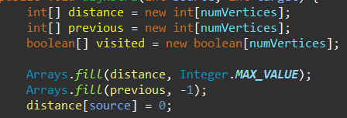
- distance[]: holds the shortest known distance from the source to every node (initialized to ∞).
- previous[]: tracks the path by storing the previous node on the shortest path.
- visited[]: marks nodes that have already been finalized.
- The distance to the source node is set to 0.

Step 2: Priority Queue Setup
- A min-heap priority queue is used to always process the next node with the smallest known distance.
- Initially, the source node is added with weight 0.

Step 3: Main Loop
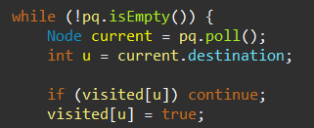
- The loop continues until the queue is empty.
- The node with the smallest known distance is processed first.
- If it’s already visited (finalized), it’s skipped.

Step 4: Relaxation of Neighbors
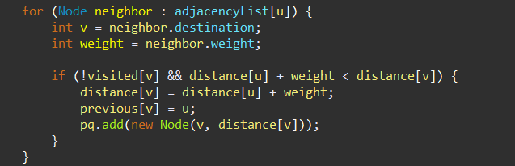
- Each neighbor of the current node is examined.
- If a shorter path to the neighbor is found, the distance and previous arrays are updated.
- The neighbor is then re-added to the queue with the new updated distance.

Information Hiding, Encapsulation, and the Role of ADTs in Object-Oriented Programming
Implementing each data structure as a self-contained class with private internal data and limited access via public methods, I applied information hiding and encapsulation principles across all six features. This approach not only simplified the management of the system but also adhered to fundamental object-oriented programming (OOP) principles, where Abstract Data Types (ADTs) constitute the structural basis.
Hiding information in my code
Information hiding involves securing the internal state of a class from external modification and access. This was accomplished by:
Only exposing the object data via getter and setter methods like getStudentId(), getDescription(), or getPriority; and encapsulating it in domain classes such Lost_item, Student, Locker, and RoomRequest.
OOP is built on ADTs in what ways
In object-oriented programming, this idea becomes a class with hidden inner logic and a public interface. Abstract Data Types (ADTs) specify a set of behaviors that operations a structure must support (such as push/pop for a stack or insert/search/delete for a BST)—without indicating how they should be implemented.
In my code:
A singly linked list was used to implement the Queue ADT. Outside classes never had to worry about nodes or links; they only used register() and processRegistration().
Using a custom Node<T> linked list, the Stack ADT was created such that the Manager class applied encapsulated techniques like pop() and push() for undo/redo never revealed the underlying data.
The BST ADT for locker allocation exposed straightforward interfaces to the outside world (insert(), search()), therefore enabling me to utilize it from the main program without having to grasp tree balancing or traversing.
This abstraction mirroring how objects work in OOP determines what each structure does, not how. It simplifies the scalability, testing, and maintenance of the programme.

Trade-offs Between Selected ADTs and Alternative Data Structures
Each component in the development of the campus management system was created employing a particular Abstract Data Type (ADT) depending on its planned use and access patterns. Still, different data structures could have been used to build every ADT. The selected data structure for every aspect is contrasted in this section with a practical substitute to assess the trade-offs in terms of space utilization, time complexity, and practical applicability.
Feature 1 – Lost & Found
- Selected ADT: Linked List
- Alternative: ArrayList

Trade-Off:
Operation | LinkedList | ArrayList | Notes
Insert at End | O(n) | O(1) amortized | LinkedList needs to traverse to the end unless you track tail
Insert at Head | O(1) | O(n) | ArrayList shifts elements when inserting at index 0
Search | O(n) | O(n) | No indexing advantage here
Memory Usage | Higher | Lower | LinkedList stores extra pointers for next nodes
Justification:
The LinkedList was selected since lost items are usually added often without indexed access or dynamic resizing, which would be expensive in an ArrayList. For the advantages of flexible insertions, the overhead in memory is bearable.

Feature 2 – Room Booking
- Selected ADT: Queue
- Alternative: Linked List
Trade-Off:
Operation | Sorted Linked List | Unsorted Linked List | Notes
Enqueue (Insert) | O(n) | O(1) | Sorted list requires traversal to insert at the right priority
Dequeue (Remove) | O(1) | O(n) | Sorted list keeps the highest-priority request at the front
Peek (Front) | O(1) | O(n) | Sorted list allows immediate access to the highest priority request
Memory | Slightly Higher | Lower | Both use nodes, but sorted insert logic adds a bit of overhead

Feature 3 – Student Orientation Help (Graph)
- Selected ADT: Adjacency List
- Alternative: Adjacency Matrix

Trade-Off:
Operation | Adjacency List | Adjacency Matrix | Notes
Space (sparse) | O(V + E) | O(V²) | Matrix wastes space if few edges
Check edge (u,v) | O(degree(u)) | O(1) | Matrix gives constant-time edge lookup
Iterate neighbors | O(degree(u)) | O(V) | List is more efficient here
Dijkstra Ready | ✔ | ✔ | Works with both, but list is faster on sparse graphs

Justification:
The adjacency list is ideal for sparse graphs, like campus layouts, where most buildings are not directly connected. It saves memory and supports efficient neighbor traversal during Dijkstra’s algorithm.

Feature 4 – Undo/Redo
- Selected ADT: Stack (Linked List)
- Alternative: Stack using Array (Array-based stack)
Trade-Off:
Operation | Linked List Stack | Array Stack | Notes
Push/Pop | O(1) | O(1) | Same performance
Peek | O(1) | O(1) | Constant-time access
Dynamic Resize | Built-in (linked) | Costly if resize needed | Linked list grows naturally
Memory | Higher | Lower | Linked nodes use extra space
Justification:
The linked list stack avoids resizing overhead and is more flexible. Since undo/redo operations are frequent and unpredictable in size, a dynamically sized structure was more appropriate despite the small memory overhead.

Feature 5 – Event Registration
- Selected ADT: Queue (Linked List)
- Alternative: Array-Based Circular Queue
Trade-Off:
Operation | Linked List | Circular Array | Notes
Enqueue | O(1) | O(1) | Both are efficient
Dequeue | O(1) | O(1) | Both are efficient
Resize Needed | No | Yes (manual) | Circular array must handle full queue cases
Memory | Higher | Lower | Linked list uses extra space per node
Justification:
The linked list queue provides flexibility without needing to manage buffer overflow or resizing logic, making it more practical and maintainable for first-in-first-out registration handling.

Feature 6 – Locker Allocation
- Selected ADT: Binary Search Tree (BST)
- Alternative: HashMap
Trade-Off:
Operation | BST (avg case) | HashMap (avg case) | Notes
Insert | O(log n) | O(1) | BST gives sorted structure
Search | O(log n) | O(1) | HashMap is faster
Delete | O(log n) | O(1) | HashMap is simpler
Sorted Output | Easy (in-order) | Difficult | BST naturally ordered
Justification:
BST was selected to sort locker assignments by student ID, therefore facilitating administrative review. Search would be quicker with HashMap, but it does not allow ordering, which is critical while presenting locker records in chronological sequence.

References

- Arora, Dhawal. “Understanding Time Complexity with Simple Examples.” GeeksforGeeks, 14 Nov. 2017, www.geeksforgeeks.org/understanding-time-complexity-simple-examples/.
- Ch, Kumar, and rakant. “Graphs in Java | Baeldung.” Www.baeldung.com, 28 Nov. 2018, www.baeldung.com/java-graphs .
- “Data Structure and Algorithms Tutorial - Tutorialspoint.” Www.tutorialspoint.com, www.tutorialspoint.com/data_structures_algorithms/index.htm.
- GeeksforGeeks. “Dijkstra’s Algorithm to Find Shortest Paths from a Source to All.” GeeksforGeeks, 25 Nov. 2012, www.geeksforgeeks.org/dsa/dijkstras-shortest-path-algorithm-greedy-algo-7/.
- ---. “Stack Data Structure.” GeeksforGeeks, 24 Jan. 2024, www.geeksforgeeks.org/dsa/stack-data-structure/.
- “W3Schools.” W3schools.com, 2025, profile.w3schools.com/log-in?redirect_url=https%3A%2F%2Fwww.w3schools.com%2Fjs%2Fjs_errors.asp. Accessed 15 June 2025.

