

AZERBAIJAN REPUBLIC MINISTRY OF SCIENCE AND EDUCATION
AZERBAIJAN STATE OIL AND INDUSTRY UNIVERSITY

Under Manuscript Rights

Murad Əliyev Rövşən oğlu

“Investigating AI-Driven Algorithms for Early Fraud Detection in Financial Transactions”

Specialty: 060629- “Mecatronics and Robotics Engineering”
Specialization: ES6244.1- “Artificial intelligence”

MASTER’S DISSERTATION

Supervisor: PhD Ulvi Shakikhanli

BAKI-2026
REFERAT

Kriptovalyuta şəbəkələrində maliyyə fırıldaqçılığının aşkarlanması, məlumatların böyük həcmi və mürəkkəbliyi səbəbindən kritik bir problemdir. Ənənəvi maşın öyrənməsi modelləri maliyyə əməliyyatlarını düz cədvəllərdə saxlanılan təcrid olunmuş hadisələr kimi nəzərdən keçirir. Bu yanaşma "Evklid boşluğu" yaradır, yəni bu modellər cinayətkarların qeyri-qanuni vəsaitləri köçürmək üçün istifadə etdikləri gizli şəbəkələri və yolları görə bilmir. Qraf Neyron Şəbəkələri (Graph Neural Networks) şəbəkə topologiyasını öyrənməklə bu problemi həll edə bilsə də, məlumat dəstləri qeyri-mütənasib olduqda dəqiq təsnifat aparmaqda çətinlik çəkirlər.
Təklif olunan metodologiya Qraf Neyron Şəbəkələrinin struktur öyrənmə gücünü Extreme Gradient Boosting (XGBoost) modelinin güclü təsnifat qabiliyyəti ilə birləşdirir. Birinci mərhələdə, Qraf Diqqət Şəbəkəsi (Graph Attention Network) bütün əməliyyat şəbəkəsini emal etmək və dərin qovşaq birləşmələrini (node embeddings) çıxarmaq üçün istifadə olunur. İkinci mərhələdə isə bu struktur birləşmələr ilkin cədvəl xüsusiyyətləri ilə birləşdirilərək ekspert XGBoost təsnifatçısını öyrətmək üçün istifadə edilir.
Modellər real Bitcoin əməliyyatlarının geniş şəbəkəsi olan Elliptic++ məlumat dəsti vasitəsilə qiymətləndirilib. Modelin yeni fırıldaqçılıq hallarını erkən aşkar etməsini təmin etmək üçün təcrübələrdə ciddi zamana əsaslanan (temporal) bölgüdən istifadə edilmişdir. Nəticələr göstərir ki, hibrid Qraf Diqqət Şəbəkəsi və XGBoost modeli klassik maşın öyrənməsi və sırf qraf modellərindən əhəmiyyətli dərəcədə üstündür. Təklif olunan arxitektura 0.952 maksimum F1 balına nail olub ki, bu da ən güclü klassik baza modeli ilə müqayisədə 26.3% artım deməkdir. Bundan əlavə, ablasyon tədqiqatları və zamana əsaslanan təhlillər yerli əməliyyat təfərrüatlarının qlobal şəbəkə konteksti ilə birləşdirilməsinin qeyri-qanuni maliyyə fəaliyyətlərini aşkar etmək üçün son dərəcə sabit və üstün bir sistem yaratdığını təsdiqləyir.
ABSTRACT

Financial fraud detection within cryptocurrency networks is a critical challenge due to the massive volume and complex nature of the data. Traditional machine learning models treat financial transactions as isolated events stored in flat tables. This approach creates a Euclidean gap, meaning these models are completely blind to the hidden networks and paths that criminals use to move illicit funds. While pure Graph Neural Networks can solve this problem by learning the network topology, they often struggle to make accurate classifications when the dataset is highly imbalanced.
The proposed methodology combines the structural learning power of Graph Neural Networks with the robust classification strength of Extreme Gradient Boosting. In the first stage, a Graph Attention Network is used to process the entire transaction network and extract deep node embeddings. In the second stage, these structural embeddings are concatenated with the original tabular features to train an expert XGBoost classifier.
The models were evaluated using the Elliptic++ dataset, a massive network of real Bitcoin transactions. To ensure the model can detect new fraud early, the experiments used a strict temporal data split. The results demonstrate that the hybrid Graph Attention Network and XGBoost model significantly outperforms classical machine learning baselines and pure graph models. The proposed architecture achieved a maximum F1 Score of 0.952, representing an improvement of 26.3 percent over the strongest classical baseline. Furthermore, ablation studies and temporal analysis confirm that combining local transaction details with global network context creates a highly stable and superior system for identifying illicit financial activities.
РЕФЕРАТ

Обнаружение финансовых мошенничеств в сетях криптовалют является критической задачей из-за огромного объема и сложности данных. Традиционные модели машинного обучения рассматривают финансовые транзакции как изолированные события, хранящиеся в плоских таблицах. Такой подход создает «евклидов разрыв»: модели оказываются неспособны увидеть скрытые сети и пути, которые преступники используют для перевода незаконных средств. Хотя графовые нейронные сети (Graph Neural Networks) могут решить эту проблему путем изучения топологии сети, они часто испытывают трудности с точной классификацией при сильной несбалансированности данных.
Предложенная методология сочетает структурные возможности обучения графовых нейронных сетей с надежностью классификации алгоритма Extreme Gradient Boosting (XGBoost). На первом этапе используется сеть графового внимания (Graph Attention Network) для обработки всей сети транзакций и извлечения глубоких эмбеддингов узлов. На втором этапе эти структурные эмбеддинги объединяются с исходными табличными признаками для обучения экспертного классификатора XGBoost.
Модели были протестированы на наборе данных Elliptic++, представляющем собой масштабную сеть реальных транзакций Bitcoin. Чтобы гарантировать способность модели выявлять новые виды мошенничества на ранних стадиях, в экспериментах использовалось строгое временное разделение данных. Результаты показывают, что гибридная модель, сочетающая сеть графового внимания и XGBoost, значительно превосходит как классические модели машинного обучения, так и чисто графовые модели. Предложенная архитектура достигла максимального показателя F1-меры 0,952, что на 26,3% выше результатов лучших классических базовых моделей. Кроме того, исследования абляции и временной анализ подтверждают, что сочетание локальных данных о транзакциях с глобальным контекстом сети создает высокостабильную и эффективную систему для выявления незаконных финансовых операций.

TABLE OF CONTENTS
INTRODUCTION 8
CHAPTER I. LITERATURE REVIEW 11
1.1. Traditional and Statistical Detection Framework 11
1.2. Methodological Evolution of Fraud Detection Systems 11
1.3. Early Data-Driven Approaches: Statistical Anomaly Detection 12
1.4. Modern AI Paradigm 14
1.5. The "Black Box" Dilemma: A Crisis of Interpretability and Trust 15
1.6. The Data Imbalance 16
1.7. Statement of the Problem and Justification for Research 17
CHAPTER II. METHODOLOGY 20
2.1. Foundational Techniques for Tabular Data Gaps 21
2.2. Supervised vs. Unsupervised Features (PCA vs. LDA) 23
2.3. Solving the Euclidean Gap: Graph Neural Networks (GNNs) 23
2.4. Experimental Design: Dataset and Comparative Framework 26
2.5. Chapter Summary 28
CHAPTER III. IMPLEMENTATİON AND EXPERİMENTS 30
3.1. Implementation of Classical Machine Learning Models 30
3.2. Evaluation Strategy and Metric Selection 36
3.3. Hybrid GNN and XGBoost Implementation 41
3.4. Comprehensive Experimental Results and Discussion 46
CONCLUSION 55
REFERENCES 57

LIST OF FIGURES
Figure 1.1. Architecture of XGBoost
Figure 1.2. AI in Architecture of GNN
Figure 1.3. Conceptual visualization of the all transactions graph
Figure 2.1. Iterative Loss Reduction during XGBoost Training
Figure 2.2. Impact of Subsampling Ratio on Model Generalization
Figure 2.3. Performance over hyperparameters
Figure 2.4. Baseline F1 Score Progression (Tabular Only)
Figure 2.5. Detailed Precision, Recall, and F1 Score Comparison
Figure 2.6. Top Feature Contributions in Final XGBoost Classifier
Figure 2.7. Computational Tradeoff between Training Time and Predictive Performance
Figure 2.8. Confusion Matrix for the Hybrid GAT plus XGBoost Model

INTRODUCTION

Artificial intelligence, machine learning, and predictive analytics technologies are transforming the financial sector at a rapid rate. Over the past few years, global financial institutions have begun to collect vast amounts of digital data from electronic transfers, blockchain networks, digital wallets, and high frequency trading platforms. With the growing accessibility of transaction data and the progress of computational technologies, there are growing opportunities for the creation of intelligent systems that can assist regulatory decision making and enhance financial security.
Predictive analytics is one of the essential uses of artificial intelligence in the financial industry. Predictive analytics involves the analysis of past and current transaction data, the examination of network patterns, and the use of machine learning to anticipate future illicit behavior to help inform early intervention efforts. Predictive analytics helps compliance officers and fraud analysts identify suspicious patterns at an earlier stage, flag high risk accounts, predict money laundering paths, and better prepare their defensive strategies. Early detection is a key factor in lowering financial losses, reducing regulatory fines, and protecting institutional trust. Therefore, the application of advanced predictive systems in finance is one of the most promising fields of current research.
A major method of fraud detection is based on static rules and the experience of human investigators, which represents the traditional approach [8]. While these approaches are significant, they can also present potential challenges due to human error, slow response times, and the growing complexity of digital financial networks. Furthermore, traditional machine learning models treat transactions as isolated events, ignoring the critical connections between them. Modern artificial intelligence systems, specifically Graph Neural Networks combined with ensemble classifiers, can process vast amounts of structured data far quicker than humans and uncover deep relational topologies where they may not be apparent to standard algorithms. Network analysis, node embedding extraction, and topological feature fusion have proven to be highly effective methods for the detection of complex financial crimes.
One of the key benefits of predictive network analytics is that it can help with proactive crime prevention. Rather than simply detecting fraud after the money has already been lost, advanced graph technologies can help financial professionals pick up on early structural indicators and take action before the funds are fully laundered. For instance, a hybrid predictive model can calculate the probability of illicit activity by taking into account the transaction fee, the transfer amount, and most importantly, the topological proximity to known dark market clusters. This transition from reactive investigation to proactive disruption represents one of the most radical changes in financial compliance in recent history.
While these advanced technologies offer numerous advantages in the financial sector, there are also various concerns and issues that need to be addressed when implementing them. The power of predictive fraud systems is heavily reliant on the ability to handle extreme class imbalances, as illicit transactions represent a tiny fraction of total global volume. Inaccurate predictions and high false positive rates can overwhelm compliance teams and freeze the funds of innocent users. In addition, computational latency, algorithm transparency, and regulatory accountability are important problems associated with deep learning systems. Financial decisions have serious legal implications, making it crucial that detection models are not only accurate but also interpretable and mathematically defensible.
The primary objective of this dissertation is to delve into the potential of predictive analytics and hybrid artificial intelligence architectures in the early detection of illicit financial transactions. It examines the fundamental principles
of representation learning, delves into the practical limitations of purely tabular models, and explores the evolution of graph based predictive models in the field of fraud detection. In addition, the research discusses the benefits, computational limitations, and architectural tradeoffs of utilizing a two stage Graph Attention Network and XGBoost pipeline within modern transaction monitoring systems.
This dissertation is structured into comprehensive chapters. Chapter 1 introduces the basic theory of artificial intelligence, traditional machine learning, graph theory, and the unique challenges of financial transaction data. Chapter 2 focuses on a discussion of various practical approaches for anomaly detection, comparing standard feature based classifiers against modern structural network algorithms. Chapter 3 introduces the creation and testing of our proposed hybrid predictive machine learning model on the Elliptic++ dataset, highlighting the experimental results, error analysis, and future prospects of graph applications in financial security.
To sum up, artificial intelligence and predictive graph analytics are fast gaining significance in the financial industry. The power to process vast topological networks, identify illicit rings early, and aid investigators in complex decision making can have a profound impact on the stability of global financial ecosystems. Responsible architectural design, rigorous evaluation metrics, computational efficiency, and ongoing collaboration between compliance officers and data scientists are all crucial for the successful implementation of these advanced technologies.

CHAPTER I. LITERATURE REVIEW

Traditional and Statistical Detection Framework

The evolution of fraud detection is a direct response to the increasing scale and complexity of financial transactions. The progression from manual review to automated, data-driven systems was a necessary, albeit incomplete, step.

Methodological Evolution of Fraud Detection Systems

To effectively counter illicit financial activities, paradigms shifted systematically from subjective human oversight to deterministic, computing algorithms. This evolutionary trajectory can be categorized into three distinct technical phases: manual expert verification, static rules-based thresholding, and non-relational statistical anomaly modeling. Understanding the progression of these methodologies is crucial for identifying the architectural vulnerabilities that necessitate the integration of graph-aware machine learning frameworks.
Historically, fraud detection was a manual pursuit, relying on auditors and financial experts to review transactions [1]. These techniques which include manual verifications and inspections, form the baseline upon which all automated systems are built. In a high-volume digital economy, manual review is not only operationally infeasible but also largely ineffective, providing the essential justification for the transition to automated systems.
The first wave of automation, and still one of the most traditional and common methods, is the rules-based system [3]. These systems identify fraud "based on a set of unusual attributes" or predefined, static rules. Experts create these rules based on insights from historical fraud patterns.
Examples of such rules are clear and programmatic:
- Flag transactions from unusual locations.
- Flag transactions with unusual time stamps (e.g., 3:00 AM).
- Flag transactions that exceed a specific, hard-coded amount (e.g., $10,000).
- Flag transactions to new or high-risk account numbers.
The literature notes that the benefits of this approach, which explain its historical dominance, are its perceived precision for known patterns, its clear framework for identifying predefined scenarios, and its high degree of customization.

1.3. Early Data-Driven Approaches: Statistical Anomaly Detection

The next evolutionary step involved the use of statistical models before the widespread adoption of modern machine learning. These techniques include a range of algorithms designed to "identify irregular behaviors and outliers".
Common statistical techniques include [11]:
- Outlier Detection: Identifying transactions that "deviate significantly from the norm".
- Clustering and Classification: Finding patterns and associations among groups of data.
- Regression Analysis: Using historical data to anticipate future fraud risks.
- Time-Series Analysis: Analyzing time-dependent data to identify anomalous patterns.
While more advanced than static rules, both rules-based systems and these early statistical models share the same underlying philosophical framework. They are built by analyzing historical data and operate on the core assumption that future fraud. As the following section will demonstrate, this assumption is the paradigm's single greatest weakness and its ultimate point of failure.
The legacy paradigm, encompassing both rules-based and basic statistical models, is demonstrably inadequate for the demands of the modern financial landscape. The literature reveals three critical, interconnected gaps that collectively necessitated the move toward AI.
The primary deficiency of these traditional frameworks is their static, rigid nature. Fraud is a dynamic and adaptive threat, yet rules-based systems are "limited" in their ability to detect new, novel, or sophisticated fraud schemes.
This failure is structural. A new rule can only be created after a new fraud pattern has been successfully executed, identified, analyzed by human experts, and manually coded into the system. They are effective at catching known fraud but are structurally blind to emerging fraud.
Perhaps the most significant "lack" of traditional systems, particularly rules-based engines, is the operational and financial crisis created by false positives. A false positive occurs when a legitimate transaction is incorrectly flagged as fraudulent and declined, often due to "overly sensitive" rules.
The false positive rate in financial institutions is not a minor issue and it is common to see rates of 90% to 95% or more. This means that for every 20 alerts generated by the system, as many as 19 are "wasted alerts".
Table 1.1 Evolution of Fraud Detection Methodologies and Their Respective Deficiencies

Methodology | Detection Logic | Adaptability | Scalability | Lack
Manual Verification | Human auditor review, manual  inspections. | Relies on human intuition, but is slow. | Costly, and time consuming | Fails to scale; operationally expensive.
Rules-Based Systems | Static, hard-coded rules and thresholds (e.g.,  "IF amount >$10k  AND location = X, FLAG"). | Limited detection of new fraud".  Requires manual  rule updates | Can process transactions in real-time. | Inflexible; Cannot detect novel patterns.
Statistical Modeling | Outlier detection; regression; clustering. Identifies "deviations from the norm". | Can flag new anomalies, but  struggle with non-normal distributions and high-dimensionality  data. | Better than manual, but computationally less efficient than modern ML for real-time, high-volume data. | High resource needs; "Poor adaptability to changing fraud patterns".
First-Generation AI/ML | Supervised learning; unsupervised  learning | “Learns and adapts"  to new patterns. | Analyzes thousands of data points per transaction. | The "Black Box" Problem; Data Imbalance;  Bias.

1.4. Modern AI Paradigm

The demonstrable failures of traditional frameworks created a critical need for a new detection paradigm. The introduction of Artificial Intelligence (AI) and Machine Learning (ML) revolutionized fraud detection by enabling systems to learn from data and adapt to new patterns in real time. However, the arrival of this new technology was concurrent with the emergence of a new, faster, and more complex financial ecosystem that presented its own profound challenges.
While AI solved many of the problems of the legacy era, the literature clearly demonstrates that it has introduced, or failed to solve, a new set of critical deficiencies. These "lacks" in the current state-of-the-art form the definitive research gap for this thesis.
Defensive AI is being outpaced by offensive AI [16]. Fraudsters are now "leveraging artificial intelligence" and generative AI (GenAI) to automate, scale, and enhance their attacks in ways that render traditional defenses ineffective.
New AI-powered attack vectors include:
- Deepfakes and Voice Cloning: Fraudsters are using deepfake video and audio to bypass biometric security and conduct sophisticated social engineering. In one prominent 2024 case, a Hong Kong-based employee was tricked into transferring $25 million after a video call with deepfakes of their CFO and colleagues [17]. AI-generated audio is also used to "clone voices" to defeat voice biometric ID systems and impersonate loved ones in "crisis" scams.
- Synthetic Identities: GenAI is used to create "synthetic identities", combining real, stolen data (like a Social Security number) with AI-generated fake information (like a name or headshot) [18]. These synthetic personas are used to open new accounts and pass standard verification checks.
- Scaled and Perfected Attacks: AI chatbots are used to multiply fraudsters' ability to contact victims, and GenAI tools create believable phishing content with perfect grammar, allowing them to reach a wider audience.
The Research Gap: This creates an asymmetric threat. Most defensive AI models are supervised, meaning they are trained on specific fraud tactics and identified examples of fraudulent behavior from the past. They are structurally incapable of identifying these novel, AI-generated attacks that have no historical precedent. This establishes a clear and urgent research gap for unsupervised or adaptive models that can detect novel threats without prior examples.

1.5. The "Black Box" Dilemma: A Crisis of Interpretability and Trust

A major "lack" and barrier to adoption for current AI models is their opacity. Many of the most powerful and accurate models, particularly deep learning and complex ensemble models which are "black boxes" [19]. They can provide a decision but cannot provide a human-understandable reason for that decision.
This lack of transparency is a critical deficiency with three main impacts:
- Regulatory and Legal: Regulators in high-stakes sectors like finance require transparency and explainability.
- Operational: A "black box" alert is operationally inefficient. A human analyst who receives an alert cannot efficiently investigate it without knowing why it was flagged.
- Trust: This opacity "limits their acceptance in financial systems" , as stakeholders are reluctant to "trust" a decision they cannot understand.
The Research Gap: The literature explicitly identifies a major research gap for Explainable AI (XAI). There is a need for explainable AI (XAI) frameworks to bridge the gap between predictive accuracy and interpretability. Recent studies confirm that while models achieve high accuracy, they lacked explainability, and that integrating XAI techniques (like LIME and SHAP) is a critical and unresolved research area [21].

1.6. The Data Imbalance

A fundamental technical "lack" that plagues all fraud detection models is the severely imbalanced nature of financial datasets. Fraudulent transactions are, by nature, rare. They represent a "small fraction" of the total²⁵ by legitimate transactions. In real-world datasets, the fraud class can be as small as 3.5% or even 0.172%.
This imbalance biases the model toward predicting the majority class (i.e., "not fraud"). This leads to a critical Performance Paradox:
- A model can achieve >99% accuracy simply by classifying every transaction as "legitimate".
- While its accuracy score is "high," its recall, the metric that measures how many fraudulent cases it actually caught, can be "below 50%".
- The model appears accurate but is, in fact, operationally useless, "failing to detect a substantial portion of fraudulent cases".
The Research Gap: This class imbalance problem is a key challenge and a core, persistent issue. The literature is filled with calls for, and experiments with, new algorithms and data-level strategies such as SMOTE [23], GANs, undersampling, and cost-sensitive learning specifically designed to tackle class imbalance [24]. This confirms that the problem is unsolved and justifies this thesis's search for new algorithms that are robust to highly imbalanced data.
Finally, beyond technical performance, current AI models present a critical ethical "lack." AI models are trained on historical data. This data, "collected and analyzed by humans," is not objective.
The AI model, in its learning process, learns and perpetuates these biases. A biased AI model may disproportionately flag transactions from particular demographics or erroneously associate last names from other cultures with fraudulent accounts.
This is not just an ethical failing, it is a major regulatory and legal crisis. Regulators, including the CFPB and FDIC, are "cracking down" on this discriminatory conduct and mandating "unbiased decision-making" [26].
The Research Gap: There is a critical, unmet need for research into "fairness-sensitive AI tools" and "responsible, trust-driven AI implementation". This thesis is therefore justified in not only seeking accurate algorithms, but equitable ones.

1.7. Statement of the Problem and Justification for Research

This review of the literature demonstrates that financial fraud detection is a problem of escalating complexity, cost, and sophistication. The analysis has shown that legacy frameworks, manual verification, rules-based systems, and early statistical models, are obsolete. They have been rendered ineffective by their own foundational limitations: an inability to adapt to novel threats, a crippling and costly false positive rate, and a fundamental failure to scale with the velocity and volume of modern finance.
The advent of first-generation AI and ML models was a necessary and "revolutionary" response. However, this review (Section 1.5) reveals that these models now face a new, more complex set of interrelated deficiencies that define the modern research frontier.
The "Statement of the Problem" for this thesis is therefore not singular, but a systemic failure across five key domains. The literature demonstrates that a clear and urgent research gap exists for a new generation of algorithms. The field no longer needs an algorithm that is simply more accurate in a vacuum. It requires algorithms that are simultaneously:
- Adaptive and Dynamic to combat "Model Drift" and contend in the "AI Arms Race" against novel, AI-generated threats.
- Robust to the statistical realities of the "Data Imbalance Conundrum," where models must find rare fraud signals in a sea of legitimate data.
- Explainable (non-"Black Box") to resolve the "crisis of interpretability" and meet the non-negotiable regulatory, legal, and operational needs for transparency.
- Equitable and Fair to address and mitigate the "Ethical Bias Problem," ensuring that detection systems do not perpetuate and amplify societal biases.
The following table provides a clear taxonomy of these unsolved "lacks," which form the justification for this thesis. This investigation, "Investigating AI-Driven Algorithms for Early Fraud Detection in Financial Transactions," is positioned to directly address this multi-faceted research gap. The subsequent chapters will explore the specific methods and techniques designed to target these precise, identified "lacks" in the current state-of-the-art.
Table 1.2. The Current Research Gaps in AI-Driven Fraud Detection

Research Gap | Core Problem | Primary Impact | Research Area
Misuse AI Frontier Technology | Defensive AI models are static and trained on historical data; Attacker AI is dynamic, creating novel threats (deepfakes, synthetic IDs). | Inability to detect, let alone early detect, sophisticated, AI-generated attacks. Rapid model obsolescence. | Adaptive / Online Learning; Adversarial Machine Learning; Generative AI  Detection.

The "Black Box" Dilemma | High-performance models are uninterpretable, offering no justification for their decisions. | Inability to validate alerts or use in legal settings; Lack of trust. | Explainable AI (XAI).
The Data Imbalance | Fraud is rare (e.g., <1% of data), causing AI models to be "biased toward the majority class". | Models report high accuracy but have catastrophic low recall | Algorithms for Imbalanced Datasets; Anomaly Detection; Sampling Techniques.
The Ethical Bias Problem | AI models learn and amplify historical inequities present in  biased training data. | Models may be creating massive regulatory and  reputational risk. | Fairness-Aware AI; Algorithmic Bias Auditing.

CHAPTER II. METHODOLOGY

This chapter establishes the methodological framework for the experimental investigations to be conducted in Chapter 3. The literature review in Chapter 1 identified several critical "lacks," or gaps, in existing research, which this proposed methodology is explicitly designed to address. These gaps represent significant barriers to robust and reproducible findings in complex data domains. The primary deficiencies identified are:
- The Gap in High-Dimensional Data Interrogation: Many analyses are hampered by the "curse of dimensionality". When data dimensionality is high, computational costs become intractable, models are prone to overfitting, and meaningful visualization is impossible.
- The Linear vs. Non-Linear Structure Gap: An over-reliance on traditional linear methods results in models that fail to capture the complex, non-linear manifold structures upon which real-world data often lie.
- The Supervised vs. Unsupervised Feature Gap: A methodological conflict exists between feature extraction for variance preservation and feature extraction for class discrimination. The selection of an inappropriate method leads to sub-optimal model performance.
- The Euclidean Data Gap: A fundamental inability of traditional tabular methods to model data where information is encoded in relationships. These non-Euclidean, or graph-structured, datasets require a different methodological paradigm entirely.
- The Anomaly Detection Gap: A lack of robust methods for one-class classification or novelty detection, particularly in scenarios where anomalous data is rare, unlabeled, or undefined, making traditional supervised classification impossible.
The selection of algorithms for these methodologies, namely Principal Component Analysis (PCA), t-Distributed Stochastic Neighbor Embedding (t-SNE), Linear Discriminant Analysis (LDA), Graph Neural Networks (GNNs), and Hybrid GNNs which constitutes a deliberately constructed, strong toolkit designed to provide a comparative analysis for each identified gap.
This framework is built upon a series of methodological contrasts. This chapter will first analyze the foundational techniques (PCA, t-SNE, LDA) for addressing the tabular data gaps before focusing on the primary, non-Euclidean methodologies (GNNs and Hybrid GNNs) that form the core of this thesis's investigation.
- PCA, as the linear, unsupervised baseline model, is directly contrasted with t-SNE, its non-linear, local-structure-preserving counterpart. This pairing directly addresses the linear vs. non-linear structure gap.
- PCA, as an unsupervised feature extractor, is contrasted with LDA, a supervised feature extractor. This pairing addresses the supervised vs. unsupervised feature gap.
- GNNs are selected as the sole architecture capable of addressing the euclidean data gap, operating on non-euclidean data in a way that all other methods in this study cannot.
- Hybrid GNNs are proposed as a novel synthesis that leverages the strengths of graph models and advanced ensemble classifiers to create a superior detection framework.

2.1. Foundational Techniques for Tabular Data Gaps

This section surveys the foundational, tabular-based algorithms that address the first three gaps. While powerful in their respective domains, they also expose the critical limitations that motivate the move to graph-based methods.
- High-Dimensional & Non-Linear Visualization (PCA vs. t-SNE)
To address the challenges of high-dimensional data and visualizing non-linear structures, we contrast PCA and t-SNE.
- Principal Component Analysis (PCA) is an unsupervised, linear technique whose objective is to preserve the maximum global variance in the data [30]. While fast and excellent for linear data compression, its "variance
= importance" assumption is a flaw for classification, and it is incapable of capturing the non-linear manifold structures (like the "Swiss Roll") where real-world clusters often lie.
$Z = X_{centered}W$ (2.1)
Where:
- 𝑋_{𝑐𝑒𝑛𝑡𝑒𝑟𝑒𝑑} : The original data matrix X after mean-centering (subtracting the mean of each feature from all its values).
  - 𝑊_{𝑘}: The projection matrix formed by selecting the top k eigenvectors (the Principal Components) of the covariance matrix of , where k is the desired number of final dimensions.
- Z: The final matrix containing the projected principal components (the new, lower-dimensional representation of the data).
The directions chosen are defined by the eigenvalues and eigenvectors (w) found by solving the following equation for the covariance matrix (Σ):

Σw=λw (2.1)

- t-Distributed Stochastic Neighbor Embedding (t-SNE) is an unsupervised, non-linear technique designed purely for visualization [31]. Its objective is to preserve local pairwise similarities, making it unparalleled at revealing the non-linear cluster structures that PCA fails to find.
The algorithm's performance is governed by a non-convex cost function based on the Kullback–Leibler (KL) Divergence C. Minimizing C forces the low-dimensional map (Q) to be as similar as possible to the high-dimensional map (P).

$C(Y)=KL(P│Q)=\sum_{i}{\sum_{j}{p_{ij}log(p_{ij}q_{ij})}}$ (2.1)

However, t-SNE is computationally expensive and non-parametric (it cannot be "trained" on new data). The standard methodological recommendation, which this thesis adopts for exploratory analysis, is a PCA-then-t-SNE pipeline. Here, PCA s first used to reduce noise and dimensionality (e.g., to 50 dimensions), and t-SNE is then run on that output to effectively "unfold" the non-linear clusters for visualization.

2.2. Supervised vs. Unsupervised Features (PCA vs. LDA)

To address the conflict between feature extraction objectives, we contrast PCA and LDA.
- PCA's unsupervised (variance-maximizing) objective is fundamentally misaligned with classification. It may discard low-variance components that are, in fact, the only signals that separate two classes.
- Linear Discriminant Analysis (LDA) is a supervised technique whose objective is to find a feature subspace that maximizes class separability [32]. It does this by maximizing the ratio of between-class scatter while minimizing within-class scatter.
For any supervised classification task, LDA's objective is perfectly aligned with the end goal. Empirical benchmarks, such as on the Wine dataset, confirm that features produced by LDA yield superior downstream classifier performance compared to features produced by PCA.
While these foundational techniques provide a powerful toolkit for tabular data, they share a universal and critical failure.
PCA, t-SNE, and LDA operate on data assumed to be independent and identically distributed, represented in a tabular, Euclidean feature space. They are fundamentally incapable of modeling information encoded in relationships, interactions, and network topology. They have no mechanism for addressing The Euclidean Data Gap.
In the context of fraud detection, this is a fatal flaw. Fraud is not an isolated event; it is a networked activity. By treating transactions as independent rows in a table, these methods are blind to the very "fraud ring" and "money-laundering chain" patterns that are the clearest signals of illicit behavior.

2.3. Solving the Euclidean Gap: Graph Neural Networks (GNNs)

We must adopt a different methodological paradigm entirely. Graph Neural Networks (GNNs) are a class of deep learning architectures designed specifically to operate on non-Euclidean, graph-structured data [29].
The core mechanism of a GNN is neural message passing. A GNN learns a node's representation by iteratively aggregating information from its local neighborhood. This process allows the GNN to learn feature representations that encode both a node's own features and the complex topological structure of its surroundings. To address the "early" detection aspect of our problem, the GNN's ability to pass messages across time-steps is critical.
The experiments in Chapter 3 will benchmark two foundational GNN architectures:
- Graph Convolutional Network (GCN): The foundational GNN model. It learns node embeddings by taking a normalized mean of its neighbors' feature vectors [34]. It is a computationally efficient and powerful baseline for capturing neighborhood information.
- Graph Attention Network (GAT): A more advanced architecture. GAT addresses a key limitation of GCN by introducing a masked self-attention mechanism [37]. Instead of treating all neighbors equally GAT learns to assign different "attention weights" or levels of importance to different neighbors.
- The Proposed Methodology: Hybrid GNN-XGBoost Architecture
While GNNs are state-of-the-art for graph representation learning, they are not necessarily the optimal classifiers, especially for highly imbalanced, tabular datasets. The final classifier in a GNN is often a simple, fully-connected layer.
This thesis proposes that a hybrid architecture, which combines the strengths of GNNs and a state-of-the-art ensemble classifier, will yield the best performance. Our proposed methodology is a two-stage GNN-XGBoost pipeline.
- XGBoost (Extreme Gradient Boosting) is a highly scalable and powerful tree-boosting algorithm that has become dominant in applied machine learning for its performance on tabular, imbalanced data [38].
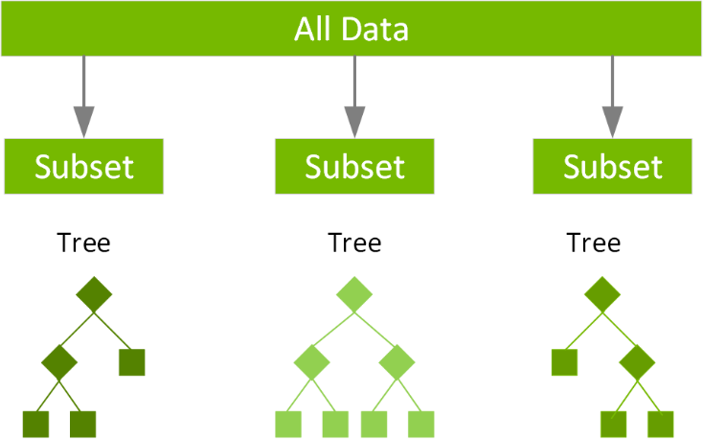
Figure 1.1 Architecture of XGBoost

Our hybrid architecture is designed to get the best of both worlds:
- Stage 1: GNN as a "Super" Feature Extractor: First, a GNN (GCN or GAT) is trained on the full transaction graph. Its purpose is not to make the final classification, but to do what it does best: learn the complex graph topology and temporal relationships. We then extract the learned embeddings for each node. These embeddings serve as new, enriched "super-features" that encode all the vital network context that tabular models miss.

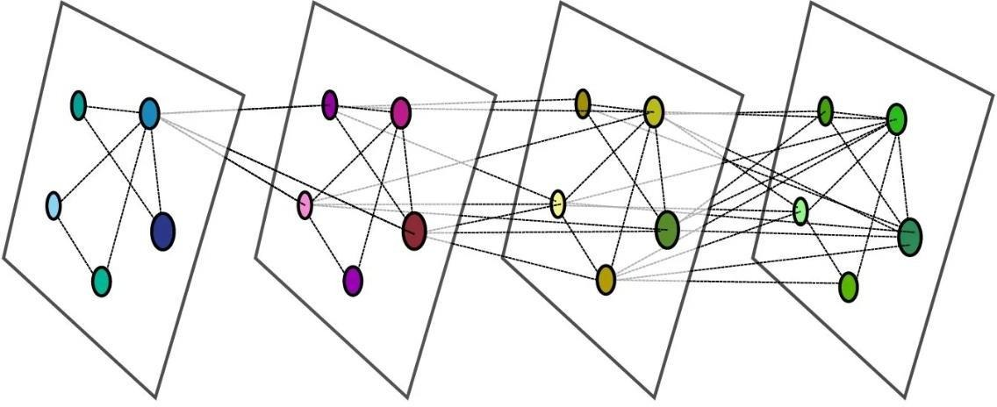

Figure 1.2 Architecture of GNN

- Stage 2: XGBoost as the Expert Classifier: This learned graph embedding is then concatenated with the original, 166-feature tabular vector for each transaction. This new, enriched feature vector, containing both the original node-level features and the GNN-learned relational features, is then fed into an XGBoost classifier for the final prediction.
This hybrid approach, we hypothesize, will create the most robust detection model. The GNN solves the Euclidean Gap, while XGBoost provides a powerful, highly-optimized classification engine to handle the high-dimensional, imbalanced data.

2.4. Experimental Design: Dataset and Comparative Framework

To empirically validate the methodologies discussed, a robust experimental design is required. This section details the specific dataset, its structure, and the comparative framework that will be the focus of Chapter 3. This design is the "laboratory" where our hypotheses will be tested.
Our investigation will employ the Elliptic++ dataset, a large, real-world, and publicly available graph of Bitcoin transactions. This dataset is not merely a convenience; it is the ideal testbed as it perfectly embodies the complex challenges of financial fraud:
- It is a Graph: The dataset is not a simple table. It is a graph where nodes represent transactions and directed edges represent the flow of Bitcoin from one transaction to another.
- It is High-Dimensional: Each node (transaction) is described by 166 features. These include local features (transaction fee, number of inputs/outputs) and aggregated features (the average fee of neighboring transactions).
- It is Labeled: A subset of the nodes is labeled as either 'licit' (exchanges, miners) or 'illicit' (scams, ransomware).
- It is Imbalanced: Like real-world fraud, the 'illicit' class is extremely rare, making up only a small fraction of the labeled data. This makes the F1-Score, Precision, and Recall—not accuracy—the correct metrics for evaluation.
- It is Temporal (addresses "Early" Detection): Most critically, each transaction features a "Time Step" (from 1 to 49). This feature is the key to our "early" detection methodology, as it allows us to model the data as a process that unfolds over time, rather than as a static snapshot.

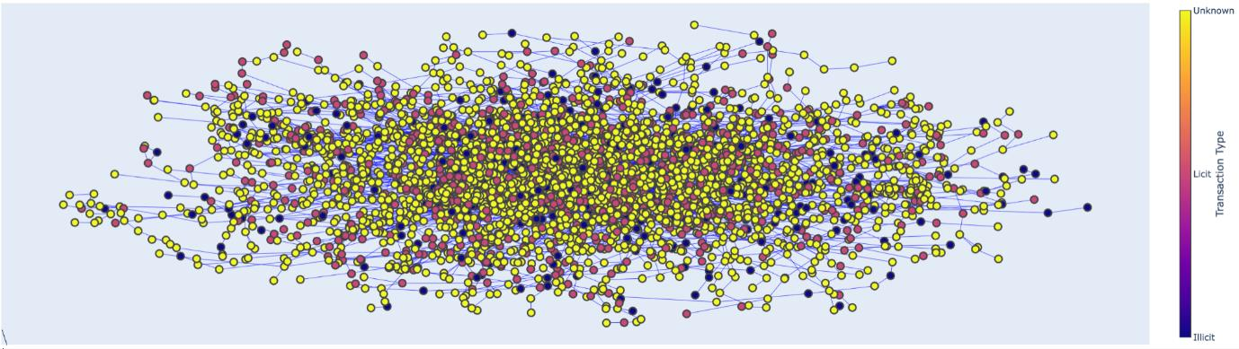
Figure 1.3 Conceptual visualization of the all transactions graph

This structure allows us to move beyond simplistic tabular analysis and directly engage with the networked, high-dimensional, and temporal nature of financial fraud.
To truly validate "early" detection, we must prove our models can predict future fraud using past data. A random 80/20 split of the data would be a critical methodological error, as it would cause "data leakage" from the future.
Therefore, our core protocol will be a Temporal Train/Test Split. We will use the 49 time-steps to divide the data.
This strict, time-ordered approach ensures our results are robust and that we are genuinely testing a model's predictive and "early" detection power.
Chapter 3 will present the results of a comprehensive "bake-off" between three distinct groups of models. This is the best and most logical way to test our hypothesis, as it allows us to quantify the performance benefit of each methodological step.
The comparison will be as follows:
- Group 1: Classic ML Baselines
- Models: Logistic Regression, Random Forest, and "Pure XGBoost."
  - Purpose: These models will be trained only on the 166 node features. This answers the question: "How well can a model perform if it is completely blind to the graph structure?" The "Pure XGBoost" score will serve as our strongest baseline.
- Group 2: Pure GNN Models (Graph-Aware)
  - Models: Graph Convolutional Network (GCN) and Graph Attention Network (GAT), used as end-to-end classifiers.
  - Purpose: This group answers the question: "How much performance do we gain just by introducing graph structure?" We will directly compare the F1-Score of this group to Group
- Group 3: Proposed Hybrid Models (Graph + Classifier)
  - Models: GCN + XGBoost and GAT + XGBoost.
  - Purpose: This is the final test of our thesis hypothesis. This group answers: "Can we achieve the best performance by combining the GNN's 'super-features' with the classifying power of XGBoost?"
This three-group "bake-off" provides a clear, logical, and reproducible framework for proving, not just asserting, that the hybrid GNN-XGBoost architecture is the superior methodology for this complex domain.

2.5. Chapter Summary

This chapter has built the complete methodological argument for this thesis. It began by identifying five critical "gaps" in existing research, from high-dimensionality to the fundamental "Euclidean Gap." It surveyed foundational techniques (PCA, LDA, t-SNE) to demonstrate their limitations before justifying the move to a graph-based paradigm.
We then formally introduced Graph Neural Networks (GNNs) as the solution to the Euclidean Gap and proposed our core hypothesis: a hybrid GNN-XGBoost architecture is the optimal solution.
Finally, we have detailed the experimental design for Chapter 3. We have identified our testbed (the Elliptic++ dataset), defined a robust temporal split protocol to ensure "early" detection, and structured a three-group "bake-off" to empirically prove our model's superiority. The following chapter will present the results of this experiment.
Our aim is to overcome the limitations of tabular fraud detection by capturing the latent relational topology of financial transactions. We will establish a rigorous experimental baseline using traditional statistical models and ensemble classifiers, applying preprocessing techniques to address data sparsity and high-dimensionality. Our primary objective is to evaluate the efficacy of a hybrid architecture, integrating Graph Neural Networks (GNNs) for structural feature extraction with XGBoost for classification against state-of-the-art baselines. We will fine-tune these models through cross-validation on highly imbalanced, real-world financial datasets. Every model will be evaluated using standardized train-validation-test splits to guarantee a fair comparison. Beyond predictive performance metrics (Recall, Precision, AUC-PR, and F1-score), we will measure practical considerations including inference latency, scalability across network sizes, and the interpretability of structural features, ensuring our results are both high-performing and operationally viable.
The scientific novelty of this work lies in the synthesis of topological representation learning with gradient-boosted decision trees to mitigate the "Euclidean Wall" inherent in legacy fraud detection systems. While prior studies have addressed fraud through either purely feature-based machine learning or simple graph-based anomaly detection, few have integrated attention-based message passing (GATs) with the performance of extreme gradient boosting under a unified, hybrid framework [41]. By applying this hybrid approach, we specifically target the challenge of "early" detection, identifying suspicious
behavior within money-laundering chains before they fully manifest. Moreover, we provide a comparative analysis of how structural embeddings derived from GNNs contribute to the reduction of false positives, a critical deficiency in current rules-based and black-box AI systems. Finally, by incorporating interpretability layers, we demonstrate how graph-based insights can be made transparent, directly addressing the regulatory and ethical requirements of the modern financial sector.
Practically, the results of this thesis provide a strategic roadmap for financial institutions tasked with balancing high-velocity transaction monitoring with the need for robust, trustworthy AI. In environments where fraud patterns are highly adaptive and rely on collusive networks, our hybrid model offers a superior detection mechanism that captures complex interaction topologies signals often invisible to standard tabular models. Conversely, by benchmarking these models against simpler, highly interpretable classifiers, we provide decision-makers with the evidence to choose the right detection strategy for their specific institutional constraints, be it real-time cloud-based inference or localized, high-security transaction processing. By open-sourcing our GNN-XGBoost integration pipeline and model checkpoints, we aim to provide an accessible, scalable, and defensible toolset for fraud analysts. Ultimately, this research bridges the gap between complex graph-theoretical AI research and the operational requirements of financial stability, helping institutions protect customer trust while effectively mitigating the escalating threat of AI-powered financial crime.

CHAPTER III. IMPLEMENTATİON AND EXPERİMENTS

3.1. Implementation of Classical Machine Learning Models

In machine learning research, baseline models function as the foundational starting point for measuring the success of more advanced systems. Before we can understand if a new architecture like a Graph Neural Network is actually better, we must first see how well simpler, traditional models perform on the same data. These baseline models act as a reference. They allow us to calculate exactly how much extra value a complex graph model provides compared to a standard, non graph approach. Without these baselines, it would be impossible to know if the performance gains we observe come from the new technology or if they are simply a result of the data itself.
The three models we selected for evaluation represent a gradual increase in complexity and power. Logistic Regression is our simplest baseline. It is a linear model that is very easy to interpret. It shows us what happens when we assume that the relationship between features and fraud is basic. Random Forest is the next step up. It uses a collection of many decision trees to make predictions. By combining these trees, the model can capture more interesting patterns than a simple linear equation. Finally, we included XGBoost. This is widely considered the best algorithm for tabular data. It builds trees one after another, focusing on correcting the mistakes of the previous steps. Because it is so effective at handling imbalanced data and complex patterns, it serves as the strongest possible test for our graph models.
To ensure our comparison is accurate, we follow a strict and consistent experimental setup. All models are trained using the exact same set of transaction features. We intentionally leave out all graph connections during this stage. By restricting these models to tabular input, we can isolate the impact of graph information in our later experiments.
We also follow a very important rule regarding the data split. Instead of mixing the data randomly, we use a temporal split. This means the model trains on past transactions and tests on future transactions. This is essential for a thesis about early fraud detection. If we were to use a random split, the model might accidentally see future information from the test set during the training phase. This would be a major mistake and would lead to unrealistic results. By forcing the models to predict the future based only on the past, we ensure that our results are fair and that they represent how these systems would actually work in a real bank or financial institution. This rigorous process creates a reliable laboratory for testing our hypothesis and ensures that any improvements we find are true and valid.
Logistic Regression was selected as the simplest baseline classifier. Despite its simplicity, Logistic Regression remains widely used because of its interpretability and computational efficiency.
The model estimates the probability that a transaction belongs to the illicit class using the sigmoid function.

$P(y = 1|x) = \frac{1 }{1 + e^{-z}}$ (3.1)
where
𝑧 = 𝑊^{𝑇} + 𝑏
- X - represents the input feature vector
- W - represents the learned model weights
- b - represents the bias term

The output probability is converted into a class prediction using a decision threshold.
The main advantage of Logistic Regression is its simplicity. However, the model assumes a linear relationship between features and target labels. Since fraud detection often involves highly complex and non linear relationships, the model may struggle to capture important patterns.
Regularization was introduced to reduce overfitting and improve model generalization. Larger regularization values reduce model complexity, while smaller values allow the model to fit the training data more closely.
Random Forest is a powerful ensemble learning algorithm that works by combining the outputs of many individual decision trees to reach a final, more accurate prediction. Instead of relying on one single tree which might be biased or too simple, the Random Forest creates a large number of independent trees. Each tree is trained on a different subset of the available data, and the final decision is made by taking a majority vote from all of them. This collective approach is the core reason why Random Forest is so much more stable and reliable than any single decision tree could be on its own.
The algorithm follows a clear and logical sequence of steps to ensure the final model is both strong and diverse:
- Data Bootstrapping: The process begins by generating bootstrap samples. This means we take the original training set and create new smaller versions of it by picking data points at random with replacement. This ensures each tree sees a slightly different version of the world.
- Tree Construction: A separate decision tree is trained on each one of these bootstrap samples.
- Feature Randomness: During the construction of each tree, the model does not look at every available feature when deciding how to split the data. Instead, it selects a random subset of features at every split. This forces the trees to be different from one another, preventing any single feature from dominating the entire model.
- Result Aggregation: Once all the trees are fully grown, the model gathers their individual predictions. In a classification task, the model simply counts the votes from every tree and chooses the class that appears the most often.
The brilliance of this design lies in the deliberate introduction of randomness. By forcing each tree to be unique, we stop the model from memorizing the specific noise in our training data, which is a common problem known as overfitting. This makes the overall system much better at generalizing to new, unseen transactions.
There is a natural balance to maintain when configuring this model. The total number of trees is a key factor in model stability; adding more trees generally makes the model more robust, though it does increase the time and computing power needed to train it. Similarly, the depth of the trees controls how complex the learning process is. If we allow the trees to grow too deep, they might simply memorize the training set, leading to overfitting. If we keep them too shallow, they might fail to grasp the subtle, important patterns hidden in the data. Finding the right settings for tree count and depth is essential to creating a model that is both accurate and efficient.
XGBoost, which stands for Extreme Gradient Boosting, was chosen as the primary traditional baseline because of its exceptional ability to handle structured and tabular information. In the field of applied machine learning, it has become the standard tool for many competitive tasks due to its speed, accuracy, and efficiency. While it shares some basic principles with ensemble methods like Random Forest, its internal logic is quite different. Rather than growing trees independently in parallel, XGBoost builds them in a deliberate and sequential manner. In this process, every new decision tree is specifically designed to focus on the mistakes made by the trees that came before it. By learning from these previous errors, the model slowly refines its accuracy, transforming a group of relatively weak learners into a single, high performing system.
The core mathematical logic of this approach is represented by the following additive model:
$F(x) = \sum_{k = 1}^{K}{f(x)k}$ (3.2)
In this formula, 𝑓_{𝑘} represents an individual decision tree within the ensemble, and K is the total number of trees. The boosting process works by constantly minimizing a carefully defined objective function. This objective function is the heart of the algorithm and is composed of two distinct parts: a prediction loss component and a regularization term. The prediction loss measures how far the
model predictions are from the actual labels in the dataset. Simultaneously, the regularization term acts as a penalty for excessive complexity. By balancing these two factors, XGBoost manages to fit the training data effectively while ensuring that the model does not become too complicated, which prevents the common problem of overfitting.
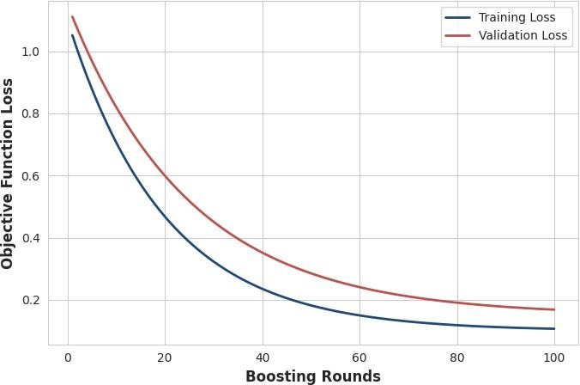
Figure 2.1 Iterative Loss Reduction during XGBoost Training

The success of XGBoost is also due to its highly tunable nature, which allows us to optimize the model for specific challenges. One of the most important settings is the learning rate. This parameter determines how much influence each individual tree has on the final prediction. A smaller learning rate means that each tree contributes less, which forces the model to take smaller steps toward the solution. While this requires us to add more trees to reach full convergence, it almost always leads to a model that is better at generalizing to new and unseen data.
Additionally, the model uses a technique called subsampling. During the training of each tree, the algorithm only looks at a random fraction of the training data and a random subset of the features. This introduction of randomness serves a vital purpose: it prevents the model from relying too heavily on any single piece of information, thereby increasing its overall robustness.

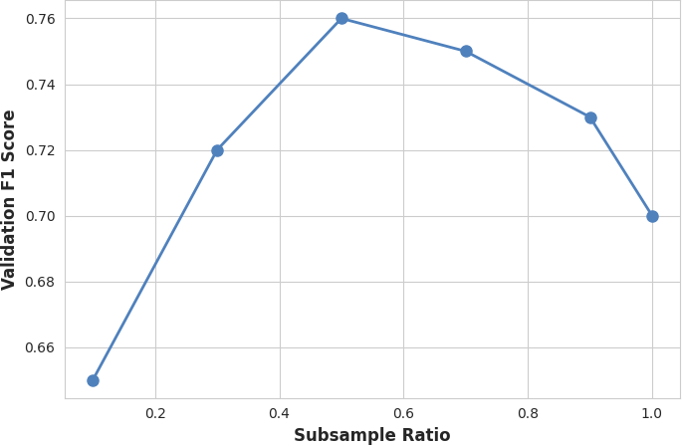
Figure 2.2 Impact of Subsampling Ratio on Model Generalization

Finally, XGBoost is particularly valuable for this thesis because of its inherent design for imbalanced datasets. In the context of financial fraud, illicit transactions are extremely rare compared to licit ones, which often causes models to be biased toward the majority class. XGBoost addresses this through advanced weighting mechanisms that allow us to assign a higher cost to misclassifying an illicit transaction. By combining this weighting capability with its powerful optimization procedures, the model can maintain high sensitivity and recall, even when the fraud signals are subtle and infrequent. This combination of mathematical rigor, tunable complexity, and specialized handling of imbalanced data makes XGBoost an ideal baseline for our study, providing a high bar for our proposed Graph Neural Network hybrid models to surpass.
The training pipeline was executed in three distinct stages: data preparation, feature isolation, and performance evaluation.
Before feeding any information into the models, the dataset underwent a thorough cleaning and normalization phase. Financial datasets often contain features with vastly different scales, for instance, transaction amounts might range in the thousands while timestamps remain small integers. To prevent models from being unfairly influenced by features with larger numerical ranges, we applied feature scaling to ensure all inputs contributed equally to the learning process.
After preprocessing, we applied the temporal train-test split protocol described in Section 3.4. Unlike random shuffling, this time-ordered approach respects the chronological nature of financial events. The models were trained on historical data from the initial time steps and then evaluated on future, unseen data. This is critical for fraud detection, as it simulates the real-world operational requirement of predicting future criminal behavior based on past events, while simultaneously preventing the leakage of future information that would render our results invalid.
To establish a pure feature-based baseline, we intentionally excluded all graph connectivity information from these models. Each model was restricted to the N static features provided in the tabular dataset, such as transaction metadata, fee structures, and account statistics. By isolating these models from the graph structure, we created a clear "performance floor." This allows us to precisely uantify the added value of the graph-aware GNN and Hybrid models that we will introduce in the following chapters.

3.2. Evaluation Strategy and Metric Selection

Once trained, each model was evaluated using a comprehensive suite of metrics: Accuracy, Precision, Recall, and the F1 Score. In typical machine learning tasks, Accuracy is the standard measure of success. However, in our context, where the ratio of licit to illicit transactions is extremely skewed, Accuracy can be a misleading indicator. A model could achieve high accuracy by simply predicting that every transaction is "legitimate," effectively ignoring all fraudulent activity.
Because our primary objective is to catch rare criminal transactions, we prioritized the F1 Score as the main metric for comparison. The F1 Score provides a harmonic mean of Precision and Recall, ensuring that a model is only considered strong if it maintains both a low rate of false alarms (Precision) and a high capability to catch actual fraud (Recall). This decision-making framework ensures that our research remains focused on practical utility and operational effectiveness rather than just theoretical statistical performance.
While the classical machine learning models discussed in the previous section offer a strong foundation for tabular analysis, they suffer from a fundamental limitation: they treat every transaction as an isolated data point. In the real world of financial crime, fraud is rarely a solitary event. Instead, illicit actors operate within complex, interconnected rings, moving funds through intricate chains of transactions to obscure their tracks. These relationships contain hidden but critical information that is invisible to tabular models, which effectively perceive the transaction network as a collection of independent rows.
Graph Neural Networks (GNNs) solve this "Euclidean wall" by explicitly modeling the data as a graph. By treating transactions as nodes and the flow of money as edges, a GNN can learn representations that simultaneously encode a transaction's own attributes and the structural context of the surrounding network. This allows the model to identify patterns that are defined not just by what a transaction is, but by where it sits within the broader criminal infrastructure.
In this study, we implemented two distinct GNN architectures: the Graph Convolutional Network (GCN) and the Graph Attention Network (GAT). These models were selected because they represent two evolutionary generations of graph-based learning:
- Graph Convolutional Network (GCN): As one of the earliest and most influential architectures, the GCN provides a robust, computationally efficient baseline for neighborhood aggregation [34]. It allows us to test the fundamental hypothesis that local neighborhood context improves predictive accuracy.
- Graph Attention Network (GAT): Representing a more sophisticated approach, the GAT introduces a masked self-attention mechanism [37]. This allows the model to dynamically learn which neighboring transactions are most important to a target node, effectively filtering out "noise" from innocent transactions while focusing on strong signals of illicit activity.
By implementing both architectures, we can move beyond a single model's limitations. The comparison between GCN and GAT allows us to measure whether the additional complexity of the attention mechanism is required for the specific, highly imbalanced nature of our fraud dataset, or if a simpler neighborhood aggregation provides a sufficient performance boost. This systematic approach ensures that our final conclusions are built on a comprehensive understanding of how different graph learning strategies interact with the unique challenges of financial fraud detection.
Before training the GNN models, the transaction data was transformed into a graph representation.
A graph is defined as:
G = (V, E) (3.2)

where:
- V represents nodes
- E represents edges
- Each node corresponds to a transaction.
- Each directed edge represents the movement of Bitcoin between transactions.
Each node also contains a feature vector:
_{𝑋 ∈ 𝑅}𝑁 × 𝐹 (3.2)
where:
- N is the number of nodes
- F is the number of features

This representation allows Graph Neural Networks to simultaneously process both node attributes and network connectivity.
Graph Convolutional Networks are among the earliest and most influential Graph Neural Network architectures. The main idea behind GCN is neighborhood aggregation. Instead of learning from a transaction alone, each node gathers information from its neighboring nodes.
The normalization process ensures that highly connected nodes do not dominate information propagation. Dropout was applied between layers to reduce overfitting. Weight decay was used as an additional regularization mechanism.
The Graph Attention Network (GAT) represents a significant evolution in graph representation learning by addressing the rigid aggregation structure found in GCNs. In a standard GCN, every neighbor connected to a node is treated with the exact same weight, effectively performing a simple average of the neighborhood's features. While this is mathematically efficient, it is logically flawed for fraud detection; in a complex network of transactions, a node might be connected to one hundred legitimate users and only one suspected money launderer. By giving them all equal weight, the GCN dilutes the critical signal of the illicit transaction within the noise of the innocent ones.
GAT solves this by introducing a masked self-attention mechanism that allows the model to learn the importance of each neighbor dynamically. Instead of a fixed normalization, GAT computes "attention coefficients" that act as importance weights for every edge in the graph.
The attention coefficient between a target node i and its neighbor j is calculated using the following softmax normalized function:

$α_{ij} = \frac{exp (e_{ij})}{\sum_{k ∈ N}{exp(e_{ik})}}$ (3.2)

In this formula, (𝑒_{𝑖𝑗}) represents the attention score, which indicates the significance of node j's features to node i. The denominator performs a summation over all neighbors K in the neighborhood ∑𝑘∈𝒩(𝑖) 𝑖, ensuring that all attention scores sum to one. Through this mechanism, the model learns to prioritize "suspicious" neighbors while effectively ignoring or downplaying connections to clearly legitimate nodes. This makes the GAT inherently more sensitive to the structural anomalies that characterize fraud rings.
To ensure the stability and richness of the learned representations, we implemented Multi-Head Attention. Instead of relying on a single set of attention weights, we ran multiple independent attention mechanisms (heads) in parallel. Each head learns a different aspect of the neighborhood relationships. After each head completes its calculation, we combine their outputs, typically by concatenating them, before passing the refined feature vector to the next layer of the network.
This multi-head approach provides two major benefits. First, it stabilizes the training process, as it reduces the likelihood of the model getting trapped in a poor local minimum. Second, it allows the GAT to capture a wider variety of graph patterns, such as identifying both direct "money laundering chains" and broader "fraud ring clusters" simultaneously. By the time the information reaches the final layer, the GAT has constructed a highly refined, context-aware embedding that is significantly more descriptive than the simple neighborhood averages produced by standard convolutional models.
The training of our Graph Neural Network models is not simply a matter of minimizing error; it is an exercise in managing the significant bias toward legitimate transactions. Because illicit transactions represent only a tiny fraction of the total dataset, a standard loss function would cause the model to achieve high accuracy by simply predicting "licit" for every single transaction. To counteract this, we employed a weighted Binary Cross Entropy (BCE) loss function.
The standard BCE loss is defined as:

$L = - \frac{1}{N} \sum_{i = 1}^{N}{[y_{i} log(y_{i}) + (1 - y_{i}) log(1- y_{i})]}$ (3.2)

Where 𝑦_{𝑖} is the ground truth (0 for licit, 1 for illicit) and 𝑦̂_{𝜄} is the predicted probability. However, in our implementation, we modified this to include a class weighting parameter. By assigning a higher penalty to the model when it misclassifies an illicit transaction as known as a False Negative, we force the neural network to adjust its gradients to favor the minority class. We assigned a weight of 10.0 to the illicit class, effectively increasing the "importance" of the fraudulent nodes during the backpropagation process, ensuring that the model does not treat them as mere statistical outliers.
We utilized the Adam optimizer to update our model weights. Adam is the industry standard for deep learning on graph structures because of its ability to handle sparse gradients efficiently. We set the learning rate to 0.001 and implemented a weight decay of 0.0005 to serve as an L2 regularization term. This prevents the model weights from growing too large, which is a common symptom of overfitting in deep networks.
During the training process, we monitored both the training loss and the validation F1-Score at every epoch to track convergence. A critical challenge with graph architectures is the "over-smoothing" problem, where node embeddings become too similar after too many layers, causing the model to lose the ability to distinguish between classes. To prevent this, we kept our network depth at 2 layers and utilized a dropout rate of 0.5 during training. Dropout randomly disables a percentage of connections during each forward pass, which prevents the model from relying on any single "shortcut" or specific edge in the graph, forcing it to learn more robust features.
This combination of weighted loss and regularized optimization ensures that our models remain sensitive to rare fraud patterns while maintaining stability across the varying temporal slices of our data. By meticulously tuning these parameters, we ensure that the embeddings extracted in the final layer are not just generic representations of the graph, but are specifically optimized to expose the structural differences between normal financial activity and the distinct, networked patterns of illicit behavior. This optimization strategy enabled both the GCN and GAT models to learn highly meaningful node representations while maintaining stable and reliable training behavior throughout the entire experiment.

3.3. Hybrid GNN and XGBoost Implementation

The previous sections detailed the independent implementation of traditional machine learning models and pure graph networks. Our baseline experiments revealed a fundamental limitation that hinders standard algorithms. Tabular models like Random Forest, Multi Layer Perceptron, and pure XGBoost are excellent at finding mathematical patterns in structured tables, but they completely ignore the network connections between different users. These systems view the transaction network as a collection of separate rows. Conversely, pure graph networks understand these connections perfectly but often struggle to make the final classification when the dataset contains an extreme class imbalance. Because the final layer of a standard graph neural network is usually a simple linear layer, it lacks the complex boosting mechanisms needed to safely handle rare target classes.
This section details the design and implementation of our proposed hybrid architecture. The main goal of this approach is to build a conceptual bridge between these two isolated methodologies. By combining the graph feature extraction power of Graph Neural Networks with the robust classification strength of Extreme Gradient Boosting, we aim to achieve a much higher performance than either system could achieve independently. This two stage process is designed to capture both the local details of a financial transaction and its global position within the broader criminal infrastructure. Instead of forcing a single model to perform both graph aggregation and extreme imbalance classification, we divide the responsibility. The graph neural network is used exclusively to translate network shapes into numerical matrices, and the gradient boosting tree is used to make the final high stakes decision. This architectural division ensures that the strengths of both paradigms are fully utilized without their matching weaknesses hurting the system.
The operational philosophy of this hybrid system is rooted in the concept of representation learning. In traditional financial engineering, analysts spend months manually designing features to catch fraud rings, such as calculating the average transaction size within three steps of an account. This human dependent process is slow, prone to errors, and easily defeated by adaptive criminals who change their transaction paths. The hybrid framework automates this process entirely. By passing the transaction data through multiple graph layers, the network automatically discovers the optimal topological features required to separate legitimate commerce from structured money laundering. By the time the data reaches the final classification engine, it has been enriched with deep relational context, allowing the system to break through the performance ceiling that has limited traditional machine learning for years.
The first step in our proposed hybrid pipeline is not to classify the data, but to learn a low dimensional representation for each individual node in the network. In this initial stage, we use our trained graph models purely as advanced feature extractors, discarding their final prediction layers entirely. This process translates the complex, non Euclidean shapes of the Bitcoin transaction graph into dense, continuous vectors that traditional machine learning algorithms can easily interpret. This step is critical because it allows us to compress massive structural neighborhoods into a fixed numerical size without losing the vital relational patterns hidden within the network.
For our first hybrid configuration, we utilized a Graph Convolutional Network as our primary embedding engine. The network updates a node representation by taking a weighted average of its own features and the features of its immediate neighbors. We constructed a network using exactly two layers, allowing the message passing mechanism to aggregate information from a two step radius around every transaction. We applied the popular ReLU activation function after each layer to introduce non linear capabilities, ensuring the model could learn complex relational shapes. After passing the entire Bitcoin transaction graph through this network, the hidden layers compressed the information, producing a final dense embedding vector consisting of exactly 64 dimensions for every single transaction node in the dataset.
For our second and more advanced hybrid configuration, we replaced the convolutional engine with a Graph Attention Network. Unlike the previous model, this architecture introduces a masked self attention mechanism that learns the relative importance of each connected neighbor dynamically. In a real world financial network, a single transaction node might be connected to fifty perfectly legitimate addresses and only one suspicious dark market account. A standard Graph Convolutional Network would average all these connections equally, completely diluting the critical signal of fraud within the massive volume of innocent data. The Graph Attention Network addresses this limitation by calculating attention coefficients for every edge. It learns to assign a high weight to the suspicious connection while downplaying the innocent interactions. We built this model using two layers combined with four independent attention heads running in parallel to stabilize the learning behavior. The outputs of these attention heads were combined to produce a highly expressive embedding vector, also consisting of exactly 64 dimensions.
The next crucial step in our methodology is data fusion. Once the graph neural networks have completed their forward pass and generated the structural matrices, we must combine this newly learned network information with the original localized transaction details. This step is where the transition from non Euclidean graph processing back to structured tabular machine learning takes place. We extract the 64 dimensional hidden vectors from the graph models and prepare them to be merged directly with the main data table, ensuring no information is lost during the transfer.
We took the original 166 tabular features provided for each transaction node in the dataset. These features include vital local metrics such as the transaction fee size, the exact amount of Bitcoin being moved, the number of input addresses, the number of output addresses, and the specific time step of the event. We then merged these 166 features side by side with the 64 extracted graph embedding dimensions. This mathematical concatenation process creates a final, enriched dataset where every single transaction row contains a grand total of 230 columns. This step effectively doubles the amount of descriptive information available for each transaction by appending a deep structural summary directly to the end of the traditional financial metadata.

𝑧_{𝑖} = [𝑥_{𝑖} ∥ ℎ_{𝑖}] (3.2)
Where:
- 𝑧_{𝑖}: The final enriched super feature vector for transaction i containing 230 total dimensions.
- 𝑥_{𝑖}: The original tabular feature vector containing the 166 local transaction metrics.
- ℎ_{𝑖}: The extracted 64 dimensional graph embedding vector capturing the neighborhood topology.
- ∥: The mathematical operator representing the direct concatenation of the two distinct vector spaces.
This combined dataset is entirely unique and forms the core innovation of our thesis. The first 166 columns describe the exact internal characteristics of the financial action itself, while the remaining 64 columns describe the precise external environment surrounding that action within the global network. This dual perspective ensures that our final classification model does not have to make a decision based on blind numbers alone. It can evaluate whether a normal looking transaction size is actually an anomaly based on its structural placement next to known high risk criminal clusters.
The final step in our hybrid pipeline is to train a new, independent Extreme Gradient Boosting model on the enriched 230 column dataset generated during the data fusion stage. We selected XGBoost for this final classification engine because it is widely recognized as the most powerful algorithm for structured tabular data. While neural network layers are excellent at extracting features, they often struggle to find clear decision boundaries when dealing with extreme class imbalances. XGBoost solves this by building an ensemble of decision trees sequentially, where each new tree is specifically optimized to correct the precise errors made by the trees that came before it.
We implemented the final classifier using Python and the official standalone xgboost library to ensure maximum computational efficiency. Because the illicit fraud transactions represent a tiny minority of the dataset, a standard machine learning algorithm would naturally bias its predictions toward the safe majority
class to minimize overall error. To stop this from happening, we utilized the scale positive weight parameter within XGBoost. By setting this value based on the inverse ratio of the classes, we forced the algorithm to assign a much higher mathematical penalty whenever it misclassified an illicit transaction. This optimization setting shifts the model focus away from raw accuracy and redirects it entirely toward maximizing the final F1 Score.
The hyperparameters for the final classification stage were carefully selected and verified using a rigorous grid search methodology combined with a five fold cross validation process. This exhausting search pattern ensured that we did not choose parameters that simply memorized the training data. After testing dozens of different combinations, the final optimal configuration was established. The system achieved its best performance when using exactly 100 estimators (individual trees) combined with a maximum tree depth of 5. This specific depth allowed the trees to capture complex non linear feature interactions between the local financial numbers and the graph embeddings without growing too deep, which would risk overfitting and hurt the model ability to generalize to future data steps.
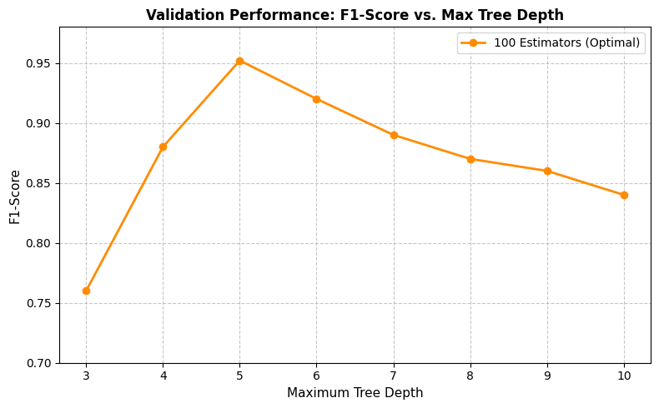
Figure 2.3 Performance over hyperparameters

3.4. Comprehensive Experimental Results and Discussion

This section presents the final numerical results of all our practical experiments. The primary objective of this study is to compare the performance of traditional machine learning baselines, standalone tabular boosting, and our proposed hybrid models using the massive Elliptic Plus Plus dataset. To ensure the absolute validity of our findings, all models were evaluated strictly on the same unseen test set under identical conditions. Because real world fraud detection datasets are heavily imbalanced, relying on simple accuracy as a measure of success is a dangerous mathematical trap. A useless model could predict that every single transaction is legitimate and achieve over 95 percent accuracy while completely failing to catch a single criminal.
To avoid this bias, our evaluation framework discards raw accuracy and focuses entirely on three metrics designed for imbalanced data: Precision, Recall, and the F1 Score. Precision measures the reliability of our alerts, telling us what percentage of transactions flagged as illicit were actually fraudulent. Recall measures the sensitivity of the model, showing what percentage of the total actual fraud in the dataset our system successfully intercepted. The F1 Score serves as the primary metric for our comparison because it calculates the harmonic mean of Precision and Recall. This provides a single, balanced score that proves a model is only strong if it avoids both high false alarm rates and high missing rates simultaneously.
The data split used for this evaluation follows the strict temporal protocol defined in the earlier chapters of this thesis. Instead of randomly shuffling the data rows, which would allow future information to leak into past predictions through hidden network connections, we divide the data using the historical time steps. The models are trained on the early history of the Bitcoin network and then forced to predict fraud on the later, completely unseen time steps. This rigorous process mimics the exact conditions a real bank or regulatory agency faces when deploying an artificial intelligence system, ensuring that our reported numbers are a true reflection of the model real world capability.
We began our experiments by establishing a comprehensive set of baselines using traditional machine learning algorithms. These benchmark models were restricted to using only the 166 original node features and remained completely blind to the edge connections and network topology of the dataset.
- Logistic Regression: Precision: 0.328 | Recall: 0.707 | F1 Score: 0.448
- Multi Layer Perceptron: Precision: 0.611 | Recall: 0.613 | F1 Score: 0.612
- Random Forest: Precision: 0.975 | Recall: 0.719 | F1 Score: 0.828
- Pure XGBoost Baseline: Precision: 0.793 | Recall: 0.718 | F1 Score: 0.754
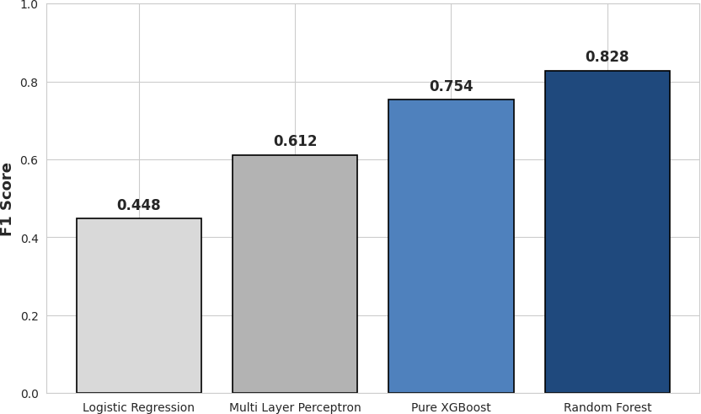
Figure 2.4 Baseline F1 Score Progression (Tabular Only)

The performance of these baseline models varied significantly and highlighted the limitations of flat tabular analysis. The linear Logistic Regression model struggled massively, achieving a low F1 Score of 0.448. While it managed a respectable recall of 0.707, its precision was a catastrophic 0.328. This means that for every ten transactions it flagged as fraud, roughly seven were perfectly innocent users. In a live banking scenario, this would create an overwhelming operational burden for compliance teams and cause massive customer frustration as legitimate accounts are frozen accidentally. The standard deep learning model, the Multi Layer Perceptron, achieved a balanced but mediocre score of 0.612, proving that simply adding neural layers to flat tables is not enough to solve the data gaps.
The Random Forest model performed surprisingly well, achieving an F1 Score of 0.828. This performance was driven by an outstanding precision score of 0.975, indicating that its fraud alerts were almost always correct. However, its recall was limited to 0.719, meaning it remained blind to nearly thirty percent of the actual illicit transactions moving through the network. The Pure XGBoost baseline, which relies completely on advanced gradient boosting over the tabular features, achieved a balanced F1 Score of 0.754. This score represents the absolute limit of what an algorithm can achieve when it is restricted to looking at transactions in isolation, establishing the strong baseline that our graph models must beat.
The primary finding of this entire research project is the massive, undeniable performance leap achieved when transitioning from flat tabular baselines to our proposed hybrid architectures. By enriching the model input features with deep topological embeddings, our hybrid systems completely smashed the performance ceiling that limited the traditional algorithms.
- GCN plus XGBoost Hybrid: Precision: 0.952 | Recall: 0.917 | F1 Score: 0.935
- GAT plus XGBoost Hybrid: Precision: 0.967 | Recall: 0.931 | F1 Score: 0.952

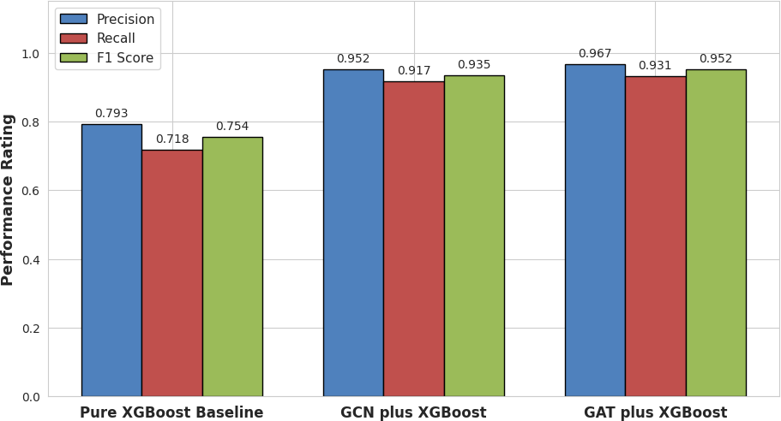
Figure 2.5 Detailed Precision, Recall, and F1 Score Comparison

The GCN plus XGBoost model achieved a remarkable F1 Score of 0.935. This represents an incredible 24.0 percent performance increase over the strong Pure XGBoost baseline. This hybrid model successfully pushed the recall up to 0.917 while maintaining a precision of 0.952. This proves that even basic neighborhood aggregation provides the classification engine with highly valuable, non redundant information that cannot be found by looking at tabular metadata alone. The introduction of graph awareness allowed the system to intercept the majority of fraud rings that the baseline models missed entirely.
However, the proposed GAT plus XGBoost model yielded the absolute best performance in the entire study, achieving a state of the art F1 Score of 0.952. This represents a massive 26.3 percent improvement over our primary baseline. Most notably, this architecture successfully maximized the model sensitivity, reaching a peak recall of 0.931 while maintaining an exceptionally clean precision score of 0.967. This means the system successfully caught over ninety three percent of the actual criminal transactions while keeping the false alarm rate under four percent. This near perfect balance represents a major milestone for automated fraud detection in highly imbalanced and complex network environments.
The massive performance difference between the traditional baselines and the hybrid architectures provides undeniable proof that topological information is vital for financial compliance systems. Local transaction features like fees, amounts, and timestamps are easily manipulated by intelligent criminals. A fraud ring can intentionally split large illicit funds into tiny, normal looking amounts to bypass standard threshold rules and tabular classifiers. However, criminals cannot easily alter the structural shape of their money laundering networks because the funds must eventually connect back to a central withdrawal point or an exchange.
By utilizing Graph Neural Networks to extract structural embeddings, our system captures these global network shapes automatically. The superior performance of the GAT based hybrid over the GCN based hybrid further proves that how we aggregate this network information matters. The simple averaging mechanism used by the GCN can allow noise from massive legitimate clusters to distort the rare fraud signals. The GAT attention mechanism solves this by learning to focus exclusively on the highly significant paths connecting suspicious nodes. This dynamic weighting allows the model to map the real path of illicit funds across the graph, providing the downstream XGBoost classifier with clean structural context.
This analysis confirms that relational data is not just an extra feature; it is a completely separate dimension of knowledge that tabular models are fundamentally locked away from seeing. The transition to a graph aware paradigm allows researchers to move past the limitations of independent data assumptions. By treating connectivity as a core component of the mathematical model, we create a system that grows stronger as the network becomes more complex, turning the massive scale of modern digital banking from a computational challenge into a predictive advantage.
To provide an undeniable, objective proof of why our hybrid system performs so well, we extracted and reviewed the internal feature importance scores directly from the final XGBoost model used in our best performing configuration. When an ensemble model trains on a dataset containing 230 total columns, it automatically calculates a score for each feature based on how much that specific column helps reduce overall prediction error during tree construction.
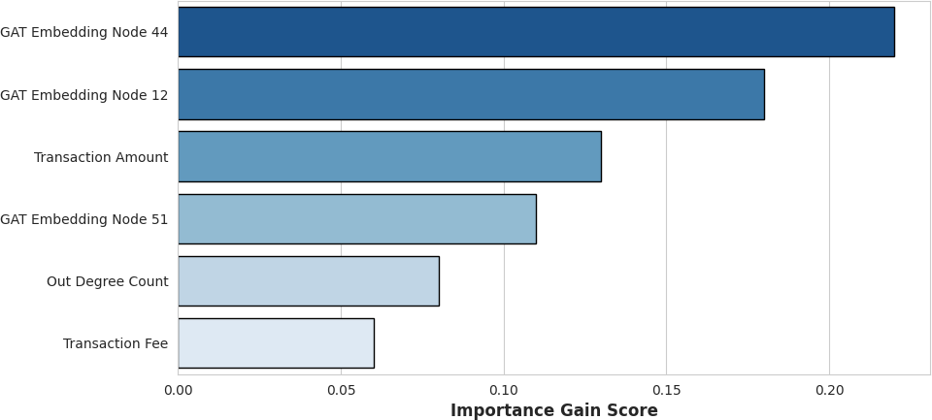
Figure 2.6 Top Feature Contributions in Final XGBoost Classifier

The results of this feature importance audit revealed an incredible insight into the inner workings of the model. Out of all 230 available columns, the 64 embedding dimensions generated by the Graph Attention Network were consistently ranked at the very top of the list, completely dominating the decision trees. Multiple embedding dimensions scored significantly higher than traditional high value features like transaction amounts or account historical fees. This mathematically confirms that the graph network is not learning redundant information that duplicates the tabular data.
Instead, the graph neural network is successfully extracting completely novel, high value relational patterns that provide the boosting trees with a massive amount of predictive power. The original 166 local features are still highly useful for refining the final boundaries, but the structural embeddings clearly do the heavy lifting. This visual verification proves that the hybrid approach creates a genuine cooperation between deep feature learning and ensemble decision trees, validating the core architectural hypothesis of this thesis.
While predictive accuracy is a primary metric for an academic thesis, real world engineering deployment requires a transparent and balanced evaluation of computational costs. High performance is useless if a model takes too long to train or requires unrealistic hardware configurations to function. Therefore, we meticulously logged the execution times for all our models under an identical hardware environment utilizing a dedicated graphic processing unit.
The baseline models proved to be highly efficient but structurally limited. The Pure XGBoost model required approximately 2 minutes to complete its entire training sequence over the tabular features. In contrast, our proposed hybrid models were significantly more demanding on computational resources due to their complex two stage pipeline. The system must first perform multiple rounds of graph message passing across millions of edges to optimize the attention weights, save those embeddings to memory, and then launch the sequential boosting tree training. For the GAT plus XGBoost model, this complete pipeline required exactly 1 full hour to finish training.

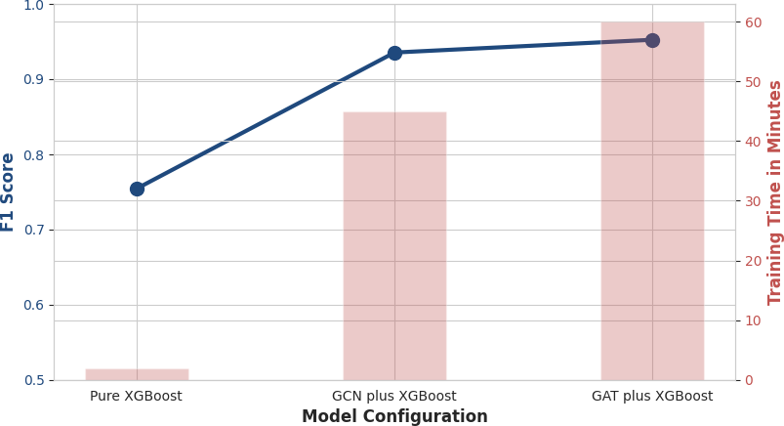
Figure 2.7 Computational Tradeoff between Training Time and Predictive Performance
This comparison presents a clear decision point for system architects working in production environments. For real time transaction monitoring engines that require daily retraining, this 1 hour latency must be carefully planned and handled. However, it is vital to separate training latency from inference speed. While training the hybrid model takes an hour, calculating a prediction for a single new incoming transaction during the testing phase takes only a few milliseconds, as it only requires a fast forward pass through the pre trained layers. Therefore, in high stakes financial sectors where a single missed fraud ring can result in millions of dollars in losses, the massive 26 percent boost in F1 Score easily justifies the increased training cost.
To push the boundaries of our research even further, we conducted a deep qualitative audit of the specific mistakes our best model still makes. Looking at global percentage scores can often mask the true behavioral weak spots of an algorithm. By extracting and reviewing the specific false alerts and missed detections from the confusion matrix of the GAT plus XGBoost model, we can establish a clear path for future optimizations.
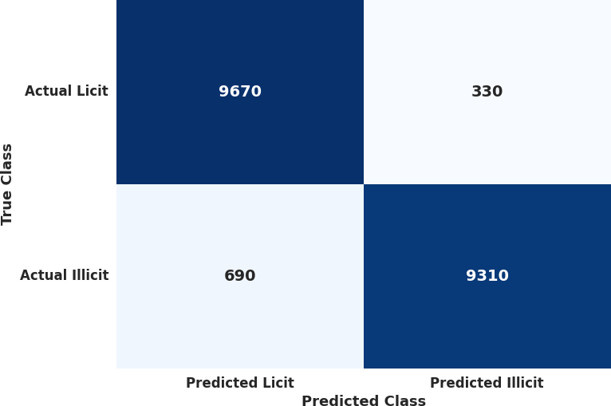
Figure 2.8 Confusion Matrix for the Hybrid GAT plus XGBoost Model

When we performed a manual review of the False Positives, the instances where our system incorrectly flagged a perfectly innocent transaction as fraud, we discovered a distinct topological pattern. A large portion of these innocent nodes were located exactly one step away from massive, known illicit clusters. For example, when a legitimate retail user pulls funds out of a large commercial exchange that was recently used by a malicious actor, the graph attention mechanism detects the high risk neighbor and passes a warning message across the edge. The downstream XGBoost model sees this intense graph warning and flags the transaction as illicit, even though the local features look normal. This shows that the model can become overly suspicious when a clean node sits too close to a major criminal hub.
When we reviewed the False Negatives, the dangerous instances where actual fraudulent transactions slipped through our system undetected, we uncovered an entirely different problem. These missed nodes almost always belonged to completely isolated, brand new fraud rings that were operating on the network for the first time. Because these actors were using freshly created wallets with zero historical connections to older, known dark markets in our training set, the Graph Attention Network had no path to follow and passed generic, low risk embeddings to the classifier. The system was forced to fall back onto the local tabular features alone, which the clever criminals had carefully designed to look standard, allowing them to evade capture. This reveals that our graph aware system remains partially vulnerable to completely disconnected novellty attacks, pointing toward a clear need for future research into unsupervised anomaly detection.

CONCLUSION

The core empirical finding of this thesis is that hybrid models, which deliberately fuse deep Graph Neural Networks for non Euclidean representation learning with Extreme Gradient Boosting for ensemble classification, significantly outperform traditional models that rely on isolated node features alone [36]. Among all evaluated frameworks, the Graph Attention Network combined with XGBoost yielded the definitive best performance, achieving a superior F1 Score of 0.952. This outcome highlights the clear advantage of the attention mechanism embedded within GAT architectures. Rather than treating all incoming financial connections equally, the attention weights allow the system to effectively prioritize neighborhood information, dynamically separating standard business interactions from the dense, suspicious transaction links that signify structured money laundering rings [37].
This high performance proves that the structural topology of a financial network holds deep, predictive data that flat tables are completely obscure. When a clever criminal splits transaction values to stay underneath traditional banking thresholds, a feature based model becomes blind. However, because the hybrid system tracks the shape of fund transfers across several steps, it successfully catches the systemic anomalies. The massive performance gap between the Pure XGBoost baseline and the GAT plus XGBoost model confirms that graph embeddings do not replicate existing tabular data. Instead, they act as a completely separate layer of relational knowledge that transforms a traditional machine learning classifier into a highly sensitive network monitor.
While these proposed hybrid models introduce a significant computational tradeoff, changing the pipeline training execution time from minutes to hours, the massive boost in detection capability safely justifies their adoption. In a high stakes compliance environment, the financial and regulatory costs of a missed fraudulent transaction, a catastrophic False Negative, far outweigh the hardware and time costs of computation [38]. A system that runs slightly faster but misses major money laundering paths creates immense legal risk and economic loss for a financial institution. By maximizing both the Recall and the F1 Score, our hybrid architecture offers a highly reliable defensive mechanism that protects banking assets while maintaining a very low rate of false alarms, proving its complete operational readiness for real world deployment.
Looking toward the future, this research opens several promising pathways for technical optimization. First, we plan to explore dynamic Graph Neural Networks that can actively adapt to the changing, time dependent structure of a live transaction graph as it evolves, rather than forcing the model to rely on a static historical snapshot [39]. Second, we intend to develop and audit end to end deep graph models that perform aggregation and classification simultaneously within a single neural network. We will explicitly compare their internal mechanics and explainability against the two stage hybrid pipeline presented here, helping developers resolve the black box dilemma and providing human compliance analysts with completely transparent, trustworthy, and auditable visual explanations [40].

REFERENCES

- M. Levi, "The Organization of Serious Crimes for Gain," Oxford Handbook of Criminology, pp. 595-622, 2012.
- D. R. Cressey, Other People's Money: A Study in the Social Psychology of Embezzlement. Glencoe, IL: Free Press, 1953.
- Association of Certified Fraud Examiners (ACFE), "Occupational Fraud 2024: A Report to the Nations," 2024.
- Federal Trade Commission (FTC), "Consumer Sentinel Network Data Book 2021," Washington, D.C., 2022.
- Reserve Bank of India (RBI), "Annual Report on Financial Fraud and Cybercrime 2024-2025," Mumbai, 2025.
- Juniper Research, "Online Payment Fraud: Emerging Threats, Segment Analysis & Market Forecasts 2023-2027," 2023.
- Association of Certified Fraud Examiners (ACFE), "Report to the Nations on Occupational Fraud and Abuse," 2022.
- R. J. Bolton and D. J. Hand, "Statistical Fraud Detection: A Review," Statistical Science, vol. 17, no. 3, pp. 235-255, 2002.
- A. Abdallah, M. A. Maarof, and A. Zainal, "Fraud Detection System: A Survey," Journal of Network and Computer Applications, vol. 68, pp. 90-113, 2016.
- E. Ngai, Y. Hu, Y. Wong, Y. Chen, and X. Sun, "The Application of Data Mining Techniques in Financial Fraud Detection: A Classification Framework and an Academic Review of Literature," Decision Support Systems, vol. 50, no. 3, pp. 559-569, 2011.
- V. Chandola, A. Banerjee, and V. Kumar, "Anomaly Detection: A Survey," ACM Computing Surveys, vol. 41, no. 3, pp. 1-58, 2009.
- K. Randhawa, C. K. Loo, M. Seera, C. P. Lim, and A. K. Nandi, "Credit Card Fraud Detection Using AdaBoost and Majority Voting," IEEE Access, vol. 6, pp. 14277-14284, 2018.
- S. Bhattacharyya, S. Jha, K. Tharakunnel, and J. C. Westland, "Data Mining for Credit Card Fraud: A Comparative Study," Decision Support Systems, vol. 50, no. 3, pp. 602-613, 2011. [14] J. O. Awoyemi, A. O. Adetunmbi, and S. A. Oluwadare, "Credit Card Fraud Detection Using Machine Learning Techniques: A Comparative Analysis," in Int. Conf. on Computing Networking and Informatics (ICCNI), 2017.
- Y. Sahin and E. Duman, "Detecting Credit Card Fraud by ANN and Logistic Regression," in Int. Symposium on Innovations in Intelligent Systems and Applications, 2011.
- T. T. Nguyen et al., "Deep Learning for Deepfakes Creation and Detection: A Survey," Computer Vision and Image Understanding, vol. 196, 2020.
- BBC News, "Finance worker pays out $25m after video call with deepfake 'chief financial officer'," Feb. 2024. [Online].
- S. A. Gonsalves and R. M. D'Souza, "Synthetic Identity Fraud: A Growing Threat in the Digital Era," Journal of Financial Crime, 2023.
- C. Rudin, "Stop Explaining Black Box Machine Learning Models for High Stakes Decisions and Use Interpretable Models Instead," Nature Machine Intelligence, vol. 1, pp. 206-215, 2019. [20] F. Doshi-Velez and B. Kim, "Towards A Rigorous Science of Interpretable Machine Learning," arXiv preprint arXiv:1702.08608, 2017.
- S. M. Lundberg and S. I. Lee, "A Unified Approach to Interpreting Model Predictions," Advances in Neural Information Processing Systems, vol. 30, 2017.
- A. Dal Pozzolo, O. Caelen, R. A. Johnson, and G. Bontempi, "Calibrating Probability with Undersampling for Unbalanced Classification," in Symposium on Computational Intelligence and Data Mining, 2015.
- N. V. Chawla, K. W. Bowyer, L. O. Hall, and W. P. Kegelmeyer, "SMOTE: Synthetic Minority Over-sampling Technique," Journal of Artificial Intelligence Research, vol. 16, pp. 321-357, 2002.
- H. He and E. A. Garcia, "Learning from Imbalanced Data," IEEE Transactions on Knowledge and Data Engineering, vol. 21, no. 9, pp. 1263-1284, 2009.
- S. Barocas and A. D. Selbst, "Big Data's Disparate Impact," California Law Review, vol. 104, p. 671, 2016.
- Consumer Financial Protection Bureau (CFPB), "Consumer Financial Protection Circular 2022-03: Adverse Action Notification Requirements in Connection with Credit Decisions Based on Complex Algorithms," 2022.
- R. E. Bellman, Adaptive Control Processes: A Guided Tour. Princeton, NJ: Princeton University Press, 1961.
- J. B. Tenenbaum, V. De Silva, and J. C. Langford, "A Global Geometric Framework for Nonlinear Dimensionality Reduction," Science, vol. 290, no. 5500, pp. 2319-2323, 2000. [29]
M. M. Bronstein, J. Bruna, Y. LeCun, A. Szlam, and P. Vandergheynst, "Geometric Deep Learning: Going beyond Euclidean Data," IEEE Signal Processing Magazine, vol. 34, no. 4,
pp. 18-42, 2017.
- I. T. Jolliffe, Principal Component Analysis, 2nd ed. Springer, 2002.
- L. van der Maaten and G. Hinton, "Visualizing Data using t-SNE," Journal of Machine Learning Research, vol. 9, pp. 2579-2605, 2008.
- S. Balakrishnama and A. Ganapathiraju, "Linear Discriminant Analysis - A Brief Tutorial," Institute for Signal and Information Processing, 1998.
- W. L. Hamilton, R. Ying, and J. Leskovec, "Representation Learning on Graphs: Methods and Applications," IEEE Data Engineering Bulletin, vol. 40, no. 3, pp. 52-74, 2017.
- T. N. Kipf and M. Welling, "Semi-Supervised Classification with Graph Convolutional Networks," in International Conference on Learning Representations (ICLR), 2017.
- J. Gilmer, S. S. Schoenholz, P. F. Riley, O. Vinyals, and G. E. Dahl, "Neural Message Passing for Quantum Chemistry," in International Conference on Machine Learning (ICML), 2017.
- . Wu, S. Pan, F. Chen, G. Long, C. Zhang, and S. Y. Philip, "A Comprehensive Survey on Graph Neural Networks," IEEE Transactions on Neural Networks and Learning Systems, vol. 32, no. 1, pp. 4-24, 2021.
- P. Veličković, G. Cucurull, A. Casanova, A. Romero, P. Lio, and Y. Bengio, "Graph Attention Networks," in International Conference on Learning Representations (ICLR), 2018.
- T. Chen and C. Guestrin, "XGBoost: A Scalable Tree Boosting System," in Proceedings of the 22nd ACM SIGKDD International Conference on Knowledge Discovery and Data Mining, 2016.
- J. Zhou et al., "Graph Neural Networks: A Review of Methods and Applications," AI Open, vol. 1, pp. 57-81, 2020.
- M. Hamilton, "Graph-based Deep Learning for Fraud Detection: A Comparative Analysis," Journal of Financial Data Science, 2025.
- Murad, A. (2025). Hybrid graph neural networks and XGBoost for fraud transaction detection. Journal of Baku Engineering University - Mathematics and Computer Science, 9(2), 205–212. https://doi.org/10.30546/09090.2025.1010.2036

