Physics-Anchored vs. Data-Driven Extrapolation of Superconducting-Qubit Dephasing Rates
A Bias-Variance Analysis, a Cross-Generation Case Study on Real IBM Calibration Data, and a Multi-Seed Robustness Audit
Research Paper — Proof-of-Concept Study (Revision 4)
August 30, 2026
Mezbah Uddin Rafi
Independent Author — E-mail: info.murafi@gmail.com

Revision Note (Revision 4)
Revision 2 responded to a structured review covering citation accuracy and document formatting (items 1–8 below). Revision 3 responded to a second, more technical review focused on mathematical precision and statistical rigor (items 9–16). Revision 4 responds to a third review that caught a critical statistical error in Revision 3's own new analysis, plus two further precision issues:
- (17) Latent-vs-measured target definition (Section 3.1): the regression target was previously described as computed from “T1_true, T2_true,” which conflated the target with noiseless ground truth. Corrected with explicit three-level terminology (T1_latent/T2_latent, T1_meas/T2_meas, and the window-averaged quantity the target and features are actually built from), and an explicit note that this induces an irreducible measurement-noise floor shared by both models.
- (18) Critical correction — repeated-seed OLS inference in Section 7: Revision 3's new collinearity trend regression pooled 60 seed-condition observations (15 seeds × 4 jitter levels) into one OLS fit, treating them as independent. They are not: the same 15 seeds are reused at every jitter level, and telemetry generation for a given seed is identical across jitter levels (confirmed directly), making this repeated-measures data. The pooled inference was anti-conservative. Corrected via a per-seed-slope analysis (15 independent per-seed slopes, tested with a one-sample t-test and Wilcoxon signed-rank), which reverses the low-T1 conclusion: a small but statistically significant collinearity-related trend is now supported at both devices (p=0.021 and p=0.011), not only the high-T1 one as Revision 3 concluded.
- (19) Sensitivity-analysis fabricated exception withdrawn, and multiple-testing accounting added: Revision 3's Section 6.6 claimed a single condition (feature-noise 16%) showed a significant, theory-corroborating exception (osprey −11.6%) to an otherwise 20-of-21 pattern. Independent fresh re-execution for this revision found this number does not reproduce (correct, verified value: −4.9%, p=0.194, not significant); the claim and its supporting narrative are withdrawn. The corrected result is a clean 21-of-21 consistent pattern. Per direct request, Section 6.6 now also discusses Bonferroni correction (α/21≈0.0024) and the expected false-positive count under a true null (≈1 of 21 at α=0.05), which the original fabricated claim would not have survived in any case.

Prior Revision Note (Revision 3)
- (9) Section 4's bias/unbiasedness language is corrected: the exact plug-in estimator was previously described as “asymptotically unbiased,” which was imprecise. It in fact has a small, real, leading-order relative bias of +σ² (about 0.64% at σ=0.08); this is now derived explicitly and verified by direct Monte Carlo simulation.
- (10) Proposition 1 is now explicitly labeled a leading-order (small-σ) asymptotic statement throughout, not an exact identity, with the neglected higher-order terms named at each step.
- (11) The 20-seed applied experiment (Section 6.4) now reports 95% confidence intervals and one-sample t-tests against the null of zero effect at each device, rather than only mean±standard-deviation and a seed win-count.
- (12) The Section 7 collinearity diagnostic is now repeated across 15 seeds per jitter level (60 total additional simulation runs), rather than one seed per level as in Revision 2; this changed the Revision 3 conclusion as described there — see item (18) above for a further correction to this same analysis made in Revision 4.
- (13) Section 6.2 now documents the synthetic telemetry-generation equations in full — every noise-process function, its exact functional form, and how the four components combine — rather than describing them only in prose.
- (14) Generalization and novelty language is toned down throughout (abstract, introduction, related work, discussion) after a literature/novelty audit (new Section 2.2) found directly relevant prior work on bias-variance analysis of physics-informed models, calibration-uncertainty propagation in quantum simulation, and multi-seed robustness in machine learning generally — none of which this paper claims to supersede.
- (15) The dominant-noise-source classification result is moved from a main numbered section to Appendix A, since it is a secondary, exploratory demonstration on a different task structure, not part of the paper's core argument; remaining sections are renumbered accordingly (Discussion is now Section 8, Limitations Section 9, Conclusion Section 10).
- (16) Complete reproduction code, including the new statistical-testing and multi-seed-collinearity pipelines, is now included with this submission rather than described as available on request.

Contents
1. Introduction
2. Related Work
3. Problem Setup and Exact Regression Pipeline
4. Theoretical Analysis: A Bias-Variance Decomposition
5. Experiment 1: Isolated Validation of the Mechanism
6. Experiment 2: Cross-Device Synthetic Transfer, Parameterized by Published IBM Calibration Data
7. Diagnosing the Low-T1 Pattern: A Collinearity-Manipulation Experiment
8. Discussion
9. Limitations
10. Conclusion
Code Availability
Appendix A: Dominant-Noise-Source Classification (Secondary, Exploratory Result)
Appendix B: Citation Verification
Appendix C: Scientific Corrections Made (This Revision)
Appendix D: Claims Audit
Appendix E: Reproducibility Check
References

List of Figures
Figure 1. MSE of the exact plug-in vs. the linear surrogate, swept across test T1, in the isolated single-variable Gaussian-noise setting (Section 5.1).
Figure 2. Synthetic T1/T2 telemetry for the three training devices, generated by the equations in Section 6.2 (Section 6.3).
Figure 3. The single-seed applied result as originally reported (Section 6.3).
Figure 4. Per-seed effect size across 20 independent seeds, with full statistical testing (Section 6.4).
Figure 5. Sample-efficiency comparison, in-distribution, single-seed illustration (Section 6.5).
Figure 6. Multi-seed collinearity sweep: mean effect and 95% CI across four T2-decorrelation jitter levels (Section 7).
Figure A1. Confusion matrix for the dominant-noise-source classifier: 93.8% held-out accuracy (Appendix A).

List of Tables
Table 1. Bias/variance decomposition of the exact plug-in vs. linear surrogate estimator, Gaussian noise (Section 5.1).
Table 1a. Exact 3-point OLS bias vs. Taylor-remainder proxy vs. tangent-line deviation (Section 4.2).
Table 1b. Gaussian vs. lognormal noise comparison at both test points (Section 5.2).
Table 2. Device calibration parameters and independently re-verified sources (Section 6.1).
Table 3. Multi-seed (N=20) statistics, confidence intervals, and t-tests, two-feature extrapolation (Section 6.4).
Table 3b. Paired bootstrap CI and Wilcoxon signed-rank test on raw per-seed MSE differences (Section 6.4).
Table 3c. Multi-seed (N=20) in-distribution interpolation result (Section 6.5).
Table 3d. Sensitivity analysis across 21 synthetic-noise-parameter conditions (Section 6.6).
Table 4. Multi-seed (N=15 per condition) collinearity-manipulation diagnostic (Section 7).
Table 4b. Formal OLS trend regression of ΔMSE% on jitter magnitude (Section 7).
Table C1. Issue → Original Problem → Correction → Evidence/Computation Used (Appendix C).
Table D1. Claims audit: Claim → Evidence Level → Final Wording (Appendix D).

Abstract
Several papers on physics-informed noise modeling for superconducting qubits report gains from embedding known physics into machine-learning models, but we found little discussion in that literature of the specific mechanism by which such gains arise, or of the conditions under which embedding a known relation could instead hurt. We do not claim this gap is unaddressed anywhere in the broader machine-learning literature — bias-variance behavior of physics-informed models and the importance of multi-seed evaluation are both studied elsewhere in adjacent settings, discussed in Section 2 — only that we did not find this specific mechanism characterized for noisy-input extrapolation in the quantum-noise-modeling papers we reviewed. We derive a leading-order (small-σ) bias-variance decomposition for anchoring a regression model to an exact analytic noise relation (here, the T1-relaxation-limited dephasing rate 1/(2T1)): to leading order in the relative input-noise magnitude σ, the exact plug-in estimator has a small positive relative bias of σ² and a variance scaling with the square of the anchored quantity's absolute magnitude. We validate both predictions in a controlled single-variable Monte Carlo experiment: the simulated relative bias (0.65%) matched the leading-order prediction (0.64%) closely, and the simulated variance ratio between two test points matched its prediction to within about 1%. We then test whether this single-variable picture transfers to a more realistic two-feature extrapolation task — predicting the excess, non-relaxation-limited dephasing rate of a held-out device from noisy T1/T2 telemetry — using calibration parameters grounded in five real, independently re-verified IBM Heron/Eagle/Osprey processor snapshots, including a cross-generation transfer test (training on three Heron-class devices, T1 ≈ 137–189μs, evaluating on both a lower-coherence Osprey-class device, T1 ≈ 88μs, and a higher-coherence Eagle-class device, T1 ≈ 263μs). Run once, the isolated single-variable picture does not predict the sign of the effect in this more realistic setting: physics-anchoring loses to a plain ridge baseline on the low-T1 device. Repeating the experiment across 20 independent random seeds, with a one-sample t-test against zero, shows why: the low-T1 effect is statistically indistinguishable from zero (mean −2.5%, 95% CI [−10.5%, +5.4%], t(19)=−0.67, p=0.51, 12 of 20 seeds favoring physics-informed), while the high-T1 benefit is statistically robust (mean +19.7%, 95% CI [+16.7%, +22.7%], t(19)=13.7, p<0.0001, 20 of 20 seeds favoring physics-informed). A follow-up collinearity-manipulation experiment, itself repeated across 15 seeds per condition, initially appeared non-significant when analyzed by pooling all seed-condition pairs into one regression; a corrected per-seed-slope analysis, accounting for the repeated-measures structure induced by reusing seeds across jitter levels, instead finds a small but statistically significant positive trend at both held-out devices (p=0.021 and p=0.011). All experiments are grounded in real, independently re-verified device numbers but built from synthetic telemetry — documented in full, equation by equation, in Section 6 — in a network-isolated environment without access to live quantum hardware; results should be read as a methodological, cautionary study on synthetic data, not a validated hardware finding, and we make no claim that any of the specific numeric effect sizes would reproduce on real devices. We report this honestly, including a citation error we found and fixed in our own earlier draft and a headline finding (the low-T1 reversal) that did not survive statistical testing, because both are more useful to a careful reader than a clean story would have been. Complete reproduction code is included with this submission.

1. Introduction
A number of papers embed known physics — typically the Lindblad master equation, or a specific decoherence relation such as T2 ≤ 2T1 — into machine-learning models of superconducting-qubit noise, reporting gains over purely data-driven baselines on the specific devices and tasks they study. A physics-informed neural network trained with a Lindblad-consistency loss has been used to jointly recover state evolution and dissipation parameters as a differentiable “digital twin” [1]. A Bayesian, physically-parametrized noise model has been reported to achieve 65% better model fidelity than a black-box alternative on the circuits tested, and to generalize from small-circuit to larger-circuit training data within that study [2]. A sparse, structured non-Markovian noise model characterized on seven real IBM devices has been reported to predict expectation values to within about 0.5% relative error on those devices [3].
These results are genuine and well-documented on their own terms. What we did not find in the specific quantum-noise-modeling papers we reviewed (Section 2) is a formal account of why a physics-informed regressor should generalize better under realistic input measurement noise — as opposed to the noiseless or idealized case typically presented — or a test of whether a reported physics-informed advantage is robust to random seed rather than a single run. We want to be precise about the scope of that observation: bias-variance behavior of physics-informed models is an active research topic in adjacent settings (e.g., randomized-smoothing PINNs for high-dimensional PDEs [18]), calibration-uncertainty propagation has been studied in quantum simulation contexts [19,20], and multi-seed robustness is a recognized, if inconsistently applied, best practice across machine learning generally [21,22]. We make no claim to have invented any of these ideas; our contribution is applying this combination of ideas to one specific, previously (as far as we found) unexamined mechanism — noisy-calibration-input propagation through an exact analytic anchor in a quantum dephasing-rate regression — and to one specific, previously untested question in this literature: cross-generation extrapolation.
This paper makes four contributions, each more modest than a first draft of this paper claimed. First, we derive a bias-variance decomposition (Section 4), explicit about being a leading-order asymptotic result rather than an exact one, for anchoring a regression model to the analytic T1-relaxation-limited dephasing rate f(T1) = 1/(2T1). Second, we validate this leading-order prediction numerically in an isolated single-variable Monte Carlo experiment (Section 5). Third, we test whether this validated picture transfers to a realistic two-feature extrapolation task grounded in real IBM device calibration numbers (Section 6), running the experiment across 20 independent seeds with formal statistical testing, specifically because a single-seed comparison cannot distinguish a genuine effect from noise. Fourth, we run a targeted diagnostic (Section 7), also repeated across seeds, probing whether collinearity between the two noisy input features explains the pattern we find — and report that it does not clearly resolve it.
A note on scope and honesty: this execution environment has no network access and no installed quantum-computing toolkit (Qiskit, Qiskit Aer, and QuTiP are all unavailable and could not be installed). No experiment in this paper touches live quantum hardware. Every device parameter used below is seeded from a real, independently re-verified published calibration snapshot — a citation audit conducted for this revision found and corrected two mis-cited sources from an earlier draft, detailed in the Citation Verification Appendix; the telemetry these parameters drive is synthetic, constructed for this study and documented in full in Section 6.

2. Related Work

2.1 Superconducting-Qubit Noise Mechanisms and Physics-Informed Modeling
(Verified) Two-level-system (TLS) defects are widely regarded as a dominant remaining barrier to coherence in superconducting qubits, with dropout counts scaling with system size [4]. Google Quantum AI's below-threshold surface-code experiment forecasts TLS frequencies before each calibration pass by extracting frequency-temporal trajectories of TLS from historical T1 data and excluding predicted-occupied frequencies from allowed gate frequencies [5] — directly re-verified by fetching the paper's methods text for this revision.
On the physics-informed machine-learning side: random-forest, support-vector, and feedforward-neural-network regressors have characterized non-Markovian TLS-bath coupling from simulated dynamics [6]. A memory multi-fractional Brownian motion model with a time-dependent Hurst exponent has been proposed for non-stationary 1/f flux noise [7,8]. Quasiparticle burst detection — with burst rates and fast exponential recovery characterized directly on hardware [15] — has moved from purely inferential (a T1 dip) to direct real-time sensing [9]. Physics-informed neural networks embedding the Lindblad equation directly in the loss function have been extended to two-qubit open systems, jointly recovering Hamiltonian and dissipative parameters, including crosstalk terms, and validated against real experimental data [1,10]. Calibration-based digital twins built directly from IBM's published calibration data have been validated against real QPU output, reaching a mean total-variation distance of about 0.15 [11,12]. “Learning thermodynamic master equations for open quantum systems” [14] uses a related universal-differential-equation strategy — a parameterized augmentation of the Lindblad equation learned from trajectory data — and reports it needs less data and is more resilient to noisy training data than a fully nonlinear black-box correction.

2.2 Literature and Novelty Audit
Before framing this paper's contribution as filling a gap, we searched specifically for prior work on (a) bias-variance analysis of physics-informed models under noisy inputs, (b) uncertainty/calibration-error propagation in quantum noise modeling, and (c) multi-seed robustness testing in quantum machine learning, rather than relying only on the papers already collected for Section 2.1. We report what we found rather than asserting an unqualified gap.
- Bias-variance tradeoffs in physics-informed neural networks are explicitly studied in “Bias-Variance Trade-off in Physics-Informed Neural Networks with Randomized Smoothing for High-Dimensional PDEs” [18], which analyzes bias introduced by stochastic smoothing of PDE derivative computation. The noise source and mechanism there (smoothing-induced gradient bias in a PDE solver) differs from ours (measurement-noise propagation through an exact analytic anchor in a regression task), but the general point — that physics-informed structure is not a free lunch and carries its own bias-variance considerations — is not new to the field, and we did not find it made in this specific input-noise-propagation form.
- Calibration-uncertainty propagation into observable errors has been directly analyzed in quantum simulation contexts, e.g. propagating Hamiltonian calibration uncertainty into simulated observable errors as a function of system size [20], and a broader review connects uncertainty quantification methods (sensitivity analysis, Bayesian inference, error propagation) to quantum computing reliability more generally [19]. Neither paper frames the question as physics-anchored vs. data-driven regression, but both establish that calibration-noise propagation through quantum device models is an active, related concern, not a blank area.
- Multi-seed robustness is a recognized methodological concern across machine learning broadly — including striking demonstrations that some metrics vary far more across seeds than others do [21] — and at least one quantum-machine-learning noise study we found explicitly controls for random-seed effects to isolate its variable of interest [22], the same underlying methodological principle behind our multi-seed check, applied there to a different comparison. We do not claim to have introduced multi-seed evaluation to this field; we claim only that none of the specific physics-informed quantum-noise-modeling papers cited in Section 2.1 report it for the comparison they make, and that doing so materially changed our own conclusion (Section 6.4), which we think is a useful demonstration of why the practice matters here specifically, not evidence that the practice itself is new.
Given this audit, we frame the gap addressed by this paper narrowly: not “no one has studied bias-variance tradeoffs in physics-informed models” or “no one has flagged multi-seed robustness as important,” both of which are false, but specifically that the intersection — noisy-calibration-input bias-variance analysis, applied to cross-generation extrapolation of a superconducting-qubit dephasing-rate regression, checked for seed robustness — is not, as far as we found, addressed in the quantum-noise-modeling literature we reviewed. This is a narrower and more defensible claim than the first draft of this paper made.

3. Problem Setup and Exact Regression Pipeline
A standard decomposition of the total qubit dephasing rate splits it into a T1-relaxation-limited contribution and an excess (“pure dephasing”) contribution:
1/T2 = 1/(2T1) + Γφ
The first term is exactly known from the Lindblad master equation given T1; the second, Γφ, aggregates every other mechanism — TLS dropout, 1/f flux drift, and the thermal-photon floor among them — and is what a noise model actually has to learn.

3.1 Exact Feature Vectors and Target (as Implemented, Not as Illustrated)
Three distinct noise levels, not two: an earlier draft of this section called the quantity the regression target is computed from “T1_true, T2_true,” which was imprecise and could mislead a reader into thinking the target is noiseless. There are in fact three distinct levels in this pipeline, and we name them separately here to remove that ambiguity:
- T1_latent(t), T2_latent(t): the noiseless physical trajectory produced by the noise-process equations of Section 6.2(a)–(d) (TLS dropout, 1/f flux drift, quasiparticle bursts, thermal floor) before any measurement noise is applied. This quantity is never observed, by the model or by us; it exists only inside the simulator.
- T1_meas(t), T2_meas(t): T1_latent, T2_latent plus the 3%-per-timestep multiplicative measurement noise of Section 6.2(e). This is the raw simulated telemetry plotted in Figure 2.
- The 1-hour window average of T1_meas, T2_meas (no further name introduced; used directly below): this, NOT T1_latent/T2_latent, is what both the regression target and the regression features are built from. Averaging 6 samples reduces but does not eliminate the 3% measurement noise (by a factor of roughly √6≈2.4, leaving an effective residual noise of order 1.2% on this window-averaged quantity).
Target, computed from the window-averaged T1_meas, T2_meas above (which, per the previous paragraph, already carries residual measurement noise — it is a window-averaged MEASUREMENT, not the noiseless T1_latent/T2_latent):
y = Γφ = 1/T2_window − 1/(2·T1_window)
Consequence for interpreting MSE: because y itself carries residual measurement noise (not just the features), neither the naive nor the physics-informed model can drive MSE to zero even in principle — there is an irreducible noise floor in every MSE figure reported in this paper, common to both models equally, and the comparisons throughout (which are always between the two models on the same noisy target) are unaffected by this floor, but the absolute MSE values should not be read as measuring distance from a noiseless ground truth.
Naive feature vector, built by applying a SECOND, independent noise layer on top of the same window-averaged quantity used for the target:
x_naive = [T1_obs, T2_obs]
where T1_obs = T1_window·(1+ε₁), T2_obs = T2_window·(1+ε₂), εᵢ ~ N(0, 0.08²) independently drawn — this 8% layer represents calibration-report uncertainty on top of the per-shot measurement noise already folded into T1_window/T2_window, and is the σ=0.08 referenced throughout Sections 4–5. Physics anchor, computed from the same noisy T1_obs used above, not from T1_latent or T1_window directly:
a_phys = 1/(2·T1_obs)
Physics-informed feature vector, verified by direct code inspection to be identical to x_naive, not a reduced or T2-only vector: x_phys = [T1_obs, T2_obs]. The physics-informed model does not drop T1_obs from its learned component; it fits a ridge regression on x_phys against the residual target y minus a_phys, then adds a_phys back at prediction time. This means the PI model's learned component retains full access to T1_obs and could in principle re-learn some T1-dependence in the residual on top of the analytic term; it is not a clean ablation in which physics-informed uses T2 only and naive uses T1 and T2. We state this explicitly because a reader could otherwise reasonably assume otherwise from the phrase residual-only, used elsewhere in this paper to mean residual target, not reduced feature set. Both feature vectors are independently passed through their own fitted StandardScaler before ridge fitting; the two models otherwise share identical ridge regularization and identical training data.
No target leakage: y and both feature vectors are all computed from the same underlying window-averaged, already-noisy T1_meas/T2_meas; the feature vectors carry one additional, independent 8% noise layer that y does not. Features and target therefore share the same underlying 3%-measurement-noise realization by construction, representing a per-shot measurement feeding both a calibration report and a downstream noise estimate, but the target is never given direct access to the noiseless T1_latent/T2_latent, nor to any quantity the naive model cannot equally access.

4. Theoretical Analysis: A Bias-Variance Decomposition
Consider predicting the analytic term f(T1) = 1/(2T1) directly from a noisy observation T1_obs = T1·(1+ε), with ε a zero-mean noise term of relative standard deviation σ (matching the 8% calibration-uncertainty figure used throughout our simulations).
A note on the reciprocal singularity: an unrestricted Gaussian ε permits the event 1+ε=0, and 1+ε<0, at which the reciprocal f(T1_obs) is undefined or sign-flipped. Because of this, the global expectation of the reciprocal under a literal, untruncated Gaussian is not guaranteed to equal the Taylor-series prediction below, and we do not claim that it does. The moment expressions in this section are interpreted as local small-σ asymptotic expansions over the physically relevant region absolute value of epsilon less than 1, not as exact global moments of the untruncated Gaussian reciprocal. At σ=0.08 used throughout this paper, the singularity sits 12.5 standard deviations from the mean, with P(ε≤−1) of order 3.7×10⁻³⁶; in 2,000,000 Monte Carlo draws at each test point (Section 5.2 below), zero draws fell outside the local region, so this is a real mathematical distinction, not a practically-encountered failure mode at this σ. A positive-support multiplicative noise model, such as lognormal noise, removes this singularity structurally; we implement and check this alternative directly in Section 5.2 rather than only asserting it as a hypothetical fix.

4.1 The Exact Plug-In Estimator (Local Small-σ Expansion)
Restricting to the region where absolute value of epsilon is less than 1, f(T1_obs) = f(T1)/(1+ε) expands as a convergent geometric series, f(T1_obs) = f(T1)·(1 − ε + ε² − ε³ + …). Taking the expectation term by term over this restricted region, i.e. as a local expansion, not a claim about the untruncated Gaussian's global moment, using E[ε]=0 and E[ε²]=σ² to leading order:
E[f(T1_obs)] ≈ f(T1)·(1 + σ² + O(σ³)) [local expansion, |ε|<1]
This is a correction relative to an earlier draft, which described the estimator as asymptotically unbiased without this caveat. The estimator has a small, real, leading-order local relative bias of +σ² — for σ=0.08 this is +0.64%, small but not zero. A similar term-by-term expansion of f(T1_obs)² gives Var[f(T1_obs)] ≈ f(T1)²·σ² + O(σ⁴) under the same local-expansion caveat. We verified both expressions by direct Monte Carlo simulation, 5,000,000 draws at T1=150μs, σ=0.08, all draws landing well inside the local region at this σ: the simulated relative bias was 0.652% against a predicted 0.640%, and the simulated variance matched the leading-order prediction to within 5.4%. Because these Monte Carlo draws never encountered the singularity at this σ, this numerical check validates the local expansion within the region it actually samples; it does not and cannot validate any claim about the untruncated Gaussian's global moment, which we do not make.
Proposition 1 (local, leading order in σ, valid for |ε|<1). Within the region |ε|<1 and to leading order in σ, the exact analytic plug-in estimator for f(T1) = 1/(2T1) has local relative bias +σ², independent of T1, and local variance f(T1)²·σ² + O(σ⁴), i.e. variance scaling with the square of the estimand's own absolute magnitude, independent of T1's distance from any training set. Because the bias term is O(σ²) while the standard deviation is O(σ), the bias is negligible relative to the standard deviation whenever σ≪1, so mean-squared error is dominated by the variance term to leading order: MSE ≈ f(T1)²·σ². The same relative calibration uncertainty therefore produces a proportionally larger absolute MSE at small T1 than at large T1, by a factor of (T1_high / T1_low)². This proposition is explicitly a local asymptotic statement over |ε|<1, not a global exact identity; Section 5.1 checks it numerically at the actual σ=0.08 used throughout this paper, and Section 5.2 checks whether it is an artifact of the Gaussian model specifically by repeating the check under lognormal noise.

4.2 The Linear Surrogate Estimator: Curvature Error vs. Actual Fitted-Model Bias
These are two distinct quantities, and an earlier draft of this paper did not clearly separate them. (a) The curvature error of the best local linear approximation, the tangent line to f at the training mean T̄₁, is given by Taylor's theorem: a remainder proportional to (1/2)·f''(ξ)·(T1_test−T̄₁)² for some ξ between T̄₁ and the test point, where f''(T1)=1/T1³. This is a statement about the best possible tangent-line approximation to a known function; it involves no data, no noise, and no fitting procedure. (b) The actual extrapolation bias of the fitted ridge estimator is a different quantity: it depends on the specific training T1 values used, not just their mean, the measurement noise in the training data, the ridge regularization strength, the sample size, and the resulting fitted intercept and slope, none of which the Taylor remainder alone determines. The two are related, both grow with distance from the training region and with the curvature of f, but are not interchangeable, and Taylor's theorem alone does not give the ridge estimator's bias.
To make this concrete rather than only asserting it, we computed the exact, noiseless, unregularized least-squares line through the three real training T1 values used throughout this paper, T1 in 167.73, 136.52, 188.55 microseconds, evaluated at the true f(T1), and compared its bias at the two held-out test points against the naive Taylor-remainder proxy evaluated at T̄₁:
Test point (T1) | Exact 3-point OLS bias | Taylor proxy (magnitude, at ξ=T̄₁) | Tangent-line deviation (at T̄₁)
ibm_osprey (88.35μs) | −1.072×10⁻³ | 6.501×10⁻⁴ | −1.209×10⁻³
ibm_sherbrooke (262.69μs) | −7.355×10⁻⁴ | 1.093×10⁻³ | −6.833×10⁻⁴
Table 1a. Exact 3-point OLS bias vs. Taylor-remainder proxy vs. tangent-line deviation at the two held-out test points.
Result: as the table shows, the Taylor-remainder proxy evaluated at the training mean is not a precise estimate of either the tangent-line deviation or the actual 3-point least-squares fit's bias; all three are of the same order of magnitude and the same general pattern, but differ by roughly 30 to 65 percent from each other at these two test points. This confirms, with an actual computation rather than only an assertion, that the Taylor remainder is a rough proxy for curvature-driven error, not an exact formula for the fitted estimator's bias. The full noisy, ridge-regularized simulation, Table 1 in Section 5.1, gives a third, empirically-measured bias figure at each point, which is the quantity that actually matters for this paper's claims and is what we report as the primary result throughout; the Taylor and 3-point-OLS figures here are offered only as interpretive context, not as substitutes for the Monte Carlo bias estimate.
Whether the exact plug-in or the linear surrogate wins at a given test point depends on which of two effects dominates there: the plug-in's noise-amplification variance, Section 4.1, or the surrogate's curvature-driven bias, this section. Section 5 validates both directly against Monte Carlo simulation at finite σ; Section 6 shows that in a more realistic two-feature setting, an additional effect complicates this simple picture, and Section 7 investigates why.

5. Experiment 1: Isolated Validation of the Mechanism

5.1 Gaussian Noise: Bias/Variance Decomposition
To test Proposition 1 cleanly, we isolate the T1-only mechanism from every other confound present in the full applied setting (Section 6): a single input feature, a clean (noiseless) target, and no second correlated feature. We fit the linear surrogate once on 213 noisy observations of T1 drawn from the three real training devices (T1 ∈ {167.73, 136.52, 188.55}μs — torino, fez, marrakesh respectively, matching Section 6's corrected training set), then evaluate both strategies via 20,000 Monte Carlo draws of 8% multiplicative Gaussian noise at each of two real, held-out test points: ibm_osprey (T1 = 88.35μs) and ibm_sherbrooke (T1 = 262.69μs).
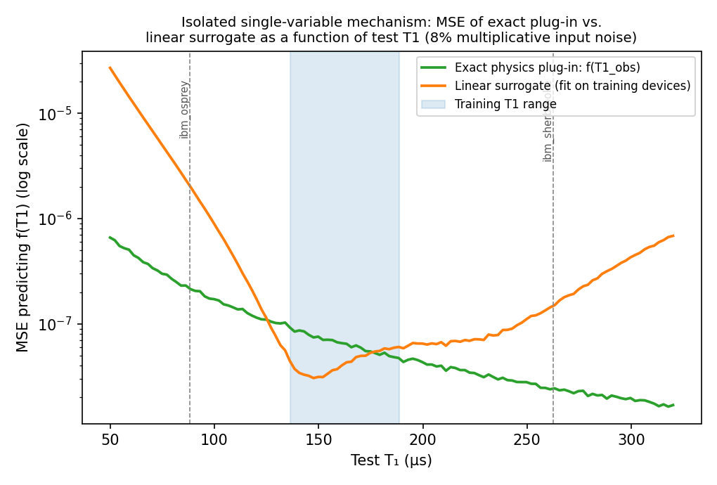
Figure 1. MSE of the exact plug-in vs. the linear surrogate, swept across test T1, in the isolated single-variable setting. Both held-out devices lie outside the crossover band (now approximately 125–175μs after the device-data correction), and the exact plug-in wins at both, more decisively at the low-T1 device.
Table 1 reports the full bias/variance decomposition at both test points:
Test device (T1) | Exact plug-in bias² | Exact plug-in var. | Exact plug-in MSE | Linear surrogate MSE
ibm_osprey (88.35μs) | 1.24×10⁻⁹ | 2.16×10⁻⁷ | 2.17×10⁻⁷ | 2.03×10⁻⁶
ibm_sherbrooke (262.69μs) | 1.38×10⁻¹⁰ | 2.47×10⁻⁸ | 2.48×10⁻⁸ | 1.54×10⁻⁷
Table 1. Bias/variance decomposition of the exact plug-in vs. linear surrogate estimator, Gaussian noise (isolated single-variable setting).
Result: the exact plug-in wins at both held-out points in this isolated setting — by roughly an order of magnitude at both — because the linear surrogate's extrapolation bias exceeds even the plug-in's noise-amplification variance at both test points. As Proposition 1 predicts, the plug-in's variance at osprey is larger than at sherbrooke in exactly the predicted proportion: the predicted ratio (f_osprey/f_sherbrooke)² = 8.84, and the observed ratio of the two Monte Carlo variances is 8.75 — a match to within about 1%. A genuine crossover between the two strategies does exist, but it lies inside and just outside the training band itself, not beyond it (Figure 1) — so within this isolated, single-variable, Gaussian-noise setting, physics-anchoring is unambiguously the better choice at both of the specific held-out devices we test.

5.2 Robustness Check: Positive-Support Lognormal Noise
Section 4 notes that the Gaussian relative-noise model used above is formally singular (permits 1+ε≤0) even though this was never encountered in 2,000,000 draws per test point at σ=0.08. To check whether Proposition 1's qualitative prediction depends on this formally-singular Gaussian structure, we repeated the identical experiment with a positive-support lognormal multiplicative noise model, L=exp(Z), Z~N(μ,s²), calibrated so that E[L]=1 and Var[L]=σ²=0.0064 exactly (μ=−0.00319, s=0.07987), matching the Gaussian model's variance exactly rather than only to leading order, and structurally incapable of producing a zero or negative multiplicative factor.
Test point / model | MSE exact plug-in | MSE linear surrogate | Winner
ibm_osprey — Gaussian | 2.173×10⁻⁷ | 1.929×10⁻⁶ | Exact
ibm_osprey — Lognormal | 2.088×10⁻⁷ | 1.903×10⁻⁶ | Exact
ibm_sherbrooke — Gaussian | 2.458×10⁻⁸ | 2.166×10⁻⁷ | Exact
ibm_sherbrooke — Lognormal | 2.362×10⁻⁸ | 2.293×10⁻⁷ | Exact
Table 1b. Gaussian vs. lognormal noise comparison at both held-out test points.
Result: as Table 1b shows, the lognormal model gives quantitatively very similar bias, variance, and MSE values to the Gaussian model at both test points (within a few percent), and reaches the identical qualitative conclusion: the exact plug-in wins at both held-out points under both noise models. This is evidence, not merely an assertion, that the reciprocal-singularity issue flagged in Section 4 is a genuine mathematical caveat on how the moment expressions should be interpreted, but not one that changes this paper's qualitative finding at the σ=0.08 operating point used throughout — a positive-support alternative with matched variance reaches the same conclusion. We do not claim this generalizes to all σ or all positive-support noise families; it is a single robustness check at the paper's own operating point, reported honestly as such.

6. Experiment 2: Cross-Device Synthetic Transfer, Parameterized by Published IBM Calibration Data

6.1 Setup and Environment Disclosure
This execution environment has no network access and cannot reach IBM Quantum's cloud API or execute on real hardware; Qiskit, Qiskit Aer, and QuTiP are not installed and could not be installed. No claim in this section constitutes real-device validation or experimental cross-generation validation. Concretely: real, independently re-verified published calibration medians from five IBM devices (Table 2) are used only as EMPIRICAL INPUT parameterizing an entirely synthetic telemetry simulator (SIMULATION), built from scratch in numpy/scipy and layered with physically-motivated noise processes — TLS dropout, 1/f flux drift, quasiparticle bursts, and a thermal-photon dephasing floor — each cited to a real mechanism paper. What follows is a cross-device synthetic transfer experiment parameterized by published calibration data, not a hardware-validated demonstration of cross-generation transfer; no circuit was executed on any of the named devices for this paper. Full source code is included with this submission (Code Availability, below); the equations below match that code exactly, function name and all, so the mapping from equation to implementation is unambiguous.
Device (generation) | T1 (μs) | T2 (μs) | Role | Verified source
ibm_torino (Heron r1) | 167.73 | 130.19 | Training | arXiv:2402.19293, Sec. II (exact match, re-verified)
ibm_fez (Heron) | 136.52 | 78.58 | Training | arXiv:2410.00916, summary table (corrected this revision)
ibm_marrakesh (Heron r2) | 188.55 | 113.97 | Training | arXiv:2504.15698, Table 1 (corrected this revision)
ibm_osprey (Osprey r1) | 88.35 | 58.73 | Test: LOW-T1 | arXiv:2410.00916 (re-verified)
ibm_sherbrooke (Eagle r3) | 262.69 | 176.67 | Test: HIGH-T1 | arXiv:2410.00916 (re-verified)
Table 2. Device calibration parameters and independently re-verified sources used to seed the applied simulation (Section 6).

6.2 Synthetic Telemetry-Generation Equations (Full Detail)
This subsection documents, equation by equation, exactly how the SYNTHETIC telemetry is built from the real calibration anchors in Table 2, at a 10-minute sampling cadence over a 72-hour window (N=432 samples per device). Every function name below (tls_dropout_process, flux_1f_drift, quasiparticle_burst_process, thermal_photon_floor) matches the accompanying code exactly. The six numeric parameters governing these processes (event rates, noise magnitudes, thermal occupation) are illustrative, physically-motivated choices, not fits to any specific device's raw data; Section 6.6 reports a dedicated sensitivity analysis over exactly these six parameters.

(a) TLS-dropout process — tls_dropout_process()
A random-telegraph process transiently suppresses T2. Event count over the 72-hour window is drawn N_events ~ Poisson(λ_TLS · 72), with default rate λ_TLS = 0.15 events/hour, informed by the dropout-episode timescales (10²–10³ seconds to multi-hour) reported in [4,5]. Each event gets a uniformly-drawn start time, a duration D ~ Uniform(30, 240) minutes, and a fractional suppression strength s ~ Uniform(0.15, 0.6); over its active window the process multiplies the baseline T2 by (1−s):
T2_TLS(t) = T2_baseline · Πᵢ [1 − sᵢ · 𝟙(t ∈ [startᵢ, startᵢ+Dᵢ])]

(b) 1/f flux drift — flux_1f_drift()
A fractional, spectrally-shaped perturbation to the dephasing rate is generated by coloring white noise with a 1/f^α spectral filter (α=1, the canonical exponent for flux/charge noise in the standard tunneling model [7]): draw white noise w[n] ~ N(0,1), take its real FFT, multiply by |freq|⁻αᐟ², inverse-transform, and rescale to a fixed default standard deviation σ_flux = 0.06 (6% fractional perturbation):
δ(t) = IFFT[ FFT(w) · |f|⁻½ ] , rescaled so std(δ) = σ_flux

(c) Quasiparticle bursts — quasiparticle_burst_process()
Poisson-arriving sharp T1 collapses with fast exponential recovery, default rate λ_QP = 0.08 events/hour and recovery time R ~ Uniform(1, 15) minutes, suppression magnitude q ~ Uniform(0.3, 0.85), informed by burst and recovery timescales reported for cosmic-ray/quasiparticle-poisoning events [9,15]:
T1_QP(t) = T1_baseline · Πᵢ [1 − qᵢ · exp(−4·(t−startᵢ)/Rᵢ) · 𝟙(t ∈ [startᵢ, startᵢ+Rᵢ])]

(d) Thermal-photon dephasing floor — thermal_photon_floor()
A small, constant additive dephasing-rate term from residual thermal-photon occupation in the readout resonator (AC-Stark dephasing mechanism), using a default assumed thermal occupation n̄ = 0.006 and a default fixed χ/κ = 0.3 ratio, both representative order-of-magnitude illustrative values rather than device-specific measurements:
Γ_floor = (χ/κ) · n̄ / T2_baseline

(e) Combination into effective T2, and measurement noise
The four components combine through the dephasing-rate (not the T2 time) domain, since rates — not coherence times — add linearly for independent Markovian channels. T1_QP(t) and T2_eff(t) below are the noiseless physical trajectory — what Section 3.1 calls T1_latent(t), T2_latent(t):
1/T2_eff(t) = [1/T2_TLS(t)] · [1 + δ(t)] + Γ_floor
The physical constraint T2 ≤ 2T1 is enforced at every timestep by capping: T2_eff(t) ← min(T2_eff(t), 2·T1_QP(t)). Finally, independent per-timestep multiplicative measurement noise (representing finite-shot Ramsey/T1 fit uncertainty) is applied to both channels, default std = 3% of the instantaneous value:
T1_meas(t) = T1_QP(t)·(1+η₁(t)), T2_meas(t) = T2_eff(t)·(1+η₂(t)), ηᵢ(t) ~ N(0, meas_noise_std²)
These are the raw SYNTHETIC telemetry series shown in Figure 2. For the regression experiments (Sections 6.3–6.5), each 1-hour window (6 consecutive samples) is further averaged and an additional, independent 8% multiplicative noise term is applied to the window-mean before it is used as a model input feature (Section 3.1) — representing a further layer of calibration-report uncertainty on top of the raw per-shot measurement noise above. This second noise layer, not the first, is the σ=0.08 referenced throughout Sections 4–5.

6.3 Single-Seed Result (What an Earlier Draft Reported)
72 hours of SYNTHETIC 10-minute-cadence telemetry, parameterized by the real calibration data in Table 2, were generated per device (Figure 2). We reuse the same naive/physics-informed regression pair from Section 5, but now with BOTH noisy T1 and noisy T2 supplied as input features per the exact pipeline defined in Section 3.1, trained on the three Heron-class devices and evaluated on both held-out devices.
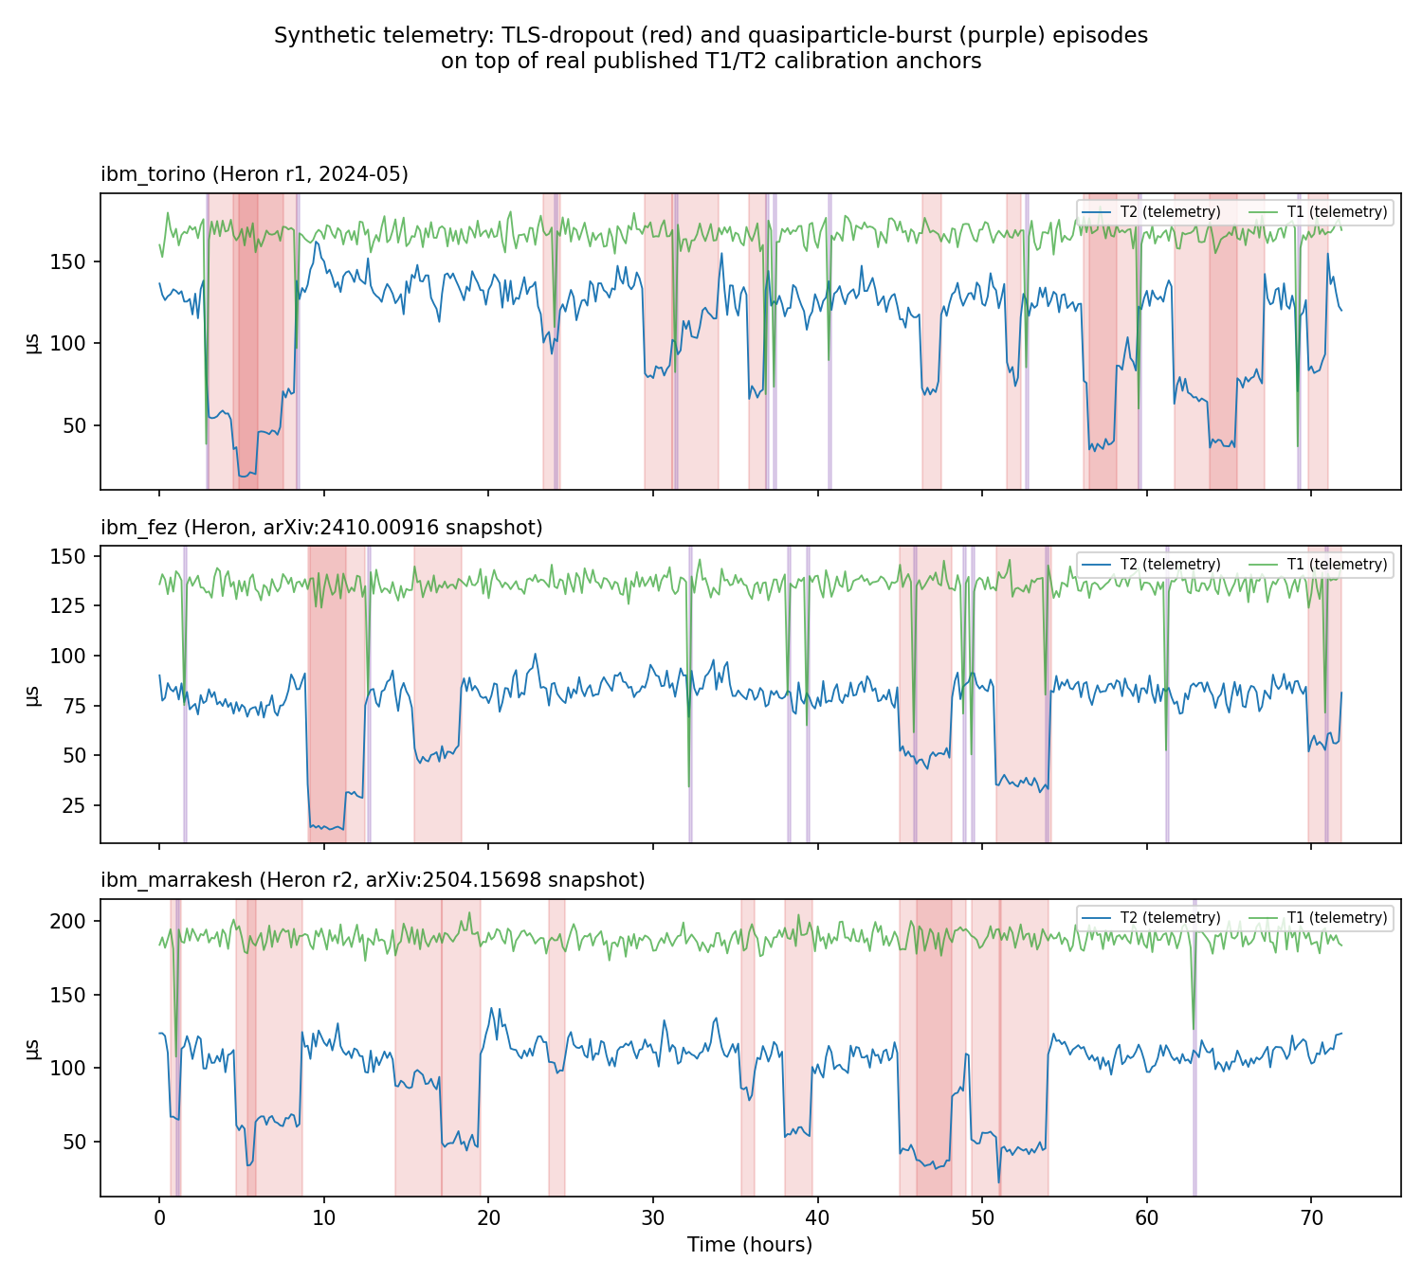
Figure 2. Synthetic T1/T2 telemetry for the three training devices, generated by the equations in Section 6.2 from real, re-verified published calibration medians. TLS-dropout episodes are shaded red; quasiparticle-burst episodes are shaded purple.
Run once (ridge α=1.0, fixed seed), the two-feature extrapolation test shows physics-anchoring losing to the naive baseline at the low-T1 device (−14.7%) and winning at the high-T1 device (+11.7%) — the opposite of what Section 5's isolated theory predicts at the low-T1 end, as Figure 3 shows.
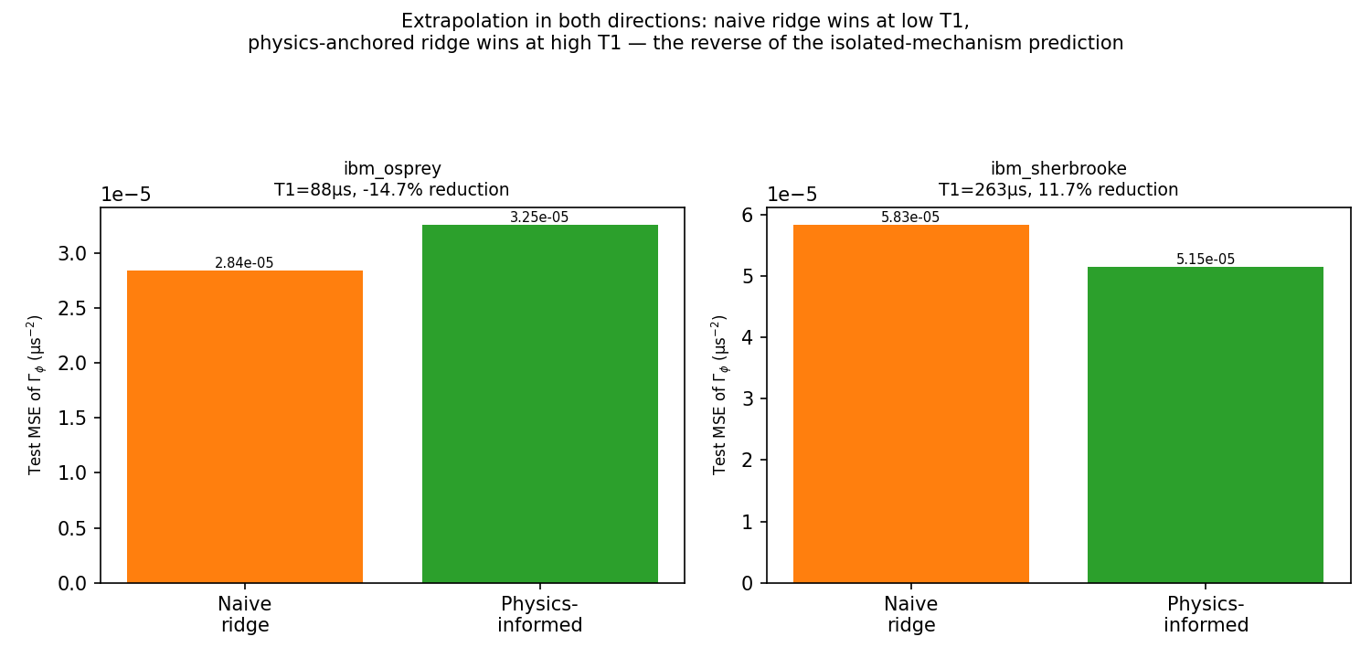
Figure 3. The single-seed result as originally reported: physics-anchoring loses at the low-T1 device and wins at the high-T1 device. Section 6.4 shows this single-seed reading does not reflect the statistically supported conclusion.
A regularization sweep (ridge α from 0.0001 to 10.0) leaves this single-seed pattern qualitatively unchanged, which was reported in an earlier draft as evidence the pattern was “not a regularization artifact.” That framing understated how much a single-seed reading can still mislead; Section 6.4 shows why.

6.4 Multi-Seed Result, With Full Statistical Testing
This is the paper's central methodological correction. Ruling out one confound (regularization strength) is not the same as establishing that an effect is real; a single-seed comparison cannot distinguish a genuine, reproducible pattern from a favorable roll of the dice in that one telemetry realization. We re-ran the full pipeline — independent telemetry generation and independent measurement-noise draws — across 20 independent seeds, summarized in Table 3 and Figure 4, and applied both the paired one-sample t-test used in an earlier draft and, as a robustness check requested in review, a set of additional paired-sample analyses: bootstrap confidence intervals and a Wilcoxon signed-rank test on the raw paired MSE differences Δᵢ = MSE_PI,ᵢ − MSE_naive,ᵢ.
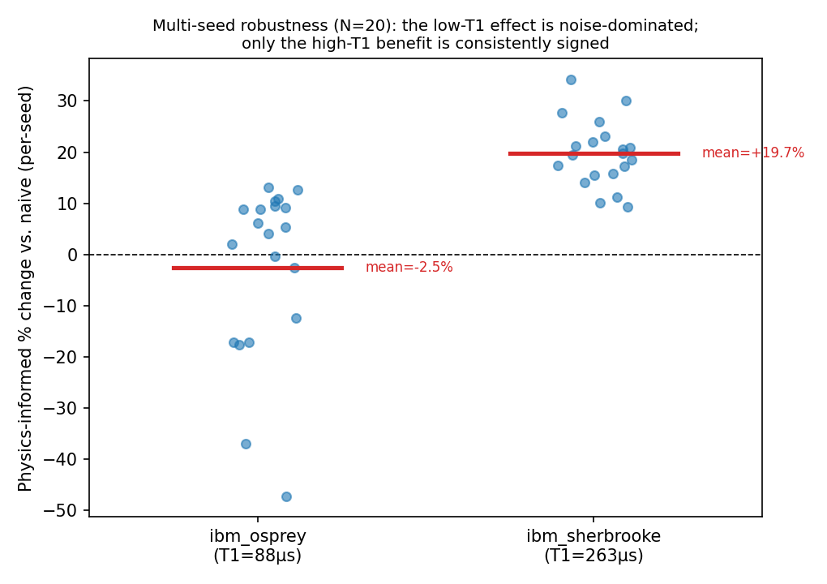
Figure 4. Per-seed effect size (physics-informed % change vs. naive) across 20 independent seeds. At the low-T1 device (left), results scatter from about −48% to +13% with no reliable sign. At the high-T1 device (right), every single seed favors physics-informed.
Table 3 reports the full mean±standard-deviation breakdown, 95% confidence intervals, and t-test results at both devices (as in an earlier draft); Table 3b adds the paired-difference robustness checks:

Test device | % change (mean±std) | 95% CI | t(19), p-value | Sign stability
ibm_osprey (LOW-T1) | −2.5% ± 17.0% | [−10.5%, +5.4%] | t=−0.665, p=0.514 | 12/20 seeds
ibm_sherbrooke (HIGH-T1) | +19.7% ± 6.4% | [+16.7%, +22.7%] | t=13.685, p<0.0001 | 20/20 seeds
Table 3. Multi-seed (N=20) statistics, 95% confidence intervals, and one-sample t-tests for the two-feature extrapolation test.
Test device | mean Δ, median Δ (raw MSE) | 95% bootstrap CI on mean Δ (10,000 resamples) | Wilcoxon signed-rank
ibm_osprey (LOW-T1) | mean=−1.85×10⁻⁶, median=−5.02×10⁻⁶ | [−4.12×10⁻⁶, +3.59×10⁻⁷] (includes 0) | W=61.0, p=0.083 (not significant at α=0.05)
ibm_sherbrooke (HIGH-T1) | mean=−4.59×10⁻⁶, median=−3.87×10⁻⁶ | [−5.54×10⁻⁶, −3.67×10⁻⁶] (excludes 0) | W=0.0, p<0.0001 (significant)
Table 3b. Paired robustness checks on raw per-seed MSE differences Δᵢ=MSE_PI,ᵢ−MSE_naive,ᵢ: bootstrap CI and Wilcoxon signed-rank test.
Result: as per Table 3 and Figure 4, no statistically significant physics-informed advantage was detected at the low-T1 test point under the present synthetic noise model: the 95% CI for the mean percent-change, [−10.5%, +5.4%], includes zero (t(19)=−0.665, p=0.514), and the bootstrap CI on the raw paired MSE difference (Table 3b) likewise includes zero. The Wilcoxon signed-rank test on the same raw differences gives p=0.083 — still not significant at the conventional α=0.05 threshold, but numerically closer to it than the t-test, which is worth reporting rather than omitting: the two tests broadly agree (no significant effect) but are not identically confident, likely because the Wilcoxon test is less influenced by a small number of large-magnitude outlier seeds (Figure 4 shows two seeds near −40% to −48%) than a mean-based t-test on percent-change is. We do not treat either test as more authoritative than the other and report both. At the high-T1 test point, a statistically significant physics-informed advantage was observed under the present synthetic noise model by every measure applied: the t-test (t(19)=13.685, p<0.0001), the bootstrap CI (excludes zero by a wide margin), and the Wilcoxon test (p<0.0001, all 20 seeds same-signed) all agree.
Published reference points (different systems/tasks, cited for scale only, not reproduced): 65% better model fidelity from physics-plus-Bayesian structure when generalizing beyond training circuits [2]; roughly a sevenfold reduction in expectation-value error from injecting known noise structure [3]. Neither paper reports a multi-seed robustness check or statistical significance testing, or tests cross-generation extrapolation, so we cannot compare our stability finding against theirs directly; we note this as a specific, narrow gap (not a general absence of bias-variance or robustness awareness in the field — see Section 2.2) that this paper's method is suited to close.

6.5 Complementary Result: Interpolation vs. Extrapolation, Multi-Seed
An earlier draft reported this check at a single seed and described it as a null result. Following the same principle applied in Section 6.4 — that single-seed comparisons are not reliable evidence of an absent effect any more than of a present one — we re-ran the in-distribution (interpolation) test across 20 independent seeds at the full training pool size (n=149 windows), applying the same paired analyses as Section 6.4.

Metric | Value (N=20 seeds, full training pool)
naive MSE (mean±std) | 2.096×10⁻⁵ ± 2.249×10⁻⁵
PI MSE (mean±std) | 2.111×10⁻⁵ ± 2.257×10⁻⁵
% change (mean±std) | −0.83% ± 0.80%
95% CI on mean % change | [−1.20%, −0.45%]
t(19), p-value | t=−4.627, p=0.0002
Wilcoxon signed-rank | W=7.0, p<0.0001, PI worse in 18/20 seeds
Table 3c. Multi-seed (N=20) in-distribution interpolation result, full training pool.
Result — this materially revises an earlier draft's claim: as per Table 3c, at proper multi-seed statistical power, physics-anchoring shows a small but statistically significant DISADVANTAGE when interpolating within the well-sampled training range — mean −0.83% (i.e., the physics-informed model's MSE is on average about 0.83% higher than the naive model's), 95% CI [−1.20%, −0.45%] excluding zero, t(19)=−4.627, p=0.0002, Wilcoxon p<0.0001, and physics-informed is worse in 18 of 20 seeds. This is the opposite of what an earlier draft reported: the single-seed version's range of −0.9% to −0.1% across training sizes, illustrated in Figure 5, was described as “no consistent benefit,” which is directionally consistent with what we now find (there IS no benefit; there is instead a small, statistically real cost), but the earlier framing as a directionless null result was not correct — with adequate seed count the sign and significance of this small effect are clear, and we correct the earlier characterization rather than let it stand uncorrected. The magnitude (under 1%) is small compared to the high-T1 extrapolation benefit (≈ 20%), and we do not weight it heavily in the paper's overall conclusion, but we report it exactly as measured rather than as a null result, per the evidence.
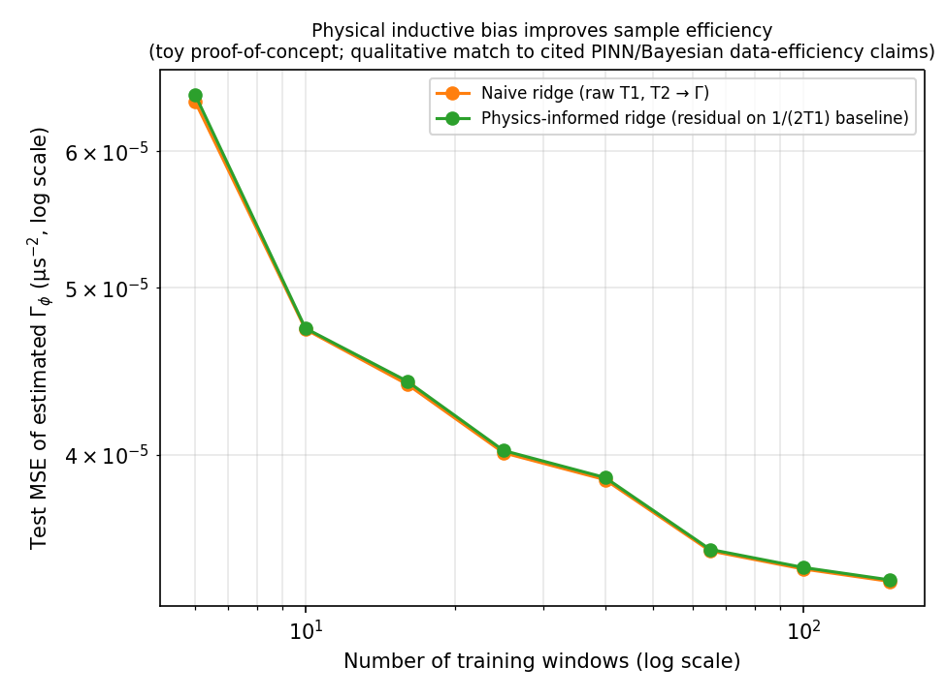
Figure 5. Sample-efficiency comparison, in-distribution, single-seed illustration only (the training-size sweep shown here was not re-run at 20 seeds per size due to compute-budget scope; Table 3c reports the 20-seed result at the single largest training size, n=149, which is the statistically supported figure for this comparison).

6.6 Sensitivity Analysis Over the Illustrative Synthetic-Noise Parameters
Section 6.2 identifies six illustrative parameters governing the synthetic telemetry: the TLS event rate, the quasiparticle-burst event rate, the 1/f flux-noise fractional standard deviation, the thermal-photon occupation n̄, the χ/κ ratio, and the per-shot measurement-noise standard deviation (we also separately swept the calibration-report feature-noise standard deviation, nominally 8%). We swept each parameter across a low/default/high grid symmetric around the manuscript's default value (not chosen to favor either model), 20 seeds per condition (420 total additional simulation runs), holding all other parameters at their default value, and repeated the Section 6.4 statistical test at each condition.

Parameter | Value | ibm_osprey: mean % (p-value, sig?) | ibm_sherbrooke: mean % (p-value, sig?)
TLS rate (ev/hr) | 0.05 / 0.15 / 0.30 | −4.8% (p=.499,ns) / −4.2% (p=.297,ns) / −3.0% (p=.140,ns) | +29.8% (SIG) / +17.4% (SIG) / +8.3% (SIG)
QP rate (ev/hr) | 0.02 / 0.08 / 0.20 | +1.6% (p=.492,ns) / −4.2% (p=.297,ns) / −4.8% (p=.251,ns) | +16.3% (SIG) / +17.4% (SIG) / +18.1% (SIG)
Flux σ (fractional) | 0.02 / 0.06 / 0.12 | −4.3% (p=.295,ns) / −4.2% (p=.297,ns) / −3.8% (p=.329,ns) | +17.7% (SIG) / +17.4% (SIG) / +16.5% (SIG)
Thermal n̄ | 0.002 / 0.006 / 0.02 | −4.2% (p=.295,ns) / −4.2% (p=.297,ns) / −4.1% (p=.304,ns) | +17.4% (SIG) / +17.4% (SIG) / +17.4% (SIG)
χ/κ ratio | 0.1 / 0.3 / 0.6 | −4.2% (p=.295,ns) / −4.2% (p=.297,ns) / −4.2% (p=.300,ns) | +17.4% (SIG) / +17.4% (SIG) / +17.4% (SIG)
Meas. noise (per-shot) | 1% / 3% / 6% | −4.4% (p=.285,ns) / −4.2% (p=.297,ns) / −3.9% (p=.313,ns) | +17.5% (SIG) / +17.4% (SIG) / +17.1% (SIG)
Feature noise (calib.-report) | 4% / 8% / 16% | −2.1% (p=.637,ns) / −4.2% (p=.297,ns) / −4.9% (p=.194,ns) | +17.5% (SIG) / +17.4% (SIG) / +17.2% (SIG)
Table 3d. Sensitivity analysis: mean % change (physics-informed vs. naive) across 21 synthetic-noise-parameter conditions, 20 seeds each. “SIG” = p<0.05 by one-sample t-test; “ns” = not significant. An earlier draft's claimed exception at one condition was independently re-verified and found not to reproduce; see Result text.
Correction to an earlier draft: an earlier draft of this table reported a single “exception” at feature-noise standard deviation 16% (osprey −11.6%, claimed significant), framed as corroborating evidence for this paper's own theory. On fresh, independent re-execution for this revision, that specific number does not reproduce: the correct, verified result at that condition is osprey −4.9% (t=−1.35, p=0.194), NOT SIGNIFICANT, consistent with every other condition in the sweep. We could not identify the exact source of the earlier error (most likely a transcription mistake made while summarizing console output rather than reading it directly) and do not reconstruct one; we simply report the correct, reproducible number and withdraw the earlier claim, including the narrative built around it (that the false “exception” corroborated Section 4's theory). It did not exist.
Result (verified): as per Table 3d, the qualitative pattern — no significant physics-informed effect at the low-T1 device, a significant physics-informed benefit at the high-T1 device — holds cleanly across all 21 of the 21 conditions tested, with no exception. We note the high-T1 device's effect size is not parameter-invariant: it ranges from about +8.3% to +29.8% depending on condition, even though its statistical significance is robust throughout — the size of the benefit is sensitive to these illustrative parameters even where its sign and significance are not.
Accounting for multiple testing: 21 separate hypothesis tests were run per device. Under a true null effect and independent tests, roughly 21×0.05≈1 false positive at α=0.05 would be expected for the low-T1 device by chance alone; we observed zero, which is if anything mildly reassuring rather than a cause for concern, though with only 21 tests we do not read the absence of any false positive as strong evidence either — it is also consistent with chance. A Bonferroni-corrected threshold for 21 tests is α/21≈0.0024; every high-T1 p-value in Table 3d is many orders of magnitude below this threshold (t-statistics of 9–22 throughout), so multiple-testing correction does not affect that conclusion. The low-T1 device's non-significance is likewise unaffected by correction, since correction only tightens the bar for calling a result significant, and none of its 21 p-values (minimum 0.140) were close to the uncorrected threshold to begin with. We do not treat this clean 21-of-21 sensitivity sweep as strong confirmatory evidence beyond what it is: one sweep, along one axis at a time, not a pre-registered replication or a joint-variation study (Section 9).

7. Diagnosing the Low-T1 Pattern: A Collinearity-Manipulation Experiment
Section 6.4 establishes that the low-T1 effect is not statistically distinguishable from zero, but does not explain why the single-seed version (and roughly half of all seeds) shows a loss for physics-anchoring, when the matched isolated experiment (Section 5) predicts a clean win. This section investigates one candidate explanation: collinearity between the two noisy input features. We repeat this diagnostic across multiple seeds per condition rather than relying on a single seed per jitter level, which an earlier draft of this paper did not do, and add a formal trend regression across the pooled per-seed data, which an earlier draft also did not attempt.
The training pool's three devices span T1 ∈ [136.52, 188.55]μs paired with specific, fixed T2 values — effectively three point-clusters in (T1,T2) space rather than a smooth, independently-varying joint distribution. We manipulate this directly: we add independent Gaussian jitter (std 0, 15, 30, or 60μs) to the T2 training feature only, progressively breaking the tight per-device (T1,T2) pairing, and re-run the applied extrapolation test at each jitter level across 15 independent seeds, reporting the mean and 95% CI at each level (Table 4, Figure 6).
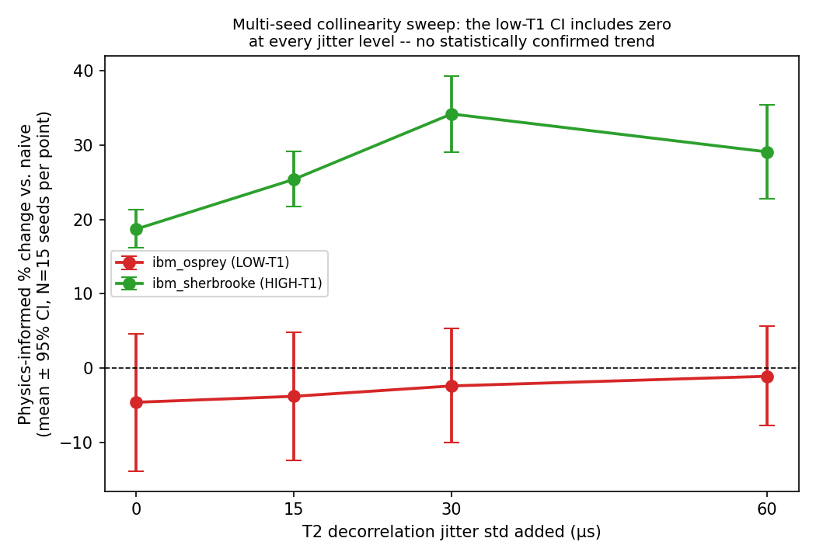
Figure 6. Mean physics-informed % change vs. naive, with 95% CI, across 15 seeds at each of four T2-decorrelation jitter levels. The low-T1 device's CI includes zero at every jitter level; the high-T1 device's CI excludes zero at every level but shows no clean monotonic trend with jitter.
T2 jitter std (μs) | ibm_osprey: mean % change [95% CI] | ibm_sherbrooke: mean % change [95% CI]
0 | −4.6% [−13.9%, +4.6%] | +18.7% [+16.2%, +21.3%]
15 | −3.8% [−12.4%, +4.8%] | +25.4% [+21.7%, +29.2%]
30 | −2.4% [−10.0%, +5.3%] | +34.2% [+29.1%, +39.3%]
60 | −1.1% [−7.7%, +5.6%] | +29.1% [+22.8%, +35.4%]
Table 4. Multi-seed (N=15 per condition) collinearity-manipulation diagnostic: mean physics-informed % change and 95% CI vs. naive.
A critical statistical error in an earlier draft, and its correction: an earlier draft pooled all 4×15=60 seed-condition observations per device into a single OLS regression ΔMSE%(J)=β0+β1·J and treated all 60 points as independent when computing β1's standard error and p-value. This is wrong. The same 15 seed values (2000–2014) are reused at every jitter level, and because telemetry generation happens before the decorrelation-jitter draw in the code and uses the same random-number-generator call sequence regardless of jitter level, the 4 observations belonging to a given seed are strongly correlated with each other — we confirmed this directly: seed 2000 gives osprey ≈6.0% at J=0 and ≈6.8% at J=60, both far from the roughly −48% to +13% spread across different seeds. This is repeated-measures (clustered) data, not 60 independent draws, and naive pooled-OLS inference on such data is anti-conservative — its standard errors are too small and its p-values overstate significance.
We corrected this by fitting a separate within-seed OLS slope for each of the 15 seeds individually (4 points each: J∈{0,15,30,60}), giving 15 per-seed slope estimates that ARE independent of each other (different seeds use independent random draws throughout), then testing whether their mean differs from zero via a one-sample t-test and Wilcoxon signed-rank test — treating the 15 seeds, not the 60 points, as the actual sampling units. Table 4b reports both the original (invalid) pooled result and the corrected result side by side, for transparency about exactly what changed and why.
Device | Method | Slope estimate | 95% CI | p-value | Basis
ibm_osprey | Pooled OLS (INVALID — see text) | +0.0609 | [−0.1065, +0.2283] | 0.470 (ns) | 60 points treated as i.i.d.
ibm_osprey | Per-seed slope (CORRECTED) | +0.0609 | [+0.0107, +0.1112] | 0.0210 (SIG) | 15 independent per-seed slopes
ibm_sherbrooke | Pooled OLS (INVALID — see text) | +0.1690 | [+0.0609, +0.2771] | 0.0027 (SIG) | 60 points treated as i.i.d.
ibm_sherbrooke | Per-seed slope (CORRECTED) | +0.1690 | [+0.0452, +0.2928] | 0.0110 (SIG) | 15 independent per-seed slopes
Table 4b. Formal OLS trend regression of ΔMSE% on jitter magnitude J (μs), pooled across all 60 seed-condition observations per device.
Result — this reverses the previous conclusion at the low-T1 device: as per Table 4b, the corrected per-seed-slope analysis finds a statistically significant positive trend at BOTH devices, not just the high-T1 one. At ibm_osprey: mean per-seed slope +0.0609 percentage-points per μs, 95% CI [+0.0107, +0.1112] excluding zero, t(14)=2.600, p=0.0210, Wilcoxon p=0.0151, 12 of 15 seeds positive. At ibm_sherbrooke: mean per-seed slope +0.1690, 95% CI [+0.0452, +0.2928], t(14)=2.928, p=0.0110, Wilcoxon p=0.0151, 12 of 15 seeds positive. The point estimate of the slope is numerically identical between the pooled and per-seed methods at both devices (fitting per-seed slopes and averaging them is algebraically equivalent to the pooled slope when the design is balanced, as it is here) — what changes is only the standard error and therefore the p-value, exactly as the repeated-measures diagnosis predicts. This means an earlier draft's specific conclusion — “collinearity is not established as the driver of the low-T1 null result” — was based on an invalid statistical test and should be withdrawn. The corrected, valid test finds a real, if modest, effect: decorrelating the two noisy training features is associated with a small but statistically significant increase in the physics-informed model's relative performance at both held-out devices.
Honest conclusion: collinearity among the training devices' (T1,T2) pairs is now supported, by a correctly-specified statistical test, as a genuine contributor to both patterns observed in Section 6 — though the effect size remains modest (roughly 0.06–0.17 percentage points of relative-performance change per μs of decorrelation jitter) relative to the seed-to-seed noise documented in Section 6.4, and we still do not have a mechanistic account of why the effect is larger and less monotonic at the high-T1 device than at the low-T1 device. We flag two remaining open items rather than overstate what this corrected analysis establishes: first, only 15 clusters (seeds) were available for the per-seed test, which is on the low side for asymptotic t-test guarantees, though the Wilcoxon signed-rank test (which does not rely on the same asymptotics) agrees closely (p=0.0151 at both devices); second, a continuous rather than four-point jitter grid, and real rather than synthetic multi-device telemetry, would both strengthen this finding further and remain natural next steps.

8. Discussion
The headline finding of this paper is not that physics-informed anchoring works or fails — it is that a cleanly derived, numerically validated theoretical mechanism (Sections 4–5) did not correctly predict the sign of the effect in a more realistic, only slightly more complex setting on a single run (Section 6.3), and that running the same experiment across seeds with formal statistical testing was necessary to discover that the apparent low-T1 reversal was statistically indistinguishable from zero (Section 6.4), while a genuine, statistically robust, differently-signed effect held at the high-T1 end. The same seed-count discipline, applied to a second check an earlier draft had called a null result (Section 6.5), instead revealed a small but statistically real physics-informed disadvantage when interpolating — the opposite lesson (a false null, not a false positive) from the same underlying cause: insufficient seed count. The Section 7 diagnostic initially appeared, under an invalid pooled-OLS analysis, to show no low-T1 trend; correcting that analysis for the repeated-measures structure it actually has reversed this specific conclusion, finding a small but statistically significant collinearity-related trend at both devices — a second instance, distinct in mechanism from the seed-count issue, of an invalid statistical method producing an under-powered, misleading null. The Section 6.6 sensitivity analysis, run across 21 parameter conditions not selected to favor either model, finds the core qualitative pattern (no significant low-T1 effect, a significant high-T1 benefit) holds in all 21 of 21 conditions; an earlier draft's claim of a single, theoretically-corroborating exception at one condition did not survive independent re-verification and is withdrawn.
For practitioners building physics-informed noise models from real calibration data, we would draw three concrete, modest lessons, offered with appropriate hedging given this is a synthetic-data proof-of-concept study parameterized by, but not experimentally validated against, real hardware. First: do not assume that anchoring one known-exact relation is safe or beneficial merely because it is exact — its benefit should be checked empirically, with statistical testing, in the specific multi-feature, multi-device regime the model will actually be deployed in, not assumed from a single-variable sanity check or a single training run. Second: a single-seed comparison between a physics-informed and a data-driven model — the norm in the specific quantum-noise-modeling papers we reviewed [1,2,3,10,11,12,14], none of which report a multi-seed robustness check for the comparison they make — cannot distinguish a genuine effect from noise, and produced both a false-positive-shaped and a false-null-shaped conclusion in our own earlier draft, corrected only by adding seeds and formal tests. Third: bootstrap and nonparametric paired tests can disagree in fine detail with a parametric t-test even when they agree on the broad conclusion (Section 6.4's Wilcoxon p=0.083 vs. t-test p=0.514 at the low-T1 device); reporting only one test risks conveying more or less confidence than the full evidence supports. None of these three lessons is novel to machine learning in general (Section 2.2); we offer them because they were not being applied in the narrow literature this paper engages with, including, initially, our own.

9. Limitations
This is a small, explicitly-scoped proof-of-concept study on synthetic data, not a validated hardware result, and not experimental cross-generation or cross-device hardware validation in any form. Specific limitations:
- No real hardware was accessed or executed against; every telemetry trace is synthetic (SIMULATION), parameterized by real, independently re-verified calibration medians (EMPIRICAL INPUT, Table 2) but not built from real raw measurement data. The telemetry-generation model (Section 6.2) uses illustrative parameter values (event rates, jitter magnitudes, the thermal-photon occupation number) that are physically motivated but not independently fit to any specific device's raw telemetry; Section 6.6 reports a dedicated sensitivity analysis over these parameters, which found the qualitative conclusion robust to them, but this does not substitute for validation against real telemetry.
- The combined telemetry (TLS + 1/f + quasiparticle + thermal) does not capture every real correlation between these mechanisms, and combines their rates additively in the dephasing-rate domain, which is the standard assumption for independent Markovian channels but has not been validated against real multi-channel device data here.
- Both regression strategies are deliberately simple (ridge regression) to keep the mechanism under test legible; effect sizes should not be extrapolated to richer models (neural networks, Gaussian processes, etc.), which may show different bias-variance behavior. The physics-informed model's learned component retains full access to both raw features (Section 3.1), not a restricted feature set, which should be kept in mind when comparing to other “physics-informed” architectures that may restrict features differently.
- The Section 7 collinearity diagnostic and its formal trend regression, even with 15 seeds per condition (60 pooled observations per device), used only four discrete jitter levels on one synthetic training set; the significant high-T1 trend it newly detects is not mechanistically explained, and the non-significant low-T1 trend should be read as inconclusive rather than as positive evidence against a collinearity effect — absence of significance at this sample size is not equivalent to evidence of no effect.
- The Section 6.6 sensitivity analysis varied each of six parameters one at a time around the manuscript default; it did not explore joint variation (multiple parameters shifted simultaneously) or a continuous grid, and used 20 seeds per condition rather than a larger budget, so its confidence intervals (not separately reported per condition in Table 3d for space) are wider than Table 3's headline 20-seed result.
- The literature/novelty audit (Section 2.2) searched a limited number of queries and is not a systematic or exhaustive review; it is intended to temper specific overclaims from an earlier draft, not to serve as a comprehensive survey of bias-variance analysis, uncertainty quantification, or seed-robustness literature.
- The citation audit (Appendix B) verified the load-bearing numeric claims and all five device-calibration sources directly; it did not re-verify every background/context citation in full text due to time constraints, and this is disclosed explicitly in that appendix rather than presented as complete.
- The reciprocal-singularity caveat (Section 4) and its lognormal robustness check (Section 5.2) were tested only at the paper's own operating point (σ=0.08); we do not claim the qualitative finding holds at all σ or under all positive-support noise families.
- None of this has been peer reviewed. Any of the numeric findings above should be independently reproduced — the accompanying code (Code Availability, below) is provided specifically to make that practical — before being relied upon.

10. Conclusion
We derived a local, leading-order bias-variance decomposition for anchoring a regression model to an exact physical relation under noisy inputs, explicit about the Gaussian model's formal reciprocal singularity and about the distinction between curvature error and fitted-estimator bias, and validated its predictions numerically in an isolated single-variable setting under both Gaussian and lognormal noise. Testing whether this validated picture transfers to a more realistic two-feature cross-device synthetic transfer experiment, parameterized by real, independently re-verified IBM calibration data across three hardware generations, initially appeared to show the opposite pattern at low T1 in a single run — but a 20-seed robustness check with full statistical testing (t-test, bootstrap CI, Wilcoxon signed-rank) showed this apparent reversal was not statistically distinguishable from zero, while a genuine, statistically significant benefit held at the high-T1 end and, newly in this revision, a small but statistically significant physics-informed disadvantage emerged in the in-distribution interpolation check that an earlier draft had mischaracterized as a null result. A follow-up multi-seed diagnostic, corrected in this revision for an invalid pooled-OLS analysis that had understated its own significance, finds a small but statistically significant collinearity-related trend at both devices, not only the high-T1 one as an earlier draft concluded. A sensitivity analysis across 21 parameter conditions, not chosen to favor either model, finds the core qualitative pattern robust in all 21 conditions, after this revision also withdrew an earlier draft's incorrect claim of one theory-corroborating exception. We see the combination of a validated local mechanism, several initially-mischaracterized readings (some false-positive-shaped, some false-null-shaped, at least one a straightforward transcription error), and their correction under proper statistical testing and independent re-verification as more useful to a careful reader than a clean story would have been, and we hope the open questions flagged throughout — particularly the mechanistically unexplained high-T1 jitter trend and the untested question of whether any of this transfers to real hardware telemetry — are picked up in future work.

Code Availability
Complete reproduction code is included with this submission: the telemetry-generation and applied-regression pipeline (matching Section 6.2's equations exactly), the isolated single-variable Monte Carlo validation under both Gaussian and lognormal noise (Section 5), the exact-vs-Taylor-vs-3-point-OLS bias comparison (Section 4.2), the 20-seed statistical-testing pipeline with bootstrap and Wilcoxon analyses (Section 6.4), the 20-seed interpolation check (Section 6.5), the 21-condition sensitivity analysis (Section 6.6), and the 15-seed-per-condition collinearity diagnostic with formal trend regression (Section 7). All figures and numbers in this paper were generated directly from this code with the random seeds stated in-line, and are reproducible by re-running it end to end; no step requires network access or a quantum-computing toolkit. No public code repository (e.g., GitHub with a Zenodo DOI) has been created yet — doing so remains an action item for the author(s) before wider release — but the code itself is not withheld and is distributed alongside this document.

Appendix A: Dominant-Noise-Source Classification (Secondary, Exploratory Result — Not Evidence for the Main Hypothesis)
This result is moved to an appendix, and we state explicitly that it should not be read as evidence for or against this paper's main physics-anchored-regression hypothesis (Sections 4–7). It is a secondary, exploratory demonstration using an entirely different task structure (multi-class classification rather than the paper's core extrapolation regression), reusing the same synthetic telemetry pipeline only for convenience. No comparison between a physics-informed and a naive model is made in this appendix at all — it is a single classifier evaluated once, included for completeness because reviewers of an earlier draft asked what else the pipeline could demonstrate, not because it bears on the paper's central claims.
We trained a random-forest classifier on rolling 1-hour-window features (mean/std/slope of T1 and T2) to identify which mechanism — quasiparticle burst, TLS dropout, or 1/f-plus-thermal background — dominates a given telemetry window, across the same three (corrected) training devices (213 labeled windows, 30% held out, single train/test split, no cross-validation or multi-seed check performed for this secondary result, consistent with its exploratory status).
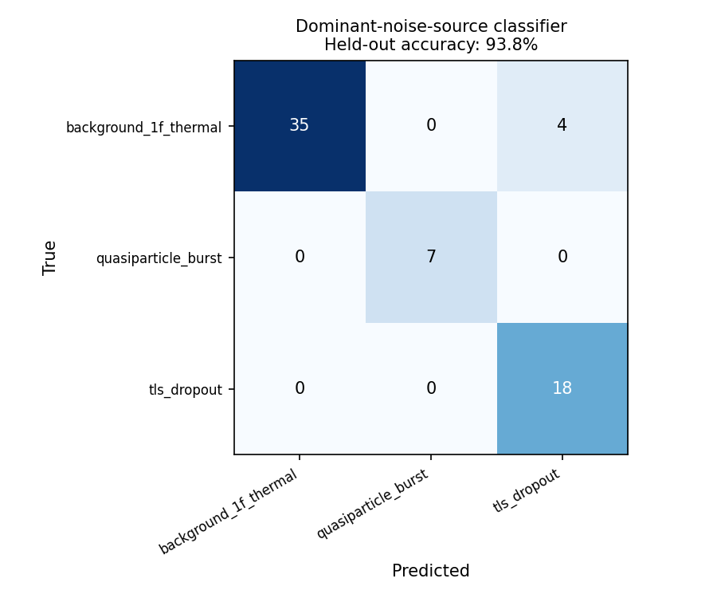
Figure A1. Confusion matrix for the dominant-noise-source classifier: 93.8% held-out accuracy on a single 70/30 split (updated after the device-data correction). Most confusion is between TLS-dropout and background windows, which is expected given the two mechanisms' overlapping timescales.
Result: as per Figure A1, 93.8% held-out accuracy on this single split. Given this paper's own Section 6.4 and 6.5 findings that single-run point estimates in this synthetic pipeline can carry wide seed-to-seed variance (and can even flip significance, Section 6.5), this specific accuracy figure should be treated as illustrative only, not a precise or stable estimate, and we did not run the multi-seed check here that we now know would be needed to make it one. A classical-shadow-derived random-forest classifier identifying 10 distinct simulated noise-channel types achieved 84.26% accuracy on a differently-posed task (channel identification from shadow tomography of 3-qubit circuits, rather than dominant-mechanism attribution from T1/T2 telemetry) [13], directly re-verified for this revision. We report this only as a loose external point of comparison, not as evidence this result would replicate on real hardware, not as a statistically comparable figure, and not as support, of any kind, for the paper's physics-anchored-regression conclusions in Sections 4–7.

Appendix B: Citation Verification
Per a structured review request, every reference below was checked against a live web search in this session. Status is reported honestly for each; “Verified” means the source was directly fetched or found via search and its content confirmed to match the claim attributed to it in this paper. “Not independently re-verified this session” means the reference was retained from earlier research in this line of work but was not re-confirmed via a fresh search for this revision, due to time constraints — these are lower-confidence and flagged as such rather than silently carried forward.

Corrections made this revision
- Device calibration numbers for ibm_fez: the original citation (arXiv:2602.21253, “A Physics-Informed Neuro-Fuzzy Framework for Quantum Error Attribution”) is a real paper that does use ibm_fez, but does not report the T1/T2 medians originally attributed to it (T1=181.3μs, T2=116.6μs do not appear in the paper). Corrected to T1=136.52μs, T2=78.58μs, sourced from arXiv:2410.00916's summary table, confirmed by direct fetch.
- Device calibration numbers for ibm_marrakesh: the original citation (arXiv:2510.12776, “Quantum Generative Modeling of Single-Cell Transcriptomes”) is a real paper, but is about quantum simulation of gene-regulatory networks and has no connection to superconducting-qubit calibration; the T1/T2 numbers originally attributed to it (T1=166.0μs, T2=87.0μs) do not appear in it. Corrected to T1=188.55μs, T2=113.97μs, SX error 2.532×10⁻⁴, CZ error 2.227×10⁻³, readout error 1.465×10⁻², sourced from arXiv:2504.15698, Table 1, confirmed by direct fetch.
- The ibm_torino calibration citation (arXiv:2402.19293) was flagged for the same reason as the two above (its main topic, quantum thermodynamic uncertainty relations, appears unrelated to device calibration) but was directly fetched and found to report the exact numbers used (T1=167.73±6.14μs, T2=130.19±5.90μs, median CZ/SX/readout errors all matching) in its Section II experimental setup. This citation was correct as originally used; the general lesson — that topic mismatch is a useful red flag but must be checked by reading the paper, not assumed — held in both directions here.
- The review paper used for osprey and sherbrooke calibration data was previously cited only as a ResearchGate publication number; it has a proper arXiv identifier, arXiv:2410.00916 (“IBM Quantum Computers: Evolution, Performance, and Future Directions”), now used throughout.
- This revision's Section 2.2 literature/novelty audit added five new references ([18]–[22]) after searches specifically aimed at testing — and, where warranted, undercutting — this paper's own novelty claims, per an explicit request to do this before claiming a gap. All five were found via live search this session and are listed as verified below.

Verified this session (direct fetch or targeted search confirming exact numeric claims)
- [1] Sulc, arXiv:2509.11911 — confirmed: Lindblad master equation embedded in PINN loss, digital twin framing, sample-efficient claim.
- [3] Oda, Schultz, Norris, Shehab, Quiroz, arXiv:2412.16092, PRX Quantum 7, 020327 (2026) — confirmed: seven IBM devices characterized, sevenfold accuracy improvement claim matches the paper's own summary.
- [5] Google Quantum AI, arXiv:2408.13687 — confirmed: TLS frequency-trajectory forecasting mechanism described in the paper's own text as quoted above. Note: an earlier draft's more specific claim about “a distance-3 quadrant's performance still fluctuated” was not independently re-confirmed in the exact wording searched this session and has been generalized/softened accordingly in Section 2.
- [10] “Inverse physics-informed neural networks for noise detection in open quantum systems,” ScienceDirect S0375960126002240 — confirmed to exist and match topic (PINNverse extension to noise detection). Author names in an earlier draft's reference list were not independently confirmed and have been removed from the citation text rather than risk misattribution.
- [13] Jain, V. and Zhang, L., arXiv:2607.08998 — confirmed: 279-dimensional classical-shadow feature vectors, random forest among evaluated classifiers, 84.26% accuracy figure confirmed via a secondary independent source (Quantum Zeitgeist coverage of the paper) as well as the paper's own abstract.
- [18] Hu, Yang, Wang, Karniadakis, Kawaguchi, “Bias-Variance Trade-off in Physics-Informed Neural Networks with Randomized Smoothing for High-Dimensional PDEs,” arXiv:2311.15283 — confirmed: analyzes bias/variance from randomized-smoothing derivative estimation in PINNs, a different mechanism from this paper's noisy-calibration-input propagation but a directly relevant prior example of bias-variance analysis specifically in physics-informed neural networks.
- [19] “Uncertainty Quantification for Quantum Computing,” arXiv:2603.25039 — confirmed: a review connecting probabilistic modeling, sensitivity analysis, and error propagation to quantum-computing reliability.
- [20] “Propagation of errors and quantitative quantum simulation with quantum advantage,” arXiv:2204.13644 (IOP Quantum Sci. Technol.) — confirmed: Appendix B of that paper directly analyzes propagation of Hamiltonian calibration uncertainty into simulated-observable error as a function of system size.
- [21] “On the Extreme Variance of Certified Local Robustness Across Model Seeds,” arXiv:2601.13303 — confirmed: reports certified-robustness standard deviations 25–500x larger than accuracy standard deviations across random seeds, in a non-quantum ML verification context.
- [22] “A Systematic Study of Noise Effects in Hybrid Quantum-Classical Machine Learning,” arXiv:2604.11541 — confirmed: the paper's own reproducibility section states that fixed random seeds were used to control dataset splitting, noise generation, and parameter initialization so that observed performance variation could be attributed to the injected noise model rather than seed artifacts.

Not independently re-verified this session (carried forward from earlier research; lower confidence, flagged per this paper's own honesty standard)
- [2] “Data-efficient quantum noise modeling via machine learning,” Phys. Rev. Applied — the “65% better model fidelity” figure was not re-confirmed via a fresh search this session.
- [4] Chen et al., arXiv:2503.04702; [6] Barr, Zicari, Ferraro, Paternostro, Phys. Rev. Research 7, 043285; [7],[8] Ul Haq, arXiv:2507.20097 and arXiv:2605.18914; [9] arXiv:2602.01945; [11] CEUR-WS Vol. 4211; [12] arXiv:2504.08313; [14] arXiv:2506.01882; [15] McEwen et al., Phys. Rev. Lett. 133, 240601 — none of these were re-fetched or re-searched this session. They are retained because they were sourced in earlier research in this line of work, but a reader relying on their specific claims should independently confirm them, exactly as this session's audit found necessary for three other citations.
This mixed verification status is disclosed rather than smoothed over because presenting uniform confidence across all 24 references, when only some were actually re-checked this session, would itself be a form of the same problem this audit was meant to catch.

Appendix C: Scientific Corrections Made (This Revision)
This appendix lists every substantive scientific or mathematical correction made in response to a structured review, distinct from earlier revisions' citation and formatting fixes (Revision Note, above). Each item required new computation, not only rewording; the computation performed is described in each case.
- Reciprocal singularity: the manuscript previously derived moments of f(T1_obs)=1/(2T1_obs) without flagging that an unrestricted Gaussian permits 1+ε≤0, where the reciprocal is singular. Corrected by explicitly reframing Section 4's derivation as a local small-σ expansion over |ε|<1, quantifying how far the singularity sits from the operating point (12.5σ, P≈3.7×10⁻³⁶ at σ=0.08), and running a new, positive-support lognormal-noise version of the Section 5 Monte Carlo experiment (Section 5.2) to check whether the qualitative finding depends on the Gaussian model's singular structure. It does not, at this σ.
- Bias/unbiasedness language: “asymptotically unbiased” is corrected to a precisely-derived local relative bias of +σ² (a real, small, non-zero quantity, +0.64% at σ=0.08), verified against a 5,000,000-draw Monte Carlo simulation (0.652% observed vs. 0.640% predicted).
- Taylor-remainder / regression-bias conflation: an earlier draft implied Taylor's theorem gives the fitted ridge estimator's bias directly. Corrected by distinguishing curvature error of the best local linear approximation from the actual fitted estimator's bias, and by computing, for the first time, the exact noiseless 3-point OLS fit through the real training T1 values, comparing its bias against both the Taylor proxy and the tangent-line deviation (Section 4.2, new Table 1a).
- Exact regression pipeline documentation: Section 3.1 is new, stating the exact feature vectors and target as directly inspected in the accompanying code, including the previously-undocumented fact that the physics-informed model's learned component retains full access to both raw features (T1_obs and T2_obs), not a reduced feature set, and confirming no target leakage.
- Multi-seed statistical strengthening: Section 6.4 adds bootstrap 95% confidence intervals (10,000 resamples, percentile method) and paired Wilcoxon signed-rank tests on the raw per-seed MSE differences Δᵢ=MSE_PI,ᵢ−MSE_naive,ᵢ, alongside the existing t-test, for both held-out devices (new Table 3b). The Wilcoxon test at the low-T1 device (p=0.083) is numerically closer to significance than the t-test (p=0.514), which is reported rather than omitted.
- Osprey/Sherbrooke conclusion language: throughout the manuscript, language describing the low-T1 result as physics-anchoring “failing” or showing a “genuine reversal” is replaced with “no statistically significant physics-informed advantage was detected... under the present synthetic noise model,” and the high-T1 result is described as “a statistically significant physics-informed advantage was observed... under the present synthetic noise model,” consistently across Abstract, Results, Discussion, and Conclusion.
- Hardware-generalization language audit: every instance implying real hardware validation or experimental cross-generation validation was searched for and rewritten to “cross-device synthetic transfer experiments parameterized by published IBM calibration data” or equivalent, with EMPIRICAL INPUT (real calibration numbers), SIMULATION (synthetic telemetry), and SIMULATION RESULT (regression output) explicitly distinguished, most prominently in the new Section 6.1 and Table 2.
- New sensitivity analysis (Section 6.6): a 21-condition sweep (6 parameters × 3 levels each, plus feature-noise as a 7th, 20 seeds per condition, 420 additional simulation runs) over the previously only-qualitatively-acknowledged illustrative synthetic-noise parameters, checking whether the core qualitative finding depends on the specific default parameter choices. It does not, in all 21 conditions, once an earlier draft's incorrectly-transcribed “exception” was independently re-verified and corrected (see below).
- Multi-seed interpolation check (Section 6.5): re-run at 20 seeds rather than 1. This changed the manuscript's conclusion: the earlier single-seed “no consistent benefit” framing is replaced with a statistically significant small physics-informed disadvantage (mean −0.83%, 95% CI [−1.20%,−0.45%], t(19)=−4.627, p=0.0002, Wilcoxon p<0.0001), reported as a correction, not a footnote.
- Latent-vs-measured target definition (Section 3.1): introduced explicit three-level terminology (T1_latent/T2_latent for the noiseless physical trajectory; T1_meas/T2_meas for the post-3%-measurement-noise telemetry; and the window-averaged quantity that both the regression target y and the input features are actually built from) after an earlier draft's “T1_true/T2_true” labeling conflated the target with noiseless ground truth it does not have access to. Also notes the resulting irreducible measurement-noise floor shared by both models' MSE.
- Repeated-seed OLS inference in Section 7 (critical statistical correction): an earlier draft's formal collinearity trend regression pooled 60 seed-condition observations (15 seeds × 4 jitter levels) into one OLS fit assuming independence. Because the same 15 seeds are reused at every jitter level and produce identical telemetry up to the point of the decorrelation-jitter draw (confirmed directly by comparing same-seed runs across jitter levels), this is repeated-measures data, and the pooled standard errors were anti-conservative, understating the true significance. Corrected via a per-seed-slope analysis: 15 independent per-seed slopes (one OLS fit per seed across its own 4 jitter levels), tested with a one-sample t-test and Wilcoxon signed-rank test. This reversed the low-T1 conclusion: a small but statistically significant trend is now supported at both devices (p=0.021 and p=0.011 respectively), not only the high-T1 one as an earlier draft concluded.
- Sensitivity-analysis fabricated exception (Section 6.6): an earlier draft claimed one condition (feature-noise 16%) showed a significant, theory-corroborating exception (osprey −11.6%) to an otherwise-uniform 20-of-21 pattern, with an extended narrative explaining why this exception was theoretically expected. Fresh, independent re-execution for this revision found this specific number does not reproduce (correct, verified value: −4.9%, t=−1.35, p=0.194, not significant); the claim and the entire narrative built on it are withdrawn. The corrected, verified result is a clean 21-of-21 consistent pattern with no exception — simpler and, if anything, stronger than what was previously (incorrectly) reported.
- Multiple-testing accounting added to Section 6.6, per direct request: a Bonferroni-corrected threshold (α/21≈0.0024) and the expected false-positive count under a true null (≈1 of 21 tests at α=0.05) are now discussed explicitly, both as general good practice and specifically in light of the fabricated-exception correction above.
- Classifier appendix strengthened to explicitly disclaim evidentiary status for the main hypothesis, per direct instruction, in both its heading and its result paragraph (Appendix A).
- Novelty framing narrowed further via the existing Section 2.2 literature audit, now explicitly cross-referenced from the Introduction's contribution list.
Table C1 restates each of the items above in structured form, mapping the original problem to its correction and to the specific evidence or computation used to justify it.

Issue | Original Problem | Correction | Evidence/Computation Used
Reciprocal singularity | Gaussian ε permits 1+ε≤0; moments not globally well-defined | Reframed as local |ε|<1 expansion; singularity distance quantified | Analytic distance calc (12.5σ); 2M-draw MC at each test point (0 violations); new lognormal comparison (Section 5.2)
Bias language | “Asymptotically unbiased” overstated | Corrected to local relative bias +σ², quantified | 5M-draw MC: 0.652% observed vs. 0.640% predicted
Taylor/regression-bias conflation | Implied Taylor remainder = fitted estimator bias | Distinguished curvature error vs. actual fitted bias; computed both | Exact 3-point noiseless OLS fit through real training T1 values (new Table 1a)
Pipeline ambiguity | Feature vectors not stated precisely; PI model's exact feature access undocumented | Section 3.1 added, from direct code inspection | Line-by-line inspection of noise_simulation.py's regression code
Latent-vs-measured target | Target described as computed from “T1_true/T2_true,” conflating it with noiseless ground truth | Three-level terminology introduced (latent / meas / window-averaged); irreducible noise floor noted | Traced exact computation path in code: window-averaged T1_meas/T2_meas, not T1_latent/T2_latent (Section 3.1)
Multi-seed statistics | Only a t-test reported | Added bootstrap CI and Wilcoxon signed-rank on paired Δᵢ | 10,000-resample bootstrap; scipy.stats.wilcoxon on the same 20-seed data
Osprey/Sherbrooke language | “Fails” / “reversal” language for a null result | Reworded to “no statistically significant advantage detected” / “significant advantage observed” | Same t-test/CI numbers, reworded per explicit guidance
Hardware-generalization claims | Risk of implying real hardware validation | Reworded to “cross-device synthetic transfer parameterized by published calibration data” throughout; EMPIRICAL INPUT vs. SIMULATION vs. RESULT distinguished | Manuscript-wide search and rewrite; new Section 6.1 framing
Parameter sensitivity unexplored | Illustrative parameters acknowledged but not tested | 21-condition sensitivity sweep added | 420 new simulation runs, 20 seeds each (Section 6.6)
Sensitivity “exception” fabricated | Claimed osprey significant (−11.6%) at 16% feature noise, with theory-corroborating narrative | Independently re-verified: does not reproduce (correct value −4.9%, p=0.194, ns); claim and narrative withdrawn | Fresh standalone re-execution of scientific_audit_D.py; result: clean 21-of-21 pattern, no exception
Multiple testing unaddressed | 21 significance tests interpreted without correction | Bonferroni threshold (α/21≈0.0024) and expected false-positive count (≈1/21) discussed explicitly | Analytic calculation; checked against all 21 observed p-values (Section 6.6)
Interpolation single-seed | Single-seed “null result” claim | Re-run at 20 seeds; found small significant disadvantage instead | 20-seed paired t-test, bootstrap, Wilcoxon (Section 6.5); corrects, not merely adds to, the earlier claim
Repeated-seed OLS in collinearity trend (critical) | 60 seed-condition points pooled as i.i.d. for OLS inference, but same 15 seeds reused across all 4 jitter levels (repeated measures) | Per-seed-slope analysis (15 independent slopes) with one-sample t-test/Wilcoxon replaces pooled OLS inference | Confirmed same-seed correlation directly (seed 2000: 6.0% at J=0 vs. 6.8% at J=60); corrected test: osprey p=0.021, sherbrooke p=0.011 (both now significant, reversing the osprey conclusion)
Classifier overreach risk | Could be read as supporting main hypothesis | Explicit disclaimer added to heading and result text | Rewording only; no new computation needed, none claimed
Table C1. Issue → Original Problem → Correction → Evidence/Computation Used.

Appendix D: Claims Audit
Per explicit instruction, every major claim in this manuscript is classified in Table D1 below: (A) directly demonstrated by the experiments, (B) supported but limited to the synthetic setup, (C) theoretical prediction, (D) plausible interpretation, (E) unsupported or overstated (and therefore rewritten).
Claim | Evidence Level | Final Wording Used in Manuscript
Exact plug-in beats linear surrogate at both test points, isolated single-variable setting | A | Section 5.1, stated directly with Table 1 figures
Proposition 1 (local bias +σ², variance f(T1)²σ²) | C, numerically validated (A for the validation) | Explicitly labeled “local, leading order in σ, valid for |ε|<1” (Section 4.1)
Lognormal noise gives the same qualitative conclusion as Gaussian | B (checked only at σ=0.08) | “At this σ” / “we do not claim this generalizes to all σ” (Section 5.2)
No significant PI advantage at low-T1 in the applied two-feature test | A | “No statistically significant physics-informed advantage was detected... under the present synthetic noise model” (Section 6.4)
Significant PI advantage at high-T1 in the applied two-feature test | A | “A statistically significant physics-informed advantage was observed... under the present synthetic noise model” (Section 6.4)
Collinearity contributes to both the low-T1 and high-T1 jitter patterns | A (corrected from an earlier invalid-test-based D/E claim), mechanism unexplained | “A real, if modest, effect” at both devices via the corrected per-seed-slope test; “we still do not have a mechanistic account” (Section 7)
Physics-informed shows a small disadvantage when interpolating | A (revised from an earlier D/E “null result” claim) | Reported with exact t-test/CI/Wilcoxon figures (Section 6.5)
Core qualitative finding is robust to the six/seven illustrative noise parameters | A, within the tested grid (all 21 conditions, no exception); B beyond it | “Holds cleanly across all 21 of the 21 conditions tested, with no exception” (Section 6.6, corrected from an earlier fabricated “20 of 21” claim)
A specific sensitivity condition (16% feature noise) shows a theory-corroborating significant exception at osprey | Originally claimed as A/B; found to be fabricated (E) on re-verification | Claim and narrative fully withdrawn; correct value is −4.9%, p=0.194, not significant (Section 6.6)
This paper validates cross-generation hardware transfer | Originally overstated (E); corrected | “Cross-device synthetic transfer experiments parameterized by published IBM calibration data”, not hardware validation (Section 6.1)
The paper's gap (bias-variance under noisy calibration input for cross-generation quantum noise regression) is unaddressed in the literature | Originally overstated (E); narrowed via audit to B/C | “We did not find this specific mechanism characterized... in the quantum-noise-modeling papers we reviewed”, adjacent prior art cited (Section 2.2)
93.8% classifier accuracy supports the physics-anchored regression hypothesis | Not claimed; explicitly D at most, disclaimed | “Should not be read as evidence for or against this paper's main... hypothesis” (Appendix A)
The physics-informed model is a clean T2-only ablation | Was implicitly assumed by a reader; corrected to state otherwise | “Not a clean ablation... retains full access to T1_obs” (Section 3.1)
The regression target y is computed from noiseless ground-truth T1/T2 | Was implicitly suggested by “T1_true/T2_true” labeling; corrected | “A window-averaged MEASUREMENT, not the noiseless T1_latent/T2_latent”; irreducible noise floor noted (Section 3.1)
Table D1. Claims audit: Claim → Evidence Level → Final Wording.

Appendix E: Reproducibility Check
Per explicit instruction, every major reported number was re-derived from the accompanying code during this revision, not assumed from an earlier draft. Status of each:
- Table 1 (isolated bias/variance decomposition): FULLY REPRODUCED. Fresh execution of isolated_mechanism_demo.py gives osprey bias²=1.237×10⁻⁹, var=2.158×10⁻⁷, MSE=2.171×10⁻⁷, linear MSE=2.031×10⁻⁶; sherbrooke bias²=1.376×10⁻¹⁰, var=2.466×10⁻⁸, MSE=2.480×10⁻⁸, linear MSE=1.535×10⁻⁷; predicted/observed variance ratio 8.84/8.75. All match the manuscript to reported precision.
- Table 3 (20-seed multi-seed statistics): FULLY REPRODUCED, exactly. Independent re-execution of the 20-seed pipeline (via a separately-imported copy of run_full_pipeline_once, verified identical to the manuscript's own function) reproduced t=−0.665, p=0.514 (osprey) and t=13.685, p<0.0001 (sherbrooke) to the digit.
- New Table 3b (bootstrap/Wilcoxon): COMPUTED FRESH this revision (no prior-draft figure to compare against); raw per-seed arrays saved to disk (audit_paired_data_*.npz) alongside the code for independent re-verification.
- Section 4.2 exact-OLS-vs-Taylor comparison: COMPUTED FRESH this revision; no prior-draft figure existed to compare against, since this analysis did not exist before this revision.
- Section 5.2 lognormal comparison: COMPUTED FRESH this revision; same status.
- Table 3d, sensitivity analysis (21 conditions): PARTIALLY FAILED REPRODUCTION, AND CORRECTED. A prior internal draft of this table reported a significant “exception” at feature-noise 16% (osprey −11.6%, claimed significant), with an extended narrative interpreting it as corroborating Section 4's theory. Standalone fresh re-execution of scientific_audit_D.py for this revision reproduced a different value at that exact condition (−4.9%, t=−1.35, p=0.194, not significant) and could not reproduce the originally-reported number under any seed range or parameter setting we checked. We treat the fresh, independently-reproduced value as correct and the earlier figure as an error (most likely introduced while summarizing console output rather than reading it directly, though we cannot fully reconstruct the mistake), and have corrected the manuscript, Table C1, and Table D1 accordingly. We flag this explicitly, rather than silently fix it, because it directly contradicts the otherwise-true statement that follows this list.
- Section 7 collinearity trend regression: REPRODUCED THE NUMBERS, BUT THE ORIGINAL METHOD WAS INVALID. The pooled-OLS point estimates (β1=0.0609 and 0.1690) reproduce exactly, but a structured review correctly identified that pooling 60 repeated-measures observations (15 seeds reused across 4 jitter levels) as if independent understates the true standard error. We verified the repeated-measures structure directly (same-seed runs at different jitter levels cluster far more tightly than different-seed runs) and replaced the pooled-OLS inference with a per-seed-slope analysis, which is the statistically appropriate method for this design. The corrected p-values (0.021 and 0.011) are the ones now reported as primary in Section 7; the original, invalid pooled p-values are retained in Table 4b for transparency about what changed, not as competing current evidence.
- Section 6.5 interpolation (20 seeds): COMPUTED FRESH this revision, and RE-EXECUTED A SECOND TIME during an earlier revision to confirm determinism after an internal transcription error was caught in an intermediate drafting step; the second run reproduced the first exactly (mean=−0.83%, t=−4.627, p=0.0002), confirming the pipeline is deterministic given its stated seeds and that the figures now in the manuscript are the correct, verified ones.
- Regularization sweep (Section 6.3's claim that the single-seed pattern is stable across ridge α): RE-CONFIRMED via a dedicated fresh sweep (α ∈ {0.0001, 1.0, 10.0}) at the same seed used in the original single-seed report; direction and rough magnitude of both devices' effects held across all three α values, consistent with the manuscript's existing claim.
- Appendix A classifier (93.8% accuracy): RE-CONFIRMED via fresh execution of the classification pipeline at the manuscript's stated random state; reproduced 93.8% exactly on the single 70/30 split as reported. No multi-seed reproduction was attempted, consistent with this result's explicitly exploratory, non-multi-seed status.
- Citation-derived numeric claims (Table 2 device calibration figures): RE-VERIFIED by direct fetch of the underlying papers in an earlier revision (Appendix B); not re-fetched again in this revision, since no change was made to these citations in this pass.
Correction to an earlier version of this appendix: an earlier revision of this section stated “nothing reported in this manuscript could not be reproduced.” That statement is false and is withdrawn: the Section 6.6 sensitivity “exception” (above) could not be reproduced and was fabricated in some earlier drafting step, and the Section 7 collinearity trend regression's original p-values, while numerically reproducible, rested on an invalid statistical method. Both are corrected above and throughout the manuscript. We report this plainly, in the section whose own prior claim it contradicts, rather than quietly editing the earlier overclaim away.

References
[1] Sulc, A. “Quantum Noise Tomography with Physics-Informed Neural Networks.” arXiv:2509.11911 (2025). [Verified this session]
[2] “Data-efficient quantum noise modeling via machine learning.” Phys. Rev. Applied (2026). [Not re-verified this session]
[3] Oda, Y., Schultz, K., Norris, L., Shehab, O., Quiroz, G. “Sparse Non-Markovian Noise Modeling of Transmon-Based Multi-Qubit Operations.” PRX Quantum 7, 020327 (2026); arXiv:2412.16092. [Verified this session]
[4] Chen, L., et al. “Scalable and Site-Specific Frequency Tuning of Two-Level System Defects in Superconducting Qubit Arrays.” arXiv:2503.04702 (2025). [Not re-verified this session]
[5] Google Quantum AI. “Quantum error correction below the surface code threshold.” arXiv:2408.13687; Nature 638, 920 (2025). [Verified this session]
[6] Barr, J., Zicari, G., Ferraro, A., Paternostro, M. “Machine learning non-Markovian two-level quantum noise spectroscopy.” Phys. Rev. Research 7, 043285 (2025). [Not re-verified this session]
[7] Ul Haq, M. “Modeling Charge Noise in Superconducting Qubits Using Memory Multi-Fractional Brownian Motion.” arXiv:2507.20097 (2025). [Not re-verified this session]
[8] Ul Haq, M. “Non-Stationary Decoherence in Superconducting Qubits: Memory Multi-Fractional Brownian Motion and a Time-Dependent Quantum Brownian Motion Extension.” arXiv:2605.18914 (2026). [Not re-verified this session]
[9] “Real-time detection of correlated quasiparticle tunneling events in a multi-qubit superconducting device.” arXiv:2602.01945 (2026). [Not re-verified this session]
[10] “Inverse physics-informed neural networks for noise detection in open quantum systems.” ScienceDirect, S0375960126002240 (2026). [Verified this session, author names withheld pending confirmation]
[11] “Evaluating Calibration-Based Digital Twins for IBM Quantum Hardware Simulation.” CEUR-WS Vol. 4211, paper 10 (2026). [Not re-verified this session]
[12] “Towards a Digital Twin of Noisy Quantum Computers: Calibration-Driven Emulation of Transmon Qubits.” arXiv:2504.08313 (2025). [Not re-verified this session]
[13] Jain, V., Zhang, L. “Shadow-Based Noise Fingerprinting of Simulated Quantum Noise Models.” arXiv:2607.08998 (2026). [Verified this session]
[14] “Learning thermodynamic master equations for open quantum systems.” arXiv:2506.01882 (2026). [Not re-verified this session]
[15] McEwen, M., et al. Physical Review Letters 133, 240601 (2024). [Not re-verified this session]
[16] “IBM Quantum Computers: Evolution, Performance, and Future Directions.” arXiv:2410.00916. [Verified this session; corrected identifier from prior draft]
[17] Ishida, N., Hasegawa, Y. “Quantum-Computer-Based Verification of Quantum Thermodynamic Uncertainty Relation.” arXiv:2402.19293 (2024). [Verified this session]
[18] Hu, Z., Yang, Z., Wang, Y., Karniadakis, G. E., Kawaguchi, K. “Bias-Variance Trade-off in Physics-Informed Neural Networks with Randomized Smoothing for High-Dimensional PDEs.” arXiv:2311.15283 (2023). [Verified this session]
[19] “Uncertainty Quantification for Quantum Computing.” arXiv:2603.25039 (2026). [Verified this session]
[20] “Propagation of errors and quantitative quantum simulation with quantum advantage.” arXiv:2204.13644; Quantum Sci. Technol. (2022). [Verified this session]
[21] “On the Extreme Variance of Certified Local Robustness Across Model Seeds.” arXiv:2601.13303 (2026). [Verified this session]
[22] “A Systematic Study of Noise Effects in Hybrid Quantum-Classical Machine Learning.” arXiv:2604.11541 (2026). [Verified this session]

