Laboratory Work 3

Task 1
--LAB3_TASK1 Generate and insert 200 random rows
INSERT INTO Airport(
airport_id,
airport_name,
country,
state,
city,
created_at,
updated_at
)
SELECT
1000 + gs,
'Airport' || gs,
(ARRAY[
'Kazakhstan',
'United Kingdom',
'Japan',
'France',
'Germany',
'Turkey'
])[floor(random()*6+1)::int],
'State'|| floor(random()*30+1)::int,
'City'|| gs,
TIMESTAMP '2022-01-01'
+ random()*(TIMESTAMP '22025-12-31' - TIMESTAMP '2022-01-01'),
CURRENT_TIMESTAMP
FROM generate_series(1,200) AS gs;
--CHECK
SELECT COUNT(*) AS inserted_rows
FROM AIRport
WHERE airport_id BETWEEN 1001 AND 1200;
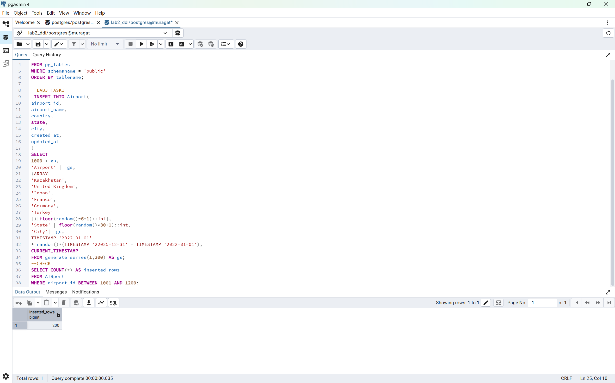
Task 2
--TASK2 Add KazAir
INSERT INTO Airline(
airline_id,
airline_code,
airline_name,
airline_country,
created_at,
updated_at
)
VALUES(
100,
'KAZ',
'KazAir',
'Kazakhstan',
CURRENT_TIMESTAMP,
CURRENT_TIMESTAMP
);
--CHECK
SELECT*
FROM Airline
WHERE airline_name ='KazAir';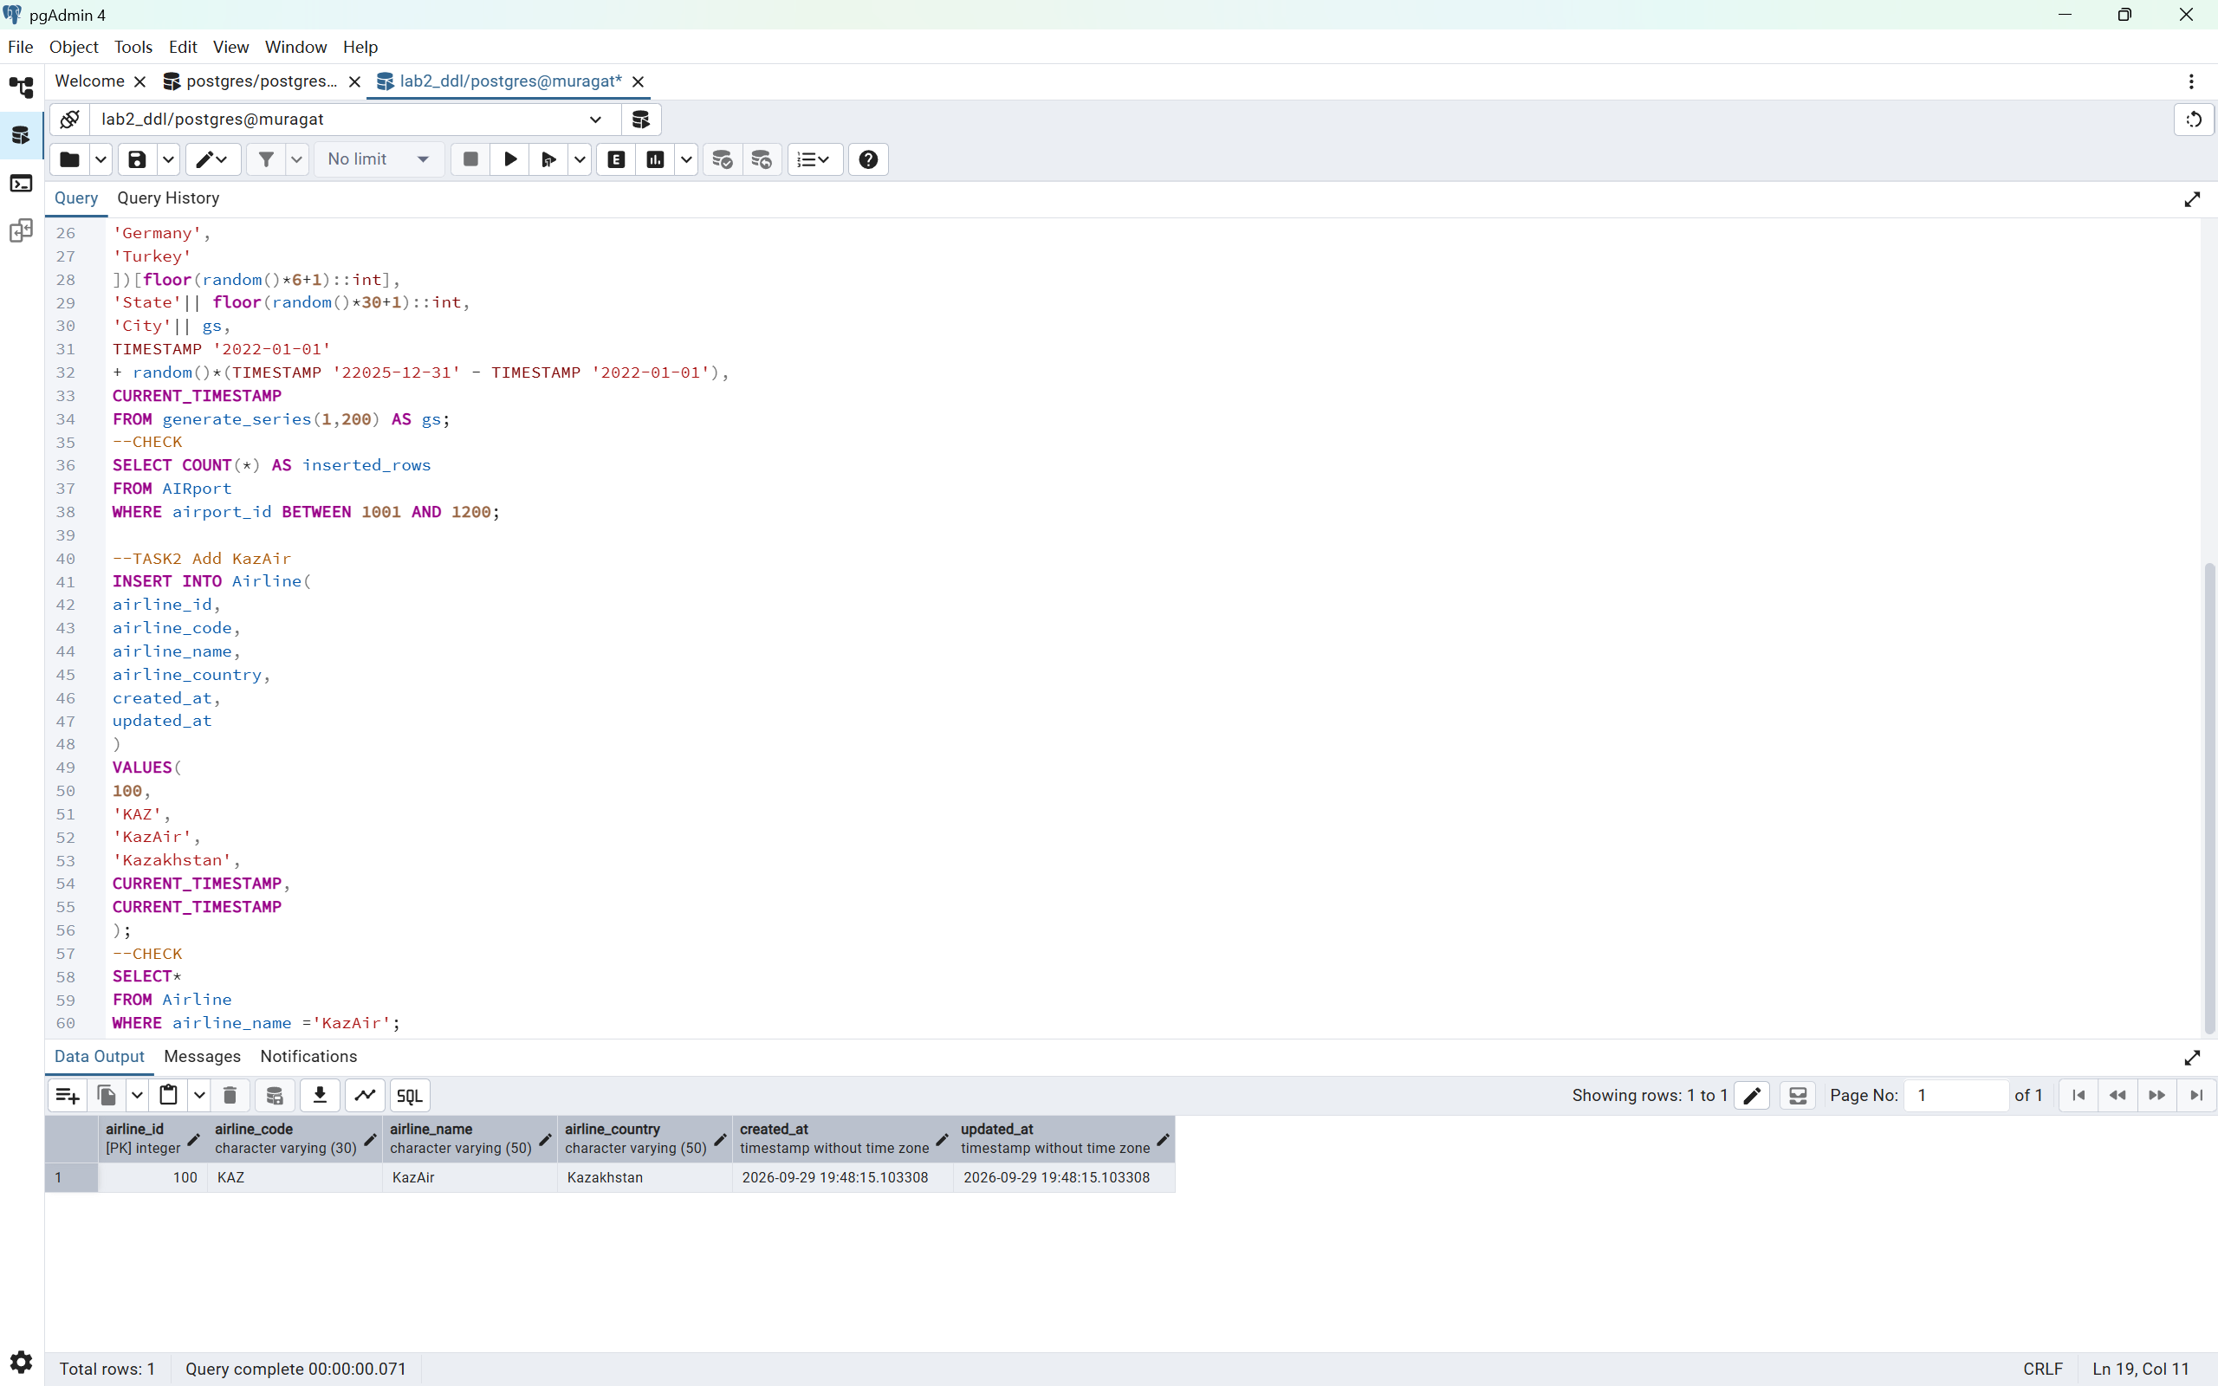
Task 3
--TASK3 Update KazAir country to Turkey
UPDATE Airline
SET airline_country ='Turkey',
updated_at = CURRENT_TIMESTAMP
WHERE airline_name = 'KazAir';
--CHECK
SELECT airline_id, airline_name, airline_country, updated_at
FROM Airline
WHERE airline_name = 'KazAir';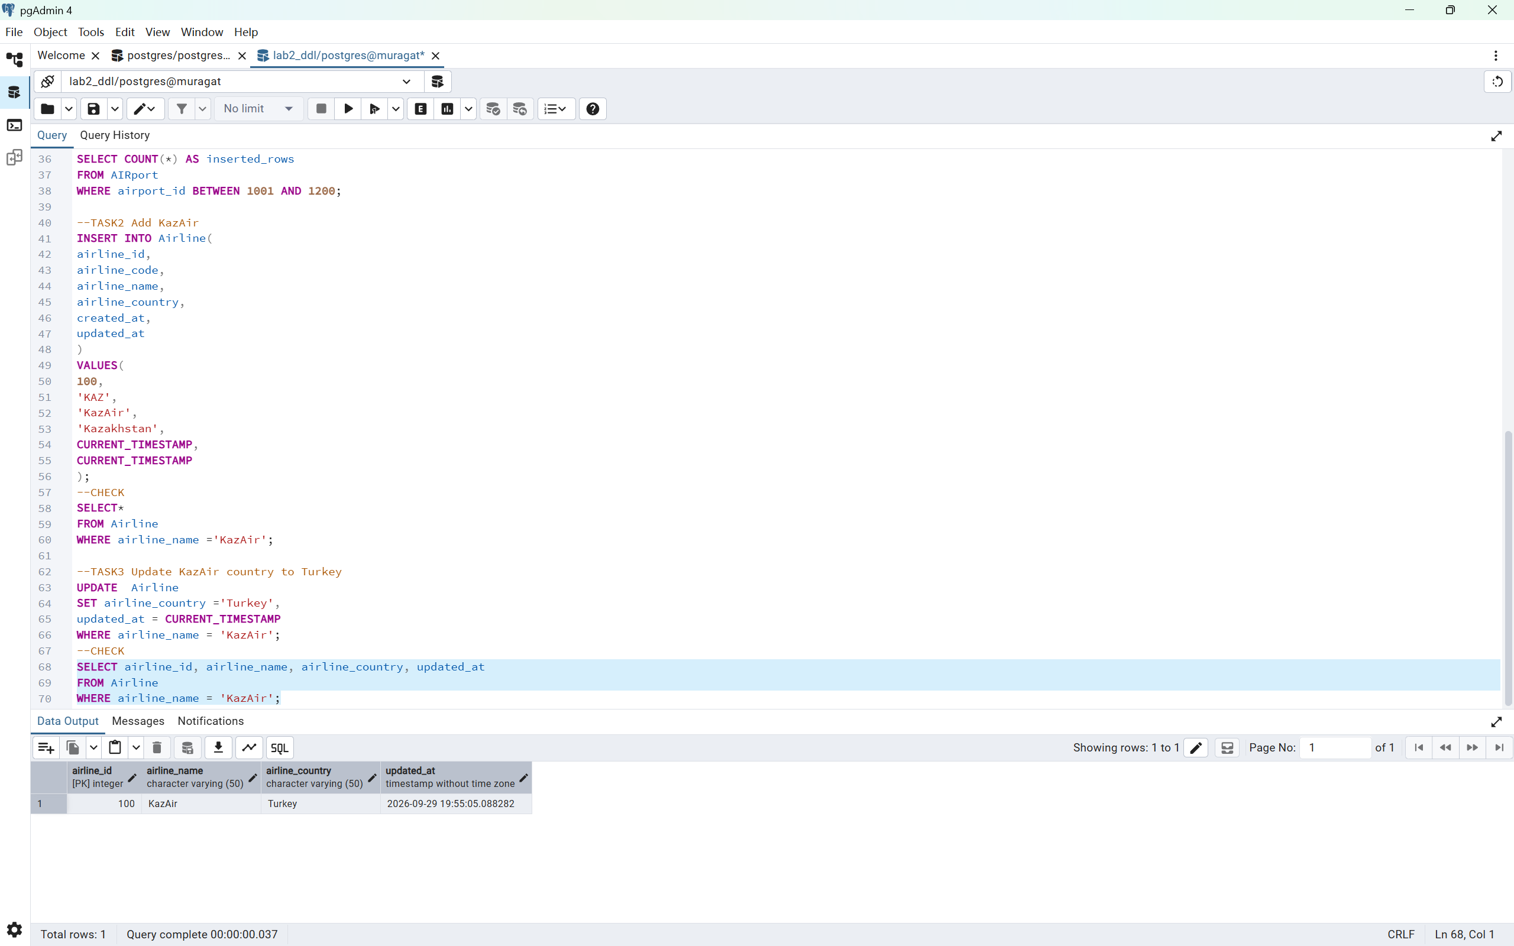
Task4
-- Task 4: Add three airlines at once
INSERT INTO Airline (
airline_id,
airline_code,
airline_name,
airline_country,
created_at,
updated_at
)
VALUES
(101, 'AE', 'AirEasy', 'France', CURRENT_TIMESTAMP, CURRENT_TIMESTAMP),
(102, 'FH', 'FlyHigh', 'Brazil', CURRENT_TIMESTAMP, CURRENT_TIMESTAMP),
(103, 'FF', 'FlyFly', 'Poland', CURRENT_TIMESTAMP, CURRENT_TIMESTAMP);
--CHECK
SELECT airline_id, airline_code, airline_name, airline_country
FROM Airline
WHERE airline_name IN ('AirEasy', 'FlyHigh', 'FlyFly');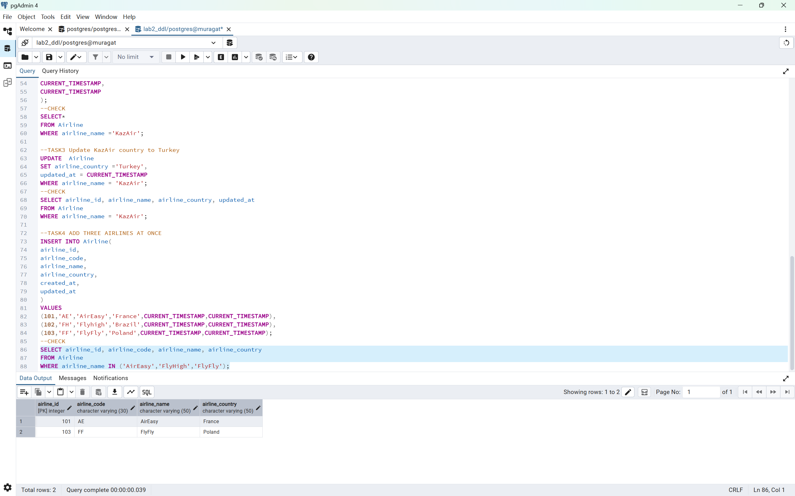
Task5
--TASK5
--CHECK FLIGHTS ARRIVING IN 2024
SELECT*
FROM Flights
WHERE EXTRACT(YEAR FROM sch_arrival_time) = 2024;
-- DELETE FLIGHTS ARRIVING IN 2024
DELETE FROM Flights
WHERE EXTRACT(YEAR FROM sch_arrival_time) = 2024;
--CHECK
SELECT COUNT(*) AS remaining_2024_flights
FROM Flights
WHERE EXTRACT(YEAR FROM sch_arrival_time) = 2024;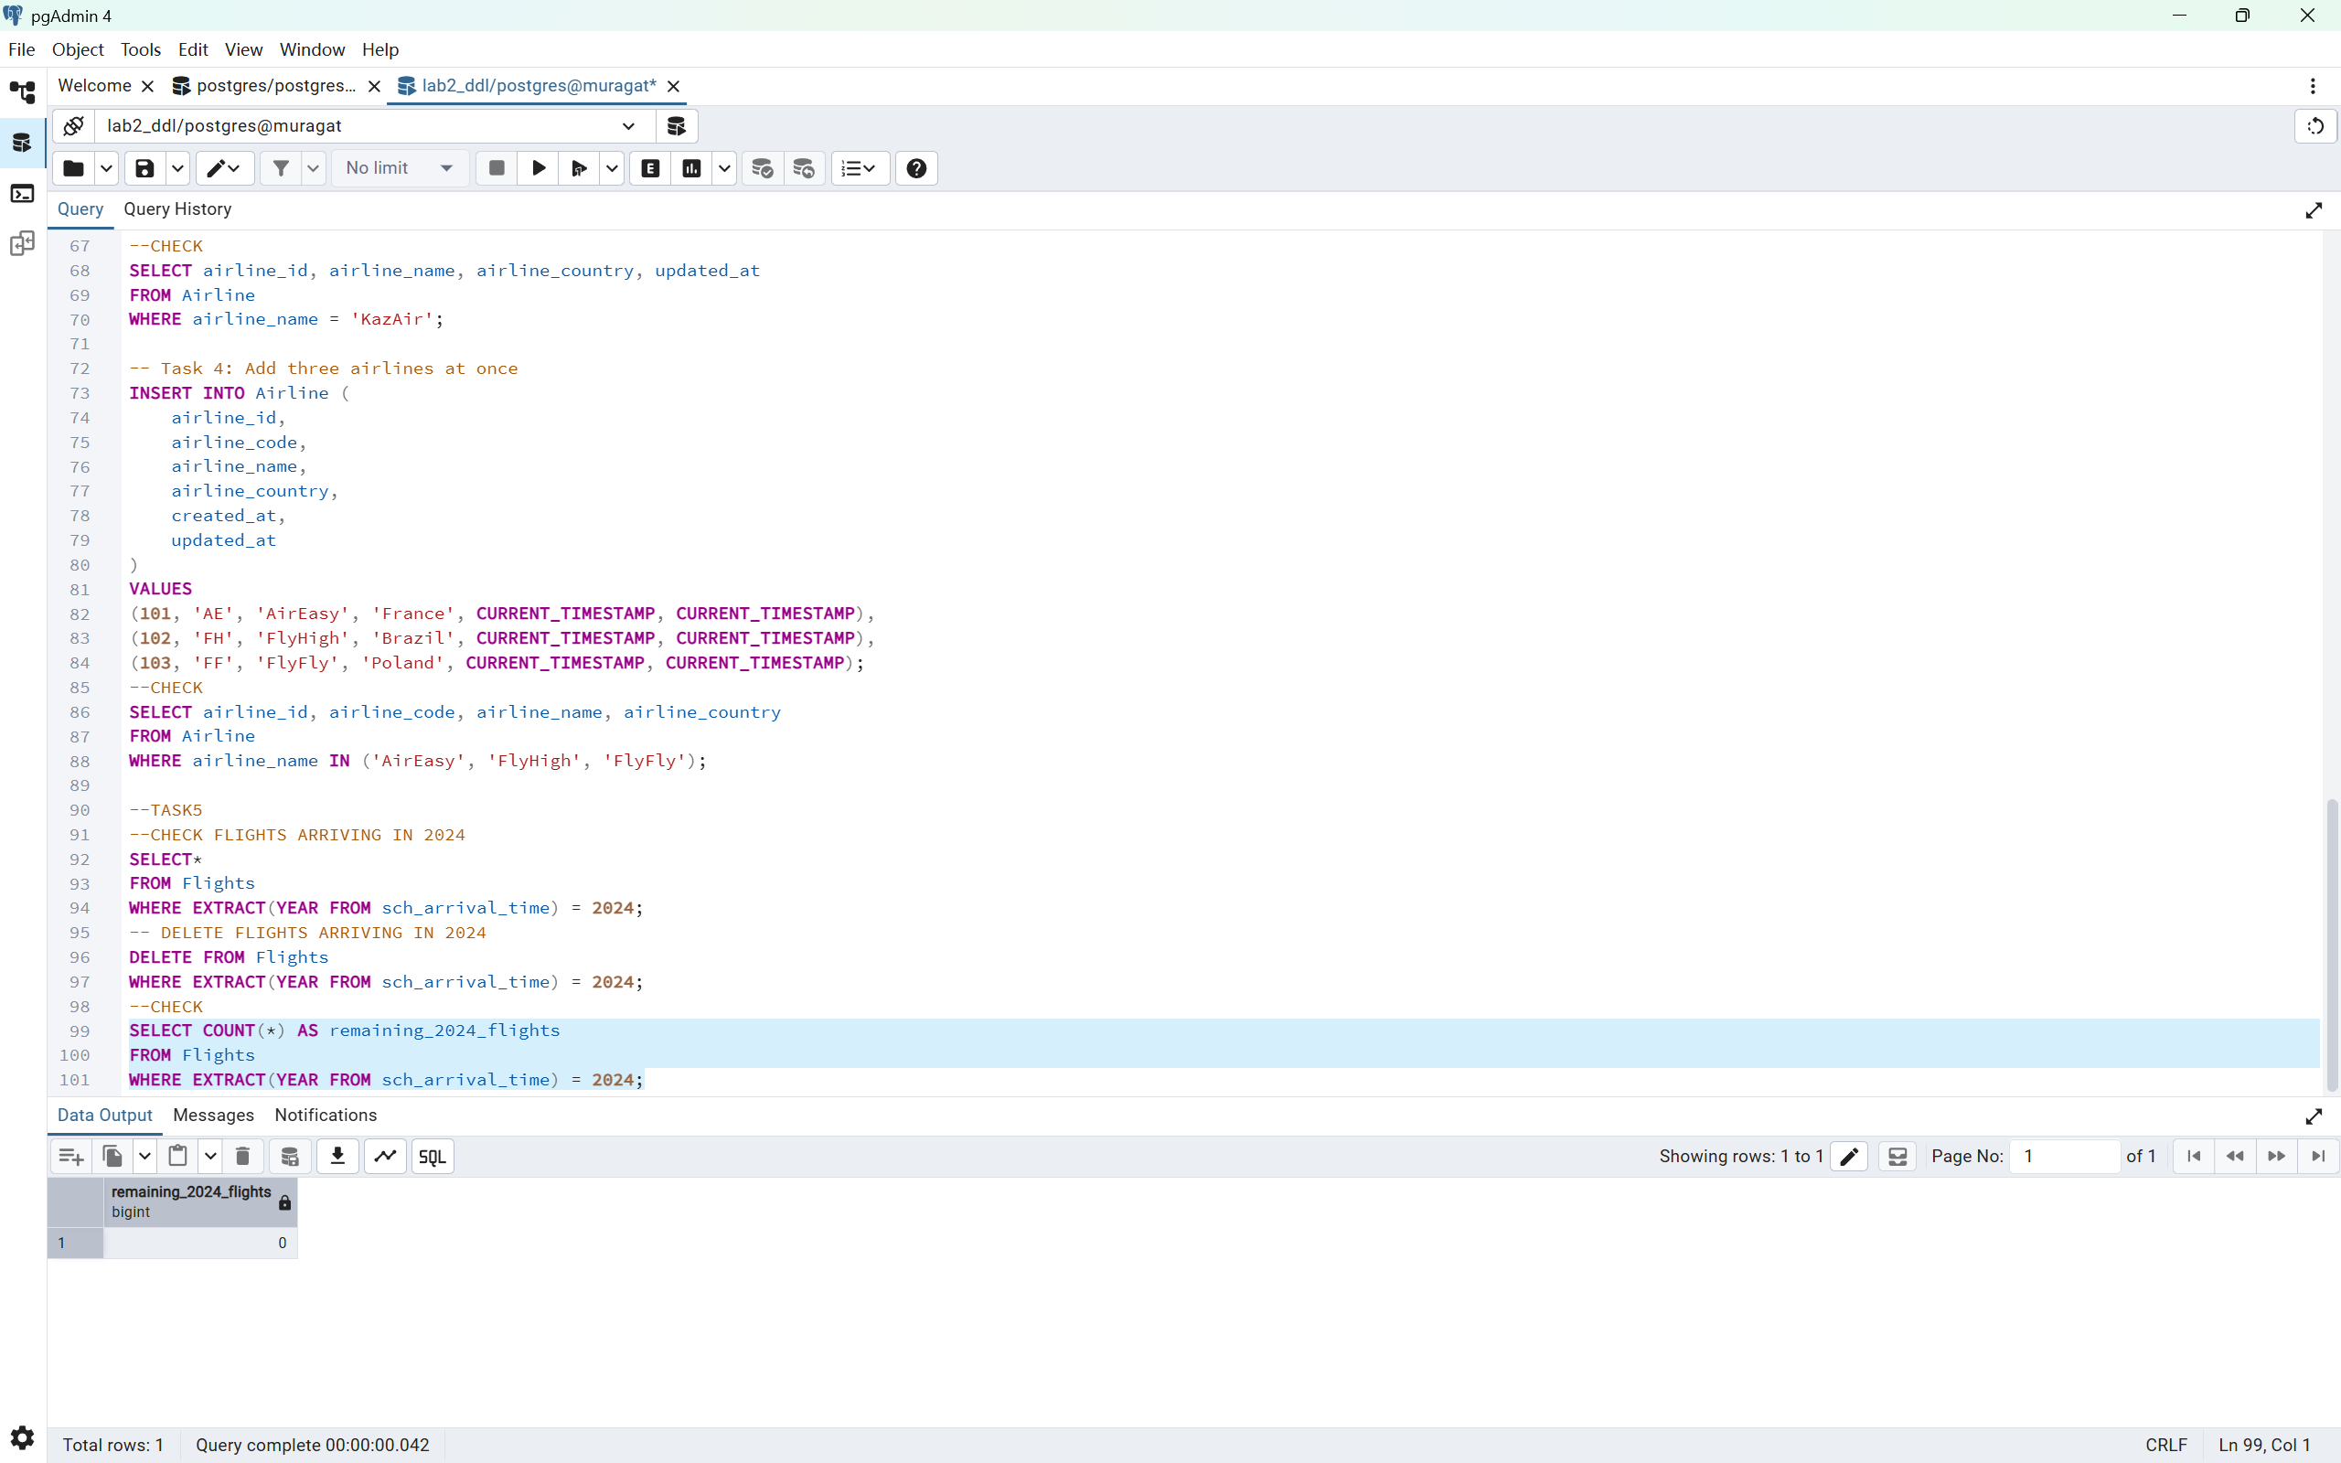
Task6
--TASK6 INCREASE ALL TICKET PRICES BY 15%
UPDATE Booking
SET ticket_price = ticket_price * 1.15;
--CHECK
SELECT booking_id, ticket_price
FROM booking
ORDER BY booking_id; 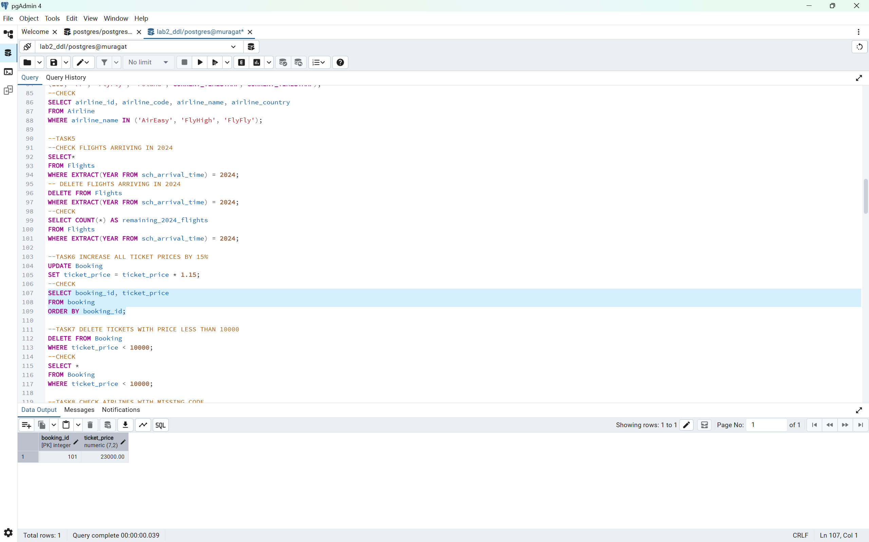
Task7
--TASK7 DELETE TICKETS WITH PRICE LESS THAN 10000
DELETE FROM Booking
WHERE ticket_price < 10000;
--CHECK
SELECT *
FROM Booking
WHERE ticket_price < 10000;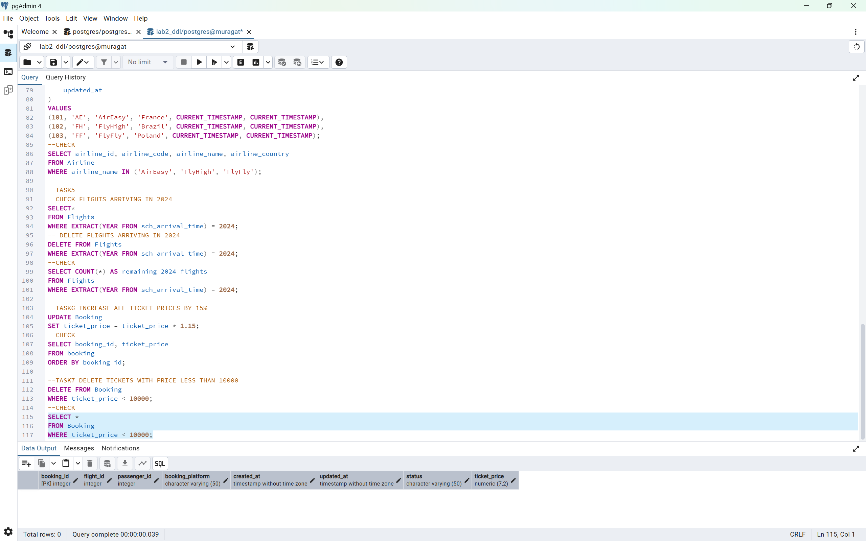
Task8
--PREPARE TEST FOR TASK8
ALTER TABLE Airline
ALTER COLUMN airline_code DROP NOT NULL;

INSERT INTO Airline(
airline_id,
airline_code,
airline_name,
airline_country,
created_at,
updated_at
)
VALUES(
999,
NULL,
'NoCode Air',
'Kazakhstan',
CURRENT_TIMESTAMP,
CURRENT_TIMESTAMP
);
--TASK8 CHECK AIRLINES WITH MISSING CODE
SELECT airline_id, airline_name, airline_code
FROM Airline
WHERE airline_code IS NULL;
--SET MISSING AIRLINE CODES TO UNK
UPDATE Airline
SET airline_code = 'UNK'
WHERE airline_code IS NULL;
--CHECK
SELECT airline_id, airline_name, airline_code
FROM Airline
WHERE airline_code = 'UNK';
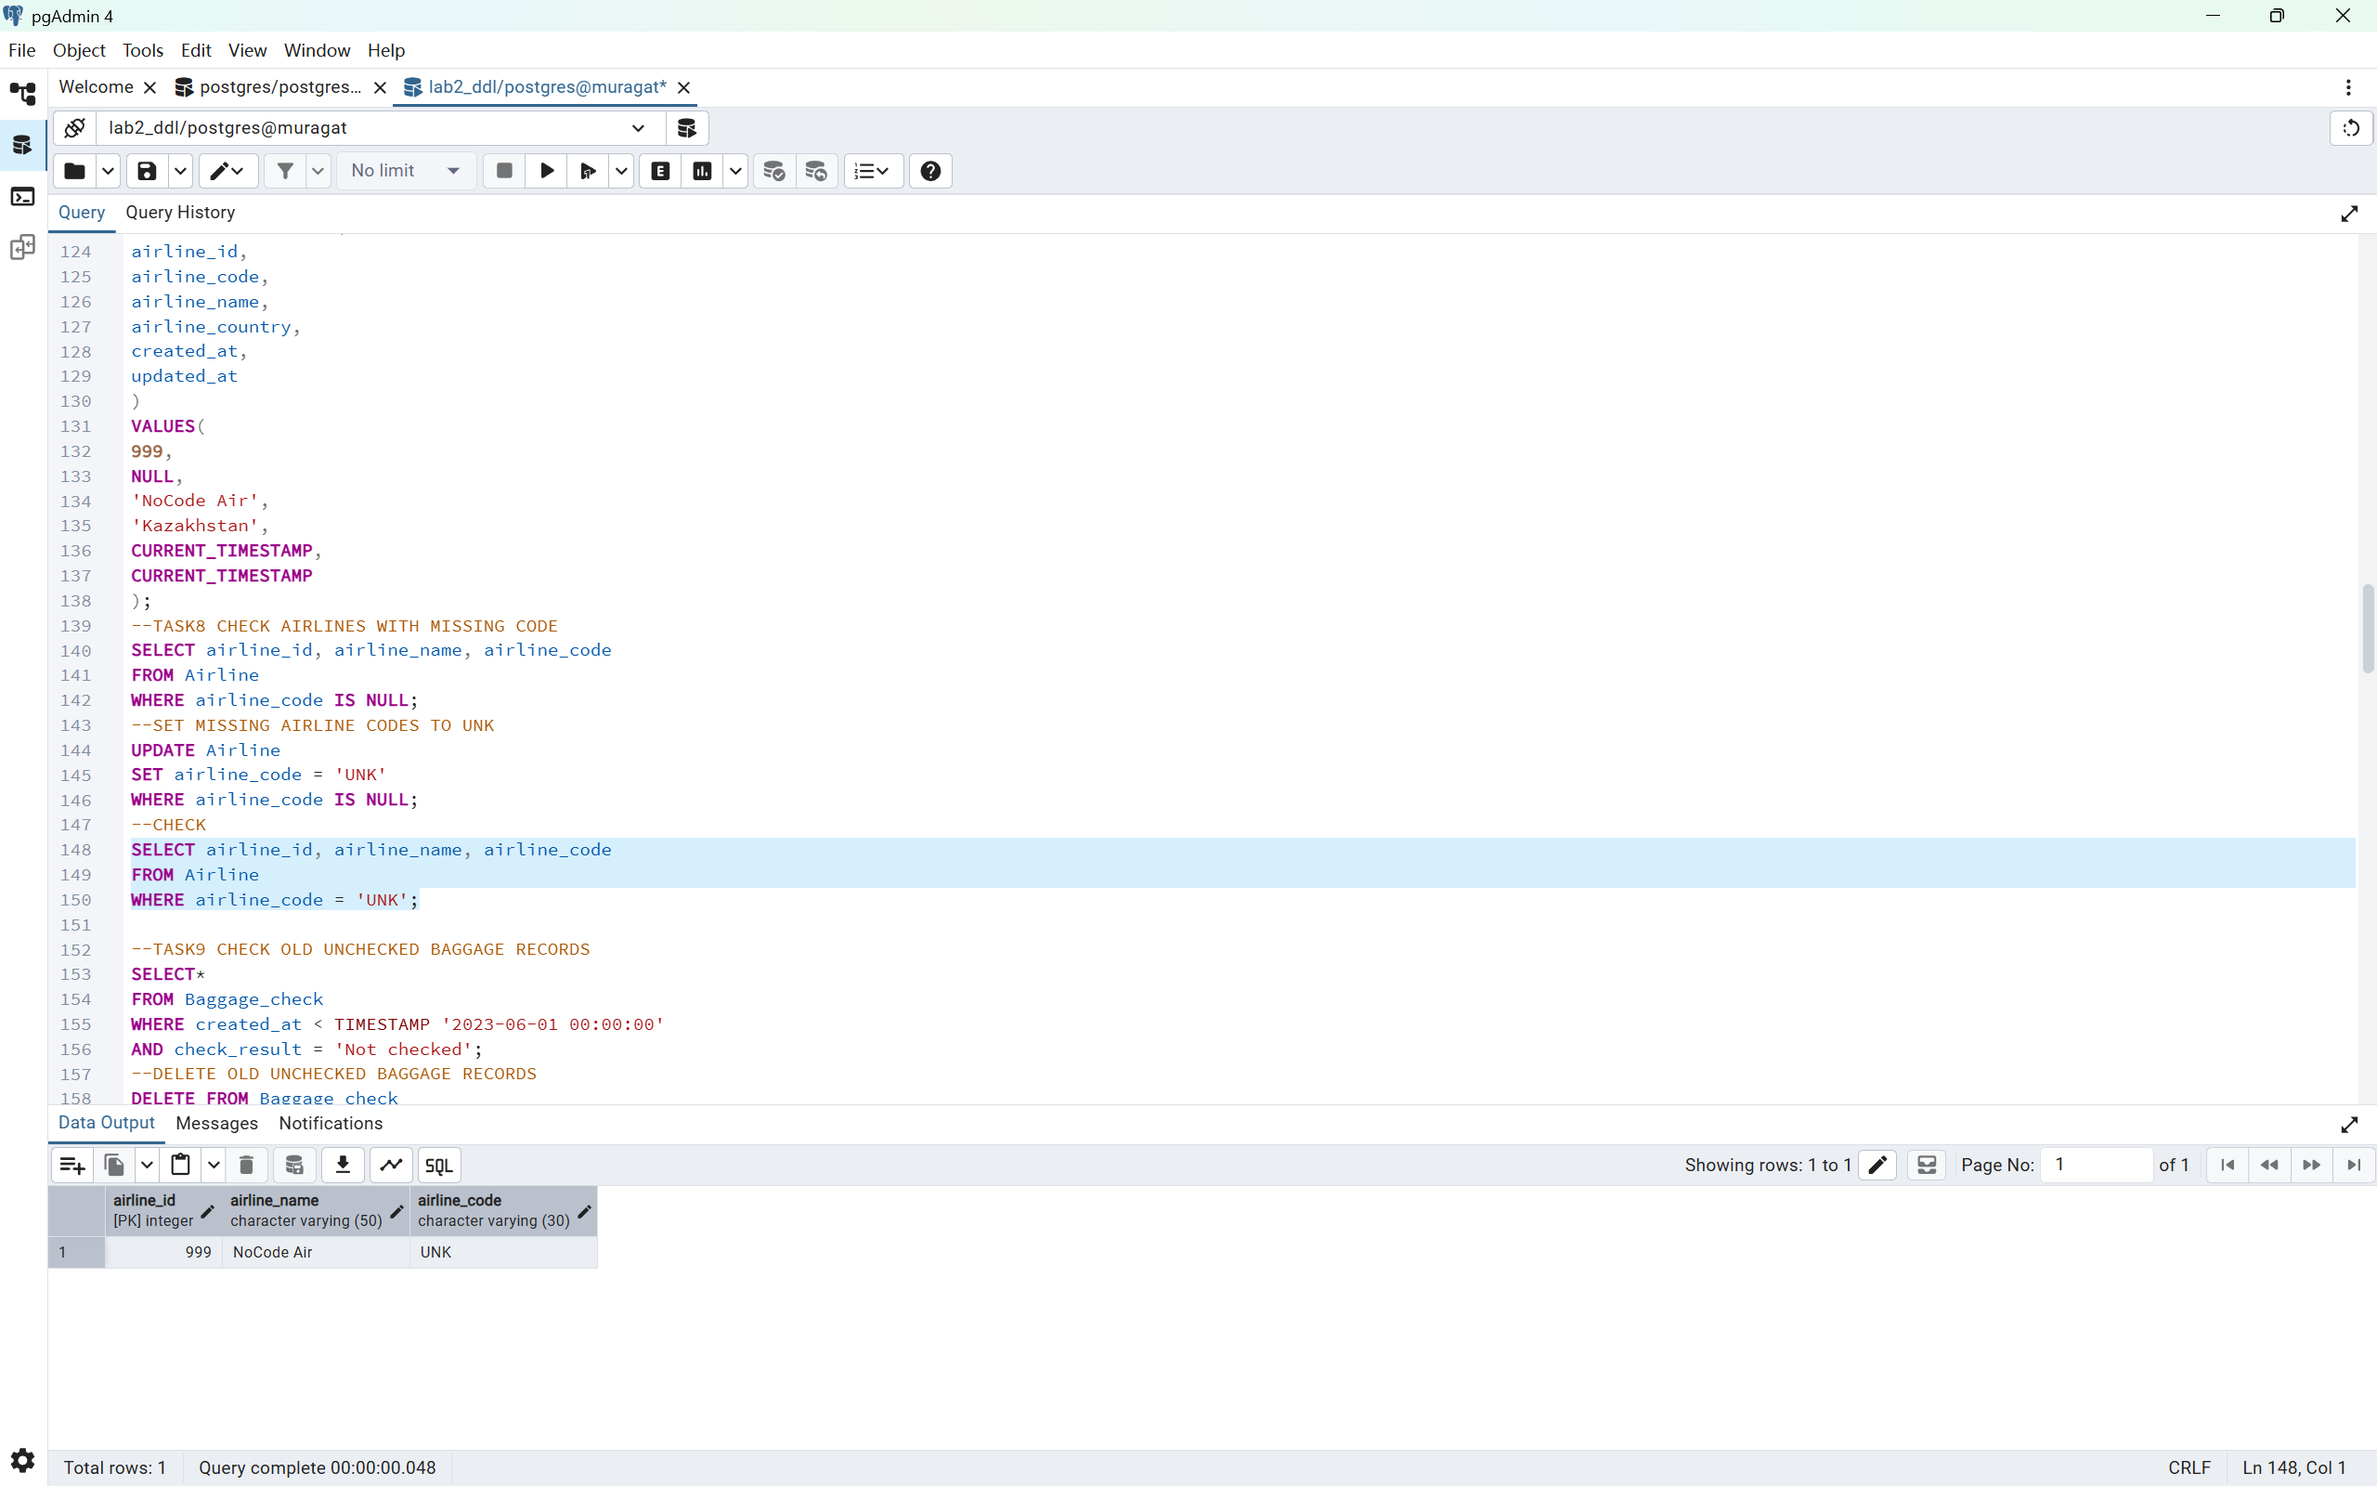
Task9
--TASK9 CHECK OLD UNCHECKED BAGGAGE RECORDS
SELECT*
FROM Baggage_check
WHERE created_at < TIMESTAMP '2023-06-01 00:00:00'
AND check_result = 'Not checked';
--DELETE OLD UNCHECKED BAGGAGE RECORDS
DELETE FROM Baggage_check
WHERE created_at < TIMESTAMP '2023-06-01 00:00:00'
AND check_result = 'Not checked';
--CHECK
SELECT COUNT(*) AS remaining_records
FROM Baggage_check
WHERE created_at < TIMESTAMP '2023-06-01 00:00:00'
AND check_result='Not checked';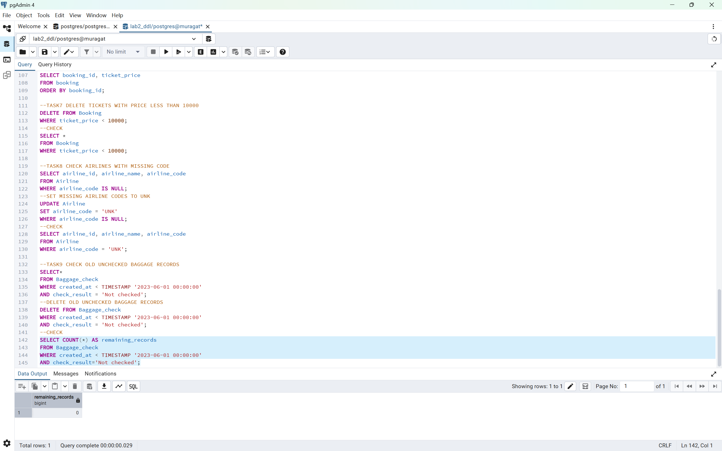
Task10
--TASK10 CHECK MATCHING AIRPORTS
SELECT*
FROM Airport
WHERE state IS NULL
AND city IN('Mlawe','Kepuh');
--DELATE MATCHING AIRPORTS
DELETE FROM Airport
WHERE state IS NULL
AND city IN('Mlawe','Kepuh');
--CHECK
SELECT COUNT(*)AS remaining_records
FROM Airport
WHERE state IS NULL
AND city IN ('Mlawe','Kepuh');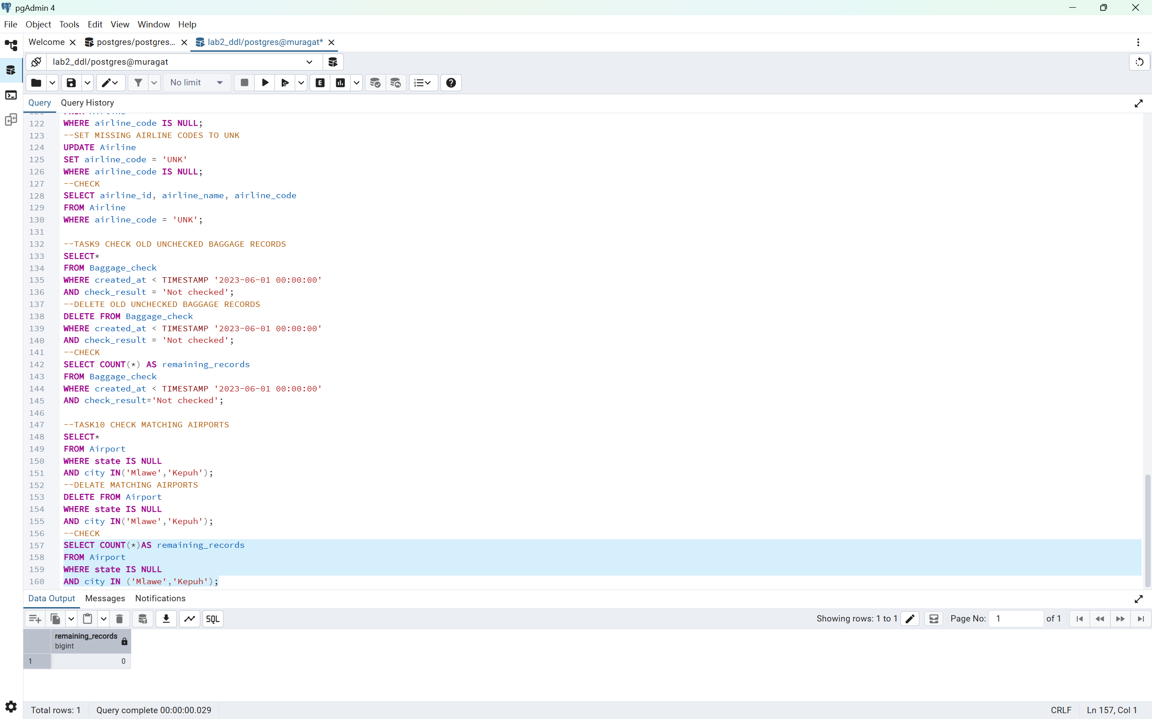
Task11
--TASK11 INSERT BAGGAGE CHECK AND RETURN GENERATED VALUES
INSERT INTO Baggage_check(
baggage_check_id,
check_result,
created_at,
updated_at,
booking_id,
passenger_id
)
VALUES(
(SELECT COALESCE(MAX(baggage_check_id),0) + 1 FROM Baggage_check),
'Not checked',
CURRENT_TIMESTAMP,
CURRENT_TIMESTAMP,
101,
1
)
RETURNING baggage_check_id, created_at;
--CHECK ID
SELECT booking_id FROM Booking ORDER BY booking_id LIMIT 5;
SELECT passenger_id FROM Passengers ORDER BY passenger_id LIMIT 5;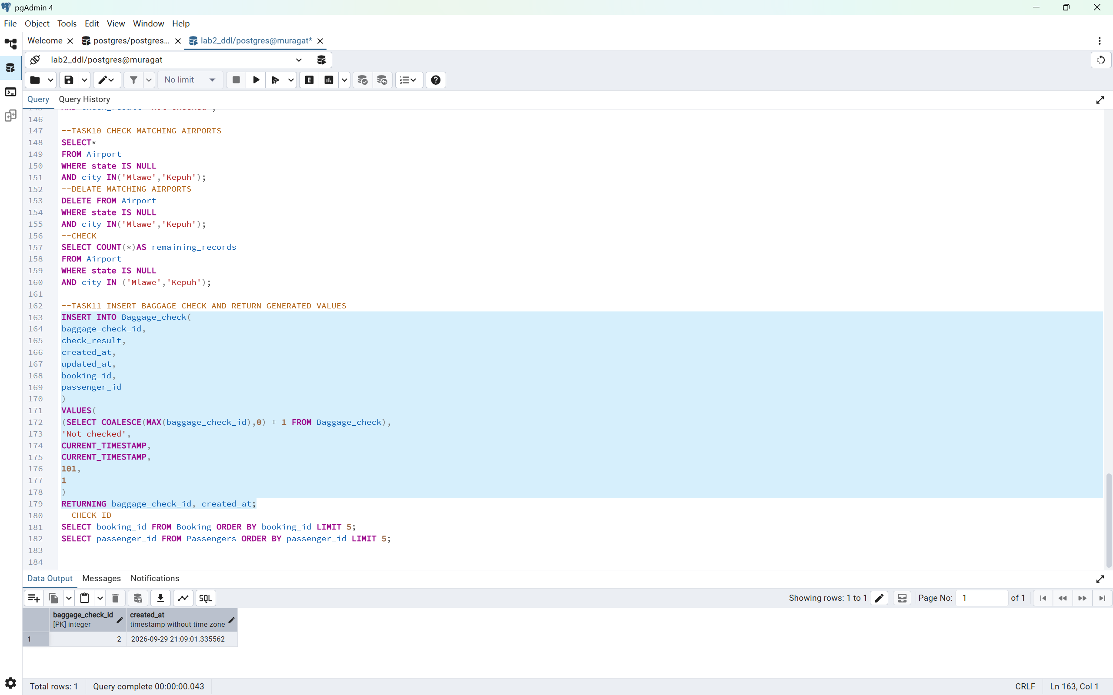
Task12
--TASK12 CONVERT ALL COUNTRIES TO UPPERCASE
UPDATE Airline
SET airline_country = UPPER(airline_country);
--CHECK
SELECT airline_id, airline_name, airline_country
FROM Airline
ORDER BY airline_id;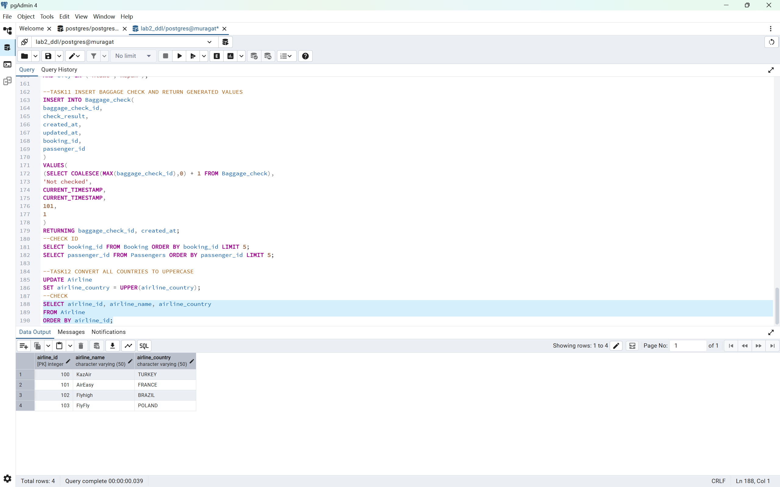
Task13
-- Prepare test data for Task 13
INSERT INTO Airline (
airline_id,
airline_code,
airline_name,
airline_country,
created_at,
updated_at
)
VALUES (
5,
'GA',
'Old Airline',
'Old Country',
CURRENT_TIMESTAMP,
CURRENT_TIMESTAMP
);
-- Task 13: Check airline_id = 5
SELECT *
FROM Airline
WHERE airline_id = 5;
-- CHECK TASK 13
SELECT airline_id, airline_name, airline_country, updated_at
FROM Airline
WHERE airline_id = 5;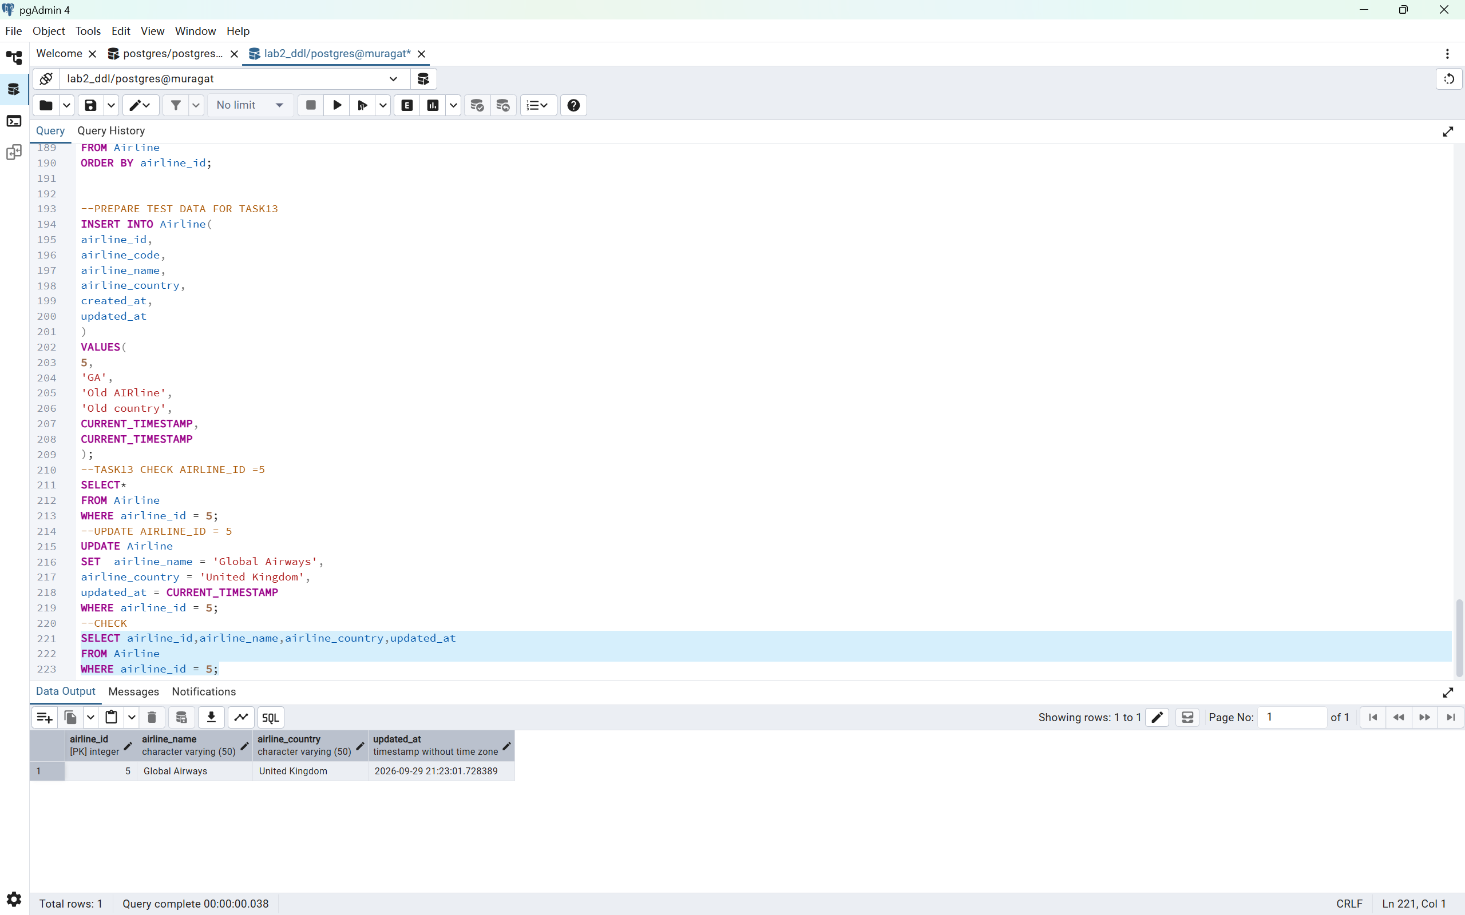
Task14
--PREPARE TEST DATA FOR TASK 14
INSERT INTO Airport(
airport_id,
airport_name,
country,
state,
city,
created_at,
updated_at
)
VALUES
(2001,'Astana Test Airport','Kazakhstan','Old State','Astana',CURRENT_TIMESTAMP,CURRENT_TIMESTAMP),
(2002,'London Test Airport','United Kindom','Old State','London',CURRENT_TIMESTAMP,CURRENT_TIMESTAMP),
(2003,'Tokyo Test Airport','Japan','Old State','Tokyo',CURRENT_TIMESTAMP,CURRENT_TIMESTAMP);
--TASK14 CHECK TARGET AIRORTS
SELECT airport_id,airport_name, city, state
FROM Airport
WHERE city IN ('Astana','London','Tokyo');
--UPDATE STATE
UPDATE Airport
SET state = 'Capital District'
WHERE city IN ('Astana','London','Tokyo');
--CHECK
SELECT airport_id, airport_name,city,state
FROM Airport
WHERE city in('Astana','London','Tokyo');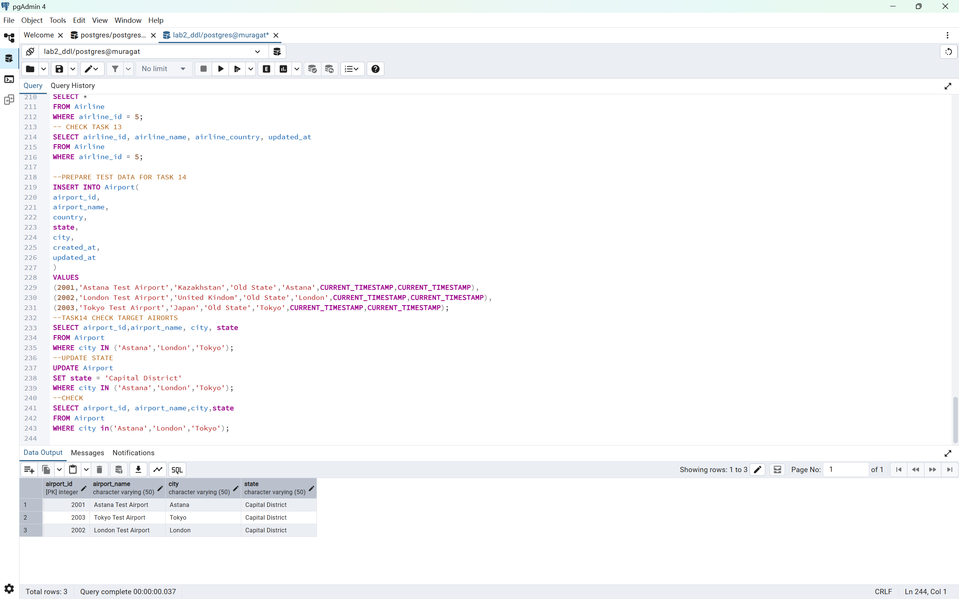

Task 15
--PREPARE TEST DATA FOR TASK 15
INSERT INTO Baggage_check(
baggage_check_id,
check_result,
created_at,
updated_at,
booking_id,
passenger_id
)
VALUES(
(SELECT COALESCE(MAX(baggage_check_id),0)+1 FROM Baggage_check),
'Not checked',
TIMESTAMP '2024-03-15 10:00:00',
TIMESTAMP '2024-03-15 10:00:00',
101,
1
)
RETURNING baggage_check_id,check_result,created_at;
--TASK15 CHECK MARCH 2024 UNCHECKED BAGGAGE RECORDS
SELECT*
FROM Baggage_check
WHERE created_at>=TIMESTAMP '2024-03-01 00:00:00'
AND created_at< TIMESTAMP '2024-04-01 00:00:00'
AND check_result = 'Not checked';
--MARK MARCH 2024 BAGGAGE CHECKS AS CHECKED
UPDATE Baggage_check
SET check_result='Checked',
updated_at=CURRENT_TIMESTAMP
WHERE created_at>=TIMESTAMP '2024-03-01 00:00:00'
AND created_at<TIMESTAMP '2024-04-01 00:00:00'
AND check_result= 'Not checked';
--CHECK
SELECT baggage_check_id,check_result,created_at,updated_at
FROM Baggage_check
WHERE created_at>=TIMESTAMP'2024-03-01 00:00:00'
AND created_at=TIMESTAMP '2024-04-01 00:00:00';

UPDATE Baggage_check
SET check_result ='Checked',
updated_at= CURRENT_TIMESTAMP
WHERE baggage_check_id=5;

SELECT baggage_check_id,check_result,created_at,updated_at
FROM Baggage_check
WHERE baggage_check_id=5;
