A REPORT ON
Student Management System
By

Name (s) of the student ( s) Registration No.
Duggirala Binitha Naga sri Vyshnavi AP23110010690

Prepared in the partial fulfillment of the
Summer Internship Course
AT
SALESFORCE SMARTBRIDGE, HYDERABAD

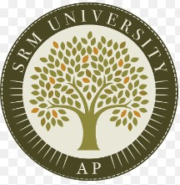

SRM UNIVERSITY, AP (July, 2025)

joining Report

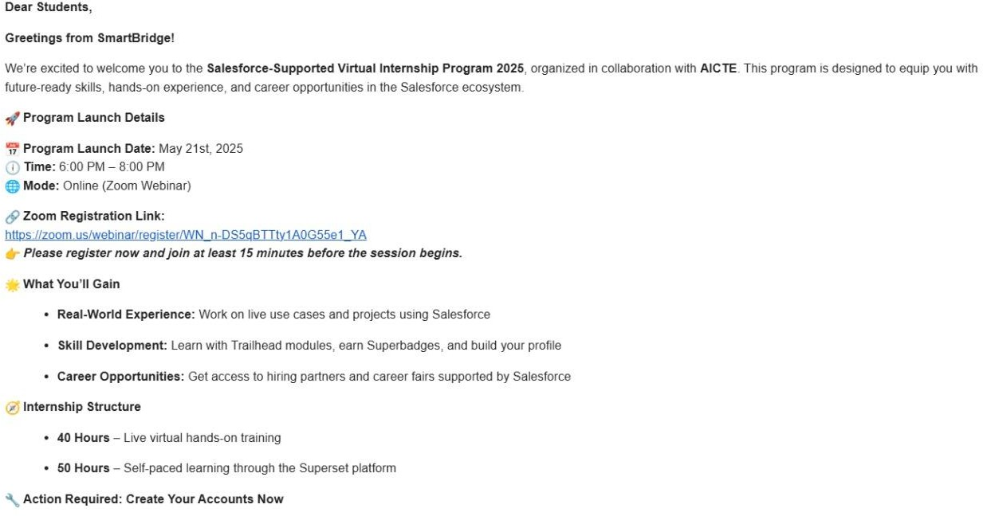

Acknowledgements

I would like to express my sincere gratitude to SmartBridge for providing me the opportunity to undergo this Salesforce internship.
I would also like to thank my faculty mentor, Dr. Anusha Nalajala, for her continuous guidance and support throughout the internship.
I am grateful to all the mentors and instructors who helped me in understanding Salesforce concepts and completing my project successfully.
Finally, I thank my friends and family for their encouragement and support.

Abstract

The Student Management System using Salesforce CRM is a cloud-based application developed to efficiently manage and organize student-related data in educational institutions. The primary objective of this project is to replace traditional manual record-keeping methods with a centralized and automated digital system.

In many institutions, student data such as personal details, course information, attendance, and academic performance is maintained manually or across multiple platforms, which can lead to data redundancy, inconsistency, and difficulty in retrieval. This project addresses these challenges by utilizing Salesforce CRM, a powerful cloud platform, to store and manage data in a structured and secure manner.

The system is developed using key Salesforce features such as custom objects, fields, reports, dashboards, and Lightning App Builder. A custom object named “Student” is created to maintain records, along with fields to store attributes like student name, course, marks, and attendance. Reports and dashboards are used to analyze and visualize student performance, helping users make informed decisions.

Table of Contents

Section | Title | Page No.
1 | Joining Report | 2
2 | Acknowledgements | 3
3 | Abstract | 4
4 | A Brief Introduction | 6
5 | Overview of the organization | 7
6 | Plan of the Internship Program | 8
7 | Introduction | 9
8 | Main text | 10
9 | Outcomes | 11
10 | Conclusions and Recommendations | 12
11 | References | 13

A brief introduction of the organization’s business sector

In today’s digital era, managing student information efficiently is essential for educational institutions. Traditional methods of maintaining records using paper or basic tools are time-consuming, error-prone, and difficult to manage. As the number of students increases, it becomes challenging to store, update, and retrieve data accurately.
To overcome these issues, this project introduces a Student Management System using Salesforce CRM, a cloud-based platform that helps in organizing and managing student data effectively. The system allows users to store important details such as student name, course, marks, and attendance in a structured format.
By using Salesforce features like objects, fields, reports, and dashboards, the system provides an easy and efficient way to handle data. It also helps in analyzing student performance and generating useful insights.
This project highlights how modern CRM tools can simplify data management, reduce manual work, and improve overall efficiency in educational institutions.

Overview of the organization

SmartBridge is a leading organization that focuses on providing industry-oriented training and internship programs for students. It aims to bridge the gap between academic learning and industry requirements by offering practical exposure in emerging technologies.
The organization offers training in various domains such as Salesforce CRM, Artificial Intelligence, Cloud Computing, and Full Stack Development. Through its structured internship programs, students gain hands-on experience by working on real-time projects and learning from industry experts.
The Salesforce internship program conducted by SmartBridge is designed to help students understand the fundamentals of CRM and develop applications using Salesforce tools. It covers key concepts such as objects, fields, automation, reports, and dashboards.
Additionally, SmartBridge provides certification opportunities, project guidance, and placement support to help students enhance their career prospects. The organization plays a significant role in preparing students for the IT industry by equipping them with the necessary technical skills and hands-on experience.
Overall, SmartBridge plays an important role in enhancing students’ technical skills, improving their employability, and preparing them for real-world challenges in the IT industry.
Plan of your internship program
Internship Department: Salesforce (Smartbridge Internship Program)

Internship Duration: 21 May 2025 – 31 July 2025

Key Activities and Responsibilities:

The internship program was divided into the following phases

Phase 1: Introduction to Salesforce CRM and basic concepts

Phase 2: Learning about objects, fields, and relationships

Phase 3: Understanding reports, dashboards, and automation tools

Phase 4: Project development – Student Management System

Phase 5: Testing and final presentation

Introduction

In today’s digital era, managing student information efficiently is essential for educational institutions. Traditional methods of maintaining records using paper or basic tools are time-consuming, error-prone, and difficult to manage. As the number of students increases, it becomes challenging to store, update, and retrieve data accurately.

To overcome these issues, this project introduces a Student Management System using Salesforce CRM, a cloud-based platform that helps in organizing and managing student data effectively. The system allows users to store important details such as student name, course, marks, and attendance in a structured format.

By using Salesforce features like objects, fields, reports, and dashboards, the system provides an easy and efficient way to handle data. It also helps in analyzing student performance and generating useful insights.

This project highlights how modern CRM tools can simplify data management, reduce manual work, and improve overall efficiency in educational institutions

.

Text

🔹 System Design
The system is built using Salesforce components such as:
Custom Objects (Student)
Fields (Name, Course, Marks, Attendance)

🔹 Implementation
Created a Student object to store data
Added required fields for student details
Entered sample records
Generated reports based on marks and attendance
Created dashboards for visualization

🔹 Features
Add and manage student records
Track attendance and marks
Generate reports and dashboards
Easy user interface using Lightning App

Outcomes

- Gained practical knowledge of Salesforce CRM
- Learned how to create objects and fields
- Understood report and dashboard creation
- Developed a functional Student Management System

Conclusions and Recommendations

Conclusions:
    - The Student Management System developed using Salesforce CRM provides an efficient way to manage student data.
    - It reduces manual work, improves accuracy, and helps in better decision-making through reports and dashboards.
    - This project demonstrates the importance of CRM tools in real-world applications..

Recommendations:

- Add automation using Salesforce Flows
- Implement email notifications for student performance
- Enhance security features
- Integrate with mobile applications for better accessibility

References
- Salesforce Trailhead Modules – https://trailhead.salesforce.com
- Skill Wallet – https://myskillwallet.ai/login
- SmartBridge Internship Program Resources

