Retail Checkout 1.3: End-to-End Short-Term Forecast Process
Technical Review

Version 1.1

Revision History
Date | Version | Description | Author
01/01/2007 | 1.0 | TechniTechnical Review | Savant
01/01/2007 | 1.1 | TechniTechnical Review revised | Savant

Table of Contents
1. Purpose of the Technical Review 3
2. Scope of the Project 3
2.1 Global Settings 3
2.2 Pricing Configuration 3
2.3 Pricing 3
2.4 Security Administration 3
3. System Architecture 3
4. Technical Requirements 3
4.1 System Interfaces 3
4.2 Programming Languages 3
4.3 Development/Design Tools 3
4.4 Availability / Fault Tolerance 3
4.5 Risk Assessment 3
4.6 Hardware 3
4.7 Operating System(s) 3
4.8 Telecommunications 3
4.9 Database(s) 3
4.10 Reporting 3
4.11 Web / Application Infrastructure 3
5. Project Design Specifications 3
5.1 Data Model (Click Data Model to view the Data Model) 3
6. Sample Screen Shots 3

Retail Checkout 1.3: End-to-End Short-Term Forecast Process

Purpose of the Technical Review
The purpose of this document is to have a single point reference containing the technical specifications as well as the implementation details of the ‘Customer Pricing’ System.

Scope of the Project

Currently, TriEagle uses a manual Excel spreadsheet based ‘Customer Pricing’ process for the customers it serves which does not include automated pricing update capabilities and whose performance is sacrificed when pricing customer proposals with a large number of ESI-Ids. The customer pricing using existing Excel model involves two steps:

- The creation / storage of Pricing Input Creator (PIC) for each prospective customer.

- The creation / run / storage of Pricer for each prospective customer which takes PIC as an input.

The current project scope is to develop a Portal solution for ‘Customer Pricing’ which replicates the functionalities of the Pricer. The goals for building a Portal solution is as follows:
- To bring efficiencies in the Customer Pricing process by introducing automation wherever it is possible and thereby reduce the overall time taken to prepare pricing and the possibility of human errors.
- To enable pricing for customers to be automatically generated on a daily basis
- To reduce the time necessary to prepare pricing for customers with a large number of ESI-Ids
- To move the Pricing Process’s generation of Customer presentation tools beyond the Pricing Analyst and enable the sales representative to be able to select the pricing product options and terms to be presented to the customer from the active pricing list that the sales representative deems will best meet the customers needs and capture or retain their business for TriEagle Energy.
- To have a historical database non-modifiable record of Pricing Runs

The scope of this project is limited to the following broad functionalities

- Global Settings
- Pricing Configuration
- Pricing
- Security Admin

The description of these modules is given under the different sections below.

Global Settings

This functionality is for setting the different parameters required for ‘Customer Pricing’ process. The various sub functionalities involved in Configuration are briefly explained below:

- Zone – This module lists various Congestion and Weather Zones. The authorized user can view / modify / delete the existing details whenever necessary.

- TDSP
TDSP – The list of various Transmission and Distribution System Providers (TDSP) and their relevant information are maintained by this module.

AREP – The list of Affiliated Retail Electric Providers (AREPs) and their relevant information are maintained here.

Meter Type – This maintains the different meter types like IDR, NIDR, etc.

Rate Code – The customer rate code, rate class, SCUD, service voltage, etc given by different TDSPs are maintained in this module. The authorized user can include / remove a new rate code whenever applicable.

Meter Read Cycles – This module shows the different meter read cycles associated with different TDSPs. Provision has been given to view / modify / delete a read cycle, of a particular TDSP, for an eligible user.

- Season – The list of seasons (Winter, Spring, Summer and Fall) and their associated months are maintained here.

- Profile – The various Non-Interval Data Recorder (NIDR) profiles are maintained here.

- Losses – The TDSP wise Distribution Loss Factors (DLF) codes and their description are maintained by this module.

- Pricing

Price Blocks – This module maintains the various prices blocks and their description. A new price block can be defined by this module.

- Calendar –

Holiday – This module lists all the upcoming holidays.

Day Type – This includes weekday, weekend and holiday. Typically holidays are considered as weekends.

- Charges

Charge Category – This module maintains different charge categories like Energy charges, Delivery charges, Rep charges, etc. It also maintains different charges in each charge category.

Taxes – This includes Sales Tax, County & City Tax and Gross Receipts Provision is given to view/modify the tax values

- Zip code - This module maintains the association of ZIP Code to Weather and Congestion Zone

Pricing Configuration

This functionality is for setting the different parameter values associated with ‘Customer Pricing’ process. User can view / modify the parameter values.

1. TDSP

AREP – The association of Affiliated Retail Electric Providers (AREPs) with TDSPs are maintained by this module.

Meter Read Dates – This module shows the meter read cycles and the associated read dates of all TDSPs for different month / year. Provision has been given to view / modify / delete a particular read cycle and the associated read dates for an eligible user.

2. Charges

TDSP Charges – This module maintains different TDSP charges (like Delivery charge, Demand Charge, etc), Unit of Measures and Charges.

Other Charges – This includes ERCOT admin fee, REC Cost, Ancillary Service Charges, etc. The details are provided for every month. The valid user can view/modify charges of a particular month.

Premium – This maintains VIB Premium and T&D Premium, etc.

3. Pricing

Pricing Scalars – This module maintains zone wise pricing scalar values that are used for pricing computation. The values are given for every month and every hour for a zone.

Hour Flag – The hours associated with peak and off-peak hours for weekday & weekend are maintained in this module.

4. Losses

The TDSP wise Distribution Loss Factors (DLF) and season wise Transmission Loss Factors (LTF) are maintained by this module. It also maintains different loss factor codes associated with TDSPs.

Pricing

- Import – This module is for uploading the daily forward curves and TEE Natural gas prices (xls files) into ‘Pricing’ database. This uploading is done once in a day. The authorized user can do the file imports.

- View Inputs – This will be used to validate the successful uploading of input files (Fwd Curve and TEE Natural gas prices). Provision also given to view the IDR and NIDR profiles based on the selected ESIID or Profile Name.

- Prospective Customers – This is for maintaining the active prospective customers. It involves three stages.

Step 1: Customer Information

This functionality is for collecting customer contact information, current provider, associated sales rep, etc. This is more similar to customer data record. The sales team can select a particular customer and change his status.

Step 2: PIC Importation

This module is for storing the Pricing Input Creator’s (PIC) output into the Pricing database. The output of PIC contains the past twelve months (may not be the recent past twelve months) usage details (in kWh) of each ESI ID (a customer may have one or more ESI IDs). The usage details are not calendar month wise but are meter read-cycle wise. These twelve read-cycle details are used as a reference for the future 60 read-cycles. The user can view the imported PIC files through the application portal.

Step 3: Setting Preferences

This is for maintaining the customers’ pricing run preferences like term of contract, list of ESI IDs, product, etc. These preferences can be viewed / modified by the application.

- Pricer – This is the core functionality.

Run:

This module collects all prospective customers’ information, their preferences, etc and run the pricing. This pricing process is automatic as well as manual. The automatic pricing process fetches all the active prospective customers, their default preferences and run pricing. The automation pricing process is a scheduled task and it is once in a day. Alternatively, the authorized user can select a particular customer from the list and change his preferences and run the pricing. The user can do the number of pricing run manually. In both the pricing run, in case of data unavailability, the Pricer will take the latest available files.

The high level computational modules, sub modules involved in the core Pricing Run, computational module’s key inputs & outputs are briefly described below:

- Load Extrapolation

- Period Wise Total Usage

The purpose of this function is to extrapolate the past 12 read-cycles usage details (from PIC) to the future 60 periods. The future 60 periods is based on the customer’s contract start month. The table below shows the key inputs and outputs of this functional module.

Key Inputs | Key Outputs
Contract start date  TDSP  TDSP Meter read cycle  ESI ID (PIC output) | ESI ID  Nominal Current Month  Nominal Previous Month  CP start  CP End  Term Count  ForcastedkWh  Demand kW  Demand kVA  Load Factor

Computation Logic:

Look Up Period

The existing logic repeatedly assigns the past 12 months (read-cycle) usage details for the future 60 periods by comparing the months (ie the start and end months of PIC read cycle should match with the start and end months of future period).

Select Usage from PICOutput where
PIC.StartMonth = period.StartMonth and
PIC.EndMonth = period.EndMonth

Current Period

The meter read-cycle dates are assigned based on the period months and meter read cycle (this may differ for each ESI IDs). Then in proportion to the number of days in the meter-read cycle the usage details are assigned from the look period to all future periods.

The future 60 periods usage can also be computed in the following way:

For each future period get the

minimum of GetDifferenceInDays(PIC.StartMonth = MeterRead.StartMonth) +
GetDifferenceInDays(PIC.EndMonth = MeterRead.EndMonth).

Then assign the PIC Usage to the Period usage.

- Period/Month Wise Block Usage

The purpose of this module is to split the period usage into month wise, block wise usage based on the load profile (IDR and NIDR) information.

ReadCycleProfilePowerBlock – is the procedure (utility) for computing the power blocks kWhs for each load profile. The key input and output are listed below:

Key Inputs | Key Outputs
Profile Name  Profile Load Information (IDR and NIDR profiles are available in MS Access Database)  TDSP  TDSP Meter Read Cycle | Profile Name  Month  Price block ID  Forecasted Usage by block kWh

The output of the above module is the block wise usage details in kWh (5X16, 5X8, 2X16, 2X8) for a day (Week day or Week end) for all months (Jan to Dec) and profiles (72 profiles).

Period/Month Wise Block Usage function will use the above information to find out the period wise usages for all 60 periods. The results obtained will be stored month wise (ie each period will have eight entries, four for current month and four for previous month). The key inputs and outputs of this module is given below

Key Inputs | Key Outputs
ESI ID (PIC output)  Profile Name  TDSP  TDSP Meter Read Cycle | ESI ID  Term Count  MonthYear  Price Block ID  Forecasted Usage by block kWh  kW (this entry may be duplicated)  kVA (this entry may be duplicated)  (Load Factor)

Some Utility Modules relevant to the above computations:

GetNoOfDaysInMonth()

- Get the number of days in a given month. (Is it necessary?)

GetNoOfWeekDays ()

- Get the number of week days in a given month.

GetNoOfWeekEndDays ()

    - Get the number of weekend days in a given month.

- Cost Computation

  - Trieagle Charges

The TriEagle charges include energy charges and sales Rep charges (Overhead and deal components + Margin). Energy charges are computed for each ESI ID. Rep charges are computed for the aggregated load details (all ESI IDs). The key inputs and outputs are

Key Inputs | Key Outputs
Pricing Run ID  Forward Curves  ESI ID  Term Count  Month type flag  Profile Name  Ref Read Date  Transmission Loss Factor  Distribution Loss Factor  Season  Pricing Scalars  % VIB Premium  Ancillary Service charge rate  Congestion charge rate  GR Assess fee rate  UFE rate  ERCOT Admin fee rate  Regulatory cost rate | Wholesale Energy Costs  Based on Forward Profile Price ($)  Based on Forward Zonal Price:  Energy 5 x 16 ($)  Energy 2 x 16 ($)  Energy 7 x 8 ($)  Shaping Premium 5 x 16 ($)  Shaping Premium 2 x 16 ($)  Shaping Premium 7 x 8 ($)  VIB Premium ($)  Ancillary Service Charges ($)  Congestion Charges ($)  GR Assess Fee ($)  UFE ($)  ERCOT Admin ($)  Regulatory Costs ($)

  - TDSP Charges

TDSP charges are computed based on the current period (ie billing period, not based on current and previous month). This has to be computed ESI ID wise.

Key Inputs | Key Outputs
ESI ID  TDSP  TDSP Rate Code/Class  TDSP Rates (based on customer rate class)  This includes  Customer Charge rate  Metering Charge rate  Retail Clawback Credit rate  Transmission System Charge rate  Distribution System Charge rate  System Benefit Fund rate  Transition Charge rate  Nuclear Decommissioning Charge rate  TCRF rate  Excess Mitigation Charge rate  SCUD Discount rate  NMS and RR Credit rate  Option on TDSP Charge (based on T&D premium)  CP Usage kWh  CP Demand kW | Customer Charge ($)  Metering Charge ($)  Retail Clawback Credit ($)  Transmission System Charge ($)  Distribution System Charge ($)  System Benefit Fund ($)  Transition Charge ($)  Nuclear Decommissioning Charge ($)  TCRF ($)  Excess Mitigation Charge ($)  SCUD Discount ($)  NMS and RR Credit ($)  Option on TDSP Charge ($)  Delivery Charge Rate ($)  Previous Month Allocation ($)

- Result Aggregation

This procedure is to aggregate the results of all ESI IDs (kWh, Energy charges, TDSP charges, etc) and store them Term (1 to 60) wise. In addition to that it has to find out the Rep charges, which are based on the aggregated load.

Run Results:

This module lists the recent days pricing results including the current day. From the results user (pricing analyst) can select a particular customer and view his pricing dashboard. The post pricing run adjustment can be done by the analyst at this stage. The proposal data can be imported into the proposal database form the dashboard. The deal levers settings are stored along with the pricing run id. Each pricing run results can be retrieved by the pricing run id.

Security Administration

The application supports authentication and role based authorization. Specifically, the application provides screens for the administrator to do user as well as role administration. The users and roles for the Pricing application are maintained in the ‘Pricing’ database.

System Architecture

The diagram below shows the system architecture of Pricing application.

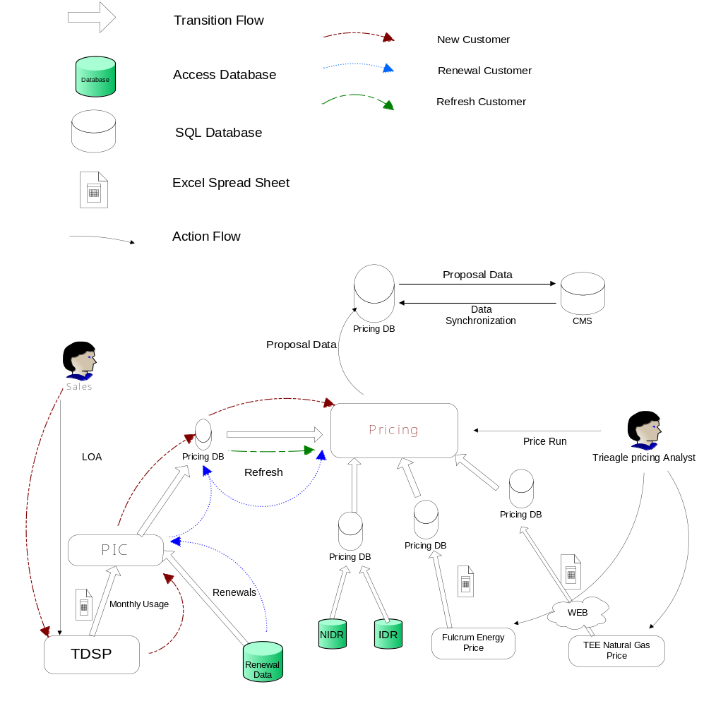

Technical Requirements

System Interfaces
The ‘Pricing’ application pulls information from the following data sources.

- Non-IDR Typical Profiles (Access Data base) – Different NIDR profiles
- IDR Typical Profiles (Access Data Base) – Different IDR Profiles
- TEE Gas Forward Curve (Excel) – Forecasted Natural Gas Price Downloaded from Internet
- Forward Curve (Excel) – Forecasted Energy Price.
- Customer Usage Information(Excel) – from PIC(Pricing Input Creator)

This information for Forward Curves are received in flat file formats (xls) and uploaded into ‘Pricing Database’. The application will collect the Profile Information (Incremental) from Access Database and Customer Information from CMS database.

Programming Languages

Purpose | Language/Platform
Back-End Processing and Storage | SQL Server 2000: T-SQL
Front-End Application | JSP and Struts 1.1
Middle Tier | Java and Hibernate

Development/Design Tools

Purpose | Language/Platform
Back-End Processing and Storage | SQL Enterprise Manager, SQL Query Analyzer
Front-End Application | Tomcat Apache Server

Availability / Fault Tolerance

Risk Assessment

Hardware

Operating System(s)
Windows

Telecommunications
None.

Database(s)
Database Name | Database Type | Server Location
Pricing | SQL-Server 2000 | TriEagle

Reporting

Dashboard (Pricing):
The dashboard shows the Energy Cost Components, TDSP Charges, “Price Quote” value, Deal lever settings, % savings, etc. for a selected Customer.

Price Run Tracking:

Pricing Analyst could track each Price Run along with the Results and selected settings.

Web / Application Infrastructure

Tomcat Apache Server.

Project Design Specifications

Data Model (Click Data Model to view the Data Model)

  - This database contains the Input, output and admin tables.

  - Admin tables contain the details of Users and Roles.

  - Input tables contain the details of Fulcrum forward Curves, TEE Natural Gas Price, Customer Usage Details, Customer Profile Details, TDSP Rate Codes, Charges, etc.

  - Output tables contain the details of Usage forecast, Energy Cost Components, “Price Quote” values, generated Proposals, etc.

Sample Screen Shots

Global Settings

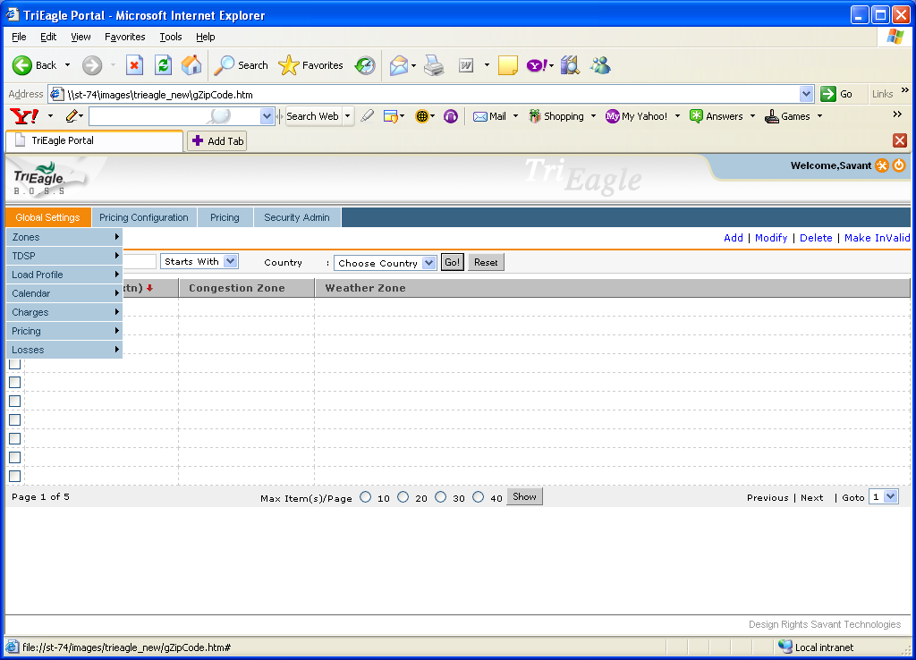

Global Settings -> Load Profiles

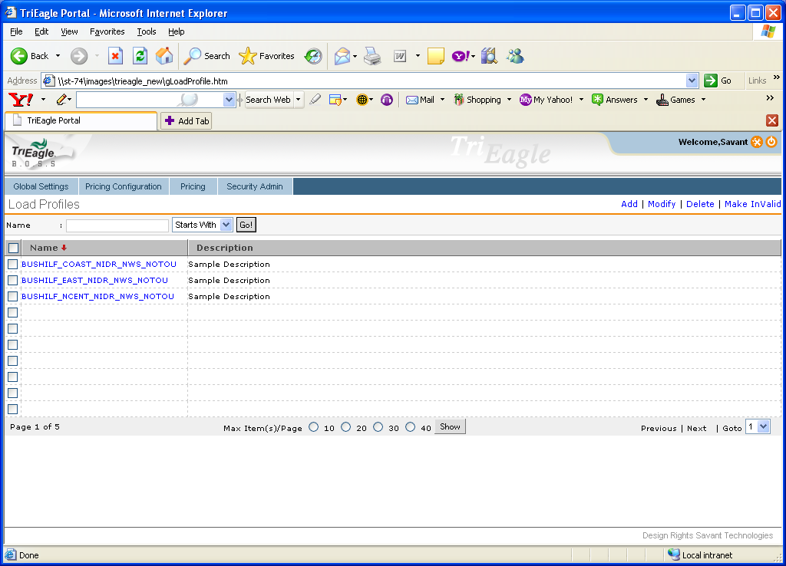

Pricing Configuration -> Charges -> Other Charges

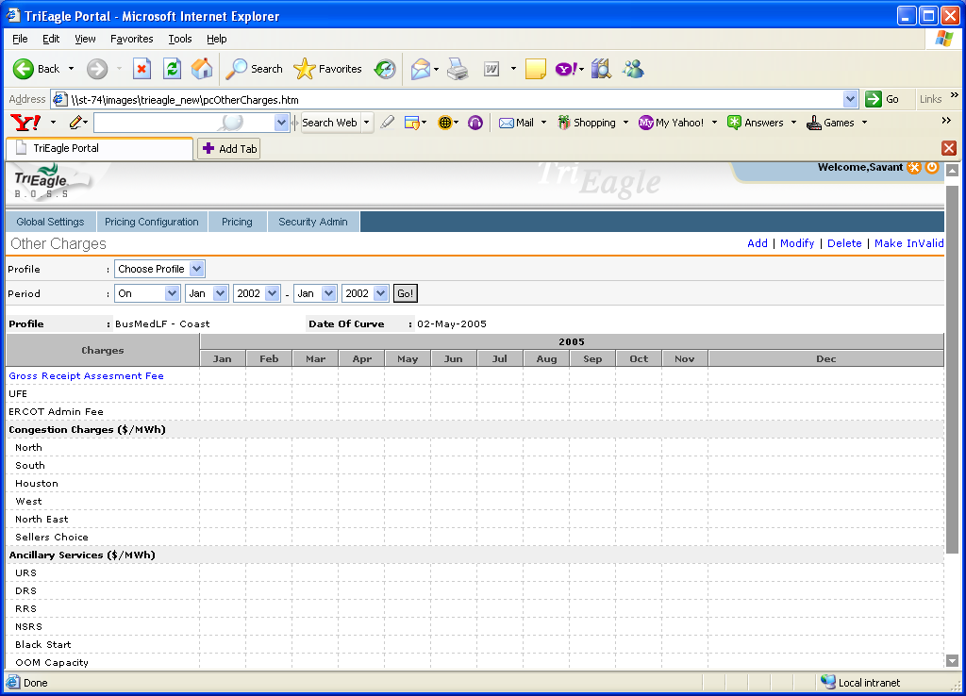

Pricing -> Prospective Customers

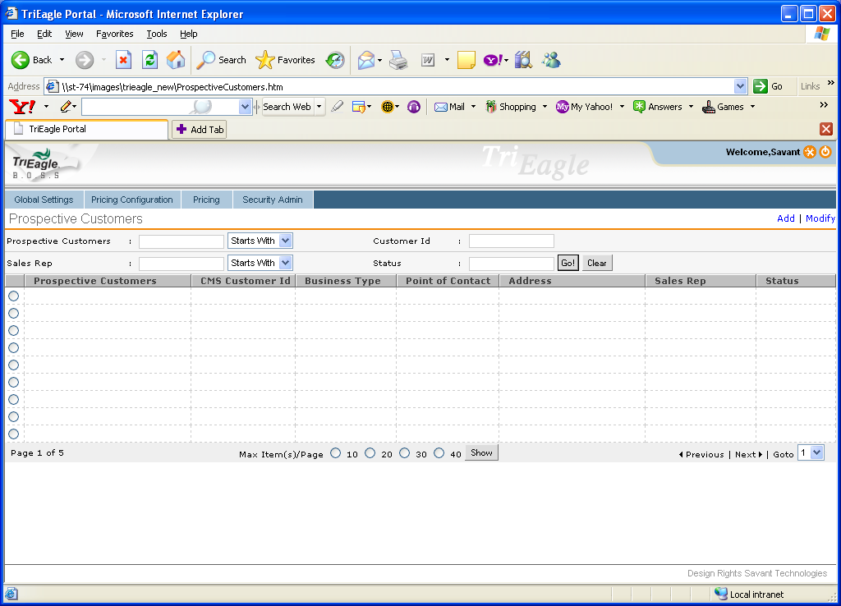

Pricing -> Prospective Customers -> Add -> Import PIC

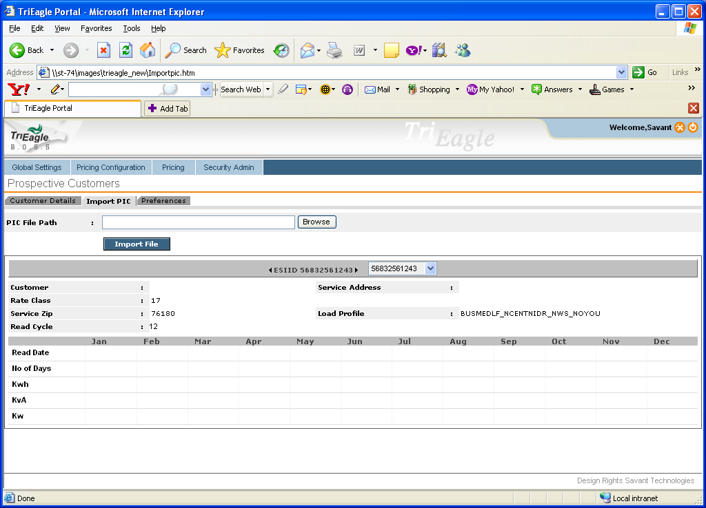

Pricing -> Prospective Customers -> Add -> Preferences

