Image Comparator - Troubleshooting Guide

Image Compare is a very simple and easy-to-use application and you will simply need to launch the application and get started. That still does not rule out the fact that there might be a few issues coming in the way. This document helps you troubleshoot the common problems that you might encounter when using Image Comparator.

Image Comparator Web Portal Link : <https://imageprocessorengine.azurewebsites.net/>

#### User complain they are unable to upload images that passed validation

Image Comparator uploads the image files upon validation to the Azure Blob Storage. The connectivity to the storage is established using the Connection String of the storage account. Please validate if the right connection string is configured.

**Solution**

* Navigate to Azure Portal and Login
* Browse to the storage account **imagestorelz**
* On the left pane, navigate to keys to find the Connection String for the storage account

#### User wants to perform a bulk upload of Image files

#### User reaches out to perform a bulk upload of a bunch of image files to the blob storage for comparison.

#### Solution

#### Download Azure Storage Explorer

#### Get the Connection String of the Storage Account

* + Navigate to Azure Portal and Login
  + Browse to the storage account **imagestorelz**
  + On the left pane, navigate to keys to find the Connection String
* Login to the Blob Storage via. Azure Storage Explorer
* Browse to the Landing Zone folder
* Upload the files provided by the user in bulk and confirm back to the user (*please note the validations will be skipped here*)

**How do I check how many users are using the application?**

Azure inbuilt offering AppInsights has been leveraged to log the Telemetry of the tool.

Solution:

* Logon to [AppInsights](https://portal.azure.com/#@muralekarthickoutlook.onmicrosoft.com/resource/subscriptions/b58f80bc-e524-42e0-bb3e-e45859f3c207/resourceGroups/ImageProcessingProd/providers/microsoft.insights/components/ImageProcessorEngineWeb/overview)
* Go to the Usage section on the left navigation pane to find out the usage details

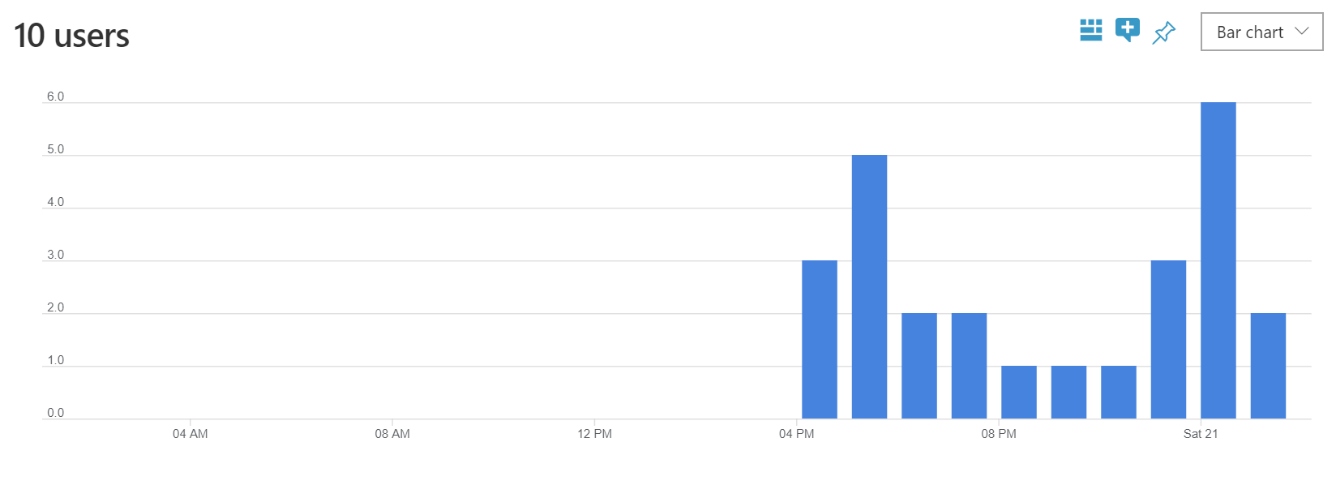

**How do I check for exceptions in Application Insights?**

Azure inbuilt offering AppInsights has been leveraged to log the Telemetry of the tool.

Solution:

* Logon to [AppInsights](https://portal.azure.com/#@muralekarthickoutlook.onmicrosoft.com/resource/subscriptions/b58f80bc-e524-42e0-bb3e-e45859f3c207/resourceGroups/ImageProcessingProd/providers/microsoft.insights/components/ImageProcessorEngineWeb/overview)
* Go to the Search section on the left navigation pane to find out the usage details

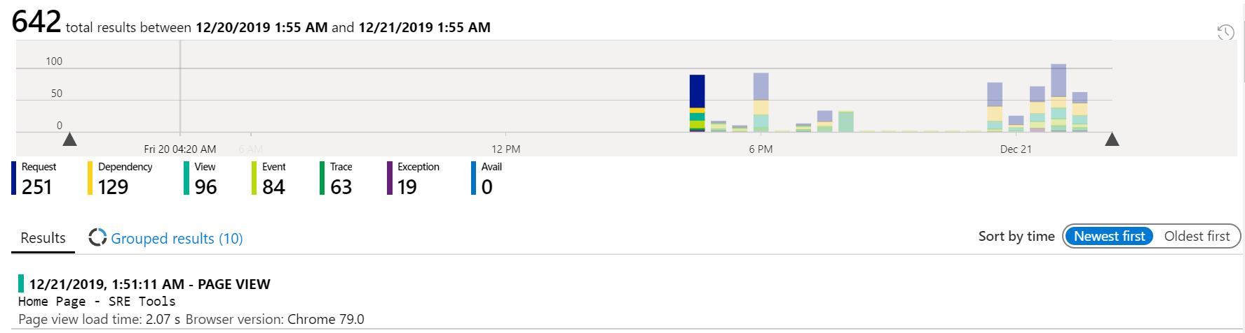

**Entire application is down. What do I do?**

Please check if there are any outages with Azure at <https://status.azure.com/en-us/status>. If Azure is down, kindly contact Azure support based on the support contract.