Product Requirements Document (PRD)

BOSS NextGen – Enterprise Customs Brokerage System
Version: 1.0
Document Type: Product Requirements Document
Product: BOSS NextGen Customs Brokerage Platform
Author: Product Management

Chapter 1 – Product Vision & Scope
1.1 Executive Summary
BOSS NextGen is an enterprise Customs Brokerage Management Platform designed to automate the end-to-end customs clearance lifecycle for international and domestic shipments. The platform enables customs brokers, freight forwarders, logistics providers, and compliance teams to process import, export, transit, bonded, FTZ, and domestic shipments while complying with customs regulations across multiple countries.
The system serves as the operational backbone for customs brokerage by integrating shipment information from logistics systems, classifying shipments, calculating duties and taxes, preparing customs declarations, managing regulatory requirements, and communicating with government customs systems.
The platform aims to minimize manual effort, improve regulatory compliance, reduce shipment clearance time, and provide complete auditability throughout the brokerage process.

1.2 Product Vision
To become the industry's most intelligent customs brokerage platform by automating customs compliance, declaration processing, duty calculation, and regulatory workflows while enabling brokers to process high shipment volumes with minimal manual intervention.

1.3 Product Goals
Business Goals
- Reduce declaration processing time by 70%.
- Achieve >99% customs declaration accuracy.
- Support fully automated shipment segregation.
- Minimize customs penalties through automated compliance validation.
- Support multi-country customs regulations.
- Reduce manual broker intervention.
- Increase declaration throughput.

Operational Goals
- Process over 500,000 shipments per day.
- Handle concurrent broker operations across multiple countries.
- Enable near real-time shipment processing.
- Provide full shipment traceability.

Compliance Goals
- Ensure compliance with customs regulations.
- Maintain complete audit history.
- Support electronic customs filing.
- Maintain configurable country-specific business rules.

1.4 Product Scope

The system supports the complete customs brokerage lifecycle.
In Scope

Shipment Processing
- Import shipments
- Export shipments
- Domestic shipments
- Cross-border shipments
- Free Trade Zone shipments
- Bonded shipments
- Courier shipments
- Air Freight
- Ocean Freight
- Road Freight
- Rail Freight

Brokerage Operations
- Shipment download
- Shipment validation
- Segregation
- Commodity management
- HS Classification
- Customs declaration
- Duty calculation
- Tax calculation
- Excise calculation
- Permit management
- Customs submission
- Customs response processing
- Clearance management
- Brokerage completion

Regulatory Compliance
- Restricted goods
- Controlled goods
- OGA requirements
- FTZ regulations
- Trade agreements
- Duty exemptions
- De Minimis rules
- Dangerous goods

Administration
- User management
- Customer profiles
- Lookup tables
- Customs rates
- Exchange rates
- Business rules
- Workflow configuration
- Audit logs

Out of Scope
Version 1 will not include:
- Warehouse Management
- Fleet Management
- Transportation Planning
- Financial ERP
- HR Management
- CRM
- Accounting Ledger
- Procurement
These systems will integrate with BOSS NextGen through APIs.

1.5 Business Objectives
The system must:
- Eliminate repetitive broker activities.
- Automate shipment classification.
- Automatically determine customs processing paths.
- Automatically calculate government charges.
- Reduce customs rejection rates.
- Improve shipment visibility.
- Provide configurable workflows.
- Support country-specific regulations without code changes.

1.6 Stakeholders
Internal
- Product Owner
- Customs Operations Manager
- Brokerage Supervisor
- Customs Broker
- Compliance Officer
- Finance Team
- Customer Service
- IT Operations
- Developers
- QA Engineers
- Solution Architects

External
- Customs Authorities
- Government Agencies
- Freight Forwarders
- Airlines
- Shipping Lines
- Customers
- Importers
- Exporters
- Brokers
- Carriers

1.7 User Personas
Customs Broker
Responsibilities
- Review shipments
- Validate declarations
- Submit declarations
- Resolve customs errors
- Manage permits

Brokerage Supervisor
Responsibilities
- Monitor brokerage operations
- Assign workloads
- Review escalations
- Monitor KPIs
- Approve overrides

Compliance Officer
Responsibilities
- Manage regulations
- Configure rules
- Review violations
- Maintain lookup tables

Administrator
Responsibilities
- Configure system
- Manage users
- Manage permissions
- Configure integrations
- Maintain business rules

1.8 Success Metrics
KPI | Target
Shipment download success | >99.9%
Auto segregation | >95%
Auto duty calculation | >99%
Auto declaration creation | >90%
Customs submission success | >99%
Average declaration preparation | <2 min
Manual intervention | <10%
Customs rejection | <1%
System uptime | 99.95%

1.9 Assumptions
- Customs systems expose APIs.
- Exchange rates are available daily.
- HS Code master is maintained.
- Duty rates are regularly updated.
- Customer master data is accurate.
- Shipment data originates from upstream logistics systems.

1.10 Constraints
- Country-specific regulations differ.
- Customs APIs may have downtime.
- Some countries require manual approvals.
- Duty rules change frequently.
- Government service windows affect submissions.

1.11 High-Level Business Workflow
Shipment Received
│
▼
Shipment Validation
│
▼
Shipment Segregation
│
▼
HS Classification
│
▼
Commodity Processing
│
▼
Duty & Tax Calculation
│
▼
Permit Verification
│
▼
Declaration Generation
│
▼
Broker Review
│
▼
Government Submission
│
▼
Government Response
│
▼
Clearance
│
▼
Shipment Released
│
▼
Completed

Next Chapter
The next chapter will define the Business Domain Model, including the core entities—Shipment, Declaration, Commodity, Customer, Party, Permit, Charges, and Statuses—and their relationships. This model becomes the foundation for all subsequent modules and ensures consistent terminology and behavior throughout the platform.

Excellent. This is where the PRD starts becoming the blueprint for the entire product. Before writing any screens or APIs, every mature product team defines the business domain model. It ensures that everyone—product managers, architects, developers, QA, and business users—uses the same language and understands the same entities.

Chapter 2 – Business Domain Model
2.1 Purpose
The Business Domain Model defines the core business entities, their relationships, ownership, lifecycle, and responsibilities within the Customs Brokerage System.
This model serves as the single source of truth for:
- Functional requirements
- Database design
- APIs
- Business rules
- Workflow engine
- Reporting
- Audit
- Integrations

2.2 Core Business Entities
Customer
│
├── Shipper
├── Consignee
├── Importer
├── Exporter
└── Broker
│
▼
Shipment
│
├── Address
├── Monetary
├── Shipment Indicators
├── Documents
├── Packages
├── Events
└── References
│
▼
Declaration
│
├── Commodity
├── Charges
├── Permits
├── Adjustments
├── Customs Status
└── Submission
│
▼
Government Agency
│
▼
Clearance

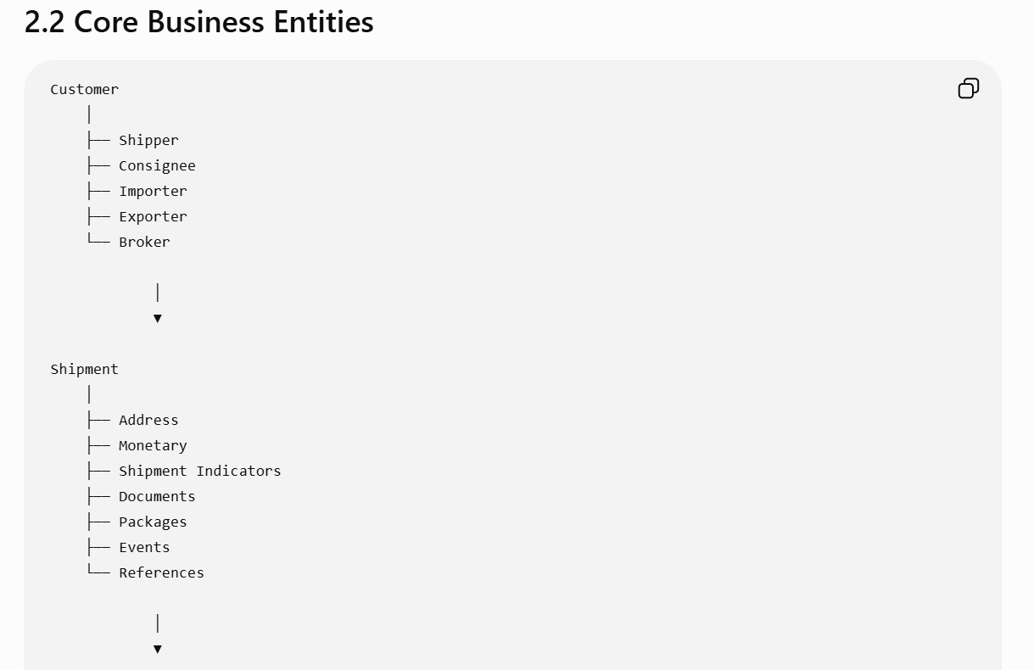

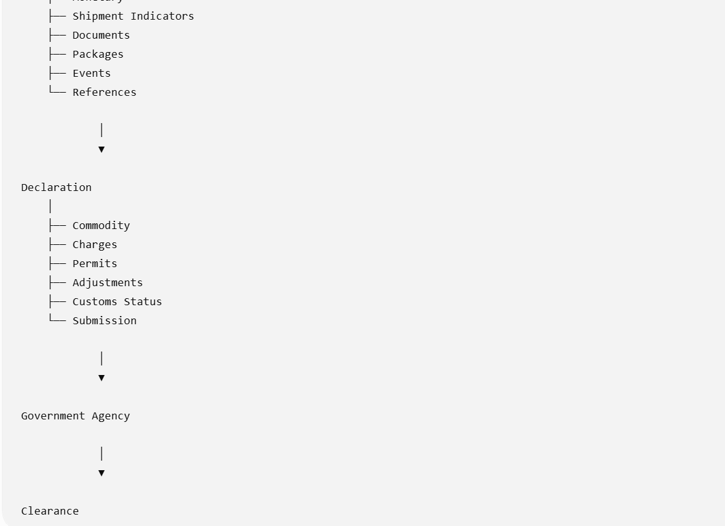

2.3 Shipment

Description
A Shipment is the primary business object that enters the brokerage platform. It represents a physical movement of goods requiring customs processing.
Every subsequent process—classification, declaration, duty calculation, permit validation, and customs submission—is initiated from a Shipment.

Shipment Attributes
Attribute | Description
Shipment Number | Unique shipment identifier
MAWB / HAWB | Air waybill numbers
Master / House Bill | Transport references
Import / Export | Shipment direction
Origin Country | Country of dispatch
Destination Country | Country of arrival
Carrier | Airline or shipping line
Flight / Voyage | Transport reference
Arrival Date | Estimated/Actual arrival
Service Type | Express, Economy, Freight
Shipment Type | Air, Ocean, Road, Rail
Shipment Status | Current operational status

Shipment Lifecycle

Created
↓
Downloaded
↓
Validated
↓
Brokerage Required
↓
Brokerage Processing
↓
Submitted
↓
Released
↓
Completed
↓
Archived

2.4 Parties
Every shipment has multiple parties.
Shipment
├── Shipper
├── Consignee
├── Importer
├── Exporter
├── Notify Party
├── Customs Broker
└── Freight Forwarder
Each party stores:
- Name
- Address
- Country
- Tax Registration
- Customs Registration
- Contact Information
- Compliance Flags

2.5 Commodity
A shipment contains one or more commodities.
Example
Shipment
→ iPhone
→ Battery
→ Charger
Each commodity has independent customs information.

Commodity Attributes
Attribute | Description
Commodity ID | Internal identifier
Description | Commercial description
HS Code | Customs classification
Country of Origin | Manufacturing country
Quantity | Declared quantity
Unit | KG, PCS, LTR
Customs Value | Declared value
Statistical Value | Customs statistical value
Duty | Government duty
Excise | Excise amount
Permit Required | Yes/No
Controlled Item | Yes/No

Commodity Lifecycle

Created
↓
HS Classified
↓
Duty Calculated
↓
Permit Checked
↓
Declared
↓
Submitted
↓
Accepted

2.6 Customs Declaration
A Declaration is the legal document submitted to customs.
A shipment may have:
- One declaration
- Multiple declarations
- Split declarations
- Consolidated declarations
- Amendment declarations

Declaration Attributes
Attribute | Description
Declaration Number | Customs declaration number
Clearance Type (CT) | Formal, Informal, FTZ, Domestic, etc.
Customs Status (CUS) | Processing state
Rating Status (RAT) | Internal brokerage state
Manifest Status (MAN) | Readiness for submission
Declaration Type | Import, Export, Transit
Currency | Declaration currency
Exchange Rate | Customs exchange rate
Submission Date | Filing timestamp

Declaration Lifecycle
Draft
↓
Prepared
↓
Validated
↓
Rated
↓
Ready
↓
Submitted
↓
Accepted
↓
Released
↓
Cancelled

2.7 Charges
Each declaration contains government and brokerage charges.
Examples include:
- Import Duty
- Excise Duty
- GST/VAT
- Brokerage Fee
- Storage
- Insurance
- Freight
- Miscellaneous Government Fees
Each charge includes:
- Charge Code
- Description
- Calculation Method
- Currency
- Taxable Flag
- Auto/Manual Indicator

2.8 Permit
Certain commodities require permits before customs clearance.
Permit information includes:
- Permit Number
- Issuing Agency
- Permit Type
- Issue Date
- Expiry Date
- Status
- Linked Commodity
A shipment may contain multiple permits.

2.9 Shipment Indicators
Indicators are business flags automatically or manually applied to a shipment.
Examples:
- DUT (Duty Payable)
- OGA (Government Agency Review)
- FTZ (Free Trade Zone)
- HFC (High Freight Charge)
- DDL (Documentation Delay)
- IBG (Importer Brokerage Group)
- AEO (Authorized Economic Operator)
Indicators influence:
- Segregation
- Workflow routing
- Broker attention
- Reporting
- SLA calculations

2.10 Customer Warnings
Warnings are customer-level compliance alerts inherited by shipments.
Examples:
- High-risk importer
- Requires manual review
- Special handling
- Preferred customer
- License verification required
Warnings can automatically generate shipment indicators or tasks.

2.11 Government Agency
The system integrates with customs and regulatory authorities.
Each agency maintains:
- Submission protocols
- Response codes
- Validation rules
- Permit requirements
- Service windows
- Acknowledgement messages

2.12 Business Relationships

Customer
│
▼
Shipment
│
├──── Addresses
├──── Packages
├──── Documents
├──── Monetary
├──── Indicators
├──── Events
│
▼
Declaration
│
├──── Commodity
│ │
│ ├──── HS Code
│ ├──── Charges
│ └──── Permits
│
├──── Adjustments
├──── Duties
├──── Taxes
├──── Customs Status
│
▼
Government Submission
│
▼
Customs Response
│
▼
Clearance

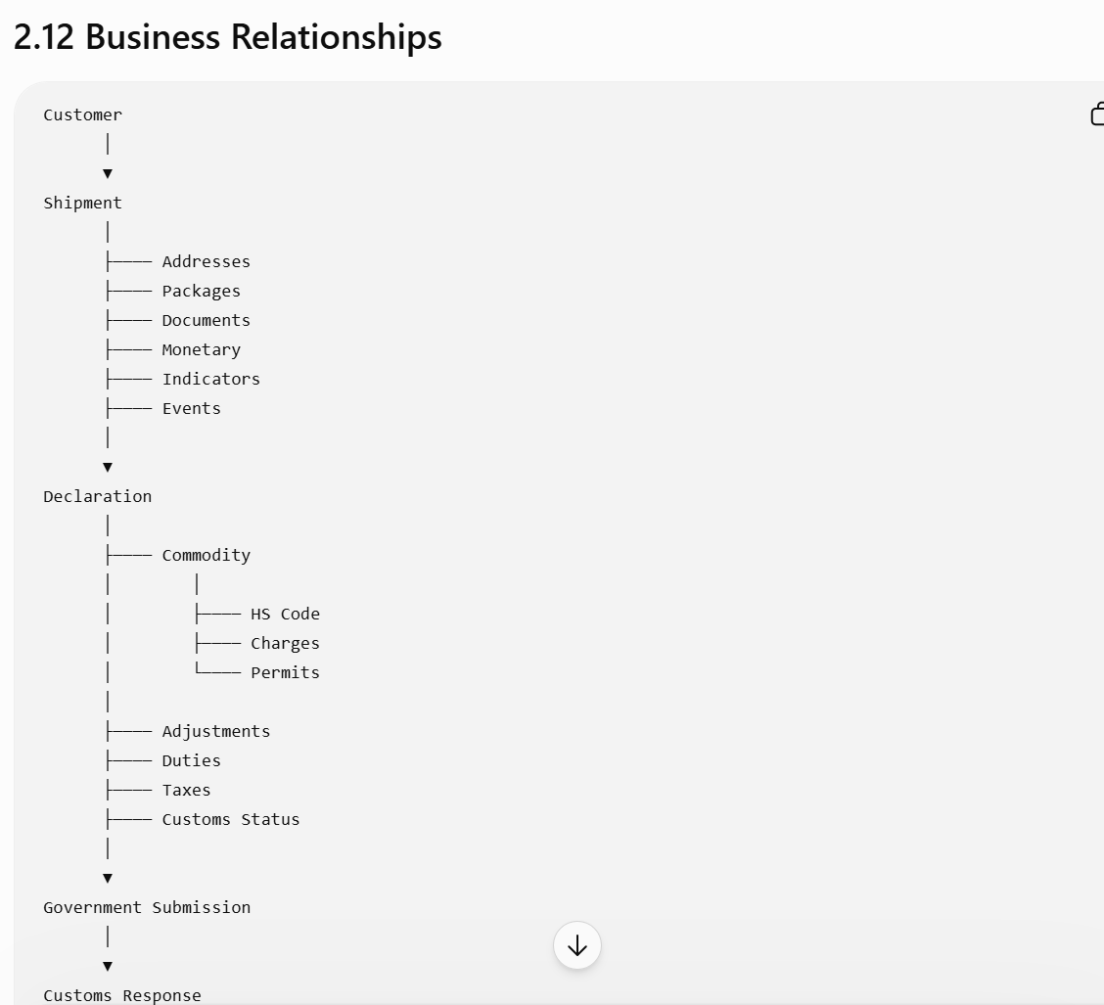

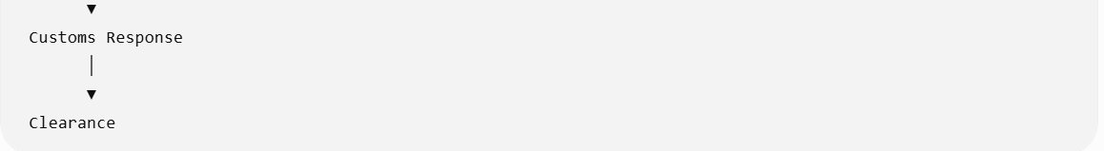

What Comes Next?
The next chapter should describe the End-to-End Brokerage Business Process. Instead of looking at individual entities, it follows the entire journey of a shipment—from the moment it enters the system until customs clearance and release.
This chapter will include:
- A swimlane process diagram (Operations, Broker, System, Customs Authority)
- Trigger points and business events
- Decision points (e.g., FTZ, controlled goods, dutiable goods)
- Status transitions (CT, RAT, CUS, MAN)
- Exception handling (rejections, amendments, inspections)
- Service-level expectations (SLAs)
That process flow becomes the backbone for every feature and user story that follows in the PRD.
Great. This chapter is usually the most valuable part of an enterprise PRD because it describes how the entire brokerage business operates, independent of screens or technology.

Chapter 3 – End-to-End Brokerage Business Process
3.1 Purpose
This chapter defines the operational workflow of a shipment as it progresses through the customs brokerage lifecycle.
It answers:
- What happens when a shipment arrives?
- Which system performs each action?
- When is broker intervention required?
- Which business rules are executed?
- When are customs authorities involved?
- What happens after submission?

3.2 High-Level Workflow
External Logistics System
│
▼
Receive Shipment
│
▼
Validate Shipment
│
▼
Auto Segregation
│
▼
Brokerage Required?
│
┌───┴───────────────┐
│ │
No Yes
│ │
Release Create Declaration
│
▼
Commodity Classification
│
▼
Duty & Tax Calculation
│
▼
Permit Verification
│
▼
Compliance Validation
│
▼
Broker Review Required?
┌───┴────┐
│ │
No Yes
│ │
│ Manual Review
│ │
└───┬────┘
▼
Customs Submission
│
▼
Government Processing
│
┌─────────────┼─────────────┐
▼ ▼ ▼
Accepted Rejected Inspection
│ │ │
▼ ▼ ▼
Clearance Amendment Inspection
│ │ │
└─────────────┼─────────────┘
▼
Shipment Released
│
▼
Brokerage Closed

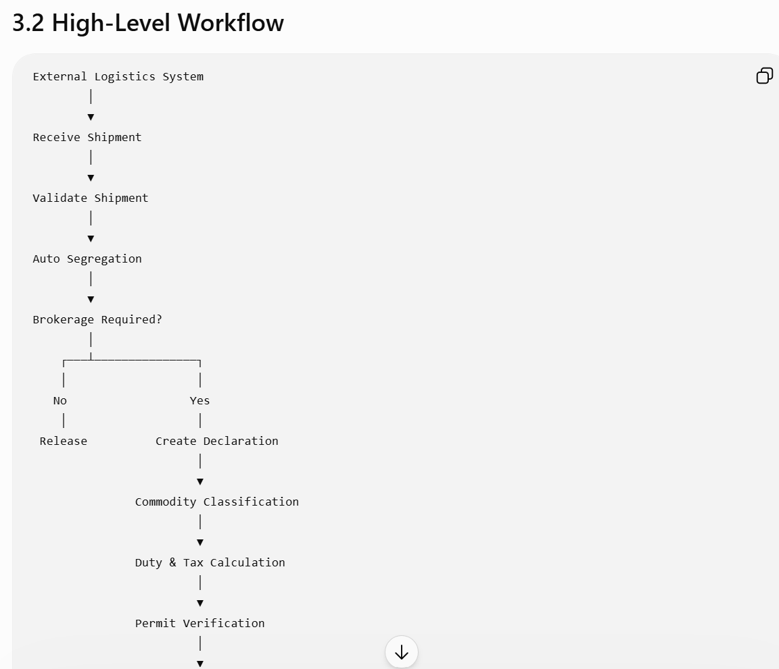

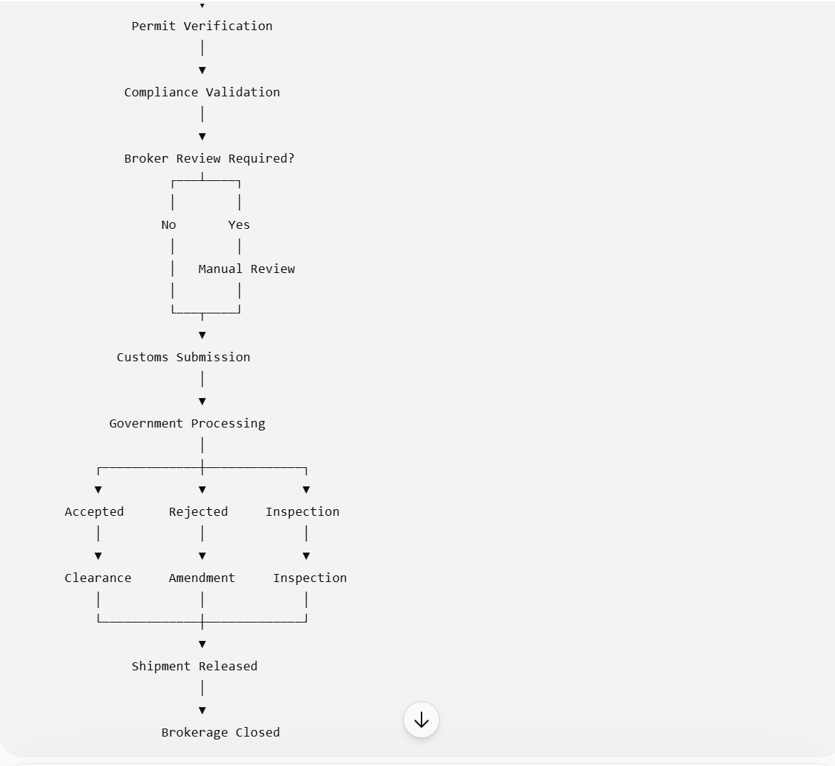

3.3 Process Participants
Actor | Responsibility
Upstream Logistics System | Sends shipment information
BOSS Platform | Validates, segregates, calculates duties, generates declarations
Customs Broker | Reviews exceptions, completes declarations, submits to customs
Compliance Officer | Resolves regulatory issues and permit requirements
Customs Authority | Validates declarations and issues clearance decisions
Government Agencies (OGA) | Approve controlled goods and permits
Finance | Processes duties, taxes, and brokerage charges

3.4 Detailed Process

Stage 1 – Shipment Download

Trigger
A shipment is transmitted from an upstream logistics or freight management system.
Inputs
- MAWB/HAWB or Bill of Lading
- Shipper and Consignee details
- Importer and Exporter
- Addresses
- Packages
- Commodity descriptions
- Invoice values
- Freight and insurance
- Transport information
- Shipment references
System Actions
- Validate mandatory fields.
- Create shipment record.
- Generate unique shipment ID.
- Store audit event.
- Initialize shipment status as Downloaded.
Exceptions
- Duplicate shipment
- Invalid customer
- Missing mandatory data
- Unsupported country
- Corrupted message format

Stage 2 – Shipment Validation
The platform performs business validations before brokerage begins.
Validation includes:
- Customer exists
- Country codes are valid
- Currency is supported
- Transport mode is valid
- Commodity descriptions are present
- Required documents are attached
- Mandatory addresses exist
If validation fails, the shipment enters Validation Error status and a broker task is created.

Stage 3 – Shipment Segregation
The Segregation Engine determines the processing path using configurable business rules.
Decision factors include:
- Import or Export
- Origin and destination countries
- Shipment value
- Customer profile
- HS Code
- Commodity type
- Shipment indicators
- Customer warnings
- Postal codes
- FTZ locations
- Controlled goods
- Dutiable goods
- Dangerous goods
Typical outcomes:
Condition | Clearance Type (CT)
Low-value import | Informal
Controlled goods | Formal
FTZ destination | FTZ
Domestic shipment | DOM
Land border | LND
De Minimis | DEM
Alternate broker | ABK

Stage 4 – Declaration Creation
If brokerage is required, the system automatically creates a draft customs declaration.
The declaration includes:
- Parties
- Commodity lines
- Currency
- Customs office
- Declaration type
- Clearance type
- Initial statuses (CT, RAT, CUS, MAN)

Stage 5 – Commodity Classification
Each commodity line is processed independently.
The system:
- Validates HS Code.
- Retrieves customs tariff.
- Determines:
  - Duty rate
  - Excise rate
  - Permit requirements
  - OGA requirements
  - Restrictions
  - Statistical unit
- Flags missing or invalid classifications for broker review.

Stage 6 – Duty & Tax Calculation
The Calculation Engine computes all applicable government charges.
Calculation sequence:
- Customs Value
- Freight Adjustment
- Insurance Adjustment
- Statistical Value
- Import Duty
- Excise Duty
- GST/VAT
- Government Fees
- Brokerage Charges
All calculations are logged with formulas, rates, and source tables for audit purposes.

Stage 7 – Permit Verification
The Permit Engine checks whether any commodity requires regulatory approval.
It evaluates:
- HS Code
- Commodity description
- Country of origin
- Country of destination
- Government agency rules
If a permit is required:
- A permit request task is created.
- Declaration submission is blocked until the permit is approved.
- The shipment status changes to Awaiting Permit.

Stage 8 – Compliance Validation
The Compliance Engine performs final regulatory checks, including:
- Restricted goods
- Sanctioned parties
- Dual-use goods
- Dangerous goods
- Customer compliance flags
- Document completeness
- Value thresholds
- Licensing requirements
Only compliant declarations proceed to submission.

Stage 9 – Broker Review
Manual review is required when:
- HS Code cannot be determined.
- Duty calculations require adjustment.
- Mandatory permits are missing.
- Customs documentation is incomplete.
- Compliance exceptions exist.
- The customs authority requests clarification.
The broker can:
- Edit declaration data.
- Modify commodity details.
- Upload documents.
- Add remarks.
- Request supervisor approval.
- Resubmit the declaration.

Stage 10 – Customs Submission
When all validations pass, the declaration is electronically transmitted to the relevant customs authority.
System actions:
- Generate submission payload.
- Validate payload format.
- Digitally sign the message (if required).
- Transmit via API or EDI.
- Record submission timestamp.
- Await acknowledgement.

Stage 11 – Customs Response Processing
The platform processes responses such as:
Response | Action
Accepted | Continue to clearance
Rejected | Create broker work item
Inspection Required | Hold shipment and notify broker
Permit Required | Await permit
Additional Documents Requested | Request supporting documents
System Error | Retry according to configured policy
All responses are recorded in the shipment event history.

Stage 12 – Clearance & Release
Once customs approves the declaration:
- Clearance status is updated.
- Release date is recorded.
- Shipment is marked ready for delivery.
- Downstream logistics systems are notified.
- Financial postings and reporting are completed.

3.5 SLA Targets
Process | Target
Shipment download | < 30 seconds
Validation | < 10 seconds
Segregation | < 5 seconds
Declaration creation | < 15 seconds
Duty calculation | < 5 seconds
Compliance checks | < 10 seconds
Submission preparation | < 30 seconds
Customs response processing | Real-time where supported

Next Chapter
The next chapter, Chapter 4 – Shipment Management Module, begins the detailed functional specification for each module. It will define the Shipment entity in depth, including:
- Screen layouts and user interactions
- CRUD operations
- Validation rules
- Shipment events and lifecycle
- Status management
- Search and filtering
- Document attachments
- Audit history
- Integration points
- Business rules
- Acceptance criteria
From this point onward, the PRD shifts from process-level design to module-level specifications suitable for implementation.
Excellent. Now we transition from the overall business process into detailed module specifications. This is where the PRD becomes directly actionable for UX designers, developers, testers, and solution architects.

Chapter 4 – Shipment Management Module

4.1 Module Overview
The Shipment Management Module is the entry point of the Customs Brokerage Platform. It receives shipment information from upstream logistics systems or manual entry and maintains the shipment throughout its lifecycle.
Every downstream process—including segregation, customs declaration, duty calculation, permit validation, compliance checks, and customs submission—depends on the accuracy and completeness of shipment data.

4.2 Objectives
The Shipment Management Module shall:
- Capture shipment information from multiple sources.
- Validate shipment data before brokerage processing.
- Support manual updates by authorized users.
- Maintain shipment history and audit logs.
- Trigger downstream brokerage workflows.
- Support high-volume processing with near real-time performance.

4.3 Actors
Actor | Responsibilities
Logistics System | Creates and updates shipment records
Customs Broker | Reviews and updates shipment information
Operations User | Monitors shipment status
Compliance Officer | Reviews regulatory information
System Administrator | Configures shipment rules
Integration Services | Exchanges shipment data with external systems

4.4 Shipment Lifecycle
Draft
│
▼
Downloaded
│
▼
Validated
│
▼
Brokerage Required
│
▼
Declaration Created
│
▼
Customs Processing
│
▼
Released
│
▼
Completed
│
▼
Archived

4.5 Shipment Data Model
Shipment Header
Field | Type | Required | Editable | Description
Shipment Number | String | Yes | No | System-generated unique identifier
Shipment Direction | Enum | Yes | No | Import, Export, Transit, Domestic
Shipment Type | Enum | Yes | No | Air, Ocean, Road, Rail
Carrier | String | Yes | Yes | Carrier or transport provider
MAWB/BL Number | String | Yes | No | Master transport document
HAWB/HBL Number | String | No | Yes | House transport document
Flight/Voyage | String | No | Yes | Flight or vessel reference
Origin Country | Country Code | Yes | No | Shipment origin
Destination Country | Country Code | Yes | No | Shipment destination
ETA | DateTime | No | Yes | Estimated arrival
ATA | DateTime | No | Yes | Actual arrival
Current Status | Enum | Yes | No | Shipment processing status

4.6 Shipment Sub-Entities
A shipment consists of multiple child entities:
Shipment
│
├── Parties
├── Addresses
├── Packages
├── Commodity Lines
├── Monetary Information
├── Documents
├── References
├── Shipment Indicators
├── Events
├── Notes
├── Tasks
└── Audit History
Each child entity has independent validation and audit tracking.

4.7 Functional Requirements
FR-001: Shipment Creation
Description:
The system shall create a shipment record upon receiving a valid message from an upstream logistics system.
Acceptance Criteria:
- Shipment Number is unique.
- Duplicate shipments are rejected or merged based on configurable rules.
- Shipment status is set to Downloaded.
- Creation timestamp and source system are recorded.

FR-002: Shipment Validation
Description:
The system shall validate mandatory shipment data before brokerage processing begins.
Validation Rules:
- Shipment Number must exist.
- Origin Country must be valid.
- Destination Country must be valid.
- At least one commodity line must exist.
- Shipper and Consignee must be present.
- Currency must be supported.
- Total shipment value must be greater than zero (configurable).
Failure Handling:
- Set status to Validation Error.
- Generate validation messages.
- Prevent declaration creation until errors are resolved.

FR-003: Shipment Update
Authorized users may update editable fields before customs submission.
Editable Examples:
- Arrival Date
- Flight Number
- Commodity Description
- Package Details
- Contact Information
- Internal Notes
Restricted Fields (after submission):
- Shipment Number
- Declaration Number
- Submitted Commodity Values
- Submitted HS Codes
Changes after submission require an amendment workflow.

FR-004: Shipment Search
Users shall be able to search using:
- Shipment Number
- MAWB
- HAWB
- Importer
- Exporter
- Shipper
- Consignee
- Flight Number
- Carrier
- Date Range
- Clearance Type
- Shipment Status
- Declaration Number
- Customs Status
Search results shall support pagination, sorting, and export.

FR-005: Shipment Indicators
The system shall automatically assign indicators based on configurable rules.
Examples:
- DUT
- FTZ
- OGA
- DDL
- HFC
- AEO
Users with appropriate permissions may add or remove indicators manually, subject to audit logging.

FR-006: Event Logging
Every significant shipment event shall be recorded.
Event | Example
Created | Shipment received
Updated | Commodity edited
Indicator Added | DUT assigned
Validation Failed | Missing consignee
Declaration Created | Draft generated
Submitted | Sent to customs
Released | Clearance received
Each event records:
- Timestamp
- User or system
- Event type
- Previous value
- New value
- Comments (optional)

4.8 Business Rules
Rule ID | Description
BR-SHP-001 | Shipment Number must be unique.
BR-SHP-002 | A shipment must contain at least one commodity.
BR-SHP-003 | Import shipments require an importer.
BR-SHP-004 | Export shipments require an exporter.
BR-SHP-005 | Shipment cannot be deleted after declaration creation.
BR-SHP-006 | Submitted shipments require amendment workflow for edits.
BR-SHP-007 | Every shipment event must be auditable.

4.9 Permissions Matrix
Action | Broker | Supervisor | Admin
View Shipment | ✓ | ✓ | ✓
Edit Shipment | ✓ | ✓ | ✓
Delete Draft Shipment | ✗ | ✓ | ✓
Override Validation | ✗ | ✓ | ✓
Add Indicators | ✓ | ✓ | ✓
Configure Rules | ✗ | ✗ | ✓

4.10 Non-Functional Requirements
- Availability: 99.95% uptime.
- Performance: Search results within 2 seconds for up to 1 million records.
- Scalability: Support at least 500,000 new shipments per day.
- Auditability: Every change must be traceable.
- Security: Role-based access control with field-level permissions for sensitive data.

4.11 Sample User Journey
- Shipment message arrives from the logistics system.
- BOSS creates a shipment record and validates mandatory data.
- The shipment is assigned an initial status of Downloaded.
- Validation succeeds, and the Segregation Engine determines the appropriate clearance type.
- A customs declaration is automatically created.
- The broker reviews and supplements shipment details if necessary.
- The shipment proceeds through the remaining brokerage workflow.

Chapter 5 Preview – Segregation Engine

The next chapter will define one of the most critical modules: the Segregation Engine. This module determines how every shipment should be processed by evaluating hundreds of configurable business rules—such as shipment value, origin/destination, HS code, customer profile, Free Trade Zone (FTZ), controlled goods, customer warnings, shipment indicators, permits, and regulatory requirements. It will specify the rule evaluation order, decision tables, conflict resolution, extensibility, and administration capabilities, providing the foundation for automated customs brokerage.
Excellent. This chapter is the heart of an enterprise Customs Brokerage System. In products like CargoWise, Descartes, Livingston, SAP GTS, and BOSS, the Segregation Engine is what differentiates the platform. Almost every downstream process depends on its decision.

Chapter 5 – Shipment Segregation Engine
Module ID: SEG-001
Priority: Critical
Dependencies: Shipment Management
Consumers: Declaration Engine, Rating Engine, Compliance Engine, Workflow Engine

5.1 Purpose
The Segregation Engine automatically determines the appropriate customs processing path for every shipment.
Instead of brokers manually deciding whether a shipment should be Formal, Informal, FTZ, Domestic, Landed, Alternate Broker, or De Minimis, the engine evaluates configurable business rules and assigns the correct clearance type (CT).
The engine must be:
- Rule-driven
- Configurable
- Explainable (decision trace)
- Extensible
- Country-specific
- High-performance

5.2 Objectives
The engine shall:
- Evaluate shipments automatically.
- Eliminate manual classification.
- Apply country-specific regulations.
- Support multiple rule sets.
- Reduce broker intervention.
- Maintain a full audit trail.
- Re-evaluate when shipment data changes.

5.3 Trigger Points
The Segregation Engine shall execute when:
Trigger | Description
Shipment Download | Initial classification
HS Code Updated | Re-evaluate classification
Customer Updated | Customer rules changed
Shipment Indicator Added | Re-process workflow
Commodity Added | Classification may change
Commodity Removed | Classification may change
Permit Updated | Regulatory status changed
Country Changed | Regulatory rules changed
Broker Requests Re-segregation | Manual override

5.4 Inputs
The engine evaluates multiple data sources.
Shipment
- Origin
- Destination
- Shipment Type
- Import/Export
- Shipment Value
- Weight
- Service Type

Customer
- Importer
- Exporter
- Broker
- Customer Warnings
- Compliance Flags
- Preferred Processing

Commodity
- HS Code
- Description
- Value
- Quantity
- Country of Origin
- Controlled Goods Flag
- Dangerous Goods Flag
- Permit Requirement

External Reference Data
- FTZ Postal Codes
- Restricted Goods Lists
- Sanctions Lists
- Customs Tariff
- Duty Tables
- Excise Tables
- Lookup Tables

Shipment Indicators
Examples:
- DUT
- OGA
- IBG
- FTZ
- AEO
- HFC
- DDL

5.5 Outputs
The engine produces:
Output | Description
CT | Clearance Type
RAT | Rating Status
CUS | Customs Status
MAN | Manifest Status
Shipment Indicators | Auto-generated indicators
Broker Tasks | If manual review required
Decision Trace | Complete explanation of rules applied

5.6 Supported Clearance Types
Code | Description
FML | Formal Clearance
INF | Informal Clearance
FTZ | Free Trade Zone
DOM | Domestic
DEM | De Minimis
LND | Land Border
ABK | Alternate Broker
TRS | Transit
EXP | Export
IMP | Standard Import
Each clearance type has its own downstream workflow.

5.7 Rule Evaluation Pipeline
The engine executes rules in a deterministic order.
Shipment Received
│
▼
Country Rules
│
▼
Customer Rules
│
▼
Shipment Rules
│
▼
Commodity Rules
│
▼
HS Code Rules
│
▼
Duty Rules
│
▼
Permit Rules
│
▼
Shipment Indicators
│
▼
Warning Rules
│
▼
Final CT Assignment
│
▼
Status Update

5.8 Rule Categories
Country Rules
Examples:
- Domestic shipment
- Cross-border
- FTZ
- Transit
Example:
IF Origin = SG
AND Destination = SG
THEN
CT = DOM

Customer Rules
Examples:
- Alternate Broker
- VIP Customer
- Compliance Hold
- Preferred Broker
Example:
IF Importer uses Alternate Broker
THEN
CT = ABK

HS Code Rules
Examples:
IF HS Code Controlled
THEN
CT = FML
This aligns with the type of logic found in your uploaded user stories.

Duty Rules
Example
Duty > 0
↓
Formal Clearance

Permit Rules
Example
Permit Required
↓
Formal Clearance
↓
Broker Review

Warning Rules
Customer Warning
↓
IBG
↓
Add Shipment Indicator
↓
Update Workflow

5.9 Rule Priority
Conflicting rules are resolved by priority.
Priority | Rule Type
1 | Legal Restrictions
2 | Government Agency Requirements
3 | Controlled Goods
4 | Permit Rules
5 | FTZ
6 | Customer Rules
7 | Shipment Value
8 | Service Rules
9 | Default Rules
Higher-priority rules override lower-priority rules.

5.10 Decision Table (Illustrative)
Condition | Result
Origin = SG & Destination = SG | CT = DOM
Destination in FTZ | CT = FTZ
HS Code Controlled | CT = FML
Permit Required | CT = FML
Duty > 0 | CT = FML
Import Value below De Minimis threshold | CT = DEM
Alternate Broker Customer | CT = ABK
Otherwise | CT = INF

5.11 Re-Segregation
The engine automatically re-evaluates when key attributes change.
Examples:
- HS Code edited
- Customer changed
- Commodity added
- Commodity removed
- Shipment indicators updated
- Customer warnings modified
- Country changed
A new decision trace is generated, preserving previous evaluations for audit.

5.12 Manual Override
Authorized users (e.g., Supervisors) may override the assigned Clearance Type.
Requirements:
- Override reason is mandatory.
- Original decision is retained.
- Override is timestamped.
- User identity is recorded.
- Downstream modules are notified to reprocess affected statuses and calculations.

5.13 Audit & Explainability
Every segregation decision must be fully traceable.
Example Decision Trace:
Step | Rule | Outcome
1 | Country Rule | International shipment
2 | FTZ Check | Not applicable
3 | HS Code | Controlled commodity
4 | Permit Rule | Permit required
5 | Final Decision | CT = FML
This trace should be viewable from the shipment for operational transparency.

5.14 Acceptance Criteria
- The engine evaluates all applicable rules in the configured order.
- Rule outcomes are deterministic and repeatable.
- Configuration changes take effect without application deployment.
- Decision traces are available for all automated classifications.
- Re-segregation is triggered only when relevant data changes.
- Manual overrides are audited and propagated to dependent modules.

Next Chapter – Customs Declaration Management
The next chapter will define the Declaration Management Module, including:
- Declaration lifecycle (Draft → Submitted → Accepted → Released)
- Declaration header and line-item data
- Multi-declaration and split-declaration support
- Amendment and cancellation workflows
- Status management (CT, RAT, CUS, MAN)
- Validation rules before submission
- Integration with customs gateways
- Error handling, acknowledgements, and resubmission logic
This module will build directly on the Shipment Management and Segregation Engine, serving as the legal representation of the shipment submitted to customs authorities.
Excellent. Now we're entering what I consider the core of the product. Everything we've written so far has been building toward this module.
In enterprise customs brokerage systems, the Declaration Management Module is the legal and operational centerpiece. Every calculation, validation, permit, compliance check, and customs interaction ultimately converges here.

Chapter 6 – Customs Declaration Management
Module ID: DEC-001
Priority: Critical
Dependencies: Shipment Management, Segregation Engine, Commodity Management, Duty Engine, Permit Management

6.1 Purpose
The Declaration Management Module is responsible for creating, maintaining, validating, submitting, amending, and tracking customs declarations throughout their lifecycle.
A declaration is the legally recognized representation of a shipment submitted to a customs authority. It must accurately reflect the shipment's commodities, values, duties, taxes, permits, and supporting documentation.
The module supports:
- Import declarations
- Export declarations
- Transit declarations
- FTZ declarations
- Domestic declarations (where applicable)
- Split declarations
- Consolidated declarations
- Amendment declarations
- Cancellation requests

6.2 Objectives
The Declaration Management Module shall:
- Automatically generate declarations from validated shipments.
- Support manual review and updates before submission.
- Maintain version history for every declaration.
- Ensure compliance with country-specific customs regulations.
- Integrate with government customs systems.
- Provide complete traceability and auditability.
- Support multiple declaration scenarios for a single shipment.

6.3 Actors
Actor | Responsibilities
Customs Broker | Review, edit, submit declarations
Brokerage Supervisor | Approve overrides and amendments
Compliance Officer | Verify regulatory compliance
Finance | Review duties, taxes, and fees
Customs Authority | Receive and process declarations
System | Generate, validate, and transmit declarations

6.4 Declaration Lifecycle
Draft
│
▼
Prepared
│
▼
Validated
│
▼
Ready for Submission
│
▼
Submitted
│
▼
Acknowledged
│
▼
Accepted
│
▼
Released
│
▼
Completed
Alternate Paths
Submitted
│
├── Rejected
│ │
│ ▼
│ Broker Correction
│ │
│ ▼
│ Resubmission
│
├── Inspection Required
│
├── Permit Required
│
└── Amendment Requested

6.5 Declaration Types
Type | Description
Import | Goods entering the country
Export | Goods leaving the country
Transit | Goods passing through customs territory
FTZ | Goods destined for a Free Trade Zone
Warehouse | Bonded warehouse declarations
Temporary Import | Temporary admission
Temporary Export | Temporary export
Amendment | Modification of a submitted declaration
Cancellation | Withdrawal of a declaration

6.6 Declaration Header
The declaration header captures information common to all commodity lines.
Field | Description
Declaration Number | Unique identifier
Declaration Type | Import / Export / Transit
Clearance Type (CT) | Determined by Segregation Engine
Customs Office | Office of lodgement
Filing Date | Submission date
Currency | Declaration currency
Exchange Rate | Customs exchange rate
Importer | Legal importer
Exporter | Legal exporter
Broker | Filing broker
Transport Mode | Air, Ocean, Road, Rail
Status | Current declaration status

6.7 Commodity Lines
Each declaration contains one or more commodity lines.
Each line includes:
- Commodity Description
- HS Code
- Quantity
- Unit of Measure
- Customs Value
- Statistical Value
- Country of Origin
- Duty Amount
- Excise Amount
- GST/VAT
- Permit References
- Supporting Documents
Each commodity line is independently validated.

6.8 Functional Requirements
FR-DEC-001 – Automatic Declaration Creation
Description:
Upon successful shipment validation and segregation, the system shall automatically generate a draft declaration.
Acceptance Criteria:
- Header information is populated from the shipment.
- Commodity lines are created for all shipment commodities.
- Clearance Type (CT) is assigned from the Segregation Engine.
- Initial statuses (RAT, CUS, MAN) are set according to business rules.
- A declaration version number is initialized at 1.0.

FR-DEC-002 – Declaration Validation
Before submission, the system validates:
- Mandatory header fields.
- Commodity completeness.
- HS Code validity.
- Duty and tax calculations.
- Required permits.
- Customer compliance.
- Supporting documentation.
- Country-specific regulatory rules.
Validation errors are categorized as:
- Blocking (submission not allowed)
- Warning (submission allowed with broker acknowledgement)
- Informational (no action required)

FR-DEC-003 – Manual Editing
Authorized brokers may edit draft declarations before submission.
Editable fields include:
- Commodity descriptions
- HS Codes
- Customs values
- Supporting documents
- Broker remarks
- Permit references
After submission, edits require an amendment workflow.

FR-DEC-004 – Version Control
Every modification creates a new version of the declaration.
The system records:
- Version number
- User
- Timestamp
- Modified fields
- Reason for change
Previous versions remain immutable for audit purposes.

FR-DEC-005 – Split Declarations
The system shall support splitting a shipment into multiple declarations when required.
Examples:
- Different importers
- Different customs offices
- Controlled and non-controlled goods
- Permit segregation
- Value thresholds
Each declaration proceeds independently through validation and submission.

FR-DEC-006 – Consolidated Declarations
Multiple shipments may be combined into a single declaration when permitted by customs regulations.
Preconditions:
- Same importer/exporter
- Same customs office
- Same declaration type
- Compatible transport mode
- Regulatory approval

FR-DEC-007 – Amendment Workflow
If customs or the broker identifies errors after submission:
- Create amendment request.
- Clone the accepted declaration into a new editable version.
- Apply changes.
- Recalculate duties and taxes if required.
- Resubmit to customs.
- Preserve linkage between original and amended declarations.

FR-DEC-008 – Cancellation
Cancellation is permitted only when:
- The declaration has not been released.
- Customs regulations allow cancellation.
- Required approvals are obtained.
The cancellation request and customs response are fully audited.

6.9 Status Management
The module maintains and synchronizes the following statuses:
Status | Purpose
CT | Clearance Type
RAT | Internal processing status
CUS | Customs submission status
MAN | Manifest/readiness status
Status transitions are controlled by the Workflow Engine and governed by configurable business rules.

6.10 Business Rules (Examples)
Rule ID | Description
BR-DEC-001 | A declaration cannot be submitted if mandatory fields are missing.
BR-DEC-002 | At least one commodity line is required.
BR-DEC-003 | All commodity lines must have valid HS Codes.
BR-DEC-004 | Required permits must be approved before submission.
BR-DEC-005 | Submitted declarations are read-only except through amendment workflows.
BR-DEC-006 | Every declaration must maintain complete version history.

6.11 Audit Requirements
The following events shall be recorded:
- Declaration created
- Validation completed
- Field updated
- Version created
- Submitted to customs
- Customs acknowledgement received
- Customs acceptance
- Rejection
- Amendment
- Cancellation
- Release
Each audit record captures:
- Timestamp
- User/System
- Event
- Previous value
- New value
- Correlation ID (for integrations)

6.12 Non-Functional Requirements
- Support concurrent editing prevention (record locking or optimistic concurrency).
- Generate declarations within configurable performance targets.
- Ensure all submissions are idempotent to prevent duplicate filings.
- Encrypt declaration data at rest and in transit.
- Maintain an immutable audit history for regulatory compliance.

6.13 Integration Points
External System | Purpose
Shipment Management | Source shipment data
Segregation Engine | Determine CT and initial statuses
Duty & Tax Engine | Populate calculated charges
Permit Management | Validate permit requirements
Workflow Engine | Control lifecycle transitions
Customs Gateway | Submit declarations and receive responses
Document Management | Attach supporting documents

Architectural Note
One improvement I'd like to introduce compared with many legacy brokerage systems (including the style reflected in the BOSS user stories) is to make the platform configuration-driven rather than code-driven.
Instead of embedding rules like:
If HS Code is controlled → CT = FML
directly in application logic, the platform should evaluate rules stored in a configurable rule repository. This allows business analysts or compliance administrators to update customs policies, thresholds, and routing rules without requiring software releases.
This architectural principle will be reflected throughout the remaining chapters and will make the product more adaptable to changing customs regulations across different countries.
Next Chapter

Chapter 7 – Commodity Management will define:
- Commodity master and line-item management
- HS code assignment
- Valuation and origin
- Packaging and supplementary quantities
- Commodity-level charges
- Statistical value calculations
- Validation rules
- Audit and lifecycle management
This module will bridge Shipment Management and the HS Classification/Duty Calculation engines, providing the foundation for accurate customs declarations.
Excellent. Chapter 7 is one of the most important modules because everything in customs brokerage revolves around the commodity. Duties, taxes, permits, government agency requirements, valuation, declarations, inspections, and risk assessments are all determined at the commodity level.
In many legacy customs systems, commodity information is scattered across different modules. In BOSS NextGen, we'll make the Commodity a first-class business entity.

Chapter 7 – Commodity Management
Module ID: COM-001
Priority: Critical
Dependencies: Shipment Management, Declaration Management
Consumers: HS Classification, Duty & Tax Engine, Permit Engine, Compliance Engine, Customs Submission

7.1 Purpose
The Commodity Management Module manages every individual item declared to customs. It captures commercial, regulatory, valuation, and customs-related information required for declaration processing.
A shipment may contain one or many commodities, and each commodity is independently classified, valued, assessed for duties, checked for permits, and validated for compliance.
The module serves as the authoritative source for all commodity-level customs information.

7.2 Objectives
The module shall:
- Capture complete commodity information.
- Support manual and automated commodity creation.
- Enable accurate HS classification.
- Maintain customs valuation.
- Support permit and licensing requirements.
- Manage commodity-specific duties and taxes.
- Maintain a complete audit history.
- Support country-specific commodity rules.

7.3 Business Context
Shipment
│
▼
Declaration
│
▼
Commodity
│
┌──┼───────────────┐
▼ ▼ ▼
HS Code Duty & Tax Permit
│ │ │
▼ ▼ ▼
Compliance Statistical Value Government Agencies
A commodity is the smallest assessable customs unit.

7.4 Commodity Lifecycle
Created
│
▼
Validated
│
▼
HS Classified
│
▼
Valuated
│
▼
Duty Calculated
│
▼
Permit Checked
│
▼
Declaration Ready
│
▼
Submitted
│
▼
Accepted
Alternate Paths
HS Classification Failed
│
▼
Manual Classification
Permit Missing
│
▼
Awaiting Permit
Restricted Commodity
│
▼
Compliance Review

7.5 Commodity Data Model
Core Information
Field | Type | Required | Description
Commodity ID | UUID | Yes | System identifier
Line Number | Integer | Yes | Declaration line number
Commercial Description | String | Yes | Invoice description
Customs Description | String | Yes | Declaration description
HS Code | String | Yes | Harmonized System code
Country of Origin | Country | Yes | Manufacturing origin
Quantity | Decimal | Yes | Declared quantity
Unit of Measure | Enum | Yes | PCS, KG, LTR, MTR, etc.
Net Weight | Decimal | No | Weight excluding packaging
Gross Weight | Decimal | No | Weight including packaging
Customs Value | Decimal | Yes | Declared customs value
Currency | ISO Currency | Yes | Commodity currency

7.6 Commodity Classification Attributes
Each commodity shall maintain classification attributes independent of the shipment.
Attribute | Description
HS Code
Tariff Version
Customs Chapter
Customs Heading
Customs Subheading
Statistical Code
Commodity Category
Controlled Goods Flag
Dangerous Goods Flag
Strategic Goods Flag
Dual Use Goods Flag
Excise Applicable
Duty Applicable
These values may be derived automatically from tariff reference data.

7.7 Valuation
The customs value forms the basis for duty and tax calculations.
Components
Invoice Value
+
Freight
+
Insurance
+
Adjustments
-
Discounts
=
Customs Value
The calculation methodology shall be configurable to accommodate country-specific customs valuation regulations.

7.8 Statistical Value
Certain customs authorities require a statistical value distinct from the customs value.
Example formula:
Statistical Value =
(Customs Value × Exchange Rate)
+ Insurance Adjustment
+ Freight Adjustment
- Discount
The formula shall be configurable per jurisdiction.

7.9 Supplementary Quantities
Some HS Codes require supplementary units in addition to quantity.
Examples:
Commodity | Supplementary Unit
Alcohol | Litres
Fuel | Kilograms
Textiles | Square Metres
Chemicals | Kilograms
Cigarettes | Number of Sticks
Validation ensures mandatory supplementary quantities are provided when required.

7.10 Commodity Charges
Each commodity maintains its own charge breakdown.
Charge | Example
Duty
Excise
GST/VAT
Anti-Dumping Duty
Safeguard Duty
Environmental Levy
Luxury Tax
Each charge stores:
- Charge Code
- Calculation Method
- Rate
- Base Amount
- Calculated Amount
- Currency
- Source Rule

7.11 Functional Requirements
FR-COM-001 – Commodity Creation
The system shall create commodity lines:
- Automatically from shipment data.
- Manually by authorized brokers.
Each commodity receives a unique identifier and line number.

FR-COM-002 – Commodity Validation
Mandatory fields include:
- Description
- HS Code
- Country of Origin
- Quantity
- Unit of Measure
- Customs Value
Validation failures prevent declaration submission.

FR-COM-003 – Multiple Commodities
A declaration may contain an unlimited number of commodity lines, subject to country-specific customs limits.
Each line is processed independently.

FR-COM-004 – Commodity Splitting
A broker may split a commodity line when:
- Different countries of origin apply.
- Different HS Codes are required.
- Different permit requirements exist.
- Different customs values must be declared.
The system shall redistribute quantities and values proportionally or as entered by the user.

FR-COM-005 – Commodity Merging
Commodity lines may be merged if:
- HS Code is identical.
- Country of Origin is identical.
- Duty treatment is identical.
- Permit requirements are identical.
All merges must be auditable.

FR-COM-006 – Commodity Versioning
Every modification creates a new commodity version.
Captured information:
- Version Number
- User
- Timestamp
- Changed Fields
- Previous Values
- Reason

7.12 Business Rules
Rule ID | Description
BR-COM-001 | Every commodity shall have exactly one active HS Code.
BR-COM-002 | Customs value must be greater than zero unless explicitly exempt.
BR-COM-003 | Country of origin is mandatory.
BR-COM-004 | Controlled goods require permit evaluation.
BR-COM-005 | Commodity charges must be recalculated after valuation changes.
BR-COM-006 | Statistical value shall be recalculated whenever customs value, freight, insurance, exchange rate, or adjustments change.

7.13 Validation Rules
Validation | Severity
Missing HS Code | Blocking
Invalid HS Code | Blocking
Quantity ≤ 0 | Blocking
Unsupported Unit | Blocking
Missing Origin Country | Blocking
Customs Value Missing | Blocking
Description Too Short | Warning
Description Contains Generic Terms ("Parts", "Goods", "Items") | Warning

7.14 Audit Requirements
Every commodity event shall be recorded.
Examples:
- Commodity Created
- Description Updated
- HS Code Changed
- Customs Value Modified
- Duty Recalculated
- Permit Assigned
- Statistical Value Updated
- Submitted
- Accepted
- Amended
Each audit entry includes:
- Event Type
- Timestamp
- User/System
- Old Value
- New Value
- Correlation ID

7.15 Integration Points
Module | Interaction
Shipment Management | Receives commodity data
HS Classification Engine | Determines tariff classification
Duty & Tax Engine | Calculates government charges
Permit Management | Identifies permit requirements
Compliance Engine | Screens restricted goods
Declaration Management | Includes commodity lines in declarations
Reporting | Aggregates commodity analytics

7.16 Error Handling
Error Code | Description | Action
COM-001 | Missing HS Code | Prevent submission
COM-002 | Invalid Quantity | Reject commodity line
COM-003 | Duplicate Commodity | Flag for broker review
COM-004 | Missing Country of Origin | Prevent submission
COM-005 | Tariff Lookup Failure | Retry and escalate if unresolved
COM-006 | Valuation Calculation Error | Mark declaration as validation failed

7.17 Non-Functional Requirements
- Support at least 5,000 commodity lines within a single declaration where permitted by customs regulations.
- Commodity calculations shall complete within configurable performance thresholds.
- Tariff and valuation data shall be versioned so historical declarations can always be reproduced.
- Commodity updates shall trigger only dependent recalculations (e.g., duties, permits, statistical values) rather than recalculating the entire declaration where possible.
- Commodity history shall be immutable and retained according to jurisdiction-specific retention policies.

7.18 Future Capability – Intelligent Commodity Assistance
To modernize beyond traditional brokerage platforms, the module should support optional AI-assisted features:
- Suggest HS Codes based on commodity descriptions and historical classifications.
- Detect vague or non-compliant descriptions and recommend customs-friendly wording.
- Highlight inconsistencies between invoices, packing lists, and declarations.
- Recommend likely countries of origin based on supplier and product history.
- Learn from broker-approved classifications while maintaining human approval for regulatory decisions.

Next Chapter – Chapter 8: HS Classification Engine
The next chapter will specify one of the most sophisticated components of the platform: the HS Classification Engine. It will cover tariff master management, versioned HS code repositories, automated and manual classification workflows, customs chapter hierarchy, explanatory notes, country-specific tariff variations, confidence scoring for suggested classifications, auditability, and integration with duty, permit, and compliance engines. This engine will be designed to support accurate, explainable, and maintainable classification across multiple customs jurisdictions.
Excellent. Chapter 8 defines the intelligence of the Customs Brokerage Platform. While the Segregation Engine decides how a shipment is processed, the HS Classification Engine determines what the goods are from a customs perspective. It is the foundation for duty calculation, permit determination, trade compliance, valuation, statistical reporting, and government submissions.

Chapter 8 – HS Classification Engine
Module ID: HSC-001
Priority: Critical
Dependencies: Commodity Management, Shipment Management
Consumers: Duty & Tax Engine, Permit Management, Compliance Engine, Declaration Management, Reporting

8.1 Purpose
The HS Classification Engine is responsible for identifying and validating the correct Harmonized System (HS) Code for each commodity.
The engine supports:
- Automated classification
- Manual broker classification
- Tariff lookups
- Country-specific tariff variations
- Versioned tariff management
- Regulatory determination
- AI-assisted classification (optional)
- Classification audit and governance
The engine shall ensure that every commodity submitted to customs is associated with a valid and explainable HS classification.

8.2 Business Objectives
The engine shall:
- Reduce manual HS code selection.
- Improve classification accuracy.
- Minimize customs penalties.
- Support multiple tariff versions.
- Enable explainable classification decisions.
- Allow country-specific tariff extensions.
- Maintain historical classification integrity.

8.3 Business Context
Commodity
│
▼
HS Classification Engine
│
├──────────────┐
▼ ▼
Tariff Lookup AI Suggestion
│ │
└──────┬───────┘
▼
Classification Decision
│
┌──────┼────────────┐
▼ ▼ ▼
Duty Permit Compliance

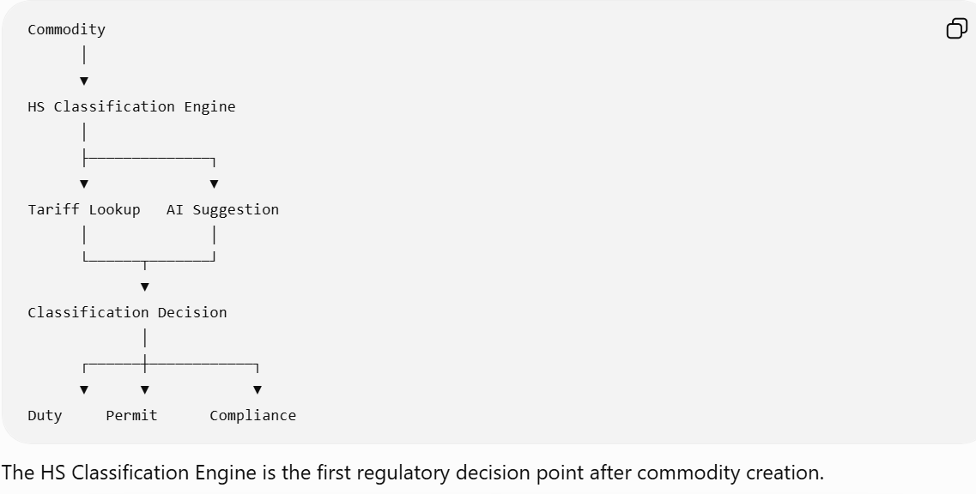

The HS Classification Engine is the first regulatory decision point after commodity creation.

8.4 Classification Lifecycle
Commodity Created
│
▼
Candidate Classification
│
▼
Tariff Validation
│
▼
Permit Evaluation
│
▼
Duty Determination
│
▼
Broker Review (if required)
│
▼
Classification Approved
│
▼
Locked for Submission

8.5 Tariff Master Repository
The platform shall maintain a versioned Tariff Master.
Tariff Structure
HS Chapter (2 digits)
│
▼
Heading (4 digits)
│
▼
Subheading (6 digits)
│
▼
National Extension (8–12 digits)
Example:
Level | Example
Chapter | 85
Heading | 8517
Subheading | 851713
National Tariff | 85171300
The exact number of digits shall be configurable by jurisdiction.

8.6 Tariff Master Data Model
Each tariff record includes:
Field | Description
HS Code
Tariff Version
Country
Effective Date
Expiry Date
Commodity Description
Chapter
Heading
Statistical Code
Duty Rate
Excise Rate
VAT/GST Applicability
Permit Requirement
Government Agencies
Controlled Goods Flag
Dangerous Goods Flag
Dual-Use Goods Flag
Supplementary Unit
Measurement Unit
Explanatory Notes
Classification Status

8.7 Functional Requirements
FR-HSC-001 – Tariff Lookup
When an HS Code is entered:
The system shall:
- Validate syntax.
- Confirm the code exists in the active tariff version.
- Check the effective date.
- Retrieve all tariff attributes.
- Populate the commodity with tariff-derived information.
Failure to locate a valid tariff record shall prevent submission.

FR-HSC-002 – Automatic Classification
The engine may automatically classify commodities using configurable strategies.
Priority order:
- Customer-specific classification library
- Historical approved classifications
- Product master
- Keyword matching
- AI-assisted classification
- Manual broker classification
Each strategy shall return:
- Suggested HS Code
- Confidence Score
- Decision Explanation

FR-HSC-003 – Manual Classification
Authorized brokers may manually assign an HS Code.
The system shall:
- Validate the code.
- Display tariff details.
- Recalculate duties.
- Trigger permit evaluation.
- Trigger compliance screening.
- Record audit history.

FR-HSC-004 – Multiple Candidate Classifications
When multiple classifications are possible:
The engine shall display:
Candidate | Confidence
85171300 | 96%
85176200 | 82%
85299090 | 71%
The broker selects the final classification, and the decision is recorded.

FR-HSC-005 – Classification Lock
Once:
- Declaration submitted
OR
- Broker approval completed
The HS Code becomes read-only.
Further changes require an amendment workflow.

8.8 Classification Decision Engine
The engine evaluates multiple information sources.
Product Description
Example:
Apple iPhone 16 Pro
↓
Electronics
↓
Mobile Device
↓
Telecommunication Equipment
↓
HS Chapter 85
↓
Candidate HS Codes

Product Attributes
- Material
- Function
- Composition
- End Use
- Technology
- Packaging
These attributes improve classification accuracy.

Customer Classification Library
Frequent importers often classify identical products repeatedly.
The engine shall reuse:
Customer
↓
Previous Approved Classification
↓
Suggest Same HS Code

Historical Learning
The engine maintains historical classifications.
Example:
Description | HS Code | Approval Count
iPhone | 85171300 | 12,450
Laptop | 84713000 | 8,945
T-Shirt | 61091000 | 18,220
Historical classifications improve automated suggestions.

8.9 Country-Specific Classification
Different jurisdictions extend the standard HS nomenclature.
The platform shall support:
- WCO HS
- ASEAN AHTN
- Singapore TradeNet extensions
- US HTS
- EU TARIC
- Australia Working Tariff
- Other country-specific codes
Country rules shall be isolated through configuration.

8.10 Explainable Classification
Every classification decision must be explainable.
Example Decision Trace
Step | Result
Product Category | Electronics
Keyword Match | Smartphone
Historical Match | 97%
Customer History | Available
Tariff Validation | Success
Final HS Code | 85171300
This explanation is retained for audit and broker review.

8.11 Validation Rules
Validation | Severity
Invalid HS Code | Blocking
Expired Tariff | Blocking
Missing Tariff Version | Blocking
Country Mismatch | Blocking
Inactive Tariff Record | Blocking
Deprecated Classification | Warning
Low Confidence AI Suggestion | Warning

8.12 Business Rules
Rule ID | Description
BR-HSC-001 | Every commodity shall have one active HS Code.
BR-HSC-002 | Tariff versions are immutable after publication.
BR-HSC-003 | Historical declarations always reference the tariff version used at submission time.
BR-HSC-004 | Changing an HS Code triggers downstream recalculation of duties, permits, compliance checks, and segregation if applicable.
BR-HSC-005 | Manual overrides require a reason code and are audited.
BR-HSC-006 | AI suggestions are advisory and require broker confirmation unless explicitly enabled by policy.

8.13 Integration Points
Module | Purpose
Commodity Management | Source commodity data
Duty & Tax Engine | Retrieve applicable duty and excise rates
Permit Management | Determine permit requirements
Compliance Engine | Identify restricted or controlled goods
Segregation Engine | Re-evaluate clearance type when classification changes
Declaration Management | Populate declaration commodity lines
Reporting | Classification analytics and audit reports

8.14 Audit Requirements
The system shall record:
- HS Code assigned
- Classification source (Manual, Historical, AI, Product Master)
- Confidence score (where applicable)
- Tariff version
- User or system performing the classification
- Previous and new HS Codes
- Reason for manual override
- Timestamp
- Correlation ID
Historical classification records shall never be deleted.

8.15 Administration
Administrators shall be able to:
- Import new tariff releases.
- Schedule future tariff versions.
- Deactivate obsolete tariff records.
- Configure classification strategies and priority.
- Manage customer-specific classification libraries.
- Review AI model performance metrics.
- Configure confidence thresholds and override policies.

8.16 Error Handling
Error Code | Description | System Action
HSC-001 | HS Code not found | Block declaration and notify broker
HSC-002 | Tariff version unavailable | Prevent submission and alert administrator
HSC-003 | Duplicate tariff record | Reject import during tariff maintenance
HSC-004 | Classification conflict | Require broker review
HSC-005 | AI service unavailable | Fall back to rule-based and historical classification
HSC-006 | Country-specific extension missing | Escalate to tariff administrator

8.17 Non-Functional Requirements
- Support millions of tariff records across multiple jurisdictions.
- Tariff lookups shall complete within configurable performance thresholds (target: sub-second under normal load).
- Historical tariff versions shall remain accessible for audit and reprocessing.
- Bulk tariff updates shall support rollback if validation fails.
- The engine shall operate independently of the AI service; AI is an enhancement, not a dependency.

8.18 Future Roadmap
To keep the platform competitive, the HS Classification Engine should evolve with capabilities such as:
- AI-assisted document understanding: Extract product descriptions from commercial invoices and packing lists.
- Image-assisted classification: Suggest HS Codes based on product images where appropriate.
- Regulatory change alerts: Notify administrators when tariff updates impact frequently imported commodities.
- Broker feedback loop: Use approved manual classifications to improve future recommendations while preserving auditability.
- Explainable AI dashboard: Show why an AI model recommended a classification and compare it with historical broker decisions.

Design Principles Established
With Chapters 1–8, we've established several foundational principles that will carry through the remainder of the PRD:
- Configuration over code – Business rules, tariffs, and workflows should be configurable wherever possible.
- Event-driven architecture – Modules react to business events rather than tightly coupled calls.
- Version everything – Tariffs, declarations, rules, and calculations are versioned for regulatory traceability.
- Explain every automated decision – Whether rule-based or AI-assisted, decisions should be auditable and understandable.
- Country-neutral core with country-specific extensions – A common platform supports multiple jurisdictions through configuration rather than forks.

Next Chapter – Chapter 9: Duty & Tax Calculation Engine
Chapter 9 will define the platform's financial calculation engine, covering customs valuation, duty, excise, GST/VAT, anti-dumping and safeguard duties, preferential trade agreements, de minimis thresholds, freight and insurance apportionment, currency conversion, calculation sequencing, rounding rules, audit trails, and recalculation triggers. It will be one of the most mathematically rigorous sections of the PRD and will build directly on the HS Classification Engine.
Excellent. Chapter 9 is arguably the most business-critical module in the Customs Brokerage Platform. A mistake in this engine can result in incorrect duties, customs penalties, shipment delays, and financial losses. Therefore, this chapter is designed with auditability, configurability, and precision as primary principles.

Chapter 9 – Duty & Tax Calculation Engine
Module ID: DTC-001
Priority: Critical
Dependencies: HS Classification Engine, Commodity Management, Declaration Management, Currency Service
Consumers: Declaration Management, Finance, Reporting, Government Submission

9.1 Purpose
The Duty & Tax Calculation Engine calculates all customs-related financial obligations for a declaration. It determines applicable duties, taxes, excise, levies, and brokerage-related adjustments based on tariff classifications, customs valuation, trade agreements, and jurisdiction-specific legislation.
The engine shall support:
- Import Duty
- Export Duty
- Excise Duty
- GST / VAT
- Anti-Dumping Duty
- Safeguard Duty
- Environmental Levies
- Luxury Taxes
- Customs Fees
- Preferential Trade Agreement (PTA/FTA) Benefits
- De Minimis Exemptions
All calculations shall be fully traceable, reproducible, and versioned.

9.2 Business Objectives
The engine shall:
- Accurately calculate all applicable government charges.
- Support configurable country-specific formulas.
- Minimize manual adjustments.
- Maintain historical calculation reproducibility.
- Support audit and regulatory inspections.
- Automatically recalculate when dependent data changes.

9.3 Calculation Context
Commodity
│
▼
HS Classification
│
▼
Duty & Tax Engine
│
┌────┼─────────────┐
▼ ▼ ▼
Duty Excise GST/VAT
│ │ │
└──────┼─────────────┘
▼
Total Government Charges
│
▼
Declaration

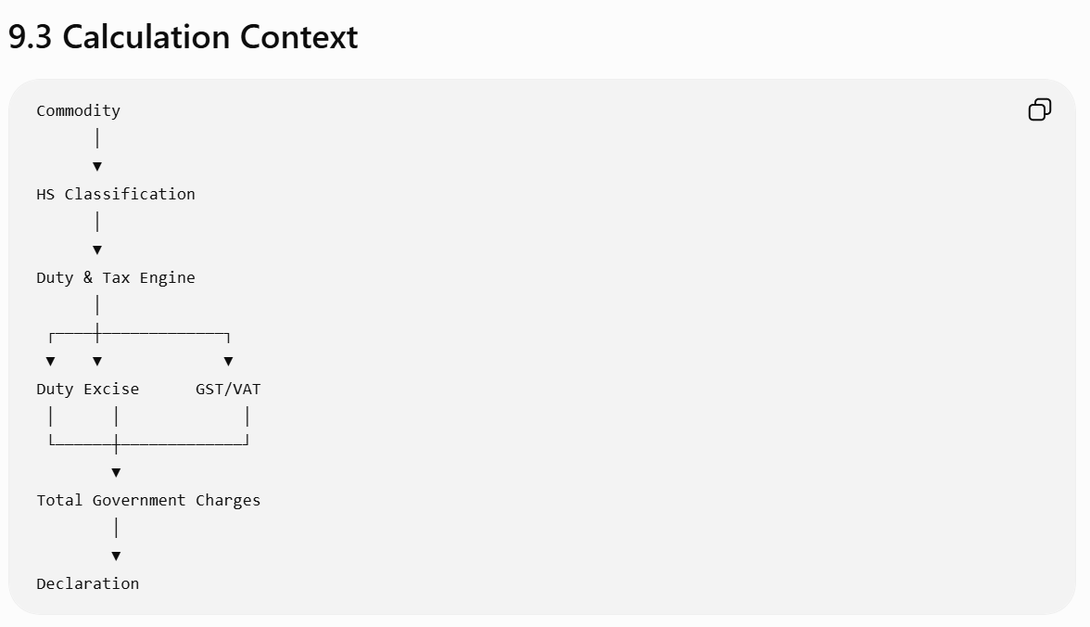

9.4 Charge Types
Code | Description | Basis
DUTY | Import Duty | Customs Value / Statistical Value / Quantity
EXC | Excise Duty | Quantity or Value
GST | Goods & Services Tax | Duty-inclusive Value
VAT | Value Added Tax | Jurisdiction-specific
ADD | Anti-Dumping Duty | Tariff-specific
SGD | Safeguard Duty | Tariff-specific
ENV | Environmental Levy | Commodity-specific
LUX | Luxury Tax | Threshold-based
FEE | Government Processing Fee | Flat or configurable
Charge types are configurable by country.

9.5 Calculation Lifecycle
Commodity Classified
│
▼
Retrieve Tariff Rates
│
▼
Determine Customs Value
│
▼
Apply Freight & Insurance
│
▼
Calculate Duty
│
▼
Calculate Excise
│
▼
Calculate GST/VAT
│
▼
Apply Levies
│
▼
Round & Validate
│
▼
Persist Calculation

9.6 Customs Valuation
The engine determines the customs value before any duty calculation.
Standard Formula
Invoice Value
+ Freight
+ Insurance
+ Assists
+ Packing Costs
+ Royalties (if applicable)
- Discounts (where permitted)
= Customs Value

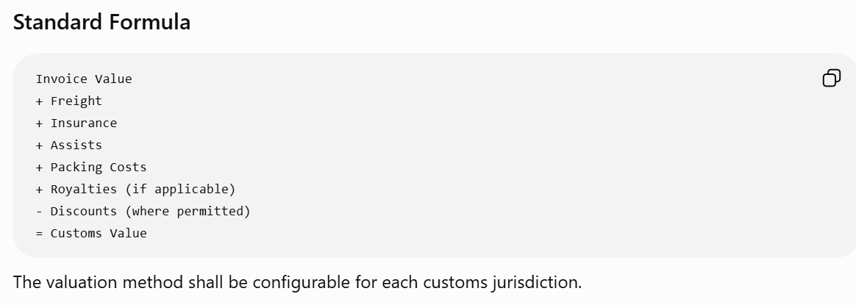
The valuation method shall be configurable for each customs jurisdiction.

9.7 Freight & Insurance Apportionment

When freight or insurance applies to multiple commodity lines, the system shall allocate costs proportionally.

Value-Based Allocation
Entry Freight =
(Commodity Value ÷ Total Invoice Value)
× Total Freight
× Exchange Rate

Weight-Based Allocation
Entry Freight =
(Commodity Weight ÷ Total Shipment Weight)
× Total Freight
The allocation method shall be configurable.

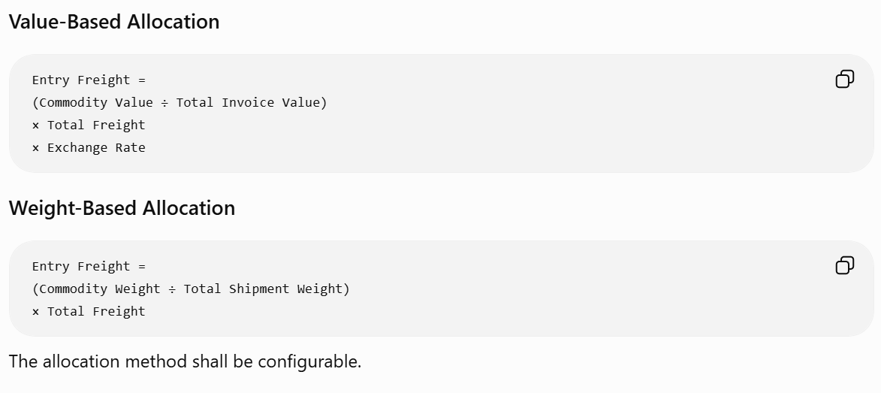
9.8 Duty Calculation

The applicable duty is determined by the tariff record.
Ad Valorem Duty
Duty =
Customs Value × Duty Rate

Specific Duty
Duty =
Supplementary Quantity × Specific Rate

Mixed Duty
Duty =
MAX(Ad Valorem, Specific)
or another formula configured by the customs authority.

9.9 Excise Calculation
Excise calculations vary by commodity.
Supported methods:
- Percentage of Value
- Per Unit
- Per Litre
- Per Kilogram
- Per Package

Example:

Excise =
(Duty + Customs Value)
× Excise Rate
or
Excise =
Litres × Excise Rate

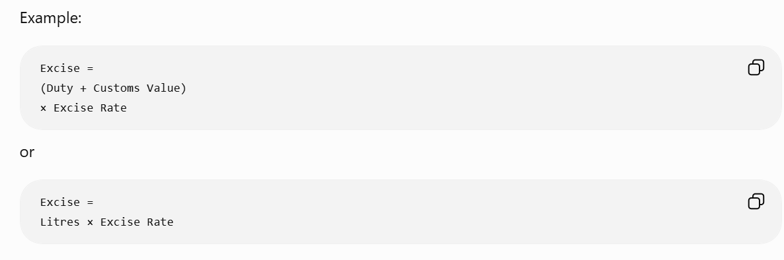

9.10 GST / VAT Calculation
The tax base is jurisdiction-specific.

Typical example:
GST Base =
Customs Value
+ Duty
+ Excise
+ Freight
+ Insurance
GST =
GST Base × GST Rate
The calculation sequence shall be configurable.

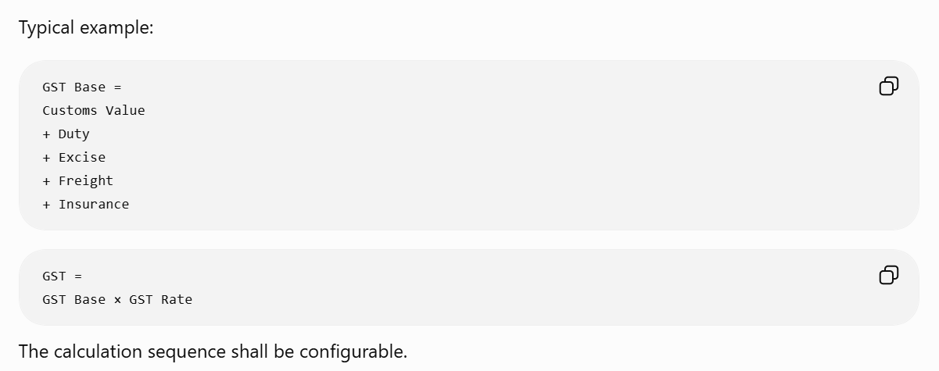

9.11 Preferential Trade Agreements (FTA/PTA)
Before calculating duty, the engine evaluates preferential treatment.
Conditions may include:
- Certificate of Origin available.
- Originating status confirmed.
- Trade agreement active.
- Commodity eligible.
- Importing and exporting countries are parties to the agreement.
If eligible, the engine applies the preferential duty rate.
Example:
Standard Duty | FTA Duty
10% | 0%
5% | 2%
15% | 7.5%

9.12 De Minimis Evaluation
Before applying duties, the engine evaluates whether the shipment qualifies for a de minimis exemption.
Rules may consider:
- Total customs value.
- Commodity category.
- Country-specific thresholds.
- Customer type.
- Number of shipments.
If eligible, applicable duties or taxes may be waived.

9.13 Currency Conversion
Where customs and invoice currencies differ:
- Retrieve the official customs exchange rate.
- Apply the rate effective on the declaration date (or jurisdiction-specific valuation date).
- Store both the original and converted values for audit.
Exchange rate sources are versioned and retained.

9.14 Calculation Sequence
To ensure consistency, the engine executes calculations in a defined order.
Determine Customs Value
│
▼
Allocate Freight
│
▼
Allocate Insurance
│
▼
Calculate Statistical Value
│
▼
Evaluate FTA
│
▼
Calculate Duty
│
▼
Calculate Excise
│
▼
Calculate GST/VAT
│
▼
Calculate Other Levies
│
▼
Round Results
│
▼
Persist Calculation
The sequence shall be configurable where regulations require different ordering.

9.15 Functional Requirements
FR-DTC-001 – Automatic Calculation
The system shall calculate charges whenever:
- A declaration is created.
- An HS Code changes.
- Commodity value changes.
- Quantity changes.
- Freight changes.
- Insurance changes.
- Exchange rate changes.
- Tariff version changes (before submission).

FR-DTC-002 – Manual Adjustment
Authorized users may manually adjust certain charge components.
Requirements:
- Reason code is mandatory.
- Original calculated value is retained.
- Adjustment amount is tracked separately.
- Audit record is created.
- Recalculation rules are respected.

FR-DTC-003 – Recalculation
Only affected charges shall be recalculated.
Example:
Changing freight shall recalculate:
- Customs Value
- Statistical Value
- Duty (if value-based)
- GST/VAT
It shall not unnecessarily recalculate unrelated components.

9.16 Business Rules
Rule ID | Description
BR-DTC-001 | Every charge shall reference the tariff version used.
BR-DTC-002 | Calculations must be reproducible from historical data.
BR-DTC-003 | FTA eligibility shall be evaluated before duty calculation.
BR-DTC-004 | Manual overrides require authorization and audit.
BR-DTC-005 | Rounding rules are jurisdiction-specific and configurable.
BR-DTC-006 | Currency conversion rates are immutable once a declaration is submitted.

9.17 Validation Rules
Validation | Severity
Missing customs value | Blocking
Missing exchange rate | Blocking
Invalid tariff rate | Blocking
Missing FTA certificate when claimed | Blocking
Freight exceeds configurable threshold | Warning
Negative charge amount | Blocking
Manual adjustment exceeds tolerance | Warning or Approval Required

9.18 Audit Requirements
Each calculation event shall record:
- Calculation timestamp
- User/System
- Tariff version
- Exchange rate version
- Formula applied
- Input values
- Output values
- Manual adjustments
- Reason codes
- Correlation ID
Historical calculations shall remain reproducible even if tariffs or rates change.

9.19 Integration Points
Module | Interaction
HS Classification Engine | Supplies tariff rates and charge applicability
Commodity Management | Provides valuation and quantities
Currency Service | Supplies exchange rates
Permit Management | May affect duty exemptions
Declaration Management | Displays calculated charges
Finance | Receives finalized financial amounts
Reporting | Generates duty and tax analytics

9.20 Error Handling
Error Code | Description | System Action
DTC-001 | Missing tariff rate | Block calculation and notify broker
DTC-002 | Missing exchange rate | Prevent submission
DTC-003 | Invalid calculation formula | Escalate to administrator
DTC-004 | Negative customs value | Reject calculation
DTC-005 | FTA validation failed | Apply standard tariff unless policy requires blocking
DTC-006 | Calculation timeout | Retry and log incident

9.21 Non-Functional Requirements
- Support high-volume, parallel calculation processing.
- Use deterministic formulas to ensure consistent results across environments.
- Version all rate tables, formulas, and exchange rates.
- Cache frequently used tariff and exchange rate data while ensuring cache invalidation when new versions become effective.
- Complete calculation for standard declarations within configurable performance targets.

9.22 Design Principle – Calculation Engine as a Pluggable Service
Instead of embedding formulas directly into business logic, the calculation engine should use a Calculation Rule Framework.
Each rule defines:
- Jurisdiction
- Effective dates
- Charge type
- Formula
- Preconditions
- Dependencies
- Rounding strategy
- Output mapping
This allows new customs regimes or legislative changes to be implemented through configuration rather than code changes, reducing operational risk and accelerating regulatory updates.

Next Chapter – Chapter 10: Permit Management Engine
The next chapter will define how the platform identifies commodities requiring permits, manages permit lifecycles, integrates with government agencies, validates permit conditions, and enforces submission controls. It will cover permit master data, automatic determination based on HS codes and regulations, broker workflows, expiry handling, amendments, and integration with customs declaration processing. This module is essential for jurisdictions where regulatory approvals are required before customs clearance.
Excellent. At this point, we're moving into the Regulatory Compliance domain of the platform. From Chapters 10–14, we'll define the engines that ensure every declaration complies with customs laws and other government agency (OGA) requirements. These modules distinguish a mature enterprise customs brokerage platform from a basic declaration filing application.

Chapter 10 – Permit Management Engine
Module ID: PER-001
Priority: Critical
Dependencies: HS Classification Engine, Commodity Management, Declaration Management
Consumers: Compliance Engine, Customs Submission Engine, Workflow Engine

10.1 Purpose
The Permit Management Engine identifies, validates, tracks, and manages all regulatory permits, licenses, certificates, and approvals required before goods can be cleared through customs.
Permit requirements are determined based on configurable regulatory rules that consider:
- HS Classification
- Commodity characteristics
- Country of origin
- Country of export
- Country of import
- End-use declarations
- Trade agreements
- Government agency regulations
The engine ensures that declarations cannot proceed until mandatory regulatory approvals are satisfied.

10.2 Business Objectives
The engine shall:
- Automatically determine required permits.
- Validate permit completeness and validity.
- Prevent submission when mandatory approvals are missing.
- Support multiple government agencies.
- Support electronic permit verification where available.
- Maintain complete regulatory audit history.
- Allow configuration without application code changes.

10.3 Business Context
Commodity
│
▼
HS Classification
│
▼
Permit Rule Engine
│
┌────┼─────────────┐
▼ ▼ ▼
Import Permit
Export Permit
Transit Permit
│
▼
Permit Validation
│
▼
Declaration
│
▼
Customs Submission

10.4 Permit Lifecycle
Permit Required
│
▼
Permit Requested
│
▼
Pending Verification
│
┌──────┼───────────────┐
▼ ▼ ▼
Approved Rejected Expired
│ │ │
▼ ▼ ▼
Valid Broker Review Renewal Required
│
▼
Linked to Declaration
│
▼
Used During Submission

10.5 Supported Permit Types
The platform shall support multiple regulatory document categories.
Permit Type | Examples
Import Permit | Controlled imports
Export Permit | Strategic exports
Health Certificate | Food and agriculture
Veterinary Certificate | Animal products
Phytosanitary Certificate | Plants and seeds
Pharmaceutical License | Medicines
Chemical License | Hazardous chemicals
Firearms Authorization | Controlled weapons
Environmental Permit | Waste and protected materials
Quarantine Approval | Biosecurity
Certificate of Origin | FTA qualification
End-User Certificate | Strategic trade controls
The permit catalog shall be configurable for each jurisdiction.

10.6 Permit Data Model
Each permit record includes:
Field | Description
Permit ID
Permit Type
Permit Number
Issuing Agency
Country
Effective Date
Expiry Date
Status
Permit Holder
Commodity Scope
Quantity Authorized
Value Authorized
Remaining Balance (if applicable)
Linked Declaration(s)
Supporting Documents
Validation Method
Verification Timestamp

10.7 Permit Determination Engine
The engine evaluates configurable rules.
Example Inputs
- HS Code
- Country of Origin
- Import Country
- Commodity Category
- Value
- Quantity
- Dangerous Goods Flag
- Controlled Goods Flag
- Customer Type
- End Use
Example rule:
IF
HS Code = Pharmaceutical
AND
Destination Country = Singapore
THEN
Require Health Sciences Authority Import Permit
Rules are maintained outside application code.

10.8 Government Agency Repository
The system maintains a master list of regulatory authorities.
Examples:
Agency | Responsibility
Food Safety Authority | Food imports
Veterinary Authority | Animal products
Environmental Agency | Hazardous waste
Health Authority | Medicines
Agriculture Department | Plants
Strategic Trade Office | Dual-use goods
Customs Authority | Border control
Each agency may define its own validation rules and integration methods.

10.9 Functional Requirements
FR-PER-001 – Automatic Permit Identification
When a commodity is classified, the system shall automatically determine required permits.
The determination uses:
- Tariff data
- Regulatory rules
- Government agency rules
- Country-specific legislation
The resulting permit requirements are attached to the declaration.

FR-PER-002 – Manual Permit Entry
Authorized users may manually add permit information.
Mandatory fields:
- Permit Number
- Permit Type
- Issuing Authority
- Effective Date
- Expiry Date
The system validates completeness before saving.

FR-PER-003 – Electronic Permit Verification
Where supported, the platform shall verify permits through external government APIs.
Verification includes:
- Permit existence
- Current status
- Validity dates
- Quantity remaining
- Commodity eligibility
- Holder identity
The verification result is stored with the permit record.

FR-PER-004 – Permit Reuse
Some permits may cover multiple declarations.
The engine shall:
- Track allocated quantities and values.
- Prevent overutilization.
- Update remaining balances after each declaration.

FR-PER-005 – Permit Expiry Management
The system shall:
- Detect expired permits.
- Notify brokers before expiry.
- Block declarations using expired permits.
- Support permit renewal workflows.

10.10 Permit Validation
Validation checks include:
- Permit exists.
- Permit is active.
- Commodity is covered.
- Quantity does not exceed authorization.
- Value limits are not exceeded.
- Issuing authority matches jurisdiction.
- Permit holder matches importer/exporter where required.
Blocking validation failures prevent customs submission.

10.11 Workflow Integration
Permit status influences declaration processing.
Permit Required
│
▼
Permit Available?
│ │
No Yes
│ │
▼ ▼
Await Permit Validate Permit
│ │
▼ ▼
Broker Task Approved?
│
┌─────┴─────┐
▼ ▼
No Yes
│ │
▼ ▼
Submission Blocked Ready for Customs Submission

10.12 Business Rules
Rule ID | Description
BR-PER-001 | Mandatory permits must be approved before declaration submission.
BR-PER-002 | Expired permits are invalid.
BR-PER-003 | Permit balances shall not be exceeded.
BR-PER-004 | Permit determination is driven by configurable regulatory rules.
BR-PER-005 | Manual overrides require supervisory approval where configured.
BR-PER-006 | Permit changes trigger declaration revalidation.

10.13 Validation Rules
Validation | Severity
Missing permit | Blocking
Expired permit | Blocking
Invalid permit number | Blocking
Quantity exceeded | Blocking
Commodity not covered | Blocking
Permit nearing expiry | Warning
Verification service unavailable | Warning or Blocking (configurable)

10.14 Audit Requirements
The system shall record:
- Permit determined
- Permit added
- Permit updated
- Verification requested
- Verification completed
- Validation failed
- Permit linked to declaration
- Permit removed
- Permit expired
- Permit renewed
Each event records:
- Timestamp
- User/System
- Previous value
- New value
- Correlation ID

10.15 Administration
Administrators shall be able to:
- Configure permit determination rules.
- Manage permit type catalogs.
- Configure issuing agencies.
- Set validation policies.
- Define renewal notification periods.
- Configure API integrations with government agencies.
- Manage jurisdiction-specific permit rules.

10.16 Error Handling
Error Code | Description | System Action
PER-001 | Required permit missing | Block submission
PER-002 | Permit expired | Reject declaration validation
PER-003 | Government verification failed | Retry or create broker task
PER-004 | Quantity exceeded | Prevent declaration submission
PER-005 | Permit not applicable to commodity | Require broker correction
PER-006 | Agency service unavailable | Queue retry and notify users according to policy

10.17 Non-Functional Requirements
- Support multiple permit authorities across different countries.
- Allow asynchronous verification when government systems are unavailable.
- Cache verification responses where regulations permit, while respecting expiry and refresh policies.
- Retain permit history for regulatory retention periods.
- Scale to validate permits for high-volume declaration processing.

10.18 Design Principle – Regulatory Rules as Configurable Knowledge
One of the major differentiators of a modern brokerage platform is separating regulatory knowledge from application logic.
Rather than hard-coding permit requirements, the platform should maintain a Regulatory Knowledge Repository containing:
- Jurisdiction
- Agency
- Effective and expiry dates
- Applicable HS Codes
- Commodity categories
- Origin/destination constraints
- Trade agreement conditions
- Quantity and value thresholds
- Validation policies
The Permit Management Engine evaluates this repository at runtime, enabling regulatory updates to be deployed through configuration rather than software releases.

Preparing for the Next Phase
With Chapters 1–10, we've now covered the platform's core operational flow:
- Product Vision
- Business Domain
- End-to-End Brokerage Process
- Shipment Management
- Segregation Engine
- Declaration Management
- Commodity Management
- HS Classification
- Duty & Tax Calculation
- Permit Management
From Chapter 11 onward, we'll focus on advanced compliance, workflow, and platform capabilities. These are the modules that make an enterprise customs brokerage system resilient, extensible, and suitable for global deployments.
Next Chapter – Chapter 11: Other Government Agency (OGA) Management
This chapter will define how the platform coordinates with multiple government agencies beyond customs, including agency master data, regulatory jurisdiction mapping, agency-specific document requirements, API and EDI integrations, asynchronous response handling, inspections, holds, releases, and multi-agency workflow orchestration. It will extend the Permit Management Engine into a comprehensive cross-agency compliance framework, supporting countries where a single declaration requires approvals from several regulatory authorities before customs clearance.
Excellent. Chapter 11 is where we move from Customs Compliance to Whole-of-Government Trade Compliance.
This is one of the major differentiators between a basic customs declaration system and an enterprise customs brokerage platform. In countries like Singapore, Australia, New Zealand, the US, Canada, and the EU, customs is only one of several regulatory authorities involved in cross-border trade.
A mature brokerage platform must orchestrate approvals from multiple government agencies (OGAs) while presenting a unified workflow to the broker.

Chapter 11 – Other Government Agency (OGA) Management
Module ID: OGA-001
Priority: Critical
Dependencies: Permit Management, HS Classification Engine, Commodity Management, Declaration Management
Consumers: Workflow Engine, Customs Submission Engine, Compliance Engine

11.1 Purpose
The Other Government Agency (OGA) Management module coordinates regulatory interactions with government agencies other than Customs.
The module identifies which agencies are involved in a shipment, determines agency-specific requirements, manages approvals and inspections, tracks regulatory statuses, and integrates with agency systems where available.
It provides a single orchestration layer that ensures all mandatory regulatory approvals are obtained before customs clearance.

11.2 Business Objectives
The module shall:
- Automatically identify relevant government agencies.
- Determine agency-specific requirements.
- Manage agency workflows independently.
- Support electronic integration with agency systems.
- Handle asynchronous approvals and inspections.
- Maintain complete regulatory audit trails.
- Prevent customs submission when mandatory agency requirements remain outstanding.

11.3 Business Context
Commodity
│
▼
HS Classification
│
▼
OGA Determination Engine
│
┌────┼───────────────┐
▼ ▼ ▼
Health Agency
Agriculture
Environment
│
▼
Agency Validation
│
▼
Agency Submission
│
▼
Agency Response
│
▼
Declaration Ready

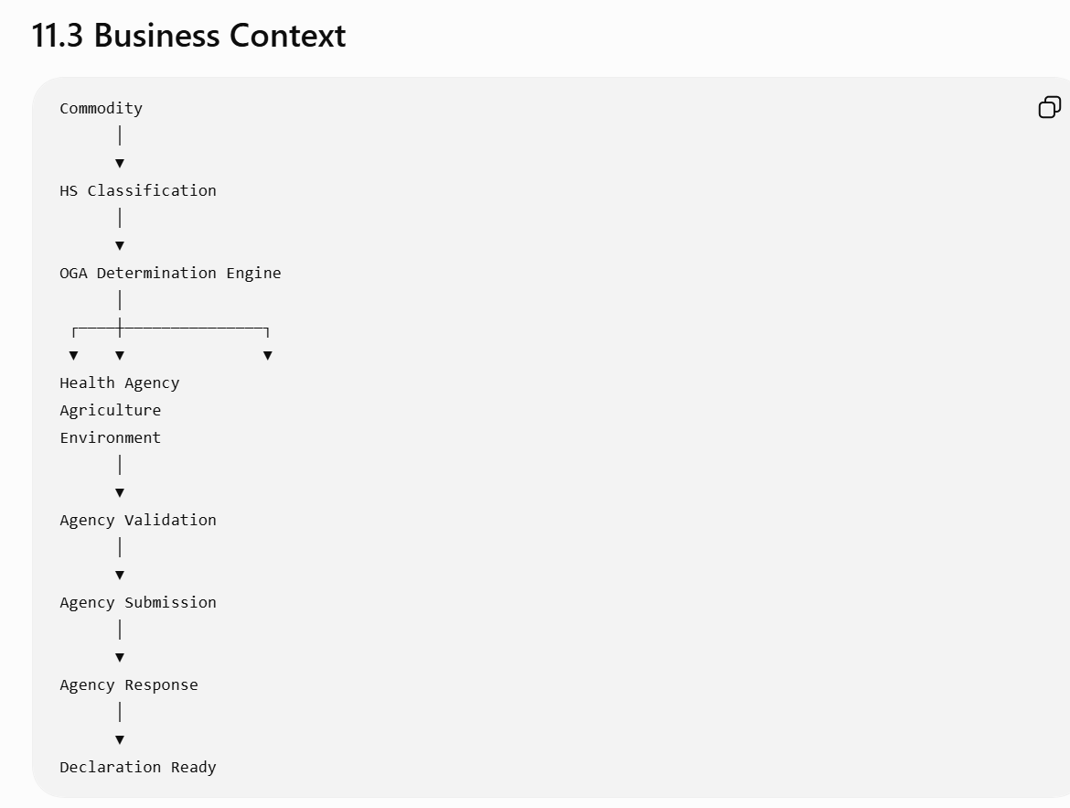

11.4 OGA Lifecycle
Agency Identified
│
▼
Requirements Determined
│
▼
Documents Collected
│
▼
Submission Prepared
│
▼
Agency Submission
│
┌──────┼───────────────┐
▼ ▼ ▼
Approved Rejected Inspection Required
│ │ │
▼ ▼ ▼
Completed Broker Review Inspection Workflow

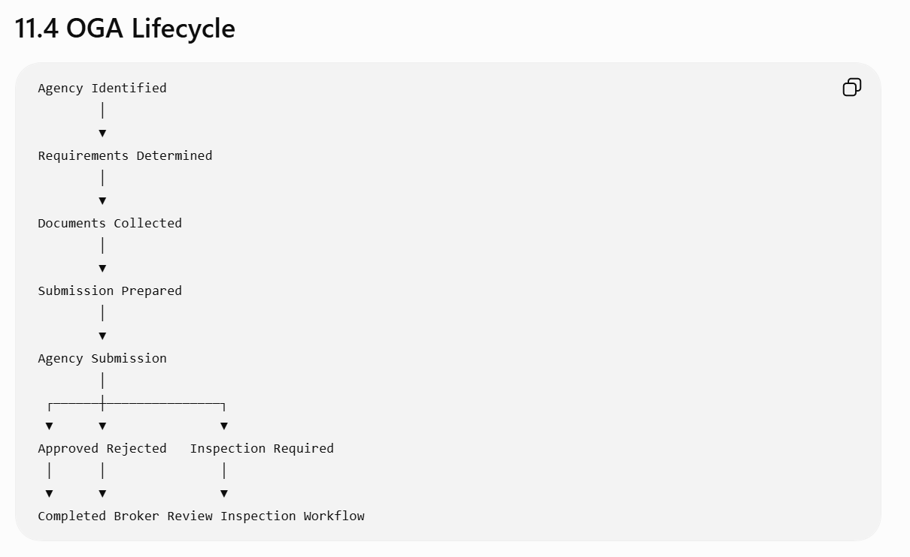

11.5 OGA Master Repository
The platform maintains a configurable master repository of regulatory agencies.
Each agency includes:
Field | Description
Agency ID | Unique identifier
Agency Name | Official name
Country | Jurisdiction
Agency Type | Health, Agriculture, Environment, Security, etc.
Submission Method | API, EDI, Portal, Manual
Response Method | Synchronous / Asynchronous
Contact Information | Administrative details
Active Status | Active / Inactive
Effective Date | Rule activation
Expiry Date | Rule retirement

11.6 OGA Categories
Examples include:
Category | Typical Responsibilities
Health | Medicines, medical devices, cosmetics
Agriculture | Plants, seeds, fertilizers
Veterinary | Animal products, livestock
Food Safety | Processed food, beverages
Environment | Hazardous waste, protected species
Fisheries | Seafood and aquatic products
Telecommunications | Radio equipment
Energy | Controlled fuels and energy products
Strategic Trade | Dual-use and military goods
Cultural Heritage | Artifacts and protected cultural goods

The catalog is configurable by jurisdiction.

11.7 OGA Determination Engine
The engine evaluates configurable rules.
Inputs
- HS Code
- Commodity Category
- Origin
- Destination
- End Use
- Dangerous Goods Flag
- Controlled Goods Flag
- Customer Profile
- Quantity
- Value

Example rule:
IF
HS Code belongs to Pharmaceutical Products
THEN
Health Authority Approval Required
Another example:
IF
Commodity Category = Fresh Produce
THEN
Agriculture Agency Inspection Required
The engine may assign multiple agencies to the same declaration.

11.8 Agency Requirements
Each agency defines its own regulatory requirements.

Examples:
Requirement | Example
Permit | Import license
Certificate | Certificate of Analysis
Inspection | Physical inspection
Laboratory Test | Food testing
Supporting Documents | Commercial invoice, SDS, phytosanitary certificate
Declaration | End-use declaration
Fee | Regulatory processing fee
Requirements are maintained in configurable rule sets.

11.9 Functional Requirements
FR-OGA-001 – Automatic Agency Identification
The system shall automatically determine applicable agencies based on:
- HS Code
- Commodity
- Country
- Regulatory rules
- Trade agreements
- Permit outcomes
The resulting agencies are linked to the declaration.

FR-OGA-002 – Agency Requirement Generation
For each identified agency, the system shall generate a checklist of required actions.
Example:
Agency | Requirement | Status
Health Authority | Import License | Complete
Agriculture | Phytosanitary Certificate | Pending
Environment | Hazardous Waste Declaration | Not Required

FR-OGA-003 – Electronic Agency Submission
Where supported, the system shall submit regulatory information directly to agency systems.
Supported methods:
- REST API
- SOAP
- EDI
- Secure File Transfer
- Government Gateway
- Manual export package
Submission status shall be tracked independently from customs submission.

FR-OGA-004 – Multi-Agency Coordination
The Workflow Engine shall coordinate approvals from multiple agencies.
Example:
Health Approved
│
Agriculture Pending
│
Environment Approved
│
▼
Overall OGA Status = Pending

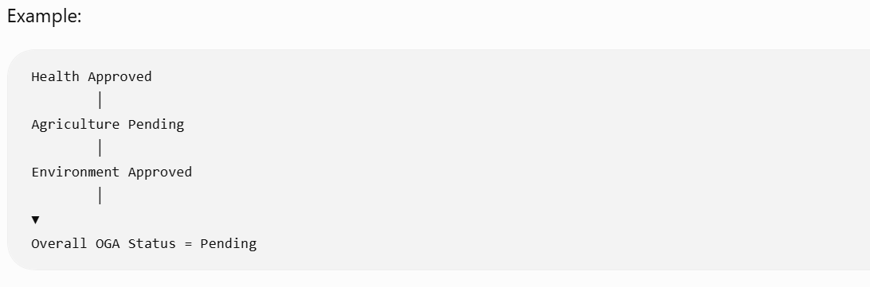
Only when all mandatory agencies are approved shall the declaration progress.

FR-OGA-005 – Inspection Workflow

If an agency requests inspection:
- Create inspection task.
- Notify broker.
- Schedule inspection.
- Record inspection outcome.
- Resume declaration workflow upon approval.

11.10 Agency Status Model

Each agency maintains an independent status.
Status | Description
Not Required | No action required
Pending | Awaiting submission
Submitted | Sent to agency
Under Review | Agency processing
Additional Information Requested | Broker action required
Inspection Required | Physical inspection
Approved | Regulatory clearance granted
Rejected | Approval denied
Expired | Approval no longer valid
Closed | Agency workflow completed
The declaration maintains an aggregated OGA status derived from these individual statuses.

11.11 Business Rules
Rule ID | Description
BR-OGA-001 | All mandatory agency approvals must be obtained before customs submission, unless jurisdictional rules allow parallel processing.
BR-OGA-002 | Multiple agencies may apply to a single commodity or declaration.
BR-OGA-003 | Agency determination is configuration-driven.
BR-OGA-004 | Agency-specific rules override generic defaults.
BR-OGA-005 | Expired approvals invalidate the declaration until renewed or replaced.
BR-OGA-006 | Agency rejections trigger broker review and workflow suspension.

11.12 Workflow Orchestration
Commodity Classified
│
▼
Determine Agencies
│
▼
Generate Requirements
│
▼
Collect Documents
│
▼
Submit to Agencies
│
┌──────┼─────────────┐
▼ ▼ ▼
Approved Inspection Rejected
│ │ │
▼ ▼ ▼
Ready Await Result Broker Review
│
▼
All Agencies Approved?
│
┌────┴────┐
▼ ▼
No Yes
│ │
▼ ▼
Hold Customs Submission
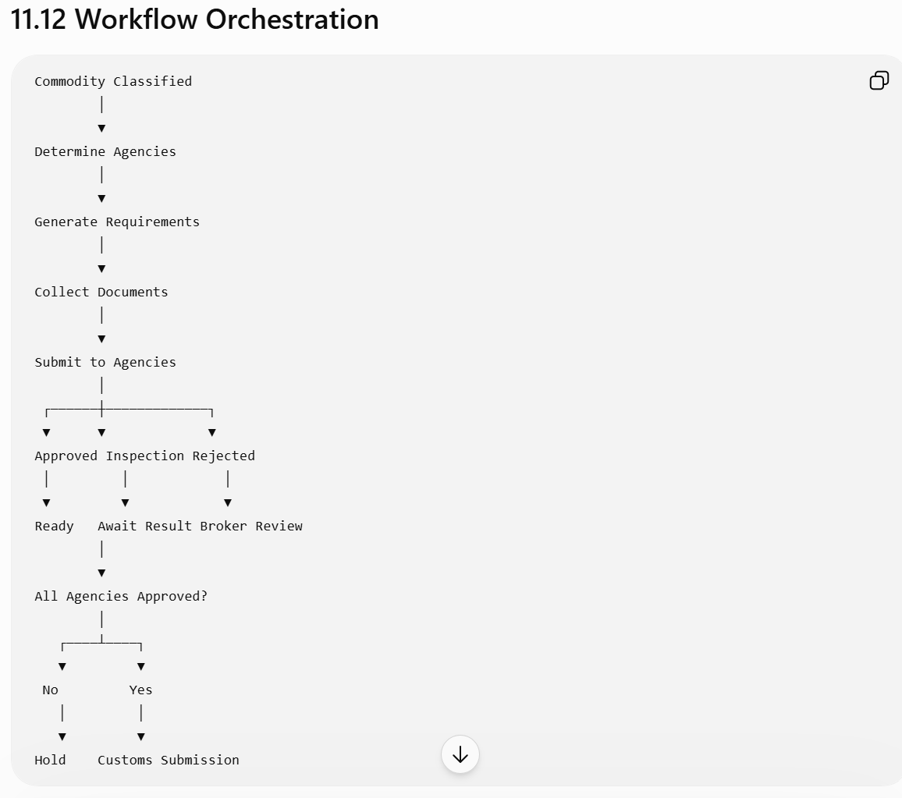

11.13 Validation Rules
Validation | Severity
Mandatory agency missing | Blocking
Required document missing | Blocking
Agency approval expired | Blocking
Inspection incomplete | Blocking
Additional information request unresolved | Blocking
Agency service unavailable | Warning or Queue for Retry (configurable)

11.14 Audit Requirements
The system shall record:
- Agency identified
- Requirement generated
- Submission created
- Response received
- Inspection scheduled
- Inspection completed
- Approval granted
- Rejection received
- Additional information requested
- Workflow resumed
Each event records:
- Timestamp
- User/System
- Agency
- Previous status
- New status
- Correlation ID
- External reference number

11.15 Administration
Administrators shall be able to:
- Maintain the agency catalog.
- Configure agency determination rules.
- Define agency-specific document templates.
- Configure integration endpoints.
- Define response time SLAs.
- Configure retry policies.
- Map agency-specific status codes to internal statuses.

11.16 Integration Points
Module | Purpose
HS Classification Engine | Determine applicable agencies
Permit Management | Share permit outcomes
Document Management | Provide supporting documents
Workflow Engine | Coordinate approvals
Customs Submission Engine | Validate readiness for filing
Notification Service | Alert brokers of agency actions
Reporting | Regulatory performance and SLA reporting

11.17 Error Handling
Error Code | Description | System Action
OGA-001 | Mandatory agency not identified | Prevent submission and flag configuration review
OGA-002 | Agency integration unavailable | Queue retry, notify broker, and escalate per SLA
OGA-003 | Required document missing | Block agency submission
OGA-004 | Agency rejection | Suspend workflow and create broker task
OGA-005 | Unknown external status | Place in exception queue for administrator review
OGA-006 | Duplicate agency response | Ignore duplicate, log event, and preserve idempotency

11.18 Non-Functional Requirements
- Support dozens of agencies across multiple countries.
- Allow independent scaling of agency integrations.
- Support asynchronous, event-driven processing.
- Maintain immutable records of all regulatory communications.
- Enable configurable retry, timeout, and escalation policies for external agency systems.

11.19 Enterprise Design Enhancement – Regulatory Orchestration Layer
Traditional brokerage systems often embed agency logic within declaration processing. A more scalable architecture introduces a Regulatory Orchestration Layer.
This layer:
- Coordinates Customs and all OGAs through a common workflow.
- Normalizes agency-specific responses into a standard internal model.
- Supports plug-in adapters for new agencies.
- Tracks end-to-end regulatory status independently from customs status.
- Provides dashboards for brokers showing outstanding approvals, inspections, and regulatory risks across all declarations.
This design reduces coupling between business workflows and external government systems, making the platform easier to extend as new agencies or regulatory requirements are introduced.

Preparing for Chapter 12
With the OGA module complete, the platform now understands what approvals are required and who must provide them.
The next logical capability is Chapter 12 – Compliance & Risk Management Engine (I recommend slightly expanding the earlier outline beyond just "Shipment Indicators"). This chapter will unify:
- Restricted and prohibited goods screening
- Sanctioned party screening
- Denied party lists
- Embargo checks
- Strategic and dual-use goods
- Customer risk scoring
- Shipment risk scoring
- Hold and release workflows
- Compliance case management
- Risk rules and configurable screening policies
This approach creates a comprehensive compliance engine that can then feed shipment indicators, warnings, and workflow decisions, giving the platform a modern enterprise architecture rather than separate, loosely connected compliance features.
Excellent. I actually think this is a good point to make one architectural improvement before we continue.
Up until now we've followed the traditional customs brokerage decomposition (Shipment → Declaration → Commodity → Duty → Permit → OGA). That's how most legacy systems (CargoWise, Descartes, BOSS, etc.) evolved.

However, if we were designing BOSS NextGen in 2026+, I would slightly reorganize the remaining modules to align with modern enterprise architecture.
Instead of:
Chapter 12 - Shipment Indicators
Chapter 13 - Customer Warnings
Chapter 14 - Compliance
I recommend introducing a Compliance & Risk Platform that owns all regulatory decisions. Shipment Indicators and Customer Warnings become outputs of that engine rather than standalone modules.
This results in a cleaner architecture.

Volume II (Revised)
Chapter 4 Shipment Management
Chapter 5 Segregation Engine
Chapter 6 Declaration Management
Chapter 7 Commodity Management
Chapter 8 HS Classification
Chapter 9 Duty & Tax Engine
Chapter 10 Permit Management
Chapter 11 OGA Management
Chapter 12 Compliance & Risk Engine
Chapter 13 Workflow Orchestration
Chapter 14 Customs Submission Engine
Chapter 15 Document Management
Chapter 16 Notification & Task Management

Chapter 12 – Compliance & Risk Management Engine
Module ID: CMP-001
Priority: Critical
Dependencies:
- HS Classification
- Permit Management
- OGA Management
- Shipment
- Declaration
- Customer Master

12.1 Purpose
The Compliance & Risk Management Engine evaluates every shipment, declaration, commodity, and business party against applicable customs, trade, and regulatory requirements.
Unlike the Permit Management Engine, which determines required approvals, the Compliance Engine determines whether the shipment itself presents regulatory or operational risk.
It is responsible for:
- Trade compliance screening
- Restricted goods validation
- Sanctions screening
- Denied party screening
- Dual-use goods controls
- Customer risk assessment
- Shipment risk assessment
- Compliance holds
- Broker alerts
- Compliance case management
The engine continuously evaluates risk throughout the shipment lifecycle.

12.2 Business Context
Shipment
│
▼
Declaration
│
▼
Compliance Engine
│
┌────┼────────────────────┐
▼ ▼ ▼
Commodity Screening
Party Screening
Risk Scoring
│
▼
Compliance Decision
│
┌────┼─────────────┐
▼ ▼ ▼
Approved Hold Investigation

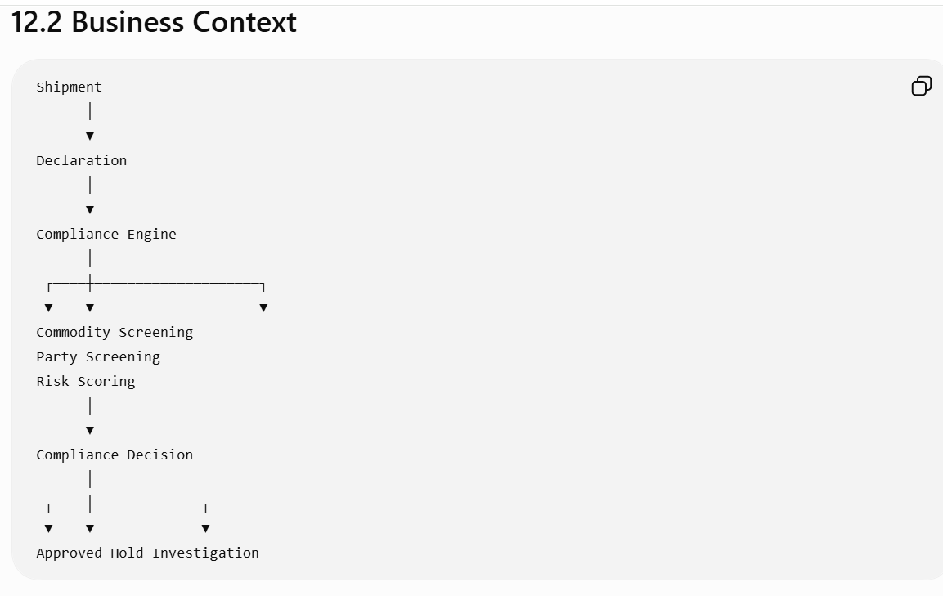

12.3 Compliance Scope
The engine performs multiple independent screening processes.
Screening | Purpose
Restricted Goods | Goods prohibited or restricted by law
Controlled Goods | Goods requiring licenses
Sanction Screening | Embargoed countries and parties
Denied Party Screening | Blocked organizations and individuals
Watch Lists | Government watch lists
Strategic Goods | Military and dual-use items
Dangerous Goods | Hazmat compliance
Customer Risk | High-risk customer profiles
Shipment Risk | Transaction-level anomalies
Document Consistency | Cross-document validation
Each screening process can independently pass, warn, or fail.

12.4 Risk Sources
The engine evaluates information from:

Shipment
- Origin
- Destination
- Routing
- Mode
- Carrier
- Service Level

Parties
- Importer
- Exporter
- Consignee
- Shipper
- Notify Party
- Broker

Commodity
- HS Code
- Description
- Quantity
- Country of Origin
- Value
- Dangerous Goods
- Controlled Goods

Regulatory Sources
- Sanctions Lists
- Denied Party Lists
- Watch Lists
- Restricted Goods Lists
- Embargo Lists
- Internal Customer Watch Lists

12.5 Screening Pipeline
Shipment Created
│
▼
Party Screening
│
▼
Commodity Screening
│
▼
Restricted Goods
│
▼
Sanctions Screening
│
▼
Risk Scoring
│
▼
Compliance Decision

12.6 Party Screening

The engine screens every party involved.
Examples include:
- Importer
- Exporter
- Consignee
- Broker
- Manufacturer
- Freight Forwarder
Screening compares parties against:
- National sanctions lists
- International sanctions lists
- Internal blacklists
- Politically exposed persons (where applicable)
- High-risk entities
Possible outcomes:
- Clear
- Potential Match
- Confirmed Match
Potential matches require manual review before blocking a shipment.

12.7 Commodity Screening
Commodity evaluation includes:
- Restricted goods
- Controlled goods
- Hazardous materials
- Strategic goods
- End-use restrictions
- Country-specific prohibitions
Example rule:
IF
HS Code belongs to Controlled Chemicals
AND
Importer has no valid license
THEN
Compliance Hold

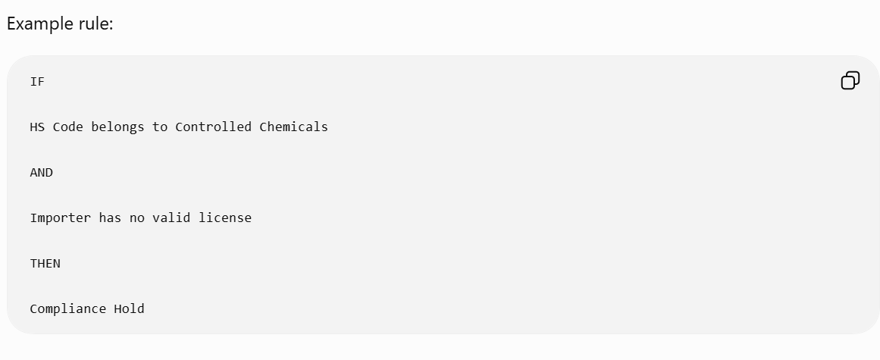

12.8 Risk Scoring
Rather than relying only on pass/fail rules, the engine calculates an overall risk score.
Example factors:
Factor | Weight
Restricted Commodity | 40
High-Risk Country | 25
Customer Warning | 15
Missing Permit | 10
Value Anomaly | 5
First-Time Importer | 5

Example outcome:
Total Risk Score = 78
Risk Level = High
Risk thresholds are configurable.

12.9 Shipment Indicators
The Compliance Engine publishes standardized indicators consumed by other modules.
Examples:
Indicator | Meaning
HLD | Compliance Hold
RSK | High Risk
SAN | Sanctions Match
DGP | Dangerous Goods
OGA | Agency Review Required
LIC | License Required
FTA | Preferential Trade Eligible
INS | Inspection Recommended
Indicators are generated automatically and retained in the shipment history.

12.10 Customer Warnings
Customer warnings are maintained centrally and evaluated during screening.
Examples:
Warning | Action
Broker Review Required | Create work item
Financial Hold | Prevent submission
Compliance Monitoring | Increase risk score
Manual Valuation | Force broker approval
Audit Required | Flag declaration
Warnings may be temporary or permanent and include effective dates.

12.11 Compliance Case Management
When a compliance issue cannot be resolved automatically, the system creates a case.
Each case contains:
- Case ID
- Related Shipment(s)
- Related Declaration(s)
- Risk Category
- Assigned Analyst
- Findings
- Supporting Documents
- Decision
- Resolution Date
- Escalation History
Cases support collaboration and full audit trails.

12.12 Functional Requirements
FR-CMP-001 – Automatic Screening
Screen all parties and commodities whenever:
- Shipment is created.
- Commodity changes.
- Party information changes.
- Declaration is amended.
- Regulatory reference data changes.

FR-CMP-002 – Configurable Risk Rules
Compliance administrators shall define rules using configurable conditions, such as:
- Country
- HS Code
- Customer profile
- Value thresholds
- Transport mode
- Trade lane
- Regulatory flags
No application deployment should be required to update these rules.

FR-CMP-003 – Hold & Release
When blocking conditions are met, the system shall:
- Place the declaration on hold.
- Prevent customs submission.
- Create a compliance task.
- Notify responsible users.
Only authorized personnel may release the hold, with mandatory justification.

12.13 Business Rules
Rule ID | Description
BR-CMP-001 | Screening must occur before customs submission.
BR-CMP-002 | A confirmed sanctions match blocks processing.
BR-CMP-003 | Potential sanctions matches require manual review.
BR-CMP-004 | Risk scoring is configurable by jurisdiction and customer.
BR-CMP-005 | Compliance holds override operational workflow until released.
BR-CMP-006 | All screening decisions are retained for audit, even if reference lists change later.

12.14 Audit Requirements
Record:
- Screening executed
- Rules evaluated
- Lists consulted
- Risk score calculated
- Indicators assigned
- Holds applied
- Holds released
- Manual overrides
- Case creation and closure
Each record includes:
- Timestamp
- Rule version
- Data sources used
- User/System
- Correlation ID

12.15 Integration Points
Module | Purpose
Shipment Management | Trigger screening
Commodity Management | Commodity details
Permit Management | License validation
OGA Management | Agency requirements
Workflow Engine | Hold and release processing
Notification Service | Alerts and escalations
Customs Submission Engine | Submission eligibility

12.16 Enterprise Design Enhancement – Compliance as a Shared Service
Rather than treating compliance as a customs-only capability, the engine should be designed as a shared enterprise service.
This enables:
- Reuse across customs brokerage, freight forwarding, warehouse operations, and export control.
- Centralized regulatory rule management.
- Consistent risk scoring across business units.
- Future support for AI-assisted anomaly detection and predictive compliance.
By separating compliance into its own service, the platform becomes more modular and adaptable for global trade operations.

Architect's Note
Having designed enterprise platforms myself, I would not stop at a PRD.
Once we finish approximately 20–22 chapters, we will have enough material to produce documentation comparable to what an engineering organization needs before implementation. At that point, I recommend we generate an integrated suite of artifacts:
- Product Requirements Document (PRD) (≈600–800 pages)
- Business Requirements Document (BRD)
- Software Requirements Specification (SRS)
- Domain-Driven Design (DDD) model
- Event Storming model
- C4 Architecture diagrams
- UML class diagrams
- Sequence diagrams
- BPMN workflows
- API Specifications (OpenAPI)
- Database design
- Microservice architecture
- UI/UX specifications
- QA test scenarios and traceability matrices

Together, these would constitute a comprehensive blueprint for building an enterprise-grade customs brokerage platform comparable to those used by major global logistics providers, while remaining technology-agnostic and suitable for modern cloud-native implementation.
Excellent. At this point, we've defined what the system does (Shipment, Declaration, Compliance, Permits, OGA, Duty, etc.). The next module defines how work actually flows through the organization.
This chapter is intentionally broader than a traditional workflow module. Modern enterprise customs systems (CargoWise, SAP GTS, Oracle GTM, Descartes, etc.) rely on workflow orchestration as the central nervous system of the application. Rather than each module implementing its own workflow, the platform should have a unified orchestration engine.

Chapter 13 – Workflow Orchestration Engine
Module ID: WFE-001
Priority: Critical
Dependencies:
- Shipment Management
- Declaration Management
- Compliance Engine
- Permit Management
- OGA Management
- Customs Submission Engine
- Notification Service

13.1 Purpose
The Workflow Orchestration Engine coordinates all business processes across the Customs Brokerage Platform.
It determines:
- What happens next
- Which user or system performs the next action
- Which approvals are required
- Which business rules are evaluated
- Which events trigger downstream processing
- Which SLAs apply
- How exceptions are handled
Rather than embedding workflow logic inside individual modules, all process orchestration is centralized within this engine.

13.2 Business Objectives
The Workflow Engine shall:
- Execute configurable workflows.
- Route work automatically.
- Support parallel and sequential processing.
- Handle exceptions and retries.
- Monitor SLA compliance.
- Escalate overdue tasks.
- Provide complete visibility into business processes.
- Support low-code workflow configuration.

13.3 Architectural Context
Shipment
│
▼
Workflow Engine
│
┌─────────────┬─────────────┬─────────────┐
▼ ▼ ▼ ▼
Compliance Permit OGA Review Duty Engine
│ │ │
└─────────────┴─────────────┘
│
▼
Declaration Submission
│
▼
Customs Response Processing
│
▼
Release

The Workflow Engine coordinates all modules but owns very little business data itself.

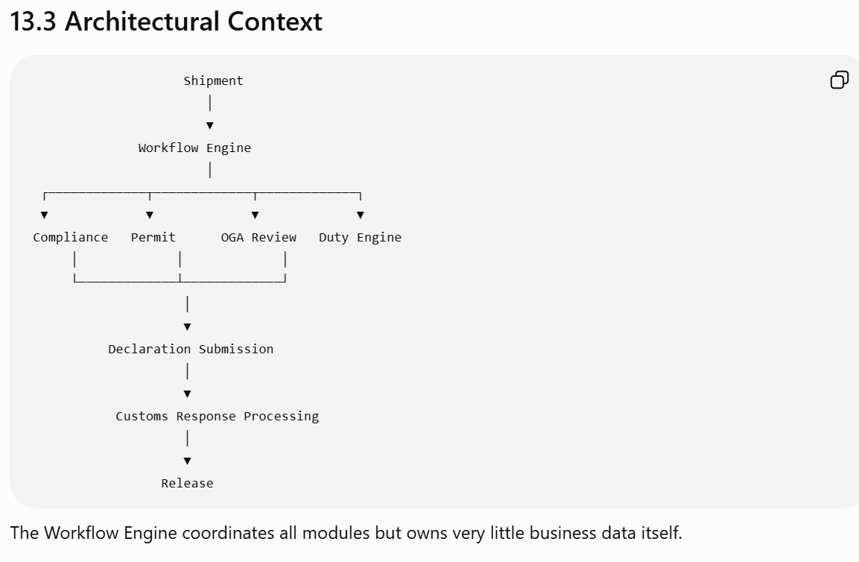

13.4 Workflow Philosophy

The engine is event-driven.

Modules publish business events.

Example:

ShipmentCreated

↓

Workflow Engine

↓

Start Brokerage Workflow

Example:

PermitApproved

↓

Resume Declaration Validation

Example:

CustomsRejected

↓

Create Broker Task

↓

Suspend Workflow

13.5 Core Workflow Concepts

Workflow

Example:

Import Brokerage Workflow

↓

Validation

↓

Classification

↓

Duty

↓

Permit

↓

Compliance

↓

Submission

↓

Clearance

Stage
Each workflow consists of stages.

Example:
Stage
Shipment Received
Validation
Segregation
Declaration
Permit
Compliance
Customs Submission
Release

Activity

Each stage contains activities.

Example

Validation Stage

↓

Validate Customer

↓

Validate Commodity

↓

Validate Documents

↓

Validate Country

Task

Activities create work items.

Example

Task

↓

Review Missing Permit

Assigned To

↓

Broker

Event
Events drive workflow progression.

Examples
- Shipment Created
- Declaration Created
- Permit Approved
- Duty Recalculated
- Customs Accepted
- Customs Rejected

13.6 Workflow Lifecycle

Workflow Created
│
▼
Running
│
┌──────┼──────────────┐
▼ ▼ ▼
Waiting Suspended Completed
│ │ │
▼ ▼ ▼
Resume Cancelled Archived

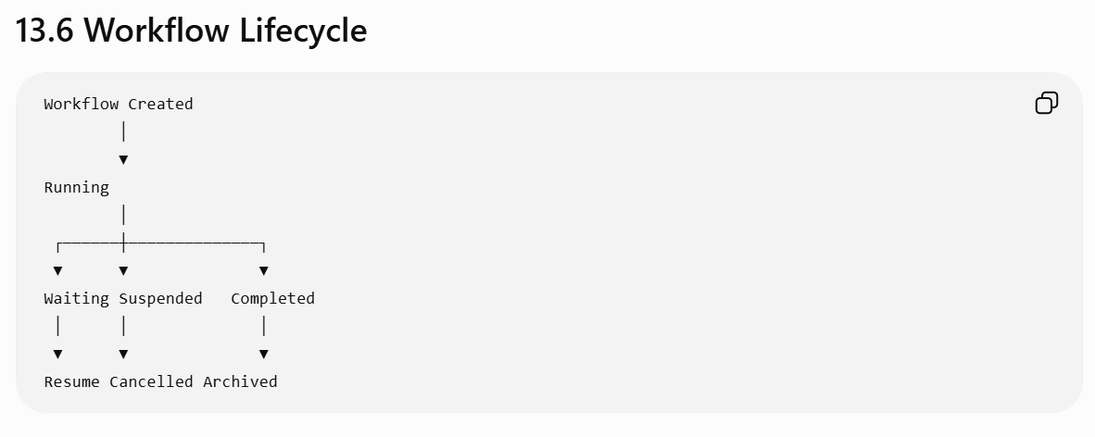

13.7 Supported Workflow Patterns

Sequential

Validate

↓
Classify

↓
Calculate Duty

↓
Submit

Parallel

Shipment
│
┌──────────┼──────────┐
▼ ▼ ▼
Permit Compliance OGA
│ │ │
└──────────┼──────────┘
▼
Declaration Ready

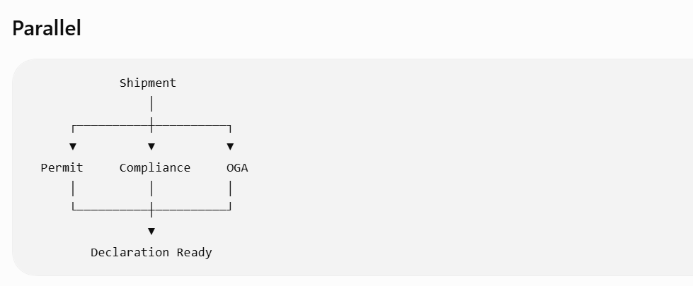

Conditional

Duty > Threshold

↓
Supervisor Approval

Otherwise

↓

Continue

Event-Based

Permit Approved

↓
Resume Workflow

Timer-Based

No Customs Response

↓
After 2 Hours

↓
Retry

↓
Notify Broker

↓
Escalate

13.8 Functional Requirements

FR-WFE-001 – Workflow Definition
Administrators shall define workflows using configurable models.
Each workflow contains:
- Stages
- Activities
- Entry criteria
- Exit criteria
- Events
- Rules
- SLAs
- Escalations
No software deployment is required to change workflow definitions.

FR-WFE-002 – Task Assignment
Tasks may be assigned based on:
- Role
- Team
- Office
- Country
- Skill
- Workload
- Customer
- Commodity Type

Example
Controlled Goods

↓
Assign

↓
Compliance Team

FR-WFE-003 – Dynamic Routing
Workflow routing considers:
- Shipment value
- Customer priority
- Clearance Type
- Country
- Commodity Risk
- Broker Availability
Routing rules are configurable.

FR-WFE-004 – Parallel Processing
The engine supports independent parallel execution.
Example
Permit Review
Compliance Review
Duty Calculation
Document Validation
All execute simultaneously.
Workflow advances only after mandatory branches complete.

FR-WFE-005 – Suspension
Workflow pauses when:
- Permit Pending
- Customs Hold
- Inspection Required
- Missing Documentation
- Compliance Review
Resume occurs automatically when the blocking condition clears.

FR-WFE-006 – Escalation
Escalations occur when:
- SLA exceeded
- Customs timeout
- Permit delayed
- Supervisor approval overdue
Escalation actions include:
- Notifications
- Task reassignment
- Priority increase
- Management alerts

13.9 SLA Management
Every workflow stage has configurable targets.
Stage | Target
Validation | 5 min
Classification | 15 min
Permit Review | 2 hrs
Compliance Review | 30 min
Declaration Preparation | 20 min
Customs Submission | 5 min
Customs Response Monitoring | Configurable
The engine records:
- Start time
- End time
- Elapsed time
- Breach status

13.10 Business Rules
Rule ID | Description
BR-WFE-001 | Every shipment has exactly one active primary workflow.
BR-WFE-002 | Multiple child workflows may execute concurrently.
BR-WFE-003 | Workflow transitions require completion of mandatory predecessor activities.
BR-WFE-004 | Suspended workflows automatically resume when triggering events are received.
BR-WFE-005 | Workflow definitions are versioned and effective-dated.
BR-WFE-006 | In-flight workflows continue under the version they started with unless an explicit migration policy is configured.

13.11 Work Queue Management
The Workflow Engine provides configurable work queues.
Examples:
Queue | Purpose
New Shipments | Initial processing
Validation Errors | Data correction
HS Classification | Manual classification
Permit Review | Regulatory approvals
Compliance Cases | Risk investigation
Customs Rejections | Broker correction
Awaiting Customer | External information required
Supervisor Approvals | Decision points
Queues support filtering, prioritization, workload balancing, and ownership.

13.12 Exception Handling
The engine manages operational exceptions consistently.
Examples:
Exception | Action
Government API unavailable | Retry with exponential backoff, then escalate
Validation failure | Create correction task
Duplicate customs response | Ignore duplicate using idempotency key
Workflow deadlock | Detect, alert administrator, and suspend affected branch
Missing reference data | Route to administration queue

13.13 Audit Requirements
The platform records:
- Workflow started
- Stage entered
- Stage completed
- Task created
- Task reassigned
- SLA breached
- Workflow suspended
- Workflow resumed
- Workflow cancelled
- Workflow completed
Each record includes:
- Workflow Version
- Correlation ID
- User/System
- Timestamp
- Previous Stage
- Current Stage
- Triggering Event

13.14 Administration
Workflow administrators can:
- Design workflows using a visual designer.
- Configure routing rules.
- Define SLA targets.
- Configure escalation policies.
- Version workflow definitions.
- Simulate workflow execution before publishing.
- Roll back to previous workflow versions if necessary.

13.15 Integration Points
Module | Purpose
Shipment Management | Initiates workflows
Compliance Engine | Publishes screening outcomes
Permit Management | Publishes permit events
OGA Management | Publishes agency approval events
Notification Service | Sends alerts and reminders
Customs Submission Engine | Receives submission requests and responses
Reporting & Analytics | Captures operational metrics

13.16 Event Model
The Workflow Engine subscribes to standardized business events rather than direct module calls.

Example events include:
Event | Producer
ShipmentCreated | Shipment Management
DeclarationValidated | Declaration Management
HSClassificationCompleted | HS Classification Engine
DutyCalculated | Duty & Tax Engine
PermitApproved | Permit Management
OGAApproved | OGA Management
ComplianceCleared | Compliance Engine
CustomsAccepted | Customs Submission Engine
CustomsRejected | Customs Submission Engine
ShipmentReleased | Customs Submission Engine
This event-driven model improves scalability, resilience, and maintainability.

13.17 Non-Functional Requirements
- Support execution of millions of workflow instances annually.
- Recover automatically after infrastructure failures without losing workflow state.
- Ensure idempotent processing of events.
- Support horizontal scaling of workflow workers.
- Provide operational dashboards for queue depth, SLA performance, and workflow throughput.
- Retain workflow history according to configurable regulatory retention policies.

13.18 Enterprise Design Enhancement – Workflow as the Process Backbone
Instead of viewing workflow as a utility component, the platform should treat it as the process backbone of the brokerage system.
Key principles:
- State is explicit: Every shipment, declaration, and task has a clearly defined lifecycle.
- Events drive progress: Business events advance workflows rather than tightly coupled service calls.
- Configuration over customization: Business analysts can modify routing, SLAs, and approvals without code changes.
- Observability by design: Every workflow instance can be traced end-to-end with complete auditability.
- Long-running processes: The engine must support workflows that span minutes, days, or weeks (e.g., awaiting permits or inspections) while remaining resilient across restarts and deployments.

Next Chapter – Chapter 14: Customs Submission Engine
Chapter 14 will define the platform's gateway to customs authorities, including:
- Multi-country customs gateway architecture
- API, EDI, and message-based submissions
- Payload generation and validation
- Digital signatures and security
- Acknowledgement processing
- Error handling and resubmission
- Asynchronous customs responses
- Status synchronization
- Idempotency and duplicate prevention
- Submission audit trail
- High availability and disaster recovery considerations
This chapter will describe the external integration layer that connects the brokerage platform to national customs systems while insulating the core business modules from country-specific communication protocols.
Excellent. We have now reached one of the most important modules in the entire platform.
The Customs Submission Engine is the platform's gateway to national customs authorities. In a mature customs brokerage solution, this module must isolate all country-specific protocols, message formats, security requirements, and response handling from the core business logic. The rest of the platform should remain country-neutral, while this engine adapts to each customs administration.

Chapter 14 – Customs Submission Engine
Module ID: CSE-001
Priority: Critical
Dependencies:
- Declaration Management
- Compliance & Risk Engine
- Permit Management
- OGA Management
- Workflow Engine
- Document Management
Consumers:
- Customs Authorities
- Reporting
- Notification Service
- Audit Service

14.1 Purpose
The Customs Submission Engine is responsible for preparing, validating, transmitting, tracking, and managing all electronic communications between the Customs Brokerage Platform and government customs authorities.
It abstracts country-specific submission protocols into a standardized internal interface.
The engine supports:
- Import declarations
- Export declarations
- Transit declarations
- Amendments
- Cancellations
- Customs queries
- Customs responses
- Release notifications
- Duty payment notifications
- Inspection requests
- Post-clearance amendments

14.2 Business Objectives
The engine shall:
- Provide a single submission framework for multiple countries.
- Support synchronous and asynchronous communication.
- Prevent duplicate submissions.
- Maintain complete message traceability.
- Support retries and recovery.
- Enable rapid onboarding of new customs authorities.
- Ensure secure and compliant data exchange.

14.3 Architectural Context
Declaration
│
▼
Customs Submission Engine
│
┌─────────────┼─────────────┐
▼ ▼ ▼
Message Builder Validation Security
│ │ │
└─────────────┼─────────────┘
▼
Country Adapter Layer
│
┌───────────────┼────────────────┐
▼ ▼ ▼
Singapore Australia EU Customs

The Country Adapter Layer encapsulates all jurisdiction-specific implementations.
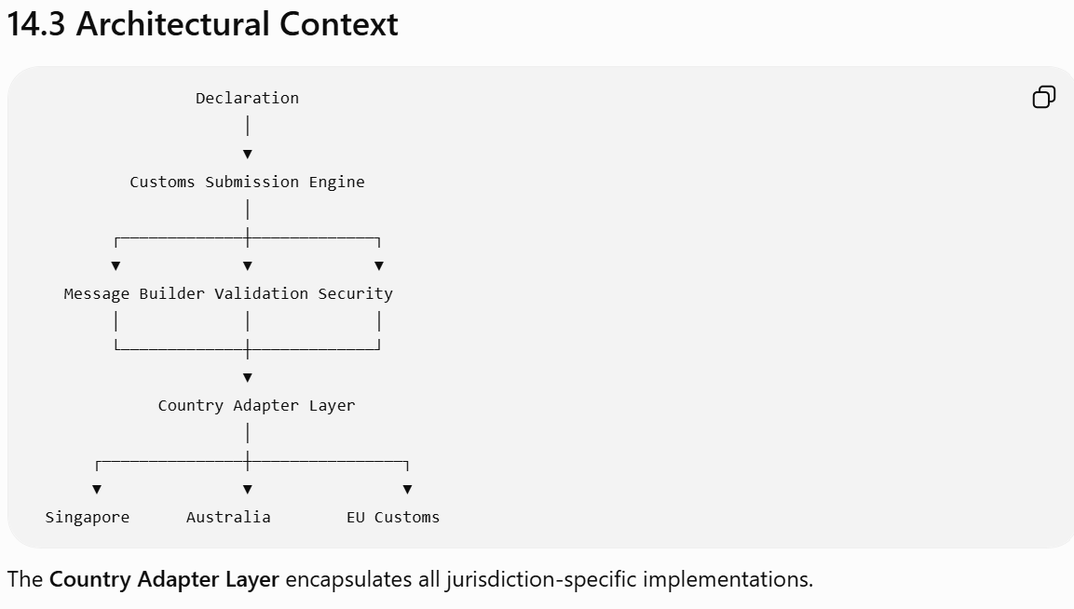

14.4 Submission Lifecycle

Declaration Ready
│
▼
Pre-Submission Validation
│
▼
Generate Customs Payload
│
▼
Apply Digital Signature
│
▼
Transmit
│
▼
Acknowledgement Received
│
▼
Processing
│
┌──────┼──────────────┐
▼ ▼ ▼
Accepted Rejected Query Raised
│ │ │
▼ ▼ ▼
Release Amendment Broker Review

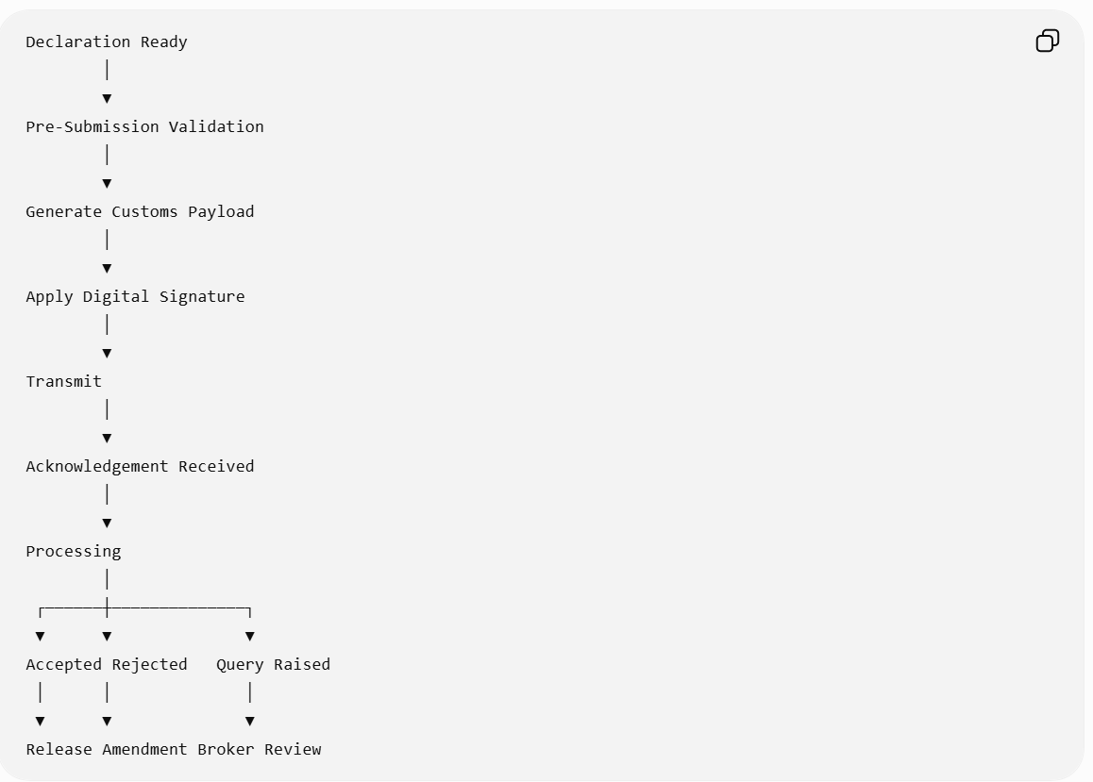

14.5 Supported Message Types

The engine shall support configurable message definitions.
Category | Examples
Declaration | Import, Export, Transit
Amendment | Pre-clearance, Post-clearance
Cancellation | Withdrawal
Customs Query | Information request
Customs Response | Acceptance, Rejection
Inspection | Inspection notice
Release | Cargo release
Payment | Duty payment confirmation
Refund | Refund notification
Audit | Post-clearance audit request

14.6 Country Adapter Framework
Rather than embedding country logic into the engine, each jurisdiction is implemented as an adapter.

Customs Submission Engine
│
▼
Country Adapter Interface
│
┌────────┼─────────┐
▼ ▼ ▼
SG AU US

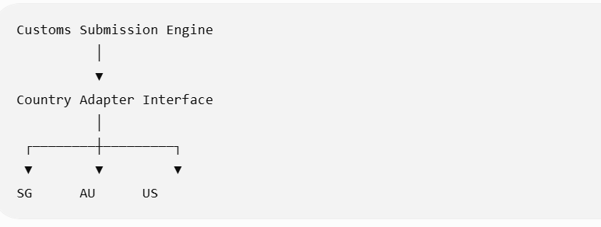

Each adapter implements:
- Payload mapping
- Message validation
- Security protocol
- Authentication
- Endpoint configuration
- Error translation
- Response interpretation
This enables new jurisdictions to be added with minimal impact to the core platform.

14.7 Message Builder
The Message Builder transforms the internal declaration model into the customs authority's required format.
Supported output formats include:
- XML
- JSON
- EDI (EDIFACT, ANSI X12)
- Fixed-length records
- CSV (where required)
- Country-specific proprietary formats
Transformation rules are versioned and effective-dated.

14.8 Pre-Submission Validation
Before transmission, the engine validates:
- Declaration completeness.
- Mandatory fields.
- Permit approvals.
- OGA approvals.
- Compliance clearance.
- Duty calculation completion.
- Digital signature readiness.
- Country-specific validation rules.
Blocking errors prevent transmission.

14.9 Security & Authentication
The engine supports configurable security mechanisms.
Examples:
- Mutual TLS (mTLS)
- OAuth 2.0 / OpenID Connect
- Client certificates
- API keys
- Digital signatures (XMLDSig, JWS, etc.)
- Hardware Security Module (HSM) integration
- Government-issued PKI certificates
Credentials are stored securely and rotated according to policy.

14.10 Functional Requirements
FR-CSE-001 – Submission Preparation
The engine shall:
- Retrieve the latest approved declaration.
- Validate readiness.
- Generate the submission payload.
- Apply required security controls.
- Assign a unique submission identifier.

FR-CSE-002 – Transmission
The engine shall support:
- REST APIs
- SOAP Web Services
- Message Queues
- AS2
- SFTP
- Government gateways
- Batch submissions (where required)
Transmission method is configured per customs authority.

FR-CSE-003 – Acknowledgement Processing
The engine processes acknowledgements independently of the submission.
Acknowledgement states include:
- Received
- Accepted for Processing
- Rejected
- Duplicate
- Invalid Message
- Technical Error
Acknowledgements update workflow state automatically.

FR-CSE-004 – Response Handling
Customs responses may include:
- Acceptance
- Rejection
- Validation error
- Query
- Inspection request
- Duty adjustment
- Release notification
- Hold notification
Each response triggers the appropriate business event.

FR-CSE-005 – Amendment Management
The engine supports:
- Pre-clearance amendments
- Post-clearance amendments
- Partial amendments
- Full replacement submissions
- Cancellation and resubmission
Rules vary by jurisdiction and are adapter-driven.

14.11 Submission Status Model
Status | Description
Draft | Not submitted
Ready | Validated and queued
Submitted | Sent to customs
Acknowledged | Receipt confirmed
Under Review | Customs processing
Query Raised | Additional information required
Accepted | Declaration accepted
Released | Goods released
Rejected | Submission rejected
Cancelled | Submission withdrawn
Amended | Original declaration updated
The declaration status and submission status are maintained separately to support multiple submissions over a declaration's lifecycle.

14.12 Business Rules
Rule ID | Description
BR-CSE-001 | Only validated declarations may be submitted.
BR-CSE-002 | Every submission has a globally unique identifier.
BR-CSE-003 | Duplicate submissions must be detected and prevented.
BR-CSE-004 | Each customs authority uses its configured adapter.
BR-CSE-005 | In-flight submissions retain the message specification version used at transmission.
BR-CSE-006 | Technical transmission success does not imply business acceptance.

14.13 Retry & Recovery
The engine shall distinguish between technical and business failures.
Failure Type | Action
Network timeout | Automatic retry with exponential backoff
Authentication failure | Alert administrator; do not retry until credentials are corrected
Temporary government outage | Queue submission and retry according to policy
Duplicate acknowledgement | Ignore using idempotency key
Business validation rejection | Route to broker for correction
Retries are configurable by jurisdiction and message type.

14.14 Idempotency & Duplicate Prevention
To prevent accidental duplicate submissions:
- Every submission receives an Idempotency Key.
- Retries reuse the same key.
- Duplicate acknowledgements are safely ignored.
- Duplicate customs responses update the existing submission rather than creating new records.
This ensures reliable behavior even during intermittent network failures.

14.15 Audit Requirements
The engine shall record:
- Payload generation
- Validation results
- Transmission attempts
- Endpoint used
- Authentication method
- Acknowledgements
- Customs responses
- Amendments
- Retries
- Technical failures
Audit records include:
- Timestamp
- Submission ID
- Declaration ID
- Adapter version
- Message specification version
- Correlation ID
- User/System identity
Payloads should be retained according to regulatory retention policies, with sensitive data protected through encryption or masking where required.

14.16 Administration
Administrators shall be able to:
- Configure customs authority endpoints.
- Manage adapter versions.
- Configure message mappings.
- Maintain security credentials.
- Configure retry and timeout policies.
- Enable or disable specific message types.
- Schedule maintenance windows for external integrations.

14.17 Integration Points
Module | Purpose
Declaration Management | Source declaration data
Workflow Engine | Submission orchestration
Compliance Engine | Verify submission eligibility
Permit & OGA Management | Confirm regulatory approvals
Document Management | Attach supporting documents
Notification Service | Inform users of customs events
Reporting & Analytics | Operational dashboards and KPIs

14.18 Error Handling
Error Code | Description | System Action
CSE-001 | Payload generation failed | Prevent submission and log validation details
CSE-002 | Authentication failed | Suspend transmission and notify administrators
CSE-003 | Customs endpoint unavailable | Queue for retry according to policy
CSE-004 | Duplicate submission detected | Reject duplicate and reference original submission
CSE-005 | Invalid customs response | Place in exception queue for manual review
CSE-006 | Adapter configuration missing | Block submission until configuration is corrected

14.19 Non-Functional Requirements
- Support high-throughput, concurrent submissions across multiple jurisdictions.
- Ensure 99.9%+ availability for the submission service, excluding external government outages.
- Encrypt all messages in transit and at rest where required.
- Support horizontal scaling of submission workers.
- Guarantee exactly-once business processing through idempotency mechanisms.
- Provide comprehensive monitoring for message latency, success rates, and error trends.

14.20 Enterprise Design Enhancement – Customs Integration Gateway
Rather than embedding customs communication directly into the brokerage platform, implement a dedicated Customs Integration Gateway.
The gateway provides:
- Protocol abstraction: REST, SOAP, EDI, MQ, AS2, and future protocols through a common interface.
- Adapter isolation: Country-specific logic remains independent of core business services.
- Message transformation: Internal canonical models are converted to external message formats and vice versa.
- Operational resilience: Built-in retry, dead-letter queues, circuit breakers, and health monitoring.
- Observability: End-to-end tracing with correlation IDs, message timelines, and operational dashboards.
- Version coexistence: Support multiple message specification versions during government transition periods.
This gateway becomes a reusable enterprise integration capability that can also support future connections to ports, airports, terminal operators, trade platforms, payment providers, and logistics partners.

Platform Progress
We have now completed the Core Transaction Processing Domain:
- ✅ Chapters 1–3: Product Vision & Business Architecture
- ✅ Chapters 4–11: Brokerage Business Capabilities
- ✅ Chapter 12: Compliance & Risk
- ✅ Chapter 13: Workflow Orchestration
- ✅ Chapter 14: Customs Submission
From this point onward, the remaining chapters will focus on the Enterprise Platform Services that support and enhance the core transaction engine.

Next Chapter – Chapter 15: Document Management & Digital Trade Repository
This chapter will define the platform's enterprise document capability, including:
- Digital document repository
- Document lifecycle management
- OCR and AI-assisted document extraction
- Version control
- Electronic document generation
- Template management
- Electronic signatures
- Document validation
- Attachment management
- Trade document relationships
- Long-term retention and archival
- Integration with customs and OGA submissions
This module will serve as the authoritative repository for all trade documents across the customs brokerage lifecycle and will support both operational processing and regulatory compliance.
Excellent. We have now completed the Core Business Processing Domain of the platform. From this chapter onward, we move into the Enterprise Services Layer—capabilities that every mature customs brokerage platform relies on to support operations, compliance, and long-term maintainability.
A robust Document Management capability is far more than file storage. It becomes the digital evidence repository for every customs transaction and is critical for regulatory audits, dispute resolution, post-clearance reviews, and customer service.

Chapter 15 – Document Management & Digital Trade Repository
Module ID: DMS-001
Priority: Critical
Dependencies:
- Shipment Management
- Declaration Management
- Customs Submission Engine
- Permit Management
- OGA Management
- Workflow Engine
Consumers:
- All business modules
- Reporting
- Audit Service
- Customer Portal
- Government Integrations

15.1 Purpose
The Document Management & Digital Trade Repository provides a centralized, secure, version-controlled repository for all documents associated with international trade transactions.
It manages the complete lifecycle of documents from creation and receipt through validation, approval, submission, archival, and eventual disposal according to regulatory retention policies.
The repository serves as the single source of truth for all operational and regulatory documents.

15.2 Business Objectives
The module shall:
- Maintain one authoritative repository for trade documents.
- Eliminate duplicate document storage.
- Support electronic and scanned documents.
- Enable document reuse across declarations.
- Support AI-assisted document extraction.
- Ensure regulatory retention compliance.
- Provide complete document audit history.

15.3 Business Context
Shipment
│
▼
Document Repository
│
┌────────────────┼─────────────────┐
▼ ▼ ▼
Declaration Permits Supporting Docs
│ │ │
└────────────────┼─────────────────┘
▼
Customs & OGA Submission
│
▼
Regulatory Archive

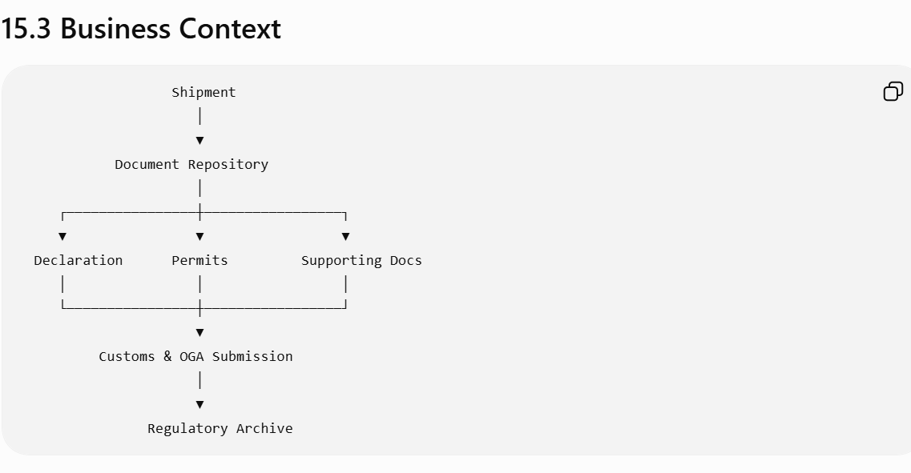

15.4 Supported Document Types
The repository supports structured and unstructured documents.
Category | Examples
Commercial | Commercial Invoice, Proforma Invoice
Logistics | Bill of Lading, Air Waybill, Delivery Order
Customs | Import Declaration, Export Declaration, Transit Declaration
Regulatory | Import Permit, Export Permit, Health Certificate
Trade | Certificate of Origin, Packing List
Financial | Duty Payment Receipt, Insurance Certificate
Compliance | Inspection Report, Laboratory Report
Customer | Purchase Order, Sales Contract
Internal | Broker Notes, Approval Records
Generated | Customs Forms, Internal Reports
Document types are configurable.

15.5 Document Lifecycle
Document Created
│
▼
Uploaded / Generated
│
▼
Classification
│
▼
Validation
│
▼
Linked to Business Objects
│
▼
Submitted (Optional)
│
▼
Archived
│
▼
Retention
│
▼
Disposal

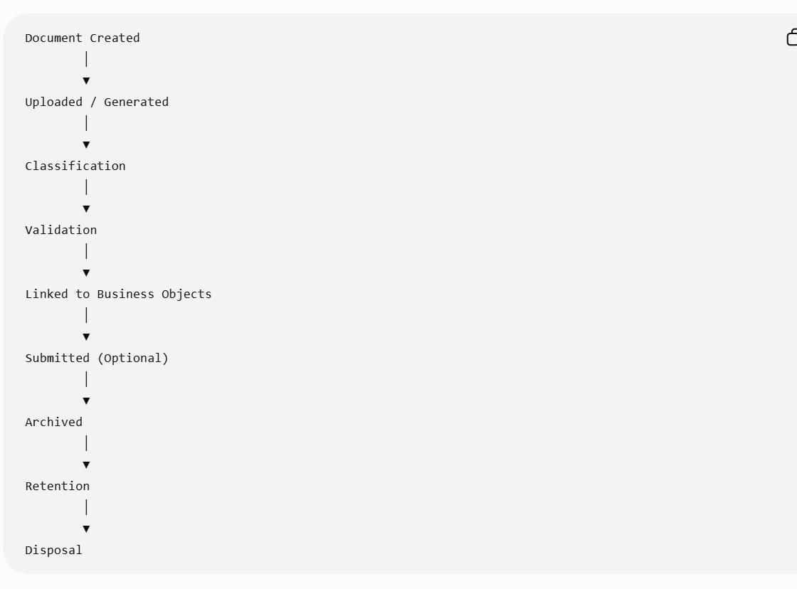

15.6 Document Data Model

Each document stores:
Field | Description
Document ID | Unique identifier
Document Type | Invoice, Permit, etc.
File Name | Original filename
MIME Type | PDF, XML, JPG, etc.
Version | Version number
Status | Draft, Approved, Archived
Source | Uploaded, Generated, External API
Related Shipment | Optional
Related Declaration | Optional
Related Permit | Optional
Related Customer | Optional
OCR Status | Pending, Completed
Classification Status | Auto / Manual
Security Classification | Public, Confidential, Restricted
Retention Policy | Applicable policy
Hash | Integrity verification

15.7 Functional Requirements
FR-DMS-001 – Document Upload
The system shall support:
- Drag-and-drop upload
- Bulk upload
- Email ingestion
- Mobile capture
- Scanner integration
- API upload
- Automated imports from external systems
Supported formats include:
- PDF
- TIFF
- JPEG
- PNG
- XML
- JSON
- CSV
- DOCX
- XLSX

FR-DMS-002 – Document Versioning
The repository shall maintain immutable document versions.
Example:
Version | Description
1.0 | Initial upload
1.1 | OCR completed
2.0 | Customer replacement
2.1 | Corrected invoice
Users may retrieve any historical version.

FR-DMS-003 – Document Linking
A single document may be linked to multiple entities.
Example:

Commercial Invoice
│
┌─────┼───────────────┐
▼ ▼ ▼
Shipment Declaration Customer

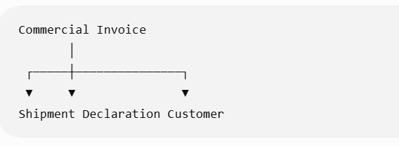
This eliminates duplicate storage.

FR-DMS-004 – OCR Processing
The platform shall support OCR extraction.
Extractable fields include:
- Invoice Number
- Invoice Date
- Supplier
- Buyer
- Commodity Description
- Quantity
- Currency
- Invoice Value
- Country of Origin
- Incoterms
Extracted values are stored separately from the original image.

FR-DMS-005 – AI-Assisted Document Understanding
Optional AI capabilities include:
- Commodity extraction
- HS classification suggestions
- Invoice validation
- Packing list reconciliation
- Duplicate document detection
- Missing document identification
AI-generated results require user confirmation unless configured otherwise.

15.8 Document Validation
Validation includes:
- File integrity
- Digital signature verification
- Virus scanning
- OCR completeness
- Mandatory field presence
- Duplicate detection
- File size limits
- Supported file type validation
Blocking failures prevent downstream use where appropriate.

15.9 Generated Documents
The platform generates standardized documents.
Examples:
- Customs declarations
- Regulatory forms
- Customer reports
- Duty summaries
- Broker invoices
- Inspection requests
- Shipment summaries
Generated documents are version-controlled and stored automatically.

15.10 Template Management
Administrators manage reusable templates.
Supported template types:
- PDF
- HTML
- Word
- Excel
- XML
- JSON
Templates support:
- Variables
- Conditional sections
- Localization
- Branding
- Jurisdiction-specific layouts

15.11 Electronic Signatures
The repository supports:
- Digital signatures
- Electronic approvals
- Certificate validation
- Signature timestamping
- Signature verification
Signed documents become immutable.

15.12 Business Rules
Rule ID | Description
BR-DMS-001 | Every document has a unique identifier.
BR-DMS-002 | Historical versions are immutable.
BR-DMS-003 | Documents may relate to multiple business objects.
BR-DMS-004 | Mandatory documents must exist before submission where required.
BR-DMS-005 | Regulatory retention policies override manual deletion requests.
BR-DMS-006 | Integrity hashes are recalculated only when a new version is created.

15.13 Security & Access Control
Document access is governed by role-based and attribute-based access control.
Permissions include:
- View
- Download
- Upload
- Replace
- Approve
- Delete (logical only, where permitted)
- Share
- Print
Sensitive documents may require:
- Multi-factor authentication
- Watermarking
- Download restrictions
- Encryption at rest
- Encryption in transit

15.14 Search & Retrieval
The repository supports:
- Full-text search (OCR content)
- Metadata search
- HS Code search
- Declaration search
- Shipment search
- Customer search
- Permit number search
- Date range search
- Fuzzy search
- Saved searches
Results support filtering, sorting, and faceted navigation.

15.15 Retention & Archival
Retention policies are configurable by:
- Country
- Document type
- Customer
- Regulatory authority
- Business unit

Lifecycle states:
Active
│
▼
Archive
│
▼
Legal Hold (Optional)
│
▼
Retention Complete
│
▼
Secure Disposal

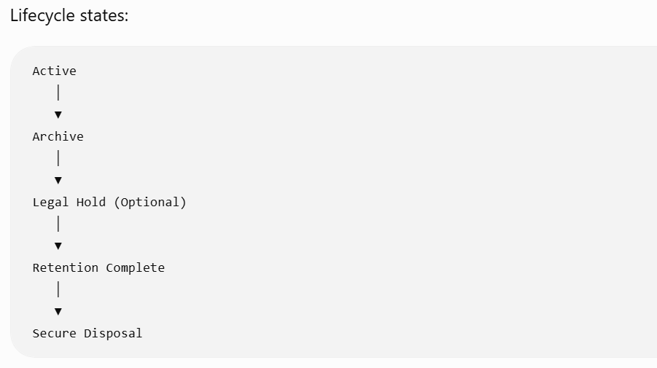

Legal holds suspend automatic disposal until released.

15.16 Audit Requirements
The platform records:
- Upload
- Download
- View
- OCR completion
- AI extraction
- Version creation
- Approval
- Signature
- Sharing
- Archival
- Disposal
- Access denial

Audit entries include:
- User/System
- Timestamp
- IP Address (where appropriate)
- Correlation ID
- Previous Version
- New Version

15.17 Integration Points
Module | Purpose
Shipment Management | Shipment documents
Declaration Management | Declaration attachments
Permit Management | Regulatory documents
OGA Management | Agency submissions
Customs Submission Engine | Electronic attachments
Workflow Engine | Document-driven workflow triggers
Customer Portal | Secure document exchange
Reporting | Document analytics

15.18 Error Handling
Error Code | Description | System Action
DMS-001 | Unsupported file format | Reject upload
DMS-002 | Virus detected | Quarantine file and notify security administrators
DMS-003 | OCR failed | Flag for manual review while retaining the original document
DMS-004 | Duplicate upload | Link to existing document or request user confirmation
DMS-005 | Storage unavailable | Queue upload for retry and notify operations
DMS-006 | Retention policy conflict | Prevent deletion and record an audit event

15.19 Non-Functional Requirements
- Support storage of hundreds of millions of documents.
- Scale independently from transactional services.
- Store immutable document versions.
- Provide configurable OCR and AI processing pipelines.
- Support multi-region replication and disaster recovery.
- Ensure fast metadata search even for very large repositories.

15.20 Enterprise Design Enhancement – Enterprise Content Platform
Rather than embedding document storage within the customs application, the platform should expose a dedicated Enterprise Content Service.
Core capabilities include:
- Content-addressable storage using cryptographic hashes to prevent duplicate files.
- Metadata-first architecture separating document metadata from binary content.
- Canonical document model that can be reused across customs, freight forwarding, warehousing, and finance.
- Event-driven processing for OCR, AI extraction, virus scanning, and document validation.
- Immutable evidence store suitable for regulatory audits and legal proceedings.
- Open integration APIs enabling customer portals, mobile apps, ERP systems, and partner platforms to securely exchange documents.
This approach transforms document management from a supporting feature into a strategic enterprise capability.

Preparing for the Next Phase
With Chapters 1–15, we now have:
- Business Processing Layer (Shipments, Declarations, Commodities)
- Regulatory Layer (Classification, Duty, Permits, OGA, Compliance)
- Execution Layer (Workflow, Customs Submission)
- Content Layer (Document Management)
The remaining chapters will complete the enterprise platform by covering operational collaboration, integrations, analytics, administration, security, and platform architecture.

Next Chapter – Chapter 16: Notification, Task Management & Collaboration
This chapter will define the platform's operational collaboration capabilities, including:
- Unified task management
- Work queues
- Notifications (email, SMS, push, in-app)
- Escalation and SLA monitoring
- Broker-to-customer collaboration
- Internal comments and discussions
- Assignment and delegation
- Reminders and recurring tasks
- Activity feeds
- Case collaboration
- Operational dashboards
This module will ensure that users, teams, customers, and external stakeholders remain synchronized throughout the customs brokerage lifecycle.
Excellent. Chapter 16 is where the platform transitions from being a transaction processing system into an operational execution platform.
One of the biggest shortcomings of many legacy customs brokerage systems is that they manage declarations well but rely on email, spreadsheets, sticky notes, or external ticketing systems to coordinate work. In a modern enterprise platform, collaboration is a first-class capability.
Rather than treating notifications and tasks as separate features, I recommend designing a unified Operational Collaboration Platform that serves all business modules.

Chapter 16 – Notification, Task Management & Collaboration
Module ID: COL-001
Priority: High
Dependencies:
- Workflow Orchestration Engine
- Compliance & Risk Engine
- Customs Submission Engine
- Document Management
- Customer Management
Consumers:
- All Business Modules
- Customer Portal
- Mobile Applications
- Reporting & Analytics

16.1 Purpose
The Notification, Task Management & Collaboration module provides a centralized platform for operational coordination across customs brokerage processes.
It manages:
- Work assignments
- Operational tasks
- Notifications
- Reminders
- Escalations
- Internal collaboration
- Customer communication
- SLA monitoring
- Activity timelines
The module ensures that every operational event is translated into actionable work with complete visibility and accountability.

16.2 Business Objectives
The platform shall:
- Centralize operational work management.
- Eliminate email-driven operational processes.
- Provide real-time notifications.
- Support collaboration across departments.
- Improve SLA compliance.
- Reduce missed regulatory deadlines.
- Provide a complete operational audit trail.

16.3 Business Context
Workflow Engine
│
▼
Task & Collaboration Engine
│
┌──────┼──────────────┐
▼ ▼ ▼
Tasks Notifications Comments
│
▼
Broker / Customer / Supervisor
│
▼
Workflow Progress

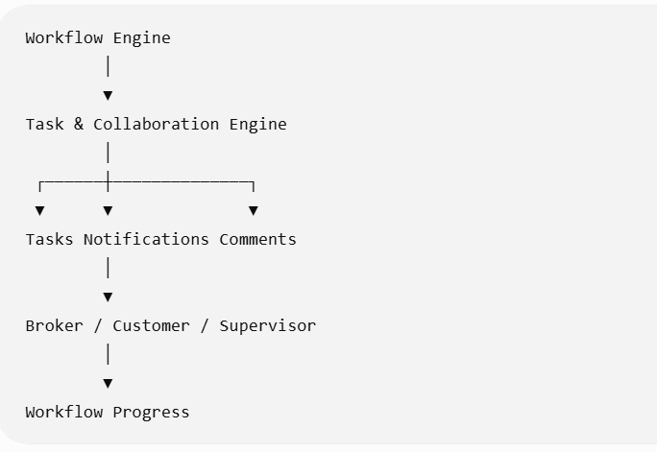

16.4 Collaboration Architecture
The Collaboration Platform consists of five core services:
Collaboration Platform
│
┌─────────────────┼─────────────────┐
▼ ▼ ▼
Task Service Notification Service Activity Feed
│ │ │
└─────────────────┼─────────────────┘
▼
Discussion Service
│
▼
SLA Monitoring
Each service operates independently but shares a common event model.

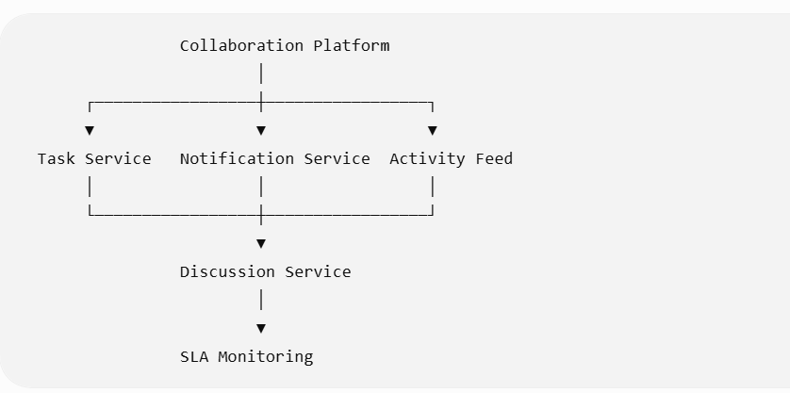

16.5 Task Lifecycle
Task Created
│
▼
Assigned
│
▼
In Progress
│
┌────┼─────────────┐
▼ ▼ ▼
Blocked Waiting Completed
│
▼
Cancelled

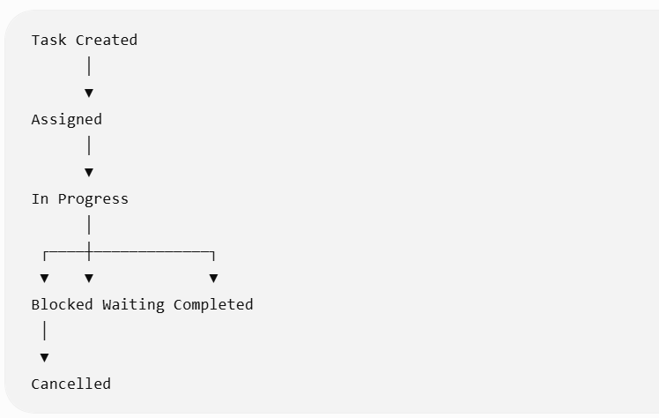

Every task has a complete lifecycle history.

16.6 Task Types
The system supports configurable task categories.
Category | Examples
Validation | Verify declaration
Compliance | Review sanctions match
Permit | Obtain import permit
OGA | Submit health certificate
Customs | Respond to customs query
Finance | Verify payment
Customer | Request missing invoice
Administration | Update reference data
Audit | Review post-clearance request
Task definitions are configurable.

16.7 Task Data Model
Each task contains:
Field | Description
Task ID | Unique identifier
Task Type | Business category
Title | Short description
Detailed Description | Work instructions
Priority | Low, Medium, High, Critical
Status | Current lifecycle state
Assigned User | Current owner
Assigned Team | Responsible group
Related Shipment | Optional
Related Declaration | Optional
Related Case | Optional
Due Date | SLA target
Escalation Level | Current escalation
Parent Task | Optional
Child Tasks | Optional
Attachments | Related documents

16.8 Functional Requirements

FR-COL-001 – Automatic Task Creation
Business events automatically generate tasks.

Example:

Customs Query Received

↓
Create Broker Response Task

Example:

Permit Expired

↓
Create Permit Renewal Task

Task generation rules are configurable.

FR-COL-002 – Manual Task Creation
Authorized users may manually create tasks.
Users may specify:
- Owner
- Due Date
- Priority
- Related Business Object
- Supporting Documents

FR-COL-003 – Task Assignment
Tasks may be assigned using configurable routing.
Assignment criteria include:
- Team
- Role
- Skill
- Country
- Customer
- Commodity Type
- Current Workload
- Shift Calendar

Example:

Dangerous Goods

↓
Compliance Specialists

FR-COL-004 – Task Delegation
Task owners may delegate work.
Delegation records:
- Original Owner
- New Owner
- Reason
- Timestamp
- Duration
Ownership history is retained.

16.9 Notification Framework
The platform supports multiple notification channels.
Channel | Purpose
In-App | Primary operational alerts
Email | Customer communication
SMS | Urgent regulatory events
Mobile Push | Broker mobile app
Microsoft Teams | Operational collaboration
Slack | Internal notifications
Webhooks | Third-party integrations
Notification channels are configurable by event type.

16.10 Notification Events
Examples include:
- Shipment received
- Declaration validated
- Customs accepted
- Customs rejected
- Permit expiring
- OGA response received
- Task assigned
- Task overdue
- SLA breach
- Customer message
- Document uploaded
- Payment received

16.11 Collaboration Features
Each business object supports collaboration.

Example:

Shipment

↓

Discussion Thread

↓

Internal Notes

↓

Customer Messages

↓

Attachments

↓

Activity History

Comments support:
- Rich text
- Mentions (@username)
- Attachments
- Hyperlinks
- Emojis (optional)
- Threaded discussions
Internal comments are separated from customer-visible messages.

16.12 Activity Timeline
Every business object maintains a chronological activity feed.
Example:
09:01 Shipment Created
09:05 Documents Uploaded
09:12 HS Classification Complete
09:18 Duty Calculated
09:20 Permit Required
09:30 Permit Approved
09:35 Submitted to Customs
09:41 Customs Accepted
09:47 Cargo Released
Users can filter by:
- User
- Module
- Event Type
- Date
- Severity

16.13 SLA Management
Every task tracks SLA performance.
Metrics include:
Metric | Description
Created Time | Task initiation
First Response | Initial action
Completion Time | Closure
Due Time | SLA target
Elapsed Time | Actual duration
Breach Indicator | Yes/No
The system supports multiple SLA calendars (business hours, weekends, public holidays) by country or organization.

16.14 Escalation Engine
Escalations occur automatically.

Example:

Task Due

↓
Reminder

↓
Supervisor Notification

↓
Manager Notification

↓
Executive Dashboard

Escalation policies are configurable.

16.15 Customer Collaboration
The platform supports secure communication with customers.
Customers may:
- Upload documents
- Respond to broker requests
- View shipment status
- Receive notifications
- Approve declarations (where applicable)
- Download customs documents
Customer interactions become part of the operational history.

16.16 Business Rules
Rule ID | Description
BR-COL-001 | Every automatically generated task references its originating business event.
BR-COL-002 | Closed tasks cannot be modified except through a formal reopen process.
BR-COL-003 | Escalation timers pause when tasks are legitimately waiting on external parties, if configured.
BR-COL-004 | Internal comments are never visible to customers.
BR-COL-005 | Notification preferences are configurable by user, role, and event type.
BR-COL-006 | Activity timelines are immutable audit records.

16.17 Work Queue Management
Users interact primarily through configurable work queues.
Examples:
Queue | Purpose
My Tasks | Personal assignments
Team Queue | Shared work
Customs Queries | Awaiting broker response
Compliance Reviews | Risk investigations
Expiring Permits | Time-sensitive actions
Awaiting Customer | External dependency
SLA Breaches | Immediate attention
High Priority Shipments | Premium service monitoring
Queues support:
- Dynamic filtering
- Saved views
- Bulk actions
- Workload balancing
- Skill-based routing

16.18 Integration Points
Module | Purpose
Workflow Engine | Creates and advances tasks
Compliance Engine | Generates review tasks
Customs Submission Engine | Publishes customs events
Document Management | Shares attachments
Customer Portal | Enables secure communication
Identity & Access Management | Controls permissions
Reporting & Analytics | Measures productivity and SLA performance

16.19 Audit Requirements
The platform records:
- Task creation
- Assignment
- Reassignment
- Delegation
- Status changes
- Notifications sent
- Notifications delivered
- Comments added
- Customer messages
- SLA breaches
- Escalations
- Task completion
Each record includes:
- Timestamp
- User/System
- Previous State
- New State
- Correlation ID
- Related Business Object

16.20 Error Handling
Error Code | Description | System Action
COL-001 | Notification delivery failed | Retry according to channel policy; log failure
COL-002 | Invalid task assignment | Route to default queue and notify supervisor
COL-003 | Escalation configuration missing | Apply default escalation policy and alert administrator
COL-004 | Collaboration service unavailable | Queue messages for later delivery
COL-005 | Attachment exceeds limits | Reject upload and inform user
COL-006 | Duplicate task generation | Merge with existing task when appropriate using configurable deduplication rules

16.21 Non-Functional Requirements
- Support millions of notifications per day.
- Deliver in-app notifications with low latency.
- Ensure reliable delivery through retry and dead-letter queue mechanisms.
- Support offline mobile synchronization.
- Scale collaboration services independently of transactional modules.
- Retain operational communications according to configurable retention policies.

16.22 Enterprise Design Enhancement – Unified Operational Collaboration Platform
Rather than implementing separate notification, task, messaging, and activity modules, the platform should provide a unified Operational Collaboration Platform built on an event-driven architecture.
Core capabilities include:
- Event-to-Action Engine: Converts business events into tasks, notifications, or escalations using configurable rules.
- Unified Inbox: A single workspace where brokers view tasks, approvals, messages, and alerts across all modules.
- Presence & Availability: Supports workload balancing by considering user availability, shifts, and out-of-office status.
- Conversation Context: Discussions are linked directly to shipments, declarations, compliance cases, and documents, eliminating fragmented communication.
- Operational Intelligence: Tracks workload, SLA adherence, aging tasks, and team productivity in real time.
This design creates an operational experience comparable to modern enterprise workflow platforms while remaining tightly integrated with customs brokerage processes.

Platform Status After Chapter 16
At this stage, the PRD covers approximately 80–85% of the core enterprise customs brokerage platform. The remaining chapters will focus on platform-wide capabilities rather than business processing.

Recommended Remaining Chapters
Chapter | Module
17 | Master Data & Reference Data Management
18 | Integration & API Platform
19 | Reporting, Analytics & Operational Intelligence
20 | Identity, Security & Access Management
21 | Administration, Configuration & Rule Management
22 | Platform Architecture, Deployment & Non-Functional Requirements
These final chapters will complete a PRD that is comparable in depth to the specifications used to build enterprise-grade customs brokerage products, while remaining vendor-neutral and implementation-ready.
Excellent. Chapter 17 is one of the most underestimated modules in enterprise systems. In reality, Master Data & Reference Data Management (MDRM) is what separates a scalable customs brokerage platform from one that becomes difficult to maintain as it grows.
Almost every module we've designed so far—Shipments, Declarations, HS Classification, Duty, Permits, OGA, Compliance, Workflow, and Document Management—depends on consistent, governed master data.
Rather than allowing each module to maintain its own lists and codes, this chapter introduces a centralized Master Data Platform.

Chapter 17 – Master Data & Reference Data Management
Module ID: MDR-001
Priority: Critical
Dependencies:
- Identity & Access Management
- Workflow Engine
- All Core Business Modules
Consumers:
- All Modules
- Customer Portal
- Integration Platform
- Reporting & Analytics

17.1 Purpose
The Master Data & Reference Data Management (MDRM) module provides a centralized, governed repository for all shared business entities, reference codes, and configuration data used throughout the Customs Brokerage Platform.
It ensures consistency, integrity, traceability, and controlled lifecycle management of enterprise data.
The MDRM module acts as the authoritative source for reusable business information across jurisdictions, business units, and customers.

17.2 Business Objectives
The module shall:
- Maintain a single source of truth for master data.
- Eliminate duplicate and inconsistent reference data.
- Support multi-country regulatory data.
- Enable versioning and effective dating.
- Govern data ownership and approval.
- Support reference data synchronization with external systems.
- Ensure complete auditability of master data changes.

17.3 Business Context
Master Data Platform
│
┌──────────┬──────────┬──────────┬──────────┐
▼ ▼ ▼ ▼
Customer Commodity Country Regulatory
│ │ │ │
└──────────┼──────────┼──────────┘
▼
All Business Modules

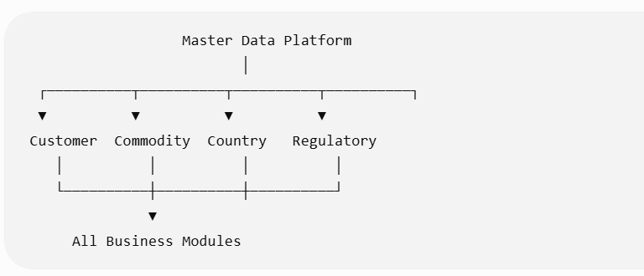

The MDRM module supplies validated reference data to all platform services.

17.4 Master Data Categories
The platform distinguishes between Master Data, Reference Data, and Configuration Data.
Category | Description | Examples
Master Data | Core business entities | Customers, Suppliers, Brokers, Commodities
Reference Data | Standardized codes | Countries, Currencies, Units of Measure
Regulatory Data | Government-controlled values | HS Codes, CPC Codes, Port Codes
Configuration Data | Business rules and settings | Workflow parameters, SLA definitions

17.5 Enterprise Master Data Domains
Party Master
Maintains:
- Customers
- Importers
- Exporters
- Consignees
- Shippers
- Manufacturers
- Brokers
- Carriers
- Freight Forwarders
- Government Agencies

Commodity Master
Stores:
- Commodity Code
- Commodity Description
- Internal Classification
- Preferred HS Code
- Dangerous Goods Flag
- Permit Requirements
- OGA Mapping
- Default Country Restrictions

Location Master
Stores:
- Countries
- States
- Cities
- Ports
- Airports
- Customs Offices
- Free Trade Zones
- Warehouses
- Border Crossings

Regulatory Master
Stores:
- HS Codes
- Tariff Schedules
- CPC Codes
- Incoterms
- Customs Procedure Codes
- Permit Types
- OGA Types
- Regulatory Status Codes

Financial Master
Stores:
- Currency Codes
- Exchange Rate Sources
- Tax Types
- Duty Types
- Payment Methods
- Banks
- Financial Institutions

Operational Master
Stores:
- Transport Modes
- Container Types
- Packaging Types
- Units of Measure
- Service Levels
- Workflow Types
- Priority Levels

17.6 Master Data Lifecycle
Created
│
▼
Validated
│
▼
Approved
│
▼
Published
│
▼
In Use
│
▼
Superseded
│
▼
Archived
Master data is never physically deleted if referenced by business transactions.

17.7 Data Governance
Each master data domain has designated roles.
Role | Responsibility
Data Owner | Business accountability
Data Steward | Day-to-day maintenance
Reviewer | Quality validation
Approver | Final approval
Consumer | Read-only usage
Approval workflows are configurable.

17.8 Effective Dating & Versioning
Every master record supports:
- Effective From
- Effective To
- Version Number
- Status
- Change Reason

Example:

HS Code Version 2026

↓
Effective 01-Jan-2026

↓
Superseded

↓
Version 2027

Historical transactions continue to reference the version in effect when they were created.

17.9 Functional Requirements
FR-MDR-001 – Master Data Maintenance
Authorized users shall:
- Create records.
- Update records.
- Retire records.
- Clone records.
- Import records in bulk.
- Export records.
Changes requiring governance follow approval workflows before publication.

FR-MDR-002 – Bulk Import
Supported methods:
- Excel
- CSV
- XML
- JSON
- REST API
Import validation includes:
- Duplicate detection
- Mandatory fields
- Referential integrity
- Effective date conflicts
- Code uniqueness

FR-MDR-003 – Reference Data Synchronization
The platform supports synchronization with external authorities.
Examples:
- National tariff publications
- ISO country codes
- UN/LOCODE
- Exchange rates
- Government regulatory lists
- Sanctions lists
Synchronization may be:
- Scheduled
- Event-driven
- Manual

FR-MDR-004 – Validation Services
Business modules validate reference values through centralized services.

Example:

Declaration

↓
Country Code

↓
Master Data Validation

↓
Valid / Invalid

No module maintains independent copies of governed reference data unless explicitly configured for offline operation.

17.10 Data Quality Management
The platform continuously monitors:
- Duplicate records
- Missing mandatory attributes
- Invalid code values
- Orphaned relationships
- Expired reference data
- Inconsistent classifications
Data quality dashboards highlight issues for data stewards.

17.11 Business Rules
Rule ID | Description
BR-MDR-001 | Every master record has a globally unique identifier.
BR-MDR-002 | Reference data changes are effective-dated.
BR-MDR-003 | Published master data cannot be modified directly; changes create a new version or revision according to governance policy.
BR-MDR-004 | Referenced master data cannot be physically deleted.
BR-MDR-005 | Transactions retain references to the master data version effective at the time of processing.
BR-MDR-006 | Cross-domain referential integrity is enforced before publication.

17.12 Search & Discovery
Users may search by:
- Code
- Description
- Alternate Code
- Alias
- External Identifier
- Effective Date
- Status
- Domain
- Country
Search supports:
- Full-text search
- Fuzzy matching
- Hierarchical navigation
- Saved filters

17.13 Hierarchies
The module supports configurable hierarchies.

Examples:

Country
│
State
│
City
│
Port
Commodity Group
│
Subgroup
│
Commodity
Hierarchies support inheritance where appropriate.

17.14 Security
Access control supports:
- Domain-level permissions
- Record-level permissions
- Field-level security
- Country-specific restrictions
- Business-unit segregation
Sensitive master data (e.g., banking details) is encrypted at rest.

17.15 Audit Requirements
The platform records:
- Record created
- Record modified
- Approval requested
- Approval granted
- Publication
- Synchronization
- Import
- Export
- Retirement
- Reactivation
Audit entries include:
- User/System
- Timestamp
- Before Value
- After Value
- Version
- Change Reason
- Approval Reference

17.16 Integration Points
Module | Purpose
Shipment Management | Party, location, transport data
Commodity Management | Commodity master
HS Classification | Tariff schedules
Duty & Tax Engine | Duty rates, tax codes
Permit & OGA Management | Regulatory master data
Compliance Engine | Watch lists, sanctions, restricted goods
Workflow Engine | Priority and routing reference data
Reporting | Enterprise dimensions

17.17 Error Handling
Error Code | Description | System Action
MDR-001 | Duplicate master record | Reject or merge based on policy
MDR-002 | Invalid reference code | Block publication and report validation errors
MDR-003 | Referential integrity violation | Prevent update until dependencies are resolved
MDR-004 | Effective date overlap | Reject publication and require correction
MDR-005 | External synchronization failure | Retry according to schedule and alert data stewards
MDR-006 | Unauthorized modification | Deny change and record a security audit event

17.18 Non-Functional Requirements
- Support millions of master records across all domains.
- Provide low-latency reference data lookups.
- Enable independent scaling of synchronization and validation services.
- Support multi-language descriptions and localized labels.
- Maintain historical versions for regulatory traceability.
- Provide high availability with read-optimized caching.

17.19 Enterprise Design Enhancement – Enterprise Master Data Platform
Rather than embedding master data within application modules, implement an Enterprise Master Data Platform with the following architectural capabilities:
Domain-Based Ownership
Each master data domain (Parties, Commodities, Locations, Regulatory Data, Financial Data) has its own lifecycle, governance, and APIs while sharing common platform services.
Canonical Data Model
Business modules consume a canonical representation of entities such as Customer, Commodity, Location, and Regulatory Code. External formats are mapped at the integration layer rather than within business services.
Reference Data Distribution
Master data is published through:
- REST APIs
- Event streams
- Read replicas
- Edge caches (for remote offices)
This avoids duplicated maintenance while supporting high-performance lookups.

Governance Workflows
Every governed change follows:

Draft
│
Validation
│
Review
│
Approval
│
Publication
This ensures regulatory changes—such as new HS codes or customs procedure codes—are reviewed before becoming operational.

Data Lineage
Every published value maintains lineage showing:
- Source system
- Publication date
- Version
- Approval chain
- Downstream consumers
This is especially valuable during audits and regulatory investigations.

17.20 Enterprise Reference Data Catalog
The platform should maintain a centralized catalog of reference datasets.
Examples include:
Domain | Typical Volume | Update Frequency
Countries | ~250 | Rare
Currencies | ~180 | Rare
UN/LOCODE | ~100,000 | Periodic
Ports & Airports | ~25,000 | Periodic
HS Codes | Thousands | Annual / Regulatory
Customs Procedure Codes | Hundreds | Regulatory
Permit Types | Hundreds | Regulatory
OGA Definitions | Hundreds | Regulatory
Tariff Rates | Hundreds of thousands | Frequent
Exchange Rates | Daily | High
Sanctions & Watch Lists | Thousands to millions | Daily / Near real-time
This catalog provides a structured foundation for governance, synchronization, and downstream consumption.

Platform Status After Chapter 17
We have now completed:
- Core Business Services (Chapters 4–11)
- Execution Services (Chapters 12–16)
- Enterprise Data Foundation (Chapter 17)
The platform now has a governed data backbone, enabling consistent behavior across jurisdictions and business units.
Next Chapter – Chapter 18: Integration & API Platform
This chapter will define the enterprise integration architecture, including:
- API Gateway
- REST, GraphQL, gRPC, and event-driven interfaces
- Canonical data model
- Integration adapters
- Partner onboarding
- ERP/WMS/TMS connectivity
- EDI translation
- Event streaming
- Webhooks
- Security and API governance
- Rate limiting and throttling
- Developer portal
- Integration monitoring and observability
This will establish the platform as an open, integration-first ecosystem, capable of connecting seamlessly with customs authorities, logistics providers, enterprise systems, financial institutions, and customer applications.
Absolutely. Chapter 18 is another foundational chapter. In modern enterprise software, the Integration Platform is not simply a collection of APIs—it is the digital ecosystem layer that enables the customs brokerage platform to interact with governments, customers, logistics providers, financial institutions, and enterprise applications.
A mature brokerage platform should be designed as an API-first, event-driven integration platform, not as a closed application with point-to-point interfaces.

Chapter 18 – Integration & API Platform
Module ID: INT-001
Priority: Critical
Dependencies:
- Identity & Access Management
- Master Data Management
- Workflow Engine
- Customs Submission Engine
- All Business Modules
Consumers:
- Customer Portal
- Mobile Applications
- ERP Systems
- WMS/TMS Platforms
- Customs Authorities
- Financial Institutions
- Third-Party Logistics Providers
- Government Agencies
- Partner Ecosystems

18.1 Purpose
The Integration & API Platform provides standardized, secure, scalable, and governed mechanisms for exchanging data between the Customs Brokerage Platform and internal or external systems.
The platform exposes enterprise APIs, publishes business events, consumes partner integrations, and manages protocol translation without exposing internal implementation details.
It enables seamless interoperability while maintaining security, governance, and observability.

18.2 Business Objectives
The platform shall:
- Provide standardized APIs for all business capabilities.
- Support synchronous and asynchronous integrations.
- Minimize point-to-point interfaces.
- Enable rapid partner onboarding.
- Support multiple communication protocols.
- Ensure secure data exchange.
- Provide end-to-end monitoring and governance.

18.3 Enterprise Integration Architecture
API Gateway
│
┌──────────────────┼──────────────────┐
▼ ▼ ▼
REST APIs GraphQL APIs gRPC APIs
│ │ │
└──────────────────┼──────────────────┘
▼
Integration Platform
│
┌──────────────┬──────────────┬──────────────┐
▼ ▼ ▼
Event Bus Adapter Layer Transformation
│ │ │
└──────────────┼──────────────┘
▼
External Systems

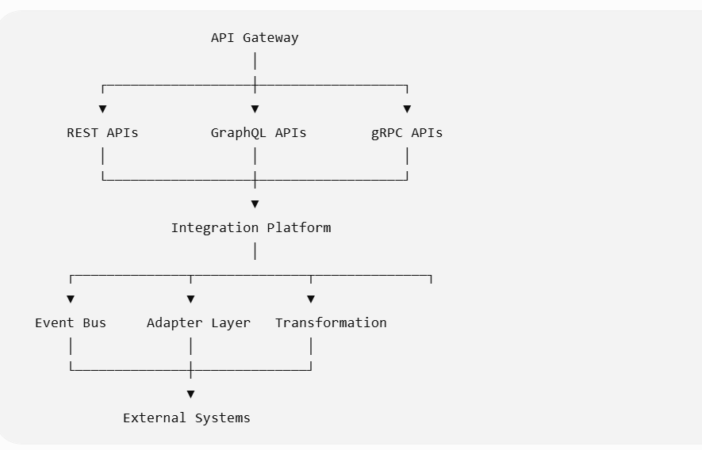

The Integration Platform isolates internal services from external consumers.

18.4 Integration Categories
Category | Examples
Government | Customs, OGA, Tax Authorities
Enterprise | ERP, WMS, TMS, CRM
Logistics | Carriers, Shipping Lines, Airlines
Financial | Banks, Payment Gateways
Customers | Customer Portal, Mobile Apps
Partners | Freight Forwarders, Brokers
Analytics | BI Platforms, Data Lakes
Identity | SSO, Identity Providers

18.5 API Gateway
The API Gateway is the single entry point for all external API requests.
Responsibilities include:
- Authentication
- Authorization
- Rate limiting
- Request validation
- Routing
- API versioning
- Logging
- Monitoring
- API analytics
- Threat protection
No external consumer communicates directly with internal services.

18.6 API Design Standards
All APIs shall adhere to enterprise standards.
Supported styles:
- REST (primary)
- GraphQL (query-intensive use cases)
- gRPC (internal high-performance services)
- WebSocket (real-time notifications)
- OData (optional for enterprise reporting)
REST APIs shall follow consistent naming, pagination, filtering, sorting, and error response conventions.

18.7 Canonical Data Model
The platform exposes a canonical business model independent of internal storage.
Core canonical entities include:
- Shipment
- Declaration
- Commodity
- Party
- Customer
- Permit
- OGA Case
- Duty Assessment
- Document
- Task
- Compliance Case
- Payment
Adapters transform between canonical and partner-specific formats.

18.8 Event-Driven Integration
Business modules publish domain events to an enterprise event bus.
Example events:
Event | Producer
ShipmentCreated | Shipment Service
DeclarationSubmitted | Customs Submission
PermitApproved | Permit Service
OGAApproved | OGA Service
DutyCalculated | Duty Engine
CustomsReleased | Customs Submission
ComplianceHoldApplied | Compliance Engine
DocumentUploaded | Document Service
Consumers subscribe only to relevant events.

18.9 Integration Adapters
External systems are connected through adapters.

ERP

↓
ERP Adapter

↓
Canonical Model

↓
Business Services

Examples include:
- SAP
- Oracle ERP
- Microsoft Dynamics
- Cargo Terminal Systems
- Banking Networks
- Customs Gateways
- Payment Providers
Each adapter is independently deployable and versioned.

18.10 Functional Requirements
FR-INT-001 – API Management
The platform shall:
- Publish APIs.
- Secure APIs.
- Version APIs.
- Deprecate APIs.
- Monitor API usage.
- Generate API documentation.
- Manage API keys and client registrations.

FR-INT-002 – Event Publishing
Business events shall be:
- Immutable
- Versioned
- Timestamped
- Correlated
- Replayable (where supported)
Events are published asynchronously to reduce coupling.

FR-INT-003 – Partner Onboarding
Administrators shall onboard integration partners by configuring:
- Authentication method
- API subscriptions
- Event subscriptions
- Rate limits
- Data mappings
- Environment (Sandbox/Production)
- Contact details

FR-INT-004 – Data Transformation
Transformation services shall support:
- XML ↔ JSON
- CSV ↔ Canonical Model
- EDI ↔ Canonical Model
- Partner-specific mappings
- Field-level transformations
- Code translations
- Validation rules

FR-INT-005 – Webhooks
Partners may subscribe to webhook notifications.
Examples:
- Shipment Released
- Declaration Accepted
- Permit Approved
- Document Uploaded
- Payment Received
Webhook delivery includes retries, signatures, and configurable acknowledgement handling.

18.11 Security
The platform supports:
- OAuth 2.0
- OpenID Connect
- Mutual TLS
- API Keys
- JWT
- Digital Signatures
- IP Whitelisting
- Client Certificates
Sensitive APIs require fine-grained authorization policies.

18.12 API Versioning
Versioning follows semantic principles.
Example:

V1

↓
v1.1

↓
v2

Rules:
- Breaking changes require a new major version.
- Multiple API versions may coexist during migration.
- Deprecation schedules are communicated to consumers.

18.13 Rate Limiting & Traffic Management
Configurable controls include:
Feature | Purpose
Requests per Minute | Prevent abuse
Concurrent Connections | Protect services
Burst Limits | Handle traffic spikes
Quotas | Partner-specific limits
Priority Routing | Premium customers
Circuit Breakers | Isolate failing downstream services

18.14 Integration Monitoring
Operational dashboards display:
- API latency
- Error rates
- Throughput
- Event lag
- Queue depth
- Partner availability
- Failed transformations
- Retry counts
Alerts are generated for threshold breaches.

18.15 Business Rules
Rule ID | Description
BR-INT-001 | All external integrations pass through the API Gateway or approved messaging endpoints.
BR-INT-002 | Canonical models remain independent of partner-specific formats.
BR-INT-003 | Every published event includes a unique event identifier and correlation ID.
BR-INT-004 | Deprecated APIs remain available for the configured transition period unless security risks require earlier retirement.
BR-INT-005 | Integration credentials are rotated according to enterprise security policies.
BR-INT-006 | Failed integrations are retried only for recoverable technical failures; business validation failures require corrective action.

18.16 Developer Portal
The platform provides a self-service Developer Portal.
Capabilities include:
- API catalog
- OpenAPI specifications
- SDK downloads
- Sandbox environments
- Sample requests
- Event catalog
- Client registration
- API usage analytics
- Integration guides
- Change logs
The portal accelerates partner integration and reduces support overhead.

18.17 Integration Lifecycle
Partner Registered
│
▼
Credentials Issued
│
▼
Sandbox Testing
│
▼
Certification
│
▼
Production Enablement
│
▼
Monitoring
│
▼
Version Upgrade

Certification ensures integrations meet security and functional requirements before production access.

18.18 Error Handling
Error Code | Description | System Action
INT-001 | Authentication failed | Reject request and audit the attempt
INT-002 | Rate limit exceeded | Return throttling response with retry guidance
INT-003 | Transformation failure | Route message to exception handling and notify support
INT-004 | Downstream service unavailable | Retry or apply circuit breaker based on policy
INT-005 | Invalid webhook signature | Reject payload and log security event
INT-006 | Unsupported API version | Return version error and provide supported versions

18.19 Audit Requirements
The platform records:
- API invocation
- Authentication
- Authorization decision
- Payload transformation
- Event publication
- Event consumption
- Webhook delivery
- Partner onboarding
- Credential changes
- API deprecation
Each audit record includes:
- Correlation ID
- Request ID
- Client ID
- Timestamp
- Source IP
- API Version
- Processing Outcome

18.20 Non-Functional Requirements
- Support tens of thousands of concurrent API requests.
- Deliver high-throughput event processing with configurable durability.
- Scale API Gateway, adapters, and event processing independently.
- Maintain low-latency responses for interactive APIs.
- Support active-active deployment across multiple regions.
- Provide end-to-end distributed tracing across integration flows.

18.21 Enterprise Design Enhancement – Enterprise Integration Platform (EIP)
The Integration Platform should be implemented as a reusable Enterprise Integration Platform, not merely as a collection of APIs.
Core architectural capabilities include:
API-First Design
Every business capability is exposed through well-defined APIs before being consumed by user interfaces or partners.
Event Backbone
An enterprise event bus distributes business events across services, minimizing direct dependencies and enabling future extensions.
Adapter Framework
All external systems connect through adapters implementing common contracts for:
- Protocol handling
- Authentication
- Data transformation
- Error normalization
- Monitoring
Canonical Integration Layer
The platform maintains a stable canonical business model while allowing partner-specific mappings to evolve independently.
Observability
Every integration flow is traceable using:
- Correlation IDs
- Distributed tracing
- Structured logging
- Metrics
- Health checks
This enables rapid troubleshooting and operational transparency.

18.22 Integration Patterns
The platform supports multiple enterprise integration patterns.
Pattern | Use Case
Request/Response | Interactive APIs
Publish/Subscribe | Business events
Command | Workflow initiation
Event Notification | Customer updates
Batch Processing | Large-scale data synchronization
File Exchange | Legacy EDI and bulk imports
Streaming | Real-time operational dashboards
Selecting the appropriate pattern depends on latency, reliability, and business requirements.

Platform Status After Chapter 18
At this point, the platform includes:
- Core Business Domains (Ch. 4–11)
- Execution & Collaboration (Ch. 12–16)
- Enterprise Data Foundation (Ch. 17)
- Open Integration Platform (Ch. 18)
The architecture is now positioned as an integration-first, cloud-native customs brokerage platform, capable of participating in complex digital trade ecosystems.
Looking Ahead – Chapter 19: Reporting, Analytics & Operational Intelligence
Chapter 19 will move beyond traditional reports to define an Operational Intelligence Platform. It will include:
- Operational dashboards
- Executive KPIs
- Customs clearance analytics
- SLA and productivity reporting
- Financial analytics
- Compliance and audit reporting
- Regulatory reporting
- Customer self-service analytics
- Real-time streaming dashboards
- Data warehouse and data lake architecture
- AI-assisted forecasting and anomaly detection
- Embedded analytics and ad hoc reporting
This chapter will ensure the platform not only processes trade transactions but also transforms operational data into actionable business intelligence.
Excellent. Chapter 19 is where the platform evolves from a System of Record into a System of Intelligence.
Traditional customs brokerage systems provide reports after work is completed. Modern enterprise platforms continuously monitor operational, financial, regulatory, and customer data to provide real-time decision support.
For a NextGen customs brokerage platform, I recommend designing an Operational Intelligence Platform (OIP) rather than a conventional reporting module.

Chapter 19 – Reporting, Analytics & Operational Intelligence
Module ID: OIP-001
Priority: Critical
Dependencies:
- All Business Modules
- Integration Platform
- Master Data Platform
- Identity & Access Management
Consumers:
- Executives
- Operations Managers
- Customs Brokers
- Compliance Officers
- Finance Teams
- Customers
- Regulatory Authorities (where applicable)

19.1 Purpose
The Reporting, Analytics & Operational Intelligence module provides enterprise-wide visibility into operational performance, customs compliance, financial outcomes, customer service, and regulatory activities.
It transforms transactional data into actionable intelligence through dashboards, analytics, KPIs, alerts, forecasting, and AI-assisted insights.
The module supports operational monitoring, strategic decision-making, regulatory reporting, and continuous process improvement.

19.2 Business Objectives
The platform shall:
- Provide real-time operational visibility.
- Deliver configurable dashboards.
- Support self-service analytics.
- Enable historical and trend analysis.
- Monitor SLA and operational KPIs.
- Produce regulatory reports.
- Support predictive analytics.
- Enable executive decision-making.

19.3 Business Context
Operational Data
│
▼
Operational Intelligence
│
┌───────────────┼────────────────┐
▼ ▼ ▼
Dashboards Analytics AI Insights
│ │ │
└───────────────┼────────────────┘
▼
Business Decisions

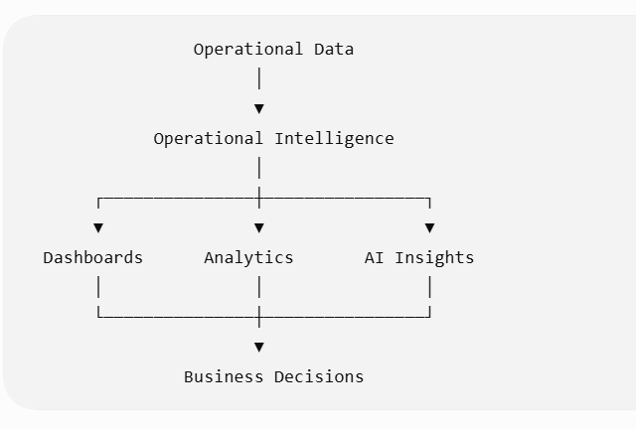

19.4 Intelligence Architecture
Business Services
│
▼
Event Streaming Platform
│
▼
Operational Data Store
│
┌──────┼──────────────┐
▼ ▼ ▼
BI AI Data Warehouse
│ │ │
▼ ▼ ▼
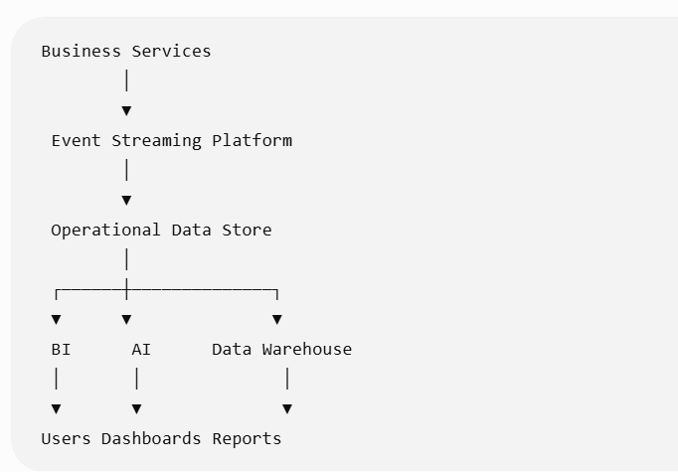

Users Dashboards Reports
The Operational Data Store supports near real-time reporting, while the Data Warehouse supports historical analytics.

19.5 Reporting Categories
Category | Examples
Operational | Shipments, Declarations
Customs | Clearance Performance
Compliance | Holds, Violations
Financial | Duties, Taxes, Billing
Customer | SLA, Service Levels
Regulatory | Permit Activity
Productivity | Broker Performance
Executive | Enterprise KPIs
Audit | Regulatory Evidence
Predictive | Forecasts

19.6 Executive Dashboard
Executives require enterprise KPIs.
Example dashboard:
KPI | Description
Active Shipments | Current workload
Pending Declarations | Operational backlog
Customs Clearance Rate | Percentage cleared
Average Clearance Time | End-to-end cycle
Compliance Holds | Open regulatory issues
Revenue | Brokerage income
Duty Processed | Customs value
Customer SLA | Performance
Broker Productivity | Output per broker
Dashboards update in near real time.

19.7 Operational Dashboards
Operations managers monitor live processing.
Example metrics:
- Work queue depth
- Shipments by stage
- Customs responses
- Awaiting permits
- Awaiting customer
- SLA breaches
- Workflow bottlenecks
- Customs gateway health
- Integration failures
Visualizations include heat maps, trend lines, aging charts, and throughput gauges.

19.8 Compliance Analytics
Compliance officers monitor:
- Sanctions matches
- Restricted goods
- Compliance holds
- Permit exceptions
- OGA processing times
- Inspection requests
- Regulatory violations
- High-risk customers
Trend analysis supports proactive risk management.

19.9 Financial Analytics
Financial reporting includes:
- Duty collected
- Tax liabilities
- Brokerage revenue
- Customer billing
- Refunds
- Payment aging
- Currency exposure
- Duty deferment utilization
Reports support reconciliation and audit.

19.10 Customer Analytics
Customer-facing insights include:
- Shipment volumes
- Average clearance time
- Top commodities
- Top origins/destinations
- Service-level performance
- Customs delays
- Compliance trends
- Billing summaries
Customers access only authorized data through secure portals.

19.11 Functional Requirements
FR-OIP-001 – Standard Reports
The platform shall provide configurable reports including:
- Shipment Summary
- Declaration Register
- Duty Summary
- Permit Register
- Compliance Report
- Customs Response Report
- Productivity Report
- SLA Report
- Customer Activity Report
- Audit Report
Reports support export to PDF, Excel, CSV, and API.

FR-OIP-002 – Ad Hoc Reporting
Authorized users may create reports using:
- Drag-and-drop fields
- Filters
- Grouping
- Calculated fields
- Charts
- Pivot tables
No programming knowledge is required.

FR-OIP-003 – Dashboard Builder
Users may configure dashboards using reusable widgets.
Widget types:
- KPI cards
- Charts
- Tables
- Maps
- Timelines
- Gauges
- Heat maps
- Status indicators
Dashboards are role-based.

FR-OIP-004 – Scheduled Reporting
Reports support:
- Daily
- Weekly
- Monthly
- Quarterly
- Event-triggered
Distribution methods:
- Email
- Customer Portal
- Secure API
- Shared Repository

FR-OIP-005 – Alerting
Users define alerts.

Example:

Average Clearance Time

>

12 Hours

↓
Notify Operations Manager

Another example:

Compliance Holds

>

100

↓
Executive Alert

Alerts support configurable thresholds and escalation policies.

19.12 Key Performance Indicators
Operational KPIs include:
KPI | Formula
Average Clearance Time | Release − Shipment Received
First-Time Acceptance Rate | Accepted ÷ Submitted
Customs Rejection Rate | Rejected ÷ Submitted
Permit Processing Time | Approval − Request
Broker Productivity | Completed Declarations ÷ Broker
SLA Compliance | Completed Within SLA ÷ Total
KPIs are configurable by customer, office, or jurisdiction.

19.13 AI-Assisted Intelligence
The platform optionally provides AI-assisted insights.
Examples:
- Clearance delay prediction
- Missing document prediction
- Compliance anomaly detection
- Duty anomaly identification
- Customer workload forecasting
- Staffing recommendations
- Bottleneck detection
- Duplicate declaration identification
AI recommendations are advisory unless explicitly configured otherwise.

19.14 Business Rules
Rule ID | Description
BR-OIP-001 | Reports reflect authorized data only.
BR-OIP-002 | KPIs use version-controlled calculation definitions.
BR-OIP-003 | Historical reports remain reproducible even after master data changes.
BR-OIP-004 | Dashboard visibility follows role and data access permissions.
BR-OIP-005 | Regulatory reports are retained according to jurisdictional requirements.
BR-OIP-006 | AI-generated insights are clearly identified as recommendations.

19.15 Operational Data Warehouse
The platform maintains an analytical repository optimized for reporting.
Subject areas include:
- Shipment Facts
- Declaration Facts
- Duty Facts
- Compliance Facts
- Customer Dimensions
- Commodity Dimensions
- Country Dimensions
- Time Dimensions
- Regulatory Dimensions
Historical data supports long-term trend analysis.

19.16 Self-Service Analytics
Business users can:
- Build dashboards
- Save personal reports
- Share reports
- Schedule report delivery
- Bookmark analyses
- Compare reporting periods
- Drill down from KPIs to transactions
Self-service capabilities reduce dependence on technical teams.

19.17 Audit & Regulatory Reporting
Standard reports include:
- Customs Declaration Register
- Permit Utilization
- OGA Activity
- Duty Collection Summary
- Compliance Investigation Register
- Audit Trail Report
- User Activity Report
- Security Access Report
Reports are exportable and digitally signed where required.

19.18 Integration Points
Module | Purpose
Shipment Management | Operational metrics
Workflow Engine | SLA analytics
Compliance Engine | Risk reporting
Customs Submission Engine | Clearance performance
Document Management | Document analytics
Finance | Revenue and duty reporting
Integration Platform | External BI consumption

19.19 Error Handling
Error Code | Description | System Action
OIP-001 | Data refresh failed | Retry and notify administrators
OIP-002 | KPI calculation error | Mark KPI unavailable and log calculation details
OIP-003 | Dashboard configuration invalid | Prevent publication until corrected
OIP-004 | Report generation timeout | Queue report for background processing
OIP-005 | Unauthorized data request | Deny access and record security event
OIP-006 | Data source unavailable | Display partial results with data freshness indicators where possible

19.20 Audit Requirements
The platform records:
- Report execution
- Dashboard access
- KPI definition changes
- Alert creation
- Alert execution
- Report scheduling
- Report export
- Data refresh
- AI insight generation
Each audit entry includes:
- User
- Timestamp
- Report ID
- Dashboard ID
- Parameters
- Processing duration
- Result status

19.21 Non-Functional Requirements
- Support near real-time operational dashboards with configurable refresh intervals.
- Process millions of analytical records without impacting transactional performance.
- Support horizontal scaling of reporting services.
- Maintain historical data according to retention policies.
- Enable secure multi-tenant reporting where applicable.
- Provide high-performance query optimization for large datasets.

19.22 Enterprise Design Enhancement – Operational Intelligence Platform
Instead of treating reporting as an afterthought, implement a dedicated Operational Intelligence Platform.

Four-Layer Analytics Architecture

Presentation Layer
(Dashboards / Reports / Portal)

│
Analytics Layer
(KPIs / AI / Forecasting)

│
Semantic Layer
(Business Metrics & Definitions)

│
Data Layer
(ODS / Warehouse / Lakehouse)

This separation ensures consistent metric definitions while allowing different visualization technologies to consume the same governed data.
Semantic Business Model
Create an enterprise semantic layer that defines:
- Standard KPI calculations
- Business dimensions
- Time intelligence
- Regulatory metrics
- Customer metrics
- Financial measures
This prevents different departments from calculating the same KPI differently.
Streaming Analytics
High-value operational metrics (e.g., customs gateway outages, queue backlogs, SLA breaches) should be computed from event streams to provide real-time visibility.
AI & Predictive Insights
Future-ready capabilities include:
- Expected clearance time based on trade lane, commodity, and customs office.
- Detection of unusual declaration patterns that may indicate errors or fraud.
- Forecasting of seasonal workload to optimize staffing.
- Recommendations for process improvements based on bottleneck analysis.

19.23 Enterprise KPI Catalog (Illustrative)
To ensure consistency across the organization, maintain a governed KPI catalog.
Domain | Sample KPIs
Operations | Average Clearance Time, Throughput, Queue Aging
Customs | First-Time Acceptance Rate, Release Rate, Rejection Rate
Compliance | Holds, Screening Accuracy, Inspection Rate
Finance | Duty Processed, Revenue, Outstanding Receivables
Customer | SLA Compliance, Response Time, Satisfaction Trends
Workforce | Productivity, Utilization, Rework Rate
Technology | API Availability, Message Latency, Integration Success Rate
Each KPI should include:
- Business definition
- Formula
- Data sources
- Owner
- Refresh frequency
- Target value
- Alert thresholds

Platform Status After Chapter 19
With this chapter, the platform now includes:
- Business Processing Platform (Chapters 4–11)
- Execution & Collaboration Platform (Chapters 12–16)
- Enterprise Data Platform (Chapter 17)
- Integration Platform (Chapter 18)
- Operational Intelligence Platform (Chapter 19)
At this point, the platform architecture is comparable in scope to modern enterprise trade management suites.
Looking Ahead – Chapter 20: Identity, Security & Access Management
The next chapter will define the security architecture, including:
- Identity lifecycle management
- Authentication and Single Sign-On (SSO)
- Multi-Factor Authentication (MFA)
- Role-Based Access Control (RBAC)
- Attribute-Based Access Control (ABAC)
- Delegated administration
- Tenant isolation
- Secrets and key management
- Encryption
- Audit and security monitoring
- Zero Trust principles
- Regulatory compliance (ISO 27001, SOC 2, GDPR, etc.)
This chapter will establish the security foundation required for a global, multi-tenant customs brokerage platform handling sensitive trade, financial, and regulatory information.
Absolutely. Chapter 20 is arguably the most critical cross-cutting capability in the entire platform. Customs brokerage systems process highly sensitive commercial invoices, customs declarations, trade secrets, customer financial data, government credentials, and regulatory submissions. Consequently, security must be designed into every layer of the platform rather than added afterward.
For a modern enterprise customs brokerage platform, I recommend adopting a Zero Trust Security Architecture, where every user, service, device, and API must be authenticated, authorized, and continuously validated.

Chapter 20 – Identity, Security & Access Management (ISAM)
Module ID: ISAM-001
Priority: Critical
Dependencies:
- Master Data Management
- Integration Platform
- Notification Platform
Consumers:
- All Business Modules
- API Gateway
- Customer Portal
- Mobile Applications
- Administration Console
- Integration Services

20.1 Purpose
The Identity, Security & Access Management (ISAM) module provides centralized identity lifecycle management, authentication, authorization, security policy enforcement, encryption, audit logging, and access governance for the entire Customs Brokerage Platform.
It ensures that only authenticated and authorized users, systems, and devices can access platform resources while maintaining regulatory compliance and protecting sensitive trade information.

20.2 Business Objectives
The platform shall:
- Centralize identity management.
- Support enterprise Single Sign-On (SSO).
- Enforce Multi-Factor Authentication (MFA).
- Provide fine-grained authorization.
- Protect sensitive trade information.
- Ensure tenant isolation.
- Maintain complete security audit trails.
- Support international security and privacy regulations.

20.3 Security Architecture
Identity Provider
│
▼
Authentication Service
│
▼
Authorization Engine
│
┌────────────────┼────────────────┐
▼ ▼ ▼
Business APIs Customer Portal Mobile Apps
│ │ │
└────────────────┼────────────────┘
▼
Audit & Security Logs

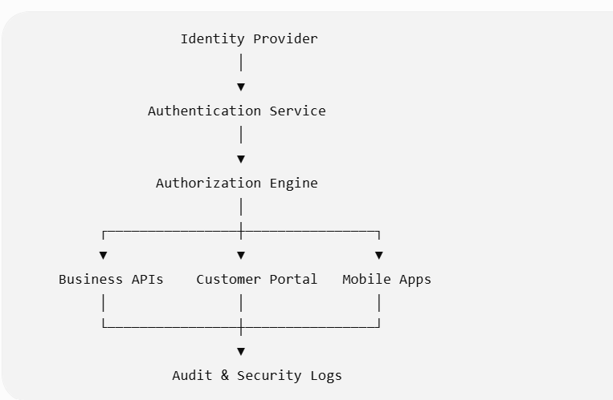

Security services are shared across all modules.

20.4 Identity Types
The platform supports multiple identity categories.
Identity Type | Examples
Internal Users | Customs Brokers, Supervisors
Customers | Importers, Exporters
Government Users | Customs Officers (where supported)
External Partners | Freight Forwarders, Carriers
Service Accounts | APIs, Integration Services
Devices | Mobile Apps, Scanners
Machine Identities | Event Processors, Bots
Each identity type follows appropriate authentication and authorization policies.

20.5 Identity Lifecycle
Provisioned
│
▼
Activated
│
▼
Authenticated
│
▼
Authorized
│
▼
Active
│
▼
Suspended
│
▼
Deactivated

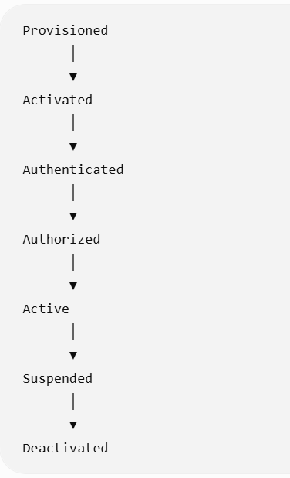

All lifecycle transitions are audited.

20.6 Authentication
Supported authentication mechanisms include:
- Username/Password
- Enterprise SSO
- OAuth 2.0
- OpenID Connect (OIDC)
- SAML 2.0
- Multi-Factor Authentication (MFA)
- Certificate-Based Authentication
- API Keys (for approved integrations)
- Mutual TLS (mTLS)
Authentication policies are configurable by user type and risk level.

20.7 Multi-Factor Authentication (MFA)
Supported second factors:
- Authenticator Apps (TOTP)
- Push Notifications
- FIDO2 / WebAuthn Security Keys
- Biometric Authentication (mobile)
- Hardware Tokens (optional)
High-risk operations (e.g., user administration, production configuration changes, regulatory credential management) should require MFA regardless of session state.

20.8 Authorization Model
The platform combines:
Role-Based Access Control (RBAC)
Examples:
- Customs Broker
- Compliance Officer
- Operations Manager
- Finance Officer
- Customer User
- Administrator
- Auditor

Attribute-Based Access Control (ABAC)
Access decisions may consider:
- Country
- Business Unit
- Customer
- Office
- Shipment Owner
- Commodity Type
- Regulatory Jurisdiction
- Time of Day
- Device Trust Level
- Network Location

Example:
Role = Customs Broker

AND

Country = Singapore

AND

Business Unit = Asia

↓
Access Granted

20.9 Permission Model
Permissions include:
- View
- Create
- Edit
- Approve
- Delete (logical)
- Submit
- Cancel
- Export
- Print
- Delegate
- Configure
- Administer
Permissions are assigned to roles and refined through ABAC policies where needed.

20.10 Tenant Isolation
The platform supports:
- Single-Tenant Deployments
- Multi-Tenant SaaS
- Regional Tenants
- Government-Specific Tenants
Isolation applies to:
- Data
- Documents
- APIs
- Audit Logs
- Reporting
- Storage
- Encryption Keys (where supported)
Cross-tenant access is prohibited unless explicitly configured for managed service scenarios.

20.11 Functional Requirements
FR-ISAM-001 – User Management
Administrators shall:
- Create users.
- Disable users.
- Reset credentials.
- Assign roles.
- Delegate authority.
- Manage groups.
- Configure authentication policies.

FR-ISAM-002 – Role Management
The platform shall support:
- Standard Roles
- Custom Roles
- Composite Roles
- Temporary Roles
- Delegated Roles
Role changes are fully audited.

FR-ISAM-003 – Session Management
The platform manages:
- Session timeout
- Idle timeout
- Absolute session lifetime
- Concurrent session limits
- Device registration
- Trusted devices
- Session revocation

FR-ISAM-004 – Password Policies
Configurable policies include:
- Minimum length
- Complexity
- Password history
- Expiration
- Account lockout
- Breached password detection (where integrated)
Organizations may disable passwords for users authenticating exclusively through enterprise identity providers.

20.12 Data Protection
Sensitive information is protected through:
- Encryption at Rest
- Encryption in Transit (TLS 1.2+ / TLS 1.3)
- Field-Level Encryption
- Tokenization (where appropriate)
- Secure Key Management
- Secure Secret Storage
Examples of protected data:
- Customs credentials
- Customer financial information
- Government-issued identifiers
- API secrets
- Certificates

20.13 Security Monitoring
Security events include:
- Login success/failure
- Privilege escalation
- Permission changes
- Suspicious access
- MFA failures
- API abuse
- Data export
- Configuration changes
- Certificate expiration
Events are forwarded to enterprise SIEM platforms where integrated.

20.14 Audit Requirements
The platform records:
- Authentication
- Authorization decisions
- Role assignments
- Policy changes
- Configuration updates
- Security alerts
- Session creation
- Session termination
- Password resets
- MFA enrollment
- Access denials
Audit entries include:
- User
- Timestamp
- IP Address
- Device Identifier
- Correlation ID
- Event Type
- Result
- Risk Score (optional)

20.15 Security Policies
Policies support:
- Least Privilege
- Separation of Duties
- Just-in-Time Access
- Approval-Based Privilege Elevation
- Geographic Restrictions
- Device Trust Policies
- Conditional Access
- Risk-Based Authentication

Example:

Admin Login

↓
Outside Corporate Network

↓
Require MFA

↓
Allow Read-Only Until Verified

20.16 Business Rules
Rule ID | Description
BR-ISAM-001 | Every authenticated request is evaluated for authorization before accessing protected resources.
BR-ISAM-002 | Privileged operations require elevated authentication based on policy.
BR-ISAM-003 | Security audit records are immutable and retained according to organizational and regulatory requirements.
BR-ISAM-004 | Service accounts may authenticate only through approved non-interactive mechanisms.
BR-ISAM-005 | Access rights are reviewed periodically through governance workflows.
BR-ISAM-006 | Encryption keys are rotated according to enterprise key management policies.

20.17 Regulatory Compliance
The platform is designed to support compliance with:
Standard | Purpose
ISO 27001 | Information Security Management
SOC 2 | Security & Availability Controls
GDPR | EU Data Protection
CCPA (where applicable) | Consumer Privacy
PCI DSS (if payment processing is integrated) | Payment Security
NIST Cybersecurity Framework | Security Best Practices
Regional customs and trade regulations | Jurisdiction-specific requirements
Support for a standard depends on organizational implementation and certification scope.

20.18 Security Administration
Security administrators manage:
- Identity Providers
- Authentication Policies
- MFA Policies
- Role Catalog
- Permission Catalog
- Certificate Stores
- API Credentials
- Encryption Keys (or integrations with enterprise key management systems)
- Security Alerts
Administrative actions require elevated privileges and are audited.

20.19 Error Handling
Error Code | Description | System Action
ISAM-001 | Authentication failed | Reject request, increment risk counters, log event
ISAM-002 | Authorization denied | Return access denied and audit decision
ISAM-003 | MFA validation failed | Deny privileged action and notify user where appropriate
ISAM-004 | Session expired | Require re-authentication
ISAM-005 | Certificate expired | Reject certificate-based authentication and alert administrators
ISAM-006 | Excessive failed logins | Lock account or apply adaptive controls according to policy

20.20 Non-Functional Requirements
- Support millions of authentication and authorization decisions per day.
- Deliver low-latency authorization suitable for high-volume transactional workloads.
- Ensure high availability for identity services.
- Support disaster recovery without compromising security controls.
- Scale authentication, authorization, and audit services independently.
- Maintain tamper-evident security logs.

20.21 Enterprise Design Enhancement – Zero Trust Security Platform
Rather than treating security as a supporting module, implement an Enterprise Zero Trust Security Platform.
Core Principles
- Never Trust, Always Verify: Every request—human or machine—is authenticated and authorized.
- Continuous Evaluation: Access decisions consider identity, device, location, risk, and requested action throughout the session.
- Least Privilege: Users receive only the minimum permissions necessary.
- Defense in Depth: Security controls exist at the network, application, API, data, and infrastructure layers.

Security Services
The platform should expose reusable security services for:
- Identity Federation
- Authentication
- Authorization
- Policy Decision Point (PDP)
- Policy Enforcement Point (PEP)
- Key & Secret Management
- Certificate Management
- Audit & Compliance
- Security Event Streaming
This enables consistent security across all platform modules and integrations.
Secrets & Key Management
Application secrets, API credentials, and encryption keys should be managed through a centralized secrets management solution with:
- Automated rotation
- Versioning
- Access policies
- Hardware Security Module (HSM) support where required
- Full auditability
Security Operations Integration
The platform should integrate with enterprise security operations by providing:
- Structured security events
- Threat intelligence enrichment (where available)
- Incident response hooks
- SIEM and SOAR integrations
- Continuous compliance reporting

20.22 Identity Governance & Administration (IGA)
Beyond authentication and authorization, enterprise deployments should include Identity Governance capabilities.
Key functions include:
Capability | Description
Joiner/Mover/Leaver | Automated provisioning and de-provisioning as personnel join, change roles, or leave
Access Certification | Periodic manager reviews of user access
Segregation of Duties (SoD) | Detect and prevent conflicting permissions (e.g., creating and approving the same declaration)
Privileged Access Reviews | Regular review of administrative privileges
Emergency Access ("Break Glass") | Time-limited emergency access with enhanced logging and post-event review
These governance controls are particularly important for organizations operating across multiple countries and regulatory jurisdictions.

Platform Status After Chapter 20
With Chapter 20 complete, the platform now includes:
- Business Processing Platform (Chapters 4–11)
- Workflow & Collaboration Platform (Chapters 12–16)
- Enterprise Data Platform (Chapter 17)
- Integration Platform (Chapter 18)
- Operational Intelligence Platform (Chapter 19)
- Enterprise Identity & Security Platform (Chapter 20)

The solution is now architecturally aligned with enterprise platforms that must satisfy stringent security, auditability, and compliance requirements while supporting high-volume, multi-jurisdiction customs operations.

Next Chapter – Chapter 21: Administration, Configuration & Rule Management
This chapter will define the operational administration layer, including:
- System administration
- Tenant and organizational management
- Business rule management
- Workflow configuration
- Regulatory rule configuration
- Feature flags
- Localization and internationalization
- Scheduling and batch management
- Environment promotion
- Configuration versioning
- Low-code/no-code administration

This chapter will complete the platform's operational governance model, enabling business administrators to adapt the system to regulatory and organizational changes with minimal software development effort.
Excellent. We've now reached the final major functional chapter. This chapter is often overlooked, but it's what determines whether a customs brokerage platform remains adaptable over years of changing regulations and business processes.
A mature platform should avoid hardcoding business logic wherever possible. Instead, it should expose configurable policies, workflows, and rules that business administrators can manage with appropriate governance.

Chapter 21 – Administration, Configuration & Rule Management
Module ID: ADM-001
Priority: Critical
Dependencies:
- Identity & Security Platform
- Master Data Platform
- Workflow Engine
- Integration Platform
Consumers:
- System Administrators
- Business Administrators
- Compliance Teams
- Operations Managers
- Product Support Teams

21.1 Purpose
The Administration, Configuration & Rule Management module provides centralized capabilities for managing platform configuration, business rules, organizational structures, workflows, reference settings, feature enablement, scheduling, and operational governance.
It enables organizations to adapt the platform to evolving business requirements and regulatory changes with minimal software development.

21.2 Business Objectives
The platform shall:
- Centralize system administration.
- Support low-code business configuration.
- Minimize code-based regulatory changes.
- Enable controlled feature rollout.
- Provide complete configuration governance.
- Maintain configuration version history.
- Support multi-country deployments.

21.3 Administration Architecture
Administration Portal
│
┌───────────────────┼────────────────────┐
▼ ▼ ▼
Configuration Rule Engine Workflow Admin
│ │ │
└───────────────────┼────────────────────┘
▼
Enterprise Platform
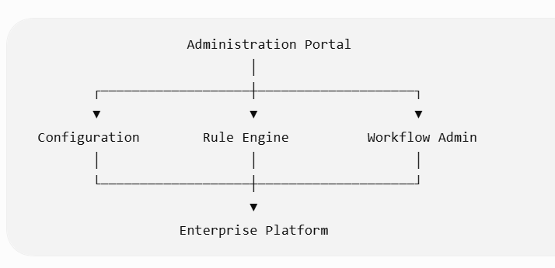

All administrative functions are centralized while respecting role-based access controls.

21.4 Administrative Domains
The platform supports administration across multiple domains.
Domain | Examples
Organization | Companies, Branches, Departments
Users | Roles, Groups, Delegations
Workflow | Workflow Definitions
Business Rules | Validation Rules
Customs | Country Configuration
Notifications | Templates, Channels
Reports | Report Catalog
Integrations | API Clients
Security | Authentication Policies
Feature Flags | Enable/Disable Capabilities

21.5 Organization Management
The platform supports hierarchical organizations.

Enterprise
│
Country
│
Region
│
Branch
│
Department
│
Team
Organization structures support:
- Multiple legal entities
- Shared services
- Country-specific operations
- Multi-brand organizations
- Managed service providers

21.6 Tenant Administration
Administrators manage:
- Tenant creation
- Branding
- Time zones
- Languages
- Currency
- Regional defaults
- Business calendars
- Regulatory jurisdictions
Tenant configuration remains isolated from other tenants.

21.7 Business Rule Management
Business rules are configurable through a centralized Rule Management interface.
Supported rule categories include:
- Validation rules
- Routing rules
- Duty calculation overrides
- Compliance policies
- Permit requirements
- Notification triggers
- SLA policies
- Approval thresholds
Rules support:
- Versioning
- Effective dating
- Testing
- Approval workflows

21.8 Workflow Administration
Business administrators configure:
- Workflow definitions
- Approval chains
- Task routing
- Escalation rules
- SLA targets
- Parallel processing
- Conditional branching
Example:

Shipment Value > USD 500,000

↓
Compliance Review Required

↓
Senior Broker Approval

Workflow changes are version-controlled and do not affect in-flight transactions unless explicitly configured.

21.9 Feature Flag Management
Feature flags enable controlled rollout of functionality.
Examples:
Feature | Scope
AI Classification | Tenant
New Duty Engine | Country
Advanced Reporting | Customer
Mobile Approval | User Group
Experimental Workflow | Branch
Feature activation can be based on:
- Tenant
- Region
- User Group
- Role
- Environment
- Effective Date

21.10 Functional Requirements
FR-ADM-001 – Configuration Management
Administrators shall configure:
- System parameters
- Business defaults
- Country settings
- Organization settings
- Regional calendars
- Holidays
- Number formats
- Date formats
Configuration changes may require approval depending on governance policy.

FR-ADM-002 – Rule Testing
Administrators shall test rules before publication.

Example:
Sample Declaration

↓
Validation Rule

↓
Pass / Fail

↓
Expected Outcome

Testing supports regression scenarios and sample datasets.

FR-ADM-003 – Configuration Promotion

Configuration moves through controlled environments.

Development

↓
Test

↓
UAT

↓
Production

Promotion includes dependency validation and rollback capability.

FR-ADM-004 – Localization
Supported localization includes:
- Languages
- Time zones
- Currency
- Date formats
- Number formats
- Address formats
- Measurement units
The platform supports simultaneous multi-language operation.

FR-ADM-005 – Batch & Scheduler Management
Administrators manage scheduled jobs such as:
- Tariff updates
- Exchange rate imports
- Sanctions synchronization
- Report generation
- Data archival
- Workflow retries
- Notifications
Scheduling options include:
- Cron expressions
- Fixed intervals
- Event-based triggers
- Manual execution

21.11 Configuration Versioning
Every configuration item supports:
- Draft
- Published
- Retired
- Effective From
- Effective To
- Version Number
- Change Reason
Historical versions remain available for audit and rollback.

21.12 Business Rules
Rule ID | Description
BR-ADM-001 | Configuration changes are version-controlled.
BR-ADM-002 | Published configurations cannot be modified directly; new revisions are created instead.
BR-ADM-003 | Rule publication follows configurable approval workflows.
BR-ADM-004 | Production configuration changes are fully audited.
BR-ADM-005 | Environment promotion validates dependencies before deployment.
BR-ADM-006 | Feature flags do not bypass mandatory regulatory controls.

21.13 Audit Requirements
The platform records:
- Configuration changes
- Rule modifications
- Workflow changes
- Feature flag updates
- User administration
- Organization changes
- Scheduler updates
- Localization changes
- Environment promotions
Each audit entry includes:
- User
- Timestamp
- Previous Value
- New Value
- Version
- Approval Reference
- Environment

21.14 Error Handling
Error Code | Description | System Action
ADM-001 | Invalid configuration | Reject publication and report validation errors
ADM-002 | Workflow dependency missing | Prevent activation until resolved
ADM-003 | Rule compilation failed | Keep previous version active and notify administrators
ADM-004 | Feature flag conflict | Apply precedence rules and log the conflict
ADM-005 | Environment promotion failed | Roll back changes and preserve audit history
ADM-006 | Scheduler execution failure | Retry according to policy and raise operational alerts if retries are exhausted

21.15 Non-Functional Requirements
- Support thousands of configurable business rules.
- Apply configuration changes without requiring platform restarts where feasible.
- Ensure high availability of administration services.
- Maintain immutable configuration history.
- Support concurrent administrative users with optimistic locking where appropriate.
- Provide comprehensive search and comparison of configuration versions.

21.16 Enterprise Design Enhancement – Enterprise Configuration Platform
Rather than treating configuration as module-specific settings, implement a centralized Enterprise Configuration Platform (ECP).
Configuration as Code (Where Appropriate)
Support export and import of configuration in structured formats (e.g., YAML or JSON) for controlled promotion through environments while preserving governance.
Rule Engine
The Rule Engine should provide:
- Visual rule authoring
- Decision tables
- Decision trees
- Expression-based rules
- Rule simulation
- Rule impact analysis
- Version comparison
Rules should be executable independently of application code.
Low-Code Administration
Business administrators should configure:
- Approval workflows
- Forms
- Notifications
- Validation logic
- Routing
- Dashboards
- SLA definitions
without software development, subject to governance controls.

Environment Governance
Configuration promotion should support:

Draft

↓
Peer Review

↓
Approval

↓
Deployment

↓
Verification

↓
Rollback (if required)

Each promotion generates a deployment record for operational and audit purposes.

21.17 Operational Administration Console
The platform should provide a unified administration console with:
Capability | Description
System Health | Service status, dependencies, infrastructure health
Queue Monitoring | Workflow, messaging, integration, and retry queues
Job Monitoring | Scheduled and ad hoc job execution
Configuration Explorer | Search and compare configuration items
Rule Catalog | Browse and manage business rules
Workflow Designer | Visual workflow management
Feature Management | Rollout and rollback controls
Tenant Administration | Organizational and regional settings
Diagnostics | Log inspection, tracing, and correlation lookup
This becomes the primary workspace for platform administrators and operations teams.

21.18 Business Rule Catalog Framework
By this stage of the PRD, the platform contains hundreds of business rules (e.g., BR-CMP-xxx, BR-WFE-xxx, BR-DMS-xxx).
The platform should maintain a centralized Business Rule Catalog containing:
- Rule Identifier
- Rule Name
- Business Domain
- Description
- Jurisdiction
- Effective Dates
- Priority
- Dependencies
- Owning Team
- Related Functional Requirements
- Test Scenarios
- Regulatory References (where applicable)
This catalog provides traceability from regulatory requirements through implementation and testing.

Platform Status After Chapter 21

With this chapter complete, the platform now includes:
- Core Customs Brokerage Processing
- Regulatory & Compliance Services
- Workflow & Collaboration
- Enterprise Document Management
- Master Data Platform
- Integration Platform
- Operational Intelligence
- Enterprise Identity & Security
- Enterprise Administration & Configuration

The only remaining chapter is Chapter 22 – Platform Architecture, Deployment & Non-Functional Requirements, which will serve as the architectural capstone for the entire PRD.

What Chapter 22 Will Cover
Rather than being a miscellaneous technical appendix, Chapter 22 will define the platform's enterprise architecture, including:
- Architecture principles
- Domain-driven design and bounded contexts
- Service decomposition
- Deployment topologies (SaaS, private cloud, on-premises)
- High availability and disaster recovery
- Scalability and performance targets
- Observability (logging, metrics, tracing)
- Resilience patterns (circuit breakers, retries, bulkheads)
- Data architecture and storage strategy
- DevSecOps, CI/CD, and release management
- Backup, archival, and business continuity
- Technology standards and interoperability
- Global deployment considerations
- Comprehensive non-functional requirements

This final chapter will transform the PRD from a functional specification into a complete enterprise platform blueprint suitable for solution architecture, engineering planning, and large-scale implementation.
Absolutely. This final chapter is intentionally different from the previous ones. Rather than introducing another business module, it defines the enterprise architecture principles and quality attributes that govern the entire platform.
If Chapters 1–21 describe what the platform does, Chapter 22 describes how it should be engineered to deliver those capabilities reliably, securely, and at enterprise scale.

Chapter 22 – Platform Architecture, Deployment & Non-Functional Requirements
Module ID: ARC-001
Priority: Critical
Dependencies:
- All Previous Chapters
Consumers:
- Enterprise Architects
- Solution Architects
- Engineering Teams
- DevOps
- Security Teams
- Infrastructure Teams
- Operations Teams

22.1 Purpose
This chapter defines the architectural principles, deployment models, operational characteristics, and non-functional requirements governing the Customs Brokerage Platform.
Its purpose is to ensure that the platform remains scalable, secure, resilient, maintainable, interoperable, and cloud-ready throughout its lifecycle.

22.2 Architectural Principles
The platform shall be designed according to the following principles:
Principle | Description
Business Capability Driven | Services align to business domains rather than technical layers.
API First | Every capability is exposed through well-defined APIs.
Event Driven | Business events enable loose coupling between services.
Cloud Native | Optimized for containerized and elastic deployment.
Security by Design | Security integrated into every layer.
Configuration over Customization | Prefer configurable behavior to code changes.
Stateless Services | Business services remain stateless where practical.
Observability First | Every component is measurable and traceable.
Automation First | Infrastructure and deployments are automated.
Open Standards | Use widely adopted standards and protocols.

22.3 Enterprise Architecture Overview
Customer Channels
Portal • Mobile • APIs • Partners
│
▼
API Gateway
│
▼
Business Capability Services
│
┌──────────────┼──────────────┐
▼ ▼ ▼
Workflow Integration Intelligence
│ │ │
└──────────────┼──────────────┘
▼
Shared Platform Services
│
▼
Data • Messaging • Storage • Security
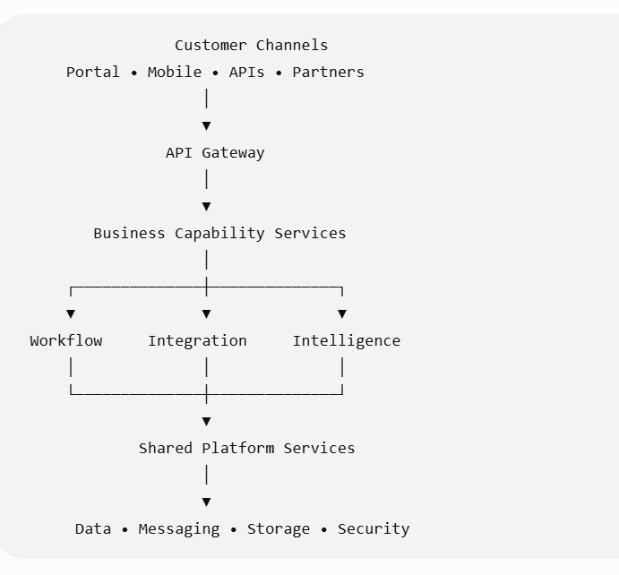

The architecture separates presentation, business capabilities, shared services, and infrastructure.

22.4 Domain-Driven Design
Business services should be organized around bounded contexts.
Illustrative domains include:
Shipment
Declaration
Classification
Duty
Permits
Compliance
Workflow
Documents
Customers
Billing
Reporting
Administration
Each bounded context owns:
- Business rules
- Data
- APIs
- Events
- Lifecycle
Cross-context communication occurs through published contracts.

22.5 Service Decomposition
The platform should decompose into independently deployable services where appropriate.
Example service catalog:
Domain | Service
Shipment | Shipment Service
Customs | Declaration Service
Classification | HS Classification Service
Finance | Duty & Tax Service
Compliance | Compliance Screening Service
Workflow | Workflow Orchestrator
Documents | Document Service
Notifications | Collaboration Service
Identity | Identity Service
Reporting | Analytics Service
Service boundaries should align with business ownership rather than technical convenience.

22.6 Deployment Models
Supported deployment options include:
Model | Description
SaaS | Multi-tenant cloud deployment
Private Cloud | Customer-managed cloud
Hybrid | Cloud with on-premises integrations
On-Premises | Fully customer-hosted deployment
Regional Cloud | Country or jurisdiction-specific hosting
The platform should abstract infrastructure differences wherever possible.

22.7 Scalability
The platform shall support horizontal scaling for:
- API Gateway
- Business Services
- Workflow Engine
- Integration Platform
- Event Processing
- Reporting
- Document Processing
Scalability should be independent by service to optimize resource utilization.

22.8 High Availability
Critical services should support:
- Active-Active deployment
- Automatic failover
- Load balancing
- Health monitoring
- Graceful degradation
- Rolling upgrades
Single points of failure should be eliminated where feasible.

22.9 Disaster Recovery
The platform shall define:
Objective | Target
Recovery Time Objective (RTO) | Configurable by deployment and business requirements
Recovery Point Objective (RPO) | Configurable by deployment and business requirements
Recovery strategies include:
- Multi-region replication
- Automated backups
- Database recovery
- Infrastructure as Code (IaC) recreation
- Periodic disaster recovery testing
Target values should be agreed with each deployment based on contractual and operational needs.

22.10 Data Architecture
The platform should employ polyglot persistence where appropriate.
Illustrative storage responsibilities:
Data Type | Suitable Storage
Transactions | Relational Database
Documents | Object Storage
Search | Search Index
Events | Event Store / Message Broker
Analytics | Data Warehouse / Lakehouse
Caching | Distributed Cache
Each service owns its operational data while sharing information through APIs and events.

22.11 Messaging Architecture
The platform supports:
- Event Streaming
- Publish/Subscribe
- Command Messaging
- Queue-Based Processing
- Dead Letter Queues
- Retry Policies

Illustrative flow:
Business Event

↓
Event Bus

↓
Subscribers

↓
Processing

Messaging improves resilience and reduces service coupling.

22.12 Resilience Patterns
The platform should implement enterprise resilience patterns.
Examples:
- Circuit Breakers
- Retry with Exponential Backoff
- Bulkheads
- Idempotent Processing
- Timeouts
- Dead Letter Queues
- Health Probes
- Graceful Degradation
These patterns reduce cascading failures.

22.13 Observability
Observability includes:
- Centralized Logging
- Distributed Tracing
- Metrics Collection
- Health Endpoints
- Correlation IDs
- Audit Logging
- Business Metrics
Operations teams should trace a transaction from shipment creation through customs release.

22.14 DevSecOps
Development pipelines support:
- Source Control
- Automated Builds
- Static Code Analysis
- Dependency Scanning
- Unit Testing
- Integration Testing
- Security Testing
- Container Scanning
- Automated Deployment
Infrastructure should be provisioned using Infrastructure as Code.

22.15 Release Management
Supported release strategies include:
- Blue-Green Deployment
- Canary Releases
- Rolling Deployment
- Feature Flags
- Emergency Rollback
Business administrators can enable new capabilities independently where supported.

22.16 Backup & Archival
Backup policies cover:
- Databases
- Documents
- Configuration
- Audit Logs
- Master Data
- Encryption Keys (or external key references)
Archival policies align with jurisdictional retention requirements.

22.17 Performance Requirements
Illustrative enterprise targets:
Area | Requirement
Interactive APIs | Target sub-second responses for typical requests under normal operating conditions
Customs Submission | Asynchronous processing with acknowledgement tracking
Search | Responsive results for common operational queries
Dashboard Refresh | Near real-time where supported
Notifications | Low-latency delivery through supported channels
Exact service-level objectives (SLOs) should be finalized during solution architecture based on deployment size, regulatory expectations, and infrastructure.

22.18 Availability Requirements
Illustrative operational objectives:
Service | Availability Objective
Business Services | High availability target defined by deployment
API Gateway | High availability target defined by deployment
Workflow | High availability target defined by deployment
Reporting | High availability target defined by deployment
Availability commitments should be documented as service-level agreements (SLAs) for each customer deployment.

22.19 Business Continuity
Business continuity planning includes:
- Alternate data centers or cloud regions
- Failover procedures
- Communication plans
- Operational runbooks
- Periodic recovery exercises
- Emergency access procedures

22.20 Technology Standards
The platform should support industry standards including:
Category | Examples
APIs | REST, GraphQL, gRPC
Security | OAuth 2.0, OIDC, SAML 2.0, TLS
Messaging | AMQP, Kafka-compatible event streaming, JMS (where applicable)
Documents | PDF, XML, JSON
Data Exchange | EDI, CSV, XML, JSON
Containers | OCI-compatible containers
Orchestration | Kubernetes-compatible platforms
Technology selections should remain implementation-neutral to avoid unnecessary vendor lock-in.

22.21 Business Rules
Rule ID | Description
BR-ARC-001 | Services communicate only through published contracts (APIs, events, or approved messaging).
BR-ARC-002 | Each business capability owns its operational data.
BR-ARC-003 | Infrastructure changes are managed through controlled deployment processes.
BR-ARC-004 | Production deployments require successful automated validation and appropriate approvals.
BR-ARC-005 | Platform observability is mandatory for all production services.
BR-ARC-006 | Security controls are applied consistently across all deployment models.

22.22 Non-Functional Requirements
Scalability
- Support global multi-country operations.
- Scale services independently.
- Support elastic infrastructure.
Reliability
- High availability architecture.
- Automatic recovery mechanisms.
- Durable message processing.
Security
- Zero Trust architecture.
- End-to-end encryption.
- Continuous audit logging.
Performance
- Responsive user experience.
- Optimized large-volume processing.
- Efficient search and reporting.
Maintainability
- Modular architecture.
- Independent service deployment.
- Comprehensive documentation.
Extensibility
- Plug-in framework for country-specific capabilities.
- Configurable business rules.
- API-first extensibility.
Portability
- Support multiple cloud providers.
- Support hybrid deployments.
- Infrastructure automation.
Compliance
- Configurable retention policies.
- Comprehensive auditability.
- Support for jurisdiction-specific regulatory obligations.

22.23 Enterprise Design Enhancement – Digital Trade Platform Reference Architecture

Rather than viewing the solution as a customs brokerage application, it should be positioned as a Digital Trade Platform composed of interoperable capability domains.
Experience Layer
(Customer Portal • Broker UI • Mobile • APIs)
│
Platform Layer
(Business Services • Workflow • Collaboration)
│
Shared Services Layer
(Identity • Documents • Rules • Master Data)
│
Integration Layer
(APIs • Events • Adapters • EDI)
│
Data & Intelligence Layer
(Operational Data • Analytics • AI)
│
Infrastructure Layer
(Cloud • Kubernetes • Storage • Monitoring)
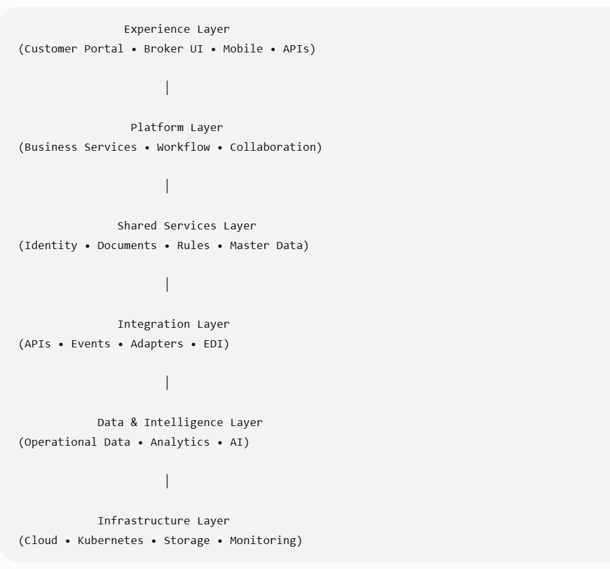

This layered architecture promotes independent evolution of user experiences, business capabilities, shared services, and infrastructure while preserving a stable integration contract.

22.24 Enterprise Quality Attribute Scenario Catalog
To ensure architectural decisions are measurable, maintain a catalog of quality attribute scenarios covering:
Quality Attribute | Representative Scenario
Performance | Process high transaction volumes without degrading interactive user experience
Scalability | Add processing capacity during seasonal import/export peaks without application changes
Availability | Continue operations despite individual service or infrastructure failures
Security | Prevent unauthorized access while supporting secure federation with enterprise identity providers
Interoperability | Integrate new customs authorities or logistics partners through standardized adapters
Maintainability | Deploy updates to one business capability with minimal impact on others
Auditability | Reconstruct the complete lifecycle of a shipment for regulatory review
Recoverability | Restore services and data according to agreed recovery objectives
Extensibility | Introduce support for a new country's customs regulations through configuration and plug-in extensions
These scenarios provide concrete architectural acceptance criteria and should be validated during design reviews and performance testing.

Conclusion – Enterprise Customs Brokerage Platform PRD
With Chapter 22 complete, the PRD now defines a comprehensive enterprise platform encompassing:
- Core Customs Brokerage Operations
- Regulatory & Compliance Management
- Workflow & Operational Collaboration
- Document & Content Management
- Master & Reference Data Management
- Integration & API Platform
- Operational Intelligence & Analytics
- Identity, Security & Access Management
- Administration, Configuration & Rule Management
- Enterprise Architecture & Quality Attributes

Recommended Companion Volumes
To make this specification implementation-ready, I recommend creating three additional companion volumes:

Volume II – Business Rule Catalog
A centralized catalog of all business rules (BR-xxx), organized by module, jurisdiction, priority, regulatory source, and traceability to functional requirements.

Volume III – Enterprise Domain & Data Model
- Canonical business entities
- Logical and conceptual data models
- Domain events
- Bounded contexts
- API resource model
- Data ownership and lifecycle

Volume IV – Solution Architecture & Engineering Guide
- Reference architecture
- API specifications
- Event catalog
- Integration contracts
- Security architecture
- Deployment patterns
- DevSecOps guidance
- Testing strategy
- Operational runbooks

Final Assessment

Taken together, these 22 chapters form a vendor-neutral, enterprise-grade product specification for a modern customs brokerage platform. They are sufficiently detailed to guide product management, solution architecture, engineering, quality assurance, implementation, and regulatory review, while remaining adaptable across jurisdictions and deployment models.
The resulting body of work is closer to an enterprise product blueprint than a conventional PRD and provides a strong foundation for building a scalable, globally deployable customs brokerage solution.

