NeuroAgent: A Team of AI Specialists for Reviewing Epilepsy EEG Data
AI in Healthcare High-Risk Project
Murali Balarama Chakaravarthy, The University of Texas at Austin, USA

Abstract
Diagnosing epilepsy from EEG data is often uncertain, even for experienced doctors. This project builds a small AI system that mirrors how doctors sometimes handle uncertain cases: by asking more than one specialist for an opinion. Three AI models, each given a different clinical role (a neurologist, an epileptologist, and a neurophysiologist), independently review the same EEG data and give their own assessment. A fourth AI model acts as a moderator, comparing the three opinions and explaining where they agree or disagree. The system also includes a small literature-lookup step and a simple classical Machine Learning baseline for comparison. Tested on eight EEG windows from two patients in the CHB-MIT database, the system produced genuine disagreement between the AI specialists, and in one case, an AI specialist and the baseline model made the exact same mistake. This suggests certain EEG patterns are genuinely ambiguous, not just for one method but across very different approaches.

1. Introduction
Epilepsy affects a large number of people, and the exact type of seizure a person has matters a great deal, because different seizure types respond to different treatments. Reading an EEG, a recording of the brain's electrical activity, to work out the seizure type is genuinely hard, even for trained specialists. Two experienced doctors can look at the same EEG and reach different conclusions.
In real hospitals, doctors sometimes handle this kind of uncertainty by bringing in a colleague, or a full team, to review a hard case together. This project asks a simple question: can a small team of AI models do something similar? Instead of one AI model giving one confident answer, this project builds a system where several AI models, each playing a different clinical role, review the same EEG data and produce a more honest picture of the uncertainty involved.
We call this system NeuroAgent. It is a research prototype built for a course project, not a medical device, and it is not meant to replace a real doctor's judgment.

2. Related Work
Kim et al. [1] built MDAgents, a system that automatically assigns a team of AI models to work together on a medical question, choosing a bigger or smaller team depending on how difficult the question is. Their results showed that a well-organized team of AI models can outperform a single AI model on complex medical tasks. This project borrows that basic idea: a team of models can be more useful than one model on a hard, uncertain question. Unlike MDAgents, this project fixes the team ahead of time, using three roles chosen to match the clinical problem, rather than choosing the team size automatically.
Choi et al. [2] built RETAIN, a healthcare AI model that highlights which parts of a patient's history mattered most to its prediction, so a doctor can see why the model reached its conclusion. This project pursues the same underlying goal, making an AI system's reasoning visible, through a different mechanism: instead of one model's internal attention weights, this project makes reasoning visible by having multiple AI agents write out their reasoning in plain language, and by showing exactly where they agree or disagree.
Shoeb and Guttag [3] built the CHB-MIT dataset used in this project, and showed that machine learning methods can detect seizure onset from EEG signals. This project uses their public dataset and extends their detection-focused approach by asking language models to reason about the EEG openly, in plain text, rather than only producing a single detection label.

3. Methodology

3.1 Data
This project uses the CHB-MIT Scalp EEG Database [3, 4], a public dataset of EEG recordings from pediatric epilepsy patients, hosted on PhysioNet. From this dataset, two patient cases (chb01 and chb05) were selected, and four EEG files were downloaded, each containing at least one labeled seizure. From these files, eight 20-second EEG windows were extracted: four during a labeled seizure and four during normal, non-seizure activity from the same patient, for contrast.

3.2 Turning EEG into text
Language models read text, not raw signal data, so each EEG window's raw numbers are first converted into a short written summary before any AI model sees it. For each window, the average power in five standard frequency bands, delta, theta, alpha, beta, and gamma, is computed and written out as a plain-language description (for example, “Delta power: 1.9e-09, Theta power: 4.3e-10 ...”). This is the only information the AI agents receive about the EEG signal itself.

3.3 A small medical reference library
Real doctors compare what they see against what they already know from training and literature. This project includes four short reference notes describing what different EEG patterns typically look like (focal seizure activity, generalized seizure activity, normal background activity, and general ictal patterns). For each EEG window, a simple scoring step picks the two reference notes that share the most relevant words with that window's description, rather than showing every AI agent every note every time. This is a small, real retrieval step, though the library itself is small and hand-written rather than a full literature search system.

3.4 Three AI specialists
Three AI agents review each EEG window independently. Each agent combines a different underlying AI model with a different clinical role, so that the three opinions come from genuinely different configurations, not just different instructions given to the same model.
Agent | Model | Role
Neurologist | GPT-4o | General seizure differential
Epileptologist | o3-mini | Subspecialist, reasons more deeply about ambiguous cases
Neurophysiologist | GPT-4o-mini | Focuses on the raw signal pattern rather than clinical presentation

All three agents currently run on models from the same company (OpenAI), so their independence comes from different model sizes and different role instructions, not from genuinely different training organizations. This is a limitation discussed further in Section 5.

3.5 The moderator
A fourth AI agent, the moderator, reads all three specialists' opinions together and summarizes where they agree, where they disagree, and what might explain the disagreement. The moderator is not asked to pick a single winning answer; the goal is to make the disagreement visible and explainable, similar to how a lead clinician might summarize a multidisciplinary discussion.

3.6 A simple comparison model
To check whether a much simpler method could already do the job, a classical logistic regression model was trained on the same five band-power numbers the AI agents see, to predict seizure versus non-seizure. Because only eight EEG windows were available, a standard train/test split would leave almost nothing to test on. Instead, leave-one-out cross-validation was used: the model is trained on every window except one, and tested on the one left out, repeated for every window. This gives an honest read from a very small dataset, though the result should still be read as illustrative rather than a validated benchmark.

3.7 Workflow
Figure 1 shows the full pipeline, from raw EEG recording through feature extraction, literature retrieval, the three specialist agents, and the moderator's consensus summary.
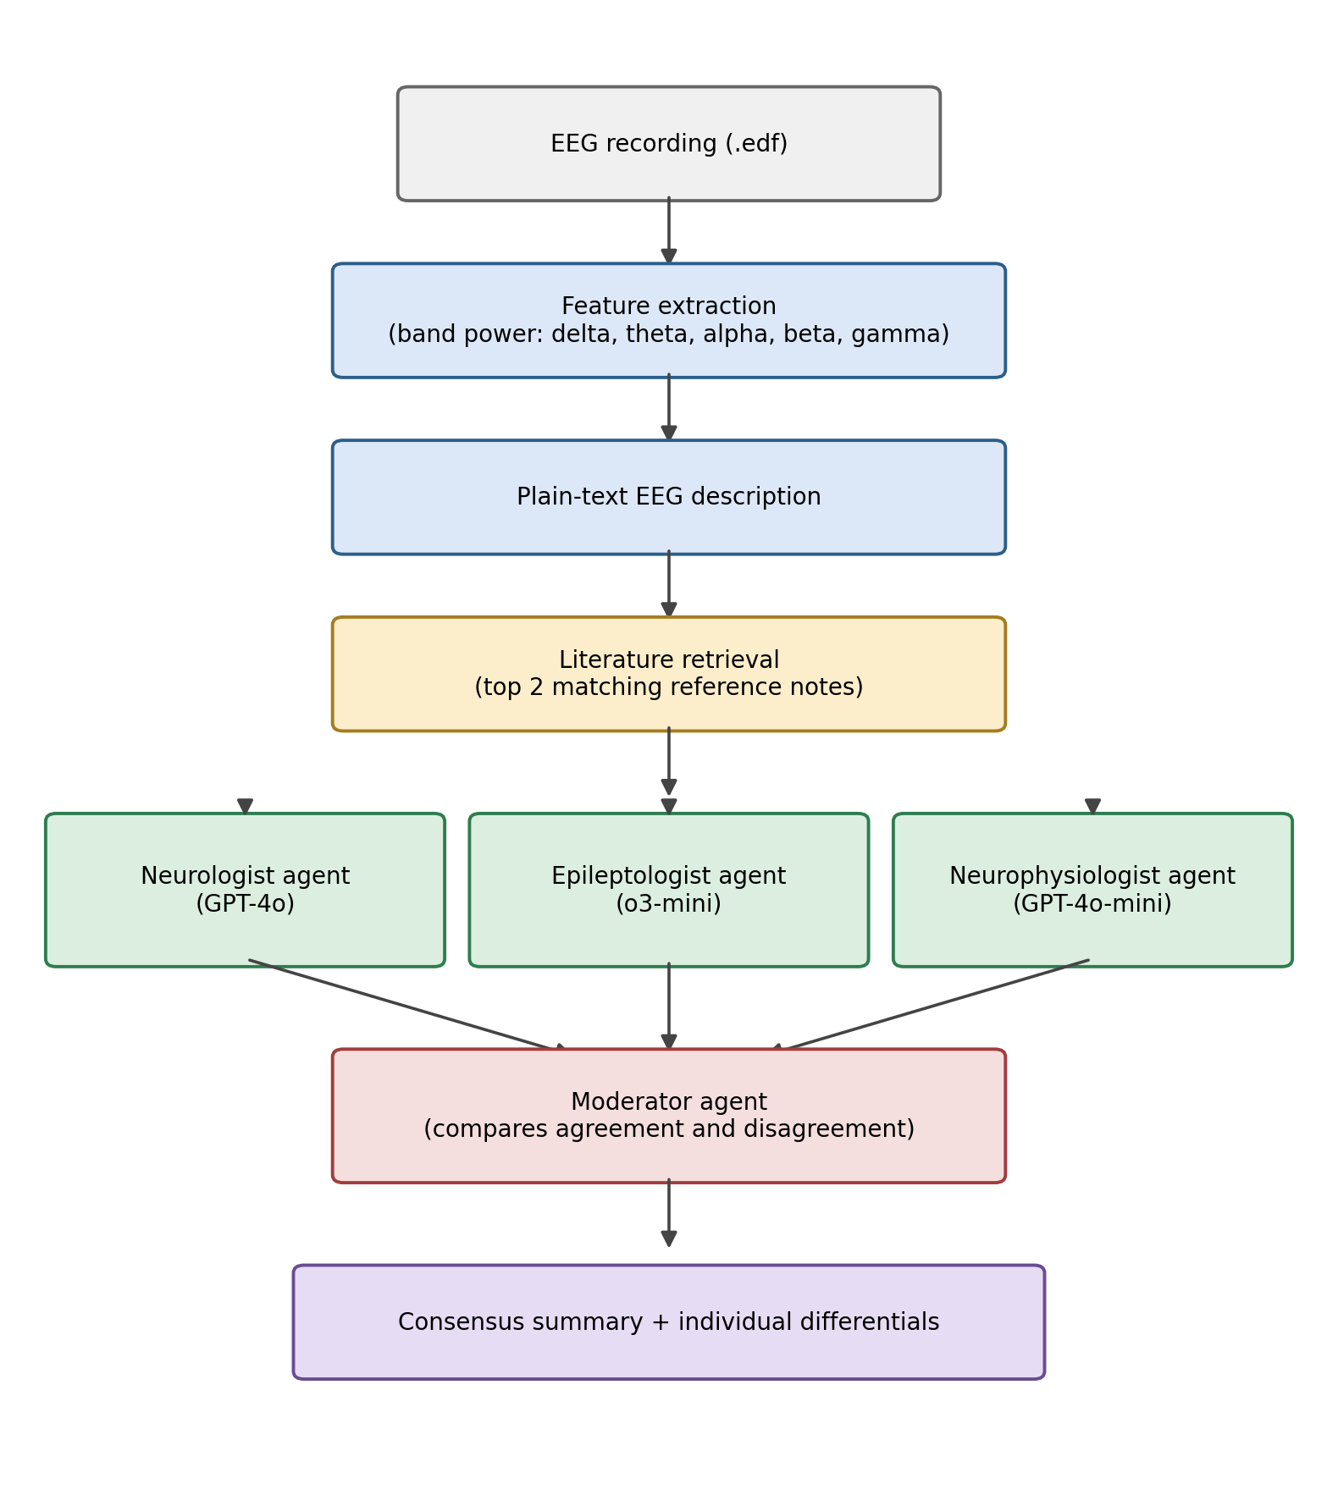
Figure 1: NeuroAgent workflow, from raw EEG to consensus summary.

4. Results

4.1 Dataset summary
Metric | Value
Patients | 2 (chb01, chb05)
EEG files used | 4
EEG windows extracted | 8
Seizure windows | 4
Non-seizure windows | 4
Window length | 20 seconds
Sampling rate | 256 Hz

4.2 Baseline classifier
The logistic regression baseline correctly classified 6 of 8 windows (75%) under leave-one-out cross-validation. With only 8 samples, this number should be read as a rough signal rather than a precise estimate of real-world accuracy.

4.3 Case study: where the baseline and an AI specialist agreed, and were both wrong
The two windows from file chb05_06.edf give a clear, concrete example of the system's behavior. One window is labeled seizure, the other non-seizure, in the original dataset.
On the non-seizure window, the baseline classifier incorrectly predicted seizure. Independently, the epileptologist agent's leading interpretation also leaned toward possible ictal (seizure) activity, at medium confidence, while the neurologist agent correctly leaned away from seizure. The moderator's summary captured this exact split between the two agents.
This is a meaningful result, not just a coincidence. It suggests that this particular EEG window has band-power characteristics that genuinely resemble seizure activity, most likely because it may have been recorded during sleep, when slow-wave (delta and theta) activity is naturally high, similar to what is seen during some seizures. Two very different methods, a classical statistical model and a large language model reasoning in plain text, were led toward the same incorrect conclusion by the same ambiguous input. That points to a real limitation in the input features (band power averaged over a 20-second window, with no information about which brain region was involved or how the pattern changed over time) rather than a random error in either method.

4.4 General pattern across all windows
Across all eight windows, the three AI specialists did not always agree with each other, and the moderator consistently pointed to specific, identifiable reasons for the disagreement, most often a disagreement about whether strong delta and theta activity should be read as sleep or as seizure activity. This is the core behavior the project set out to test: rather than a single AI model giving one falsely confident answer, the system surfaces the genuine ambiguity in the data and explains where it comes from.

5. Discussion and Limitations
- No seizure-type ground truth. CHB-MIT only labels seizure versus non-seizure, not the specific seizure type, so this system's differentials cannot yet be scored against a validated type label.
- Limited independence between agents. All three specialist agents use models from the same company, so shared training biases or blind spots are still possible. True independence would require mixing in models from different providers.
- Simple features. Band power averaged over a 20-second window does not capture which brain region was involved or how the pattern changed over time. The case study in Section 4.3 shows this limitation directly.
- Small, hand-written reference library. The retrieval step is real but works over only four reference notes, limiting how much it can meaningfully discriminate between cases.
- Very small sample size. Only 2 patients and 8 EEG windows were used, chosen to keep the project feasible within the course timeline. Results are illustrative, not a validated benchmark.
- No clinician validation. No practicing clinician has reviewed the system's outputs for clinical accuracy or usefulness.
- Prompt sensitivity. Changing the wording of a role's instructions could change that agent's output in ways not tested here.
- Hallucination risk. Like any language model, each agent can state an incorrect claim in a confident-sounding way; nothing in this system currently checks agent outputs against ground truth automatically.

6. Future Work
- Use a dataset with real seizure-type labels, such as TUSZ (access requested) or the Siena Scalp EEG Database (already public, with real clinician-diagnosed seizure types), to test whether the system can tell seizure types apart, not just detect seizures.
- Add real model diversity by including agents built on models from more than one company.
- Add a fourth agent focused on medication choice once a seizure type is known, grounded in published treatment guidelines.
- Rebuild the multi-agent coordination using AutoGen, a framework designed specifically for this kind of multi-agent conversation, instead of hand-written orchestration code.
- Use richer EEG features, such as per-channel patterns and how the signal changes over time, instead of a single band-power average per window.

7. Conclusion
This project built and tested a small multi-agent AI system for reviewing epilepsy EEG data, modeled loosely on how doctors sometimes handle uncertain cases by consulting colleagues. The system produced genuine, explainable disagreement between its AI specialists, and one case study showed a classical machine learning model and an AI specialist independently making the same mistake, pointing to a real gap in the underlying input features rather than a random error. Many limitations remain, including the small dataset, limited model diversity, and lack of clinician validation, but the prototype demonstrates that the core idea works and is worth extending further.

References
[1] Yubin Kim, Chanwoo Park, Hyewon Jeong, Yik Siu Chan, Xuhai Xu, Daniel McDuff, Hyeonhoon Lee, Marzyeh Ghassemi, Cynthia Breazeal, and Hae Won Park. 2024. MDAgents: An Adaptive Collaboration of LLMs for Medical Decision-Making. In Advances in Neural Information Processing Systems (NeurIPS 2024). arXiv:2404.15155.
[2] Edward Choi, Mohammad Taha Bahadori, Jimeng Sun, Joshua Kulas, Andy Schuetz, and Walter Stewart. 2016. RETAIN: An Interpretable Predictive Model for Healthcare using Reverse Time Attention Mechanism. arXiv:1608.05745.
[3] Ali Shoeb and John Guttag. 2010. Application of Machine Learning to Epileptic Seizure Onset Detection. In Proceedings of the 27th International Conference on Machine Learning (ICML 2010), Haifa, Israel.
[4] Ary L. Goldberger, Luis A. N. Amaral, Leon Glass, Jeffrey M. Hausdorff, Plamen Ch. Ivanov, Roger G. Mark, Joseph E. Mietus, George B. Moody, Chung-Kang Peng, and H. Eugene Stanley. 2000. PhysioBank, PhysioToolkit, and PhysioNet: Components of a New Research Resource for Complex Physiologic Signals. Circulation 101, 23 (2000), e215–e220.

