1. You might need to change the path to get the .csv file to read the data.
2. You can set **ngram_name** to get unigram or bigram word clouds.

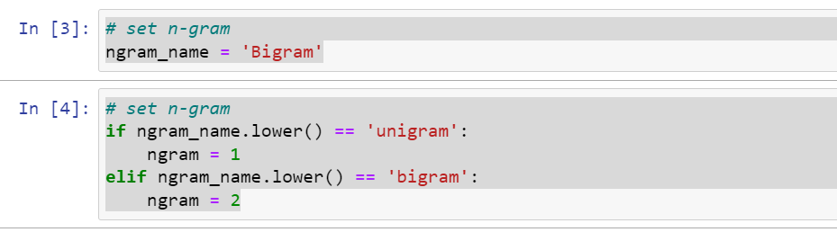

3. I set orange for positive words, black for negative words, and green for neutral words. You can easily change the color in the code if you want.

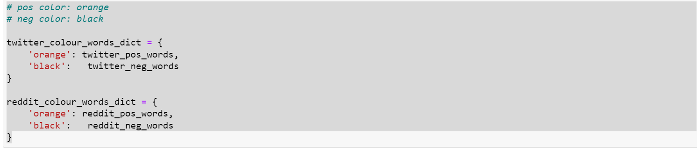

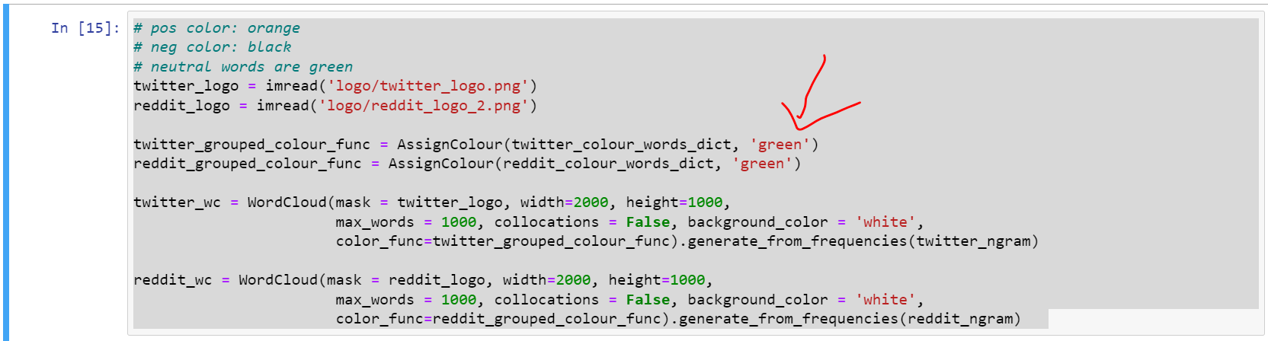

4. I modified the function **clean_text** to handle some iphone models and decimal numbers because the original version will make 14.6 to 14 6 for example. Let me know which version you want to use.