ORM 1  THE PATENTS ACT 1970 (39 of 1970) and THE PATENTS RULES, 2003 APPLICATION FOR GRANT OFPATENT  (See section 7, 54 and 135 and sub-rule (1) of rule 20) |  |  |  |  |  |  |  |  |  |  |  |  |  |  |  | (FOR OFFICE USE ONLY)
 |  |  |  |  |  |  |  |  |  |  |  |  |  | Application No.
 |  |  |  |  |  |  |  |  |  |  |  |  |  | Filing date:
 |  |  |  |  |  |  |  |  |  |  |  |  |  | Amount of Fee
 |  |  |  |  |  |  |  |  |  |  |  |  |  | CBR No:
 |  |  |  |  |  |  |  |  |  |  |  |  |  | Signature:
1. APPLICANT’S REFERENCE / IDENTIFICATION No. (AS ALLOTTED BY OFFICE)
2. TYPE OF APPLICATION [Please tick (✓) at the appropriate category]
Ordinary (✓) |  |  |  |  | Convention () |  |  |  |  |  |  |  |  |  |  |  | PCT-NP ()
Divisional () | Patent of Addition () |  |  |  | Divisional () |  |  |  |  | Patent of Addition () |  |  |  |  |  |  | Divisional () |  |  | Patent of Addition ()
1. APPLICANT (S)
Name in Full |  | Nationality |  |  |  | Country of Residence |  |  | Address of the Applicant
Mayank Chauhan  Mr.Mithun.M  Mr.RithanishMJ  Mr.Naveen S  Mr. Raja L  Mr.Pravesh P |  | Indian Indian Indian Indian Indian  Indian |  |  |  | India India India India India  India |  |  | House No. |  |  |  |  | Department of Artificial Intelligence & Data Science
 |  |  |  |  |  |  |  |  | Street |  |  |  |  | Sri Shakthi Institute of Engineering and Technology
 |  |  |  |  |  |  |  |  | City |  |  |  |  | L&T Bypass Road, Coimbatore
 |  |  |  |  |  |  |  |  | State |  |  |  |  | Tamil Nadu
 |  |  |  |  |  |  |  |  | Country |  |  |  |  | India
 |  |  |  |  |  |  |  |  | Pin code |  |  |  |  | 641 062
3B. CATEGORY OF APPLICANT [Please tick (✓) at the appropriate category]
Natural Person (✓) |  |  |  | Other than Natural Person
 |  |  |  | Small Entity () |  |  |  |  |  |  |  |  |  |  |  | Startup () |  |  | Others ()
4. INVENTOR (S) [Please tick (✓) at the appropriate category]
Are all the inventor (s)  same as the applicant (s) named above? |  |  |  |  |  |  |  |  |  |  | Yes (✓) |  |  |  |  |  |  |  | No ()
If “No”, furnish the details of the inventor (s)
Name in Full |  |  | Nationality |  |  |  |  | Country of Residence |  |  |  | Address of the Inventor(s)
Mayank Chauhan  Mr.Mithun.M  Mr.Rithanish M J  Mr.Naveen S  Mr. Raja L  Mr.Pravesh P |  |  | Indian Indian Indian Indian Indian  Indian |  |  |  |  | India India India India India  India |  |  |  | House  No. |  |  | Department of Artificial Intelligence & Data Science
 |  |  |  |  |  |  |  |  |  |  |  | Street |  |  | Sri Shakthi Institute of Engineering and Technology
 |  |  |  |  |  |  |  |  |  |  |  | City |  |  | L&T Bypass Road, Coimbatore
 |  |  |  |  |  |  |  |  |  |  |  | State |  |  | Tamil Nadu
 |  |  |  |  |  |  |  |  |  |  |  | Country |  |  | India
 |  |  |  |  |  |  |  |  |  |  |  | Pin code |  |  | 641 062
5. TITLE OF THE INVENTION
AI – Based Resume Analyzer and Interview Simulater

6. AUTHORISED REGISTERED |  |  |  |  |  |  | IN/PA No.
 |  |  |  |  |  |  | Name

PATENT AGENT (S) |  |  |  | Mobile No.
7. ADDRESS FOR SERVICE OF APPLICANT IN INDIA |  |  |  | Name |  | Dr. Mayank Chauhan
 |  |  |  | Postal Address |  | AP, Dept. Artificial Intelligence & Data Science, Sri Shakthi Institute of Engineering and  Technology, L&T Bypass Road, Coimbatore-641 062, TamilNadu
 |  |  |  | Telephone No. |  | +91 9345523122
 |  |  |  | Mobile No. |  | +91 9345523122
 |  |  |  | E-mail ID |  | mithunmithun8461@gmail.com
8. IN CASE OF APPLICATION CLAIMING PRIORITY OF APPLICATION FILED IN CONVENTION COUNTRY, PARTICULARS OF CONVENTION APPLICATION
Country | Application Number | Filing Date | Name of the Applicant |  |  | Title of the invention | IPC (as classified in the Convention Country)
9. IN CASE OF PCT NATIONAL PHASE APPLICATION, PARTICULARS OF INTERNATIONAL APPLICATION FILED UNDER PATENT CO-OPERATION TREATY (PCT)
International Application Number |  |  |  |  | International Filing Date
10. IN CASE OF DIVISIONAL APPLICATION FILED UNDER SECTION 16, PARTICULARS OF ORIGINAL (FIRST) APPLICATION
Original (first) application No. |  |  |  |  | Date of filing of original (first) application
11. IN CASE OF PATENT OF ADDITION FILED UNDER SECTION 54, PARTICULARS OF MAIN APPLICATION OR PATENT
Main application/patent No. |  |  |  |  | Date of filing of main application
12. DECLARATIONS
(i) Declaration by the inventor(s)
(In case the applicant is an assignee: the inventor (s) may sign herein below or the applicant may upload the assignment or enclose the assignment with this application for patent or send the assignment by post/electronic transmission duly authenticated within the prescribed period).
I/We, the above-named inventor (s) is/are the true & first inventor (s) for this Invention and declare that the applicant (s) herein is/are my/our assignee or legal representative.
Dated this 28th day of November 2025

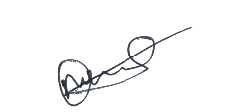
Mayank Chauhan Mithun M Rithanish M J Pravesh P Naveen S Raja L
(iii) Declaration by the applicant (s) in the convention country
(In case the applicant in India is different than the applicant in the convention country: the applicant in the convention country may sign herein below or applicant in India may upload the assignment from the applicant in the convention country or enclose the said assignment with this application for patent or send the assignment by post/electronic transmission duly authenticated within the prescribed period)
I/We, the applicant (s) in the convention country declare that the applicant (s) here in is/are my/our assignee or legal representative.

Dated this 21th day of November 2025

Mayank Chauhan Mithun M Rithanish M J Pravesh P Naveen S Raja L

- Declaration by the applicant (s)
I/We the applicant (s) hereby declare (s) that: -
  - I am/ We are in possession of the above-mentioned invention.
  - The provisional/complete specification relating to the invention is filed with this application.
ϒ The inventionasdisclosedinthespecificationusesthebiologicalmaterialfromIndia and the necessary permission from the competent authority shall be submitted by me/us before the grant of patent tome/us.
  - There is no lawful ground of objection(s) to the grant of the Patent to me/us.
  - I am/we are the true &first inventor(s).
  - Iam/we are the assignee or legal representative of true & first inventor(s).
ϒ The application or each of the applications, particulars of which are given in Paragraph-8, was the first application in convention country/countries in respect of my/our invention (s).
ϒ I/We claim the priority from the above-mentioned application (s) filed in convention country/countries and state that no application for protection in respect of the invention had been made in a convention country before that date by me/us or by any person from which I/We derive the title.
ϒ My/our application in India is based on international application under Patent Cooperation Treaty (PCT) as mentioned inParagraph-9.
ϒ The application is divided out of my /our application particulars of which is given in Paragraph-10 and pray that this application may be treated as deemed to have been filed on DD/MM/YYYY under section 16 of the Act.
ϒ The said invention is an improvement in or modification of the invention particulars of which are given inParagraph-11.
13. FOLLOWING ARE THE ATTACHMENTS WITH THE APPLICATION
(a) Form 2
Item | Details | Fee | Remarks
Complete/Provisional specification) | 3
No. of Claim (s) and No. of Pages | 4 & 1
Abstract | 1
No. of Drawing (s) and No. of Pages | 1&1

# In case of a complete specification, if the applicant desires to adopt the drawings filed with his provisionalspecificationasthedrawingsorpartofthedrawingsforthecompletespecification under rule 13 (4), the number of such pages filed with the provisional specification are required to be mentioned here.

- Complete specification (in conformation with the international application)/as amended before the International Preliminary Examination Authority (IPEA), as applicable (2copies).
- Sequence listing in electronic form
- Drawings (in conformation with the international application)/as amended before the International Preliminary Examination Authority (IPEA), as applicable (2copies).
- Priority document (s) or a request to retrieve the priority document (s) from DAS (Digital Access Service) if the applicant had already requested the office of first filing to make the priority document (s) available to DAS.
- Translation of priority document/Specification/International Search Report/International Preliminary Report on Patentability.
- Statement and Undertaking on Form3
- Declaration of Inventorshipon Form5
- Power of Authority
- ……………………………………………………………………………………
…………….

Total fee Rs. 4500/- in Cash/ Banker's Cheque /Bank Draft bearing No of “302656” Date 28.05.2025 on Canara Bank.
I/We hereby declare that to the best of my/our knowledge, information and belief the fact and matters slated here in are correct and I/We request that a patent may be granted to me/us for the said invention.

Dated this 28th day of October 2025

Mayank Chauhan Mithun M Rithanish M J Pravesh P Naveen S Raja L
To,
The Controller of Patents
The Patent Office, at Chennai

Note:
- Repeat boxes in case of more than one entry.
- To be signed by the applicant (s) or by authorized registered patent agent otherwise where mentioned.
- Tick ( )/cross (x)whicheverisapplicable/notapplicableindeclarationinparagraph-12.
- Nameoftheinventorandapplicantshouldbegiveninfull,familynameinthebeginning.
- Strikeouttheportionwhichis/arenotapplicable.
* For fee: See FirstSchedule”;

FORM 2

THE PATENTS ACT, 1970 (39 of 1970)
&

COMPLETE SPECIFICATION

(See section 10 and rule 13)
1. TITLE OF THE INVENTION
AI – Based Resume Analyzer and Interview Simulater

2. APPLICANT(S)
a) Name | b) Nationality | c) Address

Mayank Chauhan  Mr.Mithun.M  Mr.Rithanish M J  Mr.Naveen S  Mr. Raja L  Mr.Pravesh P | Indian Indian Indian Indian Indian | Dept. of Artificial intelligence & Data Science, Sri Shakthi Institute of Engineering and Technology, L&T Bypass Road, Coimbatore -641 062,  Tamil Nadu, INDIA
3. PREAMBLE TO THE DESCRIPTION
COMPLETE
The following specification particularly describes the invention and the manner in which it is to be performed
4. DESCRIPTION (Description shall start from next page)
5. CLAIMS (Claims should start with the preamble – “I/We claim” on separate page)
6. DATE AND SIGNATURE (to be given on the last page of specification)
7. ABSTRACT OF THE INVENTION (to be given along with complete specification on the separate page)
Note:
*Repeat boxes in case of more than one entry
*To be signed by the applicant (s)or the aut horized registered patent agent
*Name of the applicant should be given in full, family name in the beginning
*Complete address of the applicant should be given stating with postal index no. / code, state and country
*Strike out the column which is/are not applicable

.

Diagram

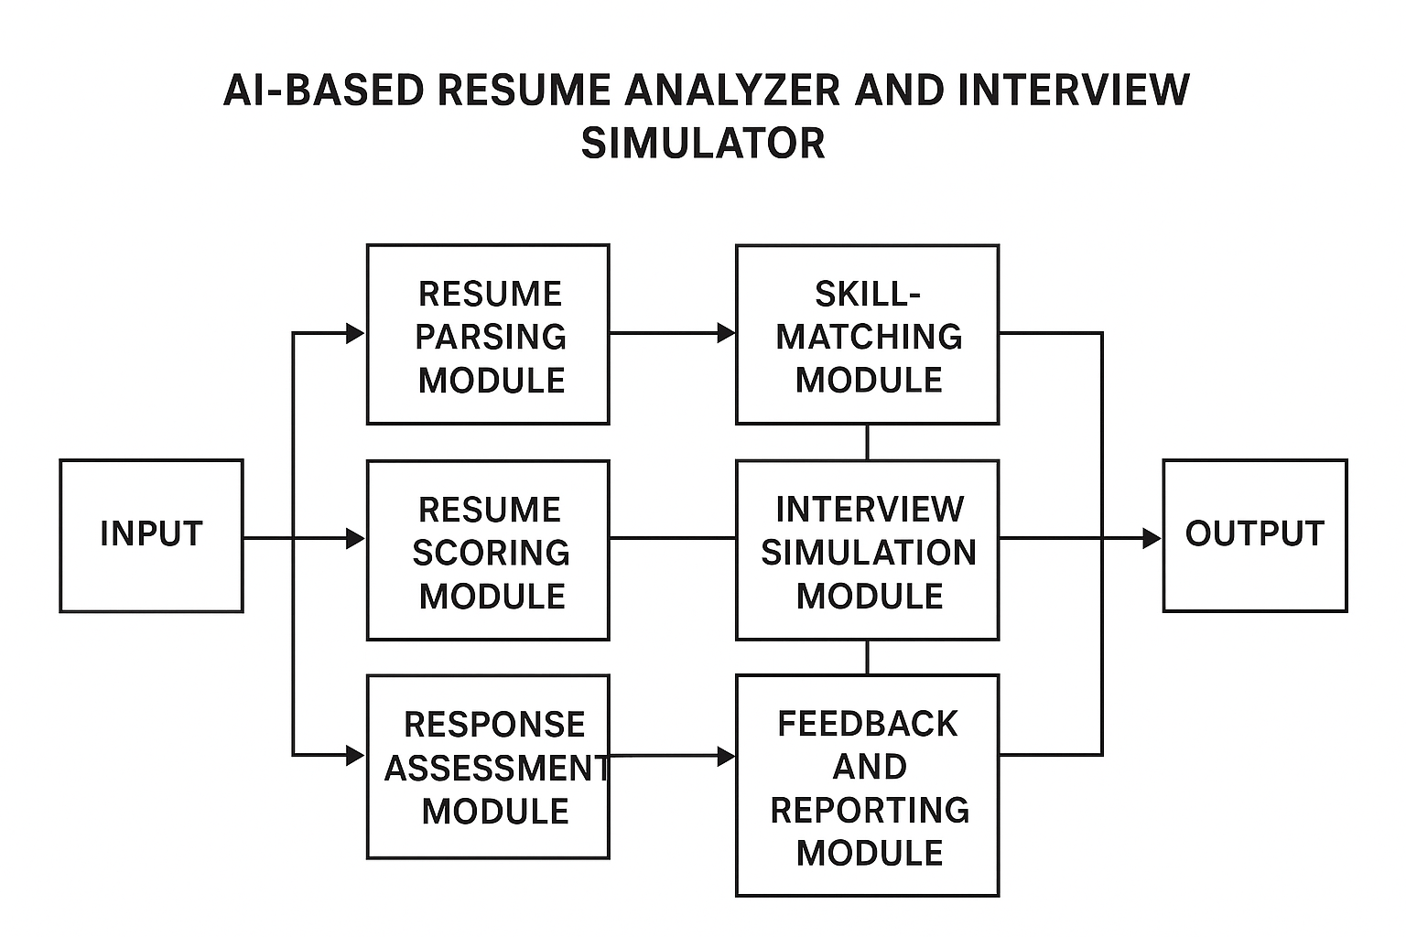

Figure 1. Work Flow of AI Based Resume Analyzer

CLAIMS

I/We Claim:

- An AI-Based Resume Analyzer and Interview Simulation System that automates end-to-end candidate evaluation, including resume analysis, skill assessment, interview simulation, scoring, and feedback generation.
- The system as claimed in Claim 1, wherein the Resume Parsing Module extracts candidate details such as skills, experience, education, and achievements using NLP and machine learning–based text processing.
- The system as claimed in Claim 1, wherein the Skill-Matching Module compares extracted skills with job-role requirements using AI similarity algorithms to generate a relevance score.
- The system as claimed in Claim 1, wherein the Resume Scoring Module evaluates resumes for keyword relevance, formatting quality, ATS compatibility, grammar, and job-role fitness to produce an AI-based score.
- The system as claimed in Claim 1, wherein the Interview Simulation Module generates role-based, skill-based, and behavioral interview questions using AI models and evaluates candidate responses in real time.
- The system as claimed in Claim 1, wherein the Response Assessment Module analyzes candidate answers for clarity, confidence, technical correctness, and communication skill using NLP and speech analysis.
- The system as claimed in Claim 1, wherein the Feedback and Reporting Module generates personalized suggestions, interview performance summaries, resume improvement tips, and downloadable reports.
- The system as claimed in Claim 1, wherein all modules operate within an integrated intelligent architecture that improves evaluation accuracy, reduces recruiter workload, and ensures consistent and unbiased candidate assessment.

Dated this 28th day of October 2025

Mayank Chauhan Mithun M Rithanish M J Pravesh P Naveen S Raja L

ABSTRACT OF THE INVENTION

The AI-Based Resume Analyzer and Interview Simulator is an intelligent recruitment support system designed to automate and enhance candidate evaluation. Traditional hiring processes are often time-consuming, subjective, and prone to human error. To overcome these limitations, the proposed system integrates advanced Artificial Intelligence techniques such as Natural Language Processing (NLP), machine learning, and speech analysis to deliver an efficient, objective, and scalable recruitment workflow.
The system automatically parses resumes, extracts key information, and evaluates candidate suitability by matching skills with job-role requirements. It generates comprehensive resume scores based on keyword relevance, formatting quality, ATS compatibility, and domain-specific criteria. In addition, an AI-driven interview simulator conducts real-time virtual interviews by generating role-based and behavioral questions. Candidate responses are analyzed for clarity, accuracy, communication skill, and confidence using NLP and voice-assessment models. The system then produces personalized feedback, detailed performance reports, and improvement suggestions.
By combining automated resume analysis with interactive interview simulation, the system significantly reduces recruiter workload, accelerates candidate screening, and ensures unbiased, data-driven evaluation. This AI-enabled solution provides an end-to-end assessment platform suitable for academic institutions, training centers, and modern recruitment environments.

FORM 3
THE PATENTS ACT, 1970 (39 of 1970) and THE PATENTS RULES, 2003
STATEMENT AND UNDERTAKING UNDER SECTION 8
(See section 8; Rule 12)
1. Name of the applicant (s). | I/We Mayank Chauhan Mithun M Rithanish M J Pravesh P Naveen S Raja L  hereby  declare:
2. Name, address and nationality of the joint applicant. | (i) that I/We have not made any application for the same/substantially the same invention outside India Not Applicable  Or  (i) that I/We who have made this application No……. dated ….…alone/ jointly with  … , made for the same/ substantially same invention, application  (s) for patent in the other countries, the particulars of which are given below:
Name of the Country | Date of Application | Application No. | Status of the Application | Date of Publication | Date of Grant
Not Applicable
3. Name and address of the assignee | (iii) that the rights in the application (s) has/have been assigned to  Mayank Chauhan (Indian)  Assistant professor, Dept. of Artificial Intelligence & Data Science, Sri Shakthi Institute of Engineering and Technology, L&T Bypass Road, Coimbatore -641 062, Tamil Nadu, INDIA.  And that I/We undertake that up to the date of grant of the patent by the Controller, I/We would keep him informed in writing the details regarding corresponding applications for patents filed outside India within six months from the date of filing of such application.  Dated this 21th day of November 2025
4. To be signed by the applicant or his authorized registered patent agent. | Signature:  Mayank Chauhan Mithun M Rithanish M J Pravesh P Naveen S Raja l
5. Name of the natural person  who has signed. | Mayank Chauhan
To
The Controller of Patents, The Patent Office, at Chennai
Note: Strike out whichever is not applicable

FORM 5
THE PATENTS ACT, 1970 (39 of 1970)

DECLARATION AS TO INVENTORSHIP

[See section 10 (6) and rule 13 (6)]

1. Name (s) of the Applicant (s)
I/We, Mayank Chauhan Mithun M Rithanish M J Pravesh P Naveen S Raja L of the invention disclosed in
the complete specification filed in pursuance of my/our application numbered…………. dated……. is/are:

2. APPLICANT
a) Name | b) Nationality | c) Address
Dated this 28th day of October 2025

Mayank Chauhan  Mr.Mithun.M  Mr.Rithanish MJ  Mr.Naveen S  Mr. Raja L  Mr.Pravesh P | Indian Indian Indian Indian Indian  Indian | Dept. of Artificial Intelligence & Data Science, Sri Shakthi Institute of Engineering and Technology, L&T Bypass Road, Coimbatore -641 062, Tamil Nadu, INDIA

Mayank Chauhan Mithun M Rithanish M J Pravesh P Naveen S Raja
- DECLARATION to be given when the application in India is filed by the applicant (s) in the convention country:

Not Applicable
We the applicant (s) in the convention country hereby declare that our right to apply for a patent in India is by way of assignment from the true and first inventor (s)
Dated this 28th day of October 2025

Signature: Not Applicable
- STATEMENT (to be signed by the additional inventor (s) not mentioned in the application form)

Not Applicable
I/We assent to the invention referred to in the above declaration, being included in the complete specification filed in pursuance of the stated application.
Dated this 28th day of October 2025
Signature of the additional inventor (s): Not Applicable

To,
The Controller of Patent The Patent Office, Chennai

FORM 9
THE PATENTS ACT, 1970 (39 of 1970)
&
THE PATENTS RULES, 2003
REQUEST FOR PUBLICATION
[See section 11A (2); rule 24A]

- Name, address and nationality of applicant(s).

We Mr.Mayank Chauhan
Mr.Mithun,Mr.Rithanish M J,
Mr.Pravesh P,Naveen S,Raja L
hereby request for early Publication of my/our Patent application No.
.......................................
dated. under section 11A(2) of
the Act.

Dated this……........day of…………..20……..

- To be signed by the applicant or authorized registered patent
agent. Signature…………………………

- Name of the natural person who has signed.
…………………………………….

To

Note.— For fee: See First Schedule.

The Controller of Patents, The Patent Office, At……………………….

