Table of Contents

- Company Profile 3
- Introduction 3
  - Purpose of this document 3
  - Scope of the Project 3
  - Definitions, Acronyms, and Abbreviations 4
- System Architecture 5
  - Overview of Modules/Components 5
  - Structure and relationships 7
  - User Interface Issues 8
- Detailed Description of Components 9
- Detailed Description of Components 9
  - Component Template Description 9
  - Component Description of RecurringTask 10
  - Component Description of SwingTrayIconTry 10
  - Component Description of AllTabs 11
  - Component Description of ToolBar 11
  - Component Description of MainScreen 12
  - Component Description of LastDay 12
  - Component Description of FileTreeModel 13
  - Component Description of FileProps 14
  - Component Description of EventList 15
  - Component Description of JCalendar 15
  - Component Description of EventTable 16
  - Component Description of Poppax 16
- Database Design 17
- Implementation Details 18
- User Interfaces 20
  - Files modified in specified time period 20
  - Organizer tab 20
  - A birthday event being added 21
  - An event notification 21
  - Editing a Meeting event 22
  - Browsing a folder 22
  - Backing up selected files/folders 23
- Conclusion 23
- References 23

Company Profile
Tata Consultancy Services (TCS) is one of the world's leading information technology companies. Through its Global Network Delivery Model™, Innovation Network, and Solution Accelerators, TCS focuses on helping global organizations address their business challenges effectively.
TCS continues to invest in new technologies, processes, and people which can help its customers succeed. From generating novel concepts through TCS Innovation Labs and academic alliances, to drawing on the expertise of key partners, it keeps clients operating at the very edge of technological possibility.
Whether TCS is envisioning a business advantage, engineering an IT solution, or executing an outsourcing strategy, it helps its customers experience certainty in their every day business.

Introduction

This section contains an overview of the entire design document. This document describes all data, architectural, interface and component-level design as well as implementation details for the software.

Purpose of this document

This document is intended for the development of the File Backup software. The different classes and models described in this document are used for implementation purposes.

Scope of the Project

This project is developed for the sake of backing-up files. The initial target audience is office workers where files need to be backed-up frequently since there are a lot of files that are modified constantly. This software will help in saving these files in user-specified location. This software also provides an option to organize events and manage them with ease.

Definitions, Acronyms, and Abbreviations

- TCS – Tata Consultancy Services
- SDD - Software Design Document
- JRE – Java Runtime Environment

Overview of Document

Section 2, System Architecture Description, provides an overview of the system architecture, including the major components of the product, the structure and relationships of the modules, and issues regarding the user's experience with the product.

Section 3, Detailed Description of Components, consists of detailed information about design, functions, and dependencies of each individual component.

Section 4, Description of Database, consists of information about the databases that are used for storing information necessary for the different components.

Section 5, Implementation Details, contains information on how the project was actually implemented, i.e. coding details.

Section 6, User Interfaces, contains screenshots and sketches of how the software will appear to the user.

System Architecture

Overview of Modules/Components

The project is divided into several modules. They are:

- RecurringTask: This is the main class from where the SwingTrayIconTry class is accessed. Since the software is run as a Java application, there needs to be a main class. The only main class that is used for the application is that of the Display class. It also assigns timers to all events.

- SwingTrayIconTry: This class is directly called from the RecurringTask class. This class contains the toolbar, the main screen and the last day detail’s classes. There may be many instances of the MainScreen class, depending on the number of tabs opened by the user. There will be only one instance of ToolBar and one or zero instance of LastDay (again depending on the user’s choice).

- AllTabs: This class is directly called from the SwingTrayIconTry class. This class contains the toolbar, the main screen and the last day detail’s classes. There may be many instances of the MainScreen class, depending on the number of tabs opened by the user. There will be only one instance of ToolBar and one or zero instance of LastDay (again depending on the user’s choice).

- ToolBar: ToolBar contains all the options like file, edit, view, help etc. This module is directly under the AllTabs module. ToolBar lets the user select option from the menu. All changes, that the ToolBar makes, are reflected only on the AllTabs module. This will be explained in detail later in the document.

- MainScreen: This is the screen which is appears as a part of a pane in the overall display. This is part of the AllTabs module. This shows the directory structure in the left side of the screen and the contents of that directory along with other information like last modification time. This also contains button to backup files.

- LastDay: This is also part of the AllTabs module. This is similar to the MainScreen module in that it appears as a tab to the user. But, it doesn’t contain the directory hierarchy. It only contains the list of files that have been modified in the last 24 hours.

- FileTreeModel: This is a module that comes under the MainScreen module. This appears as a directory structure to the user. This is what helps the user in selecting the folder to go to, so as to backup the files.

- FileProps: This is a module which is used in both the MainScreen module as well as the LastDay module. This is the module that contains all the information about the files in the particular folder or the files that were modified in the past 24 hours.

- EventList: This is a module is where all the events are organized. There is provision for adding, deleting, editing events as well as sending them to other computers. This is sub-categorized into lots of sub-modules.

- JCalendar: This contains all the calendar information and is one of the sub-modules of EventList. This module is responsible for an efficient user interface and choosing dates.

- EventTable: This is a module which shows all the events corresponding to the date chosen by JCalendar module. Hence this forms an important part of the EventList module.

- Poppax: This is a module which shows the events that are scheduled for the present time. It is displayed as a cute popup box which can be either snoozed or discarded.

Structure and relationships

RecurringTask
AllTabs
ToolBar
MainScreen
LastDay
FileTreeModel
FileProps
EventList
Database
OS
EventTable
JCalendar

User Interface Issues

The user sees the first screen with a toolbar and a tabbed pane. They will have a directory structure and file properties. There may be zero or more such tabbed panes. Another tab will contain the list of all the files that have been modified in a specified time period. Yet another tab will contain an organizer where events can be added, deleted or modified and sent to other computers.

Selecting a particular folder in the directory structure opens up the folder in the main part of the screen. This will contain all the file information along with the option to back-up the files (in the form of a check-box). The files can be selected from one folder. Then it can be backed up then and there itself, or another tab can be opened and another folder chosen. After all the folders have been chosen, all the files can be backed up as one single file by the press of a single button.

All the tabs can be saved into a perspective and loaded later on using the Save/Load Perspective options in the File menu. This helps the user to monitor a particular set of folders.

As for the organizer, the calendar will be on the right side of the screen. After choosing a particular date, all events on that particular date will be displayed on the left side of the screen. They are colored for convenience and can be edited with a small panel on top of the table. (See: Screenshots)

Detailed Description of Components

Component Template Description

Identification | The unique name for the component and the location of the component in the system.
Type | A module, a subprogram, a data file, a control procedure, a class, etc.
Purpose | Function and performance requirements implemented by the design component, including derived requirements. Derived requirements are not explicitly stated in the SRS, but are implied or adjunct to formally stated SDS requirements.
Function | What the component does, the transformation process, the specific inputs that are processed, the algorithms that are used, the outputs that are produced, where the data items are stored, and which data items are modified.
Dependencies | How the component's function and performance relate to other components. How this component is used by other components. The other components that use this component. Interaction details such as timing, interaction conditions (such as order of execution and data sharing), and responsibility for creation, duplication, use, storage, and elimination of components.
Interfaces | Detailed descriptions of all external and internal interfaces as well as of any mechanisms for communicating through messages, parameters, or common data areas. All error messages and error codes should be identified. All screen formats, interactive messages, and other user interface components (originally defined in the SRS) should be given here.
Processing | The full description of the functions presented in the Function subsection. Pseudo code can be used to document algorithms, equations, and logic.
Data | For the data internal to the component, describes the representation method, initial values, use, semantics, and format. This information will probably be recorded in the data dictionary.

Component Description of RecurringTask

Identification | RecurringTask
Type | Class
Purpose | It is a super class which means that adding functions to the project later on is easier and assigns timers to events.
Function | A class which is used to call the main class into which all the major components of the project are added into. It has a main function which makes the software a Java application.
Dependencies | This class calls the SwingTrayIconTry class. There are no other dependencies.
Processing | This is the only class in the whole project whose main function is executed. This is just a module into which AllTabs is added to.

Component Description of SwingTrayIconTry

Identification | SwingTrayIconTry
Type | Class
Purpose | This is the class which enables minimizing the software into an icon in the system tray.
Function | Its main function is that the software keeps running in the background without bothering the user.
Dependencies | It is called from the RecurringTask class
Processing | Processing depends on which of the 3 classes were selected. This depends on the region of mouse click.

Component Description of AllTabs

Identification | AllTabs
Type | Class
Purpose | This is the class which covers the whole GUI. It is into this class that all the major components are added to.
Function | There are different options that the user can choose. Mouse clicks can be on the toolbar or the MainScreen or the LastDay modules.
Dependencies | AllTabs class is called from the SwingTrayIconTry class. From this class, ToolBar, LastDay and MainScreen classes are called.
Processing | Processing depends on which of the 3 classes were selected. This depends on the region of mouse click.

Component Description of ToolBar

The ToolBar is basically a drop-down menu. It creates/removes tabs, saves/loads perspectives, exits the program, select/cut/copy/paste files, show help, set up backup bath, recurring tasks time, deleting events, log book etc.

Identification | ToolBar
Type | Class
Purpose | ToolBar provides the menu into which all the options like File, Edit, View, Help etc. A perspective is the set of tabs that are currently opened. On saving the perspective, it can be later loaded as per the user’s choice.
Function | The options are selected as a drop-down menu.
Dependencies | ToolBar is called from the AllTabs class. It has a lot of functions. Two other modules it calls are Search module and History module.
Processing | Processing depends on the menu option that was selected.
Component Description of MainScreen

Identification | MainScreen
Type | Class
Purpose | This class is the inner tab that occurs in the main frame. It contains the directory hierarch, the contents of selected folder as well as two buttons for backing up selected files in that particular tab or in all the tabs.
Function | The tabs are part of the AllTabs class. Addition of new tabs is done in the ToolBar module and a new instance of the MainScreen class is created in the AllTabs module. Clicking of either of the two backup buttons creates a backup file with a unique name.
Dependencies | MainScreen module is the tab that is present in the AllTabs module. Depending on the adding/closing of tabs in the ToolBar module, AllTabs creates new instances of MainScreen or deletes an instance. It is from MainScreen that the FileTreeModel and FileProps classes are called.
Interfaces | AllTabs interact with MainScreen based on the selected tab.
Processing | It backs-up the selected files based on which button is clicked.

Component Description of LastDay

Identification | LastDay
Type | Class
Purpose | This class is another inner tab that occurs in the main frame. It contains a module that contains the list of all the files that have been modified in the last 24 hours.
Function | There are either one or zero tabs of LastDay. It can be the selected tab or be a deselected one based on the choice made in the ToolBar module. It also contains a button indicating that all the selected files in that tab (i.e. all files modified in the last 24 hours) be backed-up.
Dependencies | LastDay module is the tab that is present in the AllTabs module. It contains the list of all the files i.e. FileProps class is used for this purpose.
Interfaces | AllTabs interact with LastDay based on the selected tab.
Processing | It backs-up the selected files when the button is clicked.

Component Description of FileTreeModel

Identification | FileTreeModel
Type | Class
Purpose | This class shows the directory hierarchy of the selected folder. It helps in easily accessing the files located in different parts of the hard-drive.
Function | FileTreeModel is a class that is part of the MainScreen class. It appears on the left side of each MainScreen tab. The contents of the selected folder are displayed along with file information in the FileProps module which is also part of the MainScreen module.
Dependencies | MainScreen module is the tab that is present in the AllTabs module. Depending on the adding/closing of tabs in ToolBar, AllTabs creates new or delete instances of MainScreen. It is from MainScreen that the FileTreeModel and FileProps classes are called.
Interfaces | FileTreeModel is the left side of each MainScreen instance.
Processing | It displays all the information of files belonging to the selected folder in the right side of the MainScreen tab.
Resources | FileTreeModel requires the directory hierarchy. This requires interaction with the Operating System.

Component Description of FileProps

Identification | FileProps
Type | Class
Purpose | This class shows the information about files including filename, pathname, last modified time, backup(yes/no) etc.
Function | There is a checkbox at the end of each file. Selecting the checkbox indicates whether or not the file needs to be backed-up or not.
Dependencies | With each instance of MainScreen module, an instance of FileProps is also made. The information shown here will be that of the folder selected in the directory hierarchy in FileTreeModel class. If there is an instance of LastDay class, then the information will be that of the files modified in the last 24 hours.
Interfaces | FileProps is the left side of each MainScreen instance and is the only part of the LastDay module.
Processing | There will be two constructors in FileProps, one for MainScreen class where the argument will be the folder location and files belonging to the selected folder will be displayed, and the other for LastDay module where there are no arguments and all files modified in the last 24 hours are displayed.
Resources | FileProps requires the information about files in a specified folder or files modified in the last 24 hours. This requires interaction with the Operating System.

Component Description of EventList

Identification | EventList
Type | Class
Purpose | This class is used to organize events in an easy and user-friendly manner.
Function | This module is run from the MainScreen module.
Dependencies | This module is dependent on the database which contains the list of all the events. Different typed of events that can be added are meetings, memos and birthdays.
Interfaces | This appears as the second tab in the Screen. There will be a calendar on the right side and a table containing all the events of the selected day on the left side with options on top of the table.
Processing | It displays all the information of files satisfying a given condition as a separate tab in the AllTabs module.
Resources | This module requires interaction with the database containing information about all the events, past, present and future.

Component Description of JCalendar

Identification | JCalendar
Type | Class
Purpose | This class displays the date in a user-friendly manner.
Function | This module is a totally independent module. This provides a very easy way to select a date.
Dependencies | JCalendar is actually not a class, but is a collection of a lot of classes. But since there are so many of them, they can be considered as one module. The dates that have events are bolded. So deletion/addition of events will result in a change in this module.
Interfaces | There is a month spinner on left top corner, an year spinner on top right corner and the main part is the calendar of the chosen month with red color for today’s date and bolded dates for those that have events.
Processing | On clicking a date, it sends all events on that particular date to the EventTable module.
Resources | JCalendar doesn’t depend on any external resource.

Component Description of EventTable

Identification | EventTable
Type | Table
Purpose | This class is used to display the events on selected date and is color-coded.
Function | The events are listed with an icon, the type and a short description. They can be edited with a small panel on top of the table. There are also options for adding, deleting and sending events in that panel.
Dependencies | This module depends on the JCalendar module as it is from there that the date is received.
Interfaces | Past events are grey in color, future are black in color and ongoing events are green.
Resources | It is dependent on the events.txt file which has a list of all the events.

Component Description of Poppax

Identification | Poppax
Type | Class
Purpose | This class is used to remind the user of events with a cute popup box.
Function | The popup box can be discarded or snoozed for specific period of time so that the user can be reminded of the event again at a later point of time.
Dependencies | This module is totally dependent on the RecurringTask module since events are assigned timers in that class.
Interfaces | There is an option to either discard the popup or to snooze it so that it can be viewed later.
Resources | It is dependent on the events.txt file which has a list of all the events.

Database Design

There is no database as such. Only files are used to store the information.

One particular file called fbi.txt contains all the file backup information. This contains the date and time of backup as well as all the files that were present in that particular backup. This can be used for future reference to find out when a particular file was last backed-up.

Another file is events.txt. This is the file which contains all the information about events. This is stored as one event per line. Each event is associated with the date and time it was made, along with the time it is scheduled. Moreover, since there are 3 types of events handled in this project, namely, Meetings, Memos and Birthdays, all 3 have different attributes. For example meetings and memos need from time as well as to time, whereas a birthday only needs a notification time. Meetings need location while birthdays require year of birth. Other than that, all 3 require a title and description. These attributes are separated by a ‘>’ symbol so that they can be easily decoded and updates, deletions etc of events can be done quite easily.

Two other files are also used. They both only contain one line of information. One is RecurringTime.txt which contains the time at which the backup process should be started and also the frequency i.e. Daily or on Mondays or Fridays etc.

Another file is backupInfo.txt which contains the path name of the default backup folder. So whenever any backup button is clicked, the default suggested path will be this path. This can be changed by the user.

Implementation Details

The software was made in Java. All the calendar modules were obtained from the internet as free software. The look and feel of the software was a library file that came along with the calendar module. Also all System-tray related code was obtained from the internet. Everything else was manually coded.

Initially a table was made which contains information about all the files in a folder along with a checkbox which can be ticked to backup that file. Backing up was done using ZipEntry. Then a jtree was used to display folders in the file system in a tree structure. Thus there was an option to add tabs where different folders can be watched. This also enables files present in more than one folder to be backed up in one click.

Next the first tab was made. This was where the list of files modified in a particular period of time was displayed and could be backed up. The choosing of dates was done using the JCalendar module which was downloaded. This was modified a little bit for convenience.

Along with this, the ToolBar module was also updated. Initially files could only be backed up manually. Later on, there was an option to set up a recurring backing up time. This meant that timers be installed as soon as the program started running. Thus it was done in RecurringTask class.

An additional requirement that came up was that there be an organizer which could help manage events like meeting, birthdays, memos etc and that can be sent across the network to other users. This was added as a tab in the AllTabs module. This was made in 2 classes. One was the small Poppax class which displayed the popup when an event occurred. The other one was the EventList class.

EventList class consisted of an instance of JCalendar. Action listeners were added to this class so that events on the selected day can be displayed as a table. This was done using jtable.

There were options like editing deleting and adding events. This was done using a small panel displayed on top of the table. All of these actions were done either through panels or dialog boxes using java swing. All event modifications were reflected on the events.txt file.

The table used a model so that alternate rows were of different colors. Also, different colors were given for past, future and ongoing events. The table actually displays only 3 columns, one for the icon, second for the type of event and third for the small event description. There is actually a fourth hidden column, which contains the all the event information. This is represented as a string, which is retrieved as a row from the events.txt file.

Finally sending of events from one computer to another is accomplished by using socket programming. Each instance acts as a server which receives events. They support multiple clients so that when more than one event is being sent to it from different computers, it is still received properly, since the connections run on separate threads.

The Poppax class was called from the RecurringTask class. This is because, timers needed to be assigned to each event. Since every event needed a timer and RecurringTask held all the timers, it makes sense that Poppax be called from RecurringTask. Hence, whenever, there was an addition or deletion or editing of events, the calendar, the table and the event timers had to be modified.

User Interfaces

Files modified in specified time period

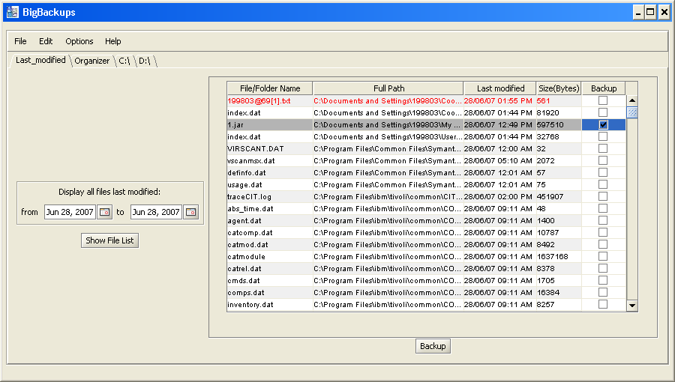

Organizer tab
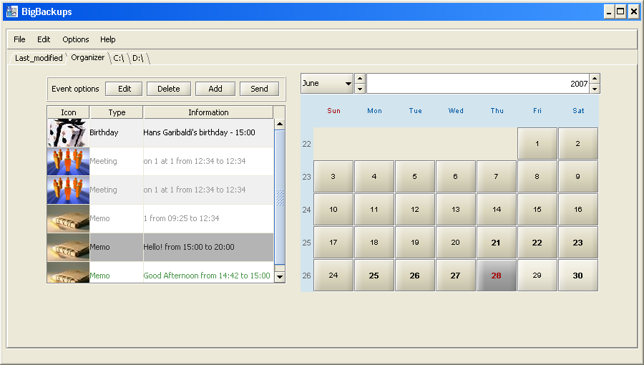

A birthday event being added

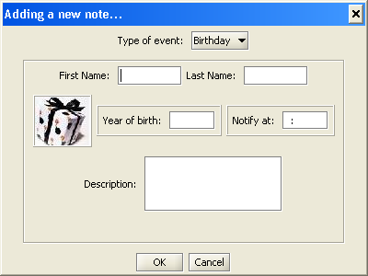

An event notification

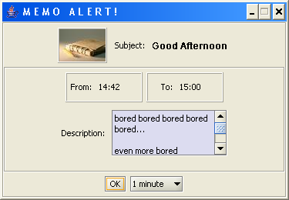

Editing a Meeting event

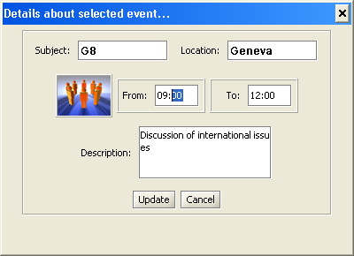

Browsing a folder

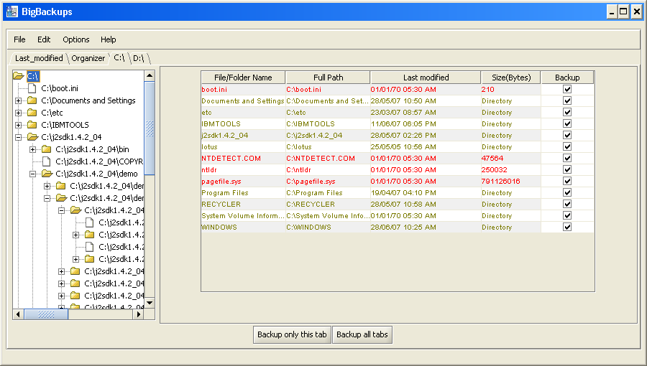

Backing up selected files/folders

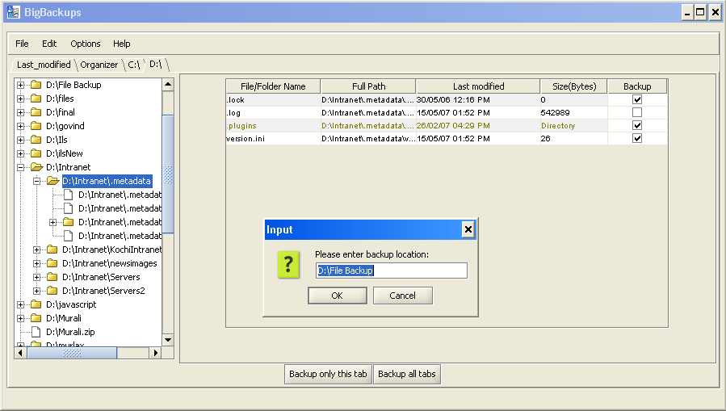

Conclusion

From the very beginning, TCS had said that there was no good File backing up software in their system. Thus, this project’s main aim was to build a daily File backing up software. Since this was finished quite early, an additional task of making an event organizer was given. This was also completed in the stipulated time and later the whole package was tested and released in the company network for use by the company employees. Thus, the project was a success, considering the fact that, not only were the requirements met, but also, additional features were incorporated; all in the specified time.

References

- http://www.cs.utexas.edu/~s2s/ for documentation formatting
- www.toedter.com for the JCalendar module
- http://jeans.studentenweb.org/java/trayicon/trayicon.html for System Tray module
- http://forum.java.sun.com for all the in-depth java help from experts

