Data Processing System: Concurrent Implementation in Java and Go

Murali Krishna Chintha
005034546

Master of Science in Computer Science
University of the Cumberlands

MSCS-632-A01: Advanced Programming Languages

Data Processing System: Concurrent Implementation in Java and Go

Introduction

This report documents the design and implementation of a multi-threaded Data Processing System in two programming languages: Java and Go. The system simulates multiple worker threads retrieving tasks from a shared queue, processing them concurrently, and writing results to a shared output resource. The implementation demonstrates key concurrency concepts including thread-safe shared data structures, synchronization techniques to prevent race conditions and deadlocks, exception and error handling, and structured logging.

The GitHub repository containing the full source code for both implementations is available at: https://github.com/muralichintha20/MSCS-632-A01-Assignment-6

Concurrency Techniques

Java: ReentrantLock and ExecutorService

The Java implementation manages concurrency through two primary mechanisms. First, a ReentrantLock is used to synchronize access to the shared task queue and the shared results list. Unlike the synchronized keyword, ReentrantLock provides explicit lock and unlock control, making it easier to reason about exactly when a critical section begins and ends. Locks are always released in a finally block to guarantee release even if an exception is thrown inside the critical section (Goetz et al., 2006).

Second, Java's ExecutorService is used to manage the worker thread pool rather than creating threads manually. Executors.newFixedThreadPool(4) creates a pool of four threads that pull tasks from the shared queue. When all tasks are complete, executor.shutdown() initiates a graceful shutdown, and executor.awaitTermination() blocks the main thread until all workers finish. If the timeout is reached, executor.shutdownNow() forces termination. This approach avoids the complexity of manually managing thread lifecycle and ensures safe termination (Bloch, 2018).

The shared queue is implemented using ConcurrentLinkedQueue, which provides a non-blocking thread-safe structure. However, the addTask() and getTask() methods are additionally wrapped in a ReentrantLock to demonstrate explicit synchronization and to allow for atomic check-then-act patterns if needed in future extensions.

Go: Goroutines, Channels, and sync.Mutex

The Go implementation uses a fundamentally different concurrency model based on goroutines and channels. Rather than a separate queue data structure, a buffered channel of type chan string serves as the concurrency-safe shared task queue. All 10 tasks are loaded into the channel upfront, and the channel is then closed. Closing the channel signals to goroutines ranging over it that no more tasks will be sent, allowing them to exit cleanly without any explicit termination flag (Donovan & Kernighan, 2016).

Four goroutines are launched using the go keyword, each receiving the same channel and reading from it concurrently. Go's channel implementation guarantees that each task is received by exactly one goroutine, eliminating the need for additional synchronization on the queue itself. A sync.WaitGroup is used to track goroutine completion: each goroutine calls wg.Done() via defer when it exits, and the main goroutine blocks on wg.Wait() until all workers have finished.

The shared results structure uses a sync.Mutex to protect concurrent writes to both the in-memory results slice and the output file. The defer keyword is used throughout Go code to ensure cleanup actions (closing files, releasing locks) always execute even if an error occurs, which is idiomatic Go resource management (Donovan & Kernighan, 2016).

Exception and Error Handling

Java: try-catch Blocks

Java uses checked and unchecked exceptions to communicate errors. The WorkerThread.run() method wraps the entire task processing loop in a try-catch block that handles two specific exceptions. InterruptedException is caught when the thread is interrupted externally; in this case, Thread.currentThread().interrupt() is called to restore the interrupted status so higher-level code can respond to it, rather than silently swallowing the interruption signal (Goetz et al., 2006). A general Exception catch covers any unexpected runtime errors, logging them with LOG.severe() so they are recorded without crashing the entire thread pool.

File I/O operations in writeToFile() are wrapped in their own try-catch block handling IOException. Java's try-with-resources syntax ensures that FileWriter and BufferedWriter are closed automatically after each write operation, even if an exception occurs. This prevents file descriptor leaks across multiple concurrent writes (Bloch, 2018).

Go: Idiomatic Error Returns

Go does not use exceptions. Instead, functions return error as a second return value, and callers are expected to check it explicitly. The processTask() function returns (string, error), and the worker goroutine checks the error before passing the result to the shared results structure. If an error is detected, the goroutine logs it and continues to the next task rather than crashing, which is a graceful degradation strategy appropriate for a data processing pipeline (Donovan & Kernighan, 2016).

File operations in AddResult() return errors that propagate up to the caller. The defer keyword is used in main() to ensure the log file and results file are closed on exit regardless of how the program terminates. This replaces the role of Java's finally blocks and makes resource cleanup more readable and reliable in Go.

Comparison of Concurrency Models

The most significant difference between the two implementations is the concurrency abstraction used. Java's model is thread-based: real operating system threads are created and managed by the JVM, and synchronization is achieved by locking shared data. Go's model is goroutine-based: goroutines are lightweight user-space threads multiplexed over OS threads by the Go runtime, and the preferred synchronization mechanism is message passing through channels rather than shared memory (Donovan & Kernighan, 2016).

Java requires more explicit coordination: the programmer creates locks, acquires and releases them manually, and manages the thread pool lifecycle. Go's channel model is more declarative: the channel itself enforces ordering and mutual exclusion, and the range-over-channel pattern provides a clean way to distribute work and signal completion. Go's approach aligns with the language's design philosophy: do not communicate by sharing memory; instead, share memory by communicating (Donovan & Kernighan, 2016, p. 220).

For error handling, Java's checked exceptions enforce that the programmer acknowledges potential failure at compile time, while Go's explicit error return values achieve the same goal without a separate exception mechanism. Both approaches prevent silent failure, but Go's style results in more linear code flow since errors are handled inline rather than in separate catch blocks.

Conclusion

This assignment demonstrated two distinct but equally valid approaches to concurrent data processing. The Java implementation used ReentrantLock, ExecutorService, and try-catch exception handling to build a thread-safe multi-worker system with structured logging. The Go implementation used goroutines, buffered channels, sync.Mutex, and idiomatic error returns to achieve the same outcome with less boilerplate and more implicit coordination. Both systems correctly process all 10 tasks across 4 concurrent workers, write results to a shared output file, and terminate gracefully. The experience reinforced that the choice of concurrency model significantly influences code structure, readability, and the kinds of bugs that are easy or hard to introduce.

References

Bloch, J. (2018). Effective Java (3rd ed.). Addison-Wesley.

Donovan, A. A. A., & Kernighan, B. W. (2016). The Go programming language. Addison-Wesley.

Goetz, B., Peierls, T., Bloch, J., Bowbeer, J., Holmes, D., & Lea, D. (2006). Java concurrency in practice. Addison-Wesley.

Appendix A: Source Code

The complete source code for both implementations is available in the GitHub repository at https://github.com/muralichintha20/MSCS-632-A01-Assignment-6
Key excerpts are shown below.

Java: SharedQueue with ReentrantLock

static class SharedQueue {
private final ConcurrentLinkedQueue<String> queue
= new ConcurrentLinkedQueue<>();
private final ReentrantLock lock = new ReentrantLock();

public String getTask() {
lock.lock();
try {
return queue.poll();
} finally {
lock.unlock();
}
}
}

Java: WorkerThread Exception Handling

try {
while (true) {
String task = queue.getTask();
if (task == null) break;
results.addResult(processTask(task));
}
} catch (InterruptedException e) {
LOG.warning("Worker interrupted: " + e.getMessage());
Thread.currentThread().interrupt();
} catch (Exception e) {
LOG.severe("Unexpected error: " + e.getMessage());
}

Go: Channel Queue and Goroutine Workers

taskCh := make(chan string, len(tasks))
for _, t := range tasks { taskCh <- t }
close(taskCh) // signals workers no more tasks coming

var wg sync.WaitGroup
for i := 1; i <= 4; i++ {
wg.Add(1)
go worker(i, taskCh, results, &wg, logger)
}
wg.Wait() // block until all goroutines finish

Go: Idiomatic Error Handling with defer

func worker(id int, taskCh <-chan string, ...) {
defer wg.Done()
for task := range taskCh {
result, err := processTask(id, task, logger)
if err != nil {
logger.Printf("Error: %v", err)
continue
}
results.AddResult(result)
}
}

Appendix B: Sample Output Screenshots

The following section contains screenshots of the sample output for both the Java and Go implementations.
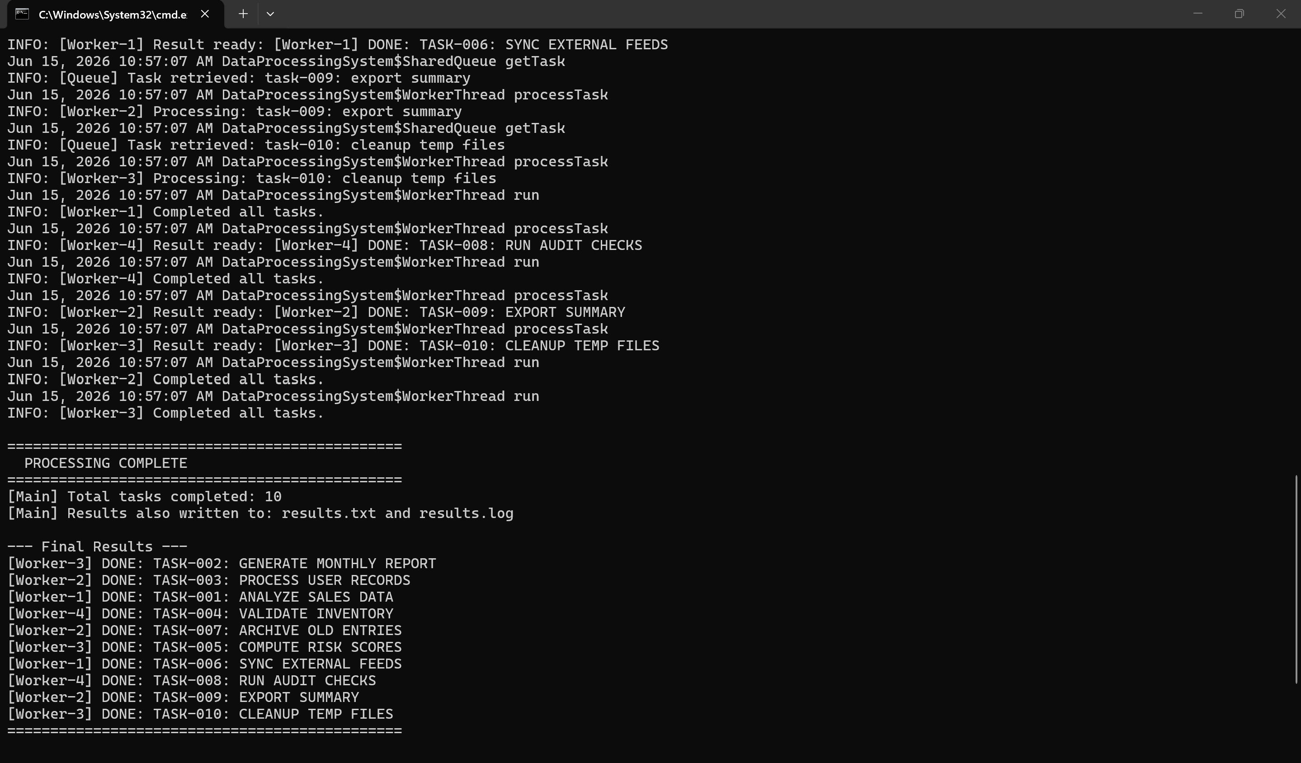
Figure 1. Java Data Processing System - terminal output.

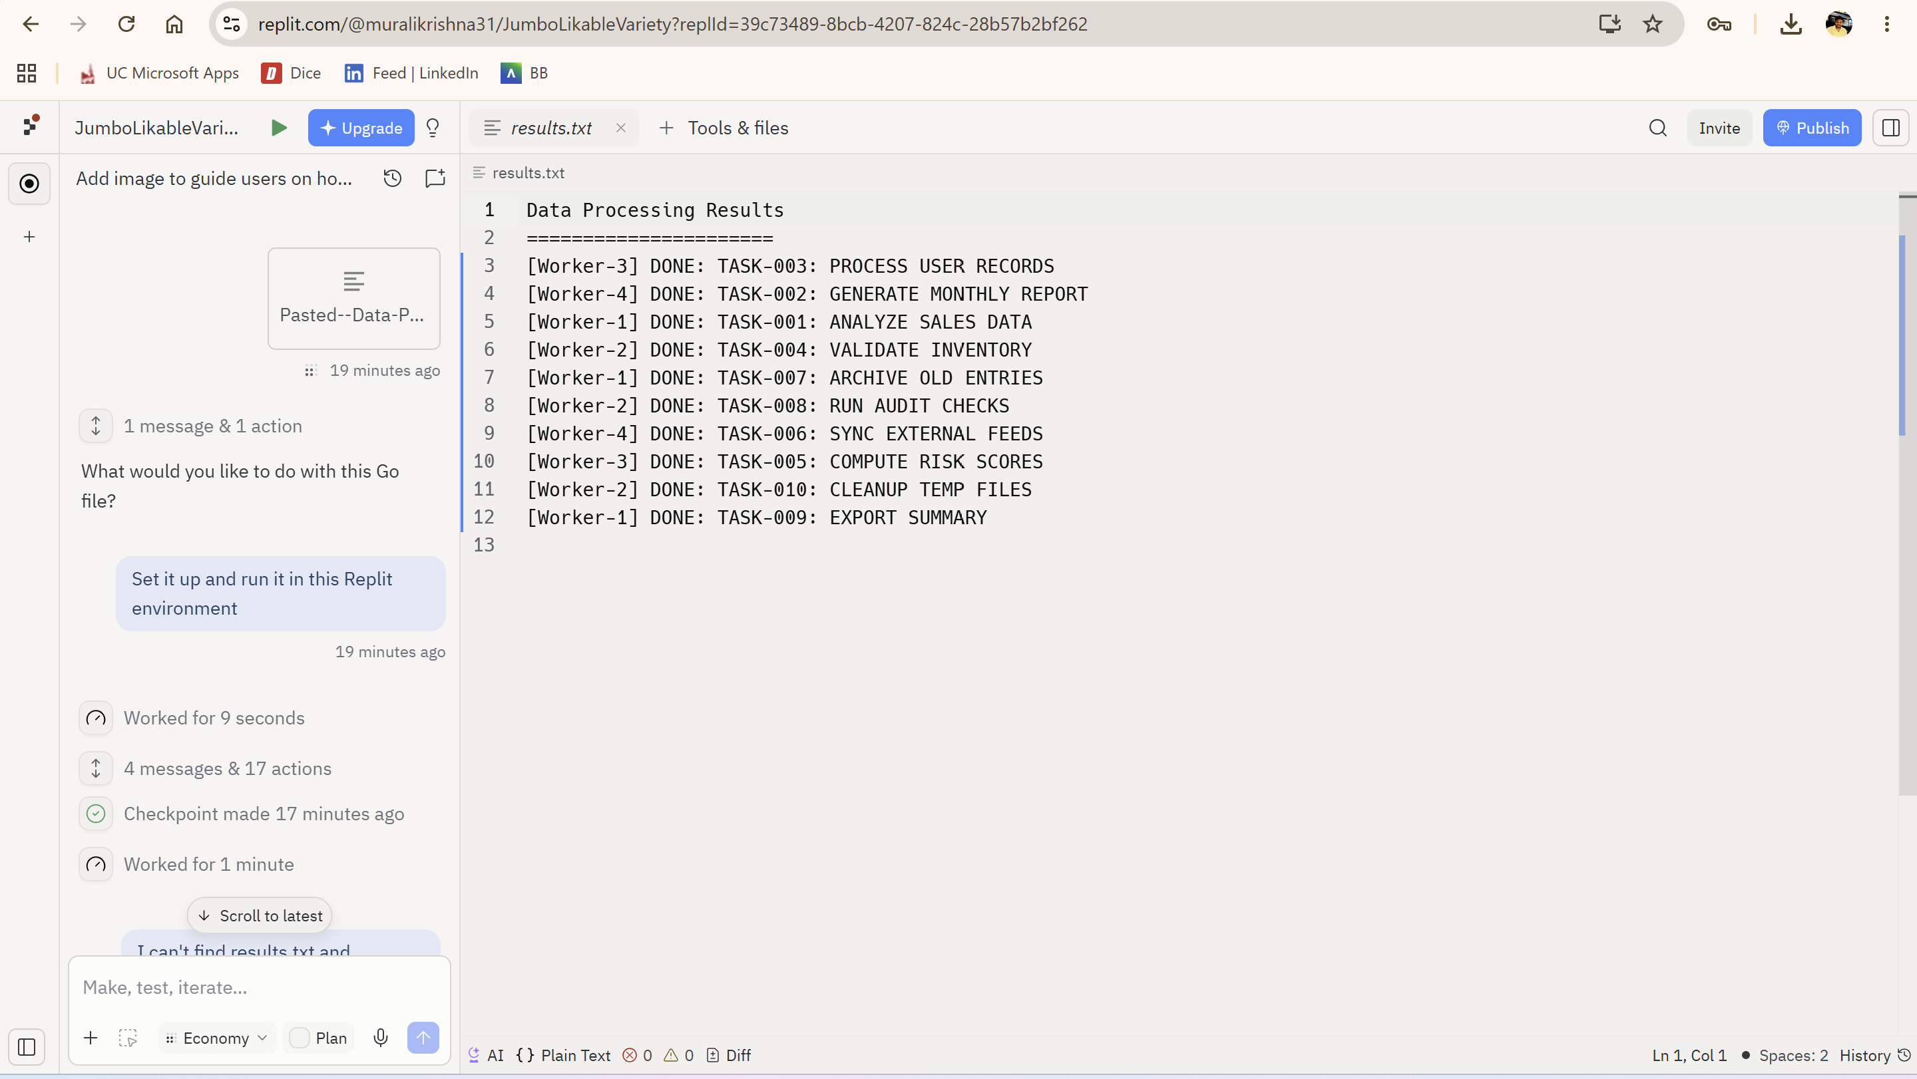
Figure 2. Go Data Processing System - Replit terminal output.

