Concurrent Data Processing: A Comparison of the Java and Go Concurrency Models

Murali Krishna Chintha
005034546

MS in Computer Science, University of the Cumberlands
MSCS-632: Advanced Programming Languages
June 15, 2026

Concurrent Data Processing: A Comparison of the Java and Go Concurrency Models
This project implements a multi-threaded Data Processing System twice, once in Java and once in Go, so that the two languages can be compared on the same workload. In both versions a pool of worker threads retrieves units of work from a shared queue, performs a short simulated computation, and writes the results to a shared output file. The objective is not only to make the system correct and free of deadlock but also to surface how each language expresses concurrency, guards shared resources, and recovers from errors.
The workload is identical across both implementations. Ten data records of the form label,n are placed on the queue, and each worker parses a record and computes the sum of the squares from 1 to n. One record, echo,not_a_number, is intentionally malformed so that the error-handling path is exercised on every run. Both programs report the same outcome of nine tasks processed, one error logged, and nine result rows written, and they compute identical numeric values, which confirms that the two concurrency models produce equivalent results.
System Design and Shared Resources
Four components make up each implementation: a task model that carries an identifier and a raw record, a thread-safe queue exposing add and retrieve operations, a worker that consumes and processes tasks, and a results sink that records every successful outcome to a comma-separated file. A simulated delay of roughly 40 to 160 milliseconds represents computational work and forces the workers to interleave, which is what makes the synchronization meaningful. Each implementation also writes a timestamped log that records when a worker starts, completes a task, encounters an error, and finishes.
Concurrency and Synchronization in Java
The Java queue wraps an ArrayDeque and guards it with an explicit ReentrantLock paired with a Condition called notEmpty. The addTask method acquires the lock, appends the task, and signals the condition. The getTask method waits on the condition while the queue is empty and still open, and it returns an empty Optional once the queue is both drained and closed. This design lets every worker terminate cleanly when the producer closes the queue, without resorting to poison-pill sentinels and without the risk of a worker blocking forever. Worker threads are managed by an ExecutorService configured as a fixed pool of four threads, and the main thread calls shutdown followed by awaitTermination to guarantee orderly completion. The shared ResultsSink uses a synchronized block so that the in-memory list update and the file append happen atomically, and two AtomicInteger counters track processed and error totals without additional locking.
Concurrency and Synchronization in Go
The Go implementation replaces explicit locks with channels. A buffered channel of tasks serves as the concurrency-safe queue, and each worker is a goroutine that ranges over that channel, a loop that ends automatically once the channel is closed and drained. A sync.WaitGroup tracks worker completion. Rather than locking the output file, a single dedicated writer goroutine owns the file and receives finished results over a results channel, so writes are serialized by design and no mutex is required. Termination follows a clear sequence: the producer calls close on the task channel, the main goroutine waits on the WaitGroup until every worker has drained the queue, and only then is the results channel closed so the writer can finish and report its count over a done channel. Two atomic counters again track processed and error totals.
Exception and Error Handling
Java relies on exceptions. The worker wraps each task in a try block and catches NumberFormatException for malformed records, IOException for write failures, and InterruptedException for thread interruption, in which case it restores the interrupt status before stopping. The main method uses try-with-resources so the logger and the results sink are closed automatically even if an exception propagates. Because a failed task is caught and logged rather than rethrown, one bad record never stops the remaining workers.
Go treats errors as ordinary return values. The process function returns a result and an error, wrapping the underlying cause so the message keeps its context, and the worker checks the error, logs it, increments the error counter, and continues with the next task. Deferred calls to Close on both the log file and the output file guarantee that resources are released even on an early return. The two approaches reach the same goal, a single malformed record is logged and skipped while all valid work completes, but Java unwinds the call stack through an exception while Go inspects an explicit value at the call site.
Comparing the Two Concurrency Models
The deepest difference is philosophical. Java follows a shared-memory model in which threads coordinate around mutable state protected by locks, conditions, and monitors, an approach that is powerful but places the burden of correct locking on the developer. Go follows the communicating sequential processes model captured by its guideline to share memory by communicating rather than communicating by sharing memory, so coordination happens by passing values over channels. Practically, Java worker threads in this project are operating-system threads supplied by a thread pool, whereas Go goroutines are lightweight routines multiplexed onto a small number of system threads by the runtime scheduler, which makes spawning many of them inexpensive.
Termination and cleanup also differ. Java required explicit condition signaling plus an executor shutdown and an awaitTermination call, while Go expressed the same intent more compactly by closing a channel, which acts as a broadcast to all ranging goroutines, and waiting on a WaitGroup. Despite these differences, both implementations avoided deadlock, processed every valid task exactly once, and produced identical, complete output, which demonstrates that two very different concurrency models can satisfy the same correctness and safety requirements.
Repository and Sample Output
The complete source for both implementations, along with run instructions, is available in the project repository at https://github.com/muralichintha20/mscs632-dataprocessing. Screenshots of the key source files and the console output for both languages are provided in Appendix A. In every run both programs report nine tasks processed, one error logged, and nine result rows written.

References
Donovan, A. A. A., & Kernighan, B. W. (2015). The Go programming language. Addison-Wesley.
Goetz, B., Peierls, T., Bloch, J., Bowbeer, J., Holmes, D., & Lea, D. (2006). Java concurrency in practice. Addison-Wesley.
Oracle. (2024). The Java tutorials: Concurrency. Oracle Corporation. https://docs.oracle.com/javase/tutorial/essential/concurrency/
The Go Authors. (2022). Effective Go. https://go.dev/doc/effective_go

Appendix A
Source Code and Sample Output Screenshots
Figure A1. Java shared queue using a ReentrantLock and a Condition for safe, deadlock-free access.
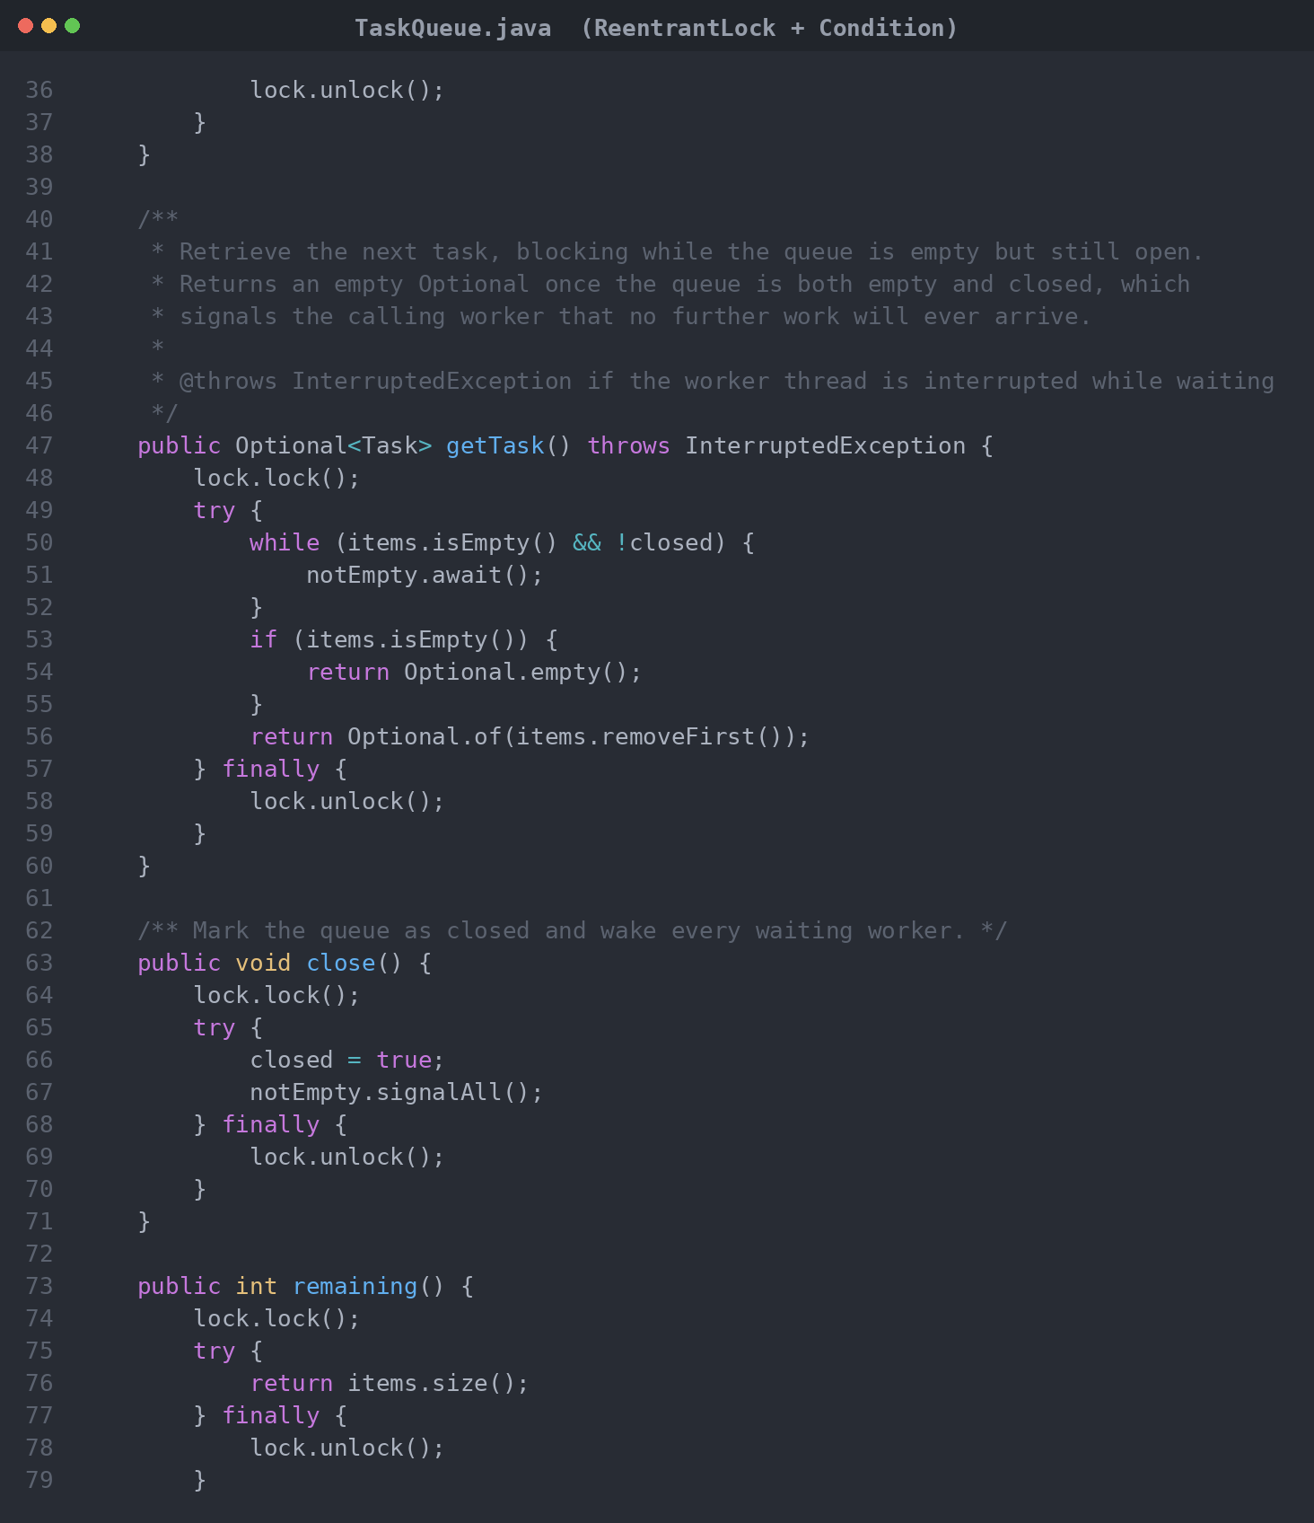
Figure A2. Java worker showing try and catch blocks for malformed records, I/O failures, and interruption.
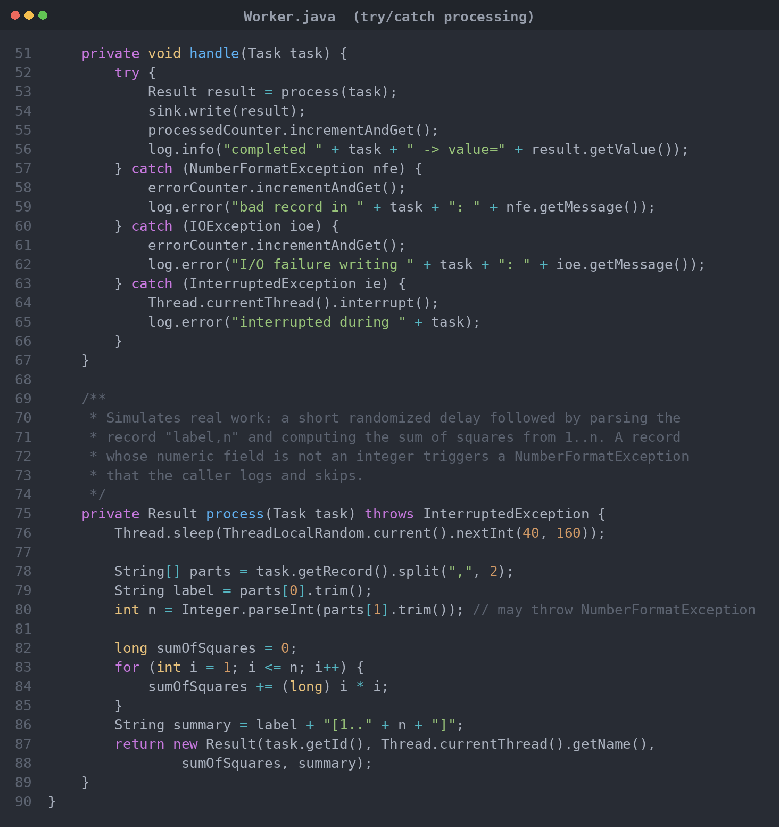
Figure A3. Java orchestration with an ExecutorService thread pool and orderly shutdown.
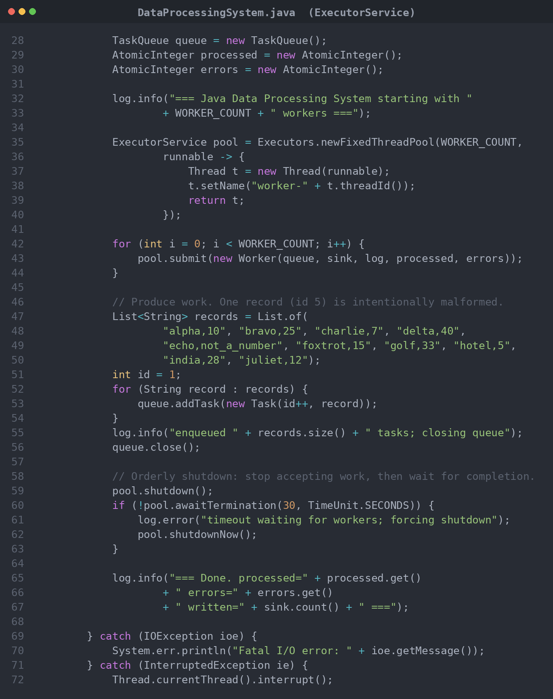
Figure A4. Java console output. Nine tasks processed, one error logged, nine rows written.
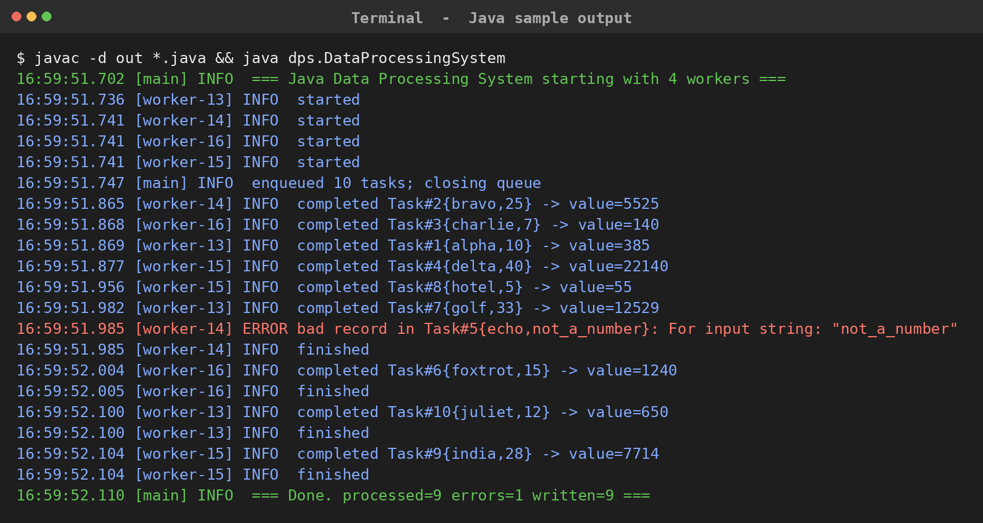
Figure A5. Go process function and worker goroutine ranging over the task channel.
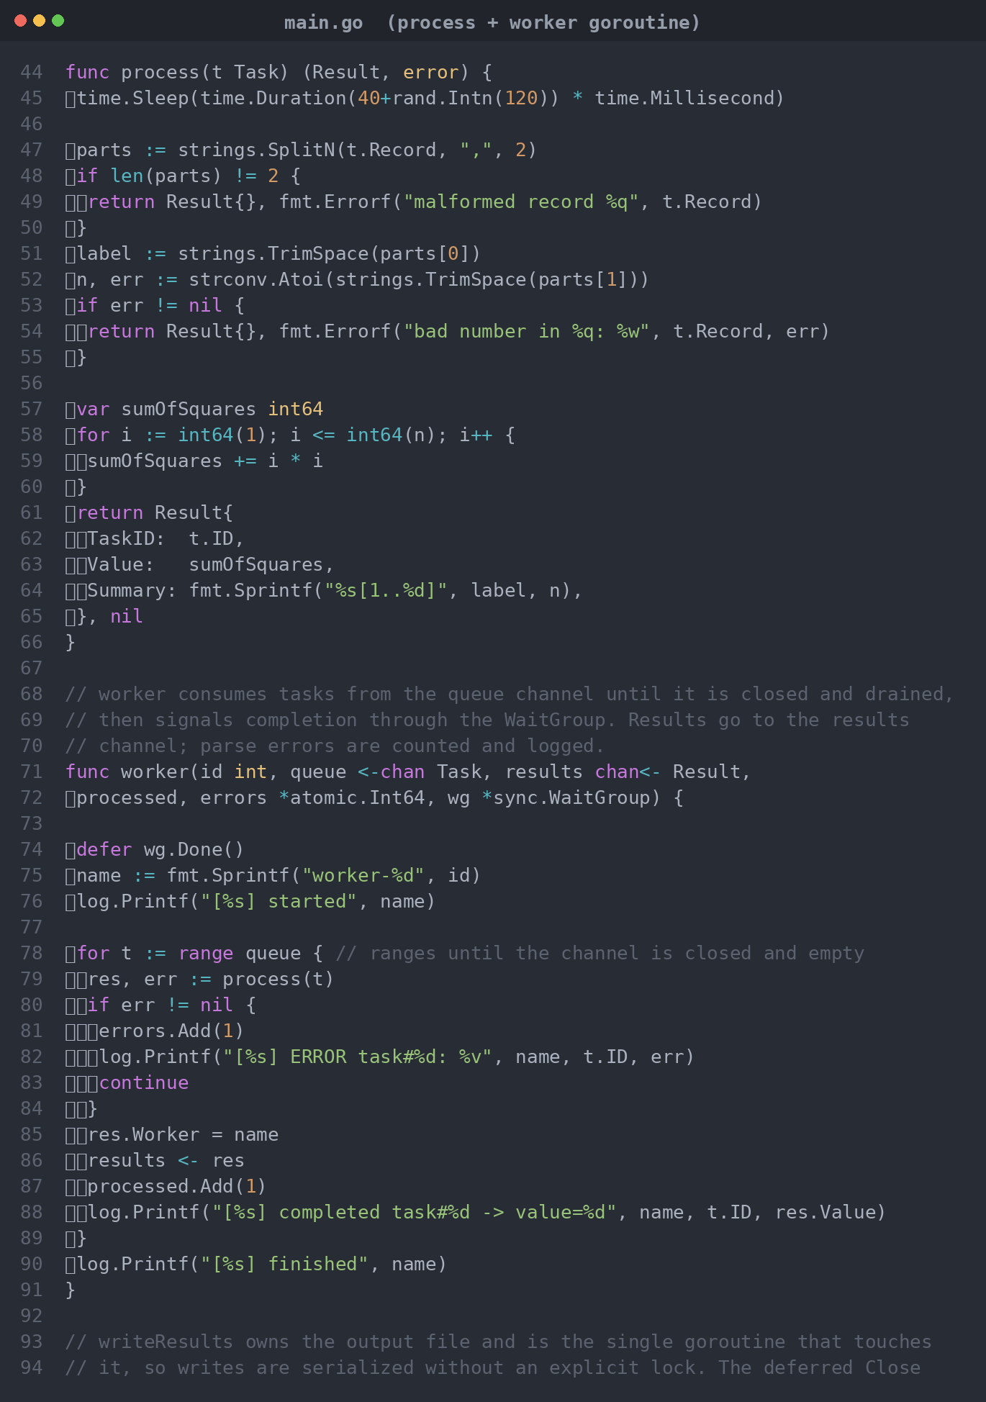
Figure A6. Go writer goroutine that owns the output file, plus channel and counter setup.
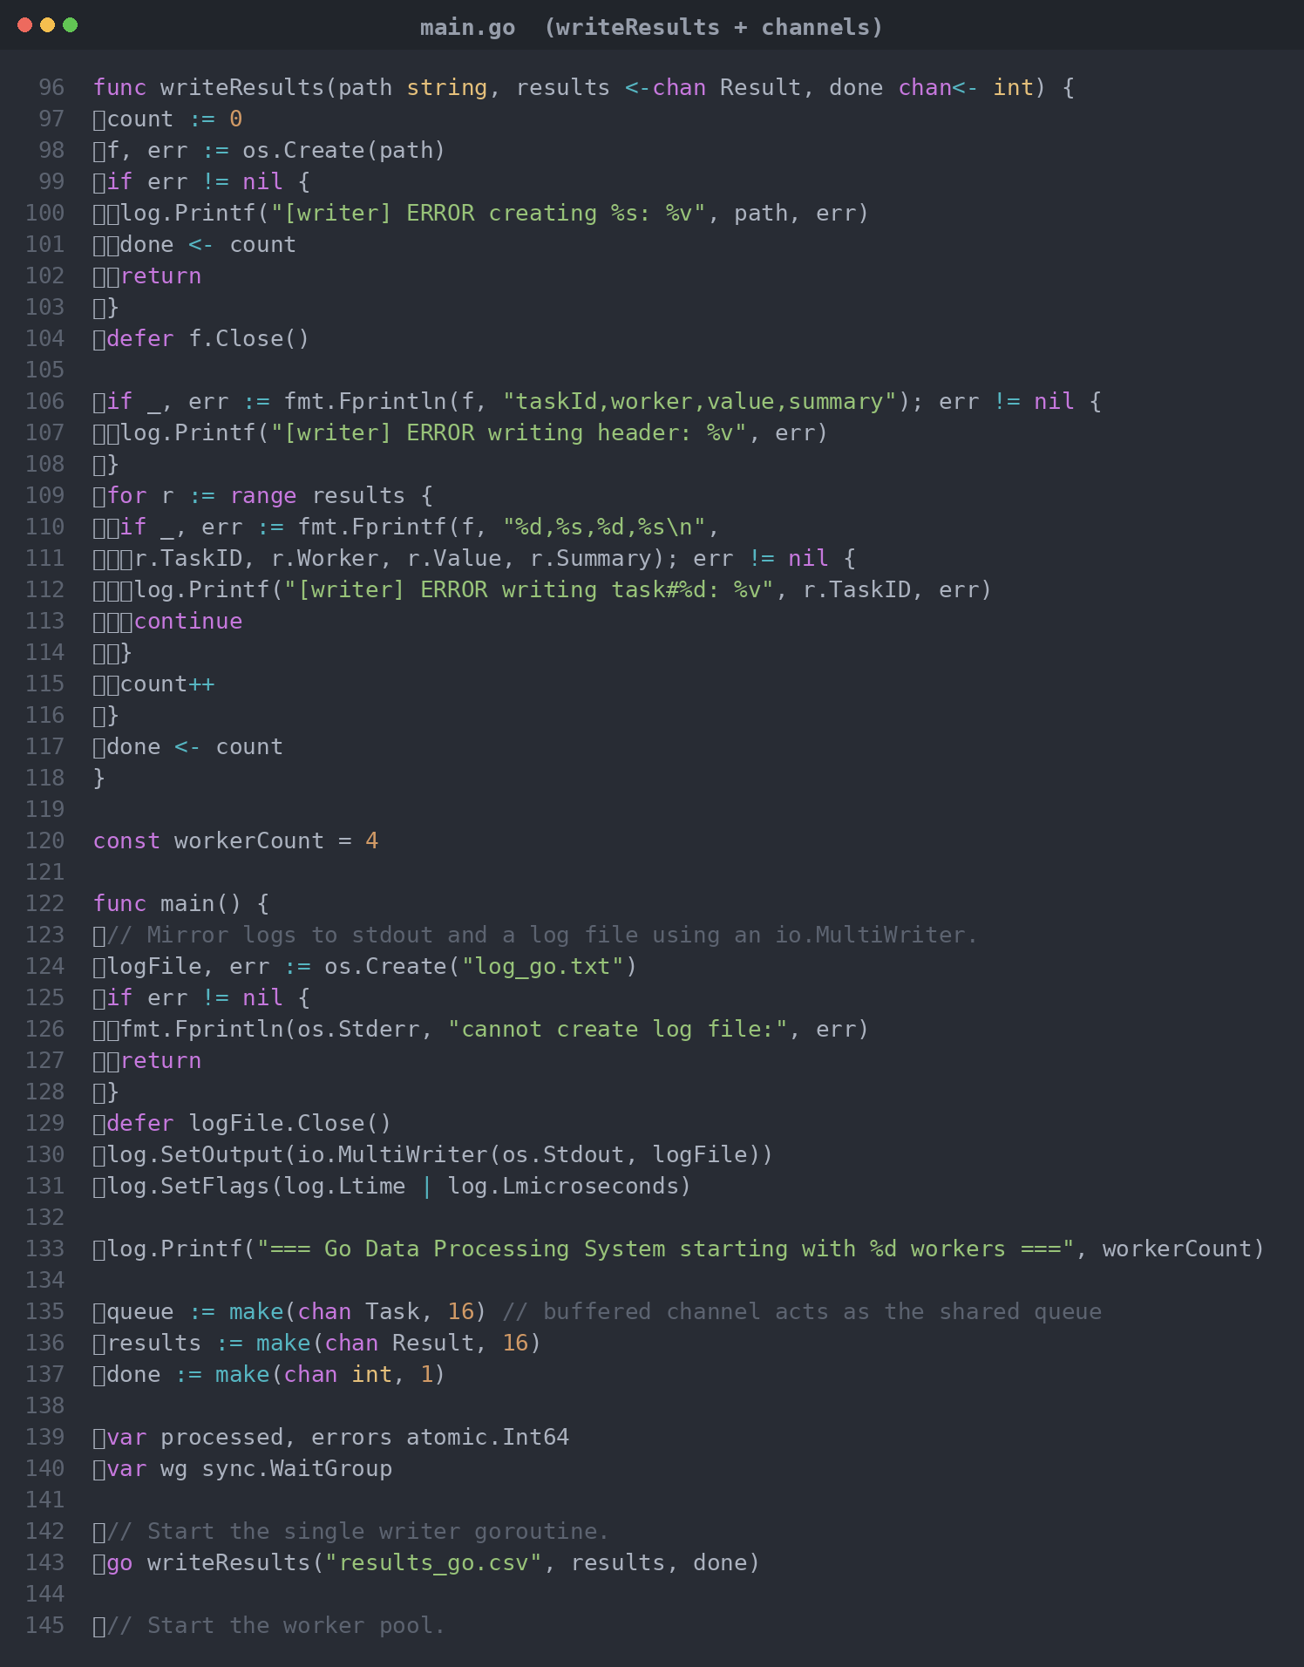
Figure A7. Go orchestration using channel close and a WaitGroup for safe termination.
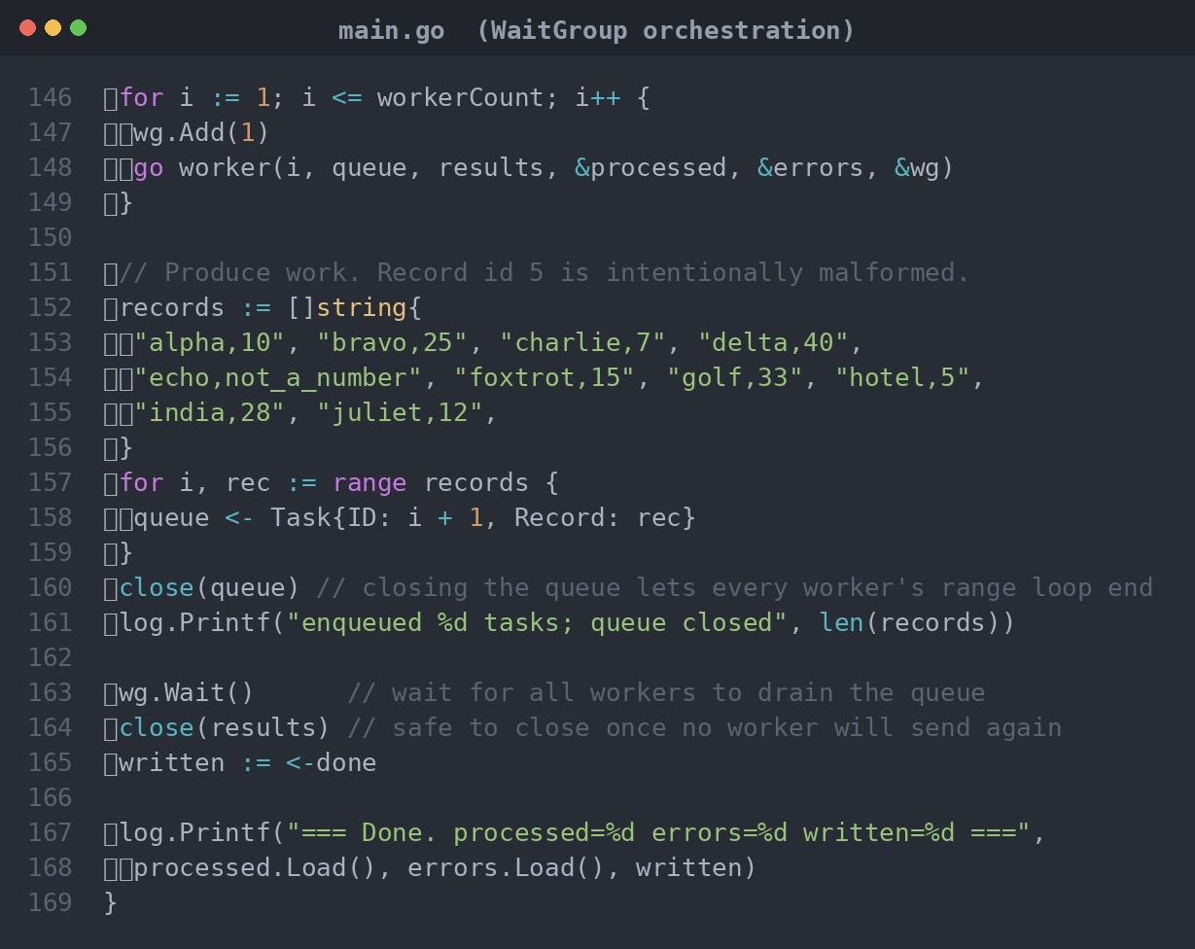
Figure A8. Go console output. Nine tasks processed, one error logged, nine rows written.
