Section 1: Chemical Product and Company Identification
Product Name: HP-PMA45

Synonyms: ZSM-5 additive
Material Uses: Specialty catalyst
Chemical Name: ZSM-5
Chemical Family: Zeolite
Chemical Formula: Na_{n}Al_{n}Si_{96–n}O₁₉₂·16H₂O (0<n<27)

Contact Details: HP Green R&D Centre
KIADB Industrial Area
Tarabahalli, Hoskote Taluk,
Devangundi. Bangalore-560067, India

Section 2: Composition and Information on Ingredients
Name |  | CAS # | %(w/w)
Aluminium oxide  Silicon dioxide  Kaolin  Aluminium Orthophosphate  Magnesium oxide |  | 1344-28-1  7631-86-9  1332-58-7  7784-30-7  1309-48-4 | 10-30  50-70  10-40  5-20  0.3-3%
Section 3: Hazards Identification
Pictogram(s):

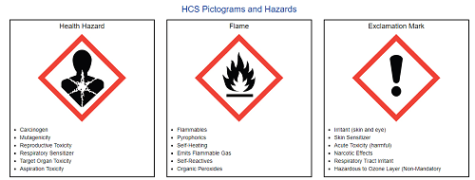
Signal word: Warning
Precautionary measures: Do not breathe dust. Do not eat, drink or smoke when using this product. Wash thoroughly after handling.

OSHA/HCS status : This material is considered hazardous by the OSHA Hazard Communication Standard (29 CFR 1910.1200).

Routes of entry Not available.

Potential Health Effects: Eyes
Exposure to airborne concentrations above statutory or recommended exposure limits may cause irritation of the eyes. Adverse symptoms may include irritation & redness

Potential Health Effects: Skin
Repeated or prolonged skin contact may cause irritation. May cause physical abrasion in contact with skin.

Potential Health Effects: Ingestion
Ingestion can cause gastrointestinal irritation

Potential Health Effects: Inhalation
Exposure to airborne concentrations above statutory or recommended exposure limits may cause irritation of the nose, throat and lungs. Dust may enter the lung and be slow to clear. Adverse symptoms may include respiratory tract irritation & coughing. Contains material that may cause target organ damage (lungs, the nervous system, upper respiratory tract, skin, eye, lens or cornea, stomach), based on animal data. Repeated or prolonged inhalation of dust may lead to chronic respiratory irritation.
Pre-existing disorders involving any target organs mentioned in this MSDS as being at risk may be aggravated by over-exposure to this product.
Section 4: First Aid Measures
First Aid: Eyes
Immediately flush eyes with water for at least 15 minutes, while holding eyelids open. Seek medical attention at once.

First Aid: Skin
Remove contaminated clothing and shoes. In case of contact, immediately flush skin with plenty of water for at least 15 minutes and shoes. Wash clothing and shoes before reuse.

First Aid: Inhalation
Move exposed person to fresh air. Assist breathing if necessary. Obtain medical attention.

First Aid: Ingestion
Wash out mouth with water. Do not induce vomiting unless directed to do so by medical personnel. Never give anything by mouth to an unconscious person. Get medical attention immediately

First Aid: Notes to Physician
No action shall be taken involving any personal risk or without suitable training. No specific treatment. Treat symptomatically. Contact poison treatment specialist immediately if large quantities have been ingested or inhaled.

Section 5: Fire and Explosion Data
Flammability: No specific fire or explosion hazard
Hazards from the substance or mixture: No specific fire or explosion hazard. Inorganic powder or granules. Non-combustible
Extinguishing Media
Suitable Extinguishing Media: Select extinguishing agent appropriate to other materials
involved. Normal extinguishing media.
Unsuitable extinguishing Media: Not known.
Special exposure hazards: Promptly isolate the scene by removing all persons from the vicinity of the incident if there is a fire. No action shall be taken involving any personal risk or without suitable training.
Hazardous thermal decomposition products: Decomposition products may include the materials: phosphorus oxides & metal oxide/oxides
Special protective equipment for fire-fighters: Fire-fighters should wear appropriate protective equipment and self-contained breathing apparatus (SCBA) with a full face-piece operated in positive pressure mode.
Fire Fighting Equipment/Instructions
Chemical goggles (EN 166). Wear suitable protective clothing. Impervious gloves and boots

Section 6: Accidental Release Measures
Evacuation Procedures
No action shall be taken involving any personal risk or without suitable training. Evacuate surrounding areas. Keep unnecessary and unprotected personnel from entering. Do not touch or walk through spilled material. Avoid breathing dust. Provide adequate ventilation. Wear appropriate respirator when ventilation is inadequate. Use personal protective equipment as required.

Environmental Precautions: Avoid dispersal of spilled material and runoff and contact with soil, waterways, drains and sewers. Inform the relevant authorities if the product has caused environmental pollution (sewers, waterways, soil or air).

Small Spills: Move containers from spill area. Vacuum or sweep up material and place in a designated, labeled waste container. Dispose of via a licensed waste disposal contractor..

Large Spills: Move containers from spill area. Approach release from upwind. Prevent entry into sewers, water courses, basements or confined areas. Vacuum or sweep up material and place in a designated, labeled waste container. Avoid creating dusty conditions and prevent wind dispersal. Dispose of via a licensed waste disposal contractor.

Section 7: Handling and Storage
Handling Procedures
Put on appropriate personal protective equipment (see Section 8). Eating, drinking and smoking should be prohibited in areas where this material is handled, stored and processed. Workers should wash hands and face before eating, drinking and smoking. Remove contaminated clothing and protective equipment before entering eating areas. Do not ingest. Avoid contact with eyes, skin and clothing. Avoid breathing dust. Keep in the original container or an approved alternative made from a compatible material, kept tightly closed when not in use. Empty containers retain product residue and can be hazardous. Do not reuse container.

Incompatibility
This product may react with oxidizing agents. This product may react with strong acids. Heated vapors or mists may from explosive mixtures in air.

Storage Procedures
Store in accordance with local regulations. Keep container tightly closed and sealed until ready for use. Containers that have been opened must be carefully resealed and kept upright to prevent leakage. Do not store in unlabeled containers. Use appropriate containment to avoid environmental contamination.

Section 8: Exposure Controls/Personal Protection
Aluminium oxide | OSHA: The legal airborne permissible exposure limit (PEL) is 5 mg/m3 (as respirable dust) and 15 mg/m3 (as total dust) averaged over an 8-hour workshift. ACGIH: The threshold limit value (TLV) is 1 mg/m3 (as the respirable fraction for Aluminum) averaged over an 8- hour workshift.
Silicon dioxide | % Silicon Dioxide +2 (as total dust) averaged over an 8-hour workshift. NIOSH: The recommended airborne exposure limit is 0.1 mg/m3 (as respirable dust) averaged over a 10-hour workshift. ACGIH: The recommended airborne exposure limit is 0.025 mg/m3 (as the respirable fraction) averaged over an 8-hour workshift.
Kaolin | The Occupational Safety and Health Administration (OSHA) has set the legal limit (permissible exposure limit) for kaolin exposure in the workplace as 15 mg/m³ total exposure and 5 mg/m³ respiratory exposure over an 8-hour workday.
Aluminium Orthophosphate | The following exposure limits are for inorganic Aluminum compounds (measured as Aluminum): OSHA: The legal airborne permissible exposure limit (PEL) is 15 mg/m3 (as total dust), and 5 mg/m3 (as respirable dust) averaged over an 8-hour workshift.
Magnesium oxide | The Occupational Safety and Health Administration (OSHA) has set the legal limit (permissible exposure limit) for magnesium oxide exposure in the workplace as 15 mg/m³ total exposure and 5 mg/m³ respiratory exposure over an 8-hour workday.
Engineering Controls
Provide adequate ventilation, including appropriate local extraction if dusts, fumes or vapours are likely to be evolved. Engineering methods to prevent or control exposure are
preferred. Methods include process or personnel enclosure, mechanical ventilation (dilution and local exhaust), and control of process conditions. Emergency shower and eye wash facilities should be readily available.

PERSONAL PROTECTIVE EQUIPMENT

Personal Protective Equipment: Eyes/Face

If operating conditions cause high dust concentrations to be produced, use dust goggles. Safety eyewear complying with an approved standard should be used when a risk assessment indicates this is necessary to avoid exposure to liquid splashes, mists, gases or dusts.

Personal Protective Equipment: Skin/Hands/Feet

Chemical-resistant, impervious gloves complying with an approved standard should be worn at all times when handling chemical products if a risk assessment indicates this is necessary. Gloves should be changed regularly to avoid permeation problems.

Personal protective equipment for the body should be selected based on the task being performed and the risks involved and should be approved by a specialist before handling this product.

Personal Protective Equipment: Respiratory
If ventilation is not sufficient to effectively prevent buildup of fume/dust, appropriate NIOSH respiratory protection must be provided. Respirators should be selected by and used under the direction of a trained health and safety professional following requirements found in OSHA's Respirator Standard (29 CFR 1910.134) and ANSI's Standard For Respiratory Protection (Z88.2-1992). A written respiratory protection program, including provisions for medical certification, training, fit testing, exposure assessment's, maintenance, inspection, cleaning and convenient sanitary storage must be implemented.

Environmental Exposure Controls:
Emissions from ventilation or work process equipment should be checked to ensure they comply with the requirements of environmental protection legislation. In some cases, fume scrubbers, filters or engineering modifications to the process equipment will be necessary to reduce emissions to acceptable levels.

Section 9: Physical and Chemical Properties
Physical state and appearance: Solid
Colour: White
Odor: Not available
Odor threshold: Not applicable
Vapor Pressure: Not applicable
Boiling Point: > 1000°C.
Solubility (H2O): Not applicable
Softening Point: Not available
pH: Not applicable
Vapor Density: Not applicable
Melting Point: Not available

Section 10: Stability and Reactivity Data
Chemical Stability: This is a stable material.
Incompatibility: No data available
Hazardous Polymerization: Not likely to occur.
Corrosivity: Not considered to be corrosive.
Hazardous Decomposition: Under normal conditions of storage and use, hazardous decomposition products should not be produced.
Special Remarks: Under normal conditions of storage and use, hazardous reactions will not occur

Section 11: Toxicological Information
Acute toxicity
Ingestion: Low oral toxicity, but ingestion may cause irritation of the gastrointestinal tract.
Inhalation: Avoid inhalation of dusts. Existing medical conditions (eg. asthma, bronchitis) may be aggravated by exposure to dust. Effects of dust may be greater, and occur at lower levels of
exposure in smokers compared to non-smokers.
Skin Contact: Dust may have a drying effect on the skin.
Eye Contact: Dust may cause discomfort and mild irritation.
Sensitisation It is not a skin sensitiser.
Mutagenicity There is no evidence of mutagenic potential.
Carcinogenicity Components are not listed by IARC, NTP or OSHA as carcinogens.
Reproductive toxicity No evidence of reproductive toxicity or developmental toxicity.
STOT - single exposure Not available.
STOT - repeated exposure Not available.
Other information Not available.

Section 12: Ecological Information
Ecotoxicity : No known significant effects or critical hazards.
Aquatic ecotoxicity
Conclusion/Summary : Not classified.
Persistence/degradability
Conclusion/Summary : Not available.

Section 13: Disposal Considerations
Waste Disposal: The generation of waste should be avoided or minimized wherever possible. Disposal of this product, solutions and any by-products should at all times comply
with the requirements of environmental protection and waste disposal legislation and any regional local authority requirements. Dispose of surplus and non-recyclable products via a licensed waste disposal contractor. Waste should not be disposed of untreated to the sewer unless fully compliant with the requirements of all authorities with jurisdiction. Waste packaging should be recycled. Incineration or landfill should only be considered when recycling is not feasible. This material and its container must be disposed of in a safe way. Care should be taken when handling emptied containers that have not been cleaned or rinsed out. Empty containers or liners may retain some product residues. Avoid dispersal of spilled material and runoff and contact with soil, waterways, drains and sewers.

Container information: Since the emptied container retains product residue, follow label warnings even after it has been emptied.

Section 14: Transport Information
TDG Information: Not regulated as a hazardous material for transportation.
Shipping Name: Not regulated as a hazardous material for transportation.
International Air Transport Association (IATA) Regulations
Shipping Name: Not regulated as a hazardous material for transportation.
International Maritime Dangerous Goods (IMDG) Code
Shipping Name: Not regulated as a hazardous material for transportation.

Section 15: Other Regulatory Information
Classification according to Regulation (EC) No. 1272/2008 [CLP/GHS]
UNITED STATES

SARA TITLE III (SUPERFUND AMENDMENTS AND REAUTHORI2ATION ACT)
FIRE: No PRESSURE GENERATING: No REACTIVITY: No ACUTE: No CHRONIC: Yes 313 REPORTABLE INGREDIENTS: Not Listed.

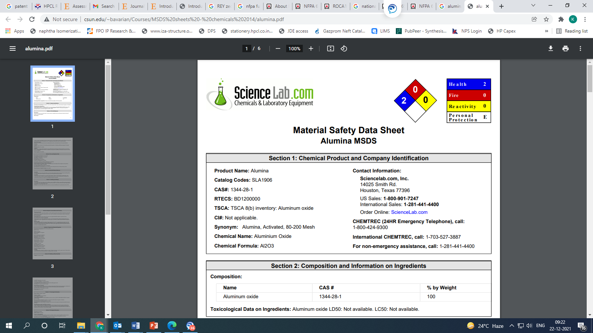
CERCLA (COMPREHENSIVE RESPONSE, COMPENSATION, AND LIABILITY ACT) CERCLA REGULATORY: Not Listed.
National Fire Protection Association (U.S.A.):
Health: 2
Flammability: 0
Reactivity: 0
Specific hazard:
TSCA (TOXIC SUBSTANCE CONTROL ACT)
TSCA STATUS: All components are listed on the TSCA Inventory or are excluded or exempt.

REGULATIONS

STATE REGULATIONS: California
CALIFORNIA PROPOSITION 65: This product does not contain chemical(s) known to the state of California to cause cancer, birth defects, or reproductive harm.

RCRA STATUS: This product, if discarded as sold, is not a Federal RCRA hazardous waste. Processing, use or contamination of this product may change the waste management options. State and local disposal regulations may differ from federal disposal regulations.

CANADA

WHMIS HAZARD SYMBOL AND CLASSIFICATION: Does not meet classification criteria pursuantto the Canadian Hazardous Products Act.

WHMIS (WORKPLACE HAZARDOUS MATERIALS INFORMATION SYSTEM): This MSDS has been prepared according to the hazard criteria of the Controlled Products Regulations (CPR) and the MSDS contains all of the information required by the CPR.

Classification according to EEC directives
- Danger Symbol and designation : No danger Symbols
- R-phrases : None
- S-phrases : None

Additional Information
To our present Knowledge the product is not a substance subject to mandatory marking in accordance with EEC-Directive 67/548/EEC or amendments.

Section 16: Other Information
Label Information: CONTAINS MATERIAL THAT MAY CAUSE TARGET ORGAN DAMAGE, BASED ON ANIMAL DATA.
Hazardous Material Information System:
Health Hazard-1
Flammability-0
Physical Hazards-0

