HINDUSTAN PETROLEUM GREEN R&D CENTER,
KIADB INDUSTRIAL AREA, TARABAHALLI VILLAGE, DEVANAGUNDI, HOSKOTE TALUK, BANGALORE-560067.
PH: 080-2807 8521/ 2807 8523

MATERIAL SAFETY DATA SHEET
HP Frost-Shield

SECTION 1. CHEMICAL IDENTIFICATION:

NAME: HP Frost-Shield
Application: Anti-icing fluid formulation for car windshield
Address:
Hindustan petroleum green R&D center,
KIADB industrial area, Tarabahalli village, Devanagundi, Hoskote Taluk, Bangalore-560067.
Ph: 080-2807 8521/ 2807 8523

SECTION 2. COMPOSITION

Name | Content
Organic alcohol mixtures | 95-100%
Inorganic components | 0-5%

SECTION 3. HAZARDS IDENTIFICATION:

- Harmful by inhalation, in contact with skin and if swallowed
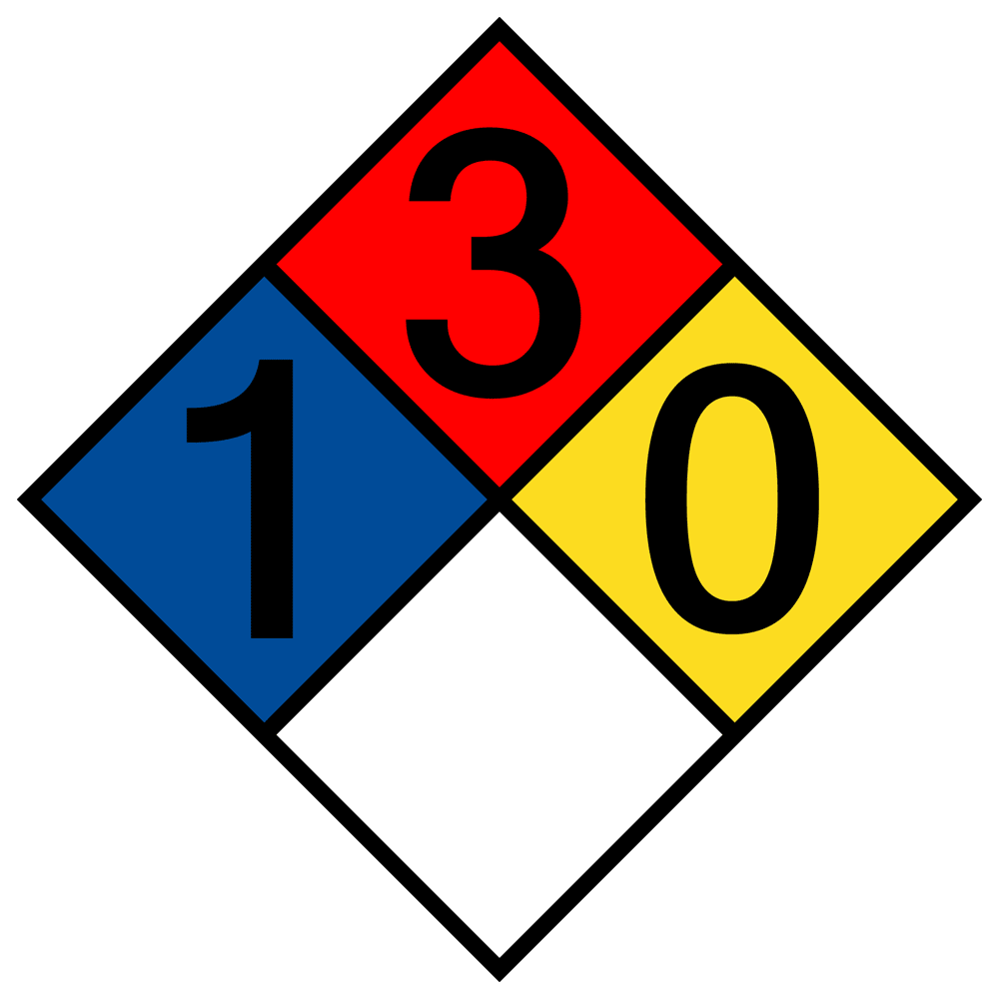

SECTION 4. FIRST AID MEASURES:

- Acute toxicity category 3
- In case of direct contact with eyes or skin, immediately flush with copious amounts of water for at least 15 minutes. Also, remove contaminated clothing and shoes.
- Ensure adequate flushing of the eyes
- If inhaled, take him/her to fresh air. If not breathing properly, give artificial respiration. If breathing is difficult, give oxygen.
- If swallowed, wash mouth with water provided the person is conscious. Call a physician. Wash contaminated clothing before reuse
Contd…. 2
-------------------------------For internal usage only-----------------------------------
M.S.D.S.
- 2 -
MATERIAL SAFETY DATA SHEET
HP Frost-Shield
------------------------------------------------------------------------------------------------------------------------------

SECTION 5. FIRE FIGHTING MEASURES:

- Flammable liquids, category 2
- Dry chemical powder (preferred)
- Carbon dioxide
- Water spray

SECTION 6. ACCIDENTAL RELEASE MEASURES:

- Evacuate area
- Wear self-contained breathing apparatus, rubber boots and heavy rubber gloves
- Sweep up, place in a bag and hold for waste disposal
- Avoid raising dust
- Ventilate area and wash spill site with water after material pickup is complete

SECTION 7. HANDLING AND STORAGE:

- Wear appropriate NIOSH/MSHA – approved respirator, chemical – resistant gloves, safety goggles and protective clothing.
- Keep the chemical in tightly closed container. Store in a cool and dry place.

SECTION 8. EXPOSURE CONTROLS/PERSONAL PROTECTION:

- Wear appropriate NIOSH/MSHA - approved respirator, chemical-resistant gloves, safety goggles and protective clothing.
- Safety shower and eye bath
- Face shield
- Do not breathe dust. Do not get in eyes, on skin, on clothing.
- Avoid prolonged or repeated exposure
- Wash thoroughly with water after handling

-------------------------------For internal usage only-----------------------------------
Contd…3
M.S.D.S.
- 3 -

MATERIAL SAFETY DATA SHEET
HP Frost-Shield
SECTION 9. PHYSICAL AND CHEMICAL PROPERTIES:

Appearance: Colorless clear liquid
Density: 850 kg/m³ at 25 °C
Flash point: 10 °C
pH at room temperature: Not applicable

SECTION 10. STABILITY AND REACTIVITY:

- Incompatible with Strong oxidizing agents and Acids

SECTION 11. TOXICOLOGICAL INFORMATION:

ACUTE EFFECTS

- Acute Toxicity Oral category 3, Acute Toxicity Inhalation category 3, STOT SE 1
- Harmful if swallowed, inhaled, or absorbed through skin
- Material is destructive to tissue of the mucus membranes and upper respiratory tract, eyes and skin
- Symptoms of exposure may include burning sensation, coughing, wheezing, laryngitis, short ness of breath, headache, nausea and vomiting
- Inhalation may result in spasm, inflammation and edema of the larynx and bronchi, chemical pneumonitis and pulmonary edema

SECTION 12. ECOLOGICAL INFORMATIONS

- Data not yet available

-------------------------------For internal usage only------------------------------------
Contd…. 4

M.S.D.S.
- 4 -

MATERIAL SAFETY DATA SHEET
HP Frost-Shield
------------------------------------------------------------------------------------------------------------------------------

SECTION 13. DISPOSAL CONSIDERATIONS:

- Dissolve or mix the material with a combustible solvent and burn in a chemical incinerator equipped with an afterburner and scrubber
- Observe all central (Govt. of India), State and local environmental regulations

SECTION 14. TRANSPORT INFORMATION

UN No : UN 1230
Hazardous Class: Class 3 - Flammable liquids

SECTION 15. REGULATORY INFORMATION:

- Harmful by inhalation, in contact with skin and if swallowed. In case of accident or if you feel unwell, seek medical advice immediately.
- In case of contact with eyes, rinse immediately with plenty of Water and seek medical advice
- Take off immediately all contaminated clothing
- Wear suitable protective clothing, gloves and eye/face

SECTION 16. OTHER INFORMATION:

The information and recommendations in literature and on labels are to the best of our knowledge reliable. However, nothing herein is to be construed as a warranty or representation. Users should make their own tests to determine the applicability of such information or the suitably of any products for their own particular purpose. License granted to make unlimited paper copies for internal use only.

-------------------------------For internal usage only--------------------------------------

