LexiFlow MCP Training Guide
Dedicated Fresher-Friendly Document
Explaining MCP, MCP Client, MCP Server, Tool Calling, JSON-RPC, and LexiFlow Implementation Files
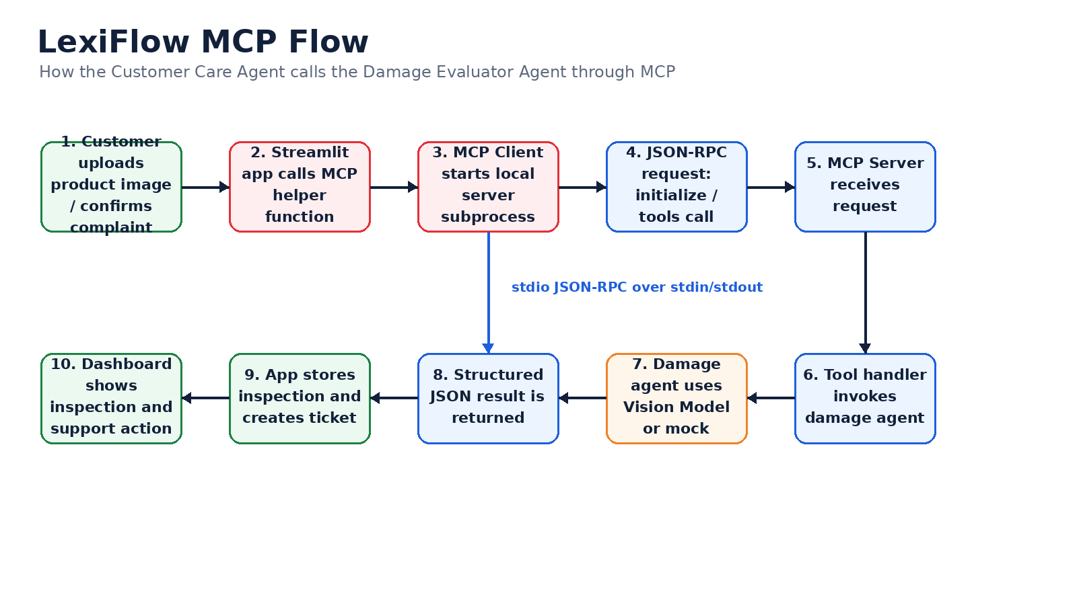
Simple definition
MCP is a standard way for an AI application or agent to call external tools or specialist agents in a structured and predictable way.

Table of Contents
1. Audience and Learning Objectives
2. What is MCP?
3. Why MCP Exists
4. Why LexiFlow Uses MCP
5. MCP vs Normal Function Call vs REST API
6. MCP Architecture in LexiFlow
7. What is MCP Client?
8. What is MCP Server?
9. What is an MCP Tool?
10. JSON-RPC Message Flow
11. Python Files Used to Implement MCP
12. mcp_client.py Deep Dive
13. mcp_server.py Deep Dive
14. damage_detection_agent.py Deep Dive
15. app.py Integration Flow
16. End-to-End Image Inspection Example
17. Error Handling and Fallbacks
18. Security and Validation Points
19. Fresher Practice Tasks
20. Interview Questions and Glossary

1. Audience and Learning Objectives
This guide is written for freshers who are learning modern AI application architecture. It explains the Model Context Protocol concept using the LexiFlow project as a practical example. The focus is not only theory; each concept is connected to the actual Python files used in the project.
Learning Goal | After reading, the fresher should be able to explain
MCP | What MCP means and why it is used in AI agent systems.
MCP Client | How the caller side creates and sends tool requests.
MCP Server | How the receiver side exposes tools and returns responses.
Tool calling | How Customer Care Agent delegates image inspection to a specialist agent.
LexiFlow files | How mcp_client.py, mcp_server.py, damage_detection_agent.py and app.py work together.

2. What is MCP?
MCP stands for Model Context Protocol. In simple terms, MCP is a communication pattern that lets an AI application call tools or specialist services in a standard way. The AI agent does not need to know the internal implementation of every capability. It only needs to know which tool is available, what input the tool expects, and what output the tool returns.
Fresher shortcut
MCP = a standard bridge between an AI agent and external tools.

Term | Simple Meaning | LexiFlow Example
Agent | AI component that performs a role | Customer Care Agent
Tool | Callable function exposed to the agent | inspect_product_damage
Client | Caller that sends the request | mcp_client.py
Server | Receiver that exposes tools | mcp_server.py
Response | Structured result returned to the caller | damage_detected, severity, confidence

3. Why MCP Exists
As AI applications grow, one agent cannot handle everything cleanly. A customer support agent may need to answer questions, inspect images, create tickets, send emails, check warranty, and escalate issues. If all of this logic is placed inside one file or one model prompt, the application becomes difficult to understand and maintain.
Without MCP | With MCP
One large agent handles everything. | Specialist tools and agents can be called when needed.
Image logic is mixed with customer conversation logic. | Image inspection is isolated behind a damage inspection tool.
Hard to replace implementation. | A mock, OpenAI vision, or trained ML model can be swapped behind the same tool interface.
Harder to explain architecture. | Clear agent-to-tool boundary for exhibition and training.

4. Why LexiFlow Uses MCP
LexiFlow uses MCP because the Customer Care Agent should focus on customer conversation, policy reasoning, complaint decisioning, and customer-friendly answers. It should not directly contain all image inspection logic. Product damage inspection is a specialist capability, so LexiFlow delegates that task to the Damage Evaluator Agent through MCP.
LexiFlow design principle
Customer Care Agent owns conversation. Damage Evaluator Agent owns image inspection. MCP connects them.

Business Need | How MCP Helps in LexiFlow
Customer uploads damaged product image | Customer Care Agent calls MCP tool instead of inspecting image itself.
Damage evaluation may change later | MCP tool interface can stay the same while model implementation changes.
Demo needs clear multi-agent story | MCP shows how one AI agent can call a specialist AI capability.
Structured support automation | Damage result is returned as JSON and used for ticket/email flow.

5. MCP vs Normal Function Call vs REST API
Freshers often ask whether MCP is just a normal function call or REST API. Conceptually, all three can call logic, but their intent is different.
Approach | What it means | When it is useful | LexiFlow view
Normal function call | One Python function calls another in same process. | Simple local logic. | Used inside files like damage_detection_agent.py.
REST API | Application calls a service using HTTP. | Web/mobile/microservice communication. | Could be future production option.
MCP | Agent/tool communication with tool discovery and structured tool calls. | AI agent ecosystems and tool invocation. | Used for damage inspection boundary.

6. MCP Architecture in LexiFlow
The following diagram shows the LexiFlow MCP flow for product image inspection.


7. What is MCP Client?
The MCP Client is the caller side. In LexiFlow, mcp_client.py starts the MCP server process, sends JSON-RPC requests, waits for responses, parses the result, and returns a Python dictionary to the Streamlit application.
Responsibility | What happens in LexiFlow
Start server | Uses subprocess.Popen to run mcp_server.py.
Initialize protocol | Sends initialize request.
Call tool | Sends tools/call request with tool name and arguments.
Read result | Reads server stdout line and parses JSON.
Close server | Terminates subprocess after use.

# mcp_client.py - simplified idea
with DamageDetectionMCPClient() as client:
report = client.inspect_product_damage(
image_path=image_path,
image_url=image_path,
order_id="ORD-1001"
)

8. What is MCP Server?
The MCP Server is the receiver side. In LexiFlow, mcp_server.py listens for JSON-RPC messages through standard input, processes the requested method, calls the appropriate tool handler, and prints the JSON response to standard output.
Server Function | Purpose
initialize | Returns protocol version, capabilities and server info.
tools/list | Returns available tools and their input schema.
tools/call | Executes a specific tool using supplied arguments.
handle_request | Routes incoming JSON-RPC requests to the correct logic.
main | Reads messages from stdin and writes responses to stdout.

# mcp_server.py - available tool registration
TOOLS = {
"inspect_product_damage": {
"description": "Inspect a customer-uploaded product image for visible damage.",
"inputSchema": {
"type": "object",
"properties": {
"image_path": {"type": "string"},
"image_url": {"type": "string"},
"order_id": {"type": "string"}
},
"required": ["image_path"]
},
"handler": tool_inspect_product_damage
}
}

9. What is an MCP Tool?
An MCP tool is a capability exposed by the MCP server. It has a name, description, input schema, and handler. In LexiFlow, the tool is inspect_product_damage. The handler calls inspect_product_image from damage_detection_agent.py.
# mcp_server.py - tool handler
def tool_inspect_product_damage(args: Dict) -> Dict:
return inspect_product_image(
image_path=args["image_path"],
image_url=args.get("image_url")
)
Tool Field | Meaning
name | Unique tool name: inspect_product_damage.
description | Human-readable explanation of what the tool does.
inputSchema | Rules for required and optional input fields.
handler | Python function executed when tool is called.

10. JSON-RPC Message Flow
LexiFlow uses a simple JSON-RPC style message over stdin/stdout. JSON-RPC is a lightweight format where every request contains jsonrpc, id, method and params. The response contains the same id and either result or error.
# Request example sent by MCP client
{
"jsonrpc": "2.0",
"id": 2,
"method": "tools/call",
"params": {
"name": "inspect_product_damage",
"arguments": {
"image_path": "uploads/ORD-1001_photo.png",
"image_url": "uploads/ORD-1001_photo.png",
"order_id": "ORD-1001"
}
}
}
# Response example returned by MCP server
{
"jsonrpc": "2.0",
"id": 2,
"result": {
"content": [
{
"type": "text",
"text": "{...damage report JSON...}"
}
]
}
}

11. Python Files Used to Implement MCP
Python File | Role in MCP Implementation | Why Fresher Should Understand It
app.py | Streamlit UI and customer workflow. Calls inspect_product_damage_via_mcp when image inspection is needed. | Shows where MCP is triggered from the user flow.
mcp_client.py | Local MCP client. Starts server, sends JSON-RPC requests, parses response. | Core file to understand caller side.
mcp_server.py | Local MCP server. Exposes inspect_product_damage tool. | Core file to understand receiver/tool side.
damage_detection_agent.py | Specialist image inspection logic using OpenAI vision or mock fallback. | Shows what the tool actually does.
customer_db.py | Stores damage inspection records, tickets, email drafts and audit logs. | Shows what happens after MCP returns a result.
requirements.txt | Lists dependencies such as OpenAI, Streamlit, LangChain, FAISS and dotenv. | Shows libraries needed by the project.

12. mcp_client.py Deep Dive
mcp_client.py is responsible for communication from LexiFlow to the MCP server. It is intentionally small so freshers can understand the complete flow.
Code Area | Explanation
DamageDetectionMCPClient.__init__ | Determines server path and starts mcp_server.py as a subprocess.
request(method, params) | Builds JSON-RPC payload, writes to stdin, reads stdout, parses response.
call_tool(name, arguments) | Wraps the tools/call MCP method.
inspect_product_damage(...) | Calls the inspect_product_damage tool and parses returned text JSON.
close() | Terminates server process safely.

payload = {
"jsonrpc": "2.0",
"id": request_id,
"method": method,
"params": params,
}
self.process.stdin.write(json.dumps(payload) + "\n")
self.process.stdin.flush()
line = self.process.stdout.readline()
response = json.loads(line)
Important learning
The MCP client does not inspect the image. It only sends a structured request to the MCP server and waits for a structured result.

13. mcp_server.py Deep Dive
mcp_server.py is the tool gateway. It receives JSON-RPC requests and decides what to do based on the method field. It exposes one learning-focused tool: inspect_product_damage.
Method | What happens
initialize | Returns protocolVersion, capabilities and serverInfo.
tools/list | Returns the list of available tools.
tools/call | Finds the tool by name and calls the handler.
Unsupported method | Returns structured error response.

def handle_request(request: Dict) -> Dict:
method = request.get("method")
request_id = request.get("id")
params = request.get("params") or {}
if method == "initialize":
result = {"protocolVersion": "2024-11-05", "capabilities": {"tools": {}}, "serverInfo": SERVER_INFO}
elif method == "tools/list":
result = list_tools()
elif method == "tools/call":
result = call_tool(params["name"], params.get("arguments") or {})

14. damage_detection_agent.py Deep Dive
damage_detection_agent.py is the actual specialist capability behind the MCP tool. It checks whether the uploaded file exists, decides whether to use mock mode, tries OpenAI vision when configured, and returns a normalized damage report.
Function | Purpose
inspect_product_image | Main entry point. Validates file and selects OpenAI vision or mock path.
inspect_product_image_with_openai | Encodes image and sends it to the configured vision model.
encode_image_as_data_url | Converts local image into base64 data URL.
parse_json_response | Parses JSON returned by the vision model.
normalize_report | Ensures output always has expected fields.
mock_damage_report | Fallback demo response when no API key or mock mode is enabled.
format_damage_report | Formats the inspection result for inclusion in the Customer Care Agent prompt.

return {
"inspection_status": str(report.get("inspection_status", "completed")),
"damage_detected": bool(report.get("damage_detected", False)),
"damage_type": str(report.get("damage_type", "unknown")),
"severity": str(report.get("severity", "unknown")),
"confidence": max(0.0, min(1.0, confidence)),
"needs_human_review": bool(report.get("needs_human_review", True)),
"recommendation": str(report.get("recommendation", "eligible_for_complaint_review")),
"image_url": image_url,
"notes": str(report.get("notes", "")),
"source": source,
"model": VISION_MODEL if source == "openai_vision" else "mock",
}

15. app.py Integration Flow
app.py is where MCP becomes part of the customer journey. When the customer confirms a complaint and the issue requires image proof, the UI asks the user to upload a product image. After upload, app.py saves the image and calls inspect_product_damage_via_mcp.
# app.py - simplified flow
image_path = save_uploaded_image(uploaded_file, case)
report = inspect_product_damage_via_mcp(
image_path=image_path,
image_url=image_path,
order_id=case["order_id"],
)
st.session_state.damage_report = report
log_damage_inspection(report=report, customer_id=case["customer_id"], order_id=case["order_id"])
Step | What app.py does
1 | Saves uploaded image under uploads folder.
2 | Calls MCP client helper.
3 | Receives structured damage report.
4 | Stores report in session state.
5 | Writes audit log and damage inspection record.
6 | Allows complaint creation from inspection.

16. End-to-End Image Inspection Example
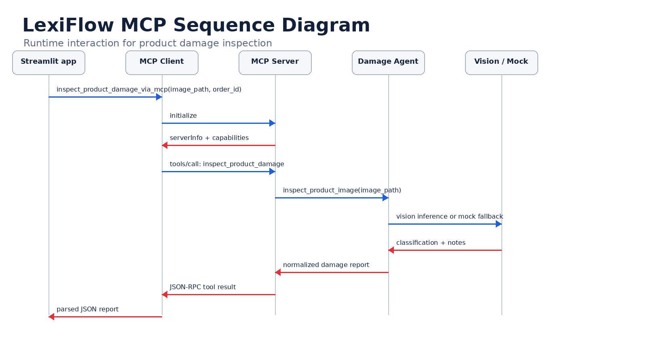
Stage | Example
Customer action | Uploads damaged product image for ORD-1001.
Customer Care Agent decision | Image proof is required before complaint creation.
MCP Client | Sends tools/call request for inspect_product_damage.
MCP Server | Routes request to tool_inspect_product_damage.
Damage Evaluator Agent | Analyzes image and returns normalized report.
Application action | Stores inspection and enables ticket creation.

17. Error Handling and Fallbacks
Freshers should understand that AI tools can fail. The image may be missing, empty, unclear, or the vision API may fail. LexiFlow handles these cases using structured fallback responses.
Failure Case | How LexiFlow Handles It
Image file missing or empty | Returns inspection_status failed and asks for clearer photo.
DAMAGE_DETECTION_USE_MOCK=1 | Uses mock_damage_report for predictable demo behavior.
OPENAI_API_KEY missing | Uses mock fallback.
OpenAI vision exception | Returns fallback mock result with inspection_status fallback.
Unknown MCP tool name | mcp_server.py returns structured JSON-RPC error.
Server stopped without response | mcp_client.py raises RuntimeError with stderr details.

if not path.exists() or size_bytes == 0:
return {
"inspection_status": "failed",
"damage_detected": False,
"recommendation": "ask_customer_for_clearer_photo",
"needs_human_review": True,
}

18. Security and Validation Points
LexiFlow is an exhibition demo, not a production-grade application. Still, freshers should learn where security controls would be added in a real system.
Security Area | Recommended Control
Image upload | Validate extension, size and MIME type.
File path | Avoid path traversal; store uploads in controlled folder.
Customer identity | Verify customer/order ownership before inspection.
Prompt injection | Do not allow image notes or user text to override policy rules.
Tool authorization | Allow only permitted tools for each agent.
Auditability | Log tool call, order ID, result status and user action.
PII protection | Do not expose customer data to unnecessary external tools.

19. Fresher Practice Tasks
Task | Expected Learning
Run mcp_server.py manually and inspect stdin/stdout behavior. | Understand server loop.
Read mcp_client.py and trace request() method. | Understand JSON-RPC request/response.
Force DAMAGE_DETECTION_USE_MOCK=1 and test image flow. | Understand mock fallback.
Add a new MCP tool called echo_order_id. | Understand tool registration.
Modify normalize_report to add a risk_level field. | Understand structured output contract.
Break image path and observe failure response. | Understand error handling.

20. Interview Questions and Glossary
Question | Expected Fresher Answer
What is MCP? | A protocol/pattern for AI agents to call external tools or specialist agents.
What is MCP Client? | The caller side that sends requests and receives responses.
What is MCP Server? | The receiver side that exposes tools and executes handlers.
Why does LexiFlow use MCP? | To separate customer conversation from image damage inspection.
What is tool invocation? | Calling a named tool with structured arguments.
Why JSON output? | It can be stored, displayed, audited and used for automation.
What happens if vision model fails? | LexiFlow uses a fallback mock response or error response.

Glossary
Term | Meaning
MCP | Model Context Protocol, used for agent/tool communication.
JSON-RPC | JSON-based remote procedure call format.
stdio | Standard input/output communication channel.
Tool | A callable capability exposed by an MCP server.
Schema | Definition of expected input format.
Handler | Python function executed when a tool is called.
Vision model | AI model that can inspect image content.
Mock fallback | Predictable demo response used when live model is unavailable.

Final summary
In LexiFlow, MCP allows the Customer Care Agent to delegate image inspection to a Damage Evaluator Agent. The client sends a JSON-RPC tool request, the server executes inspect_product_damage, the damage agent returns structured JSON, and the application uses that result for complaint and dashboard workflows.

