LexiFlow RAG Training Guide
Dedicated Fresher-Friendly Document
Explaining RAG, Embeddings, FAISS, Python Files, and Implementation Flow
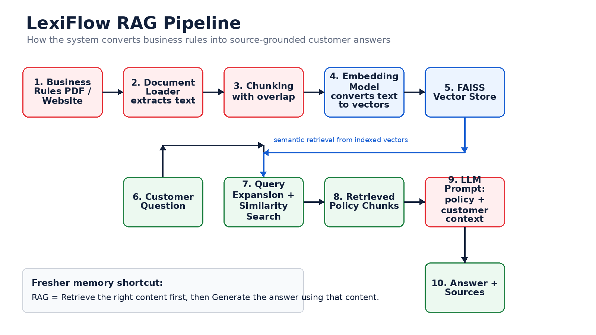
Simple definition
RAG means the AI first retrieves relevant knowledge from your documents, then generates an answer using that retrieved knowledge.

Table of Contents
1. Audience and Learning Objectives
2. What is RAG?
3. Why LexiFlow Uses RAG
4. What is an Embedding?
5. What is FAISS?
6. What is Chunking?
7. LexiFlow RAG Architecture
8. Python Files Used in This Project
9. rag_pipeline.py Deep Dive
10. app.py Integration Flow
11. Ollama Local RAG Option
12. Advanced Features
13. End-to-End Example
14. Common Fresher Questions
15. Glossary
16. Hands-on Practice Plan

1. Audience and Learning Objectives
This guide is written for freshers who are new to AI application development. It explains the RAG implementation used in the LexiFlow project in simple language and then connects each concept to the actual Python files in the codebase.
Learning Goal | After reading, the fresher should be able to explain
RAG | How retrieval and generation work together.
Embedding | How text becomes numeric vectors that computers can compare.
FAISS | How vectors are stored and searched quickly.
Python implementation | Which files implement loading, chunking, embedding, retrieval and answering.
LexiFlow flow | How a customer question becomes a source-grounded answer.

2. What is RAG?
RAG stands for Retrieval Augmented Generation. It is a design pattern used with Large Language Models. Instead of asking the LLM to answer only from its memory, the application first retrieves relevant information from documents and then sends that information to the LLM as context.
Fresher shortcut
RAG = Search first, answer second.

Without RAG | With RAG
LLM answers from general training knowledge. | Application retrieves exact document content first.
Higher risk of hallucination. | Lower risk because answer is grounded in retrieved content.
Not reliable for company-specific policies. | Good for company policies, manuals, FAQs, and support rules.
Cannot cite internal sources. | Can show source chunks and page metadata.

Example: A customer asks, "Can I get a refund after 20 days?" The LLM may not know the company policy. In RAG, LexiFlow first searches the uploaded business rules PDF, retrieves refund policy chunks, combines them with customer delivery date, and then answers based on both policy and customer facts.

3. Why LexiFlow Uses RAG
LexiFlow is a customer care demo. Customer support answers must be policy-aware. The LLM should not invent refund periods, warranty rules, or escalation promises. RAG helps the Customer Care Agent answer using the uploaded business rules document and customer database context.
LexiFlow Need | How RAG Helps
Refund and replacement policy | Retrieves the exact policy section from uploaded documents.
Warranty explanation | Uses policy chunks and selected customer/order records.
Troubleshooting guidance | Retrieves steps like charging, hard restart, and escalation.
Source-backed response | Returns answer plus source chunks shown in the UI.
Exhibition storytelling | Shows modern AI pattern: knowledge + context + action.

4. What is an Embedding?
An embedding is a numerical representation of text. Computers cannot directly compare meaning in sentences like humans do. So an embedding model converts text into a list of numbers called a vector. Similar meanings produce vectors that are close to each other.
Text | Meaning | Vector concept
refund after delivery | Refund policy question | Numbers that represent refund-related meaning
return window | Refund/return concept | Vector close to refund questions
device not turning on | Technical troubleshooting | Vector close to power issue policy
invoice correction | Billing topic | Vector close to billing policy

Important: Embeddings do not store the original text as normal words. They store meaning as numeric coordinates. FAISS uses these coordinates to find the most similar document chunks.
# In LexiFlow, embeddings are selected inside RAGPipeline.__init__
# OpenAI mode:
self.embeddings = OpenAIEmbeddings()
# Local mode:
self.embeddings = HuggingFaceEmbeddings(
model_name="sentence-transformers/all-MiniLM-L6-v2"
)

5. What is FAISS?
FAISS stands for Facebook AI Similarity Search. It is a library used to store and search vectors efficiently. In a RAG system, FAISS acts like a smart search index for embeddings.
Common typo note
You wrote "ffsai". The correct term is FAISS: Facebook AI Similarity Search.

Normal keyword search | FAISS semantic search
Looks for exact words. | Looks for meaning similarity.
May miss related wording. | Can match similar concepts even when wording differs.
Example: "refund" matches refund only. | Example: "return money" can match refund policy.
Useful but limited. | Very useful for RAG retrieval.

# In rag_pipeline.py, FAISS index is created from document chunks
chunks = self.split_documents(documents)
self.documents = chunks
self.db = FAISS.from_documents(chunks, self.embeddings)

6. What is Chunking?
Chunking means splitting a large document into smaller pieces. LLMs and vector databases work better when the document is divided into meaningful smaller chunks instead of one huge block.
Concept | Explanation
Chunk size | Maximum approximate size of each text piece. In LexiFlow default is 500.
Chunk overlap | Repeated text between chunks. In LexiFlow default is 50.
Why overlap? | To avoid losing meaning at chunk boundaries.
Why not whole PDF? | Large text is hard to retrieve precisely and may exceed prompt limits.

# In rag_pipeline.py
self.chunk_size = 500
self.chunk_overlap = 50
splitter = RecursiveCharacterTextSplitter(
chunk_size=self.chunk_size,
chunk_overlap=self.chunk_overlap
)
chunks = splitter.split_documents(documents)

7. LexiFlow RAG Architecture
The diagram below shows the RAG flow used in LexiFlow.

Stage | What happens | LexiFlow file/function
Document upload | User uploads business rules PDF from Streamlit sidebar. | app.py / process_pdf_files()
Load document | PDF pages are extracted as LangChain documents. | rag_pipeline.py / load_pdf()
Split document | Text is split into overlapping chunks. | rag_pipeline.py / split_documents()
Embed chunks | Each chunk is converted into vectors. | rag_pipeline.py / OpenAIEmbeddings or HuggingFaceEmbeddings
Store vectors | Vectors are stored in FAISS. | rag_pipeline.py / create_vector_db()
Ask question | Customer question is passed to RAG pipeline. | app.py / ask_question()
Retrieve context | Similar chunks are retrieved from FAISS. | rag_pipeline.py / similarity_search()
Generate answer | LLM receives retrieved context and question. | rag_pipeline.py / query()
Show sources | Retrieved chunks are displayed below answer. | app.py / render_sources()

8. Python Files Used in This Project
Python file | Purpose in RAG learning
app.py | Streamlit user interface. Uploads PDFs/websites, initializes RAGPipeline, sends questions, displays answers and sources.
rag_pipeline.py | Main RAG implementation. Handles document loading, splitting, embedding, FAISS indexing, retrieval, prompt building, and LLM calls.
rag_pipeline_ollama.py | Alternative local RAG implementation using Ollama LLM and HuggingFace embeddings. Useful when avoiding cloud API.
app_ollama.py | Simple Streamlit UI for the Ollama-based RAG pipeline.
advanced_features.py | Adds learning extensions: chat memory, hybrid search, role-based AI prompts, source citations, document manager.
requirements.txt | Lists required dependencies such as LangChain, FAISS, Streamlit, pypdf and sentence-transformers.
setup.py | Setup wizard to create environment, install dependencies, configure .env and run the app.
test_installation.py | Checks imports, environment file, RAGPipeline creation, file structure and Streamlit readiness.
examples.py | Learning examples for PDF RAG, website RAG, persistence, hybrid search and interview explanation.

9. rag_pipeline.py Deep Dive
This is the most important file for learning RAG in LexiFlow. It contains the RAGPipeline class.

9.1 Initialization
The constructor decides whether to use OpenAI or local Ollama. It also sets the embedding model and default chunk settings.
class RAGPipeline:
def __init__(self, api_key=None, model="gpt-3.5-turbo", use_local=False):
if use_local:
self.llm = OllamaLLM(model=model, base_url="http://localhost:11434", temperature=0)
self.embeddings = HuggingFaceEmbeddings(
model_name="sentence-transformers/all-MiniLM-L6-v2"
)
else:
self.embeddings = OpenAIEmbeddings()
self.llm = ChatOpenAI(model=model, temperature=0)
self.db = None
self.documents = []
self.chunk_size = 500
self.chunk_overlap = 50

9.2 Loading PDF and Website Content
load_pdf() reads a PDF and returns document objects. load_website() reads web content and returns document objects. Both add source metadata so the UI can show where the answer came from.
def load_pdf(self, file_path: str) -> List:
loader = PyPDFLoader(file_path)
docs = loader.load()
for doc in docs:
doc.metadata["source"] = file_path
return docs
def load_website(self, url: str) -> List:
loader = WebBaseLoader(url)
docs = loader.load()
for doc in docs:
doc.metadata["source"] = url
return docs

9.3 Creating the Vector Database
create_vector_db() performs the core indexing step. It splits documents into chunks and stores the chunk embeddings in FAISS.
def create_vector_db(self, documents: List):
chunks = self.split_documents(documents)
self.documents = chunks
self.db = FAISS.from_documents(chunks, self.embeddings)

9.4 Retrieval and Query Expansion
When a customer question comes in, LexiFlow expands support-style questions with additional policy keywords. This improves retrieval for refund, replacement, warranty, technical, delivery and escalation questions.
def _expand_support_query(self, question: str) -> str:
if "refund" in lowered or "return" in lowered:
additions.append("refund policy return window calendar days delivery approved refunds")
if "warranty" in lowered:
additions.append("warranty coverage invoice date manufacturing defects exclusions")
if "turning on" in lowered or "power" in lowered:
additions.append("device not turning on charge original charger hard restart technical support")

9.5 Generating the Answer
query() is the final RAG method. It retrieves matching chunks, builds the prompt, calls the LLM, and returns answer plus sources.
def query(self, question: str, top_k: int = 5, system_prompt: str = None):
retrieval_query = self._expand_support_query(question)
# retrieve relevant source documents
# build prompt with retrieved context
# call LLM
return {
"question": question,
"answer": answer_text,
"sources": [
{"content": doc.page_content, "metadata": doc.metadata}
for doc in source_docs
]
}

10. app.py Integration Flow
app.py connects the RAG engine to the Streamlit UI. It is responsible for letting the user upload PDFs, create/load the vector DB, ask questions and display source-backed answers.
Function | Role
ensure_pipeline() | Creates the RAGPipeline object with selected model, local/cloud mode and chunk settings.
process_pdf_files() | Saves uploaded PDFs temporarily, calls load_pdf(), then create_vector_db() or add_documents().
process_website() | Loads a website and adds it to the knowledge base.
ask_question() | Calls rag_pipeline.query(), stores answer and sources in chat history, and may offer complaint creation.
active_system_prompt() | Combines customer/order database context and damage report context with the knowledge-base prompt.
render_sources() | Displays retrieved chunks with source name and page.
render_customer_conversation() | Text box + Ask Question button + status like indexed chunks and loaded sources.

# Important app.py call path
User uploads PDF
-> process_pdf_files()
-> rag_pipeline.load_pdf()
-> rag_pipeline.create_vector_db()
User asks question
-> ask_question()
-> rag_pipeline.query()
-> render answer and sources

11. Ollama Local RAG Option
LexiFlow also contains a local RAG implementation using Ollama. This is useful for learning because the fresher can understand that RAG is not tied to only one LLM provider.
File | What it demonstrates
rag_pipeline_ollama.py | Uses OllamaLLM, HuggingFaceEmbeddings, FAISS, retriever and LCEL chain.
app_ollama.py | Simple Streamlit chat UI for the local pipeline.

# rag_pipeline_ollama.py simplified flow
self.llm = OllamaLLM(model=self.model_name, base_url="http://localhost:11434")
self.embeddings = HuggingFaceEmbeddings(model_name="all-MiniLM-L6-v2")
self.vectorstore = self._load_or_create_vectorstore()
self.retriever = self.vectorstore.as_retriever(search_kwargs={"k": 3})

12. Advanced Features
advanced_features.py is not the main RAG pipeline, but it contains useful concepts for improving the demo.
Feature | Meaning for freshers
ChatMemory | Stores previous question-answer turns so follow-up questions can use recent context.
HybridSearch | Combines semantic search from embeddings with keyword search.
RoleBasedAI | Defines different system prompts for different assistant roles.
SourceCitation | Formats source documents with page/source information.
DocumentManager | Groups and manages multiple document sets.

13. End-to-End Example
Example scenario: The customer asks, "My product is not working. What should I do?"
Step | System action | Output
1 | Customer selects ORD-1001 and asks question. | Question enters app.py.
2 | RAG query expansion detects technical/power issue. | Adds terms like device not turning on, charge, hard restart.
3 | FAISS searches indexed business rules chunks. | Finds troubleshooting policy.
4 | Customer context is added. | Name, product, delivery age, warranty status.
5 | LLM generates answer. | Troubleshooting steps + escalation next step.
6 | UI displays sources. | User can expand source chunks.
7 | Complaint workflow may start. | Ticket/email flow can continue.

14. Common Fresher Questions

Is RAG a model?
No. RAG is an architecture/pattern. It uses models, vector databases and retrieval logic.

Is embedding same as encryption?
No. Encryption hides data. Embedding converts meaning into numbers for similarity search.

Does FAISS understand English?
No. FAISS compares vectors. The embedding model converts English into vectors first.

Why not send full PDF to the LLM?
Large PDFs are too big and less precise. RAG retrieves only relevant chunks.

Why are sources important?
Sources make the answer explainable and reduce hallucination risk.

What happens if no PDF is loaded?
The app warns the user to load a PDF, website or saved vector DB before asking questions.

Can RAG work with local models?
Yes. LexiFlow includes Ollama + HuggingFace embeddings option.

15. Glossary
Term | Simple explanation
LLM | Large Language Model that generates text.
RAG | Retrieval Augmented Generation: retrieve documents, then generate answer.
Embedding | Numeric representation of text meaning.
Vector | A list of numbers that represents a chunk or query.
FAISS | Vector search library used for fast similarity search.
Chunk | Small section of a larger document.
Retriever | Component that finds relevant chunks.
Prompt | Instruction and context sent to the LLM.
Source citation | Information showing which document/page was used.
Hallucination | Incorrect answer invented by an AI model.

16. Hands-on Practice Plan
Exercise | Goal
Run test_installation.py | Verify dependencies and RAGPipeline setup.
Run streamlit run app.py | Open the LexiFlow application.
Upload customer_care_sample_policy.pdf | Build knowledge base and FAISS index.
Ask: My product is not working | Observe retrieval, answer and sources.
Search source chunks | Understand similarity search.
Change chunk size | Observe how number of chunks changes.
Try app_ollama.py | Compare cloud and local RAG behavior.
Read advanced_features.py | Understand hybrid search and source citation extension.

17. Key Takeaway
For a fresher, the most important thing to remember is that RAG does not replace the LLM. RAG supports the LLM by giving it the right knowledge at the right time. In LexiFlow, RAG helps the Customer Care Agent answer policy questions accurately by retrieving relevant business rules, combining them with customer context, and returning a source-backed response.

