**Collecting Branch :**

EPS1

**Servicing Branch :**

LIC of India, Aligarh City Br

**Transaction No :**

31774453

Laxmi Bhawan 1st Floor

Ramghat Road Aligarh ,

**Date ( Time ):**

**Receipt No :**

29/12/2020 ( 19:30:29 )

PR3291011620537203

Aligarh,202001 [bo_eps1@licindia.com HelpDesk: +91-022-1251](mailto:bo_eps1@licindia.com)

**RENEWAL PREMIUM RECEIPT**

Received with thanks ₹ 130,000.00 through Payment Gateway over the Internet from:

**Smt./Ms./Shri :**

Andraju Muralidhar

**towards the following :**

|  |  |  |  |  |  |  |  |
| --- | --- | --- | --- | --- | --- | --- | --- |
| **Policy No**  **Name**  **Agency Code** | **Plan Term D.O.C.** | **Inst. Premium**  **Mode**  **Sum Assured**  (₹) | **No Of Inst Due From Due To** | **Total Premium**  **Late Fee CD Charges** (₹) | **CGST SGST/UTGST Total Amt**  (₹) | | **Branch**  **Next Due**  **Reg. No.** |
| 678820925  Andraju Muralidhar  06303381 | 820  20  28/12/2017 | 127,077.60  YLY  20,00,000 | 1  12/20  12/20 | 127,077.60  0.00  0.00 | 1461.20  1461.20  130,000.00 | | 261  12/21  09AAACL0582HFZ6 |
| Page Total (`) | | 127,077.60 |  | 127,077.60  **0.00**  **0.00** | 1461.20  1461.20  130,000.00 | |  |
| Grand Total (`) | | 127,077.60 |  | 127,077.60  **0.00**  **0.00** | 1461.20 | |  |
|  | 1461.20 |
| **130,000.00** |

ONE LAKH THIRTY THOUSAND AND ZERO PAISE ONLY

Andraju Muralidhar

Consolidated Stamp Duty Paid

CSD/348/2020/362/20 DTD.15/02/2020

Mobile: 9032887007

Email: [muralidhar972@gmail.com](mailto:muralidhar972@gmail.com)

Payment Acknowledgement generated through

Online Portal on 29-Dec-20 Time : 19:30:30.

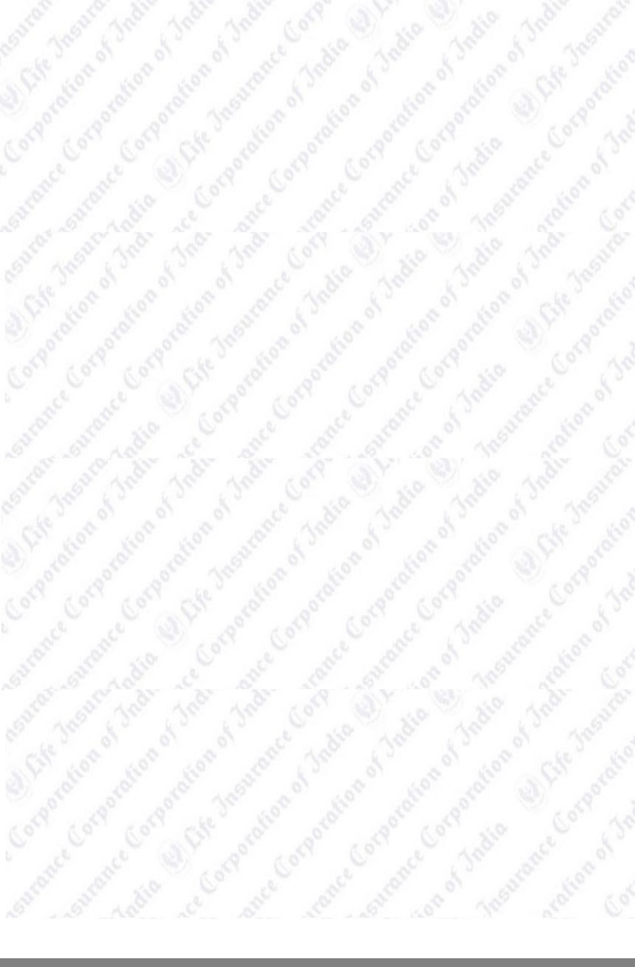

This receipt is electronically generated and no signature is required.

**Har Pal Aapke Saath!**