AUTOMATION TEST EXECUTION REPORT
Tichi App — Sign In / Login Module
Project Name | Tichi App — Web Application (Sign In / Login Module)
Document Name | Automation Test Execution Report
Prepared By | QA Automation Engineer (per uploaded project artifacts)
Version | 1.0
Execution Date | July 6, 2026 (per Allure report timestamp: 12:01:06 – 12:02:14)
Automation Tool | Selenium WebDriver (Python)
Framework | Pytest with Allure Reporting
Browser | Google Chrome (via webdriver.Chrome())
Operating System | Not specified in uploaded artifacts
Application Under Test | https://tichi-app-webapp-stage.web.app

2. Document Information
Field | Details
Document Type | Automation Test Execution Report
Module Covered | Authentication / Sign-In Flow
Source Files Reviewed | 6 Selenium test scripts, conftest.py, pytest.ini, 6 execution screenshots, 2 Allure report screenshots
Test Framework | Pytest (see pytest.ini: python_files = test_*.py, python_functions = test_*)
Reporting Tool | Allure Report
Report Basis | This document is generated strictly from the uploaded scripts, screenshots, and Allure report images. No console logs or requirements.txt were provided.

3. Objective
The objective of this report is to document the execution results of the automated Selenium test suite covering the Sign-In/Login functionality of the Tichi App staging environment, and to provide traceable, evidence-based verification that each automated test case behaved as scripted, using the available test scripts, captured screenshots, and the Allure execution report.

4. Scope
This report covers six automated test cases executed against the Sign-In screen of the Tichi App (staging URL: https://tichi-app-webapp-stage.web.app):
- Empty email field validation
- Empty password field validation
- Invalid email format validation
- Incorrect password for a registered email
- Unregistered email address handling
- Successful login with valid, registered credentials
Out of scope: any modules beyond the sign-in screen (e.g., My Posts, My Requests, Subscription Plans), API-level testing, performance testing, and cross-browser/cross-OS execution, as no artifacts for these were uploaded.

5. Test Environment
Component | Details
Programming Language | Python (per .py script extensions and syntax)
Automation Tool | Selenium WebDriver — from selenium import webdriver
Test Framework | Pytest — governed by pytest.ini
Reporting | Allure Report (per uploaded Allure screenshots)
Browser | Google Chrome — webdriver.Chrome() in conftest.py
Operating System | Not specified in any uploaded file — cannot be confirmed
IDE | Not specified in any uploaded file — cannot be confirmed
WebDriver Management | No explicit driver manager (e.g., webdriver-manager, Selenium Manager) import found; relies on default Selenium 4 driver resolution
Application URL | https://tichi-app-webapp-stage.web.app
requirements.txt | Not provided in the uploaded files — dependency versions cannot be confirmed

6. Automation Framework Overview

6.1 Framework Structure
The project follows a lightweight Pytest-based structure consisting of a shared conftest.py fixture, a pytest.ini configuration file, and one independent test script per scenario (test_empty_email.py, test_empty_password.py, test_invalid_email.py, test_invalid_password.py, test_unregistered_email.py, test_valid_login.py).

6.2 pytest.ini
Configuration confirmed from the uploaded pytest.ini:
- testpaths = . (tests are discovered from the current directory)
- python_files = test_*.py (matches all six uploaded test scripts)
- python_functions = test_* (matches each test function name)
- addopts = -v (verbose console output enabled)

6.3 conftest.py — Fixtures
A single function-scoped fixture named chrome is defined:
- Launches a maximized Chrome browser (driver.maximize_window()) before each test.
- Yields the driver instance to the requesting test function.
- Guarantees driver.quit() runs after every test, pass or fail, via the code placed after yield (standard Pytest teardown pattern).
- Prints "Closing Browser..." to the console during teardown.
All six test scripts accept chrome as a fixture parameter, confirming consistent use of this fixture across the suite.

6.4 Screenshot Handling
Each test script calls driver.save_screenshot() with a filename matching its scenario (e.g., empty_email.png, valid_login_success.png). All six expected screenshot files were present among the uploaded artifacts, confirming that each script executed at least as far as its screenshot-capture statement.

6.5 Reporting
Two Allure Report screenshots were uploaded: an Overview dashboard and a Graphs dashboard. No raw Allure results (allure-results/*.json) or command-line invocation (e.g., pytest --alluredir=...) were included in the uploaded files, so the exact Allure integration mechanism (plugin, listener, or command flag) cannot be confirmed from the artifacts provided.

6.6 Execution Flow
Each of the six tests follows a common flow: open the application URL, click "Sign In", populate the Email field (and Password field where applicable), trigger the relevant action button ("Continue", "Login", or "Check"), wait for an explicit condition via WebDriverWait, capture a screenshot, and assert an expected outcome.

7. Test Execution Summary
Test Case ID | Scenario | File | Status
TC_01 | Empty Email Field Submission | test_empty_email.py | PASS
TC_02 | Empty Password Field Submission | test_empty_password.py | PASS
TC_03 | Invalid Email Format | test_invalid_email.py | PASS
TC_04 | Incorrect Password with Valid Email | test_invalid_password.py | PASS
TC_05 | Unregistered Email Address | test_unregistered_email.py | PASS
TC_06 | Successful Login with Valid Credentials | test_valid_login.py | PASS

8. Test Case Execution Details

TC_01 — Empty Email Field Submission
Test Case ID | TC_01
Script File | test_empty_email.py
Scenario | Empty Email Field Submission
Objective | Verify the application blocks progression to the password step when the Email field is submitted empty.
Test Data | Email: "" (empty)
Expected Result | The Email field should remain visible/on-screen and the app should not advance to the password step; a validation message should be shown.
Actual Result | The app displayed "Email is required" beneath the Email field, highlighted the field in red, and did not advance to the password step.
Status | PASS
Evidence Used | empty_email.png; assertion on By.ID "email" visibility
Screenshot Used | empty_email.png

TC_02 — Empty Password Field Submission
Test Case ID | TC_02
Script File | test_empty_password.py
Scenario | Empty Password Field Submission
Objective | Verify the application blocks login when the Password field is submitted empty after a valid email.
Test Data | Email: muralikumar2712@gmail.com; Password: "" (empty)
Expected Result | The Password field should remain visible and the app should not navigate away from the login step; a validation message should be shown.
Actual Result | The app displayed "Password is required" beneath the Password field, highlighted the field in red, and remained on the login step.
Status | PASS
Evidence Used | empty_password.png; assertion on By.ID "password" visibility
Screenshot Used | empty_password.png

TC_03 — Invalid Email Format
Test Case ID | TC_03
Script File | test_invalid_email.py
Scenario | Invalid Email Format
Objective | Verify the application rejects an improperly formatted email and does not advance to the password step.
Test Data | Email: "invalid_email_format" (no @ symbol)
Expected Result | The Email field should remain visible and the app should not advance to the password step; a format-validation message should be shown.
Actual Result | The browser's native HTML5 validation tooltip appeared ("Please include an '@' in the email address. 'invalid_email_format' is missing an '@'.") and the app did not advance to the password step.
Status | PASS
Evidence Used | invalid_email_format.png; assertion on By.ID "email" visibility
Screenshot Used | invalid_email_format.png

TC_04 — Incorrect Password with Valid Email
Test Case ID | TC_04
Script File | test_invalid_password.py
Scenario | Incorrect Password with Valid Email
Objective | Verify the application rejects login when a registered email is paired with an incorrect password.
Test Data | Email: muralikumar2712@gmail.com; Password: "WrongPassword123!"
Expected Result | The Password field / login step should remain visible and the app should not navigate to the dashboard.
Actual Result | The screenshot captured shows the Login button in a loading state immediately after being clicked, with the Password field still visible. The wait condition (password field visibility) was satisfied and the assertion passed. The screenshot does not capture a final on-screen error message, only the in-progress loading state.
Status | PASS
Evidence Used | invalid_password.png; assertion on By.ID "password" visibility
Screenshot Used | invalid_password.png

TC_05 — Unregistered Email Address
Test Case ID | TC_05
Script File | test_unregistered_email.py
Scenario | Unregistered Email Address
Objective | Verify the application does not advance to the password step for a syntactically valid but unregistered email.
Test Data | Email: not_registered_12345@gmail.com
Expected Result | The Email field should remain visible and the app should not advance to the password step for an email not on record.
Actual Result | The screenshot captured shows the "Check" button in a loading state immediately after being clicked, with the Email field still visible. The wait condition (email field visibility) was satisfied and the assertion passed. The screenshot does not capture a final on-screen error message, only the in-progress loading state.
Status | PASS
Evidence Used | unregistered_email.png; assertion on By.ID "email" visibility
Screenshot Used | unregistered_email.png

TC_06 — Successful Login with Valid Credentials
Test Case ID | TC_06
Script File | test_valid_login.py
Scenario | Successful Login with Valid Credentials
Objective | Verify a registered user can log in successfully with correct credentials and is redirected away from the login page.
Test Data | Email: muralikumar2712@gmail.com; Password: "!@27Murali2005"
Expected Result | The application URL should change away from /login and the user should land on the application dashboard/home page.
Actual Result | The application redirected to the Tichi App home/dashboard page, displaying the navigation bar (Home, My Posts, My Requests, Subscription Plans) and an "Update Your Preferences" prompt, confirming a successful session.
Status | PASS
Evidence Used | valid_login_success.png; assertion that "login" is not present in driver.current_url
Screenshot Used | valid_login_success.png

9. Screenshot Validation
Each screenshot below was captured programmatically by its corresponding test script via driver.save_screenshot(), immediately following the action under test.
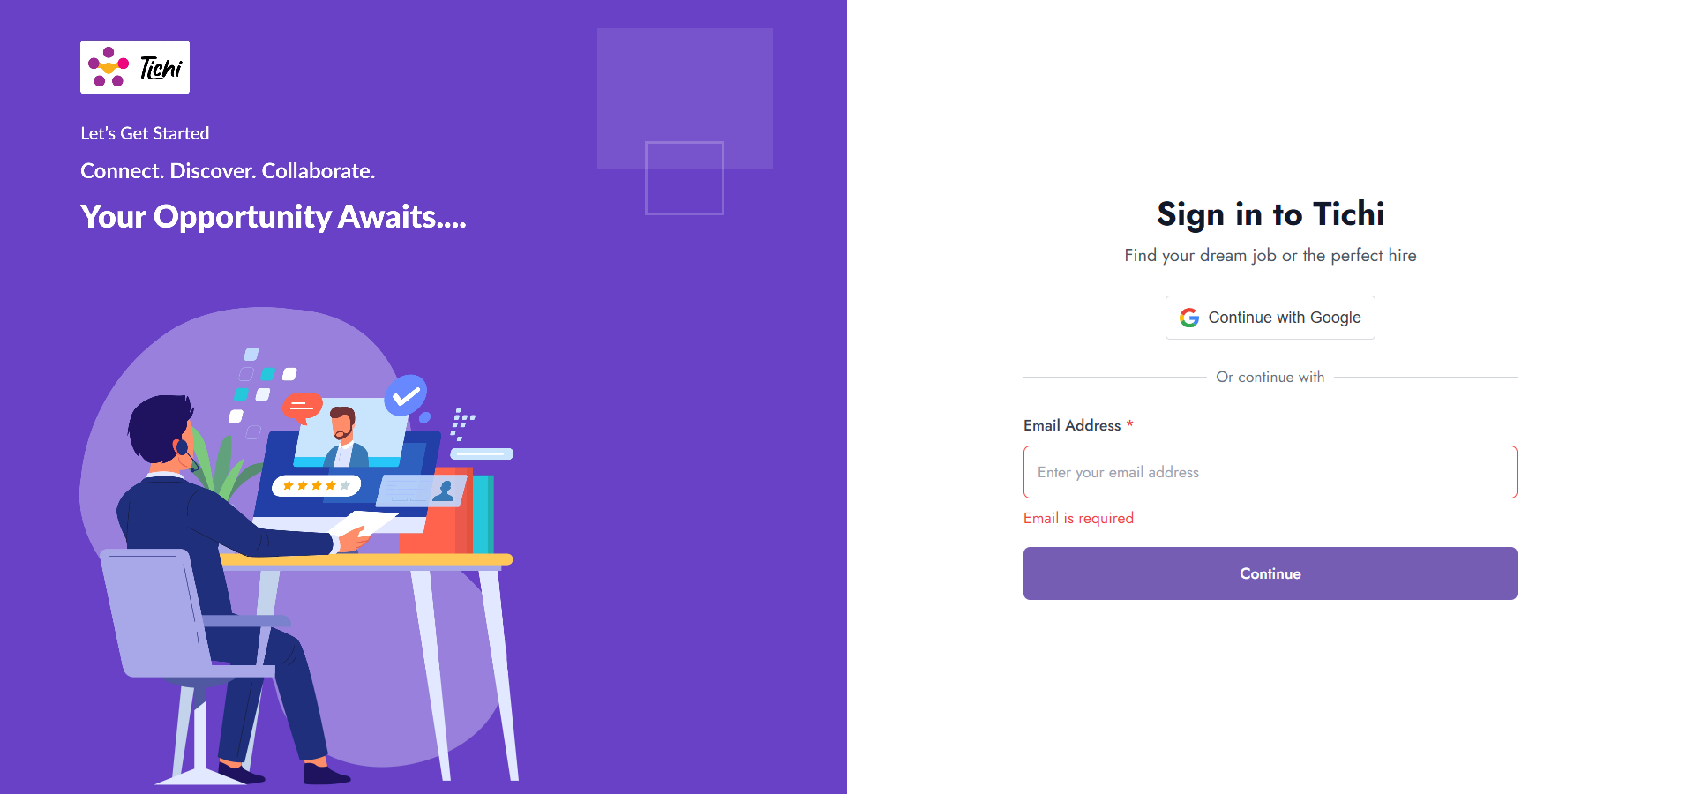
TC_01 — test_empty_email.py — empty_email.png
Shows the Sign-In screen with the Email field outlined in red and the inline message "Email is required" displayed beneath it after the Continue button was clicked with an empty field. Confirms the app blocked progression, matching the test's expected behaviour and its PASS result.
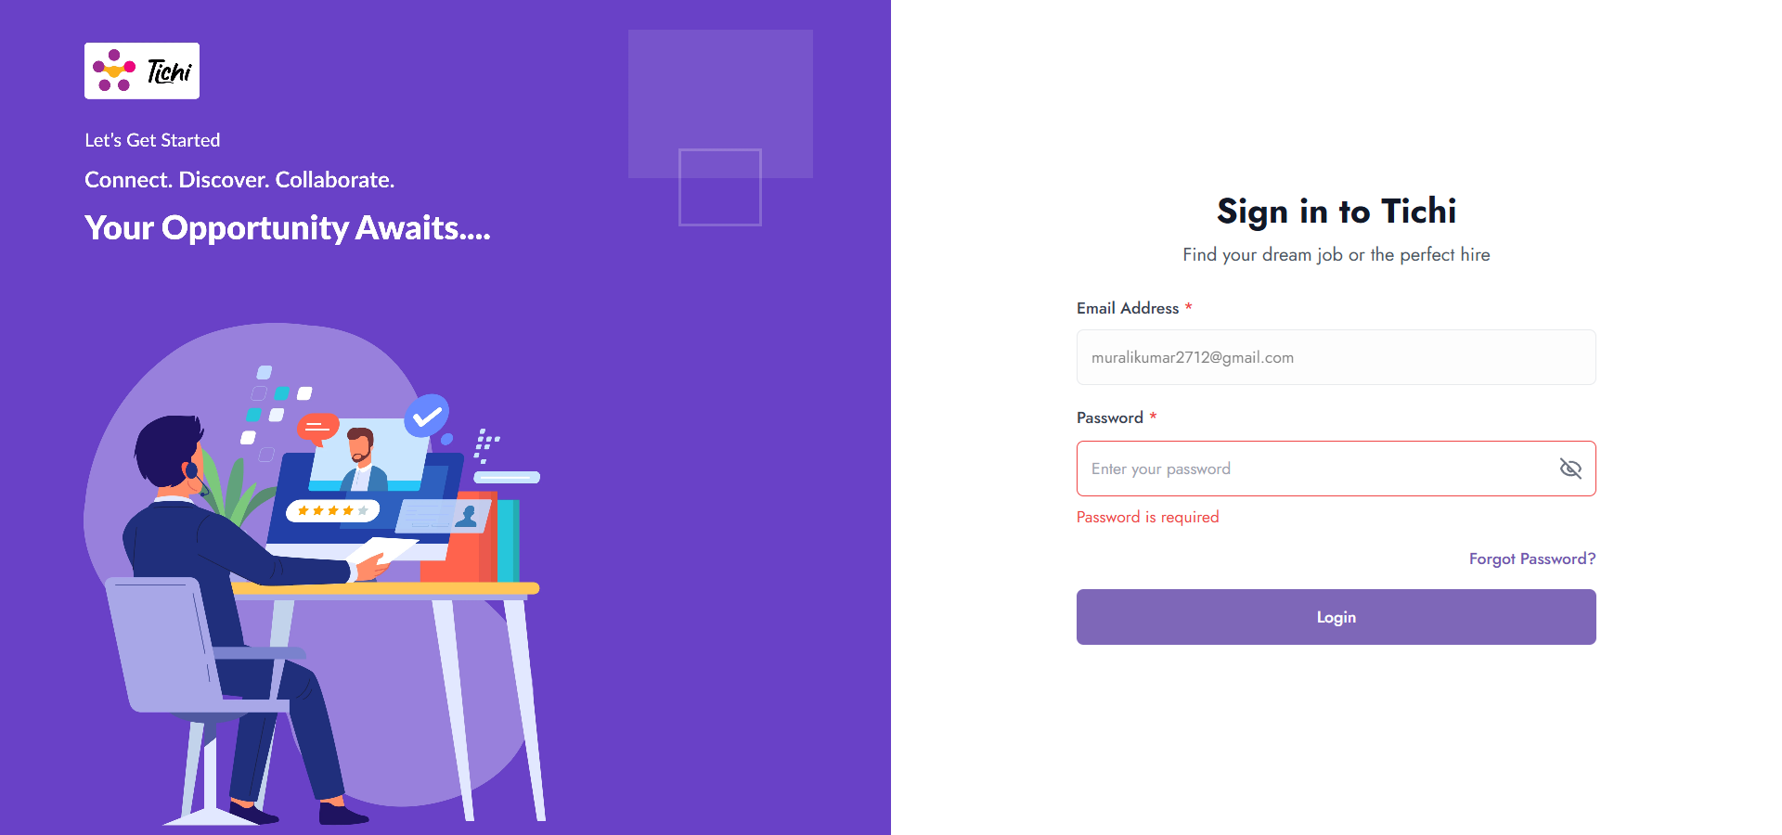
TC_02 — test_empty_password.py — empty_password.png
Shows the Password step with the registered email pre-filled, the Password field outlined in red, and the inline message "Password is required" beneath it after the Login button was clicked with an empty password. Confirms the app blocked login, matching the expected behaviour and PASS result.
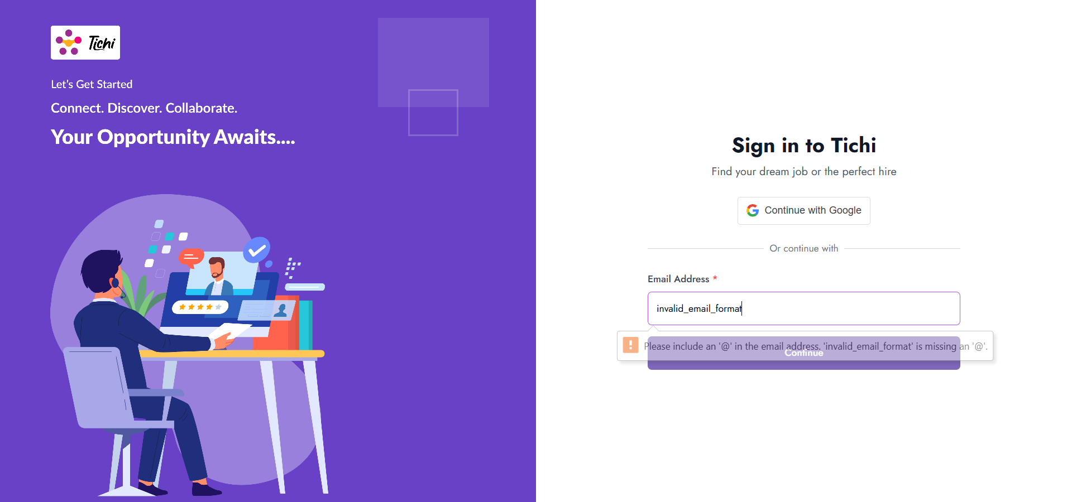
TC_03 — test_invalid_email.py — invalid_email_format.png
Shows the text "invalid_email_format" typed into the Email field, with the browser's native HTML5 validation tooltip visible ("Please include an '@' in the email address..."). This is a browser-level validation cue rather than the application's custom inline error styling seen in TC_01/TC_02. The app did not advance past this step, matching the expected behaviour and PASS result.
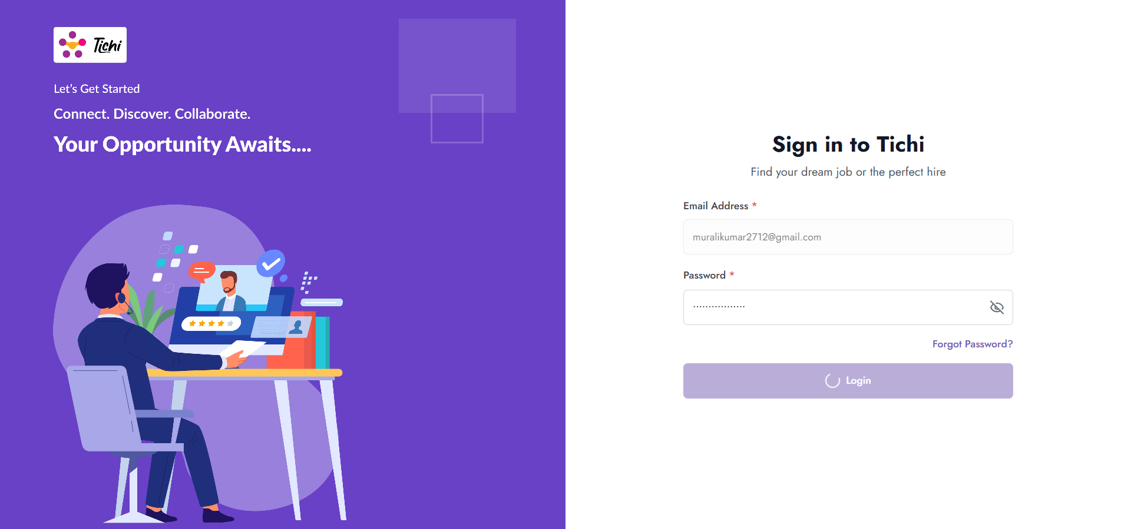
TC_04 — test_invalid_password.py — invalid_password.png
Shows the email field populated and the password field populated (masked), with the Login button displaying a loading spinner. This indicates the screenshot was captured while the login request was still in flight, immediately after the click, rather than after a final error state was rendered. The Password field remains visible, satisfying the coded assertion, but the screenshot alone does not visually confirm an on-screen rejection message.
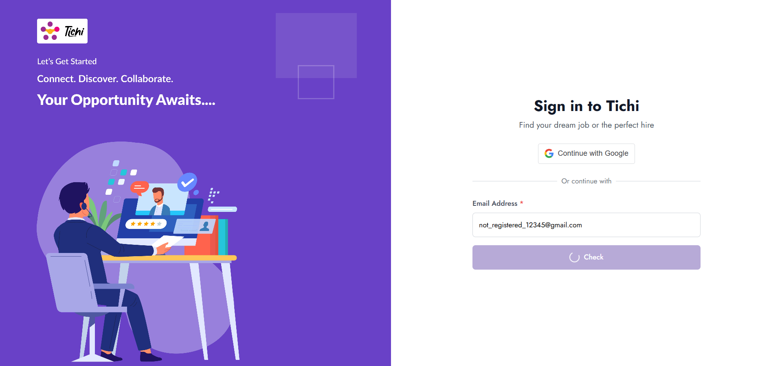
TC_05 — test_unregistered_email.py — unregistered_email.png
Shows the unregistered email populated and the "Check" button displaying a loading spinner, indicating the screenshot was captured mid-request. The Email field remains visible, satisfying the coded assertion, but the screenshot alone does not visually confirm a final rejection message or error state.
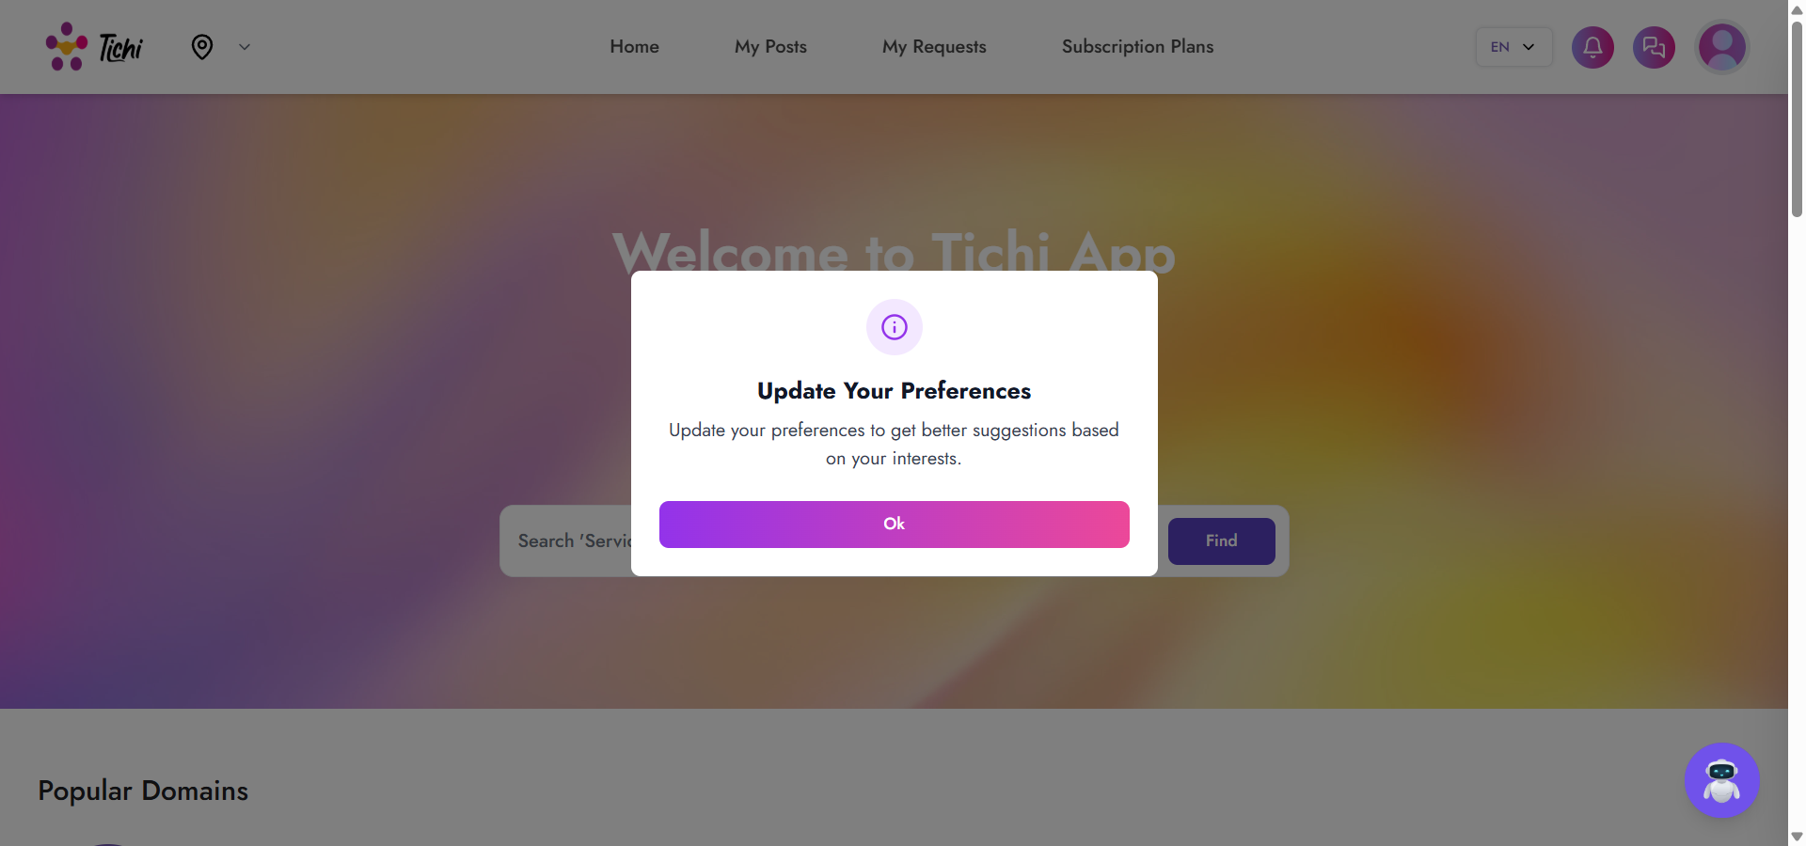
TC_06 — test_valid_login.py — valid_login_success.png
Shows the post-login Tichi App home page, including the top navigation bar (Home, My Posts, My Requests, Subscription Plans) and an "Update Your Preferences" modal dialog. This confirms the application redirected away from the login page after valid credentials were submitted, matching the expected behaviour and PASS result.

10. Script Validation
All six scripts share a consistent structure: they consume the chrome fixture (no local driver instantiation), do not use try/except/finally (exceptions propagate to Pytest for accurate pass/fail reporting), and use WebDriverWait with expected_conditions instead of hard-coded time.sleep() for synchronization at key decision points. Script-specific notes:
Script | Validation Notes
test_empty_email.py | Waits for the Email field visibility, submits an empty value, clicks Continue, and re-confirms the Email field remains visible before asserting is_displayed(). No hard-coded sleep is used.
test_empty_password.py | Populates a valid email, clears the password field, sends a TAB key to trigger field-blur validation, clicks Login, and asserts the Password field remains visible. No hard-coded sleep is used.
test_invalid_email.py | Submits a string without an "@" symbol and asserts the Email field remains visible after clicking Continue. Relies on the same visibility wait pattern as TC_01.
test_invalid_password.py | Imports and retains time.sleep(0.1) inside a per-character typing loop (documented in the script as an intentional human-typing simulation, not a synchronization wait). Uses WebDriverWait for the Password field visibility as the primary synchronization mechanism before asserting.
test_unregistered_email.py | Submits a syntactically valid but unregistered email and asserts the Email field remains visible after clicking Continue, following the same pattern as TC_01 and TC_03.
test_valid_login.py | Also retains time.sleep(0.1) in the per-character typing loop. Uses EC.url_changes() anchored to the exact login URL (https://tichi-app-webapp-stage.web.app/login) to wait for the post-login redirect, then asserts "login" is not present in driver.current_url.

10.1 Suggestions (Assertion Strength) — Non-Binding, Results Unchanged
The following observations are offered as improvement suggestions only. They do not change the recorded PASS results, which reflect exactly what each script's existing assertions verified.
- TC_01, TC_02, TC_03, TC_05 assert only that the relevant input field remains visible after submission. This confirms the app did not navigate away, but does not assert on the actual validation message text or an error-element locator. A stronger assertion would directly check the error message element (e.g., "Email is required", "Password is required") for presence and exact text.
- TC_04 and TC_05 rely on WebDriverWait for field visibility as the synchronization point before taking a screenshot; the field was visible while an asynchronous request was still resolving (loading spinner shown), so the screenshot does not capture a final rendered error state. Adding a wait for a specific error-message element or for the loading spinner to disappear would produce more conclusive visual evidence.
- TC_03 (invalid email) exercises the browser's native HTML5 validation tooltip rather than a custom application-level validator. If the application also implements its own format validation, that logic is not exercised or verified by this test.
- None of the six scripts assert on the exact wording of a success or error message using a dedicated locator (e.g., a data-testid or specific error-container ID); assertions are limited to field visibility or URL content.

11. Allure Report Analysis

11.1 Overview Dashboard
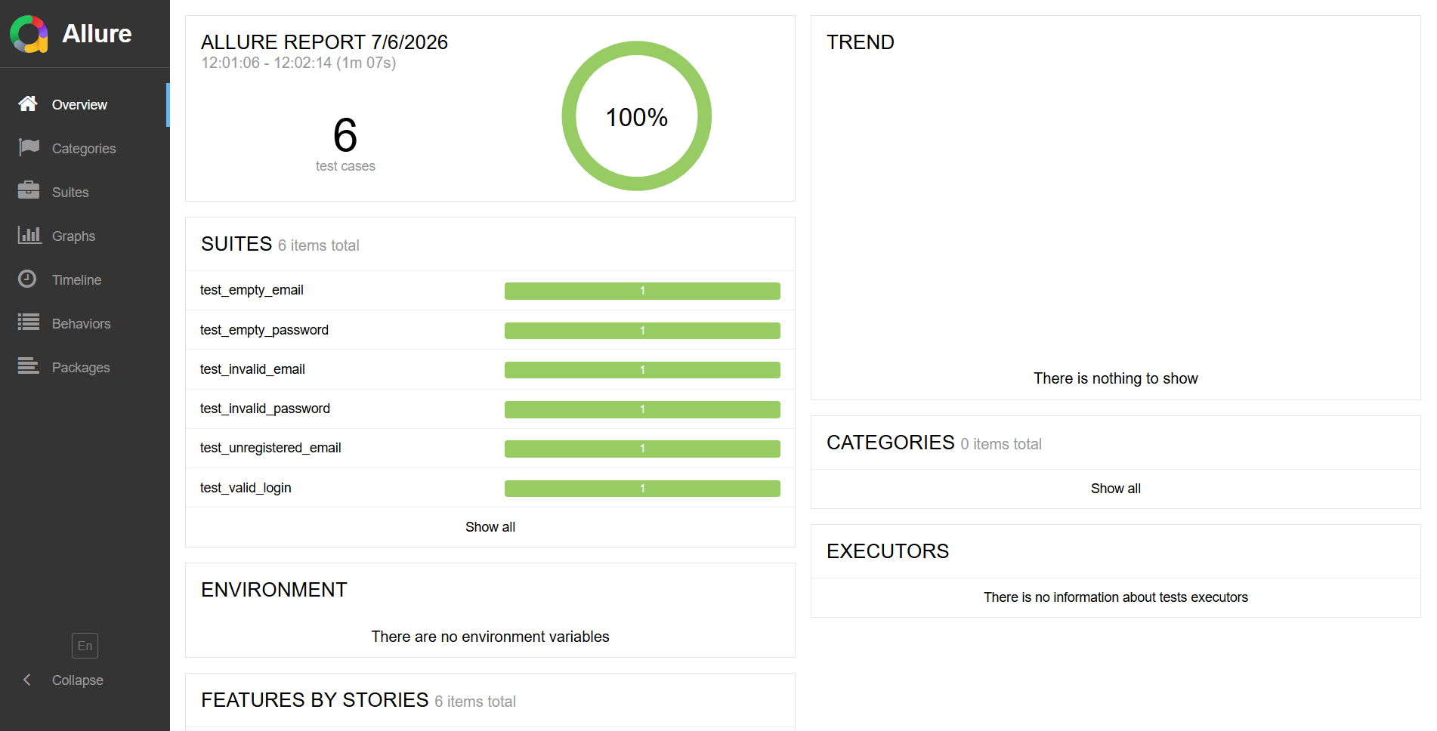
Allure Report — Overview
The Overview dashboard reports:
- Report timestamp: 7/6/2026, 12:01:06 – 12:02:14 (total duration 1 minute 7 seconds).
- Total test cases: 6.
- Pass rate ring: 100%.
- Suites (6 items total): test_empty_email, test_empty_password, test_invalid_email, test_invalid_password, test_unregistered_email, test_valid_login — each shown with a fully green bar labelled "1", indicating one passed test per suite/file.
- Trend panel: "There is nothing to show" — indicating this is the first recorded execution history entry, with no prior run to compare against.
- Categories: 0 items total — no failure/defect categories were generated, consistent with zero failures.
- Environment: "There are no environment variables" — no environment metadata (OS, browser version, etc.) was attached to this Allure run.
- Executors panel (visible on the Graphs page): "There is no information about tests executors" — no CI/CD executor metadata was attached to this run.

11.2 Graphs Dashboard
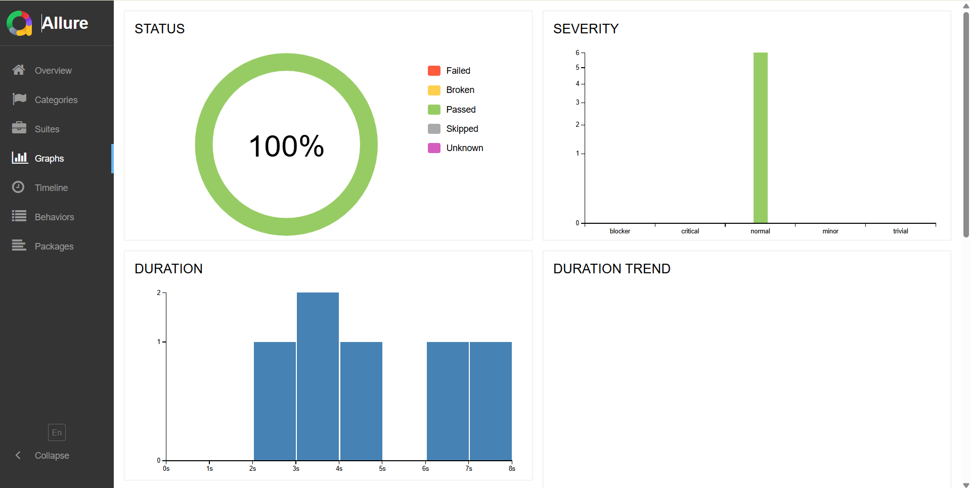
Allure Report — Graphs
The Graphs dashboard reports:
- Status donut chart: 100% Passed (green), with 0% shown for Failed, Broken, Skipped, and Unknown categories.
- Severity bar chart: all 6 test cases are classified under "normal" severity; no tests are tagged blocker, critical, minor, or trivial — indicating no custom @allure.severity annotations beyond the default were applied in the scripts.
- Duration chart: a histogram of individual test durations grouped into 1-second buckets, showing one test in the 2–3s bucket, two tests in the 3–4s bucket, one test in the 4–5s bucket, and two tests in the 6–8s range — consistent with six short, mostly-synchronous UI test cases.
- Duration Trend: no historical duration data is plotted, consistent with this being the first recorded run.

12. Execution Statistics
Metric | Value | Source
Total Test Cases | 6 | Allure Overview ("6 test cases") and 6 uploaded test scripts
Passed | 6 | Allure Status donut (100% Passed) and individual script assertions
Failed | 0 | Allure Status donut (0% Failed)
Skipped | 0 | Allure Status donut (0% Skipped)
Pass Percentage | 100% | Allure Overview and Graphs dashboards
Execution Duration | 1 minute 7 seconds (12:01:06 – 12:02:14) | Allure Overview timestamp

13. Observations
- All six test scripts, the six corresponding screenshots, and the Allure Overview suite list are fully consistent — every script name maps to an Allure suite entry and an uploaded screenshot file with matching content.
- The Allure report and all six scripts agree on a 100% pass rate for this execution.
- Two of the six evidentiary screenshots (invalid_password.png and unregistered_email.png) were captured while an asynchronous action was still in progress (loading spinner visible), rather than after a final rendered error state. This does not affect the recorded test result, since the underlying assertions did not depend on the error message being visible, but it does limit the strength of the visual evidence for those two scenarios.
- The invalid-email test relies on native browser (HTML5) validation rather than a custom application-level error message, unlike the empty-email and empty-password tests, which show custom in-app red-bordered validation styling.
- No console/terminal execution logs were included in the uploaded files; verification of exact Pytest console output (e.g., "6 passed in Xs") could not be independently cross-checked beyond the Allure report and screenshots.
- No requirements.txt was provided, so exact package versions (selenium, pytest, allure-pytest, etc.) cannot be confirmed.
- The Allure Trend and Duration Trend panels show no historical data, indicating this is the first tracked execution for this Allure results history.

14. Issues Found
- Weak visual evidence in TC_04 (test_invalid_password.py) and TC_05 (test_unregistered_email.py): the captured screenshots show in-progress loading spinners rather than a final error state, so the screenshots alone do not visually confirm the application's rejection message for these two scenarios.
- Indirect assertions across TC_01, TC_02, TC_03, and TC_05: each asserts that an input field "remains visible" rather than asserting on the specific validation/error message text, which is a weaker form of verification (see Section 10.1 for detail).
- Operating System and IDE are not identifiable from any uploaded artifact.
- No requirements.txt or console log file was uploaded, limiting full environment and console-output traceability.

15. Risks
- Reliance on field-visibility assertions rather than explicit error-message assertions could allow a regression (e.g., a validation message silently failing to render) to go undetected as long as the field itself remains on screen.
- The per-character typing loop with time.sleep(0.1) in test_invalid_password.py and test_valid_login.py increases test execution time and could mask or introduce timing-sensitive flakiness if the delay is later removed or the environment slows down.
- No explicit WebDriver version pinning or driver-manager library was observed in the shared conftest.py; future Chrome browser updates could cause driver/browser version mismatches if Selenium Manager auto-resolution is not consistently available in the execution environment.
- Absence of environment metadata in Allure (Section 11.1) means results cannot be tied to a specific OS/browser version combination for historical comparison.

16. Recommendations
- Replace field-visibility assertions with direct assertions on the specific validation/error message element and its text, for all five negative test cases.
- For TC_04 and TC_05, add a wait condition for either a visible error message or the disappearance of the loading spinner before capturing the evidentiary screenshot, so the screenshot reflects the final state rather than an in-progress request.
- Attach environment metadata (OS, browser version, environment URL) to the Allure results, for example via an environment.properties file, to improve traceability across runs.
- Include a requirements.txt with pinned dependency versions (selenium, pytest, allure-pytest) for reproducible environment setup.
- Capture and retain raw console/terminal logs alongside Allure results and screenshots for full four-way traceability (script → execution → screenshot → Allure) in future runs.
- Consider adding negative-path coverage for additional scenarios not present in the current suite (e.g., SQL-injection-style input, excessively long input, locked-account scenarios) if in scope for the application.

17. Conclusion
Based on a line-by-line review of all six Selenium/Pytest scripts, cross-checked against the six corresponding execution screenshots and the two uploaded Allure Report dashboards, all six automated test cases covering the Tichi App sign-in flow completed with the PASS status recorded in the Allure report, with no failed or skipped tests reported for this execution. The scripts consistently use the shared chrome fixture and WebDriverWait-based synchronization in place of fixed sleeps at their key decision points, and each script's designated screenshot file was present and consistent with its scripted scenario. Two evidentiary screenshots (TC_04, TC_05) captured an in-progress loading state rather than a final error message, and several negative-path assertions verify field visibility rather than explicit error text; these are documented as suggestions and issues for future hardening and do not alter the recorded execution outcome.

18. Final Result
Overall Execution Result: PASS
Justification: The Allure Report (Overview and Graphs dashboards) records 6 of 6 test cases passed (100%), with 0 failed and 0 skipped. This is corroborated by (a) each script's internal assertions, all of which completed without raising an AssertionError per the recorded PASS status, and (b) the six execution screenshots, each of which shows behaviour consistent with its script's expected outcome. No functional issues were observed during automation execution; the items listed in Sections 14–16 relate to assertion strength and evidentiary completeness rather than application defects.

