**Phase 5 project Project Title: SMART PUBLIC RESTROOM Project ID:** proj_223730_Team_1

**College code:** 6208

**College:** Gnanamani College of Technology

**Year:** IIIrd year

**Branch:** B.Tech-Information Technology

Team Members: Boopathi.V(620821205009)

Pandiyaraj.S.L(620821205039) Saranraj.P(620821205049)

Sathishkumar.V(620821205050) Muralitharan.R(620821205301)

PHASE 5

# Objective:

The Smart Public Restrooms project seeks to leverage IoT technology to create a seamless and eﬃcient public restroom experience. The primary goals are as follows:

1. **Enhanced User Experience**: To improve the quality of public restroom facilities by providing real-time information on restroom availability and cleanliness, leading to increased user satisfaction.
2. **Eﬃcient Resource Management**: To enable facility operators to manage restroom maintenance and supplies more eﬀectively, reducing waste and operational costs.
3. **Real-time Information**: To oﬀer users access to real-time data through a mobile app, allowing them to ﬁnd nearby restrooms, check occupancy status, and rate cleanliness.

# IoT Sensor Setup:

1. **Occupancy Sensors**: Infrared or ultrasonic occupancy sensors are strategically placed within each restroom stall to detect user presence. These sensors transmit occupancy data to a central server.
2. **Equipment Health Sensors**: Sensors are installed within toilet paper and soap dispensers to monitor the levels of supplies. Alerts are generated when reﬁlling is required.
3. **Environmental Sensors**: Temperature and humidity sensors are deployed in each restroom to provide data on the indoor environment for user comfort and facility management.
4. **Raspberry Pi Integration**: Each restroom is equipped with a Raspberry Pi device, acting as a local gateway. The Raspberry Pi collects data from the sensors, processes it, and securely transmits it to the central server.
5. WORKING PRINCIPLE

In the first phase, IR sensor is used to discover the dirt present in the toilet. Here the set of sample images are given as input.

After using the toilet, the sensor senses the basin of the toilet. Then it relates the sensed image with the input image.

If the dirt present, it increases the alarm.

Then the user wants to be clean the waste. Through this activity, people can get the awareness about the toilet management.

In the second phase, Figaro sensor is used to perceive the unwanted gases present in the toilet.

In the Figaro sensor, a particular range is to be stableearlier manner. If the range gets extended, it can send the alert message to the sweeper. Then they cleaned it by using proper fragrant.

In the third phase, RFID reader (Radio

Frequency Identification) is used to observe the sweeper’s activities (absence and presence in the toilet cleaning).

Initially, the sweeper wants to show his/her individuality tag in front of RFID reader. It can be shown before and after cleaning the toilet.

Then the first phase gets initiated and senses for the dirt presence in the toilet. If the dirt gets noticed, it raises the alarm.

Through this monitoring activity, the sweeper can realize their roles and responsibilities. Then they protect the people by disposing all the unwanted materials (dirt, unwanted gases) present in the toilet.

In the final phase, the sonic sensor is used to detect the depth of the septic tank. Here, the range of septic tank is fixed prior manner.

If the sewage reached with the range, then it directs message to an organization. All the message transfer can be done by the GSM (Global System for Communication).

### ARCHITECTURE OF THE PROPOSED SYSTEM

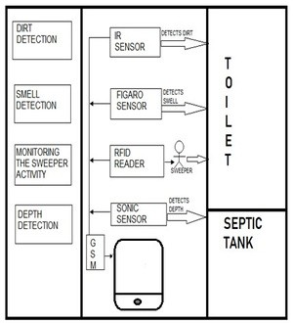

Figure 1: Architecture of the proposed system

#### DESCRIPTION OF ARCHITECTURE HARDWARE REQUIREMENTS:

Arduino Power supply LCD display Buzzer Infrared sensor Sonicsensor Gassensor RFID

GSMmodem

SOFTWARE REQUIREMENTS

Embedded C

**Arduino UNO -**

Arduino is an opensource physical programmable microcontroller board, it is also referred as a software , or IDE i.e. Integrated Development Environment which is connected through B type USB and it runs on the speciﬁc connected PC and also it allows to write and upload the code to that circuit, it has sets of computerized I/O sticks which is interfaced to some sheets called as development sheets or safeguards, this sheets had 14 I/O pins, it has working voltage of 5V and 7-12V input voltage.

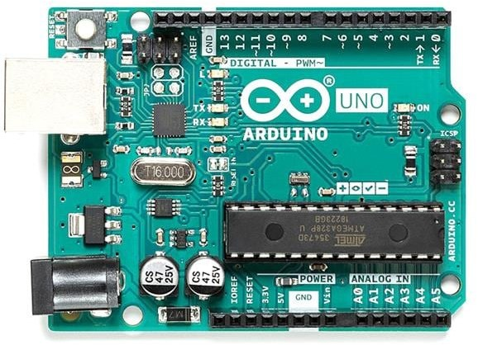

* + 1. **LCD**

LCD stands for Liquid Crystal Display. By using the LCD, all the outputs are displayed. LCD doesn’t know about the content (data or commands) supplied to its data bus. It is the user who has to specify whether the content at its data pins are data or commands.

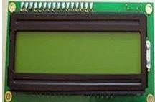

Figure 3: LCD Display

For this, if a command is inputted then a certainarrangement of 0s and 1s has to be applied to the Control lines so as to specify it is a command on the other hand if a data is inputted at the data lines thenan another combination of 0s and 1s

has to be applied to the control lines to require it is Data.

# BUZZER

Buzzer is also called as Beeper. It is a sound signalling mechanical device.

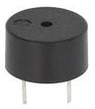

# INFRARED SENSOR

#### Figure 4: Buzzer

The IR sensor is used to detect the dirt present in the toilet. Here we nourish the image models into the sensor. It can perceive the dirt by comparing the images we feed into it, after using the toilet. If it can detect the dirt, it raises the alarm, and the users may get embraced and they clean it. This system can create the responsiveness among the people.

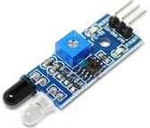

# SMELL SENSOR

#### Figure 5: IR sensor

The Smell Sensor is used to detect the unwanted smell and gases in the toilet. For this purpose, we are going to use the sensor called **Figaro** sensor.

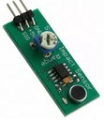

Figure 6: Smell Sensor

It cansintellect the dry gases present in the toilets such as NH3, CO2, CH4, H2S, etc. By taking those gases leads to Nausea, Drowsiness, instant loss of awareness, etc. After sensing the unwanted gases, it can blink the red light. Then the sweeper can clean it by using particular Cleaning Agents.

# RFID READER

The RFID stands for Radio Frequency Identification. It can be used for monitoring the Sweeper. The Organization wishes to provide the identity tag for the Sweeper. The Sweeper desires to show the tag before the cleaning process is going to start and after it is finished.

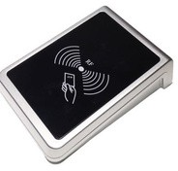

#### Figure 7: RFID Reader

Then the CR4 sensor can spot the presence of dirt. If it is present, it can blink the red light. If it is clean, it can blink the blue light. It assistances to understand the responsibilities of sweeper by his/her own. If Sweeper is not clean the toilets for period of time, his/her absence in cleaning the toilet also reported to the dependable organization. These all the details are stored in the database.

* + 1. **SONIC SENSOR**

The Sonic Sensor is used for computing the depth. Here it is used to measure the depth of the septic tank. The Sonic Sensor is fixed into the Septic tank. Then the Septic tank get filled means, it can sends the communications to particular organization. Then they will allot persons to clean the septic tank. Then septic tank cleaners will clean the tank. After cleaning it, the sensor can detect the level, and send messages to consistent organization.

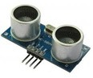

### Figure 8: Sonic sensor

This ultrasonic sensor can be used for measuring distance, object sensor, motion sensors etc.

High sensitive module can be used with microcontroller to integrate with motion circuits to measure the distance, position & motion sensitive products.

In a nutshell, water depth sensing is using a sensor to measure the depth of water in a tank or container. Although various sensors can be used for this application, we will talk about ultrasonic sensor application.

With ultrasonic sensors, we can find the water depth calculation by finding the distance between the transceiver and the surface of the water. The sensor will transmit a short ultrasonic pulse, and we can measure the travel time of that pulse to the liquid and back. We can then subtract that distance from the total depth of the tank to determine the water depth.

* 1. **BLOCK DIAGRAM:**

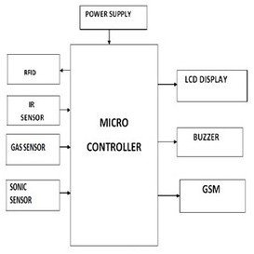

## 2.3.1GSM

#### Figure 9: Block diagram of the proposed system

GSM stands for Global System for Mobile communication. It establishes the mobile communication from one place to another place.

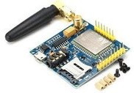

**Figure 10: GSM Module**

It transfers the information from main circuit to operator. It uses Time Division Multiple Access (TDMA).

GSM is mainly used for communicating and transferring message from one person to concerned organisation. GSM module is used to establish communication between a computer and a GSM and GPRS system.

Here we are using GSM LT-2 communication module makes it possible to use GSM paths to provide monitoring and messaging functions in alarm systems. It facilitates cooperation with SATEL and third party control panel diallers or correctly configured outputs.

He GSM LT-2 module makes it possible to implement monitoring as well as text and voice messaging functions. The caller ID retransmission function creates it likely to present the incoming callers number on telecommunication stationsarmed with this functionality.

GSM alarm system built-in GSM communication module inside, work as a mobile handset. After purchased the GSM alarm system, people need to acquisition the SIM card, and select the mobile service package. GSM alarm system can program several phone numbers for alarm receiving. When any abnormal event happens, the system will response, then inform the owner via voice call and short message (SMS).

GSM will check the messaging activities for sweepers and also need to check with their cleanliness duty for their work. The sweepers need to check with particular activity of its work by their sensors.

* 1. **WORKING MODEL**

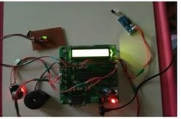

#### Figure 11: working model

This is the module of the proposed system. Here the sensors are connected with the microcontroller.

#### DIRT DETECTION

It shows the dirt detection in the toilets.

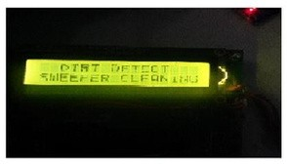

#### Figure 12: Output module, while detecting the dirt

* + 1. **SMELL AND DEPTH DETECTION**

It shows the smell detection and depth detection.

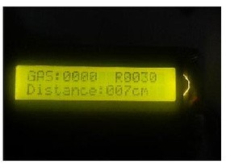

#### Figure 13: Output module, while detecting the Gas and the distance.

* + 1. **MONITORING SWEEPER ACTIVITIES**

It shows the sweeper activities.

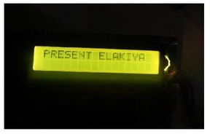

**Figure 14: Indicates the sweeper presence**

# Program :-

**#**include <LiquidCrystal.h> #include <Wire.h>

#include <SoftwareSerial.h>

LiquidCrystal lcd(12, 11, 5, 4, 3, 2); // Initialize LCD display

const int buzzerPin = 6;

const int infraredSensorPin = 7; const int ultrasonicTrigPin = 8; const int ultrasonicEchoPin = 9; const int gasSensorPin = A0;

SoftwareSerial GSM(10, 11); // GSM modem

void setup() {

lcd.begin(16, 2); // Set up LCD pinMode(buzzerPin, OUTPUT); pinMode(infraredSensorPin, INPUT); pinMode(ultrasonicTrigPin, OUTPUT); pinMode(ultrasonicEchoPin, INPUT); GSM.begin(9600); // Initialize GSM modem

}

void loop() {

// Occupancy detection using Infrared sensor

int occupancy = digitalRead(infraredSensorPin);

// Air quality monitoring using Gas sensor int gasLevel = analogRead(gasSensorPin);

// Display occupancy and air quality on LCD lcd.setCursor(0, 0);

lcd.print("Occupied: "); lcd.print(occupancy); lcd.setCursor(0, 1); lcd.print("Air Quality: "); lcd.print(gasLevel);

// Ultrasonic sensor for hand proximity long duration, distance; digitalWrite(ultrasonicTrigPin, LOW); delayMicroseconds(2); digitalWrite(ultrasonicTrigPin, HIGH);

delayMicroseconds(10); digitalWrite(ultrasonicTrigPin, LOW);

duration = pulseIn(ultrasonicEchoPin, HIGH);

distance = (duration / 2) / 29.1; // Calculate distance **in centimeters**

// Access control using RFID

// You'll need to add code to read RFID data here

// GSM modem for remote alerts and notiﬁcations if (gasLevel > threshold) {

sendSMS("Gas leak detected!");

}

// Add more functionality as needed

delay(1000); // Delay for a second

}

void sendSMS(String message) { GSM.println("AT+CMGF=1"); // Set SMS mode to text delay(1000);

GSM.print("AT+CMGS=\""); // Recipient's phone number

GSM.print("RecipientPhoneNumber"); GSM.println("\"");

delay(1000); GSM.println(message); delay(100);

GSM.write(26); // Ctrl+Z to send the SMS

delay(1000);

}

# IoT Sensor Setup:

#### Occupancy Detection:

Infrared Sensor: Place infrared sensors near the restroom entrance to detect if someone is inside.

#### Air Quality Monitoring:

Gas Sensor: Install a gas sensor inside the restroom to monitor air quality.

#### Access Control:

RFID Reader: Use RFID readers to control access to the restroom.

#### Hand Proximity Detection:

Ultrasonic Sensor: Mount ultrasonic sensors near faucets and soap dispensers to detect hand proximity

# Mobile App Development:

Develop a mobile application for users and administrators. The app should oﬀer the following features:

#### User Access:

Users can access the restroom by scanning their RFID cards.

#### Occupancy Status:

Users can check restroom occupancy status on the app.

#### Feedback:

Users can provide feedback or report issues.

#### Admin Control:

Administrators can monitor and control various aspects of the restroom.

#### Notiﬁcations:

Send alerts to users or administrators for issues like air quality problems or restroom maintenance needs

#### ADVANTAGES

It can creates an awareness among the people about the proper toilet management

It can prevents the many contagious diseases like malaria, typhoid, cholera, streptococcus, asthma, etc.. It can promotes the “Swachhbharat” scheme

#### 4.CONCLUSION

Our proposed project will create awareness among the people about the proper sanitation. It makes use of Internet of things, which is a rapidly growing technology. Our proposed system will make everyone to strictly follow the cleanliness and proper sanitation in the toilets. It prevents the many new contagious diseases that spread due to improper sanitation of the toilets. Thus by using technologies in the smarter way, we can maintain the cleanliness which is next to the godliness. Keep Clean, Be Safe.