Codebase: Github

Dependencies: Docker, environment dependencies

Config server: Store config in the environment. Ex: vault

Backing services: multiple micro services

Build Release run: GitHub, Jenkins, and Docker

Processes: stateless communication

Data isolation: each service owns its own db

Concurrency: with load balancer and horizontal scaling

Disposability:

Dev/party:

Logs: grey Log ??

Admin processes: Boot admin ??

Micro services:

Topic, Fan out, Header.

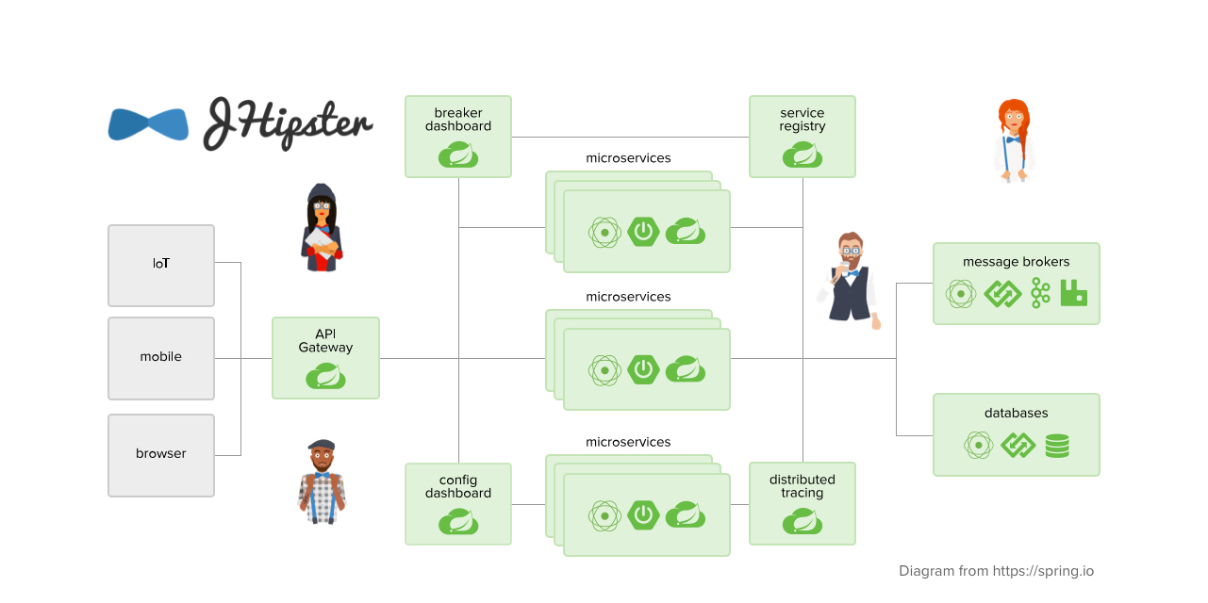

<https://github.com/topics/jhipster-microservices> : Source code

Services:

**Auth Service**: Oauth2 with JWT .In memory database/Db (Redis/H2), Single Sign on, 3rd party Oauth2 (FB, Google)

**User Service**: registration, CRUD, Guest user: user db

**Inventory Service**: Show all the items based on category, filters, sort, location etc; inventory db

**Order Service:** orders db

**Payment Service:** payment db

**Order Preparation Service:** preparation db

**Delivery Service:** delivery db

Front End:

Angular

Back end:

Spring Boot, Spring, JPA, Hibernate, MySQL, Mongo DB, Feign Client, JWT, Ribbon

Gateway: Zool Proxy ??

Service Registry: Eureka

Load Balancing:

Client side: Ribbon with eureka server??

Server side: Aws ELB?? Alternatives also we can think