**ERD Model PART 3**

Projects require planning before action. An essential skill is to learn how to use different tools to communicate your plans. To practice this valuable skill, you will create two ERD diagrams:

**Create the first using UML and the Umlet free utility.**

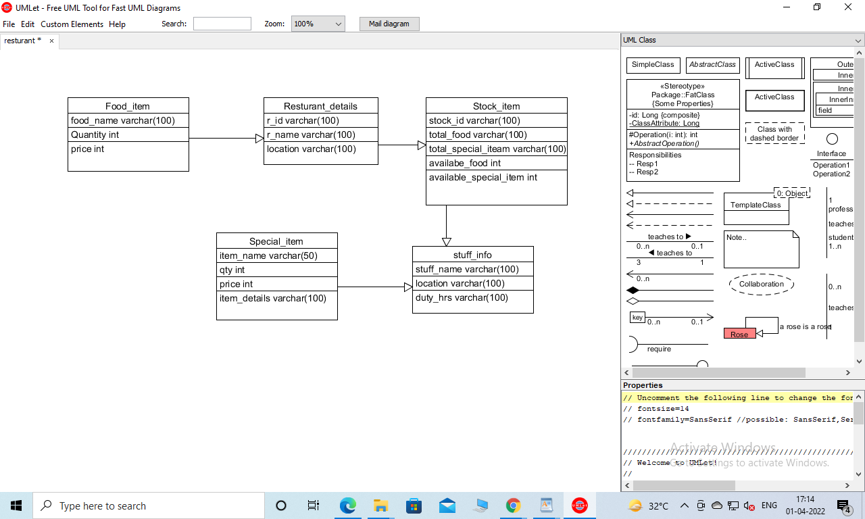

**Create the second using Crow’s Foot notation in Vertabelo.**

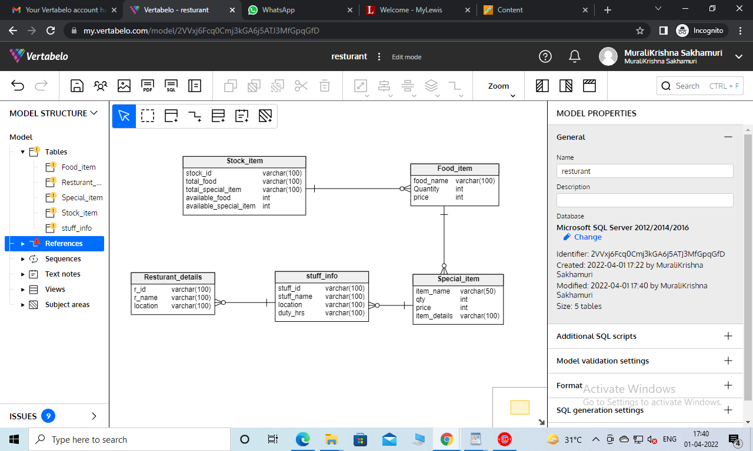

Upload both drawings to **GitHub** and make a copy of each drawing in your **Report**. The ERDs must both be **physical** models (includes data types and key information).

**Scoring:**

5 points for the Umlet drawing in your report

5 points for the Umlet drawing in GitHub

5 points for the Crow’s Foot drawing in your report

5 points for the Crow’s Foot drawing in GitHub

Total score: 20 points

The following sections contain useful information to help you complete the assignment.

**Umlet**

Go to [www.umlet.com](http://www.umlet.com) and download the appropriate version for your system.

The software is free and quick to install.

Understanding the rules of ERD diagrams, use the appropriate line connections and data details to lay out the design that describes your project. Simply choose the shape in the tool area on the right side of the program and drag a copy of it to the layout area. Rearrange the tools as necessary. To change the text in one of the shapes, simply select the shape then edit the text in the text editing window.   
  
Use the Aquarium Tracker tutorial for more information.  
  
**Vertabelo**

This software is a little more complex, but also offers helpful shortcuts.  
  
First, create a free login. Use your Lewis email address to get the educational free account.

Second, practice drawing a diagram using the Movie Tracker tutorial document.

You should be ready to draw the diagram for your project afterwards.