Find the Moment
  - Solution Architecture & Implementation Blueprint

Customer: National Heritage Archive (NHA)
Submitted by: Murali Krishna Sunkara
Assessment: Forward Deployed Engineer (AI) — Case Study

Table of Contents
1 Executive Overview 6
1.1 Background and Customer Context 6
1.2 The Problem We Are Solving 6
1.3 Proposed Solution 7
1.4 Expected Business Outcomes 8
1.5 Scope and Delivery Objectives 8
1.5.1 Target solution scope 8
1.5.2 Proof of Concept scope 9
1.5.3 Explicit exclusions from the initial release 9
2 Problem Understanding & Requirements 11
2.1 Understanding the NHA's Actual Problem 11
2.2 Stakeholders and User Requirements 11
2.3 Primary Use Case — Churchill Speech Retrieval 11
2.3.1 Input 12
2.3.2 Expected processing behaviour 12
2.3.3 Expected result contract 12
2.3.4 Important archival distinction 13
2.4 Functional Requirements 13
2.5 Non-Functional Requirements 14
2.6 Proposed initial quality targets 15
2.7 Constraints and Design Implications 15
2.8 Scope Boundaries and Assumptions 16
2.9 Definition of Success 16
3 Solution Design Principles & Architectural Decisions 17
3.1 Architecture Philosophy 17
3.2 Cloud Platform Strategy — Cloud First 17
3.2.1 Data sovereignty and deployment constraints 18
3.3 AI Strategy — Pretrained Models Before Fine-Tuning 18
3.3.1 Rationale 19
3.3.2 Model responsibilities 19
3.3.3 When fine-tuning may become justified 19
3.4 Search Platform Decision — MongoDB Atlas 19
3.4.1 Why MongoDB 20
3.4.2 Alternatives considered 20
3.4.3 Portability strategy 20
3.5 Retrieval Strategy — Hybrid Search 20
3.6 Timestamp Integrity and Source Grounding 21
3.7 RDF Knowledge Graph — Deferred 21
3.8 Summary of Major Design Tradeoffs 21
4 High-Level Solution Architecture 23
4.1 Architecture Overview 23
4.2 Logical Architecture Diagram 23
4.3 Component Responsibilities 24
4.4 Ingestion Architecture 24
4.5 Retrieval Architecture 25
4.6 Data Storage Architecture 26
4.7 Security and Access Architecture 26
4.8 Resilience and Processing Consistency 26
4.9 Architecture Boundary and Responsibility Model 26
5 Data Ingestion & AI Processing Pipeline 28
5.1 Stage 1 — Asset Registration and Validation 28
5.2 Stage 2 — Intake Queue and Workflow Initialisation 29
5.3 Stage 3 — Media Preparation and Audio Extraction 29
5.4 Stage 4 — Speech Transcription 29
5.5 Stage 5 — Transcript Normalisation and Alignment 30
5.6 Stage 6 — Timestamped Segment Generation 30
5.7 Stage 7 — AI-Based Content Enrichment 31
5.8 Stage 8 — Embedding Generation 31
5.9 Stage 9 — Search Index Construction and Publication 31
5.10 Processing Failures and Recovery 32
5.11 Processing Observability 33
5.12 Pipeline Output Contract 33
6 Data Architecture & Indexing Strategy 34
6.1 Data Architecture Objectives 34
6.2 Logical Data Model 34
6.3 Proposed Storage Model 34
6.4 Archive Asset Schema 35
6.5 Recording Version Schema 35
6.6 Transcript and Timed Word Schema 36
6.7 Search Segment Schema 36
6.8 Enrichment and Provenance Model 37
6.9 Search Indexing Strategy 37
6.10 Data Versioning and Index Lifecycle 37
7 Search, Retrieval & Clip Delivery 38
7.1 Retrieval Objectives 38
7.2 Query Processing 38
7.3 Hybrid Candidate Retrieval 38
7.4 Candidate Fusion and Ranking 38
7.5 Passage Resolution and Precise Timestamps 39
7.6 Churchill End-to-End Walkthrough 39
7.7 Search Response Contract 39
7.8 Digital Preview and Clip Export 40
7.9 Offline and Authoritative-Media Retrieval 40
7.10 Handling No-Match and Uncertain Results 40
8 Handling Real-World Archive Challenges 42
8.1 Design Approach 42
8.2 Poor Audio Quality 42
8.3 Partial or Missing Transcripts 42
8.4 Multilingual and Mixed-Language Content 42
8.5 Duplicate and Edited Recordings 43
8.6 Missing or Conflicting Metadata 43
8.7 Offline Archive Retrieval Delays 43
8.8 Human-in-the-Loop Review 43
9 Security, Governance & Preservation 45
9.1 Security and Governance Objectives 45
9.2 Identity and Access Management 45
9.3 Rights-Aware Retrieval 45
9.4 Data Sovereignty and Residency 46
9.5 Encryption and Secrets Management 46
9.6 AI Governance 47
9.7 Preservation and Source Integrity 47
9.8 Audit and Accountability 47
10 Technical Tradeoffs & Alternatives 48
10.1 Decision-Making Framework 48
10.2 Accuracy Versus Processing Cost 48
10.3 Search Latency Versus Ranking Complexity 48
10.4 Managed Services Versus Self-Hosted Models 49
10.5 Simplicity Versus Feature Completeness 49
10.6 Cost Model and Measurement 49
10.7 Decision Validation 50
11 Proof of Concept & Repository Design 51
11.1 Purpose of the Code Artefact 51
11.2 Minimum Working Demonstration 51
11.3 Recommended Implementation Scope 51
11.4 Local and Production Architecture Relationship 52
11.5 Suggested Repository Structure 53
11.6 Sample Dataset Design 53
11.7 Demonstration Acceptance Criteria 54
11.8 Explicit Proof of Concept Limitations 54
12 Evaluation & Acceptance Criteria 55
12.1 Evaluation Dataset 55
12.2 Retrieval Quality Metrics 55
12.3 Additional Quality Measurements 55
12.4 Latency Targets 56
12.5 Security Acceptance Tests 56
12.6 Evaluation Procedure 56
12.7 Pilot Exit Criteria 56
13 RAID & Dependencies 58
13.1 Assumptions 58
13.2 Risk Register 58
13.3 Current Issues and Design Limitations 59
13.4 Business Dependencies 59
13.5 Technical Dependencies 60
13.6 Open Customer Decisions 60

Executive Overview

Background and Customer Context
The National Heritage Archive (NHA) is responsible for preserving and providing access to approximately 100 years of historically significant audio and film recordings. Its collections represent an important part of the nation's cultural, political, and historical record. Although the archive's media has been digitised, authoritative storage remains on physical media. Digital copies and associated metadata support discovery and access, while preservation, custody, and delivery remain governed by the archive's established processes.
The archive serves several categories of users, including:
- Government agencies, which require access to historical recordings for research, documentation, and official purposes.
- The national broadcaster, whose producers and researchers need to identify and obtain specific excerpts for media production.
- Approved third parties, including authorised researchers and organisations with legitimate access requirements.
- Archivists and archive operations teams, who manage collections, interpret catalogue information, locate recordings, and coordinate access.
These users often know the historical event, person, or approximate meaning of the material they need, but may not know its exact title, recording identifier, date, or location within a longer recording.
Current discovery relies heavily on archivists' specialist knowledge and manual investigation. As the archive grows and the number of retrieval requests increases, this approach constrains discovery speed and places a significant operational burden on archive personnel. NHA therefore requires a more efficient way to discover precise moments within its digitised collections without compromising archival provenance, access restrictions, or the integrity of its preservation model.

The Problem We Are Solving
The central challenge is not simply finding a recording. It is identifying the correct moment within the correct version of a recording, based on an incomplete and potentially inaccurate natural-language description.
A broadcaster producer might submit the following request:
“I'm looking for that Churchill speech where he talks about fighting everywhere… I think it's during the war, maybe after a retreat? He says something like they'll never surrender.”
The request does not provide an exact title, date, or quotation. Nevertheless, the expected result is the relevant passage from We Shall Fight on the Beaches, delivered on 4 June 1940, with timestamp boundaries corresponding to a specific archived recording. A conventional catalogue search may identify a relevant speech but cannot necessarily determine where the requested passage occurs. A keyword-only search may also fail when the user remembers the meaning rather than the original wording.
The challenge becomes more complex because the archive contains:
- Historical recordings with degraded or inconsistent audio quality.
- Incomplete, missing, or imperfectly aligned transcripts.
- Multilingual content and recordings containing mixed-language speech.
- Duplicate recordings, rebroadcasts, and edited versions with different timelines.
- Missing, inconsistent, or conflicting catalogue metadata.
- Authoritative physical holdings that may require delayed retrieval.
Consequently, a search result must establish more than semantic relevance. It must provide sufficient evidence to identify the correct passage, its source recording, its timing, its provenance, and whether the user is permitted to access it.
The desired change is from manually locating recordings and passages to evidence-based, timestamped discovery that can be verified and acted upon.

Proposed Solution
We propose Find the Moment, an AI-assisted semantic indexing and retrieval platform that enables authorised NHA users to discover precise, time-based segments of historical audio and video recordings using natural-language queries. The platform converts approved digitised recordings and their associated catalogue information into a searchable catalogue of timestamped segments. It combines speech transcription, deterministic segmentation, metadata enrichment, semantic embeddings, and hybrid retrieval to identify relevant moments even when the user's query does not precisely match the words spoken in the recording.
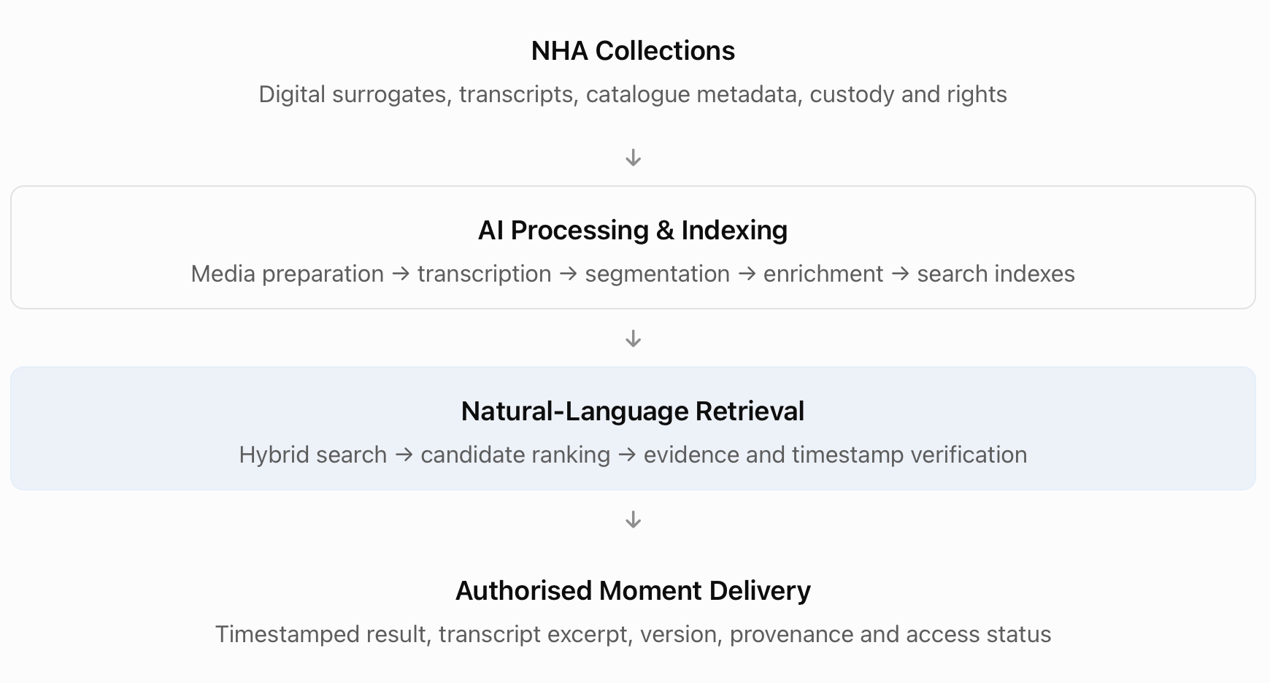
Fig 1: Conceptual Flow
The solution is designed around five capabilities:
- Automated content processing: Digitised recordings are prepared for transcription, with speech converted into time-aligned text where supported. Existing transcripts are retained as source evidence, and derived transcripts are versioned.
- Segment-level indexing: Rather than indexing only complete recordings, the platform organises timed transcript content into smaller, overlapping segments. Each segment maintains a traceable relationship to the source recording and its specific version.
- Semantic and keyword retrieval: Semantic search identifies conceptually similar passages, while keyword search preserves exact quotations, names, and terminology. Combining both approaches improves retrieval across vague descriptions and precise queries.
- Evidence-based result resolution: Retrieved segments are linked to transcript evidence, recording identity, source-specific timestamps, and quality indicators. AI-generated enrichment does not independently establish archival facts or create authoritative timing information.
- Access-aware preview and delivery: Authorised users can preview an available digital access copy or submit a retrieval request when an authoritative recording is offline. Rights and availability are evaluated separately from search relevance.
The architecture adopts an AWS-first managed-services approach, using Amazon S3, AWS Step Functions, Amazon Transcribe, Amazon Bedrock, and supporting compute and security services. MongoDB hosted on AWS is the proposed metadata and search platform, combining document storage, lexical retrieval, and vector search. The choice remains subject to NHA's procurement, residency, connectivity, and operational approval. The proposed platform complements the archive's existing preservation and custody arrangements. It does not replace authoritative physical holdings or independently determine access rights.

Expected Business Outcomes
The primary objective is to improve the speed, precision, and operational usefulness of archival discovery while maintaining the controls expected of a national heritage institution.
Business outcome | Expected value to NHA
Faster discovery | Users can find relevant moments without manually reviewing entire recordings.
Reduced archivist workload | Routine discovery is assisted by search, allowing archivists to focus on specialist verification, metadata correction, and preservation.
Improved retrieval precision | Results identify relevant passages and source-specific time boundaries instead of returning only recording-level matches.
Greater collection discoverability | Natural-language and multilingual retrieval can improve access to material not easily found through catalogue keywords alone.
Traceable archival evidence | Results retain recording identity, provenance, transcript evidence, version information, and uncertainty.
Controlled access | Discovery, preview, and authoritative-media delivery follow approved rights and custody procedures.
Sustainable operations | Managed components, repeatable workflows, monitoring, and documented handover reduce dependence on specialist ML infrastructure skills.
These represent intended outcomes, not demonstrated performance results. Their achievement will be evaluated against agreed retrieval quality, timestamp accuracy, latency, security, operational, and cost criteria during the pilot.

Scope and Delivery Objectives
PS: The proposed engagement separates the long-term architecture from the working implementation required by the assessment.

Target solution scope
The target architecture includes:
- Ingestion and processing of approved digitised audio/video and metadata.
- Speech transcription and preservation of transcript timing evidence.
- Segment generation, enrichment, and search indexing.
- Natural-language hybrid retrieval with recording and version identification.
- Timestamped result presentation and supported digital preview.
- Integration points for offline retrieval and archive approval workflows.
- Rights-aware access, data residency controls, auditability, monitoring, and recovery.
- Phased expansion across additional collections and languages.

Proof of Concept scope
The assessment implementation will demonstrate a narrower end-to-end workflow using representative sample content or time-aligned transcript fixtures. The minimum demonstrable functionality is:
- Ingest sample recordings or transcript data with source metadata.
- Create searchable, time-bounded segments.
- Index the content for natural-language retrieval.
- Execute an imprecise query and rank relevant segments.
- Return a timestamped excerpt with a traceable source identifier.
- Provide reproducible setup instructions and tests for essential logic.
The repository will clearly distinguish capabilities that are implemented from production components that are designed but not built.

Explicit exclusions from the initial release
The first release does not attempt to provide a complete archive-wide ingestion programme, replace the authoritative preservation system, automate rights adjudication, guarantee transcription of severely damaged recordings, or support full visual-event retrieval where no spoken or catalogue evidence exists.
Fine-tuned specialist models and an RDF knowledge graph are also deferred unless evaluation demonstrates a clear requirement and operational justification.

1.6 Key Architectural Decisions at a Glance
Decision area | Proposed direction | Rationale
Cloud platform | AWS-first deployment within an NHA-approved Region | Managed infrastructure and services reduce operational complexity, subject to sovereignty approval.
Speech recognition | Amazon Transcribe as the initial candidate | Provides a managed transcription baseline with timed speech output; quality must be benchmarked on representative archive media.
AI enrichment | Pretrained models through Amazon Bedrock | Supports annotations and embeddings without an initial fine-tuning programme.
Search platform | MongoDB Atlas on AWS | Flexible document records with lexical and vector retrieval; evaluate against AWS-native alternatives.
Retrieval approach | Hybrid semantic and keyword search | Supports both approximate meaning and exact historical language.
Timestamp authority | Deterministic mapping from timed source evidence | Avoids relying on language-model-generated offsets.
Archival provenance | Version-specific recording identities and preserved source evidence | Prevents confusion between original recordings, edits, rebroadcasts, and other derivatives.
Knowledge graph | Defer RDF implementation | Prioritises the core moment-retrieval use case before introducing ontology and graph stewardship.
Operating model | Managed services with explicit NHA ownership and human review | Supports maintainability, auditability, and archival oversight.
These are proposed architectural decisions rather than customer-approved commitments. They will be validated against the archive's requirements, representative datasets, regulatory constraints, operating capabilities, and budget.

Problem Understanding & Requirements

Understanding the NHA's Actual Problem
The NHA problem has three interconnected dimensions: discovery, precision, and delivery.
- At the discovery level, users frequently describe historical material through incomplete recollections, approximate language, associated events, or remembered individuals.
- At the precision level, finding a relevant recording is insufficient. Users need the actual passage, tied to a valid time range in the selected recording.
- At the delivery level, a discovered moment is not necessarily immediately accessible. Rights restrictions, offline authoritative storage, and version-specific media availability determine what can be previewed or requested.
These dimensions create a distinction between a typical document-search application and a dependable archival retrieval service.
A successful solution must connect User intent → relevant historical content → specific recording version → verified time interval → permitted access path. Omitting any of these steps risks producing a result that appears relevant but cannot be used reliably.

Stakeholders and User Requirements
The proposed system serves several users with different operational objectives.
Stakeholder | Primary need | Expected system support
National broadcaster producer | Find and validate a historical passage for production. | Vague natural-language search, excerpt preview, recording edition identification, timestamped clip request.
Government agency user | Locate relevant historical evidence within approved collections. | Searchable content, provenance, traceable evidence, authorised retrieval.
Approved third party | Discover and request materials within granted permissions. | Access-filtered results, source descriptions, permitted preview or request.
NHA archivist | Verify archival identity, correct metadata, and manage difficult requests. | Reviewable evidence, version relationships, quality flags, metadata conflict resolution.
Archive operations team | Coordinate offline and authoritative-media retrieval. | Custody references, request tracking, rights and availability status.
NHA technical/service team | Maintain the processing and retrieval platform. | Observable jobs, reproducible deployments, manageable model changes, recovery processes, cost tracking.
The initial interface should prioritise search and evidence verification for authorised users, while ensuring archive staff retain control over catalogue corrections, restricted material, and official media delivery.

Primary Use Case — Churchill Speech Retrieval
The Churchill example is the reference scenario for both architecture validation and the demonstration narrative.

Input
Natural-language request “I'm looking for that Churchill speech where he talks about fighting everywhere… I think it's during the war, maybe after a retreat? He says something like they'll never surrender.” The input contains several different types of evidence:
Query element | Interpretation
Churchill | Named-person clue
Fighting everywhere | Semantic description rather than an exact quotation
During the war | Broad historical context
Maybe after a retreat | Uncertain contextual clue
Never surrender | Approximate or near-exact phrase
No recording identifier or timestamp | The system must resolve both recording identity and relevant passage
The query should be handled as a set of evidence signals, not a rigid combination of mandatory filters. Treating uncertain details as strict constraints could exclude the correct passage.

Expected processing behaviour
- Interpret the request. Preserve the original query and extract useful names, quotations, themes, and tentative historical context without making unsupported historical assumptions.
- Retrieve candidate segments. Use lexical matching for remembered names and phrases, and semantic search for passages that express the remembered meaning.
- Rank and group candidates. Combine retrieval evidence, remove overlapping results where appropriate, and distinguish recordings or edited versions containing related content.
- Resolve the selected passage. Identify We Shall Fight on the Beaches (4 June 1940) and locate the relevant words in the timed transcript of the selected recording.
- Validate timestamps and provenance. Derive start and end offsets from recording-specific timing evidence rather than generating them through a language model.
- Present the result and access path. Display the excerpt, recording identity, source-specific offsets, provenance, quality indicators, and permitted preview or retrieval action.

Expected result contract
Proposed illustrative result structure (representative UI)
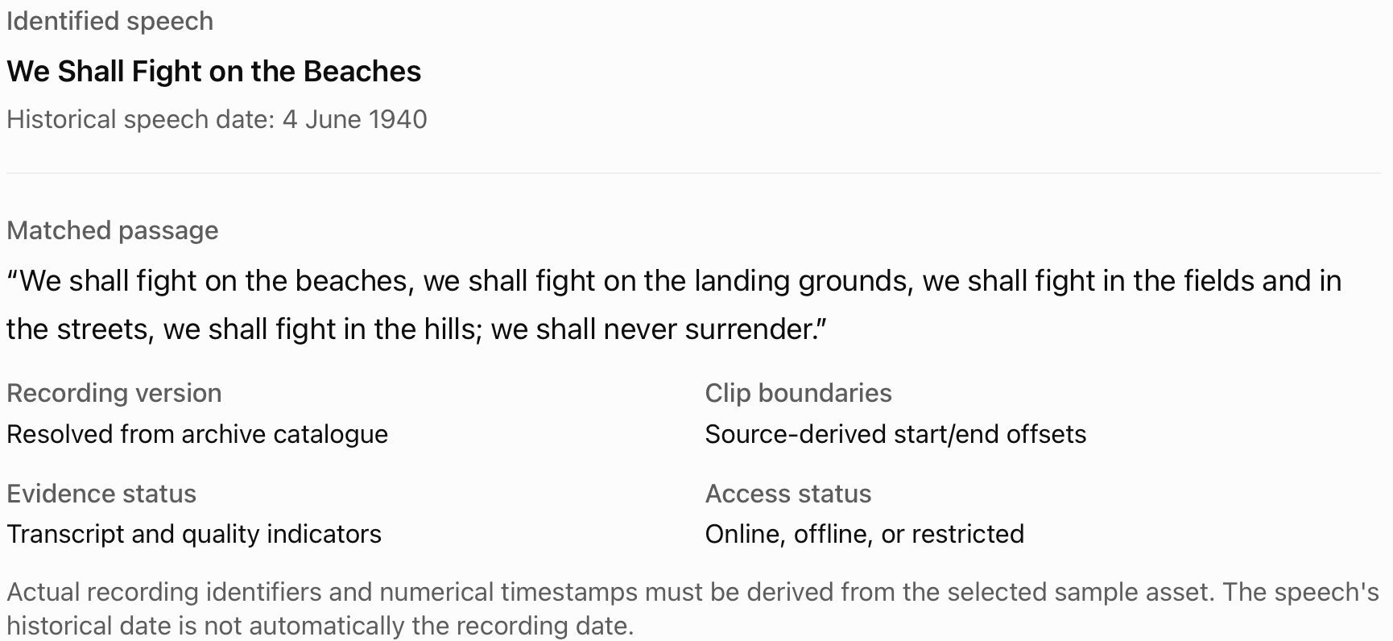

Important archival distinction
The historical speech, its original performance, a specific recorded artefact, and subsequent rebroadcasts or edited versions are not interchangeable. A recording may contain the same passage but use different introductions, edits, silence removal, or media formatting. Each version must therefore have its own identity and timing reference. The retrieval system can relate different versions to the same historical content, but it must not automatically transfer timestamps from one edition to another. This distinction is particularly important for the Churchill scenario: identifying the correct speech through semantic knowledge does not, by itself, establish that the archive holds an authentic recording of that historical performance.

Functional Requirements
The functional requirements define what the system must do to support discovery, verification, and authorised delivery.
ID | Functional requirement | Priority
FR-01 | Ingest approved digital media, transcripts, and catalogue metadata with stable source identifiers. | Must
FR-02 | Generate or import time-aligned speech transcripts while retaining raw evidence and processing metadata. | Must
FR-03 | Create searchable segments with recording-specific start/end timestamps and transcript references. | Must
FR-04 | Support natural-language queries including vague descriptions, paraphrases, remembered quotations, and named entities. | Must
FR-05 | Combine lexical and semantic retrieval to return relevant passage-level candidates. | Must
FR-06 | Return ranked segments with recording identity, excerpt, timestamp, provenance, and quality status. | Must
FR-07 | Maintain separate identities and timing for duplicates, edits, and derivative recordings. | Must
FR-08 | Enforce rights-aware discovery and media access based on the user's current entitlements. | Must
FR-09 | Clearly distinguish online preview availability from offline or authoritative-media retrieval requirements. | Must
FR-10 | Support multilingual or mixed-language material for languages validated during the pilot. | Should
FR-11 | Flag low-confidence transcription, incomplete coverage, and conflicting metadata for review. | Should
FR-12 | Support reprocessing and reindexing as models, metadata, and processing rules change. | Should
FR-13 | Provide an integration path for preview, clip export, or archive-managed retrieval requests. | Should
FR-14 | Capture suitable operational and retrieval-quality signals for monitoring and improvement. | Should
FR-15 | Allow future expansion into visual-content indexing and graph-based entity exploration. | Future
Priority definitions: Must = essential to the target core service; Should = expected within the controlled pilot or operational rollout; Future = deliberately outside the initial implementation.
PS: These are proposed solution requirements derived from the case study and working drafts, not a formally signed-off customer specification.

Non-Functional Requirements
The solution must meet requirements beyond retrieval relevance, particularly because it serves a public heritage institution with long-term preservation duties.
Category | Requirement
Retrieval accuracy | Measure correct recording and correct segment identification against archivist-validated reference queries.
Timestamp precision | Use source-derived offsets and evaluate their accuracy against manually verified boundaries.
Latency | Provide responsive search for online indexed records; measure search separately from physical-media retrieval and export.
Security | Apply least-privilege access and enforce current entitlements across search, snippets, previews, exports, and requests.
Data sovereignty | Restrict storage and processing to NHA-approved locations and services; validate model-routing and supplier arrangements.
Provenance | Preserve source identities, metadata origins, transcript revisions, timestamps, and derivative relationships.
Reliability | Make ingestion recoverable, repeatable, and resistant to partial publication or duplicate event delivery.
Maintainability | Prefer documented, managed, observable components suitable for a small institutional technical team.
Scalability | Support phased ingestion of additional collections without requiring complete redesign.
Cost control | Monitor ingestion and inference usage, search capacity, storage, and support costs against agreed budgets.
Auditability | Record relevant processing, catalogue changes, access decisions, and delivery events without unnecessarily retaining sensitive query content.
Extensibility | Version schemas and isolate service-specific integrations to support future model and search-platform changes.

Proposed initial quality targets
The working architecture draft contains preliminary targets for a controlled pilot:
Metric | Proposed target | Measurement boundary
Recording Recall@5 | ≥90% | Correct recording appears among the top five recording candidates.
Segment Recall@5 | ≥80% | A relevant passage appears among the top five segment candidates.
Timestamp boundary accuracy | ≥90% | Starts and ends within ±2 seconds of reviewed references, on at least 100 evaluated boundaries.
Warm-search p95 latency | ≤5 seconds | Ten concurrent users; excludes offline retrieval and export.
Rights isolation | No unauthorised exposure in acceptance tests | Search, snippets, media links, and entitlement revocation cases.
PS: These targets are proposals for customer agreement, not achieved results. The working draft proposes 100 recordings representing approximately 50 media hours and 100 labelled evaluation queries, split into 60 development and 40 held-out queries. This is a planning baseline, not an NHA-provided archive inventory. A 40-query holdout is useful for early evaluation but is too small to establish high-confidence performance across all languages, media conditions, and recording types. A broader representative assessment is required before production expansion.

Constraints and Design Implications
The NHA operating environment imposes constraints that directly influence the proposed architecture.
Constraint | Impact on the solution
Century-long collection | Historical audio quality, recording conventions, formats, and catalogue completeness vary widely. Processing and evaluation must be collection-aware.
Digitised media with physical custody | Discovery can operate on approved digital representations, but authoritative delivery must remain connected to physical custody references.
Degraded speech and incomplete transcripts | Retrieval quality and timestamp confidence are variable. The system needs quality indicators, coverage reporting, and review fallbacks.
Multiple languages | Transcription and semantic retrieval must be evaluated per language rather than assuming universal model performance.
Duplicate and edited recordings | Version identity and source-specific timing are mandatory for trustworthy clip requests.
Conflicting catalogue facts | Machine-generated information must remain distinguishable from curated archival metadata.
Sensitive and restricted content | Authorisation must apply to search results and derived information, not only downloaded media.
Limited specialised ML capacity | The solution should favour managed components, documented configuration, and targeted human review rather than extensive model training and maintenance.
Budget and procurement cycles | Processing can be staged, with measured backfill costs and explicit adoption gates.
Long-term preservation responsibility | Source evidence must be retained independently of replaceable indexes, models, and derived annotations.
Two boundaries are especially important.
- First, a searchable transcript is not an authoritative archival record. A model-generated transcript may contain omissions or errors and cannot overwrite original catalogue evidence.
- Second, search relevance is independent of access permission. A recording may be highly relevant but unavailable, restricted, or subject to an archive-managed retrieval process.

Scope Boundaries and Assumptions
Because the original case study does not specify total storage volume, permitted deployment locations, operating budget, expected query traffic, supported languages, or access classifications, these values require discovery with NHA. The initial solution assumes that a suitable rights-cleared pilot dataset and accompanying catalogue identifiers can be provided, and that deployment can occur in an approved environment using the selected managed services. It also assumes that authoritative-media retrieval and rights decisions remain the responsibility of NHA's established processes. Where these assumptions fail, the design must adapt rather than treating them as confirmed customer facts. For example, if external model processing is prohibited for sensitive material, those collections must be excluded from the proposed managed-AI path or processed through a separately approved local alternative. The complete assumptions, risks, dependencies, and owners are recorded in later section

Definition of Success
The system will be considered successful when it demonstrates that an authorised user can submit an imprecise natural-language query, identify a relevant archival recording, and receive an evidence-backed, source-specific timestamped passage that can be verified and acted upon.
Success has four proposed dimensions:
- Retrieval usefulness: The correct passage is found reliably, including when the query is approximate, and the result is understandable to an NHA user.
- Evidence and timestamp integrity: The returned segment can be traced to a specific recording version and its timing evidence, with uncertainty made visible.
- Archival trust and controlled access: Rights, provenance, custody, and human review are preserved throughout processing, discovery, and delivery.
- Operational sustainability: The NHA team can operate, monitor, recover, evaluate, and progressively expand the platform within an agreed cost and support model.
The working proof of concept establishes the technical feasibility of timestamped natural-language retrieval. The controlled pilot then provides the evidence needed to determine whether the system is sufficiently accurate, secure, useful, and maintainable for broader deployment.

Solution Design Principles & Architectural Decisions

Architecture Philosophy
The proposed architecture follows an AWS-first, managed-services approach, combining established cloud infrastructure with pretrained AI models and a purpose-built retrieval application. The objective is not to construct the most sophisticated AI platform possible. It is to provide a solution that the NHA can operate, evaluate, maintain, and progressively expand without becoming dependent on a large specialist machine-learning team. The architecture is therefore guided by six principles.
Principle | Design implication
1. Preserve archival authority | Physical custody, original metadata, and source recordings remain authoritative. AI-derived information is supplementary and traceable.
2. Retrieve evidence, not generated answers | AI assists discovery, but returned passages and timestamps are grounded in actual transcript and recording evidence.
3. Prefer managed, proven services | Use managed infrastructure and pretrained models where feasible instead of introducing unnecessary model hosting and operational overhead.
4. Design for imperfect data | Support missing transcripts, degraded audio, edited versions, uncertain metadata, and partial processing success.
5. Enforce security throughout | Rights, entitlement, residency, and audit constraints apply during ingestion, search, and delivery—not only at the interface.
6. Build for institutional ownership | Provide understandable components, versioned schemas, monitoring, runbooks, and explicit operational responsibilities.
These principles prioritise archival trust, engineering simplicity, and sustainable operation over feature completeness.

Cloud Platform Strategy — Cloud First
AWS is the proposed deployment platform for the ingestion, processing, AI inference, storage, application, and operational components. Any other cloud provider could offer similar capabilities. The main motivation is to reduce the number of infrastructure and operational capabilities that the NHA must build and maintain. AWS offers managed services for durable object storage, asynchronous workflow orchestration, media-processing compute, speech recognition, model inference, authentication integration, encryption, and monitoring.
Using these services allows engineering effort to focus on NHA-specific challenges, particularly recording provenance, timestamp integrity, hybrid retrieval, access governance, and integration with archive workflows. The proposed architecture uses:
Capability | Proposed service | Responsibility
Object storage | Amazon S3 | Approved media copies, transcripts, processing artefacts, embeddings exports, and clip outputs
Event buffering | Amazon SQS | Decouple ingestion events from processing workloads
Workflow orchestration | AWS Step Functions | Coordinate long-running processing, retries, failures, and processing state
Lightweight processing | AWS Lambda | Validation, dispatch, segmentation, API operations, and short transformations
Media-intensive compute | Amazon ECS with AWS Fargate | FFmpeg extraction, media preparation, and clip exports
Speech recognition | Amazon Transcribe | Generate timed speech transcripts
Model inference | Amazon Bedrock | Pretrained language-model enrichment and embedding generation
Catalogue and search | MongoDB Atlas on AWS | Metadata, segments, lexical search, and vector search
API | Amazon API Gateway and Lambda | Query processing, authorisation, retrieval, and response delivery
Identity | Amazon Cognito with NHA identity federation | Authenticate users and integrate with existing identity controls
Security | AWS IAM, KMS, Secrets Manager | Service permissions, encryption keys, and credentials
Observability | Amazon CloudWatch and CloudTrail | Metrics, logs, operational alerts, and API audit trails

Data sovereignty and deployment constraints
As a national heritage institution, NHA may be subject to restrictions on where sensitive recordings, metadata, and derived content can be stored or processed. The architecture therefore assumes deployment only in an NHA-approved AWS Region, subject to customer validation. Before production approval, the deployment must verify the residency implications of S3, Transcribe, Bedrock model inference, MongoDB Atlas, backups, logging, and any cross-Region routing. An AWS-first architecture does not automatically guarantee national data sovereignty. Each data flow and processing endpoint must be reviewed against NHA policy. If certain collections cannot be processed using approved managed services, those collections must be excluded from the managed-AI processing path or processed using an explicitly approved alternative.

AI Strategy — Pretrained Models Before Fine-Tuning
The solution proposes pretrained models for speech recognition, semantic embedding generation, and optional metadata enrichment. We deliberately exclude model fine-tuning from the initial implementation.

Rationale
The initial challenge is not primarily the absence of a specialised language model. It is the combination of unreliable source data, uncertain recording identities, incomplete transcript timing, and imprecise search queries. Fine-tuning alone does not resolve:
- Incorrect or missing source metadata.
- Misaligned transcripts.
- Edited recordings with different timelines.
- Unclear recording provenance.
- Rights and custody requirements.
- Missing speech evidence.
The first implementation should establish a measurable baseline using pretrained services before introducing the data preparation, evaluation, hosting, and maintenance responsibilities associated with custom models.

Model responsibilities
AI capability | Initial approach | Important boundary
Automatic speech recognition | Amazon Transcribe | Output is a transcription hypothesis, not an authoritative historical transcript.
Semantic embeddings | Approved Bedrock embedding model | Encodes queries and indexed text for semantic similarity.
Metadata enrichment | Approved language model via Bedrock (Preferably Anthropic Models) | Produces reviewable entity mentions, topics, and summaries tied to source text.
Candidate reranking | Initially deterministic fusion; optional model-assisted reranking | A model may help rank candidates but cannot invent source evidence or timestamps.
Model versions, processing settings, and enrichment outputs must be recorded to support reproducibility and reprocessing.

When fine-tuning may become justified
Specialist model adaptation should be reconsidered only when a significant collection repeatedly fails agreed quality thresholds. For example, recordings containing historically specific accents, specialised vocabulary, or persistent acoustic degradation may perform poorly with general-purpose speech recognition. Before introducing a specialised model, NHA should have sufficient rights-cleared, accurately labelled training and evaluation material, together with evidence that adaptation improves performance enough to justify its implementation and ongoing maintenance costs.

Search Platform Decision — MongoDB Atlas
MongoDB Atlas, deployed on AWS, is the proposed platform for storing archive catalogue records, transcript segments, enrichment annotations, and search representations. Amazon S3 remains responsible for large media files and durable processing artefacts.

Why MongoDB
The search platform must represent heterogeneous archival records without assuming that every item has complete or consistent metadata. Different recordings may have varying language information, catalogue descriptions, transcript coverage, derivative relationships, and provenance annotations. A document-oriented data model offers a practical way to store this variable structure while retaining stable identifiers and required validation rules. MongoDB Atlas also provides capabilities for lexical and vector retrieval, allowing the initial solution to consolidate catalogue and segment search rather than operating multiple independent search platforms.

Alternatives considered
Option | Advantages | Tradeoffs
MongoDB Atlas on AWS proposed | Flexible document model; lexical and vector retrieval in one managed data platform | Additional supplier, Atlas-specific search interfaces, procurement and regional approval
Amazon OpenSearch Service with suitable metadata storage | AWS-native managed search with powerful search and vector capabilities | Separate primary catalogue storage and search synchronisation may add architectural complexity
Amazon DocumentDB with an appropriate search design | AWS-managed document database option | Search capability and compatibility must be assessed against the actual query requirements; not a drop-in substitute for MongoDB Atlas Search
PostgreSQL with vector extensions | Relational integrity and potentially a smaller initial platform footprint | Semantic, lexical, and metadata retrieval implementation may require more application-level engineering
The proposal does not claim that MongoDB is universally less expensive or more performant. The final choice should be validated using equivalent workload assumptions, search relevance tests, capacity requirements, network connectivity, backups, support, and total operating cost.

Portability strategy
To limit vendor coupling, application code should access search functions through a defined repository or search-adapter interface. Recording and segment schemas should remain exportable, and index definitions should be version-controlled. A future migration may still require query rewriting, index rebuilding, and performance retesting. Portability is an engineering objective, not a guarantee of effortless migration.

Retrieval Strategy — Hybrid Search
The system adopts hybrid lexical and semantic retrieval, rather than relying exclusively on a vector database or a language model. Keyword retrieval is valuable when users remember specific phrases, names, or historical terminology. Semantic retrieval is valuable when users describe the meaning of a passage using different wording.
For the Churchill example, a lexical search may identify references to "Churchill" or "never surrender", while semantic retrieval may identify the fighting passage through the paraphrase "fighting everywhere".
The initial design uses two retrieval branches with access and publication filters applied to each branch. Candidate lists are then merged using a rank-fusion strategy, such as Reciprocal Rank Fusion (RRF). A configurable reranking stage can be introduced if held-out evaluation demonstrates a meaningful improvement in precision without unacceptable latency or cost.
Tradeoff: Hybrid retrieval introduces more indexing and query logic than pure semantic search. However, it better reflects NHA's mixed search patterns, where some users recall exact historical phrases and others remember only contextual meaning.

Timestamp Integrity and Source Grounding
A critical architectural decision is that AI models do not generate authoritative clip boundaries. All start and end timestamps must be traced to a specific recording or a validated alignment between a transcript and that recording. The transcription process produces timed words where supported. A deterministic segmentation component derives segment boundaries from those words.
When a relevant passage is retrieved, its source word intervals are used to resolve the exact time range. A small playback-context margin may be applied, provided it remains within the recording's valid duration. Existing transcripts with missing timing information may support text discovery, but they cannot independently establish precise clip offsets.
Edited versions retain separate timing references even when their spoken content substantially overlaps. This choice reduces the risk of returning a correct quotation with an unusable timestamp.

RDF Knowledge Graph — Deferred
An RDF knowledge graph is a potential future capability but is deliberately excluded from the initial solution. A graph could connect historical people, speeches, events, locations, archival identifiers, and recording versions. For example, it could express that a historical speech relates to a particular wartime event and that multiple archival recordings contain different versions of that speech. Such relationships could improve complex cross-collection research. However, introducing RDF at the outset would require ontology design, entity resolution, relationship validation, provenance governance, and ongoing archival stewardship.
The immediate requirement is passage-level retrieval, not general-purpose historical knowledge exploration. The initial MongoDB schemas will therefore retain stable entity identifiers, evidence spans, and recording relationships so that a graph can be introduced later without abandoning provenance information.
Decision gate: Revisit RDF when NHA identifies a measurable class of relationship-driven queries that hybrid retrieval cannot adequately support.

Summary of Major Design Tradeoffs
Decision | Chosen approach | Deliberately deferred or rejected | Reason
Infrastructure | Managed AWS services | Primarily self-managed infrastructure | Reduce operational overhead
AI models | Pretrained models | Immediate fine-tuning | Establish a baseline before specialist adaptation
Search | Hybrid lexical/vector retrieval | Vector-only search | Preserve exact phrase evidence alongside semantic matching
Data platform | MongoDB Atlas proposal | Immediate multi-database search architecture | Simplify initial data and retrieval operations
Timing | Source-derived deterministic offsets | LLM-generated timestamps | Maintain verifiable media references
Metadata | Source facts plus reviewable enrichment | Automatic overwriting of archive records | Preserve provenance
Knowledge representation | Document records and explicit relationships | Full RDF graph | Avoid premature ontology complexity
Delivery | Digital preview plus archive-controlled retrieval | Guaranteed instant master delivery | Respect physical custody and rights
These choices will be revisited only where customer requirements or evaluation evidence justify the additional complexity.

High-Level Solution Architecture

Architecture Overview
Find the Moment is organised into four logical layers:
- Archive source and ingestion layer: registers authorised digital surrogates, catalogue metadata, rights, and custody references.
- Processing and indexing layer: prepares media, transcribes speech, generates timed segments, enriches content, and builds search indexes.
- Retrieval and application layer: accepts natural-language requests, enforces entitlements, performs hybrid search, and resolves relevant moments.
- Access and operations layer: delivers permitted previews or retrieval requests, monitors processing, and supports long-term operation.
The architecture separates large binary media storage from searchable catalogue data and preserves immutable source evidence independently of derived AI outputs.

Logical Architecture Diagram
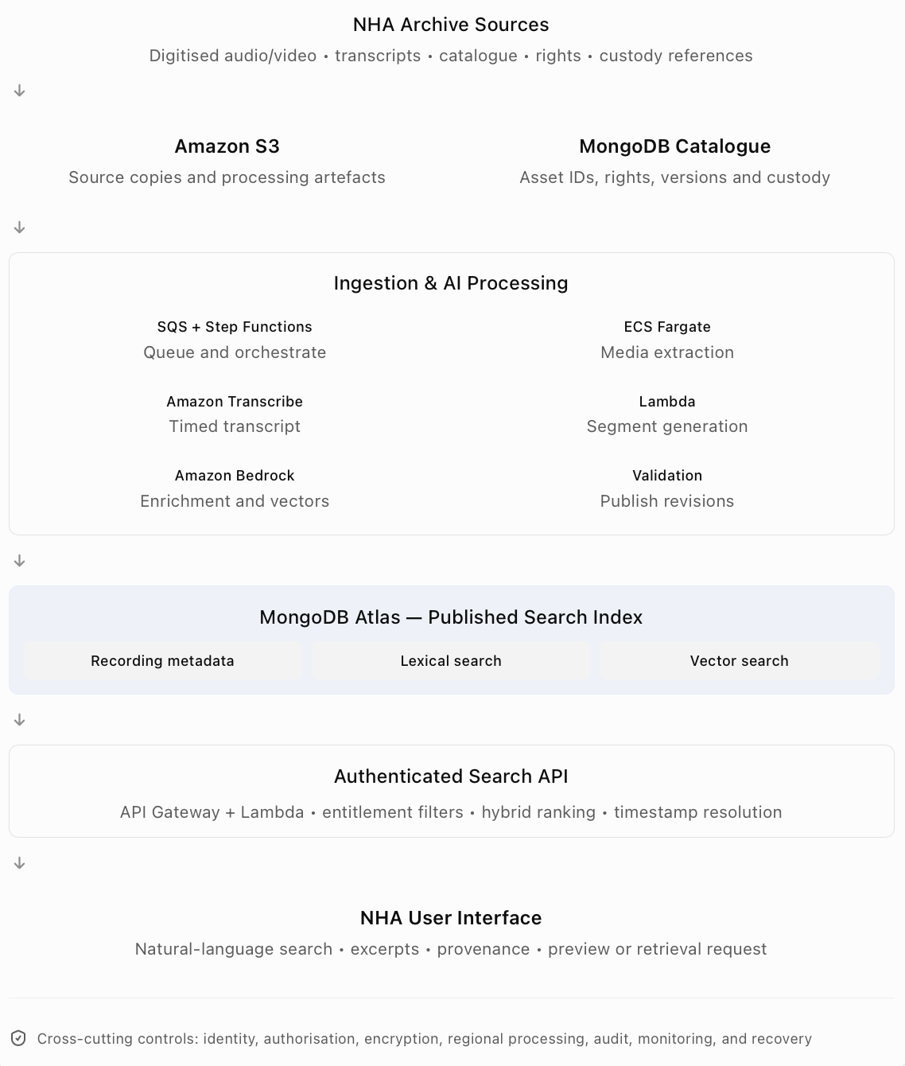
This diagram represents the proposed logical architecture. Precise network segmentation, service integrations, and security boundaries will be validated during deployment design.

Component Responsibilities
Component | Core responsibility | Primary input | Primary output
Archive registration | Validate asset identity, custody reference, rights, and processing eligibility | Media manifest and catalogue data | Registered asset and processing state
Amazon S3 | Store media copies, transcripts, and durable processing artefacts | Approved digital assets and outputs | Versioned source and derived files
Amazon SQS | Buffer and decouple ingestion work | New asset events | Processing work items
AWS Step Functions | Orchestrate asynchronous stages and recoverable processing | Registered processing job | Completed or failed pipeline state
ECS Fargate | Run sustained media transformations | Source media | Extracted audio and supported access derivatives
Amazon Transcribe | Create time-aligned transcription | Prepared audio | Transcript words, timing, and confidence data
AWS Lambda | Perform short transformations and service operations | Transcription and metadata | Segments, validations, API responses
Amazon Bedrock | Generate enrichment annotations and embeddings | Transcript segments and approved context | Structured annotations and semantic vectors
MongoDB Atlas | Store searchable records and execute lexical/vector retrieval | Catalogue, segments, annotations, embeddings | Filtered candidate search results
Search API | Authenticate, retrieve, rank, and resolve passage candidates | Natural-language query and entitlements | Timestamped results
Delivery service | Support authorised preview, export, and archive retrieval requests | Selected segment and rights decision | Preview or tracked delivery request
Operational services | Monitor performance, security, cost, and failures | Processing and access events | Alerts, audit evidence, and service metrics

Ingestion Architecture
The ingestion path begins when NHA authorises a digital asset for processing and provides its associated catalogue and custody information. The initial manifest should contain identifiers for the asset and specific recording version, source format and duration, source checksum, catalogue references, known languages, rights or access classification, and physical custody information.
Registration must succeed before downstream media processing begins. The proposed event-driven execution is:
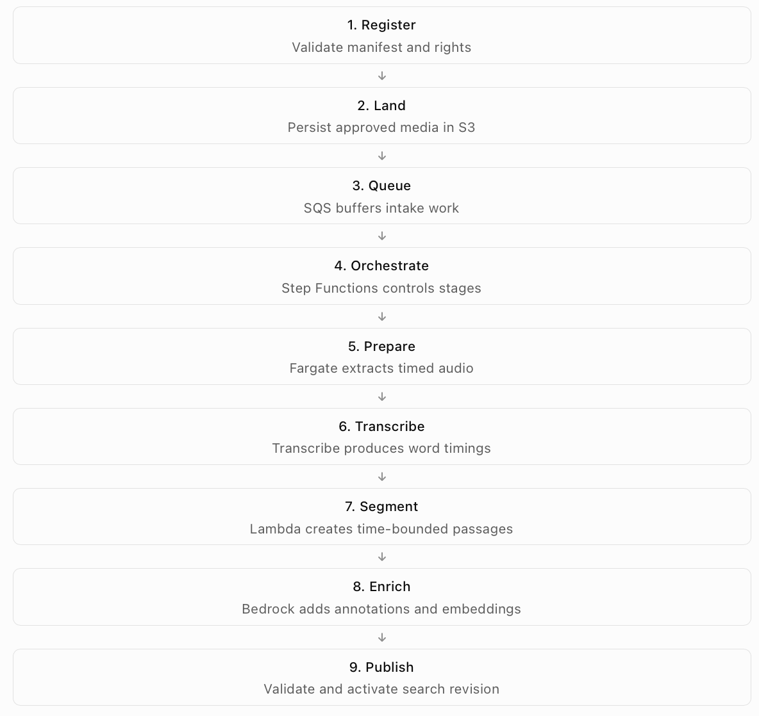
Each stage records its processing revision, input references, output references, status, and error details. Failures should not make partially processed data appear complete. A transcript that succeeds while optional enrichment fails may still support basic search, provided its published record clearly identifies the available evidence and capabilities.

Retrieval Architecture
The retrieval path is separate from ingestion and optimised for interactive search. An authenticated user submits a natural-language request. The API validates the request, resolves the user's current entitlements, and initiates lexical and vector retrieval. Each retrieval branch applies mandatory access and publication filters before candidate results are returned.

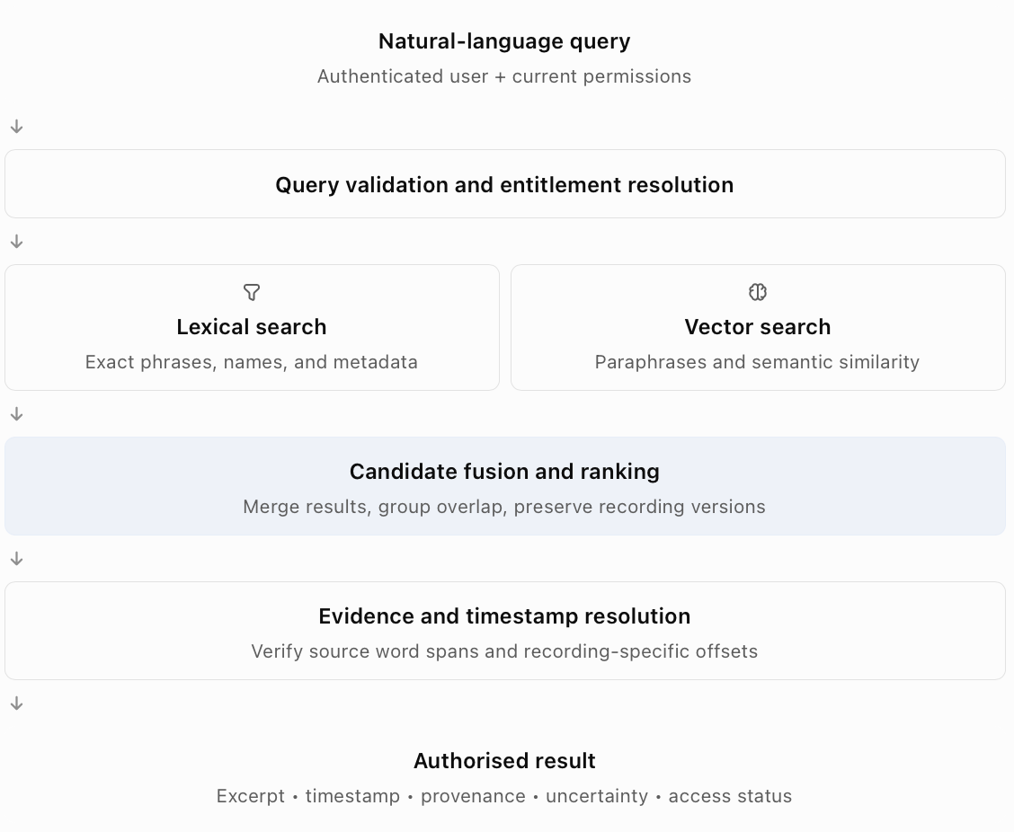
The initial search design may retrieve approximately 50 candidates from each branch before merging, deduplicating, and presenting five ranked results. These are configurable pilot settings rather than established performance requirements.

Data Storage Architecture
The architecture deliberately separates the durable source and processing artefacts from the data structures used for interactive retrieval.
Amazon S3: S3 stores approved source copies, extracted audio, raw transcription outputs, processing artefacts, and permitted access/export media. Artefacts should be logically separated by asset, recording version, and processing revision. Retention, object-locking, versioning, and encryption policies must be selected in accordance with NHA requirements. A generic cloud storage policy must not be assumed to satisfy preservation obligations.
MongoDB Atlas: MongoDB stores the operational catalogue records, searchable transcript segments, metadata enrichment, embedding references or vectors, recording-version relationships, and processing/publication status. Every indexed segment must reference its source recording version and transcript revision.
Authoritative archive custody: The NHA's existing physical-media custody system remains authoritative. The proposed platform stores references to that system; it does not redefine physical custody, overwrite catalogue authority, or treat cloud copies as preservation masters. This separation enables modern discovery without changing NHA's underlying archival responsibility.

Security and Access Architecture
Access governance is integrated into the platform rather than added as a final interface check. The proposed design uses identity federation through NHA's approved identity provider, with Cognito and API Gateway supporting authentication and API authorisation. The application maps authenticated identities to archive entitlements, collections, and permitted actions. Access checks must occur before exposing results and again before media access, export, or retrieval requests. A result's text excerpt can itself contain restricted information. Therefore, hiding the media link while returning an unauthorised transcript snippet is not sufficient. Sensitive collection separation may require additional index, storage, or network isolation where shared filtering does not satisfy policy.
Security decisions must be logged with appropriate privacy controls, while media links should be time-limited and bound to authorised actions.

Resilience and Processing Consistency
Historical media processing is expensive and can involve long-running jobs. The architecture therefore uses asynchronous workflows, bounded retries, and durable processing artefacts. A processing job should have an idempotency identity derived from its source recording version, source checksum, and pipeline version. This helps prevent duplicate events or retries from publishing duplicate results. Completed stages should be reusable where their inputs and processing versions remain valid. Failed stages should be recoverable without unnecessary repetition of previously successful work. New index revisions must be validated before becoming searchable. The previously published revision should remain available for rollback when a newer revision fails validation.

Architecture Boundary and Responsibility Model
The main responsibility boundaries are:
Boundary | Ownership
Historical and catalogue authority | NHA archivists and records owners
Physical custody and retrieval | NHA archive operations
Identity policy and access classifications | NHA security and records owners
Cloud platform configuration | NHA platform/service team, with delivery support
Media preparation and processing software | Delivery team initially; NHA engineering team after handover
Search algorithms and result interfaces | Delivery team initially; NHA application owner after handover
AI-generated enrichment | System-generated annotations subject to NHA review controls
Service monitoring and incident handling | NHA service owner after operational acceptance
This ownership separation is essential to the forward-deployable character of the solution.

Data Ingestion & AI Processing Pipeline
Pipeline Objectives: The ingestion and processing pipeline converts approved archival media into searchable, source-grounded time segments. The pipeline must accomplish several objectives simultaneously:
- Preserve a reliable connection between each derived record and its original recording.
- Produce usable timed speech evidence where supported.
- Maintain the source timeline through media transformations.
- Enrich content without overwriting original archival facts.
- Support multiple languages, incomplete transcripts, and poor-quality recordings.
- Avoid unnecessary duplicate processing.
- Recover from partial failures.
- Publish only internally consistent and authorised searchable records.
The pipeline is designed as a collection of explicit, independently observable stages rather than a single opaque AI process.

Stage 1 — Asset Registration and Validation
Processing begins with a structured asset manifest supplied or approved by NHA. The registration stage verifies that the asset can be identified, processed, and related to the archive's custody and access controls.
Input contract
Field | Purpose
asset_id | Stable identifier for an archival asset or catalogue object
recording_version_id | Unique identity for the specific recording edition being processed
source_checksum | Detect byte-identical input media and validate transfer integrity
media_uri | Location of the approved digital processing copy
custody_reference | Link to authoritative archive storage
rights_class | Discovery, preview, and delivery restrictions
availability_state | Online, offline, or other approved availability category
source_metadata | Original catalogue fields with provenance
known_languages | Language hints where supported
duration / format | Media characteristics used for processing validation
The initial validator checks required fields, media integrity, permitted processing status, and source linkage. If custody identifiers or access classifications are missing, the asset is placed into a reconciliation or restricted-processing state rather than silently assuming public access. A source checksum can detect byte-identical duplicates, but it cannot establish that independently encoded or edited recordings are equivalent.

Stage 2 — Intake Queue and Workflow Initialisation
Following registration and approved media landing in S3, an ingestion event is placed onto Amazon SQS. A Lambda dispatcher validates the event and initiates a Step Functions Standard workflow. The queue decouples file arrival from resource-intensive downstream work, enabling NHA to manage ingestion rate, priority, retry behaviour, and budget usage. The workflow records a unique job key, pipeline version, recording-version reference, stage states, and artefact locations. It should pass references to large artefacts rather than transferring complete media or transcript bodies through workflow state. The processing design includes bounded retries with backoff for transient failures, explicit terminal failures for invalid assets, and controlled concurrency to respect service quotas and cost limits.

Stage 3 — Media Preparation and Audio Extraction
Media preparation is performed by an ECS Fargate task running a reproducible media-processing container, such as an FFmpeg-based workflow. Its purpose is to create an analysis-ready audio stream while preserving the timing relationship to the selected source recording.
Typical operations include:
- Inspect media format, duration, audio streams, channels, and timebase.
- Extract a supported audio representation for speech recognition.
- Apply approved normalisation or channel handling where useful.
- Record source offsets and timing transformations.
- Create or identify an appropriate digital access copy where permitted.
- Detect unsupported or corrupt media and quarantine it for review.
Timestamp preservation: The extraction process must not reset or lose the relationship between processed audio and the source recording without recording an explicit mapping. For example, if a long recording is divided into shorter pieces for processing, each piece must retain its absolute starting offset in the source timeline. If a piece begins at source time T0, then a local word start time t maps to: $T_{\text{source}}=T_{0}+t$
This simple mapping is valid only when the derivative preserves playback rate and a constant offset. More complex transformations, such as speed changes or editing, require a validated time mapping rather than the constant-offset formula. Preparation does not overwrite source media. Raw and transformed artefacts remain distinguishable and versioned.

Stage 4 — Speech Transcription
Amazon Transcribe is the proposed initial managed speech-recognition service. Prepared audio is submitted to a batch transcription job, and the workflow tracks its completion asynchronously. The raw transcription output is preserved in S3 alongside processing configuration, language settings, service/job identifiers, and model or service metadata available for reproducibility.
Expected transcription output: Where supported, the output contains:
Element | Description
Recognised text | The transcription hypothesis produced from the recording
Word timing | Start and end offsets for recognised words
Confidence | ASR-level indication of recognition confidence, where available
Language information | Identified language or language settings
Processing metadata | Recording version, job identity, settings, and output location
Confidence scores should be treated as model signals rather than calibrated guarantees of transcription accuracy.
Historical recording handling: For degraded recordings, preprocessing options should be evaluated on representative samples rather than universally applied. Noise reduction may improve intelligibility in some cases but can also distort speech or remove useful acoustic information. The solution therefore retains original audio and compares processing alternatives before standardising them. Language settings and supported vocabulary should be selected according to the actual pilot collection and the capabilities available in the approved deployment Region. Unsupported or poor-performing language groups are routed to a human transcription or separately evaluated recognition process rather than being silently treated as successfully covered.

Stage 5 — Transcript Normalisation and Alignment
The normalisation stage transforms raw transcription data into a consistent internal representation. Its responsibilities include:
- Assign stable transcript and word identifiers.
- Convert timing offsets to a consistent unit, such as milliseconds.
- Validate word timing order and recording duration limits.
- Attach punctuation to neighbouring timed words.
- Preserve language and confidence information where available.
- Record transcript gaps or unavailable sections.
- Maintain references to the original transcript and processing revision.
Existing human-produced transcripts may also be imported. However, text without validated timing remains untimed evidence until it has been aligned to the corresponding recording. The platform must not derive precise clip boundaries from paragraph positions, estimated reading speed, or language-model guesses. If reliable alignment cannot be established, the content may remain available for metadata or text discovery, while precise playback is withheld or marked for review.

Stage 6 — Timestamped Segment Generation
The segment-generation stage converts timed transcript words into smaller searchable passages. This is a deterministic application component rather than a language-model generation task.
Segmentation approach: The initial approach uses sentence-aware windows targeting approximately 20–60 seconds, with overlap where useful to preserve context around segment boundaries. The window size and overlap are configuration parameters to be tuned against real NHA queries. Very short segments may lack sufficient semantic context, while long segments can make retrieval less precise and introduce irrelevant content. The design therefore balances search relevance with the ability to resolve a precise subspan of the returned recording.
Segment construction: Each segment stores:
- Recording version and transcript revision.
- Start and end offsets derived from timed source words.
- Source word ID range.
- Original or normalised text.
- Language and quality annotations.
- Rights and publication references.
- Segment processing version.
Overlapping segments may include the same passage. Search logic must therefore group or deduplicate overlapping candidates without confusing separate recording editions.
Timing validation: A valid segment must satisfy: $0≤t_{\text{start}}<t_{\text{end}}≤T_{\text{recording}}$. This is enforced during processing and tested using representative boundary cases. If the underlying timed words do not justify a precise boundary, the segment is flagged rather than published as a high-confidence clip interval.

Stage 7 — AI-Based Content Enrichment
Following segmentation, an optional Bedrock-based enrichment stage produces additional searchable context. The objective is to improve retrieval for queries that reference people, events, themes, or related terminology not explicitly captured by simple keyword matching.
Proposed enrichment outputs
Output | Example purpose
Named entity mentions | Identify names of people, locations, organisations, or referenced events
Topics or themes | Associate a passage with themes such as wartime resistance or political speeches
Short segment summary | Provide concise context for semantic retrieval
Evidence spans | Connect extracted statements or entity mentions to supporting transcript words
Review state | Distinguish automatically generated suggestions from archivist-confirmed information
Enrichment is grounded in transcript text and permitted catalogue context. A language model may suggest that a passage references a historical event, but it must not silently replace existing catalogue fields or claim that its inference is an authoritative archive fact.
Structured extraction and validation: Each enrichment request includes the source segment identifier, transcript revision, relevant text, and a bounded context window. The model response is expected in a structured schema.
Application-level validation checks field types, required attributes, and references to known source spans. Prompts embedded within archival content are treated as untrusted source material rather than instructions to the system. The enrichment process has no authority to call unrelated tools, modify archive records, or change recording timestamps. Invalid enrichment output is retried within a defined limit and may ultimately be marked as unavailable without blocking publication of an otherwise valid transcript segment.

Stage 8 — Embedding Generation
Each eligible segment is converted into a numerical vector representation using an approved pretrained embedding model. Embedding representations allow semantically similar language to be retrieved even when exact terms differ. The indexed input may combine transcript text with selected, validated contextual fields. Generated summaries or inferred metadata must be clearly versioned so their retrieval contribution can be evaluated. The embedding record should preserve the model identifier, vector dimensions, input content version, and processing revision. The query service must use a compatible embedding model with the segment index. Model changes that introduce incompatible embedding spaces require a separate index or controlled re-embedding process rather than mixing vectors without validation.

Stage 9 — Search Index Construction and Publication
The final processing stage persists the segment records and makes them available for retrieval. The indexing strategy combines:
- Lexical indexing, which supports quotations, historical names, and direct terminology matches.
- Vector indexing, which supports paraphrase and conceptual similarity.
- Structured metadata filtering, which supports recording identifiers, language, publication status, collection, and current access entitlements.
These capabilities are hosted in the proposed MongoDB Atlas environment.
Controlled publication: New or reprocessed segments are initially written under a staged processing revision. Before publication, the pipeline checks:
- Required identifiers and provenance references.
- Valid source timing ranges.
- Transcript and segment relationships.
- Embedding model and dimension compatibility.
- Required access classifications.
- Segment completeness and searchable-index visibility.
- Expected segment counts or documented partial-coverage state.
Once validation succeeds, the relevant revision is marked as published. Search queries consider only published and appropriately authorised revisions. The prior revision remains available for rollback under NHA's retention policy.

Processing Failures and Recovery
The processing pipeline must tolerate partial failures without corrupting the searchable catalogue.
Failure scenario | Intended system response
Invalid media or manifest | Quarantine asset, record validation error, notify responsible operator
Duplicate ingestion event | Reuse deterministic job identity and avoid duplicate publication
Transcription service throttling | Retry with bounded exponential backoff and concurrency control
Unsupported speech or failed transcription | Retain available metadata, mark coverage limitation, route for review
Invalid enrichment response | Retry within limits; preserve searchable transcript where possible
Embedding failure | Keep staged transcript and enrichment artefacts; retry indexing later
Database or index publication failure | Do not activate incomplete revision; retain previous published version
Missing or ambiguous rights | Restrict processing/publication until policy is resolved
Processing budget or quota exceeded | Pause or defer lower-priority work and alert service owner
The system should retain sufficient processing state and intermediate artefacts to replay failed stages without unnecessarily repeating expensive upstream work. Dead-letter queues can capture failed intake events, while Step Functions catch paths record and route downstream workflow failures.

Processing Observability
Operational monitoring should provide visibility into system reliability, retrieval readiness, and cost. Key ingestion metrics include processing queue age, active jobs, completion and failure rates, average processing duration per media hour, transcription coverage, enrichment failures, index publication latency, and total cost per processed media hour.
Metrics should also distinguish language, media condition, collection, and pipeline version when doing so is practical and policy-compliant. Monitoring must avoid exposing sensitive transcript text or raw media content unnecessarily.
Runbooks should explain how an NHA operator can identify failed stages, inspect artefact references, retry a job, reconcile a rights or metadata error, rebuild an index, and restore a previously published revision.

Pipeline Output Contract
A successfully processed recording produces a set of records and artefacts that form the input to the retrieval layer.
Output | Storage location | Purpose
Approved source and access media | Amazon S3 | Source evidence and permitted playback material
Raw and normalised transcripts | Amazon S3, with references in MongoDB | Reproducible transcription evidence
Timed word records | Durable structured artefacts and/or MongoDB records | Authority for segment and clip boundaries
Searchable segments | MongoDB Atlas | Passage-level retrieval
Enrichment annotations | MongoDB Atlas / versioned artefacts | Evidence-linked contextual search
Embedding vectors and model metadata | MongoDB Atlas | Semantic candidate retrieval
Processing job records | Operational data store | Retries, errors, stage status, and audit
Published index revision | MongoDB Atlas | Consistent searchable collection state
Custody and rights references | MongoDB linked to NHA systems | Provenance and authorised delivery
The key output of ingestion is not merely a transcript or a vector embedding. It is a searchable, time-bounded, version-specific archival segment whose content, origin, timing, and access policy can be traced and verified.

Data Architecture & Indexing Strategy

Data Architecture Objectives
The data architecture must support two related but distinct responsibilities:
- Preserve the identity, provenance, content, and timing evidence associated with archival recordings.
- Provide efficient passage-level retrieval using natural-language and structured queries.
The system must not treat a historical event, an archival recording, a transcript, and a searchable segment as the same entity. For example, Churchill's We Shall Fight on the Beaches speech is a historical work or event. The NHA may hold multiple recordings, broadcasts, compilations, or edited representations associated with that speech. Each recording requires its own identity, while each segment must point to the precise source version and transcript revision from which its timing was derived.
The proposed design therefore separates archival records, recording versions, timed transcript evidence, searchable segments, enrichment annotations, and processing state.

Logical Data Model
The following entities form the core data model.
Entity | Responsibility | Key relationships
Archive Asset | Represents an archival catalogue or custody object. | References catalogue identifiers, custody, rights, and recording versions.
Recording Version | Represents a specific media edition with its own playback timeline. | Belongs to or relates to an asset; has transcripts and segments.
Transcript Revision | Represents a particular transcription or alignment of one recording version. | References a recording version and timed word evidence.
Timed Word | Records recognised or validated text and its position within source media. | Belongs to a transcript revision.
Search Segment | Represents a passage-level retrieval unit with source-derived boundaries. | References word ranges, transcript revision, and recording version.
Enrichment Record | Stores model-generated annotations with evidence and review status. | References a segment and processing/model version.
Processing Job | Tracks ingestion stages, errors, artefacts, and publication revisions. | References the input recording version.
Delivery Request | Tracks authorised requests for preview, export, or physical-media retrieval. | References the user, segment, recording version, and custody record.
A historical speech or event may be referenced by several recording versions. This relationship is retained without assuming that every version contains identical content or timing.

Proposed Storage Model
The solution uses Amazon S3 for binary media and durable processing artefacts, with MongoDB Atlas for operational and searchable records.
Storage | Data | Reason
Amazon S3 | Source media copies, extracted audio, raw transcripts, processing outputs, access derivatives | Durable object storage for potentially large artefacts
MongoDB Atlas collections | Asset records, recording versions, transcripts, segments, annotations, job and delivery references | Flexible structured records and retrieval metadata
MongoDB Atlas Search | Text search over transcripts and selected metadata | Supports exact quotations, names, and lexical relevance
MongoDB Atlas Vector Search | Segment embeddings with mandatory metadata filters | Supports paraphrase and semantic similarity
Existing NHA systems | Physical custody and authoritative archival records | Preserves institutional authority and workflows
S3 objects are referenced through controlled object keys or internal URIs. They are not made directly public by storing their locations in search documents. The source and indexing layers remain independently recoverable, allowing search indexes to be rebuilt from preserved processing evidence.

Archive Asset Schema
The archive asset record represents an institutionally identifiable object. Its proposed fields include:
Field | Description
asset_id | Stable internal archive identifier
catalogue_reference | Original NHA catalogue reference
custody_reference | Authoritative physical-media location/reference
title | Catalogue title, with source provenance
description | Existing catalogue description
event_date | Historical event date, where established
recording_date | Recording date, where established
metadata_sources | Origins of catalogue values
rights_class | Access classification
collection_id | Collection ownership and filtering
recording_version_ids | Associated digital recording editions
Dates should not be collapsed into a single ambiguous field. For example, the date of a historical speech may differ from the date on which an available recording or rebroadcast was created. Conflicting values should remain traceable to their sources until resolved by an authorised archivist.

Recording Version Schema
Each unique media timeline receives a recording_version_id. This distinction is essential because two recordings may contain the same words at different offsets. The version record should include:
- Asset and source identifiers.
- Exact file checksum.
- Media duration and format.
- Audio and video stream characteristics.
- Digital media URI.
- Parent or derivative version relationships.
- Original-to-derivative timing mapping where applicable.
- Language hints.
- Availability and access-copy state.
- Processing eligibility and version status.
Byte-identical files may share some processing artefacts, subject to access constraints, but their custody and catalogue identities remain separate. Re-encoded or edited copies are not assumed to be equivalent merely because their titles or transcript text are similar.

Transcript and Timed Word Schema
A transcript is modelled as a versioned artefact attached to a specific recording edition. It records its origin, whether human-produced or machine-generated, transcription settings, language coverage, alignment quality, and storage reference. Timed word records supply the basis for precise clip boundaries.
A simplified word record contains:
{
"word_id": "w_0042",
"transcript_revision_id": "tr_001",
"text": "surrender",
"start_ms": 184250,
"end_ms": 184800,
"language": "en",
"confidence": 0.91
}
The identifiers and timing values above are synthetic schema examples, not observations from an archival recording. A word's start and end times are relative to the specific source timeline identified by its recording version. Confidence is optional where the transcript source or recogniser does not provide it.
An untimed historical transcript can support discovery but should not be used to promise precise playback until its alignment has been validated.

Search Segment Schema
The search segment is the primary unit of passage retrieval.
It connects the text indexed for search to a bounded interval within an actual recording.
{
"segment_id": "seg_001",
"recording_version_id": "rv_001",
"transcript_revision_id": "tr_001",
"start_ms": 175000,
"end_ms": 205000,
"start_word_id": "w_0034",
"end_word_id": "w_0061",
"text": "We shall fight on the beaches...",
"language": "en",
"rights_class": "approved",
"quality_flags": [],
"processing_version": "pipeline_v1",
"publication_revision": "pub_001"
}
This record illustrates the proposed contract and does not represent a verified Churchill audio source. For every segment, the system must validate source identity, timing bounds, text-to-word correspondence, and rights references before publication. Segment identifiers should remain deterministic within a processing revision so rerunning unchanged inputs does not create unnecessary duplicate records.

Enrichment and Provenance Model
Generated entity mentions, themes, and summaries are stored separately from curated archive metadata. Every enrichment record should include the source segment, supporting evidence spans, model identifier, processing settings, prompt version, generation time, and review status. For example, an enrichment model may suggest that a segment concerns wartime resistance. That classification may improve search but remains an AI-generated annotation unless an archivist validates it. This separation allows NHA to use AI enrichment without allowing model output to silently become authoritative metadata.

Search Indexing Strategy
The retrieval layer requires three complementary index types.
- Lexical index: Searches transcript text, titles, named entities, and permitted catalogue descriptions. This supports exact or near-exact remembered quotations.
- Vector index: Stores embeddings of segment text and selected validated context. This supports queries that describe concepts without reproducing exact words.
- Structured filtering: Restricts retrieval by permitted collections, publication revision, recording identity, language, access class, and other relevant structured attributes.
Both lexical and vector branches must enforce access controls before returning potentially sensitive content to the application.
Index granularity: The initial searchable unit is a timed transcript segment rather than an entire recording. A recording-level index may later support broad discovery, but passage-level indexes remain necessary to locate the requested moment. The design should evaluate whether recording-level candidate retrieval followed by segment-level retrieval improves performance at larger archive scale. It is not required for the initial proof of concept.

Data Versioning and Index Lifecycle
The pipeline must support changes in transcript quality, segmentation, metadata, embedding models, and access rights. Processing revisions therefore identify the source checksum, recording version, transcript revision, segmentation configuration, enrichment model, and embedding model. An updated embedding model creates a compatible new vector index or explicitly managed migration.
An edited recording is registered as a new version rather than overwriting the existing timeline. Publication uses a controlled active-revision mechanism so a failed reprocessing job does not expose incomplete data.

Search, Retrieval & Clip Delivery

Retrieval Objectives
The search layer must translate an imprecise user request into a set of relevant, evidence-backed archival moments. The output is not simply a generated explanation of historical content. It is a ranked set of timestamped segments, each linked to the particular recording version from which it was derived. The retrieval workflow must address semantic uncertainty, exact phrases, recording editions, access permissions, and availability.

Query Processing
An authenticated user submits a natural-language request through the application. The query service validates the request, resolves current access entitlements, and prepares the query for lexical and vector retrieval. Optional query interpretation may extract persons, phrases, topics, languages, dates, and collection preferences. However, the system distinguishes between explicit constraints and uncertain contextual clues. For the Churchill example, “maybe after a retreat” is a useful historical hint but should not become an automatic mandatory filter. The original user query is retained for retrieval, preserving information that may be lost through over-aggressive query rewriting.

Hybrid Candidate Retrieval
Two candidate retrieval branches execute against the published search corpus.
Lexical retrieval: Lexical search identifies passages containing matching words, recognised phrases, catalogue titles, or named entities. It is particularly effective for remembered quotations and historical names.
Semantic retrieval: The query is embedded using the same compatible embedding model used to index source segments. Vector similarity identifies passages that discuss comparable concepts, even where the wording differs. The semantic branch can therefore retrieve a passage involving fighting across multiple locations when the user remembers it as “fighting everywhere”.
Access-aware filtering: Each branch applies current entitlement constraints and published-revision filters. Filtering after unauthorised results have already entered application logic is insufficient, particularly where results may include sensitive snippets or metadata. Database capabilities, filter indexes, and isolation arrangements must be verified during security testing.

Candidate Fusion and Ranking
The lexical and semantic candidate lists are combined using a rank-fusion strategy.
The proposed starting point is Reciprocal Rank Fusion:
$$\operatorname{RRF}\left(d\right)=\sum_{r∈R}{\frac{1}{k+{rank}_{r}\left(d\right)}}$$
where R is the set of retrieval branches, d is a candidate document, and k is a configurable smoothing constant. RRF combines relative rankings without assuming lexical and vector similarity scores are directly comparable. Following fusion, the system groups overlapping candidate windows from the same recording version to avoid displaying multiple near-identical passages as independent results. Different recording versions remain distinguishable even when their content is similar.
Metadata such as source title or verified event context can contribute to ranking, but unsupported enrichment should not outweigh direct transcript evidence.

Passage Resolution and Precise Timestamps
Retrieval identifies a candidate passage window, which may be wider than the exact words requested. The resolution stage determines the best supported subspan from the timed transcript. For a phrase match, the system maps matched tokens back to the associated word identifiers and derives the corresponding start and end offsets. For a semantic-only match, it can identify a narrower supporting sentence or word interval using grounded transcript evidence and optional bounded reranking. If the match cannot be narrowed reliably, the system returns a broader validated passage window and indicates the remaining uncertainty. The final playback range may include a small context margin, bounded by the recording duration. The result must preserve both the matched evidence interval and the playback interval when they differ. No timestamp is accepted merely because a language model generated it.

Churchill End-to-End Walkthrough
The Churchill request serves as the reference demonstration.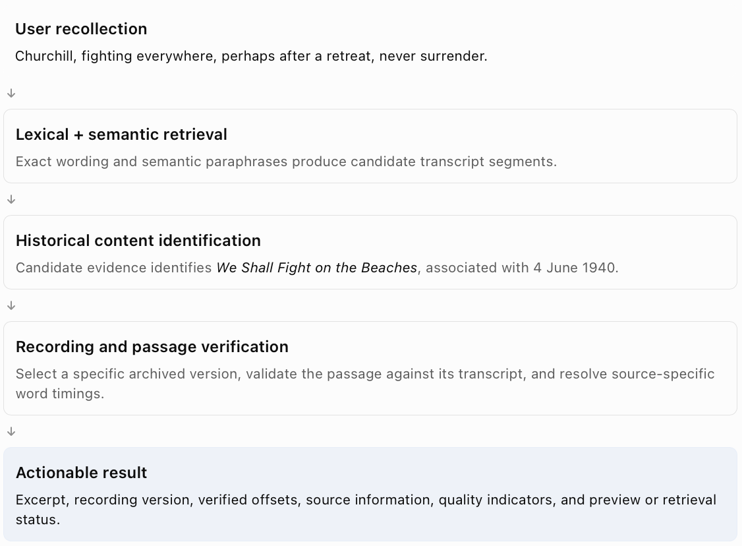
An important historical and archival distinction applies here: the case study identifies the correct speech, but the system must still verify the actual recording being returned. A later reading, broadcast, edited compilation, or other archival representation must not be mislabelled as the original performance. The proof of concept should use actual offsets from its selected sample data rather than fabricated timestamps.

Search Response Contract
A successful search response should include:
Attribute | Purpose
segment_id | Identifies the selected passage
asset_id | Links the result to the archival object
recording_version_id | Identifies the specific playback timeline
title | Human-readable source description
event_date | Historical event date, where supported
recording_date | Recording date, where supported
start_ms / end_ms | Source-specific interval
matched_excerpt | Supporting transcript text
evidence_status | Indicates timing and content verification
quality_flags | Identifies relevant uncertainty
availability_state | Indicates online, offline, or unavailable media
permitted_actions | Preview, request, export, or restricted outcome
Search relevance scores may be retained for ranking and diagnostics, but should not be displayed as calibrated probabilities without appropriate validation.

Digital Preview and Clip Export
When a seekable digital access copy exists and the user is authorised, the application can open that recording at the selected timestamp. If a separately exported clip is required, the platform may initiate an asynchronous FFmpeg-based extraction job using ECS Fargate. The export process must check current permissions, source-version identity, valid boundaries, and the selected delivery format. Any media link is time-limited and issued only after authorisation. The access copy is not automatically a broadcast-ready or preservation-quality master.

Offline and Authoritative-Media Retrieval
If the authoritative recording is stored offline, the platform should still return the relevant searchable segment where access policy permits. The interface should clearly distinguish a discovered passage from a ready-to-deliver media file. An offline request records the requester, recording and custody references, selected passage, rights context, requested output, and workflow status. Archive staff then coordinate the physical-media retrieval and delivery process according to NHA procedures.
If the retrieved physical master has a different timeline from the indexed digital surrogate, the timestamp must be validated against that master before generating the final clip. This avoids promising that offsets from one edited version apply to another.

Handling No-Match and Uncertain Results
The retrieval service must not always force an answer. For weak or ambiguous evidence, it may return multiple candidates, a broader context interval, or an explicit review-required result.
When no supported match is found, the application should state that the available indexed material does not provide a sufficiently reliable answer.
A no-match outcome is preferable to an invented excerpt, recording identity, or timestamp. The evaluation suite must include negative and misleading queries to test this behaviour.

Handling Real-World Archive Challenges

Design Approach
The NHA collection includes material spanning approximately a century, so data quality and consistency cannot be assumed. The design must support incomplete processing results, retain evidence of uncertainty, and provide archivist review paths where automation cannot meet the required confidence.
The following treatments correspond directly to the six messy-data conditions identified in the case study.

Poor Audio Quality
Historical audio may contain noise, distortion, inconsistent volume, limited frequency range, overlapping speech, or damaged sections. These conditions can reduce word recognition accuracy and affect timing reliability.
Proposed handling: Retain the unmodified source, evaluate reproducible preprocessing on derivative copies, and benchmark transcription against labelled difficult recordings. ASR confidence and independent audio-quality indicators help identify potentially unreliable segments. Poor transcription or unstable timing triggers a review flag.
Fallback: Use any trustworthy existing transcript, obtain human transcription or alignment, or return a broader context interval rather than claiming unsupported precision.
Validation: Report transcription quality and timestamp errors separately for clean and degraded audio.

Partial or Missing Transcripts
Some recordings may contain only selected transcript excerpts, descriptive catalogue notes, or transcriptions without timing. A missing portion of a transcript must not be interpreted as silence or proof that a topic was never discussed.
Proposed handling: Record transcript coverage, preserve original text, generate additional timed transcription where feasible, and distinguish source transcript text from ASR output. Where text is available but untimed, it can support discovery while precise clip retrieval remains conditional on successful alignment.
Fallback: Return a catalogue-level result or a review-required passage without presenting invented clip offsets.
Validation: Check coverage labels, gap preservation, and the absence of unsupported precise timestamps.

Multilingual and Mixed-Language Content
The archive may contain recordings in multiple languages or speakers changing languages within the same recording. Using one transcription configuration across all content may result in uneven quality.
Proposed handling: Store language information at recording and segment level where available, select appropriate supported transcription configurations, and preserve original-language text. A compatible multilingual embedding model can be evaluated for cross-language retrieval. For mixed-language recordings, language identification and segmentation may require specialised handling or separate evaluation.
Fallback: Use approved alternative transcription, translation as an explicitly derived aid, or archivist review for unsupported languages.
Validation: Report retrieval quality, transcription performance, and coverage by language rather than using only one aggregate metric.

Duplicate and Edited Recordings
The same historical speech may exist as a raw recording, compilation, rebroadcast, remaster, or edited excerpt. Exact duplicates and semantic duplicates must be treated differently.
Proposed handling: Use checksums for byte-level duplicate detection and transcript similarity or acoustic fingerprinting to suggest related editions. Every unique playback timeline maintains a separate recording-version ID. Candidate groups may link related content while preserving distinct custody and timing information.
Fallback: Send ambiguous equivalence relationships to archivist review.
Validation: Ensure no search or delivery process silently transfers offsets across edited versions.
Future: An audio based fingerprinting could be potentially implemented to mark similar content together.

Missing or Conflicting Metadata
Catalogue fields can be missing, approximate, inconsistent, or sourced from different historical references. For example, a speech's event date may be confused with the recording or rebroadcast date.
Proposed handling: Preserve source values with provenance, distinguish authoritative metadata from AI-generated suggestions, and allow archivists to reconcile conflicts. Enrichment may suggest missing entities or contextual information, but cannot silently replace catalogue records.
Fallback: Show conflicting or unknown values with appropriate uncertainty and withhold authoritative assertions pending review.
Validation: Test that metadata conflicts survive reprocessing and are not automatically overwritten.

Offline Archive Retrieval Delays
The existence of a search result does not guarantee that the authoritative recording is immediately available.
Proposed handling: Separate relevance from availability, maintain custody links, and expose permitted preview or retrieval-request actions. Requests should have status tracking and service levels established by NHA operations.
Fallback: Provide a transcript-level or access-copy preview where authorised, and queue an archival retrieval request.
Validation: Test online, offline, restricted, and missing-media outcomes independently.

Human-in-the-Loop Review
Human review is not treated as a failure of the solution. It is a necessary control where automated processing cannot establish sufficient evidence. The review queue should prioritise low-confidence timing, ambiguous versions, conflicting historical facts, rights uncertainty, and significant retrieval errors.
Review actions should retain the reviewer identity, decision, supporting evidence, and updated revision.
Corrections should be reusable during future reprocessing so the same known problem does not repeatedly consume archival effort.

Security, Governance & Preservation

Security and Governance Objectives
The NHA holds historically significant material that may have legal, cultural, political, or institutional sensitivities. The proposed platform must protect restricted information while enabling approved users to discover relevant content. Security, governance, and preservation are therefore core design requirements rather than supporting features.
The solution follows five principles:
- NHA retains authority over archival content, rights, and custody.
- Access decisions are enforced throughout processing, search, and delivery.
- Sensitive information is processed only through approved infrastructure and models.
- AI-generated information remains distinguishable from archival evidence.
- Original source artefacts and processing history remain recoverable.

Identity and Access Management
The platform uses NHA's existing identity provider as the proposed source of user authentication. Amazon Cognito may support federation, while API Gateway and application-level authorisation enforce permissions.
The access model must distinguish between the right to discover a record, view metadata, read a transcript excerpt, preview digital media, and request or export an authoritative recording.
These permissions must not be treated as equivalent.
Permission | Example
Discover | User can see that a recording exists.
View metadata | User can inspect approved catalogue information.
Read transcript | User can see authorised passage text.
Preview | User can play an approved digital access copy.
Request | User can submit an archival retrieval request.
Export | User can obtain a permitted standalone clip.
Curate | Authorised archivist can validate or correct catalogue information.
Permissions should be defined by NHA's actual identity and collection policies. A user who can discover a restricted recording may not necessarily be allowed to view its transcript or play its media.

Rights-Aware Retrieval
Access filtering must operate at the search layer and at final delivery. Both lexical and vector searches must enforce the user's permitted collection and visibility scope.
Where Atlas filter capabilities or access-policy complexity make shared indexes unsuitable, sensitive collections should use stronger logical or physical isolation. The API must revalidate permissions before returning excerpts, issuing playback links, starting exports, or submitting requests.
Search caches must also account for user entitlements and access-policy changes. A permission revocation must not leave previously authorised content accessible through stale search results or reusable media URLs beyond the accepted security policy.

Data Sovereignty and Residency
The archive's jurisdiction and data-classification policies must be confirmed before selecting the deployment Region. The design assumes that NHA-approved data may be processed in an approved AWS Region and, subject to approval, MongoDB Atlas hosted in the corresponding geography.
The following locations and processing paths require explicit validation:
Data or processing activity | Residency consideration
Original digital surrogates | S3 Region and replication policies
Speech transcription | Transcribe processing Region and service availability
Language-model enrichment | Bedrock inference endpoint and routing behaviour
Embeddings | Approved model, inference endpoint, and stored vector location
Search and metadata | MongoDB Atlas cluster location, backups, and operational processing
Logs and audit data | CloudWatch, CloudTrail, export destinations, and retention
Media delivery | Preview/export distribution endpoints and approved access paths
Regional hosting alone is insufficient evidence of sovereignty compliance. If NHA requires strictly in-Region processing, cross-Region inference configurations must not be used unless separately approved.

Encryption and Secrets Management
Media, transcripts, metadata, processing artefacts, and backups must be protected using encryption at rest and in transit. AWS KMS is the proposed key-management foundation for supported AWS services, subject to NHA key-ownership requirements.
Service identities should follow least-privilege permissions, with separate roles for ingestion, transcription, enrichment, search, and media delivery.
Credentials and connection secrets should be stored in AWS Secrets Manager rather than application code or deployment manifests.
Database connectivity should use approved private networking where supported and justified by NHA's security policy.

AI Governance
AI-generated transcripts and enrichment can be inaccurate or incomplete.
The platform therefore maintains a separation between:
- Original archive metadata and source material.
- Machine-generated transcripts.
- Machine-generated entities, themes, and summaries.
- Human-validated annotations.
- Authoritative corrections made by NHA archivists.
Generated content must include processing provenance and should be reviewable. The system must not silently use a language model to decide historical truth, resolve contested provenance, grant access rights, or create precise timestamps. Archived content is also considered untrusted input to AI processing. A transcript containing instructions must be handled as source material, not as an instruction to the processing system.

Preservation and Source Integrity
The proposed search service does not replace the NHA preservation system. Original source copies are never overwritten by preprocessing, transcript correction, or indexing. Derived audio, transcripts, embeddings, and search indexes are versioned and replaceable.
The system should retain sufficient source evidence and processing configuration to reproduce derived representations where permitted. Long-term retention and immutable-storage requirements must be agreed with NHA rather than inferred from generic cloud-storage defaults.
The central preservation boundary is: Physical custody and archival authority remain with NHA; the AI platform maintains a traceable discovery representation.

Audit and Accountability
The platform should record relevant processing events, catalogue review actions, access decisions, export requests, and operational changes. Logs should capture enough information to investigate failures and security events without unnecessarily exposing sensitive media or full user queries. Audit retention, access, and deletion requirements are subject to NHA policy.

Technical Tradeoffs & Alternatives

Decision-Making Framework
Technology choices should be evaluated against NHA's actual operating constraints, not technical sophistication alone. The primary evaluation dimensions are retrieval quality, timestamp accuracy, operational complexity, data sovereignty, vendor dependency, cost, extensibility, and availability of in-house expertise.
The following table consolidates the key choices and alternatives.
Decision | Proposed approach | Alternative | Why we prefer the proposal initially
Cloud platform | AWS managed services | Self-managed infrastructure | Reduces routine infrastructure administration
Transcription | Amazon Transcribe | Self-hosted ASR | Establishes a managed baseline before specialist adaptation
Model strategy | Pretrained Bedrock models | Fine-tuned/custom models | Avoids training-data and maintenance overhead before quality evidence exists
Retrieval | Hybrid lexical + semantic | Keyword-only or vector-only | Supports exact phrases and imprecise recollections
Search datastore | MongoDB Atlas | OpenSearch with separate metadata store | Potentially consolidates document and search responsibilities
Clip timing | Deterministic source-derived offsets | Model-generated estimates | Improves traceability and reliability
Knowledge representation | Structured records with relationships | RDF knowledge graph | Prioritises passage retrieval over ontology complexity
Processing | Async managed workflow | Single synchronous ingestion process | Handles long media jobs, retries, and backlogs
Delivery | Access copy and offline request | Immediate authoritative-master delivery | Aligns with NHA custody model

Accuracy Versus Processing Cost
More extensive preprocessing, transcription alternatives, enrichment, and reranking may improve retrieval for difficult material, but they increase per-recording processing cost. The first pilot should therefore evaluate whether each additional processing stage produces a measurable quality improvement.
For example, AI enrichment should not be mandatory if transcript-only hybrid search already meets agreed relevance targets. Likewise, an expensive reranking model should be introduced only if its improvement over simpler fusion justifies latency and inference cost.

Search Latency Versus Ranking Complexity
A simple hybrid search pipeline may return results more quickly than multi-stage model-based reranking. The proposed initial query path uses lexical retrieval, vector retrieval, rank fusion, and deterministic passage resolution.
An optional reranker can be added later. The decision depends on measured Recall@5, ranking quality, latency, and operating cost using representative NHA queries.

Managed Services Versus Self-Hosted Models
Managed services offer operational simplicity but introduce service dependency, variable cost, regional limitations, and model availability constraints. Self-hosted models may provide greater deployment control, but require infrastructure sizing, patching, model lifecycle management, capacity planning, and specialised monitoring.
The proposal chooses managed services as the default while retaining documented interfaces and durable source data to support future substitution. A fully self-hosted inference strategy should be assessed if NHA policy prohibits the required managed processing or if measured workload economics make it preferable.

Simplicity Versus Feature Completeness
The initial solution deliberately excludes several attractive but non-essential features. These include full visual-event recognition, archive-wide knowledge graphs, automatic historical fact reconciliation, autonomous rights decisions, and universal transcription coverage.
Each would introduce additional complexity beyond the core objective of reliably retrieving spoken moments from long-form recordings. This is a deliberate reduction in scope, not a claim that those features have no long-term value.

Cost Model and Measurement
A binding cost estimate cannot be produced from the case study alone because archive volume, recording durations, traffic, geographic restrictions, model availability, and infrastructure sizing are unknown.
The pilot should measure:
Cost area | Unit
Speech transcription | Cost per processed audio minute/hour
Media preparation | Compute cost per ingested media hour
Enrichment | Model input/output tokens per segment
Embeddings | Cost per indexed segment or input token volume
Object storage | Stored GB and retention period
MongoDB Atlas | Cluster, search capacity, backup, networking
Query serving | Cost per 1,000 searches
Export | Compute and storage transfer per clip
Operations | Monitoring, recovery, support, and administration
Two cost profiles should be reported separately:
- Backfill cost: The one-time cost of processing existing archival holdings.
- Steady-state cost: The ongoing cost of new ingestion, reprocessing, indexing, search, storage, and service operations.
This distinction is particularly important for an archive containing a century of material.

Decision Validation
Architecture decisions should be reconsidered when measurements or customer constraints change. MongoDB Atlas must pass procurement, security, and operational evaluation.
Transcribe must meet the quality requirements of the relevant language and media groups. Enrichment and reranking must demonstrate added value.
RDF becomes relevant only when supported relationship-retrieval use cases justify its governance burden.

Proof of Concept & Repository Design

Purpose of the Code Artefact
The working repository is intended to demonstrate the central engineering claim of Find the Moment:
- A collection of archival transcript evidence can be transformed into searchable, time-bounded segments, and an imprecise natural-language query can retrieve a relevant passage with traceable timestamps.
- The repository is not expected to implement the complete proposed production platform.
Instead, it should demonstrate a meaningful end-to-end workflow, expose the engineering decisions behind the solution, and provide a codebase that NHA engineers could understand and extend.
The assignment explicitly permits the use of sample audio/video or transcripts. This allows the proof of concept to prioritise retrieval correctness, segmentation, ranking, and reproducibility before introducing the entire AWS orchestration environment.

Minimum Working Demonstration
The primary demonstration follows this path:
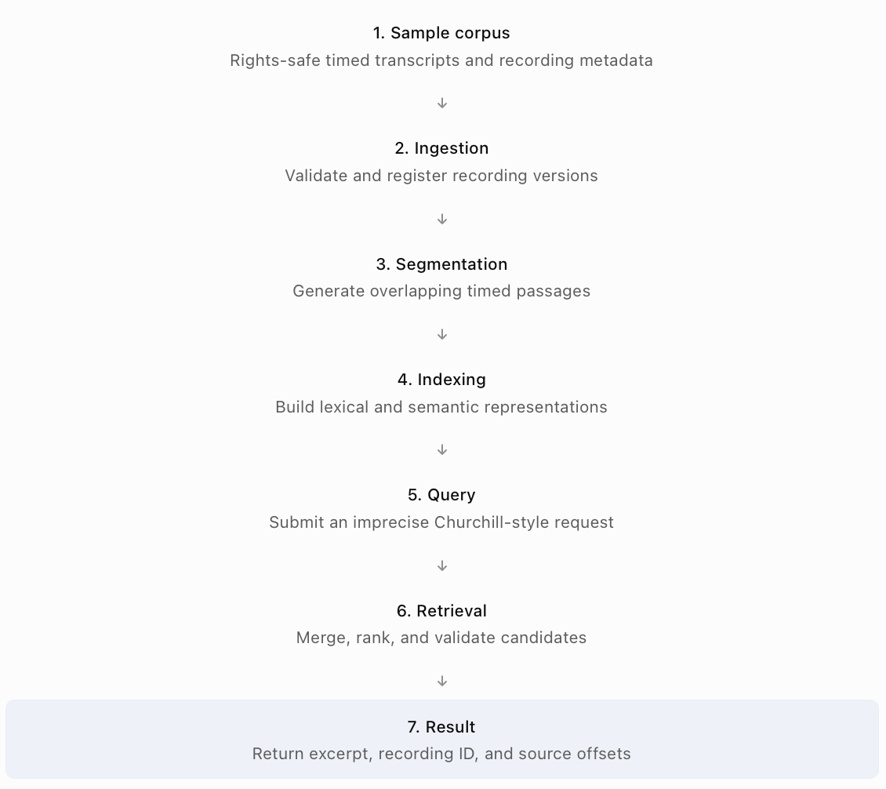
The demonstration must be executable from documented instructions without manual database edits or undocumented preparation.

Recommended Implementation Scope
The core proof of concept should include:
Component | Required behaviour
Sample ingestion | Import representative recording metadata and timed transcript fixtures
Schema validation | Reject malformed identifiers, invalid timing, and missing required fields
Segmentation | Generate sentence-aware overlapping passages with source-derived offsets
Search indexing | Create lexical and semantic indexes, or a clearly documented local equivalent
Query interface | Provide a CLI or simple API for natural-language search
Hybrid retrieval | Combine lexical and semantic candidate results
Ranking and grouping | Rank relevant results and group overlapping passages appropriately
Result formatting | Return title, recording version, excerpt, start/end, and access status
Tests | Verify timestamp integrity, version handling, filtering, and core retrieval
Documentation | Explain execution, architecture, dependencies, limitations, and next steps
An optional demonstration interface may be added if it materially improves the customer-facing presentation. It should not take priority over a reliable end-to-end retrieval implementation.

Local and Production Architecture Relationship
The production design may use Transcribe, Bedrock, S3, Step Functions, Fargate, and MongoDB Atlas. The proof of concept can use a simpler execution environment, provided the relationship between demo components and their production counterparts is explicit.
Production capability | Possible PoC implementation
S3 media/transcript ingestion | Local sample files
Amazon Transcribe | Pre-generated timed transcript fixtures or an optional transcription adapter
Step Functions orchestration | Deterministic local pipeline command
ECS media processing | Optional local FFmpeg execution
Bedrock embeddings | Configured embedding provider or documented local embedding model
MongoDB Atlas | Atlas instance or local lexical/vector search equivalent
API Gateway and Lambda | Local CLI or lightweight API
NHA identity system | Test entitlement context and simulated roles
Physical retrieval integration | Explicitly simulated offline request outcome
These are implementation options, not claims about what has already been built.
The chosen version should balance external dependencies, evaluator reproducibility, and fidelity to the target architecture.

Suggested Repository Structure
find-the-moment/
├── README.md
├── pyproject.toml
├── .env.example
├── configs/
│ └── pipeline.yaml
├── data/
│ └── sample/
│ ├── manifest.json
│ └── transcripts/
├── src/
│ └── find_the_moment/
│ ├── models/
│ ├── ingest/
│ ├── transcription/
│ ├── segmentation/
│ ├── enrichment/
│ ├── indexing/
│ ├── retrieval/
│ ├── ranking/
│ ├── delivery/
│ └── cli.py
├── tests/
│ ├── test_ingestion.py
│ ├── test_segmentation.py
│ ├── test_retrieval.py
│ ├── test_versions.py
│ └── test_permissions.py
├── scripts/
│ ├── build_index.py
│ └── run_demo.py
└── docs/
├── architecture.md
├── decisions.md
└── limitations.md
The structure separates data contracts, processing, retrieval, and delivery concerns so that individual components can be changed without rewriting the whole application. Unimplemented production modules should not be filled with misleading placeholder implementations merely to match the target architecture.

Sample Dataset Design
The demonstration corpus should include enough variation to prove more than basic exact-phrase lookup.
Recommended fixtures are:
- A Churchill-related timed passage suitable for vague semantic retrieval.
- An unrelated historical or public-domain recording to test ranking.
- An alternate edited version with different timestamps.
- A recording with missing or conflicting catalogue information.
- A transcript with incomplete timing coverage.
- An offline or restricted asset to test availability and permissions.
The dataset may use rights-safe synthetic or curated transcript fixtures where authentic media is unavailable. Any synthetic transcript, recording identity, or timestamp must be clearly labelled. The repository must not suggest that fabricated timing values came from genuine NHA recordings.

Demonstration Acceptance Criteria
ID | Acceptance criterion | Required evidence
AC-01 | Sample records ingest successfully | Reproducible command and successful output
AC-02 | Segments preserve source timing | Automated boundary tests
AC-03 | Search index is built from scratch | Repeatable indexing command
AC-04 | Vague query retrieves relevant passage | CLI/API output
AC-05 | Results identify recording version | Explicit source-version field
AC-06 | Restricted content is excluded appropriately | Permission test cases
AC-07 | No-match behaviour is supported | Negative query demonstration
AC-08 | Running ingestion twice does not create uncontrolled duplicates | Idempotency test
AC-09 | Repository is understandable and maintainable | README, modular structure, and tests

Explicit Proof of Concept Limitations
The repository does not need to deliver archive-wide ingestion, comprehensive ASR benchmarking, production rights adjudication, live physical-media retrieval, full security infrastructure, or a distributed cloud orchestration deployment. Those capabilities belong to the target architecture and phased implementation roadmap.

Evaluation & Acceptance Criteria
The pilot must demonstrate that Find the Moment produces useful, accurate, secure, and operationally sustainable results. A successful demo alone is not sufficient evidence of production readiness. Evaluation should measure the quality of recording identification, passage retrieval, timestamp precision, permissions, response latency, and processing cost.

Evaluation Dataset
The working proposal assumes approximately 100 recordings and 50 media hours for the controlled pilot. The evaluation dataset should include clean and degraded audio, incomplete transcripts, multilingual content, edited versions, metadata conflicts, restricted assets, and offline recordings.
Archivists and representative users should construct judged natural-language queries with expected source recordings and passage intervals. The preliminary split is 60 development queries and 40 held-out evaluation queries. Recording families and closely related edited versions should be kept together when splitting data to reduce leakage between development and evaluation sets.

Retrieval Quality Metrics
- Recording Recall@5: Measures how often the correct source recording appears among the first five recording candidates.
$Recall@5{=}\frac{\text{Queries with a relevant recording in top 5}}{\text{Queries with at least one relevant recording}}$Proposed initial target: at least 90%.
- Segment Recall@5: Measures whether at least one of the first five returned segments contains the passage requested by the user. Proposed initial target: at least 80%.
- Timestamp boundary accuracy: For manually validated passage boundaries, measure the absolute error between reference and predicted start/end times.
$$E_{\text{start}}=\left|t_{\text{pred,start}}-t_{\text{ref,start}}\right|$$
$$E_{\text{end}}=\left|t_{\text{pred,end}}-t_{\text{ref,end}}\right|$$

The initial target is at least 90% of evaluated boundaries within two seconds of the reference. The reported results should distinguish starts, ends, and passage overlap, rather than hiding different error types behind one metric.

Additional Quality Measurements
Metric | Purpose
Precision@5 | Evaluate how much irrelevant content appears in top results
Mean Reciprocal Rank | Evaluate how highly the first relevant result is ranked
No-answer correctness | Confirm unsupported queries do not produce invented matches
Transcript coverage | Measure how much of each recording has usable timed evidence
Word Error Rate | Evaluate transcription quality against human references
Segment overlap | Compare returned passage interval with manually marked references
Version accuracy | Verify that the correct source edition and timeline are used
Permission isolation | Confirm unauthorised content is excluded
Review rate | Measure the proportion of results requiring archivist intervention
Metrics should be reported by relevant language, recording condition, and collection. Overall averages alone can conceal failures affecting particular archival groups.

Latency Targets
The initial proposal targets warm-search p95 latency of no more than five seconds at ten concurrent users. The measurement should include authentication/authorisation, query preparation, retrieval, ranking, and response generation.
It should exclude asynchronous physical-media retrieval and separately requested clip export. Cold-start latency, query failures, and model-service throttling should be reported separately.

Security Acceptance Tests
The pilot must verify that restricted content does not leak through lexical matches, vector results, transcript excerpts, cached responses, or preview links.
Test cases should include:
- Authorised versus unauthorised users.
- Collection-specific access.
- Entitlement changes and revocation.
- Expired or reused media links.
- Restricted content appearing in semantic search candidates.
- Requests involving unknown or conflicting rights.
Any confirmed unauthorised exposure is a release-blocking defect until remediated and retested.

Evaluation Procedure
The proposed procedure is:
- Establish a frozen, documented evaluation corpus.
- Record baseline retrieval performance, including lexical-only search.
- Measure hybrid retrieval against the same queries.
- Evaluate timestamp precision and version identity.
- Test challenging conditions and negative queries.
- Measure latency and estimated running cost.
- Review errors with NHA stakeholders.
- Record whether agreed acceptance gates are met.
Changes to segmentation, embeddings, fusion, or reranking should be assessed against the same held-out evaluation methodology.

Pilot Exit Criteria
The pilot can progress only when NHA has accepted the agreed retrieval, timing, security, operational, and cost evidence.
Proposed targets from the working documents are:
Criterion | Initial target
Recording Recall@5 | ≥90%
Segment Recall@5 | ≥80%
Timestamp boundaries | ≥90% within ±2 seconds
Warm-search p95 | ≤5 seconds at ten concurrent users
Permission tests | No unauthorised exposure
No-answer queries | Explicit no-match or review outcome
Reproducibility | Repeatable pipeline and documented evaluation
Operational readiness | Runbooks, owners, and recovery procedures accepted
These thresholds remain subject to NHA agreement. The 40-query holdout should be regarded as an initial signal, not conclusive proof of production performance across a century of material.

RAID & Dependencies
The RAID register captures risks, assumptions, issues, and dependencies that influence the proposed design. It is intended to make uncertainty visible rather than presenting architectural decisions as customer-approved facts. The register should be reviewed during discovery and updated as the engagement progresses.

Assumptions
ID | Assumption | Validation or contingency
AS-01 | Approved content may be processed within an NHA-approved AWS Region. | Confirm residency and classification. Use approved local processing or exclude affected content if necessary.
AS-02 | The initial pilot contains 100 recordings representing approximately 50 media hours. | Confirm sample volume and composition with NHA; revise capacity and cost estimates if needed.
AS-03 | The pilot includes mostly English speech and smaller representative multilingual samples. | Validate the language inventory and adapt model selection.
AS-04 | Stable custody and recording-version identifiers are available or can be established. | Reconcile missing identifiers before reliable publication.
AS-05 | Pretrained transcription and embedding models provide a useful initial baseline. | Benchmark representative data before accepting the model choices.
AS-06 | MongoDB Atlas on AWS is acceptable to NHA's platform and procurement teams. | Evaluate an AWS-native alternative if rejected.
AS-07 | Only selected access copies need immediate online availability. | Confirm availability and service-level expectations.
AS-08 | Existing transcripts may contain useful text but lack trustworthy alignment. | Preserve source transcripts and validate timing before precise clip claims.

Risk Register
Risk ratings describe proposed inherent risk before mitigation; they are not findings from a completed NHA assessment.
ID | Risk | Rating | Mitigation
R01 | Poor audio causes incorrect transcript content or offsets | High | Quality evaluation, source preservation, review flags, validated alignment
R02 | AI enrichment introduces unsupported historical facts | High | Evidence spans, structured validation, separation from authoritative metadata
R03 | Restricted information leaks through search or preview | High | Entitlement filters, response rechecks, revocation testing, sensitive-content isolation
R04 | Processing violates residency restrictions | High | Approved regional endpoints, supplier verification, routing controls
R05 | Incorrect recording version causes invalid clip boundaries | High | Version-specific IDs, timing validation, duplicate review
R06 | Unsupported or mixed languages reduce retrieval quality | Medium | Language-specific testing, coverage indicators, alternative transcription
R07 | Processing backlog or model calls exceed budget | Medium | Rate limits, cost monitoring, controlled batch processing
R08 | Offline retrieval delays delivery | Medium | Availability indicators, tracked retrieval workflow, archive-defined service levels
R09 | Partial processing publishes inconsistent indexes | High | Staged revisions, idempotency, publication validation, rollback
R10 | Small evaluation set produces misleading quality results | Medium | Held-out evaluation, difficult cases, results broken down by data condition

Current Issues and Design Limitations
The following are known information gaps and design boundaries at submission time, not observed production incidents.
ID | Issue or limitation | Required resolution
I01 | Total archive volume, workload, and budget are unconfirmed. | Discovery and representative sizing
I02 | Catalogue and recording dates may conflict. | Preserve provenance and establish review policy
I03 | Initial retrieval is predominantly transcript-led. | Introduce visual indexing only after a validated requirement
I04 | Timed transcription may be incomplete or inaccurate. | Evaluate alignment and support manual review
I05 | Edited versions may be difficult to reconcile automatically. | Preserve distinct identities and require review where ambiguous
I06 | Search results do not guarantee immediate master-media availability. | Define retrieval status and operational service levels
I07 | Production performance and operational readiness are unverified. | Obtain test evidence, benchmarks, and deployment acceptance

Business Dependencies
ID | Dependency | Proposed owner
D-B01 | Rights-cleared pilot recordings, catalogue exports, and custody references | Archive lead
D-B02 | Data classification, rights, retention, and residency approval | Security/records owner
D-B03 | Judged queries with recording and passage references | Archivists and representative users
D-B04 | Defined physical retrieval and approval workflow | Archive operations
D-B05 | Agreed retrieval, latency, cost, and support targets | NHA product/service owner
D-B06 | Staff capacity for review, operations, and handover | NHA management/service owner

Technical Dependencies
ID | Dependency | Validation
D-T01 | AWS account, Region, networking, IAM, encryption, and audit configuration | Approved environment and connectivity tests
D-T02 | Transcribe and Bedrock access, model availability, and quotas | Regional smoke tests and model benchmarks
D-T03 | MongoDB Atlas deployment and search indexes | Connectivity, search, filtering, backup and restore tests
D-T04 | Reproducible media-processing environment | FFmpeg format and timebase validation
D-T05 | Stable schemas, IDs, processing revisions, and adapters | Contract and migration tests
D-T06 | Automated functional and security tests | Repeatable CI execution
D-T07 | Monitoring, incident routing, and recovery procedures | Runbook exercises and restore testing
D-T08 | Accessible and reproducible GitHub repository | Clean setup and evaluator access test

Open Customer Decisions
The most important unresolved questions are:
ID | Customer decision | Design impact
OQ-01 | Which users and content classes may discover, preview, request, or export media? | Rights and authorisation design
OQ-02 | What are the actual source volumes, media formats, and languages? | Processing model, cost, and capacity
OQ-03 | Is the primary goal immediate research preview or broadcast-ready delivery? | Delivery workflows and service-level expectations
OQ-04 | Which identifiers connect digital media, catalogue entries, and physical custody? | Provenance and version integrity
OQ-05 | Which quality metric matters most to NHA users? | Evaluation and acceptance priorities
OQ-06 | Which locations and external services may process sensitive recordings? | Deployment and AI provider selection

