UTPL Safety Management System

Company Name | Udupi Tollway Pvt Ltd
Date | July 15, 2026
Confidentiality | Internal use only. Do not distribute outside authorized UTPL stakeholders.

Confidentiality Statement
This document describes application architecture, workflows, security behavior, data models, APIs, deployment settings, and maintenance guidance for the UTPL Safety Management System. Environment variable names are documented, but secret values are intentionally not exposed.

Document Control
Item | Value
Document owner | UTPL project stakeholders / safety system maintainers
Scope | Backend API, MongoDB models, React admin panel, Expo mobile app, uploads, reports, security, and deployment configuration
Inspection boundary | Local project files under safety-system; source code was not modified
Design preset | compact_reference_guide: Calibri 11 pt, blue headings, fixed-width tables, US Letter, 1 in margins

Executive Summary
The UTPL Safety Management System is an enterprise HSE application for controlling highway work approvals, hazard and near-miss reporting, training media, reporting, user governance, and operational dashboard analytics. The active production path is a modular Node.js/Express backend under backend/src, a React admin panel under admin-panel, and an Expo React Native mobile app under mobile-app.
The backend exposes REST APIs under /api/v1, persists data in MongoDB through Mongoose models, stores upload metadata in MongoDB, and stores physical media either in Cloudinary or the local uploads directory depending on environment configuration. Authentication is JWT based, using access tokens in the Authorization header and refresh tokens stored as hashed SessionToken records.
The inspected implementation contains robust security middleware, role-based and page-level permissions, audit logging, dashboard aggregation, report data endpoints, client-side PDF/CSV/Excel export, and media preview fallback behavior. The code also contains legacy root-level Mongoose models and some client compatibility fallbacks, but the active application is the modular backend and the current React/Expo clients.
Capability | Verified implementation
Authentication | JWT access token, refresh token rotation, bcrypt password hashing, login attempt lockout, CSRF token support for cookie flows
Authorization | Role defaults plus user-specific page/module permissions; backend authorization middleware enforces view/create/update/delete decisions
Work approvals | Create with before images, edit submitted details, approve/reject/status update, complete only by uploading after image, timeline/history/signature/comment support
Hazards and near miss | Hazard and Near Miss are represented through the hazard category field; evidence and closure images support closure workflow
Training | Training records store thumbnails/videos, role recommendations, user completion progress, certificates, and watch history
Reports | Backend data endpoints plus client-side Excel, CSV, and PDF generation
Dashboard | Live KPI aggregation across users, work approvals, hazards, training, and audit logs

1. Project Introduction
The project exists to give UTPL operational teams a single system for safety governance across work approvals, hazards, near-miss logging, training awareness, reporting, and management-level visibility. The codebase is designed as a production-style web and mobile application backed by a secure REST API and MongoDB.
Project fact | Evidence from inspection
Root entry point | server.js requires ./backend/src/server and is used by deployment scripts.
Backend app | backend/src/app.js applies security middleware, serves uploads, applies CSRF protection, mounts /api/v1 routes, and installs not-found/error handlers.
Database | MongoDB via Mongoose. backend/src/config/db.js requires MONGODB_URI and includes safer logging for Atlas authentication failures.
Admin panel | admin-panel is a React 19 CRA app using Tailwind, Framer Motion, Recharts, Axios, xlsx, file-saver, jsPDF, jspdf-autotable, and lucide-react.
Mobile app | mobile-app is an Expo SDK 54 / React Native app using bottom tabs, AsyncStorage, image picker, Expo notifications, Expo video, and React Native chart kit.
Uploads | uploads contains local image/video files. backend/src/utils/uploads.js writes local files when Cloudinary is absent or development Cloudinary upload fails.

Business Objectives
- Reduce manual tracking of work permits, safety actions, closure images, and report exports.
- Provide leadership and safety teams with real-time KPIs for work, hazard, training, and user activity.
- Maintain auditable records of user creation, login activity, work status changes, hazard closures, training uploads, and report activity.
- Support both desktop administration and mobile field usage through shared backend APIs.
- Preserve evidence images and videos through a storage abstraction that can use Cloudinary or local uploads.

Scope
In scope | Current implementation
Frontend | React admin panel with dashboard, work, hazards, training, users, reports, settings, notifications, media modals, PDF/export utilities
Backend | Express 5 API, security middleware, RBAC, validation, uploads, dashboard/report services, notifications, audit logging
Mobile | Expo mobile app with authenticated tabs for dashboard, work, hazards, training, reports, users, settings
Database | Mongoose models for User, WorkApproval, Hazard, Training, CompanySettings, SessionToken, Notification, AuditLog
Legacy artifacts | Root-level models and legacy client fallbacks exist for compatibility but are not the active modular backend path

2. System Overview
A typical system lifecycle begins when a user opens the admin panel or mobile app, authenticates through the backend, receives an access token, and then uses module-specific screens. Every protected API request passes through authentication middleware and permission middleware before reaching the route handler. Route handlers validate payloads, read or write Mongoose models, store uploaded assets when required, generate audit logs, and return JSON for the clients to render.
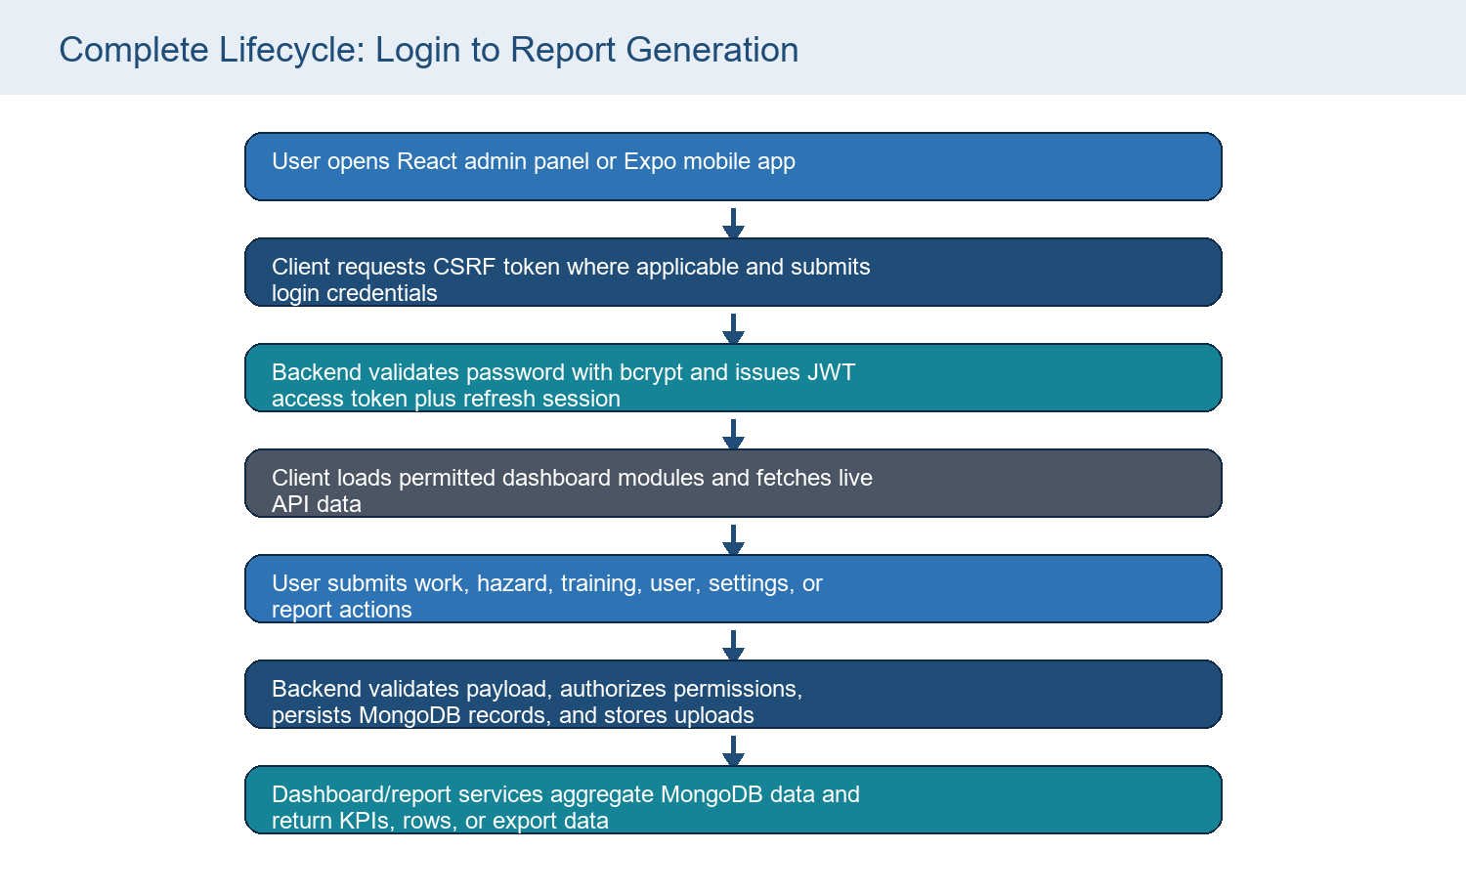
Figure 1. Complete application lifecycle

Primary Users
Audience | System relevance
VP / Head Office | Review dashboard KPIs, safety performance, report exports, governance posture, and future improvement plan.
Project Manager | Monitor work approvals, status transitions, reports, delays, and completion evidence.
Safety Team | Create hazards, near misses, corrective actions, closures, training materials, and field evidence.
Developers | Maintain backend APIs, React pages, mobile screens, models, validators, middleware, and deployments.
Future Maintenance Team | Operate environment variables, storage, deployments, backups, permissions, and troubleshooting workflows.

Operational Flow
- Authenticate through /api/v1/auth/login.
- Load /api/v1/auth/me to resolve role, status, permissions, and profile metadata.
- Show only permitted modules in the sidebar or mobile tabs.
- Perform module actions such as work creation, hazard closure, training upload, user governance, settings updates, or report generation.
- Persist records in MongoDB and assets in Cloudinary or local uploads.
- Refresh dashboard and report views from backend aggregation endpoints.
- Export reports from client-side PDF, Excel, or CSV utilities when requested.

3. Overall Architecture
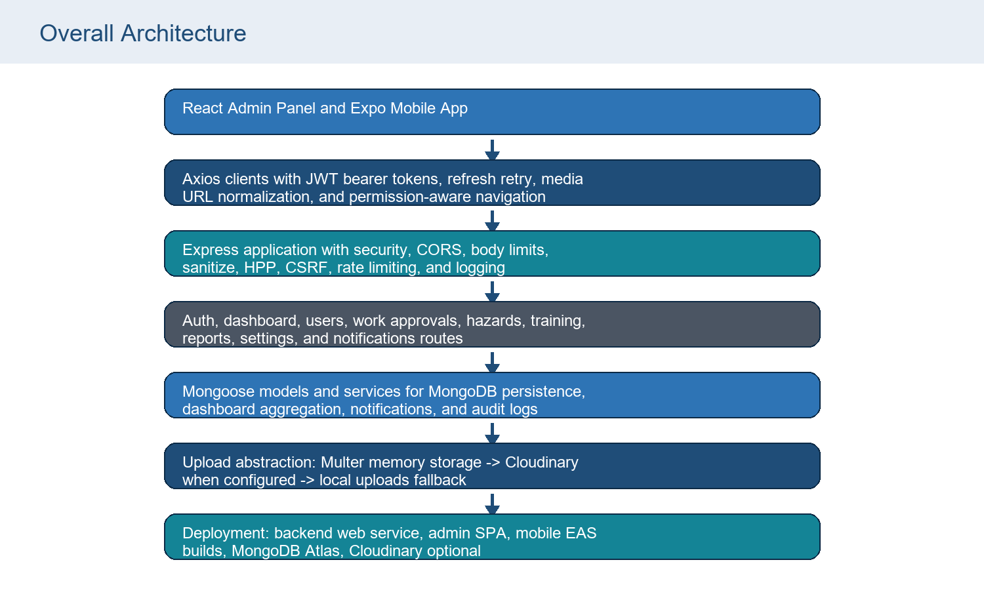
Figure 2. Architecture from frontend to storage and reports
Layer | Files | Role
Frontend web | admin-panel/src/App.js, pages, api/client.js, api/services.js | Renders authenticated enterprise admin console and calls backend APIs.
Mobile | mobile-app/App.js, navigation/AppNavigator.js, api/client.js, api/services.js | Field-focused mobile UI using the same backend API.
Backend | backend/src/app.js, server.js, routes, middleware, services, utils | Secures requests, validates payloads, handles business workflows, and returns JSON.
Database | backend/src/models/*.js | MongoDB collections modeled through Mongoose schemas.
Media | backend/src/utils/multer.js, uploads.js, app.js /uploads static handling | Validates, stores, serves, redirects, or placeholders upload assets.
Reports | backend/src/routes/reports.routes.js, admin-panel/src/utils/pdfExport.js | Serves report rows and analytics; clients export Excel, CSV, and PDF.

Architecture Clarification
The root package runs the backend through root server.js. The active backend package is not a separate npm package; it uses the root package.json dependencies and scripts.

4. Technology Stack
Technology | Used for | Why / evidence
Node.js / CommonJS | Backend runtime and module system | Root package.json declares type commonjs and backend files use require/module.exports.
Express 5.2.1 | REST API framework | Defines app, route namespaces, middleware stack, static uploads, and error handlers.
MongoDB / Mongoose 9.6.1 | Database and schema layer | All active backend models are Mongoose schemas under backend/src/models.
bcryptjs | Password hashing | Auth and user creation routes hash and compare passwords.
jsonwebtoken | Access and refresh tokens | Token utilities sign/verify access and refresh JWTs.
Zod | Request validation | Validators define payload constraints for auth, users, work, hazards, training, and settings.
Multer | Multipart upload handling | Memory upload utilities validate MIME types, file sizes, and file counts.
Cloudinary SDK | Optional production media storage | Upload helper uses Cloudinary when configured; otherwise local fallback.
Helmet, CORS, HPP, rate-limit, sanitize | Security middleware | Applied in backend/src/middleware/security.middleware.js.
React 19 / CRA | Admin panel | Single-page enterprise UI under admin-panel/src.
Tailwind CSS | Admin styling | Theme config extends fonts, colors, shadows, and animation tokens.
Framer Motion | Admin animation | Used across app shell, login, dashboard, and cards.
Recharts | Admin charts | Dashboard and reports render pies, bars, lines, areas, and radial bars.
Axios | API client | Admin and mobile clients add auth headers and retry behavior.
xlsx, file-saver, jsPDF, jspdf-autotable | Client-side report exports | Reports and detail PDF export utilities generate downloads in browser.
Expo / React Native | Mobile app | Mobile field app with dark theme, bottom tabs, image picker, notifications, and video.
Render / Vercel / EAS | Deployment surfaces | README and config files describe backend web service, admin SPA rewrite, and Android builds.

Environment Variables
Variable | Purpose
NODE_ENV | Controls production behavior such as HTTPS enforcement and secure cookies.
PORT | Backend listening port; defaults to 5000.
BACKEND_PUBLIC_URL | Public backend base URL used for upload references.
FRONTEND_URL | Allowed CORS origins. Supports comma-separated values in backend config.
MONGODB_URI | MongoDB connection string. Secret value must never be exposed in documentation.
JWT_ACCESS_SECRET / JWT_REFRESH_SECRET | JWT signing secrets. Production startup rejects default change-me values.
JWT_ACCESS_EXPIRES_IN / JWT_REFRESH_EXPIRES_IN | Access and refresh token lifetime strings such as 15m and 7d.
BCRYPT_ROUNDS | Password hashing cost; default 12.
RATE_LIMIT_WINDOW_MS / RATE_LIMIT_MAX | Global API rate-limit window and max request count.
SESSION_TIMEOUT_MINUTES | Settings/session timeout default.
CLOUDINARY_CLOUD_NAME / API_KEY / API_SECRET / UPLOAD_FOLDER | Optional Cloudinary storage configuration.
SMTP_HOST / SMTP_PORT / SMTP_USER / SMTP_PASS / SMTP_FROM | Email/OTP delivery configuration.
REACT_APP_API_URL | Admin panel API override.
EXPO_PUBLIC_API_BASE_URL | Mobile app API override.

Secret Handling
Only variable names are documented. No actual .env secret values are included.

5. Folder Structure
Path | Purpose | Important contents
backend/src/config | Runtime configuration | env.js, db.js
backend/src/middleware | Cross-cutting request controls | auth, RBAC, permissions, validation, security, CSRF, rate limits, audit, errors
backend/src/models | Active MongoDB models | User, WorkApproval, Hazard, Training, CompanySettings, SessionToken, Notification, AuditLog
backend/src/routes | API endpoints | auth, dashboard, users, work, hazards, training, reports, settings, notifications
backend/src/services | Business services | dashboard aggregation, notifications, email/OTP service hooks, auth helpers
backend/src/utils | Shared helpers | uploads, multer, tokens, reporting, chainage, logger, errors
backend/scripts | Maintenance scripts | migrate-work-chainage-range.js
admin-panel/src/pages | Admin module screens | Dashboard, WorkApprovals, Hazards, Training, Users, Reports, Settings, Login
admin-panel/src/api | Admin API layer | Axios client, service wrappers, legacy fallback adapters
admin-panel/src/components | Admin UI building blocks | layout, common, modals, settings, dashboard, visuals, brand
admin-panel/src/utils | Admin client utilities | media, permissions, chainage, alerts, PDF/export helpers, formatting
mobile-app/src/screens | Mobile screens | Dashboard, Work, Hazard, Training, Reports, Users, Settings, Login
mobile-app/src/api | Mobile API layer | Axios client, services
mobile-app/src/context | Mobile state providers | AuthContext, NetworkContext
uploads | Local upload storage | Persisted image/video assets when Cloudinary is absent or used as fallback
models | Legacy/simple schemas | Root-level old User, Work, Hazard, Incident, Training, CompanySettings schemas

Legacy Folder Note
The root models folder is documented because it exists in the repository. The active backend uses backend/src/models; root server.js delegates to backend/src/server.

6. Authentication
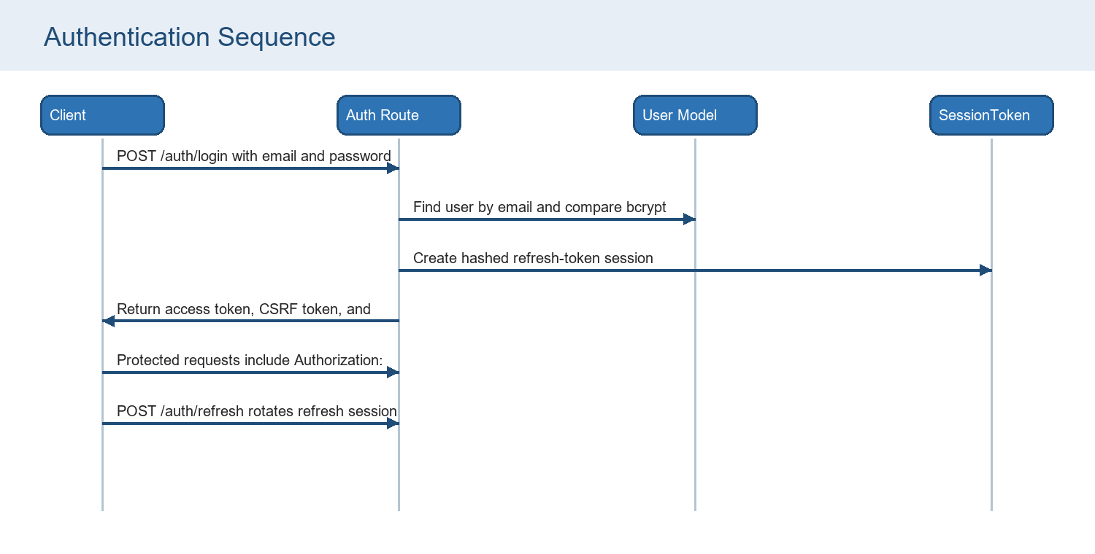
Figure 3. Authentication sequence
Authentication element | Implementation
Login | POST /api/v1/auth/login validates email/password, rate-limits login attempts, records login history, resets failed attempt counters on success, and returns token/user.
JWT access token | Signed with JWT_ACCESS_SECRET and expires according to JWT_ACCESS_EXPIRES_IN.
Refresh token | Signed with JWT_REFRESH_SECRET, stored in httpOnly cookie for web flows, and hashed into SessionToken with expiry and revokedAt.
Password hashing | bcryptjs with env.bcryptRounds during create/register/reset and bcrypt.compare at login.
Protected routes | auth.middleware.js verifies bearer token, loads user, blocks inactive status, and attaches role/permissions to req.user.
CSRF | csrf.middleware.js issues hse_csrf_token and validates x-csrf-token for non-safe cookie-based mutations; bearer flows bypass CSRF.
Logout | Revokes matching refresh token hash, clears refreshToken and hse_csrf_token cookies, returns success.
Session handling | Admin stores access token and normalized user in localStorage; mobile stores access/refresh/user in AsyncStorage.
2FA/OTP support | User model and auth.service include OTP fields and email helper, but current auth.routes login flow does not expose OTP verification endpoints.

7. User Roles
Role | Dashboard | Users | Work | Hazards | Training | Reports | Settings | Notifications | Notes
super_admin | Full | Full | Full | Full | Full | Full | Full | Full | Can modify Super Admin permissions only when current user is also Super Admin.
admin | View | Manage | Manage | Manage | Manage | View | Update | Manage | Admin can delete work/hazards through role-specific authorization.
safety_manager | View | View | Operate | Operate | Operate | View | No | Operate | Safety operational role without settings access.
supervisor | View | No | Operate | Operate | Progress | View | No | Update own notifications | Field supervisory role with partial operational access.
user | View | No | Create | Create | Progress | No | No | Update own notifications | Basic user can submit work/hazard and consume training.
viewer | View | No | View | View | View | View | No | View | Read-mostly role.

Backend role defaults live in backend/src/constants/roles.js. Page-level permissions are normalized in permission.middleware.js. The admin panel uses page-level permissions to hide or show sidebar modules, while backend middleware remains the authoritative enforcement layer.
Prompt Alignment
The user prompt named Admin, Safety Officer, User, and Viewer. The actual code contains super_admin, admin, safety_manager, supervisor, user, and viewer. This document uses the implemented roles and maps safety officer responsibilities primarily to safety_manager and supervisor.

8. Dashboard
Dashboard card | Data source | Calculation
Total Users | User.find() | Total User records.
Active Users | User.find() | Users with status active.
Total Work Approvals | WorkApproval.find() | All work approval records.
Pending Work | WorkApproval.find() | Work records with status Pending.
Approved Work | WorkApproval.find() | Work records with status Approved.
Completed Work | WorkApproval.find() | Work records with status Completed.
Total Hazards | Hazard.find() | All hazard records.
Open Hazards | Hazard.find() | Hazards whose status is not Closed.
Closed Hazards | Hazard.find() | Hazards with status Closed.
Training Records | Training.find() | All training records returned to dashboard service.

Dashboard Charts
Chart | Backend calculation | Frontend rendering
Work Status | Counts Pending, Approved, Completed, Rejected work statuses. | Admin uses Recharts PieChart; mobile uses chart-kit PieChart.
Hazard Status | Counts Open and Closed hazards. | Admin uses Recharts BarChart; mobile uses chart-kit BarChart.
Monthly Trend | Six monthly buckets for work, hazards, and completed training records. | Admin uses Recharts LineChart; mobile uses chart-kit LineChart.
User Activity | Six monthly buckets based on lastLoginAt. | Admin uses Recharts AreaChart.
Safety Performance Score | 60% work completion rate and 40% hazard closure rate, capped at 100. | Admin uses Recharts radial bar; mobile hero shows safety score fallback when not present.
Recent Activities | Latest 15 AuditLog records mapped into messages. | Admin filters and combines with local report-export activities.

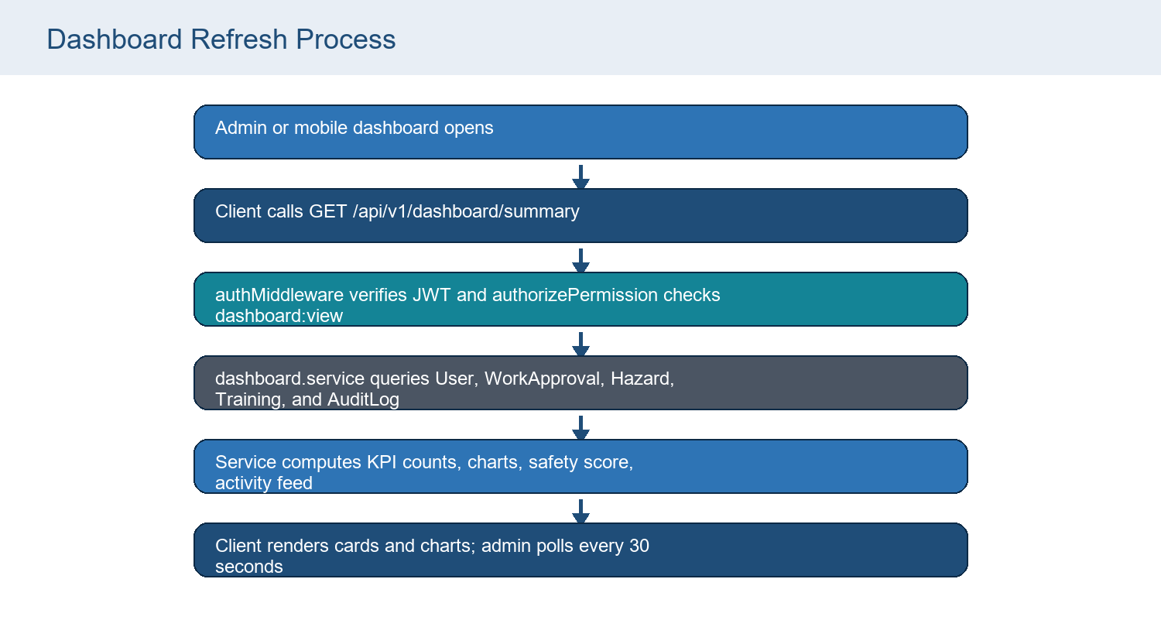
Figure 4. Dashboard data refresh

9. Work Approval Module
The Work Approval module manages safety-controlled work submissions. The current web workflow requires work type, location, chainage range, worker count, description, and at least one before image. Admin and Super Admin users can approve, reject, edit, delete, and complete records according to the UI and backend rules.
Field | Type / validation | Purpose
title | String required | Human-readable title; defaults from workType/location in route when absent.
workType | String required | Legacy work category such as Road Work or Lights Changing.
description | String | Work description, max 1000 in validator.
category | String | Defaults to General.
plaza | String | Optional plaza/site metadata.
location | String required | Location or area of work.
chainage / chainageNo | String legacy | Legacy single chainage aliases preserved for compatibility.
chainageFrom / chainageTo | String required | Current range fields. Validator rejects empty range and numeric reverse ranges.
workersCount | Number | Minimum 1 in validator; model default 0.
priority | Enum | Low, Medium, High, Critical; default Medium.
status | Enum | Pending, Under Review, Approved, Rejected, Completed.
beforeImages / afterImages | Asset arrays | Image evidence metadata with url, publicId, storage.
workflow | Array | Three default levels, each pending/approved/rejected with approver/comments/actedAt.
comments | Array | User-linked comments.
approvalHistory | Array | Action, by user, comment, timestamp.
timeline | Array | Display history labels and descriptions.
digitalSignatures | Array | SignedBy, role, signature text, signedAt.
createdBy / assignedTo | ObjectId refs | References User records.
startDate / dueDate | Date | Optional schedule metadata.

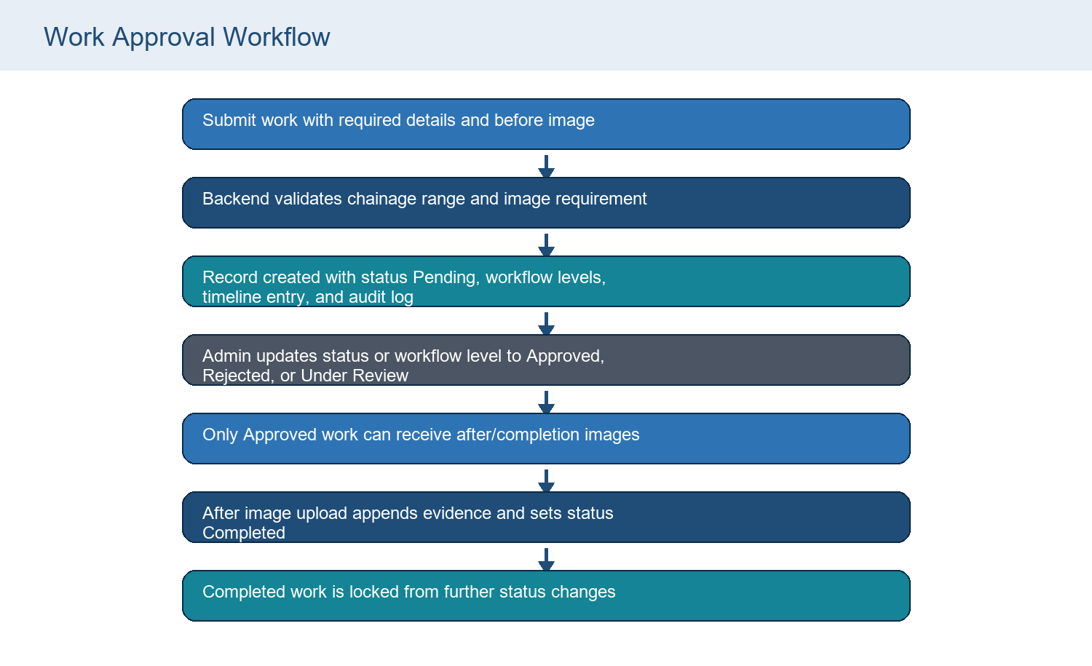
Figure 5. Work approval status lifecycle

10. Hazard and Near Miss Module
The active backend does not contain a separate near-miss route. Near Miss is implemented as a category within the Hazard module. The web admin exposes category options Hazard and Near Miss and sends the selected value to the same /hazards endpoints.
Field | Type / validation | Purpose
title | String required in model; route normalizes when absent | Hazard or Near Miss title.
description | String required in model; route normalizes when absent | Observation details.
category | String required | Implemented categories include Hazard and Near Miss from clients.
severity | Enum | Low, Medium, High, Critical.
likelihood | Enum | Rare, Possible, Likely, Almost Certain.
riskScore | Number | 0-25 validator; web computes severityWeight * likelihoodWeight.
date | Date | Observation date; defaults to now in route create.
plaza / location | String | Plaza/site and exact location or chainage.
action | String | Action team or action description.
status | Enum | Open, In Progress, Closed; legacy mapping returns Open unless Closed.
assignedTo / reportedBy | ObjectId refs | User relationships.
reportedByName | String | Legacy/manual reporter display name.
correctiveActions | Array | Action, owner, targetDate, status.
evidenceImages / closureImages | Asset arrays | Before/evidence and closure proof.
closureNotes | String | Required by close validator with at least two characters.
timeline | Array | Hazard history events.

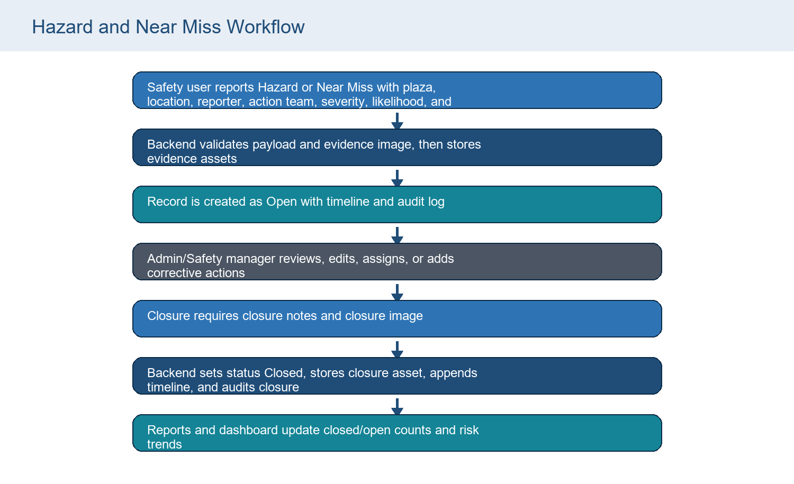
Figure 6. Hazard and Near Miss lifecycle
Mobile Alignment Required
mobile-app/src/api/services.js sends empty closureNotes during hazard close, while backend closeHazardSchema requires a non-empty corrective action. Add a closure-notes field to the mobile close workflow.

11. Training Module
Training is implemented as a media portal for safety concepts, streaming-style previews, progress tracking, certificates, and role-targeted notifications. Admin roles can upload and delete training concepts. Users can consume videos and update progress.
Field | Type / validation | Purpose
title | String required | Training title.
description | String required | Training description.
category | String required | Training category such as PPE, Electrical, Fire Safety, Road Safety.
thumbnail | Asset | Optional image asset uploaded through thumbnail field.
video | Asset | Video asset uploaded through video field.
tags | String array | Route parses comma-separated tags from string payload.
durationMinutes | Number | Optional duration metadata.
isPublished | Boolean | Soft-delete toggles this false.
createdBy | ObjectId User | Uploader/creator.
recommendedForRoles | String array | Notification targeting and recommendation filtering.
completions | Array | Per-user progress, completion status, completedAt, certificateUrl, watchHistory.

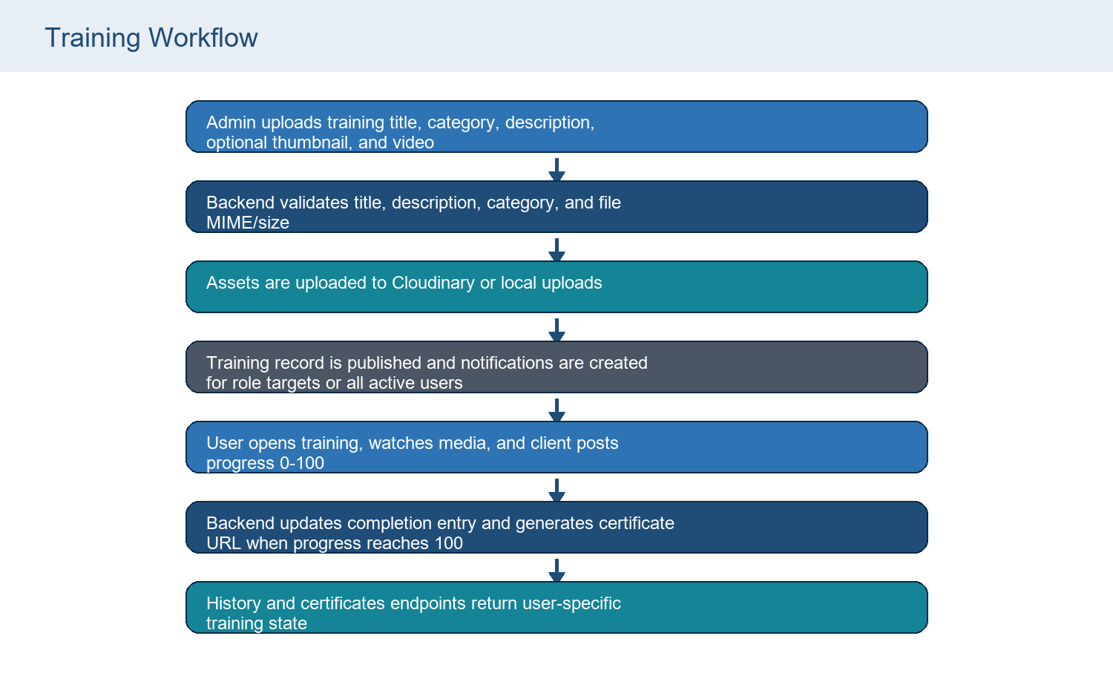
Figure 7. Training upload and completion workflow

12. Reports Module
The reporting module combines backend report-row endpoints and frontend export utilities. Backend endpoints provide work rows, hazard rows, analytics, and export datasets. The admin panel then formats reports into Excel, CSV, and PDF using xlsx, file-saver, jsPDF, and jspdf-autotable.
Report type | Data source | Filters / output
Work Report | GET /api/v1/reports/work | All work approval rows with date, plaza, type, description, location, chainage, workers, priority, status, reporter, approver, images.
Hazard Report | GET /api/v1/reports/hazard | All hazard rows with date, plaza, location, reporter, category, description, risk, action, action taken, status, images.
Analytics | GET /api/v1/reports/analytics?period= | Period values daily, weekly, monthly, yearly, all. Calculates totals, trend arrays, user performance, closure/completion rates.
Export | GET /api/v1/reports/export?format=&period= | CSV returns text/csv; PDF/Excel return rows and note for client-side rendering.
Client legacy generator | admin-panel reportService.generateLegacyReport | Date range, plaza, type filters applied client-side after fetching work/hazard rows.
Detail PDFs | detailPdfExport.js | Work and hazard detail PDFs include metadata, descriptions, timeline, and evidence/closure images where accessible.

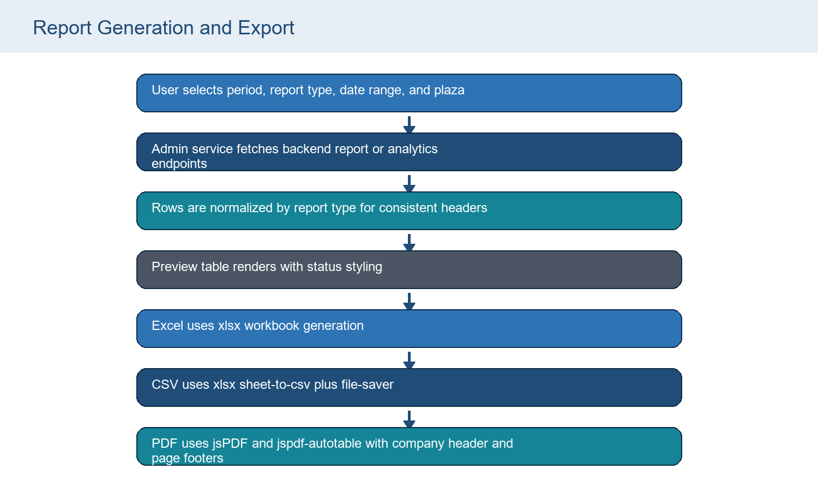
Figure 8. Report generation and export process

13. Image Upload System
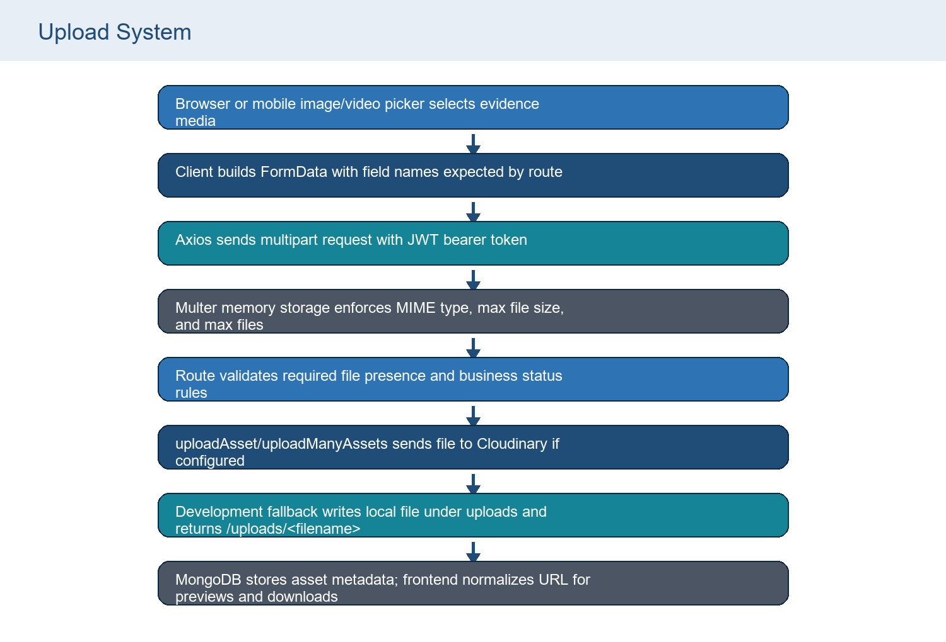
Figure 9. Browser to storage upload flow
Module | Upload fields | Limits / rules
Work create | beforeImages max 5; beforeImage max 1 | Image MIME only; 10 MB per file; at least one before image required.
Work completion | afterImages max 5; afterImage max 1 | Only Approved work can upload completion evidence; upload sets Completed.
Hazard create | evidenceImages max 6; beforeImage max 1 | Image MIME only; at least one evidence image required.
Hazard close | closureImages max 6; afterImage max 1 | Closure image and closureNotes required; Closed records are locked.
Training | thumbnail max 1; video max 1 | Image plus video MIME types; max 100 MB; thumbnail/video are uploaded in parallel.
User photo | profilePhoto max 1 | Image MIME only; 5 MB max.
Settings assets | logo, dashboardBanner, loginBackground | Image MIME only; company/branding folders.

Security Considerations
Multer validates MIME type and file size. The app still needs operational controls such as persistent storage, malware scanning for high-risk deployments, image/video optimization, and storage lifecycle management.

14. Database
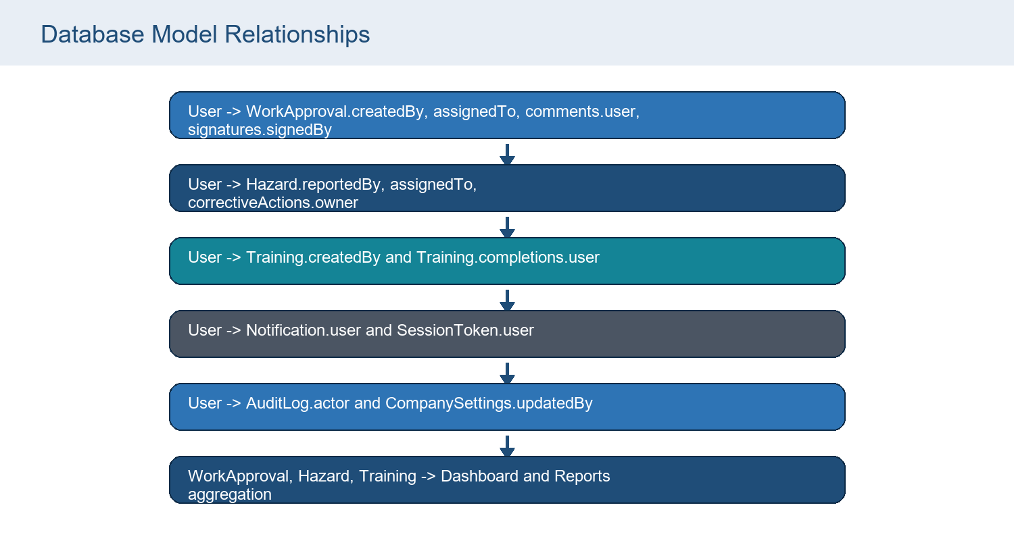
Figure 10. MongoDB model relationships

User
Field | Type / validation | Purpose
name | String required trim | Display name.
email | String required unique lowercase trim | Login identity.
mobile | String | Contact number.
password | String required | bcrypt hash.
role | Enum ROLES | super_admin/admin/safety_manager/supervisor/user/viewer.
status | active/blocked | Blocks auth when blocked.
profilePhoto | Asset object | url/publicId/storage.
permissions | Object | Page/module overrides.
lastLoginAt/loginHistory | Date/array | Login audit display.
failedLoginAttempts/lockedUntil | Number/Date | Login lockout.
otp fields | String/Date/Number/Boolean | OTP readiness for future 2FA.

WorkApproval
Field | Type / validation | Purpose
title | String required | Human-readable title; defaults from workType/location in route when absent.
workType | String required | Legacy work category such as Road Work or Lights Changing.
description | String | Work description, max 1000 in validator.
category | String | Defaults to General.
plaza | String | Optional plaza/site metadata.
location | String required | Location or area of work.
chainage / chainageNo | String legacy | Legacy single chainage aliases preserved for compatibility.
chainageFrom / chainageTo | String required | Current range fields. Validator rejects empty range and numeric reverse ranges.
workersCount | Number | Minimum 1 in validator; model default 0.
priority | Enum | Low, Medium, High, Critical; default Medium.
status | Enum | Pending, Under Review, Approved, Rejected, Completed.
beforeImages / afterImages | Asset arrays | Image evidence metadata with url, publicId, storage.
workflow | Array | Three default levels, each pending/approved/rejected with approver/comments/actedAt.
comments | Array | User-linked comments.
approvalHistory | Array | Action, by user, comment, timestamp.
timeline | Array | Display history labels and descriptions.
digitalSignatures | Array | SignedBy, role, signature text, signedAt.
createdBy / assignedTo | ObjectId refs | References User records.
startDate / dueDate | Date | Optional schedule metadata.

Hazard
Field | Type / validation | Purpose
title | String required in model; route normalizes when absent | Hazard or Near Miss title.
description | String required in model; route normalizes when absent | Observation details.
category | String required | Implemented categories include Hazard and Near Miss from clients.
severity | Enum | Low, Medium, High, Critical.
likelihood | Enum | Rare, Possible, Likely, Almost Certain.
riskScore | Number | 0-25 validator; web computes severityWeight * likelihoodWeight.
date | Date | Observation date; defaults to now in route create.
plaza / location | String | Plaza/site and exact location or chainage.
action | String | Action team or action description.
status | Enum | Open, In Progress, Closed; legacy mapping returns Open unless Closed.
assignedTo / reportedBy | ObjectId refs | User relationships.
reportedByName | String | Legacy/manual reporter display name.
correctiveActions | Array | Action, owner, targetDate, status.
evidenceImages / closureImages | Asset arrays | Before/evidence and closure proof.
closureNotes | String | Required by close validator with at least two characters.
timeline | Array | Hazard history events.

Training
Field | Type / validation | Purpose
title | String required | Training title.
description | String required | Training description.
category | String required | Training category such as PPE, Electrical, Fire Safety, Road Safety.
thumbnail | Asset | Optional image asset uploaded through thumbnail field.
video | Asset | Video asset uploaded through video field.
tags | String array | Route parses comma-separated tags from string payload.
durationMinutes | Number | Optional duration metadata.
isPublished | Boolean | Soft-delete toggles this false.
createdBy | ObjectId User | Uploader/creator.
recommendedForRoles | String array | Notification targeting and recommendation filtering.
completions | Array | Per-user progress, completion status, completedAt, certificateUrl, watchHistory.

CompanySettings
Field | Type / validation | Purpose
companyName | String | Default Enterprise Safety.
logo | Asset | Company logo.
address/contactInformation/gstNumber/website | Strings/object | Profile metadata.
branding | Object | themeSelection, accentColor, dashboardBanner, loginBackground.
security | Object | sessionTimeout, passwordPolicy, loginAttempts, twoFactorAuthentication.
updatedBy | ObjectId User | Last settings updater.

SessionToken
Field | Type / validation | Purpose
user | ObjectId User required | Session owner.
tokenHash | String required | SHA-256 refresh token hash.
userAgent/ip | String | Client/session metadata.
expiresAt | Date required TTL index | Automatic expiry through MongoDB TTL.
revokedAt | Date | Token rotation/logout revocation.

Notification
Field | Type / validation | Purpose
user | ObjectId User required | Recipient.
type | String required | work, hazard, training, user, etc.
title/message | String required | Display notification text.
data | Object | Linking metadata.
priority | low/medium/high | Notification urgency.
read | Boolean | Unread counts and mark-read.

AuditLog
Field | Type / validation | Purpose
actor | ObjectId User | User performing action, nullable.
action | String required | create, update, login, delete, etc.
module | String required | auth, users, work, hazards, training, reports, settings, notifications.
entityId | String | Affected entity id.
metadata | Object | Action payload summary.

15. Backend APIs
All active modular APIs are mounted under /api/v1 by backend/src/routes/index.js. Work routes are also mounted directly under /work for compatibility. The table below gives a quick catalog; detailed endpoint pages follow.
Method | Endpoint | Purpose | Auth
GET | /api/v1/auth/csrf | Issue CSRF token | Public
POST | /api/v1/auth/register | Create user through auth namespace | Bearer token; creator must be super_admin/admin
POST | /api/v1/auth/login | Authenticate user | Public with authRateLimiter
POST | /api/v1/auth/refresh | Rotate refresh session | Refresh token cookie or body
POST | /api/v1/auth/logout | Logout and revoke refresh token | Refresh token optional
GET | /api/v1/auth/me | Return current user | Bearer token
GET | /api/v1/dashboard/summary | Dashboard KPI summary | dashboard:view
GET | /api/v1/users | List users | users:view
POST | /api/v1/users | Create user | super_admin/admin
PUT | /api/v1/users/:id | Update user | users:update
PUT | /api/v1/users/:id/permissions | Update page permissions | super_admin/admin
DELETE | /api/v1/users/:id | Delete user | super_admin/admin
POST | /api/v1/users/:id/reset-password | Reset password | users:update
POST | /api/v1/users/:id/block | Block user | users:update
POST | /api/v1/users/:id/activate | Activate user | users:update
POST | /api/v1/users/:id/profile-photo | Upload profile photo | users:update
GET | /api/v1/users/:id/login-history | Fetch login history | users:view
GET | /api/v1/work-approvals | List work approvals | work:view
POST | /api/v1/work-approvals | Create work approval | work:create
GET | /api/v1/work-approvals/:id | Work approval details | work:view
PATCH | /api/v1/work-approvals/:id | Edit work details | work:update
PATCH | /api/v1/work-approvals/:id/workflow | Update workflow level | work:update
PATCH | /api/v1/work-approvals/:id/status | Update status | work:update
POST | /api/v1/work-approvals/:id/comments | Add comment | work:update
POST | /api/v1/work-approvals/:id/signatures | Add digital signature | work:update
POST | /api/v1/work-approvals/:id/images/after | Upload completion images | work:update
DELETE | /api/v1/work-approvals/:id | Delete work approval | super_admin/admin
GET | /api/v1/hazards | List hazards | hazards:view
POST | /api/v1/hazards | Create hazard/near miss | hazards:create
GET | /api/v1/hazards/:id | Hazard details | hazards:view
PATCH | /api/v1/hazards/:id | Edit hazard details | hazards:update
PATCH | /api/v1/hazards/:id/assign | Assign hazard | hazards:update
POST | /api/v1/hazards/:id/corrective-actions | Add corrective action | hazards:update
PATCH | /api/v1/hazards/:id/close | Close hazard | hazards:update
DELETE | /api/v1/hazards/:id | Delete hazard | hazards:delete
GET | /api/v1/training | List published training | training:view
POST | /api/v1/training | Create training | training:create
DELETE | /api/v1/training/:id | Soft-delete training | super_admin/admin
PATCH | /api/v1/training/:id/progress | Update progress | training:update
GET | /api/v1/training/history/me | My training history | training:view
GET | /api/v1/training/recommendations/me | My recommendations | training:view
GET | /api/v1/training/certificates/me | My certificates | training:view
GET | /api/v1/reports/work | Work report rows | reports:view
GET | /api/v1/reports/hazard | Hazard report rows | reports:view
GET | /api/v1/reports/analytics | Report analytics | reports:view
GET | /api/v1/reports/export | Export rows | reports:view
GET | /api/v1/settings | Get settings | settings:view
PUT | /api/v1/settings/profile | Update profile | settings:update
PUT | /api/v1/settings/branding | Update branding | settings:update
PUT | /api/v1/settings/security | Update security | settings:update
POST | /api/v1/settings/logo | Upload logo | settings:update
POST | /api/v1/settings/branding-assets | Upload branding assets | settings:update
GET | /api/v1/notifications | List notifications | notifications:view
PATCH | /api/v1/notifications/:id/read | Mark notification read | notifications:update
PATCH | /api/v1/notifications/read-all | Mark all read | notifications:update

15A. Endpoint Detail Pages

1. GET /api/v1/auth/csrf
Attribute | Detail
Purpose | Issue CSRF token
Authentication / authorization | Public
Request / validation | None
Response | success, csrfToken
Files used | csrf.middleware.js
Errors / notes | Used by admin client before login and mutating cookie flows.

2. POST /api/v1/auth/register
Attribute | Detail
Purpose | Create user through auth namespace
Authentication / authorization | Bearer token; creator must be super_admin/admin
Request / validation | registerSchema plus unique email
Response | created user summary
Files used | auth.routes.js, User, bcrypt, audit
Errors / notes | Admin bootstrap route was removed; this endpoint still requires authenticated admin.

3. POST /api/v1/auth/login
Attribute | Detail
Purpose | Authenticate user
Authentication / authorization | Public with authRateLimiter
Request / validation | loginSchema email/password
Response | access token, csrf token, user payload
Files used | auth.routes.js, User, SessionToken, bcrypt, tokens
Errors / notes | Tracks login history and account lockout.

4. POST /api/v1/auth/refresh
Attribute | Detail
Purpose | Rotate refresh session
Authentication / authorization | Refresh token cookie or body
Request / validation | refreshToken
Response | new access token and CSRF token
Files used | auth.routes.js, SessionToken, tokens
Errors / notes | Revokes old session and creates a new hashed session.

5. POST /api/v1/auth/logout
Attribute | Detail
Purpose | Logout and revoke refresh token
Authentication / authorization | Refresh token optional
Request / validation | refreshToken optional
Response | success message
Files used | auth.routes.js, SessionToken
Errors / notes | Clears refresh and CSRF cookies.

6. GET /api/v1/auth/me
Attribute | Detail
Purpose | Return current user
Authentication / authorization | Bearer token
Request / validation | None
Response | user without password plus permissions
Files used | auth.middleware.js, auth.routes.js
Errors / notes | Used to bootstrap admin and mobile sessions.

7. GET /api/v1/dashboard/summary
Attribute | Detail
Purpose | Dashboard KPI summary
Authentication / authorization | dashboard:view
Request / validation | None
Response | kpis, charts, activities
Files used | dashboard.routes.js, dashboard.service.js
Errors / notes | Aggregates User, WorkApproval, Hazard, Training, AuditLog.

8. GET /api/v1/users
Attribute | Detail
Purpose | List users
Authentication / authorization | users:view
Request / validation | None
Response | users array
Files used | users.routes.js, User
Errors / notes | Selects out password and normalizes permissions.

9. POST /api/v1/users
Attribute | Detail
Purpose | Create user
Authentication / authorization | super_admin/admin
Request / validation | createUserSchema
Response | created user
Files used | users.routes.js, User, bcrypt, notifications
Errors / notes | Creates account and notification.

10. PUT /api/v1/users/:id
Attribute | Detail
Purpose | Update user
Authentication / authorization | users:update
Request / validation | updateUserSchema
Response | updated user
Files used | users.routes.js, User
Errors / notes | Role/permission changes are normalized.

11. PUT /api/v1/users/:id/permissions
Attribute | Detail
Purpose | Update page permissions
Authentication / authorization | super_admin/admin
Request / validation | permissions object
Response | updated sanitized user
Files used | users.controller.js
Errors / notes | Non-Super-Admin cannot modify Super Admin permissions.

12. DELETE /api/v1/users/:id
Attribute | Detail
Purpose | Delete user
Authentication / authorization | super_admin/admin
Request / validation | id
Response | success message
Files used | users.routes.js, User
Errors / notes | Audited delete.

13. POST /api/v1/users/:id/reset-password
Attribute | Detail
Purpose | Reset password
Authentication / authorization | users:update
Request / validation | resetPasswordSchema
Response | success message
Files used | users.routes.js, bcrypt
Errors / notes | Hashes new password.

14. POST /api/v1/users/:id/block
Attribute | Detail
Purpose | Block user
Authentication / authorization | users:update
Request / validation | id
Response | updated user
Files used | users.routes.js
Errors / notes | Blocked users cannot authenticate.

15. POST /api/v1/users/:id/activate
Attribute | Detail
Purpose | Activate user
Authentication / authorization | users:update
Request / validation | id
Response | updated user
Files used | users.routes.js
Errors / notes | Restores active status.

16. POST /api/v1/users/:id/profile-photo
Attribute | Detail
Purpose | Upload profile photo
Authentication / authorization | users:update
Request / validation | profilePhoto file
Response | updated user
Files used | users.routes.js, uploads.js
Errors / notes | 5 MB image upload.

17. GET /api/v1/users/:id/login-history
Attribute | Detail
Purpose | Fetch login history
Authentication / authorization | users:view
Request / validation | id
Response | user and history
Files used | users.routes.js
Errors / notes | Used by admin Users page.

18. GET /api/v1/work-approvals
Attribute | Detail
Purpose | List work approvals
Authentication / authorization | work:view
Request / validation | Optional status, workType, plaza, location, search/q, date
Response | records
Files used | work.routes.js, WorkApproval
Errors / notes | Also mounted under /work for compatibility.

19. POST /api/v1/work-approvals
Attribute | Detail
Purpose | Create work approval
Authentication / authorization | work:create
Request / validation | createWorkSchema + before image
Response | created work
Files used | work.routes.js, WorkApproval, uploads.js
Errors / notes | Requires beforeImages or beforeImage.

20. GET /api/v1/work-approvals/:id
Attribute | Detail
Purpose | Work approval details
Authentication / authorization | work:view
Request / validation | id
Response | work
Files used | work.routes.js
Errors / notes | Populates createdBy, assignedTo, comments, signatures.

21. PATCH /api/v1/work-approvals/:id
Attribute | Detail
Purpose | Edit work details
Authentication / authorization | work:update
Request / validation | updateWorkSchema
Response | updated work
Files used | work.routes.js
Errors / notes | Adds timeline entry; images/status unchanged.

22. PATCH /api/v1/work-approvals/:id/workflow
Attribute | Detail
Purpose | Update workflow level
Authentication / authorization | work:update
Request / validation | workflowActionSchema
Response | updated work
Files used | work.routes.js
Errors / notes | Sets Rejected, Approved, or Under Review from workflow states.

23. PATCH /api/v1/work-approvals/:id/status
Attribute | Detail
Purpose | Update status
Authentication / authorization | work:update
Request / validation | statusUpdateSchema
Response | updated work
Files used | work.routes.js
Errors / notes | Cannot directly set Completed; after image upload is required.

24. POST /api/v1/work-approvals/:id/comments
Attribute | Detail
Purpose | Add comment
Authentication / authorization | work:update
Request / validation | commentSchema
Response | updated work
Files used | work.routes.js
Errors / notes | Pushes comment and timeline event.

25. POST /api/v1/work-approvals/:id/signatures
Attribute | Detail
Purpose | Add digital signature
Authentication / authorization | work:update
Request / validation | signatureSchema
Response | updated work
Files used | work.routes.js
Errors / notes | Stores signedBy, role, text, signedAt.

26. POST /api/v1/work-approvals/:id/images/after
Attribute | Detail
Purpose | Upload completion images
Authentication / authorization | work:update
Request / validation | afterImages or afterImage files
Response | updated completed work
Files used | work.routes.js, uploads.js
Errors / notes | Only Approved work; sets Completed.

27. DELETE /api/v1/work-approvals/:id
Attribute | Detail
Purpose | Delete work approval
Authentication / authorization | super_admin/admin
Request / validation | valid ObjectId
Response | success message
Files used | work.routes.js
Errors / notes | Audited delete.

28. GET /api/v1/hazards
Attribute | Detail
Purpose | List hazards
Authentication / authorization | hazards:view
Request / validation | None
Response | records
Files used | hazards.routes.js, Hazard
Errors / notes | Populates reporter, assignee, corrective action owners.

29. POST /api/v1/hazards
Attribute | Detail
Purpose | Create hazard/near miss
Authentication / authorization | hazards:create
Request / validation | createHazardSchema + evidence image
Response | created hazard
Files used | hazards.routes.js, uploads.js
Errors / notes | Requires evidenceImages or beforeImage.

30. GET /api/v1/hazards/:id
Attribute | Detail
Purpose | Hazard details
Authentication / authorization | hazards:view
Request / validation | id
Response | hazard
Files used | hazards.routes.js
Errors / notes | Populates relationships.

31. PATCH /api/v1/hazards/:id
Attribute | Detail
Purpose | Edit hazard details
Authentication / authorization | hazards:update
Request / validation | updateHazardSchema
Response | updated hazard
Files used | hazards.routes.js
Errors / notes | Recomputes riskScore unless explicitly provided.

32. PATCH /api/v1/hazards/:id/assign
Attribute | Detail
Purpose | Assign hazard
Authentication / authorization | hazards:update
Request / validation | assignHazardSchema
Response | updated hazard
Files used | hazards.routes.js, User, notifications
Errors / notes | Notifies assignee.

33. POST /api/v1/hazards/:id/corrective-actions
Attribute | Detail
Purpose | Add corrective action
Authentication / authorization | hazards:update
Request / validation | correctiveActionSchema
Response | updated hazard
Files used | hazards.routes.js
Errors / notes | Adds action owner/target/status.

34. PATCH /api/v1/hazards/:id/close
Attribute | Detail
Purpose | Close hazard
Authentication / authorization | hazards:update
Request / validation | closeHazardSchema + closure image
Response | closed hazard
Files used | hazards.routes.js, uploads.js
Errors / notes | Requires closure notes and closure image.

35. DELETE /api/v1/hazards/:id
Attribute | Detail
Purpose | Delete hazard
Authentication / authorization | hazards:delete
Request / validation | id
Response | success message
Files used | hazards.routes.js
Errors / notes | Audited delete.

36. GET /api/v1/training
Attribute | Detail
Purpose | List published training
Authentication / authorization | training:view
Request / validation | category, search
Response | records
Files used | training.routes.js, Training
Errors / notes | Filters published training.

37. POST /api/v1/training
Attribute | Detail
Purpose | Create training
Authentication / authorization | training:create
Request / validation | createTrainingSchema + thumbnail/video
Response | created training
Files used | training.routes.js, uploads.js
Errors / notes | Notifies active users or recommended roles.

38. DELETE /api/v1/training/:id
Attribute | Detail
Purpose | Soft-delete training
Authentication / authorization | super_admin/admin
Request / validation | id
Response | success message
Files used | training.routes.js
Errors / notes | Sets isPublished false.

39. PATCH /api/v1/training/:id/progress
Attribute | Detail
Purpose | Update progress
Authentication / authorization | training:update
Request / validation | progressSchema
Response | training
Files used | training.routes.js
Errors / notes | Creates or updates completion entry; 100 creates certificate URL.

40. GET /api/v1/training/history/me
Attribute | Detail
Purpose | My training history
Authentication / authorization | training:view
Request / validation | None
Response | history
Files used | training.routes.js
Errors / notes | Returns progress/watch history for current user.

41. GET /api/v1/training/recommendations/me
Attribute | Detail
Purpose | My recommendations
Authentication / authorization | training:view
Request / validation | None
Response | recommendations
Files used | training.routes.js
Errors / notes | Based on user role or empty recommendation list.

42. GET /api/v1/training/certificates/me
Attribute | Detail
Purpose | My certificates
Authentication / authorization | training:view
Request / validation | None
Response | certificates
Files used | training.routes.js
Errors / notes | Completed trainings only.

43. GET /api/v1/reports/work
Attribute | Detail
Purpose | Work report rows
Authentication / authorization | reports:view
Request / validation | None
Response | work row array
Files used | reports.routes.js
Errors / notes | Legacy-shaped work rows.

44. GET /api/v1/reports/hazard
Attribute | Detail
Purpose | Hazard report rows
Authentication / authorization | reports:view
Request / validation | None
Response | hazard row array
Files used | reports.routes.js
Errors / notes | Legacy-shaped hazard rows.

45. GET /api/v1/reports/analytics
Attribute | Detail
Purpose | Report analytics
Authentication / authorization | reports:view
Request / validation | period
Response | analytics and datasets
Files used | reports.routes.js
Errors / notes | Daily/weekly/monthly/yearly/all filtering.

46. GET /api/v1/reports/export
Attribute | Detail
Purpose | Export rows
Authentication / authorization | reports:view
Request / validation | format, period
Response | CSV or JSON rows
Files used | reports.routes.js, reporting.js
Errors / notes | CSV emitted server-side; PDF/Excel client-side note.

47. GET /api/v1/settings
Attribute | Detail
Purpose | Get settings
Authentication / authorization | settings:view
Request / validation | None
Response | settings
Files used | settings.routes.js
Errors / notes | Creates default settings if absent.

48. PUT /api/v1/settings/profile
Attribute | Detail
Purpose | Update profile
Authentication / authorization | settings:update
Request / validation | profileSchema
Response | settings
Files used | settings.routes.js
Errors / notes | Company name/contact/GST/website.

49. PUT /api/v1/settings/branding
Attribute | Detail
Purpose | Update branding
Authentication / authorization | settings:update
Request / validation | brandingSchema
Response | settings
Files used | settings.routes.js
Errors / notes | Theme/accent/banner/login background URLs.

50. PUT /api/v1/settings/security
Attribute | Detail
Purpose | Update security
Authentication / authorization | settings:update
Request / validation | securitySchema
Response | settings
Files used | settings.routes.js
Errors / notes | Session timeout, login attempts, password policy, 2FA flag.

51. POST /api/v1/settings/logo
Attribute | Detail
Purpose | Upload logo
Authentication / authorization | settings:update
Request / validation | logo file
Response | settings
Files used | settings.routes.js, uploads.js
Errors / notes | Image upload.

52. POST /api/v1/settings/branding-assets
Attribute | Detail
Purpose | Upload branding assets
Authentication / authorization | settings:update
Request / validation | dashboardBanner/loginBackground files
Response | settings
Files used | settings.routes.js, uploads.js
Errors / notes | Stores resulting URLs in settings.branding.

53. GET /api/v1/notifications
Attribute | Detail
Purpose | List notifications
Authentication / authorization | notifications:view
Request / validation | None
Response | unreadCount and notifications
Files used | notifications.routes.js
Errors / notes | Current user only.

54. PATCH /api/v1/notifications/:id/read
Attribute | Detail
Purpose | Mark notification read
Authentication / authorization | notifications:update
Request / validation | id
Response | notification
Files used | notifications.routes.js
Errors / notes | Finds notification by id and current user.

55. PATCH /api/v1/notifications/read-all
Attribute | Detail
Purpose | Mark all read
Authentication / authorization | notifications:update
Request / validation | None
Response | success message
Files used | notifications.routes.js
Errors / notes | Updates unread notifications for current user.

16. Frontend
The web frontend is an enterprise-styled React single-page application. App.js owns authentication state, active module state, responsive sidebar state, topbar visibility, session-timeout warnings, and module routing by state rather than a browser route table.
Frontend area | Files | Behavior
App shell | admin-panel/src/App.js, components/layout/Sidebar.jsx, Topbar.jsx | Authenticates users, shows login or module shell, filters modules by permissions, tracks inactivity timeout.
API client | api/client.js | Axios base URL, bearer token, CSRF fetch/retry, refresh-token retry, localStorage session compatibility keys.
Service wrappers | api/services.js | Domain-specific API calls plus legacy fallbacks and row normalization.
Dashboard | pages/DashboardPage.jsx | KPI cards, chart panels, polling every 30 seconds, recent activities, quick navigation cards.
Work approvals | pages/WorkApprovalsPage.jsx | Submission form, filters, chart, status buttons, completion upload, edit modal, media gallery, detail PDF.
Hazards | pages/HazardsPage.jsx | Hazard/Near Miss form, risk score, filters, closure notes/image, edit modal, evidence gallery, detail PDF.
Training | pages/TrainingPage.jsx | Streaming preview, horizontal concepts list, progress updates, upload form, certificates.
Users | pages/UsersPage.jsx | Create/edit/delete users, reset password, block/activate, photo upload, login history, role matrix.
Reports | pages/ReportsPage.jsx | Period analytics, legacy report generator, preview table, Excel/CSV/PDF exports.
Settings | pages/SettingsPage.jsx, components/settings/AccessControlPanel.jsx | Access control, security settings, notifications, theme/branding.

Frontend Layout
The UI uses glass-card panels, Tailwind classes, Framer Motion animations, safety-themed visual backgrounds, media modals, and lucide-react icons. Navigation is permission-aware in the sidebar and protected again by backend authorization.

16A. Mobile App
The mobile app is an Expo React Native application. It wraps NavigationContainer with NetworkProvider and AuthProvider, uses a dark theme, shows OfflineBanner, and uses bottom tabs filtered by permissions.
Mobile area | Files | Behavior
Bootstrap | mobile-app/App.js | SafeAreaProvider, NetworkProvider, AuthProvider, NavigationContainer, status bar, OfflineBanner.
Navigation | src/navigation/AppNavigator.js | Login stack when unauthenticated; permission-filtered bottom tabs when authenticated.
Auth | src/context/AuthContext.js, src/api/client.js | AsyncStorage access token/user, refresh retry, session expired handler, push notification registration attempt.
Dashboard | src/screens/DashboardScreen.js | KPI grid, work pie, hazard bar, monthly trend, recent activities, offline cache fallback.
Work | src/screens/WorkApprovalScreen.js | Submit work, pick images, list/filter records, approve/reject/complete for managers, offline cache fallback.
Hazard | src/screens/HazardScreen.js | Submit Hazard/Near Miss, evidence and closure image, close for managers, offline cache fallback.
Training | src/screens/TrainingScreen.js | Browse/filter training, play video, progress update, admin upload/delete.
Reports | src/screens/ReportsScreen.js | Period/type selector, report preview rows, analytics totals.
Configuration | src/config/api.js, app.json, eas.json | Hosted API URL defaults and EAS build env configuration.

Known Mobile API Gaps
Mobile notification token save tries /notifications/push-token and /users/me/push-token, but no matching backend route exists. Mobile work and hazard close payloads also need alignment with backend validators.

17. Search and Filters
Area | Current behavior
Work backend | buildWorkQuery supports status, workType, plaza, location regex, search/q across chainage/location/workType/title, and date filtering.
Work web UI | Filters by status, date, reportedBy, workType, and chainage search.
Hazards backend | GET /hazards returns all records; frontend filters locally by status, date, category, risk, and plaza.
Training backend | Filters by category and search regex over title/description.
Reports | Analytics filterByPeriod supports daily, weekly, monthly, yearly, all. Admin legacy report generator filters by date range and plaza client-side.
Indexes | User role/status; Work status/priority/createdAt and chainage fields; Hazard status/category/severity; Training category/isPublished; SessionToken expiry; Notification user/read/createdAt; AuditLog module/createdAt.

18. Validation
Validator | Rules verified
auth.validators.js | Register requires name, email, mobile optional, password min 8 with uppercase/lowercase/number, role enum; login requires email/password.
users.validators.js | Create/update/reset constraints for name, email, mobile, role, status, permissions, password.
work.validators.js | Work type, location, chainage range, workersCount >= 1, priority enum, status/workflow/comment/signature schemas.
hazard.validators.js | Category/location, severity, likelihood, riskScore 0-25, assignee, corrective action, closure notes min 2.
training.validators.js | Title, description, category, duration, tags, recommended roles, progress 0-100.
settings.validators.js | Company profile, branding theme, security session timeout/login attempts/password policy/2FA flag.
multer.js | MIME type, file size, file count, memory storage.
sanitize.middleware.js | Strips HTML-like tags and trims strings recursively from body/query/params.

19. Security
Control | Current implementation
CORS | Allowed origins from FRONTEND_URL; credentials enabled.
Helmet | Security headers with cross-origin resource policy adjusted for media.
HTTPS enforcement | Production rejects non-HTTPS when x-forwarded-proto is not https.
Rate limiting | Global express-rate-limit plus stricter login authRateLimiter.
Sanitization | Custom HTML stripping and express-mongo-sanitize dependency present; HPP protects against parameter pollution.
JWT | Access token in Authorization header; refresh token hashed in database and rotated.
CSRF | Cookie-based non-safe requests require x-csrf-token unless using bearer token.
Authorization | authorizePermission and authorizeRoles enforce action permissions.
Audit | AuditLog writes for login, user changes, work/hazard/training/settings/notification actions.
Uploads | MIME and size validation, folder scoping, local fallback, Cloudinary production error handling.
Secrets | Production rejects default JWT secrets; environment variable values must remain secret.

20. Performance
Area | Current state | Recommended improvement
Dashboard | Admin polls dashboard every 30 seconds; service loads full collections and aggregates in memory. | Use aggregation pipelines and cache summaries for large datasets.
Lists | Work/hazard/training list endpoints generally return full matching collections without pagination. | Add pagination, sorting, and backend filters for large production records.
Reports | Report endpoints pull full datasets for period filtering and client exports. | Use MongoDB aggregation and server-side streaming for large exports.
Images/videos | Uploads are stored in memory during request and then Cloudinary/local. | Add compression, thumbnail generation, and persistent object storage lifecycle policies.
Frontend bundle | CRA app uses standard build; no route-level lazy loading observed. | Add code splitting if modules grow.
Mobile offline | Mobile caches dashboard/work/hazard/training data in AsyncStorage. | Add queueing for offline submissions if field use requires it.

21. Deployment
Surface | Configuration | Process
Backend | Root server.js -> backend/src/server.js; package scripts start/dev | Deploy as Render web service or equivalent Node service; set .env values; connect MongoDB Atlas; configure Cloudinary optionally.
Admin panel | admin-panel package; vercel.json SPA rewrite | Set REACT_APP_API_URL, build React app, deploy to Vercel or static hosting.
Mobile | mobile-app app.json/eas.json | Set EXPO_PUBLIC_API_BASE_URL; EAS preview builds APK and production builds app bundle.
Database | MONGODB_URI | Atlas connection required; db.js throws if missing and gives sanitized bad-auth hint.
Uploads | Cloudinary env or local uploads | Use Cloudinary for persistent production media; local uploads may be ephemeral on some hosts.

22. Error Handling
Layer | Error handling behavior
Backend route wrappers | async-handler passes promise errors to error middleware.
ApiError | Carries statusCode, message, and optional details.
Validation | Zod failures return 400 Validation failed with issue details.
Multer | Known Multer codes map to human-readable file errors.
Uploads | Cloudinary failures throw 502 in production or fall back local in development.
Database | MongoDB auth failure logs sanitized host/username/database-path hints.
Admin Axios | 401 refresh retry, 403 CSRF retry, local session clear when refresh fails.
Admin UI | Alert/loading/success validation popups wrap user actions.
Mobile Axios | 401 refresh retry using AsyncStorage refresh token, then session expiration cleanup.
Mobile offline | Selected screens fall back to AsyncStorage caches for dashboard/work/hazard/training.

23. Project Workflow
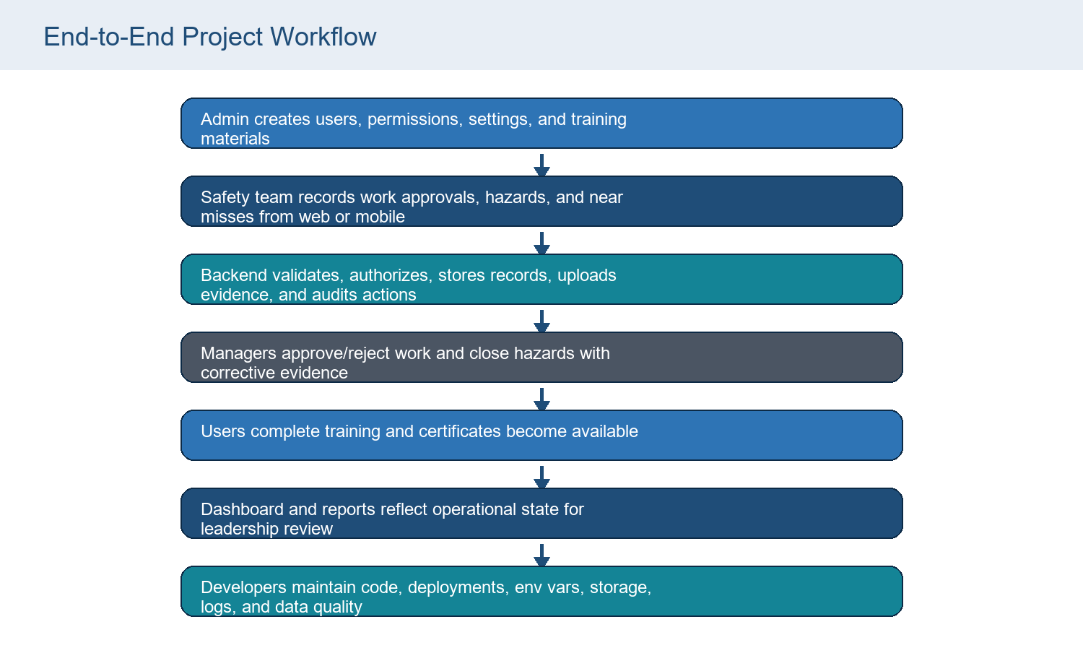
Figure 11. Complete project workflow

24. Flowcharts
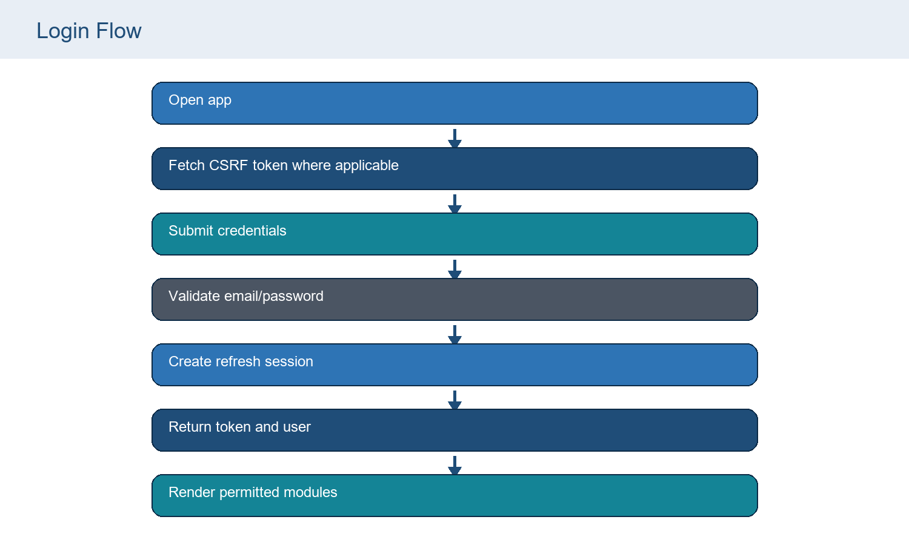
Flowchart: Login Flow

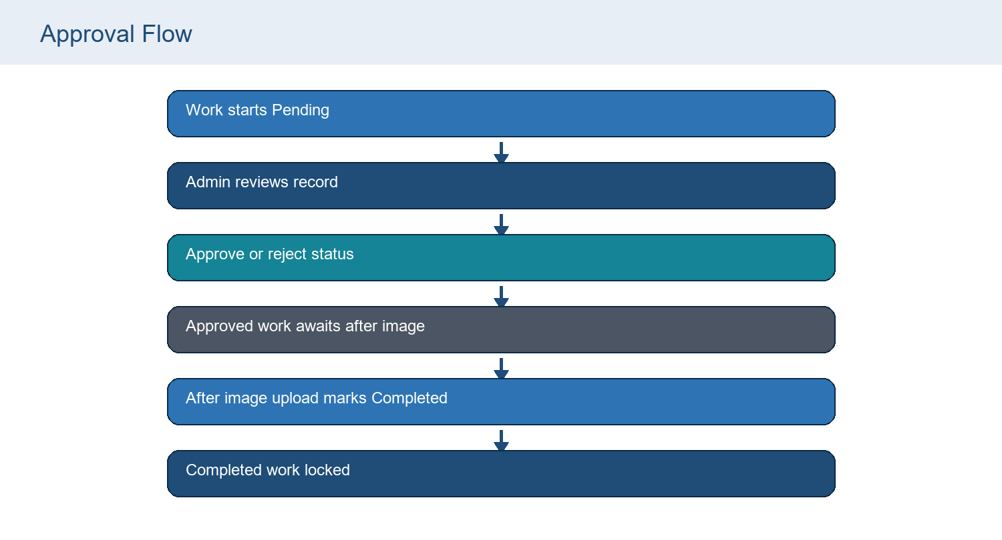
Flowchart: Approval Flow

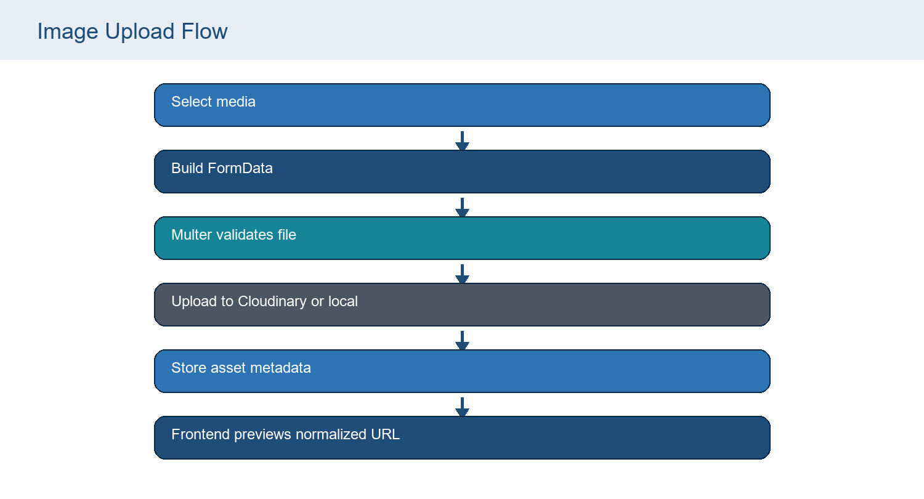
Flowchart: Image Upload Flow

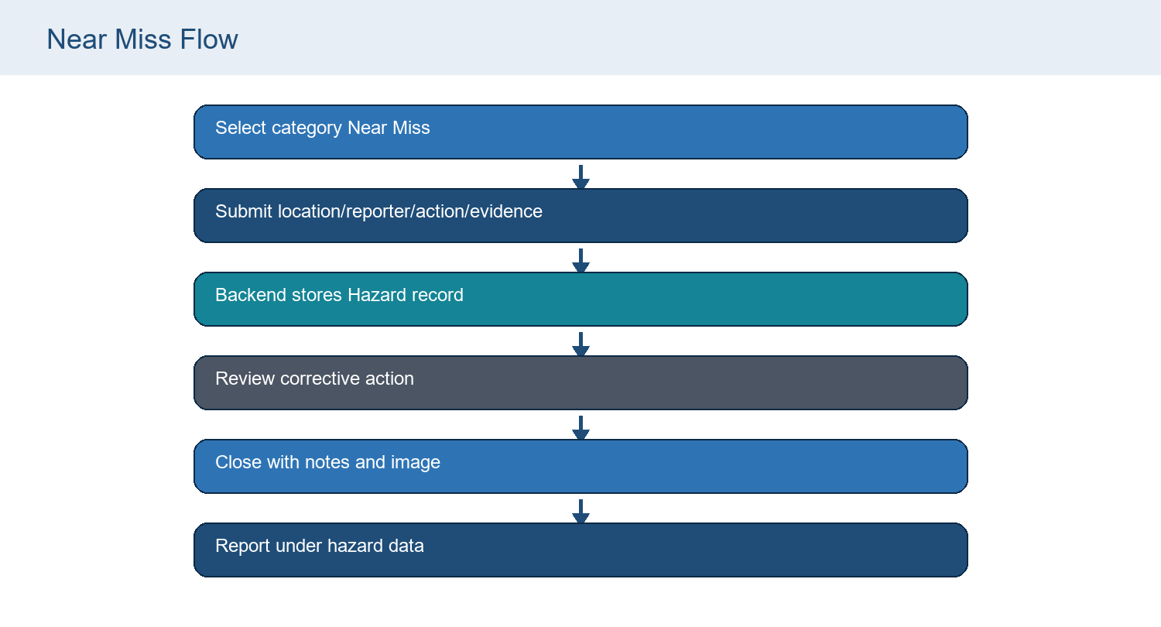
Flowchart: Near Miss Flow

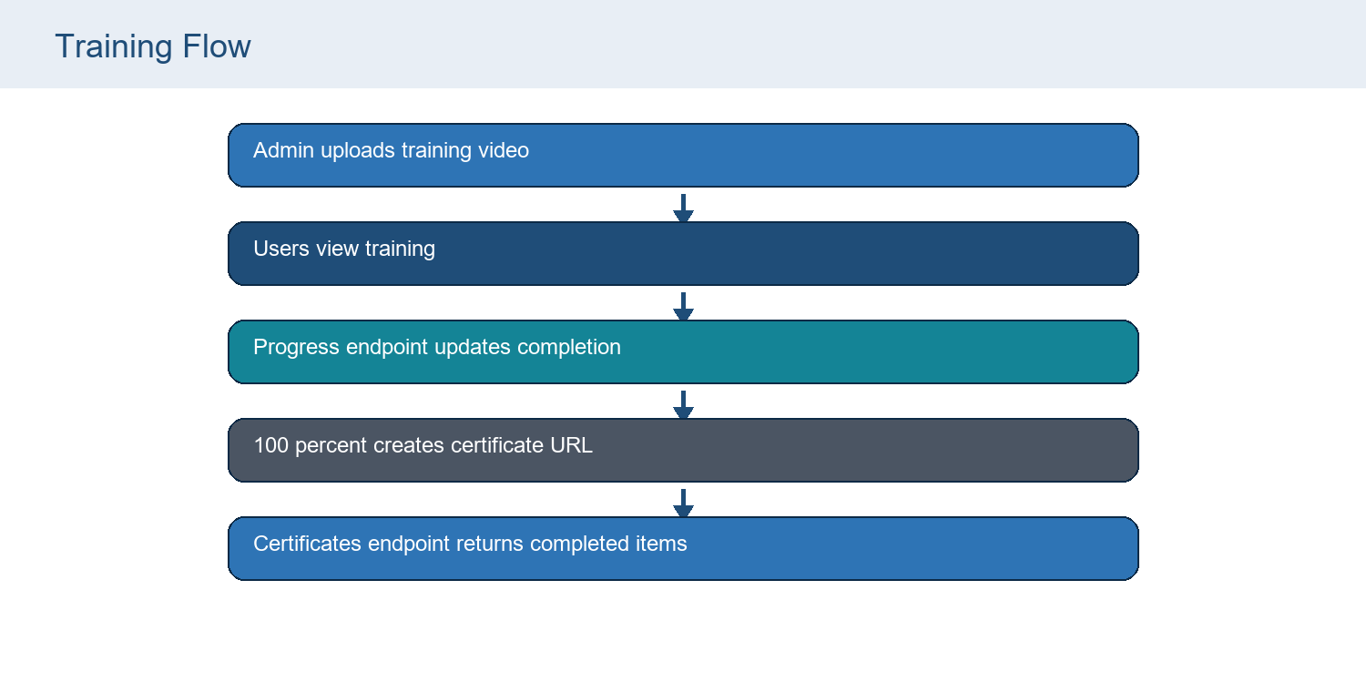
Flowchart: Training Flow

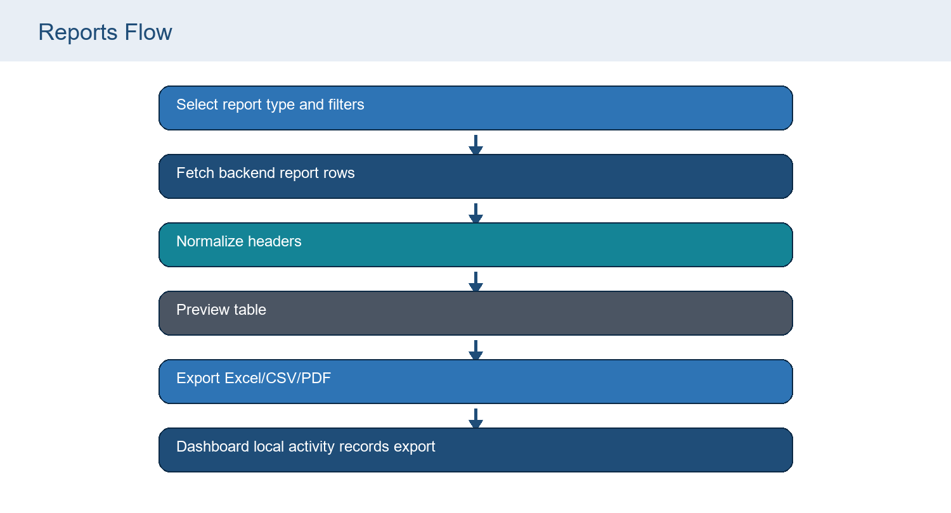
Flowchart: Reports Flow

25. Sequence Diagrams
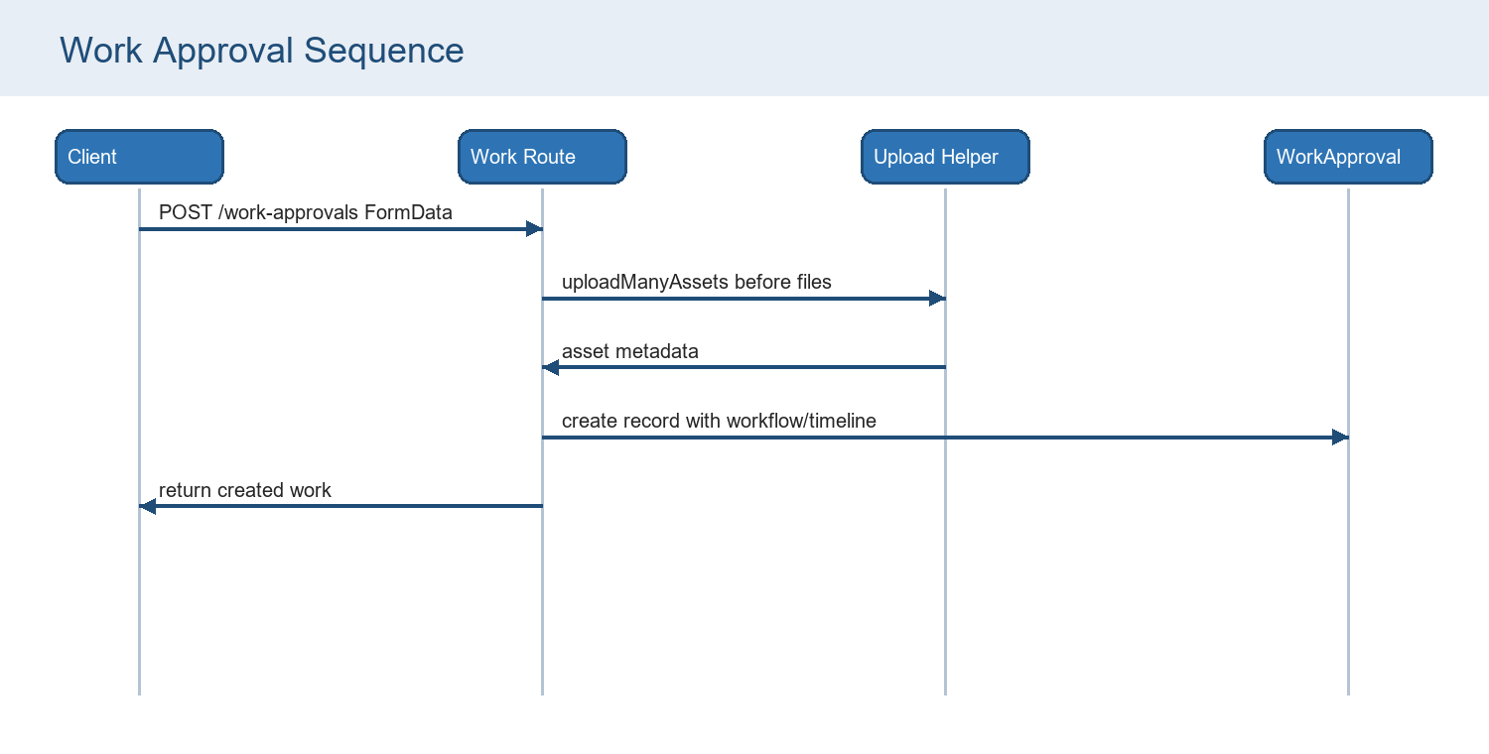
Sequence diagram: Work Approval Sequence

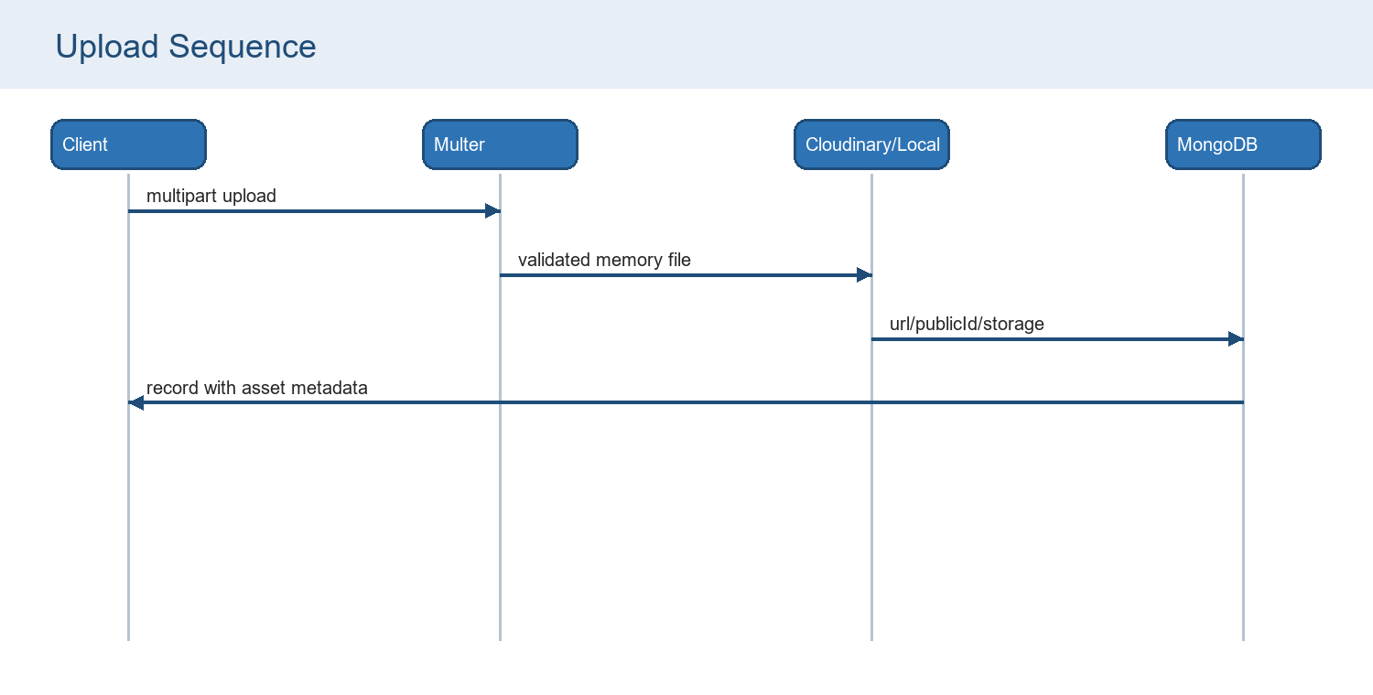
Sequence diagram: Upload Sequence

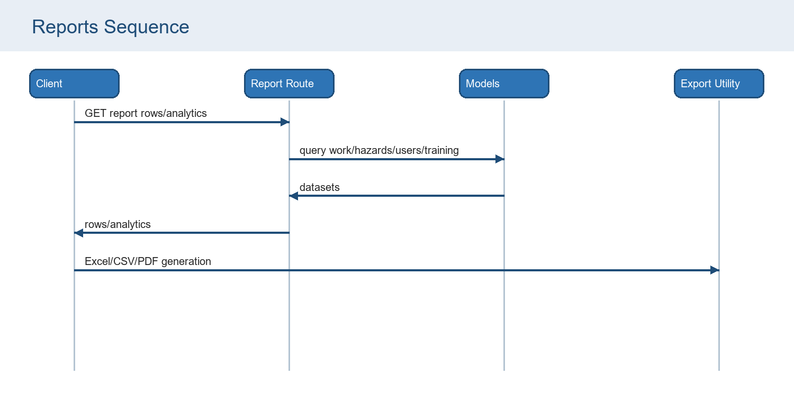
Sequence diagram: Reports Sequence

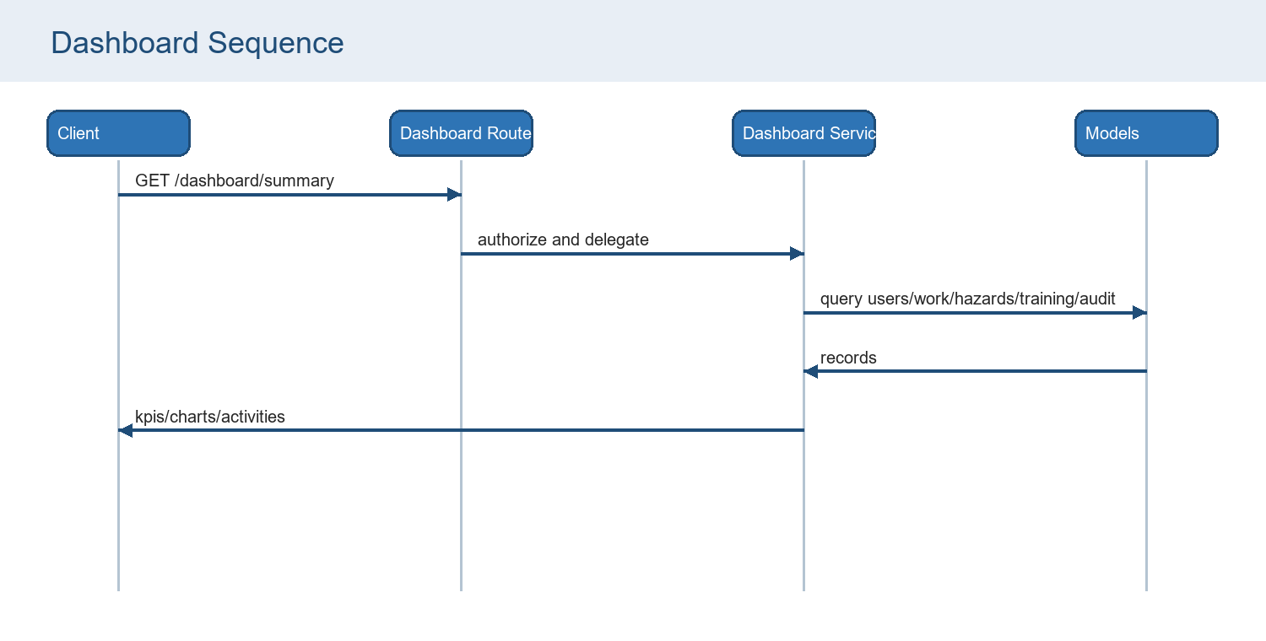
Sequence diagram: Dashboard Sequence

26. File Dependency
Source file / group | Depends on | Used by / effect
server.js | backend/src/server.js | Root deployment entry starts modular API server.
backend/src/server.js | app.js, config/db.js, config/env.js, logger | Connects MongoDB then listens on configured port.
backend/src/app.js | security middleware, csrf middleware, routes, uploads utils, error handlers | Defines Express middleware order and route mounting.
routes/index.js | auth/dashboard/users/work/hazards/training/reports/settings/notifications routes | Mounts /api/v1 namespaces.
auth.middleware.js | tokens.js, User, permission.middleware.js, roles.js | Attaches authenticated req.user for protected routes.
rbac.middleware.js | roles.js, permission.middleware.js | Enforces role/action permissions.
work.routes.js | WorkApproval, validators, uploads, chainage, notifications, audit | Implements work approvals.
hazards.routes.js | Hazard, User, validators, uploads, notifications, audit | Implements hazards and near-miss category flow.
training.routes.js | Training, User, validators, uploads, notifications, audit | Implements training catalog and progress.
reports.routes.js | WorkApproval, Hazard, User, Training, reporting, chainage | Builds report rows and analytics.
admin api/client.js | appConfig, media, permissions, axios | Adds bearer/CSRF/refresh handling and local session keys.
admin pages | api/services.js, utils, components | Render workflow modules and call service wrappers.
mobile api/client.js | AsyncStorage, config/api, storage utils | Adds bearer token and refresh retry.
mobile screens | api/services.js, context providers, media/storage utilities | Render field/mobile workflows and cache selected data.

27. Future Improvements
Theme | Recommendation
Mobile API alignment | Add chainageFrom/chainageTo inputs and closureNotes to mobile work/hazard workflows; add or remove push-token service call.
Pagination | Add backend pagination/sort/filter to list and report endpoints.
Testing | Add backend route/unit tests, frontend workflow tests, and mobile API contract tests. Root test script currently states no backend tests configured.
Monitoring | Add request logging correlation ids, error tracking, uptime checks, and dashboard/service metrics.
Storage | Use persistent Cloudinary/object storage in production; avoid relying on local uploads on ephemeral hosts.
Security | Add password-policy enforcement on reset/create to match settings, optional OTP endpoints if twoFactorAuthentication is enabled, upload malware scanning for higher risk use.
Accessibility | Audit admin/mobile color contrast, keyboard navigation, alt text, focus states, and PDF accessibility.
Data quality | Enforce consistent status names, chainage formats, reporter references, and near-miss categorization.
Performance | Move dashboard/report aggregation to MongoDB aggregation pipelines and add indexes for common searches.
Backups | Document MongoDB backup/restore and Cloudinary media backup strategy.

28. Troubleshooting Guide
Issue | Likely cause | Solution
Backend fails to start | MONGODB_URI missing or invalid | Set MONGODB_URI in root .env or Render environment; check Atlas user/password and URL encoding.
Production JWT error | JWT secrets missing or default change-me values | Set long random JWT_ACCESS_SECRET and JWT_REFRESH_SECRET.
CORS denied | FRONTEND_URL does not include the calling origin | Add admin/mobile web origin to FRONTEND_URL comma-separated list.
Login blocked | Failed attempts exceeded settings.security.loginAttempts | Wait lockout period or reset user lockedUntil/failedLoginAttempts with admin process.
Upload missing after deployment | Local uploads not persistent on host | Configure Cloudinary and set CLOUDINARY_* values.
Image preview unavailable | Asset not local and Cloudinary lookup/fallback failed | Reupload media or verify Cloudinary folder/upload folder.
Work create fails on mobile | Mobile submits chainage only but backend requires chainageTo | Update mobile form/services to send chainageFrom and chainageTo.
Hazard close fails on mobile | Mobile sends empty closureNotes | Add corrective-action/closure notes to mobile close workflow.
Report export has image issues | Browser cannot fetch/rasterize source image due to CORS or missing asset | Use backend upload URLs or Cloudinary URLs with CORS-compatible access.
Deep link refresh fails in admin | SPA rewrite missing | Ensure admin-panel/vercel.json rewrite is active.

29. Maintenance Guide
- Keep root package dependencies updated deliberately and test backend plus admin/mobile clients after each update.
- Treat backend/src/models as the active schema source; avoid adding new active models in the root legacy models folder.
- When changing API validators, update both admin-panel and mobile-app service payloads in the same change.
- Never expose .env values in docs, logs, screenshots, commits, or ticket comments.
- Review Cloudinary/local upload behavior after deployment changes.
- Add migrations for schema changes, following the existing migrate-work-chainage-range script pattern.
- Use AuditLog and Notification records as operational diagnostics when investigating user actions.
- Before production releases, run build/test/lint commands, inspect bundle output, smoke-test login, work creation, hazard closure, training upload, and report exports.

30. Conclusion
The UTPL Safety Management System is a production-oriented HSE platform with modular backend APIs, secure authentication and authorization, MongoDB persistence, evidence uploads, operational dashboards, report exports, a web admin console, and a mobile field app. The inspected codebase already contains the core architecture needed for leadership reporting and daily safety operations.
The highest-priority maintenance work is to align mobile payloads with current backend validators, add automated tests, add pagination/aggregation for scale, and strengthen production monitoring and persistent media storage. With those improvements, the system can be maintained as a reliable enterprise safety record and decision-support platform.

Appendix A. Source Files Inspected
Area | Files / directories inspected
Root | README.md, package.json, package-lock.json, .env.example, server.js, uploads inventory
Backend | backend/src/app.js, server.js, config, routes, controllers, middleware, models, services, utils, validators, scripts
Admin | admin-panel package/config, App.js, api client/services, pages, layout, settings, utils, export helpers
Mobile | mobile-app package/config, App.js, navigation, api client/services, context, screens, utilities
Legacy | models/User.js, Work.js, Hazard.js, Incident.js, Training.js, CompanySettings.js

Appendix B. Dependency Catalog
Dependency / tool | Purpose
Node.js / CommonJS | Backend runtime and module system; Root package.json declares type commonjs and backend files use require/module.exports.
Express 5.2.1 | REST API framework; Defines app, route namespaces, middleware stack, static uploads, and error handlers.
MongoDB / Mongoose 9.6.1 | Database and schema layer; All active backend models are Mongoose schemas under backend/src/models.
bcryptjs | Password hashing; Auth and user creation routes hash and compare passwords.
jsonwebtoken | Access and refresh tokens; Token utilities sign/verify access and refresh JWTs.
Zod | Request validation; Validators define payload constraints for auth, users, work, hazards, training, and settings.
Multer | Multipart upload handling; Memory upload utilities validate MIME types, file sizes, and file counts.
Cloudinary SDK | Optional production media storage; Upload helper uses Cloudinary when configured; otherwise local fallback.
Helmet, CORS, HPP, rate-limit, sanitize | Security middleware; Applied in backend/src/middleware/security.middleware.js.
React 19 / CRA | Admin panel; Single-page enterprise UI under admin-panel/src.
Tailwind CSS | Admin styling; Theme config extends fonts, colors, shadows, and animation tokens.
Framer Motion | Admin animation; Used across app shell, login, dashboard, and cards.
Recharts | Admin charts; Dashboard and reports render pies, bars, lines, areas, and radial bars.
Axios | API client; Admin and mobile clients add auth headers and retry behavior.
xlsx, file-saver, jsPDF, jspdf-autotable | Client-side report exports; Reports and detail PDF export utilities generate downloads in browser.
Expo / React Native | Mobile app; Mobile field app with dark theme, bottom tabs, image picker, notifications, and video.
Render / Vercel / EAS | Deployment surfaces; README and config files describe backend web service, admin SPA rewrite, and Android builds.

Appendix C. Visual Placeholders
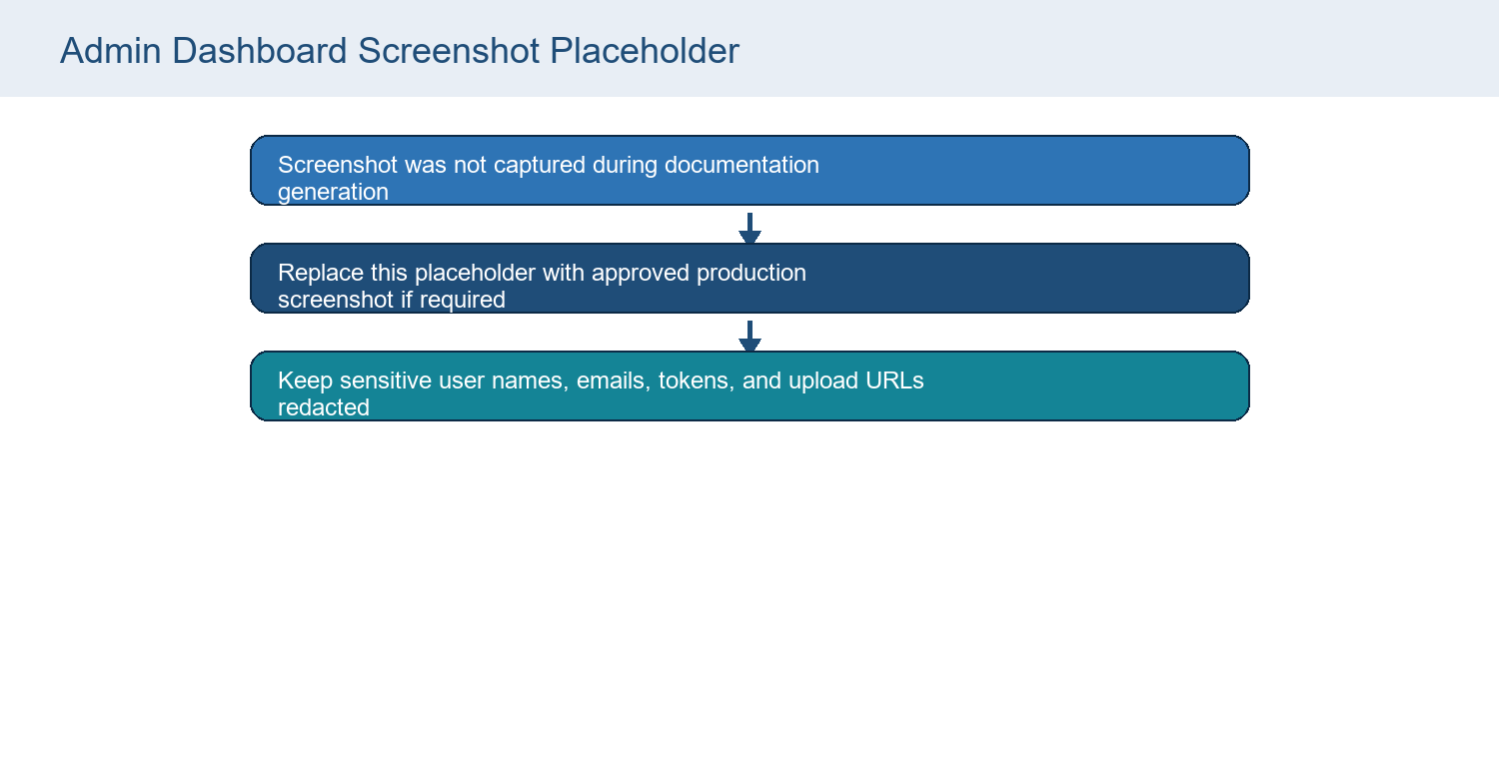
Admin Dashboard Screenshot Placeholder
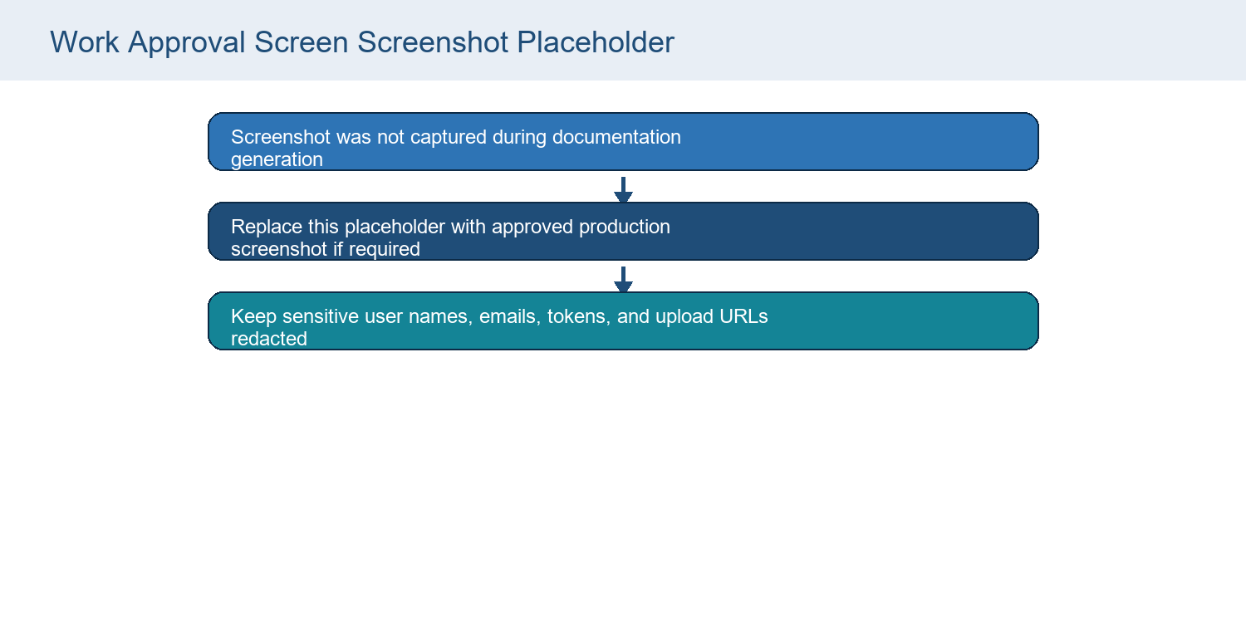
Work Approval Screen Screenshot Placeholder
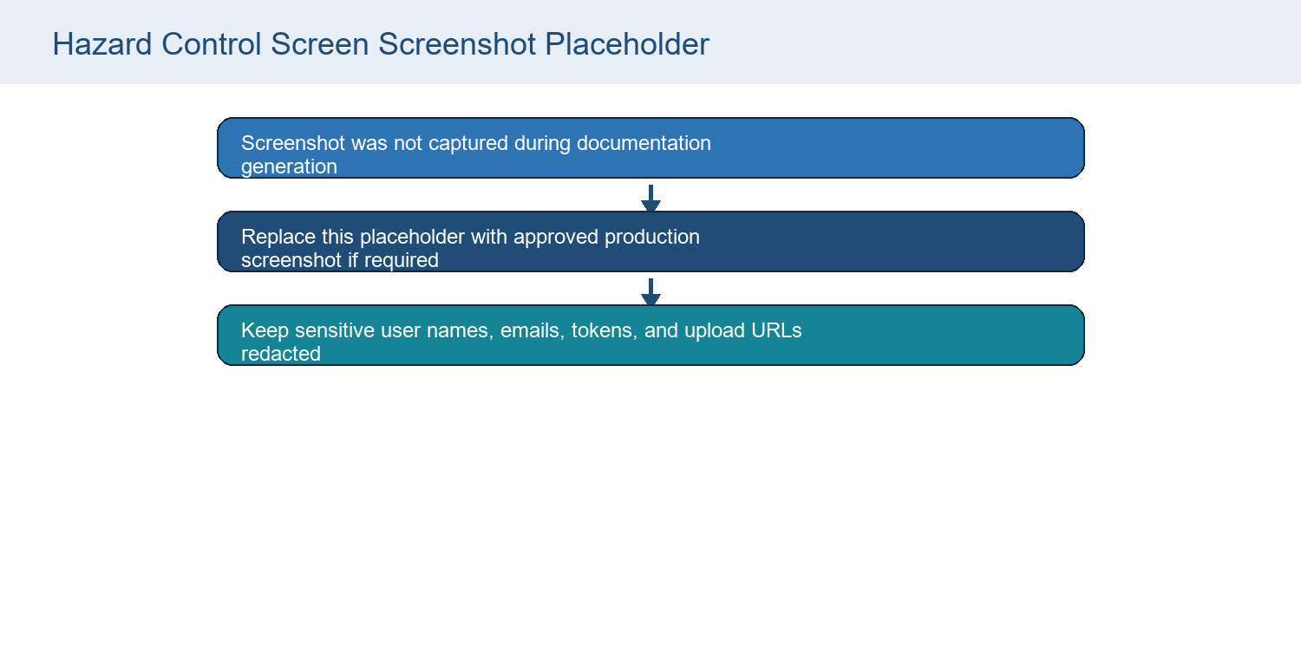
Hazard Control Screen Screenshot Placeholder
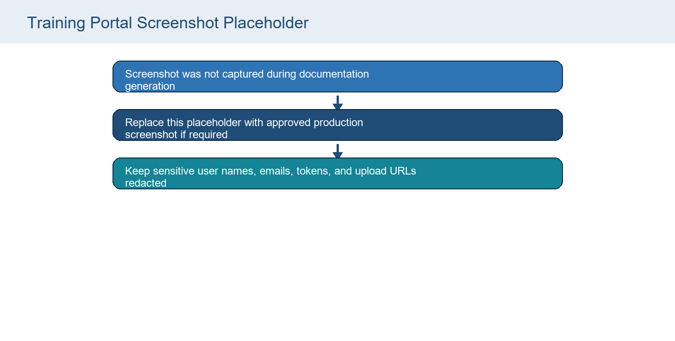
Training Portal Screenshot Placeholder
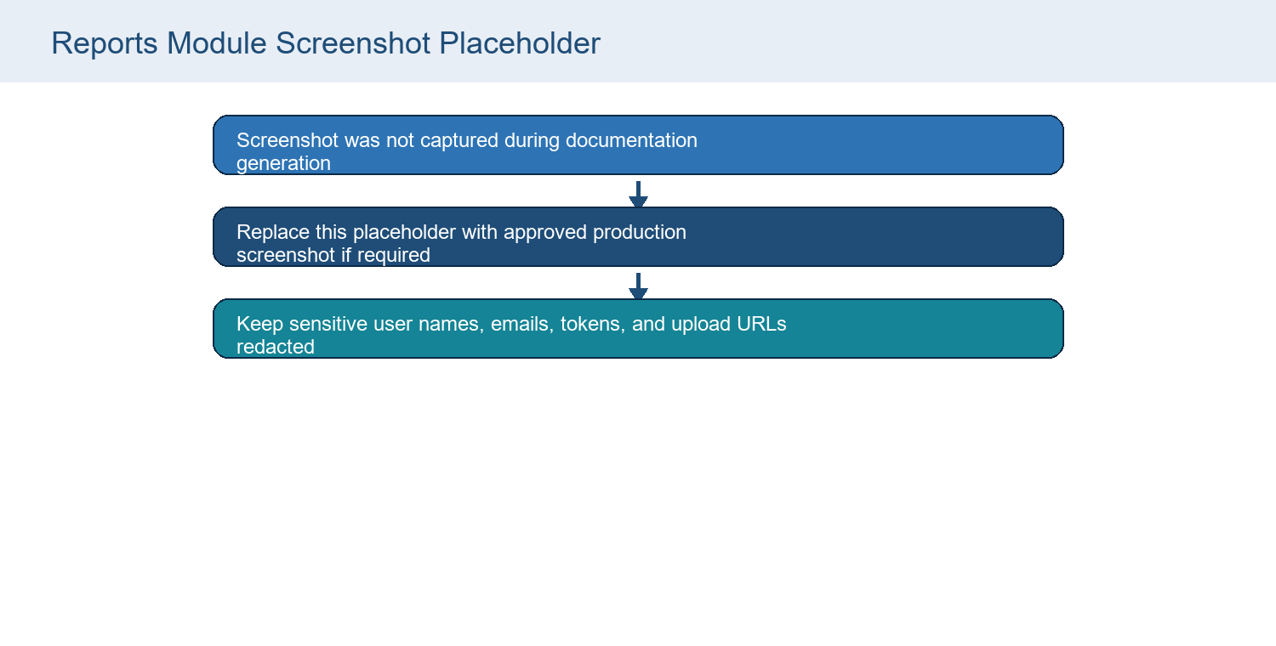
Reports Module Screenshot Placeholder
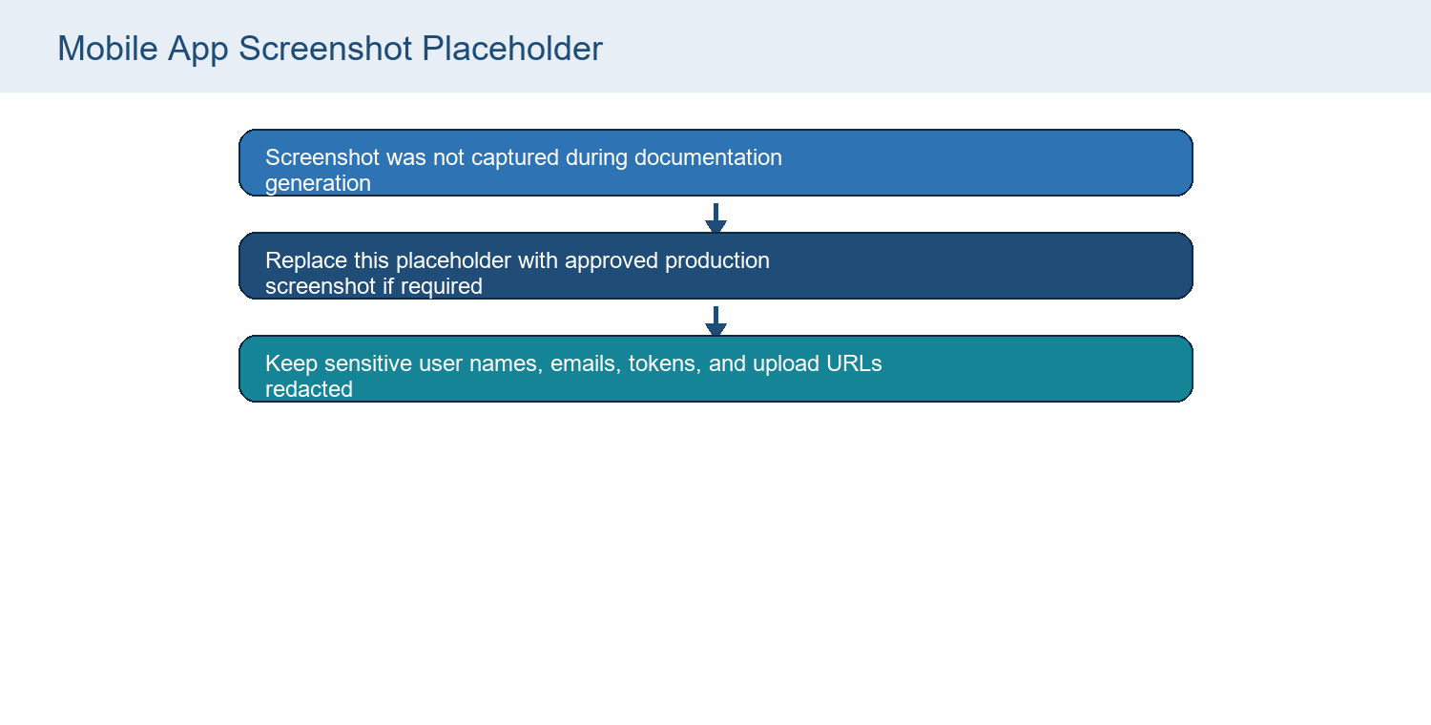
Mobile App Screenshot Placeholder

Appendix D. QA and Test Gap Summary
Area | Observed status | Recommended QA
Backend tests | Root package test script prints No backend tests configured. | Add API route tests for auth, permissions, validators, uploads, reports.
Admin tests | CRA App.test.js exists but no workflow coverage confirmed. | Add login, module guard, work/hazard/training/report flows.
Mobile tests | No mobile test harness identified. | Add service contract tests and screen behavior tests.
Render QA | This document is rendered and visually inspected as part of generation. | Keep render QA for future document updates.
Security QA | Security middleware exists; no automated security suite identified. | Add dependency audit, secret scanning, authz regression tests, and upload abuse tests.

