## Assignment 1 - Module 1

## Problem: Draw the tree corresponding to the id[ ] depicted at below. Can this be the result of running weighted quick - union? If not explain why this is impossible or give a sequence of operations that the results in the array.

I 0 1 2 3 4 5 6 7 8 9

Id [ i ] 1 1 3 1 5 6 1 3 4 5

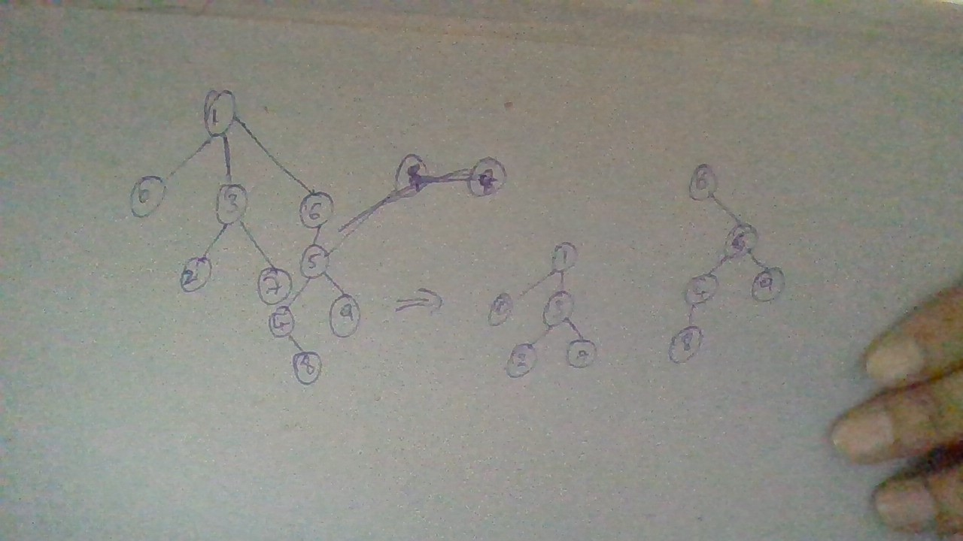

The above Tree is obtained by the given array in the question.

On taking the site ‘6’ as the root apart, ‘6’ has the weight 1, where as the child ‘5’ holds the weight 2.

It is impossible to return a weighted quick union with parent weight less than that of it’s child.

Hence, the given array can’t be the result of running weighted quick union.