Suppose that the keys A through G , with the hash values given below, are inserted in some order into an initially empty table of size 7 using a linear-probing table (with no resizing for this problem). Which of the following could not possibly result from inserting these keys?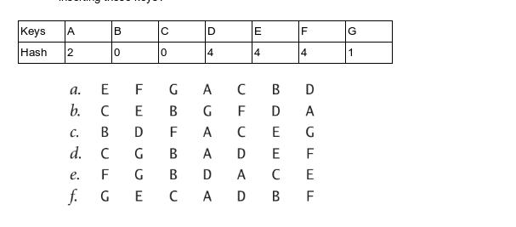

ANSWER

The patterns that won't occur from inserting in random order are - a, b, c, e and f.