Name: Murali Manokar D K

Reg No: 192324044

DSA0602-DATA HANDLING AND VISUALIZATION

Student Academic Performance Dashboard
Learning Outcome
Understand how position and color aesthetics represent different data types. Scenario
The Head of the Computer Science Department wants to analyze whether students with higher
attendance perform better in examinations. The department also wants to compare the performance across different programs.
Dataset
  - Student ID
  - Attendance (%)
  - Internal Marks
  - Department (CSE, AI, IT, ECE)

Code:
# Plot minimal · PY import pandas as pd
import matplotlib.pyplot as plt

df = pd.read_csv("student_performance.csv")

colors = {"CSE": "#1f77b4", "AI": "#ff7f0e", "IT": "#2ca02c", "ECE": "#d62728"}

plt.figure(figsize=(9, 6))
for dept, color in colors.items():
subset = df[df["Department"] == dept] plt.scatter(subset["Attendance_Percent"], subset["Internal_Marks"],

label=dept, color=color, s=70, edgecolor="black", alpha=0.8)

plt.title("Attendance vs Internal Marks by Department") plt.xlabel("Attendance (%)")
plt.ylabel("Internal Marks") plt.legend(title="Department") plt.grid(True, linestyle="--", alpha=0.4) plt.tight_layout()
plt.savefig("student_performance_plot.png", dpi=300) plt.show()

OUTPUT:
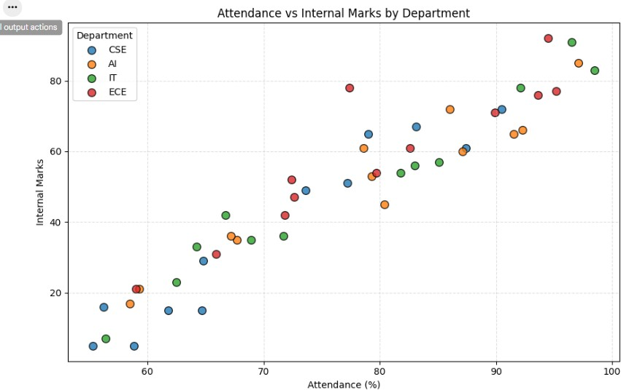

Electric Vehicle Market Analysis
Learning Outcome
Learn how size and color aesthetics can simultaneously represent multiple variables. Scenario
An automobile company is studying the relationship between battery capacity and vehicle price

to understand whether larger batteries significantly increase the selling price. Dataset
  - Vehicle Model
  - Battery Capacity (kWh)
  - Price
  - Driving Range
  - Manufacturer

CODE:
import matplotlib.pyplot as plt

# Sample Data
battery = [40, 50, 60, 75, 90, 100]
price = [15, 20, 28, 35, 45, 55]
range_km = [250, 320, 380, 450, 550, 650]
manufacturer = ["Tesla", "Tata", "MG", "Tesla", "Hyundai", "BYD"]

# Colors for manufacturers colors = {
"Tesla": "red",
"Tata": "blue",
"MG": "green",
"Hyundai": "orange",
"BYD": "purple"
}

plt.figure(figsize=(8,6))

for i in range(len(battery)):

plt.scatter(battery[i], price[i], s=range_km[i], color=colors[manufacturer[i]], alpha=0.6)

# Legend
for m, c in colors.items(): plt.scatter([], [], color=c, label=m)

plt.title("Electric Vehicle Market Analysis") plt.xlabel("Battery Capacity (kWh)") plt.ylabel("Price (Lakhs)") plt.legend(title="Manufacturer") plt.grid(True)

plt.show()

OUTPUT:
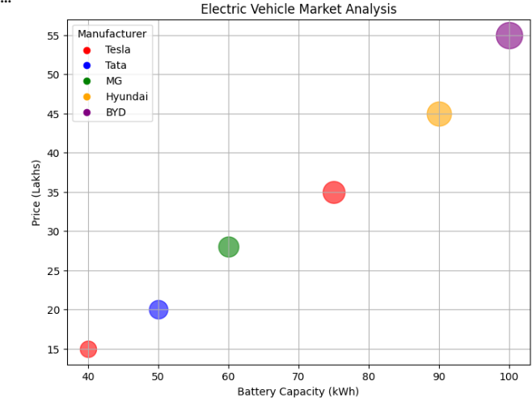

Hospital Patient Admission Analysis
Learning Outcome
Visualize categorical variables using fill color and position aesthetics. Scenario
A hospital administrator wants to compare patient admissions across departments during the last month.
Dataset
  - Department
  - Number of Patients
  - Average Treatment Cost

CODE:
import matplotlib.pyplot as plt # Sample Data
departments = ["Cardiology", "Neurology", "Orthopedics", "Pediatrics"] patients = [120, 90, 150, 110]
cost = [25000, 40000, 18000, 12000]
colors = ["red", "blue", "green", "orange"] plt.figure(figsize=(8,5))
bars = plt.bar(departments, patients, color=colors) # Display treatment cost on bars
for bar, c in zip(bars, cost): plt.text(bar.get_x() + bar.get_width()/2,
bar.get_height() + 2, f"₹{c}", ha='center')
plt.title("Hospital Patient Admission Analysis") plt.xlabel("Department")
plt.ylabel("Number of Patients")

plt.show()

OUTPUT:
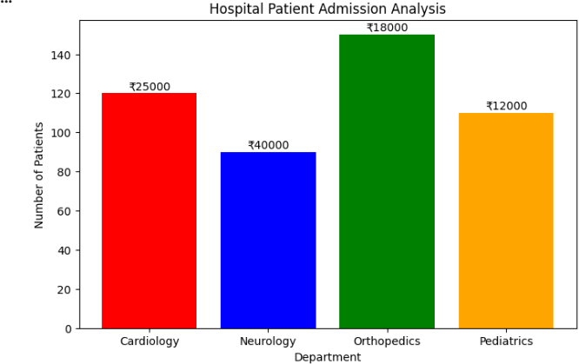

Weather Monitoring System
Learning Outcome
Understand how line type and color distinguish multiple categories. Scenario
The Indian Meteorological Department has collected daily temperature data for three cities over one month and wants to compare climate trends.
Dataset
  - Date
  - Temperature
  - City

Code:
import matplotlib.pyplot as plt # Sample Data
dates = ["Day1", "Day2", "Day3", "Day4", "Day5", "Day6", "Day7"] delhi = [36, 37, 38, 39, 37, 36, 35]

chennai = [33, 34, 35, 34, 33, 32, 33]
bengaluru = [28, 29, 28, 27, 28, 27, 28]
plt.figure(figsize=(8,5))
plt.plot(dates, delhi, color="red", linestyle="-", label="Delhi") plt.plot(dates, chennai, color="blue", linestyle="--", label="Chennai") plt.plot(dates, bengaluru, color="green", linestyle=":", label="Bengaluru") plt.title("Weather Monitoring System")
plt.xlabel("Date") plt.ylabel("Temperature (°C)") plt.legend()
plt.grid(True) plt.show()

OUTPUT:
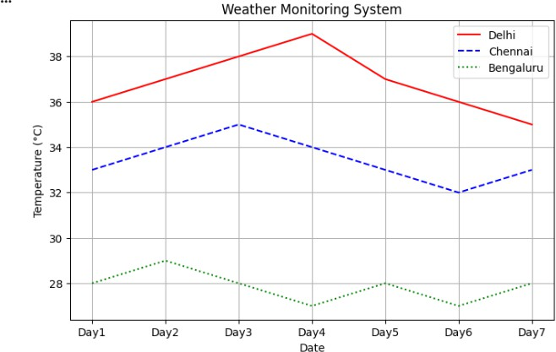

Supermarket Sales Analysis
Learning Outcome
Apply position and fill aesthetics for grouped comparisons. Scenario

A supermarket chain wants to identify which product categories generate the highest monthly sales across different branches.
Dataset
  - Month
  - Product Category
  - Sales Amount
  - Branch

CODE:
import matplotlib.pyplot as plt import numpy as np
# Sample Data
categories = ["Groceries", "Beverages", "Snacks", "Dairy"] branchA = [50000, 30000, 25000, 40000]
branchB = [47000, 32000, 27000, 38000]
branchC = [53000, 29000, 26000, 42000]
x = np.arange(len(categories)) width = 0.25 plt.figure(figsize=(8,5))
plt.bar(x - width, branchA, width, label="Branch A") plt.bar(x, branchB, width, label="Branch B") plt.bar(x + width, branchC, width, label="Branch C") plt.title("Supermarket Sales Analysis") plt.xlabel("Product Category")
plt.ylabel("Sales Amount (₹)") plt.xticks(x, categories) plt.legend()
plt.grid(axis='y') plt.show()

OUTPUT:
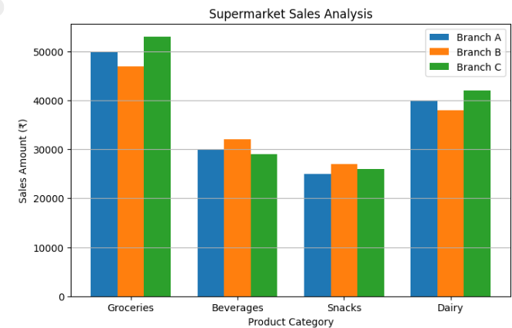

Employee Salary Distribution
Learning Outcome
Understand continuous scales and histogram binning. Scenario
The HR department wants to understand salary distribution among employees to determine whether salaries are evenly distributed across the organization.
Dataset
  - Employee ID
  - Salary
  - Experience
  - Department

CODE:
import matplotlib.pyplot as plt # Sample Salary Data
salary = [25000,30000,32000,35000,38000,40000,42000,45000,
47000,50000,52000,55000,58000,60000,62000,
65000,68000,70000,75000,80000]

# Histogram with 5 bins plt.figure(figsize=(8,5))
plt.hist(salary, bins=5, edgecolor='black') plt.title("Employee Salary Distribution") plt.xlabel("Salary (₹)") plt.ylabel("Number of Employees") plt.show()

OUTPUT:
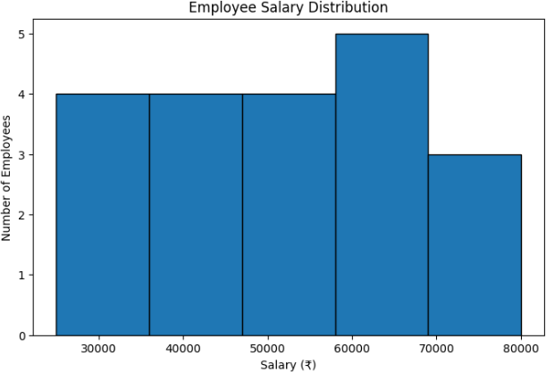

Smartphone Market Comparison
Learning Outcome
Map multiple variables using shape, size, and color. Scenario
A technology company wants to compare smartphone specifications to understand how RAM and processor speed influence product pricing.
Dataset
  - Brand
  - RAM

  - Processor Speed
  - Price
  - Storage

CODE:
import matplotlib.pyplot as plt # Sample Data
ram = [6, 8, 8, 6, 12]
price = [25000, 35000, 28000, 70000, 40000]
storage = [128, 256, 128, 256, 512]
processor = [2.2, 2.6, 2.4, 3.2, 2.8]
brands = ["Samsung", "OnePlus", "Xiaomi", "Apple", "Realme"] markers = ['o', 's', '^', 'D', '*']
plt.figure(figsize=(8,6)) for i in range(len(ram)):
plt.scatter(ram[i], price[i], s=storage[i], c=processor[i], cmap='viridis', marker=markers[i], edgecolors='black')
plt.colorbar(label='Processor Speed (GHz)') plt.title("Smartphone Market Comparison") plt.xlabel("RAM (GB)")
plt.ylabel("Price (₹)") plt.grid(True) plt.show()

OUTPUT:
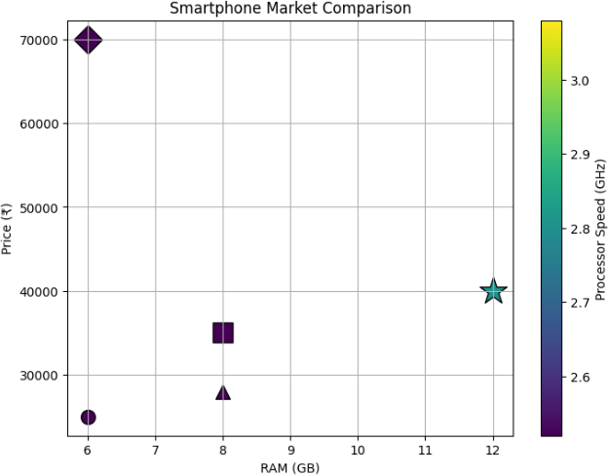

Online Movie Rating Analysis
Learning Outcome
Understand continuous color scales and gradient aesthetics. Scenario
A movie streaming platform wants to compare average ratings received by different movie genres over the past year.
Dataset
  - Genre
  - Average Rating
  - Number of Reviews
  - Release Year

CODE:
import matplotlib.pyplot as plt import seaborn as sns

import pandas as pd # Sample Data
data = {
"2022": [7.2, 6.9, 8.0, 6.8, 7.5],
"2023": [7.8, 7.1, 8.3, 7.0, 8.0],
"2024": [8.1, 7.5, 8.5, 7.2, 8.4]
}
genres = ["Action", "Comedy", "Drama", "Horror", "Sci-Fi"] df = pd.DataFrame(data, index=genres) plt.figure(figsize=(7,5))
sns.heatmap(df, annot=True, cmap="YlOrRd") plt.title("Online Movie Rating Analysis") plt.xlabel("Release Year")
plt.ylabel("Genre") plt.show()

OUTPUT:
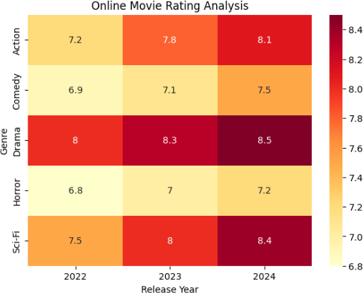

COVID-19 State-wise Analysis

Learning Outcome
Understand sequential, diverging, and categorical color scales. Scenario

The Ministry of Health wants to visualize the distribution of COVID-19 cases across different
Indian states to identify highly affected regions. Dataset
  - State
  - Active Cases
  - Vaccination Percentage
  - Population

CODE:
import matplotlib.pyplot as plt import seaborn as sns
import pandas as pd # Sample Data
data = {
"State": ["Tamil Nadu", "Karnataka", "Kerala", "Andhra Pradesh", "Telangana"],
"Active Cases": [25000, 18000, 30000, 12000, 15000]
}
df = pd.DataFrame(data) df = df.set_index("State") plt.figure(figsize=(6,4))
sns.heatmap(df, annot=True, cmap="Reds") plt.title("COVID-19 State-wise Analysis") plt.xlabel("Active Cases")

plt.ylabel("State") plt.show()

OUTPUT:
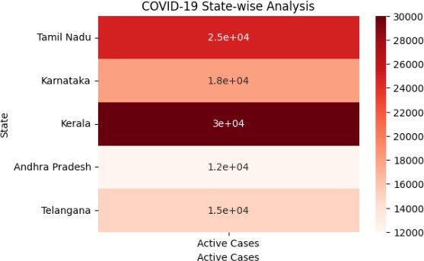

Iris Flower Classification
Learning Outcome
Understand how multiple aesthetic mappings improve pattern recognition and class separation.
Scenario
A botanist wants to analyze flower measurements to determine whether different Iris species can be visually separated.
Dataset
(Built-in Iris Dataset)
- Sepal Length
- Sepal Width
- Petal Length
- Petal Width
- Species

CODE:
import matplotlib.pyplot as plt
from sklearn.datasets import load_iris

# Load Iris Dataset iris = load_iris()
X = iris.data species = iris.target
names = iris.target_names markers = ['o', 's', '^'] plt.figure(figsize=(8,6)) for i in range(3):
plt.scatter(
X[species == i, 0], # Sepal Length X[species == i, 2], # Petal Length
s=X[species == i, 1] * 40, # Sepal Width as point size marker=markers[i],
label=names[i]
)
plt.title("Iris Flower Classification") plt.xlabel("Sepal Length (cm)") plt.ylabel("Petal Length (cm)") plt.legend()
plt.grid(True) plt.show()

OUTPUT:
