Name: Murali Manokar D K Reg No: 192324044
Scenario :1 Smart City Air Quality Monitoring.
Code:
> library(ggplot2)
>
> air_data <- read.csv("air_quality_data(1).csv")
> ggplot(air_data,
+ aes(x = PM2.5,
+ y = NO2,
+ color = PM2.5)) +
+ geom_point(size = 4) +
+ scale_color_gradient(low = "green", high = "red") +
+ labs(
+ title = "Smart City Air Quality Monitoring",
+ x = "PM2.5 (µg/m³)",
+ y = "NO₂ (ppb)",
+ color = "PM2.5"
+ ) +
+ theme_minimal()

Output:

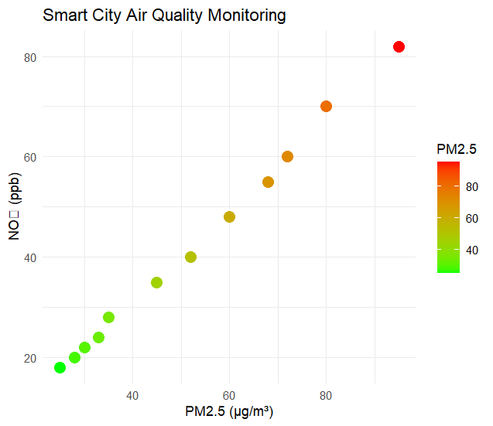

Scenario : 2 Earthquake Risk Analysis
Code:
> library(ggplot2)
>
> earthquake_data <- read.csv("earthquake_risk_analysis.csv")
>
> head(earthquake_data)
Earthquake_ID Magnitude Depth Latitude Longitude Aftershock_Frequency
1 EQ001 1.2 10 11.5 76.9 2
2 EQ002 2.8 25 12.1 77.3 5
3 EQ003 4.5 60 13.8 78.1 8
4 EQ004 5.2 120 15.2 79.4 12
5 EQ005 6.1 200 16.5 80.1 18
6 EQ006 7.0 350 18.2 81.3 25
>
> ggplot(earthquake_data,
+ aes(x = Depth,
+ y = Magnitude,
+ color = Aftershock_Frequency)) +
+ geom_point(size = 3, alpha = 0.8) +
+ scale_color_gradient(low = "lightblue", high = "red") +
+ scale_x_log10() +
+ labs(
+ title = "Earthquake Risk Analysis",
+ x = "Depth (km) [Log Scale]",
+ y = "Magnitude",
+ color = "Aftershock Frequency"
+ ) +
+ theme_minimal()

Output:

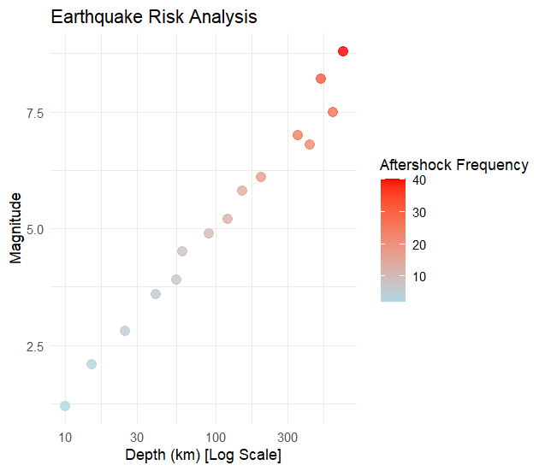

Scenario : 3 Wind Direction Analysis for Airport OperationsCode:
> library(ggplot2)
>
> wind_data <- read.csv("wind_direction_analysis.csv")
> wind_data$Wind_Direction <- factor(
+ wind_data$Wind_Direction,
+ levels = c("N","NE","E","SE","S","SW","W","NW")
+ )
>
> ggplot(wind_data,
+ aes(x = Wind_Direction,
+ y = Wind_Speed,
+ fill = Month)) +
+ geom_bar(stat = "identity", position = "dodge") +
+ coord_polar() +
+ labs(
+ title = "Wind Direction Analysis for Airport Operations",
+ x = "Wind Direction",
+ y = "Wind Speed (km/h)"
+ ) +
+ theme_minimal()

Output:

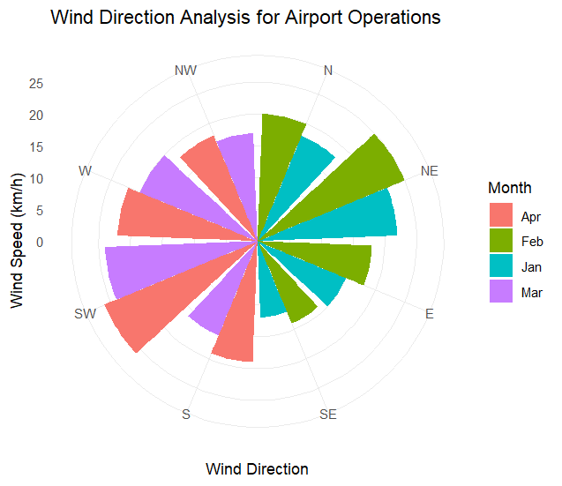

Scenario : 4 Hospital Patient Monitoring Dashboard
Code:
> library(ggplot2)
>
> patient_data <- read.csv("hospital_patient_monitoring.csv")
> patient_data$Status <- ifelse(patient_data$Heart_Rate > 100 |
+ patient_data$Oxygen_Saturation < 94 |
+ patient_data$Temperature > 38,
+ "Critical", "Normal")
>
> ggplot(patient_data,
+ aes(x = Time,
+ y = Heart_Rate,
+ color = Status,
+ group = 1)) +
+ geom_line(linewidth = 1) +
+ geom_point(size = 4) +
+ scale_color_manual(values = c("Normal" = "green",
+ "Critical" = "red")) +
+ labs(
+ title = "Hospital Patient Monitoring Dashboard",
+ x = "Time",
+ y = "Heart Rate (bpm)"
+ ) +
+ theme_minimal()

Output:

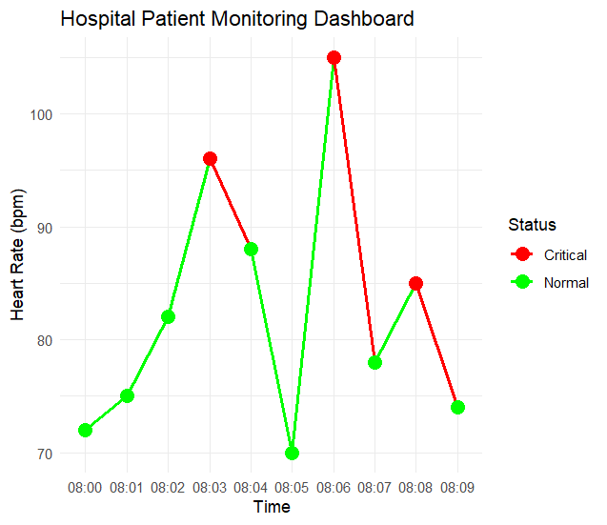
Scenario : 5 Global Climate Change Study

Code:
> library(ggplot2)
> climate_data <- read.csv("global_climate_change.csv")
> ggplot(climate_data,
+ aes(x = factor(Year),
+ y = Country,
+ fill = Temperature_Anomaly)) +
+ geom_tile(color = "white") +
+ scale_fill_gradient2(
+ low = "blue",
+ mid = "white",
+ high = "red",
+ midpoint = 0
+ ) +
+ labs(
+ title = "Global Climate Change Study",
+ x = "Year",
+ y = "Country",
+ fill = "Temperature Anomaly (°C)"
+ ) +
+ theme_minimal()

Output:

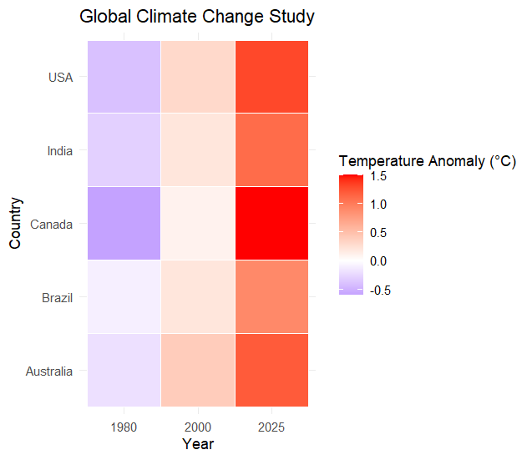

Scenario : 6 E-Commerce Sales Analytics
Code:
> library(ggplot2)
>
> sales_data <- read.csv("ecommerce_sales_analytics.csv")
>
> ggplot(sales_data,
+ aes(x = Category,
+ y = Sales,
+ fill = Category)) +
+ geom_boxplot() +
+ labs(
+ title = "E-Commerce Sales Analytics",
+ x = "Product Category",
+ y = "Sales Amount"
+ ) +
+ theme_minimal()
>
>
>
> library(ggplot2)

Output:

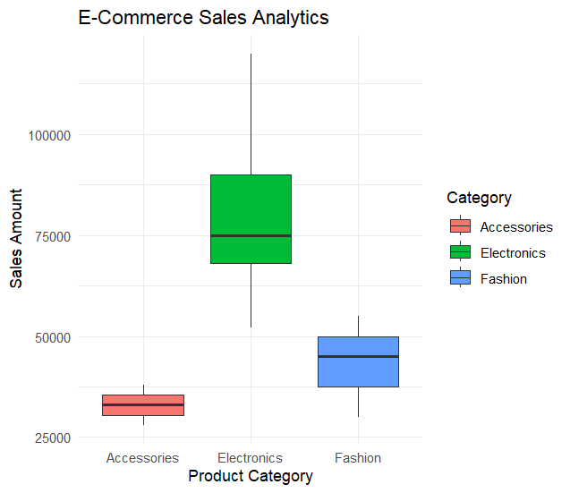

Scenario : 7 Satellite Image Vegetation Analysis
Code:
> library(ggplot2)
>
> vegetation_data <- read.csv("satellite_vegetation_analysis.csv")
>
> ggplot(vegetation_data,
+ aes(x = Region,
+ y = NDVI,
+ fill = Land_Cover)) +
+ geom_col() +
+ labs(
+ title = "Satellite Image Vegetation Analysis",
+ x = "Region",
+ y = "NDVI"
+ ) +
+ theme_minimal()
>
>
>
> library(ggplot2)

Output:

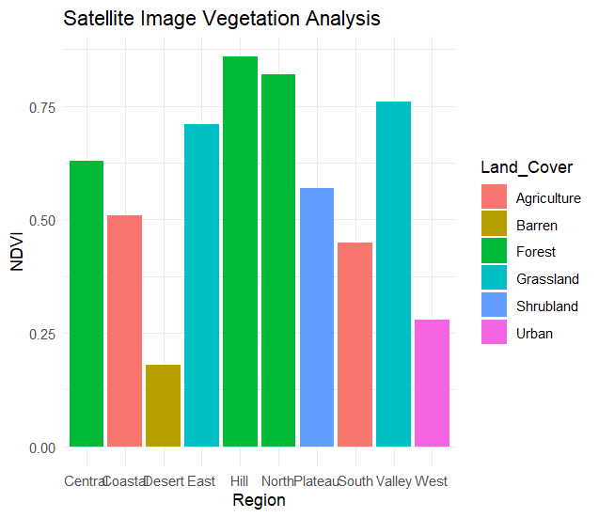
Scenario : 8 Cryptocurrency Market Volatility
Code:
> library(ggplot2)
>
> crypto_data <- read.csv("cryptocurrency_market_volatility.csv")
>
> ggplot(crypto_data,
+ aes(x = Bitcoin,
+ y = Ethereum,
+ size = Trading_Volume,
+ color = Volatility_Index)) +
+ geom_point(alpha = 0.8) +
+ scale_color_gradient(low = "blue", high = "red") +
+ labs(
+ title = "Cryptocurrency Market Volatility",
+ x = "Bitcoin Price (USD)",
+ y = "Ethereum Price (USD)",
+ color = "Volatility Index",
+ size = "Trading Volume"
+ ) +
+ theme_minimal()

Output:
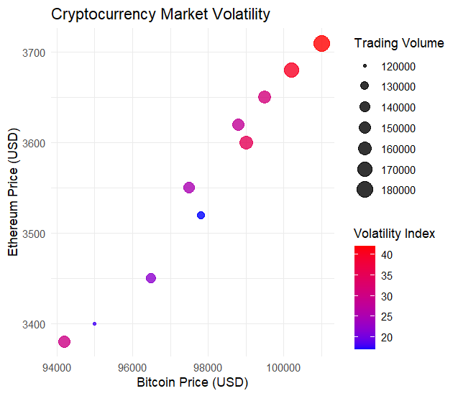

Scenario : 9 Marathon Runner Performance Analysis
Code:
> library(ggplot2)
>
> runner_data <- read.csv("marathon_runner_performance.csv")
>
> ggplot(runner_data,
+ aes(x = Age,
+ y = Finish_Time_Minutes,
+ color = Average_Speed_kmph)) +
+ geom_point(size = 4) +
+ geom_smooth(method = "lm", se = FALSE, color = "black") +
+ scale_color_gradient(low = "green", high = "red") +
+ labs(
+ title = "Marathon Runner Performance Analysis",
+ x = "Age",
+ y = "Finish Time (Minutes)",
+ color = "Average Speed (km/h)"
+ ) +
+ theme_minimal()
`geom_smooth()` using formula = 'y ~ x'

Output:

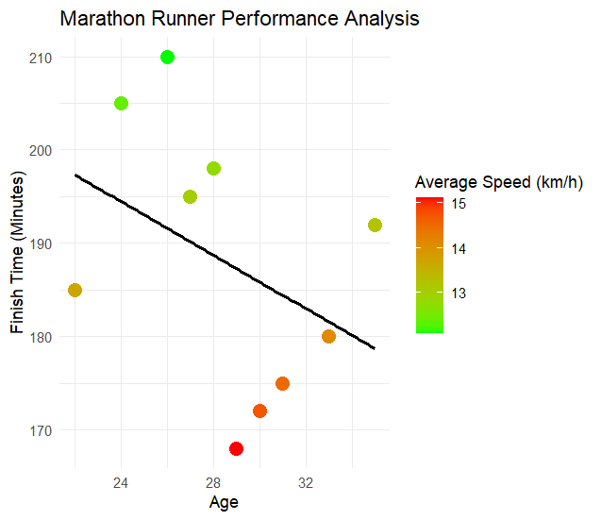
Scenario : 10 COVID-19 Vaccination Campaign Dashboard
Code:
library(ggplot2)

iris_data <- read.csv("iris_classification.csv")

head(iris_data)

ggplot(iris_data,
aes(x = Sepal_Length,
y = Petal_Length,
color = Species,
shape = Species,
size = Sepal_Width)) +
geom_point(alpha = 0.8) +
labs(
title = "Iris Flower Classification",
x = "Sepal Length",
y = "Petal Length",
size = "Sepal Width"
) +
theme_minimal()
Output:
