Assignment 13

CREATE TABLE BankDetails (

BankID int PRIMARY KEY,

AccountNumber VARCHAR2(20) NOT NULL,

BankName VARCHAR2(50) NOT NULL,

BranchName VARCHAR2(50) NOT NULL

);

CREATE TABLE Transactions (

TransactionID int PRIMARY KEY,

BankID NUMBER,

MoneyDebited NUMBER(10, 2) NOT NULL,

Account1 VARCHAR2(20) NOT NULL,

Account2 VARCHAR2(20) NOT NULL,

Balance int ;

CONSTRAINT fk_bank_details

FOREIGN KEY (BankID)

REFERENCES BankDetails(BankID)

);

INSERT INTO BankDetails VALUES (1, '12345', 'IOB', 'Chennai');

INSERT INTO BankDetails VALUES (2, '23456', 'SBI', 'Egmore');

INSERT INTO BankDetails VALUES (3, '34567', 'Kotak', 'Chetpet');

INSERT INTO BankDetails VALUES (4, '45678', 'IB', 'Chennai');

INSERT INTO BankDetails VALUES (5, '56789', 'SBI', 'Eroad');

CREATE TABLE NewTransactions (

TransactionID int PRIMARY KEY,

BankID NUMBER,

MoneyDebited NUMBER(10, 2) ,

Account1 VARCHAR2(20) ,

Account2 VARCHAR2(20) ,

Balance int

);

INSERT INTO NewTransactions VALUES (1, 1, 1000.00, '1234567890', '9876543210', 9000.00);

INSERT INTO NewTransactions VALUES (2, 2, 2000.00, '9876543210', '1234567890', 8000.00);

INSERT INTO NewTransactions VALUES (3, 1, 500.00, '1234567890', '9876543210', 8500.00);

Begin

INSERT INTO Transactions VALUES (1, 2, 1000.00, '12345', '23456', 9000.00);

savepoint s1;

INSERT INTO Transactions VALUES (3, 2, 3000.00, '34567', '23456', 5000.00);

savepoint s2;

INSERT INTO Transactions VALUES (4, 5, 2500.00, '45678', '56789', 6500.00);

Rollback to s1;

INSERT INTO Transactions VALUES (2, 5, 1000.00, '23456', '56789', 5000.00);

commit;

end;

/

Select* from Transactions ;

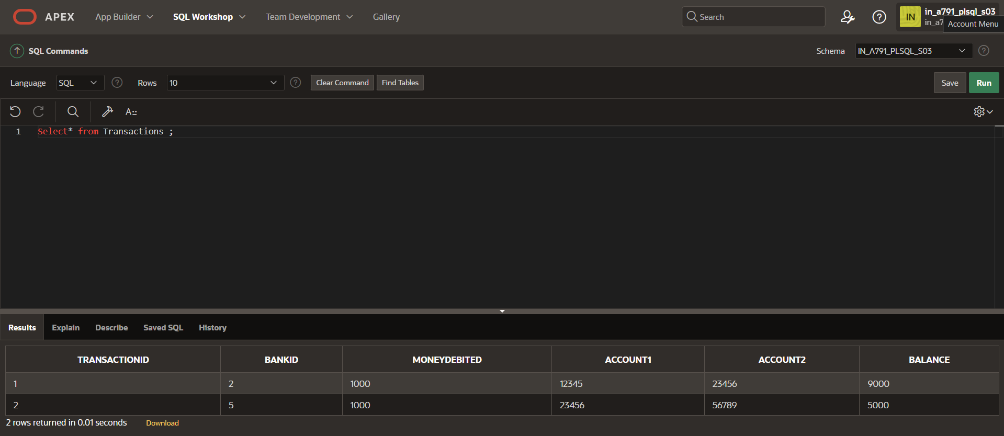

SELECT t.TransactionID, t.MoneyDebited, t.Account1, t.Account2, t.Balance, b.BankName, b.BranchName

FROM Transactions t JOIN BankDetails b ON t.BankID = b.BankID;

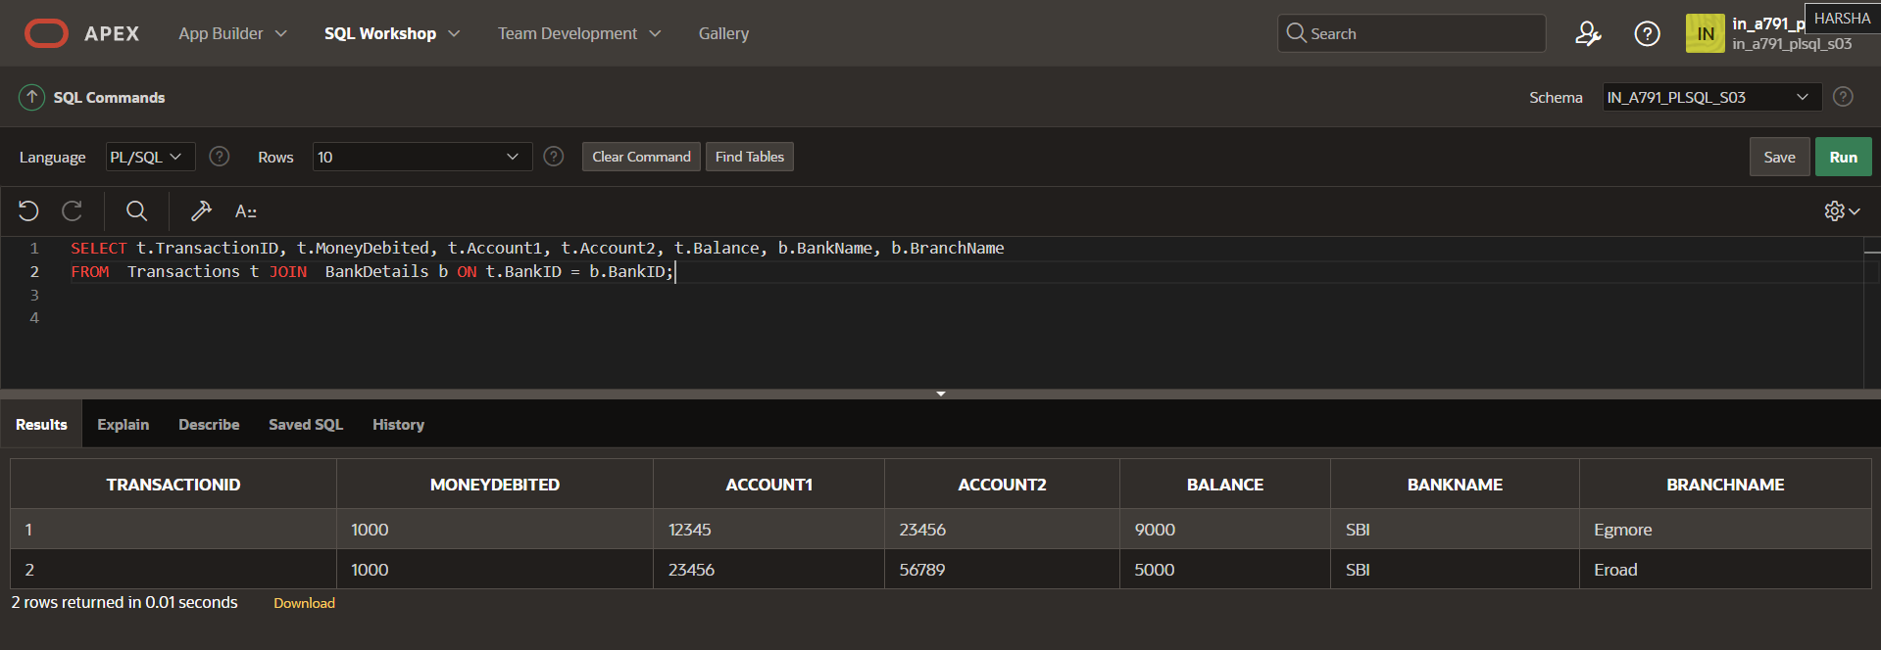

MERGE INTO Transactions t

USING NewTransactions nt

ON (t.TransactionID = nt.TransactionID)

WHEN MATCHED THEN

UPDATE SET

t.BankID = nt.BankID,

t.MoneyDebited = nt.MoneyDebited,

t.Account1 = nt.Account1,

t.Account2 = nt.Account2,

t.Balance = nt.Balance

WHEN NOT MATCHED THEN

INSERT (TransactionID, BankID, MoneyDebited, Account1, Account2, Balance)

VALUES (nt.TransactionID, nt.BankID, nt.MoneyDebited, nt.Account1, nt.Account2, nt.Balance);

/

Select* from Transactions ;

