1.REGULAR EXPRESIONS

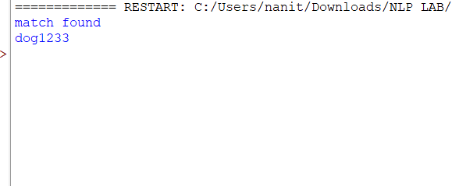

2.FINITE STATE AUTOMATION

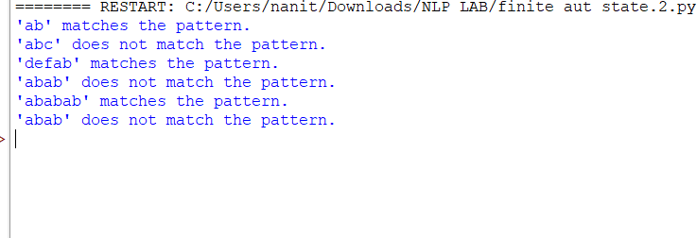

3.MORPHOLOGICAL USING NLTK

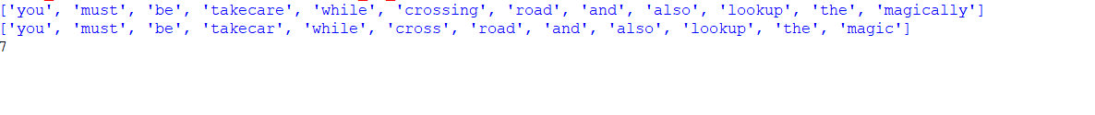

4.MORPHOLOGICAL USING FSA

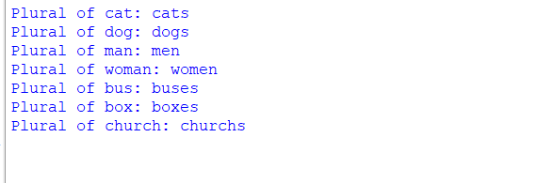

5.PORTER STEMMER



6.N GRAM



7.PARTS OF SPEECH TAGGING NLTK

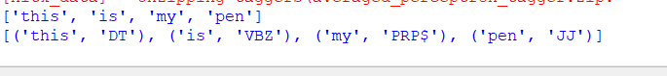

8.SIMPLE STACHOSTIC PARTS OF SPEECH

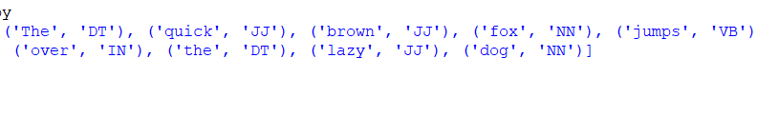

**9.RE RULE BASED POS**

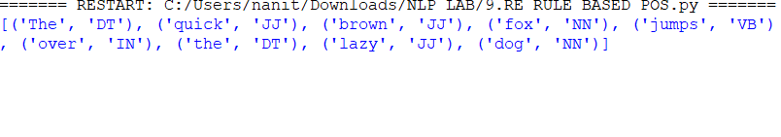

**10.TRANSFORMATION BASED TAGGING**

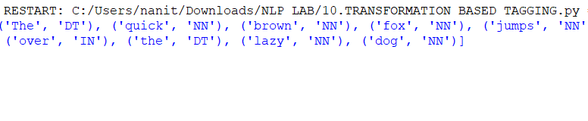

**11.SIMPLE TOP DOWN PARSER FOR CFG**

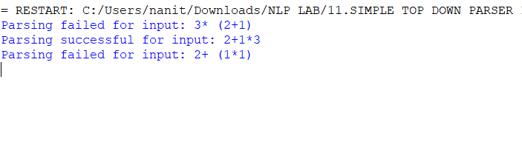

**12.EARLEY PARSER**

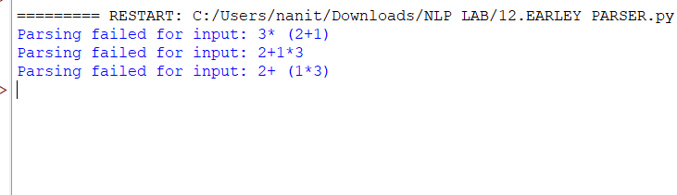

**13.PARSE TREE**

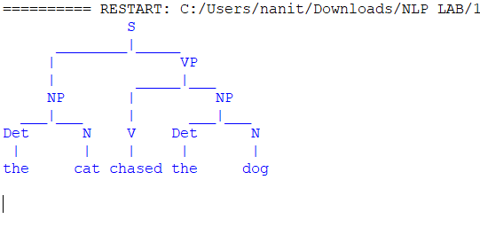

**14.CHECK FOR AGREEMENT**

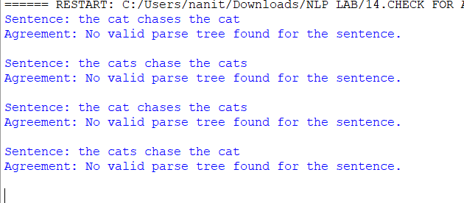

**15.PROBABILISTIC CFG**

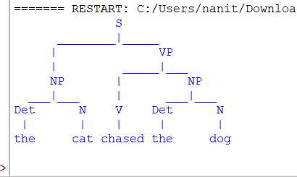

**16.NAME ENTITY RECOGNITION**

**17.ACCESS WORLD NET**

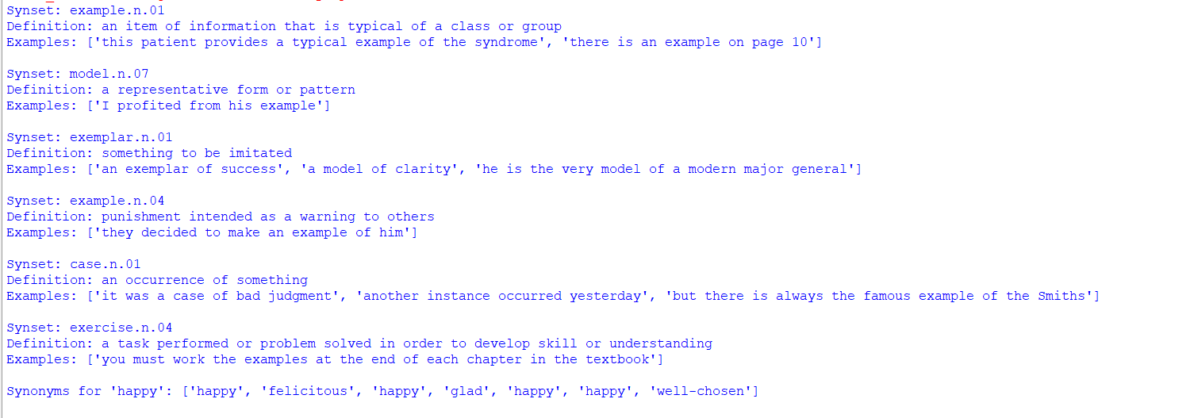

**18.FOPC PARSER FOR BASIC LOGICAL EXPRESSION**

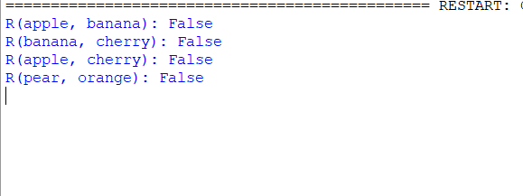

**19.DISAMIGUATION USING THE LESK**



**20.RETRIEVAL SYSTEM USING TF-IDF**

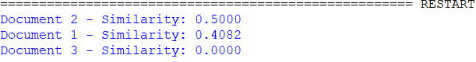

**21.SYNTAX DRIVEN SEMANTIC ANALYSIS**

**22.REFERENCE RESOLUTION WITH IN A TEXT**

**23.EVALUATE COHERENCE OF GIVEN TEXT**

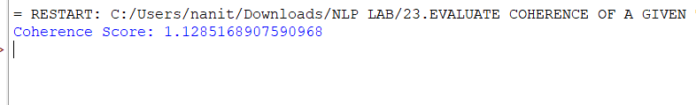

**24.RECOGNIZE DIALOG ACTS IN A GIVEN CONVERSATION**

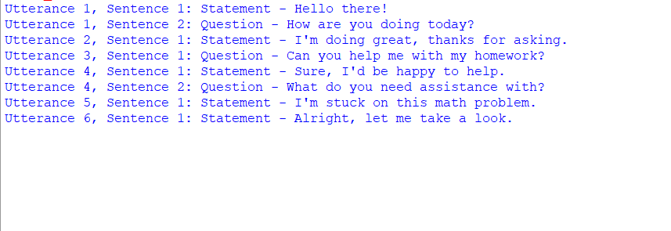

**25.UTILIZE GPT 3 MODEL**

**26.HUGGING FACE TRANSFORMERS**