## Installation Instructions:

1. Install maven and java 8 on the desktop
2. Unzip the zip file in any directory and it will create a directory as below:

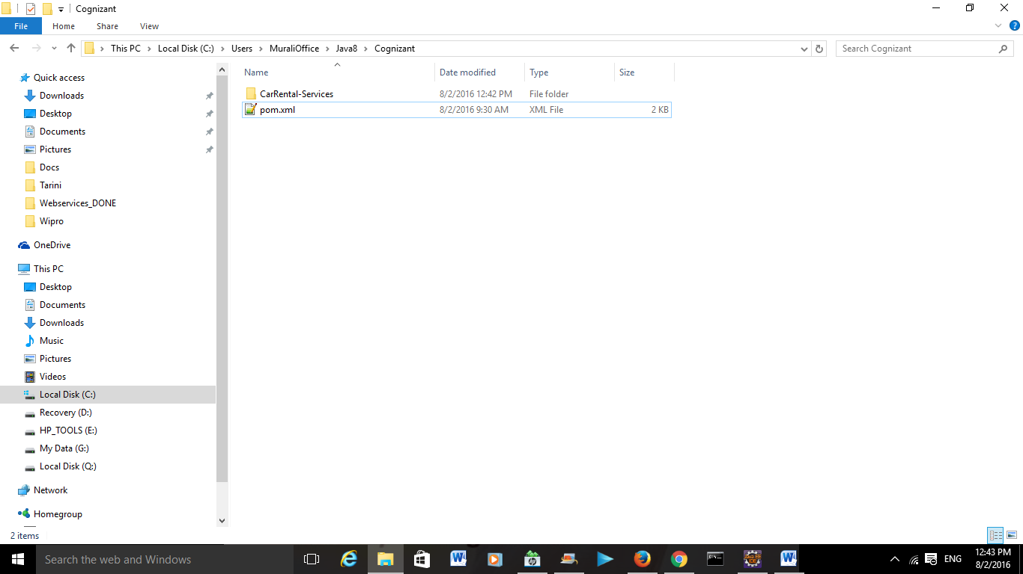

1. Open any Ide of your choice and import maven project as below(Import the directory where you unzipped Cognizant.zip file):

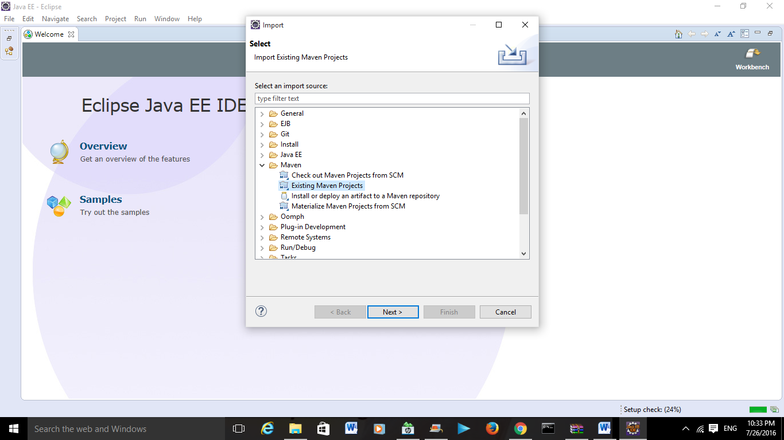

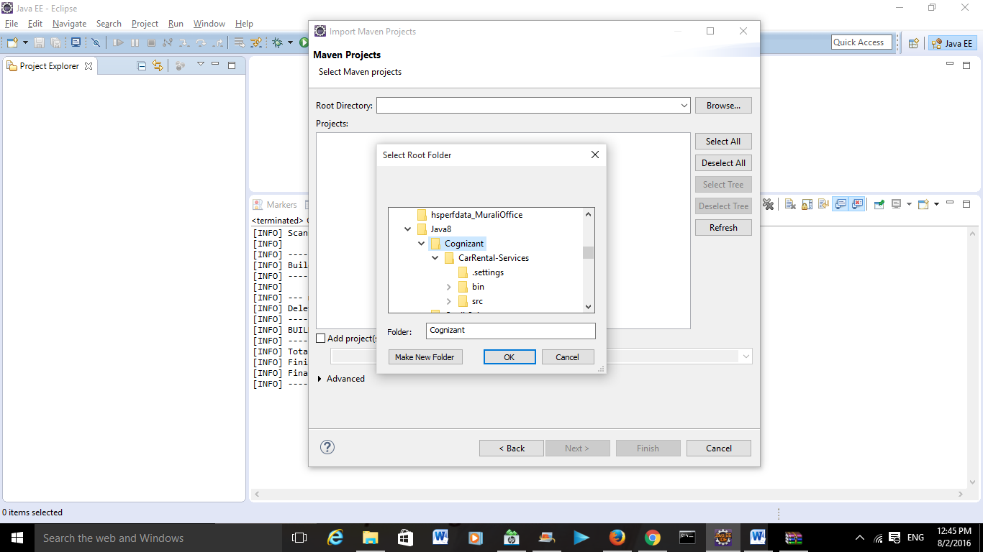

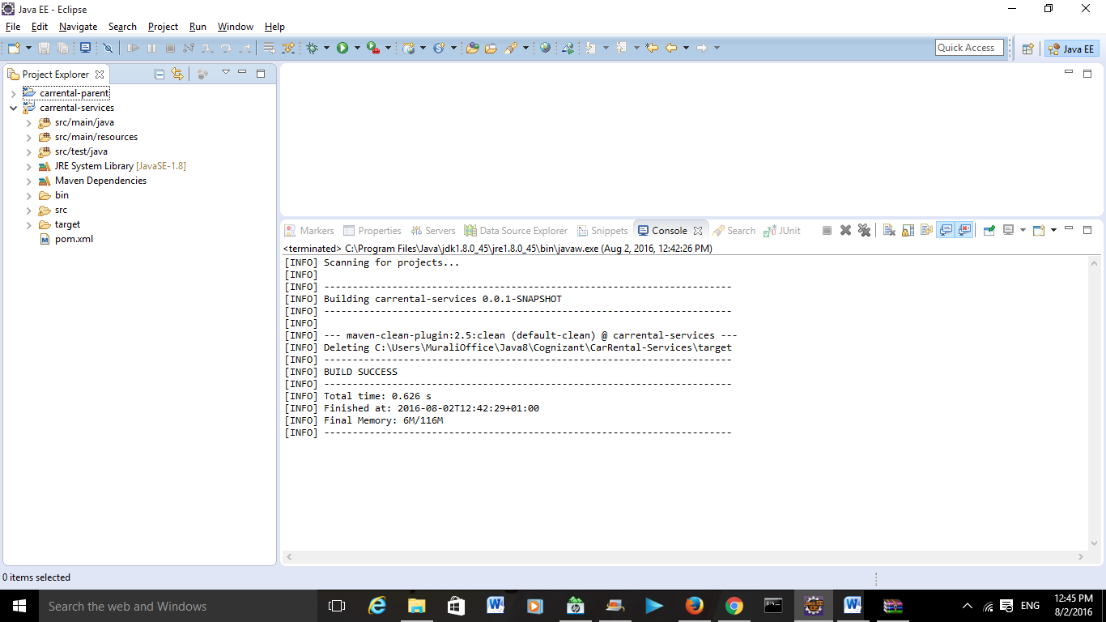

1. Do a mvn install by selecting pom.xml which will run all the tests as below and the screenshots below and will generate following log files. It executes various tests as below:

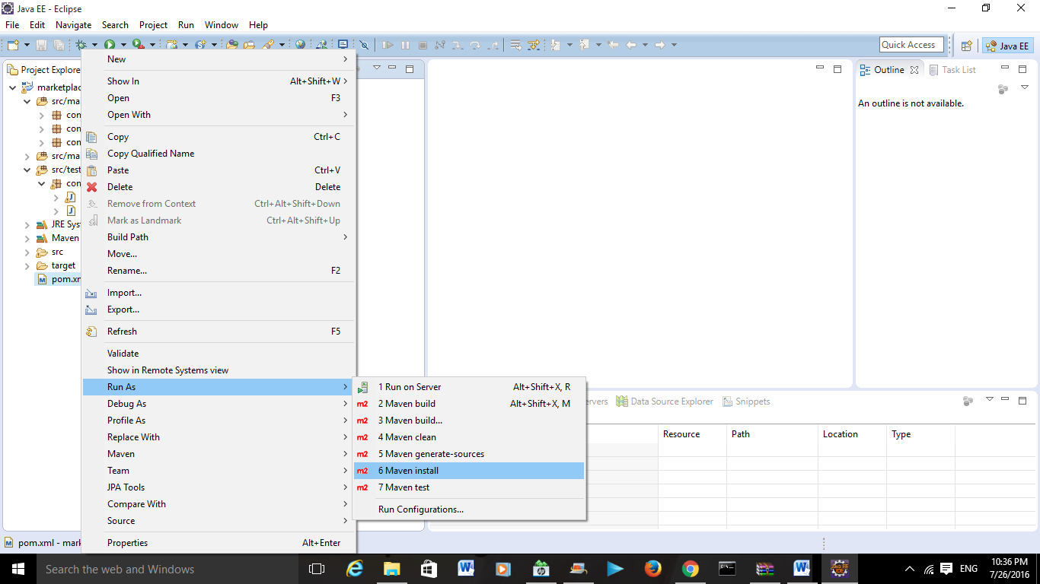

[INFO] Scanning for projects...

[INFO]

[INFO] ------------------------------------------------------------------------

[INFO] Building carrental-services 0.0.1-SNAPSHOT

[INFO] ------------------------------------------------------------------------

[INFO]

[INFO] --- maven-resources-plugin:2.6:resources (default-resources) @ carrental-services ---

[WARNING] Using platform encoding (Cp1252 actually) to copy filtered resources, i.e. build is platform dependent!

[INFO] Copying 1 resource

[INFO]

[INFO] --- maven-compiler-plugin:2.3.2:compile (default-compile) @ carrental-services ---

[WARNING] File encoding has not been set, using platform encoding Cp1252, i.e. build is platform dependent!

[INFO] Compiling 16 source files to C:\Users\MuraliOffice\Java8\Cognizant\CarRental-Services\target\classes

[INFO]

[INFO] --- maven-resources-plugin:2.6:testResources (default-testResources) @ carrental-services ---

[WARNING] Using platform encoding (Cp1252 actually) to copy filtered resources, i.e. build is platform dependent!

[INFO] skip non existing resourceDirectory C:\Users\MuraliOffice\Java8\Cognizant\CarRental-Services\src\test\resources

[INFO]

[INFO] --- maven-compiler-plugin:2.3.2:testCompile (default-testCompile) @ carrental-services ---

[WARNING] File encoding has not been set, using platform encoding Cp1252, i.e. build is platform dependent!

[INFO] Compiling 3 source files to C:\Users\MuraliOffice\Java8\Cognizant\CarRental-Services\target\test-classes

[INFO]

[INFO] --- maven-surefire-plugin:2.12.4:test (default-test) @ carrental-services ---

[INFO] Surefire report directory: C:\Users\MuraliOffice\Java8\Cognizant\CarRental-Services\target\surefire-reports

-------------------------------------------------------

T E S T S

-------------------------------------------------------

Running com.car.rental.api.BookingApiTest

Tests run: 2, Failures: 0, Errors: 0, Skipped: 0, Time elapsed: 0.068 sec

Running com.car.rental.api.BusBookingApiTest

Tests run: 4, Failures: 0, Errors: 0, Skipped: 0, Time elapsed: 0 sec

Running com.car.rental.api.SuvBookingApiTest

Tests run: 4, Failures: 0, Errors: 0, Skipped: 0, Time elapsed: 0 sec

Results :

Tests run: 10, Failures: 0, Errors: 0, Skipped: 0

[INFO]

[INFO] --- maven-jar-plugin:2.4:jar (default-jar) @ carrental-services ---

[INFO] Building jar: C:\Users\MuraliOffice\Java8\Cognizant\CarRental-Services\target\carrental-services.jar

[INFO]

[INFO] --- maven-install-plugin:2.4:install (default-install) @ carrental-services ---

[INFO] Installing C:\Users\MuraliOffice\Java8\Cognizant\CarRental-Services\target\carrental-services.jar to C:\Users\MuraliOffice\.m2\repository\com\carrental\carrental-services\0.0.1-SNAPSHOT\carrental-services-0.0.1-SNAPSHOT.jar

[INFO] Installing C:\Users\MuraliOffice\Java8\Cognizant\CarRental-Services\pom.xml to C:\Users\MuraliOffice\.m2\repository\com\carrental\carrental-services\0.0.1-SNAPSHOT\carrental-services-0.0.1-SNAPSHOT.pom

[INFO] ------------------------------------------------------------------------

[INFO] BUILD SUCCESS

[INFO] ------------------------------------------------------------------------

[INFO] Total time: 6.455 s

[INFO] Finished at: 2016-08-02T12:46:33+01:00

[INFO] Final Memory: 23M/162M

[INFO] ------------------------------------------------------------------------