Design And Implementing Heart Disease Prediction Using Naives Bayesian

In this paper author using Naïve Bayesian machine learning algorithm to predict heart disease by training algorithm with UCI heart disease dataset and this paper implementing following modules

1. User registration: allow user to register with app
2. User Login: allow user to login with the application
3. Predict disease: After login user can input various details such as cholesterol level, blood sugar, age sex etc.

User will input following details

age,sex,cp,trestbps,chol,fbs,restecg,thalach,exang,oldpeak,slope,ca,thal

screen shots

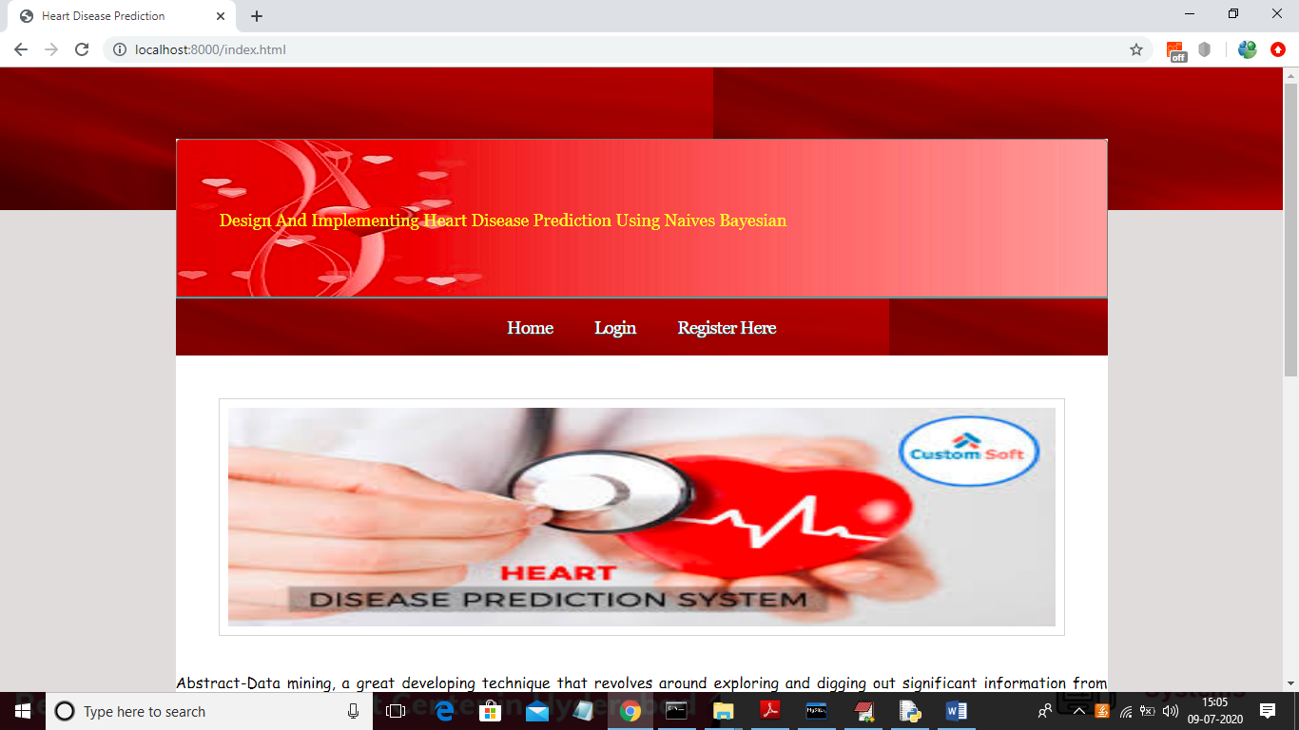

Click on ‘Register Here’ link to add new user

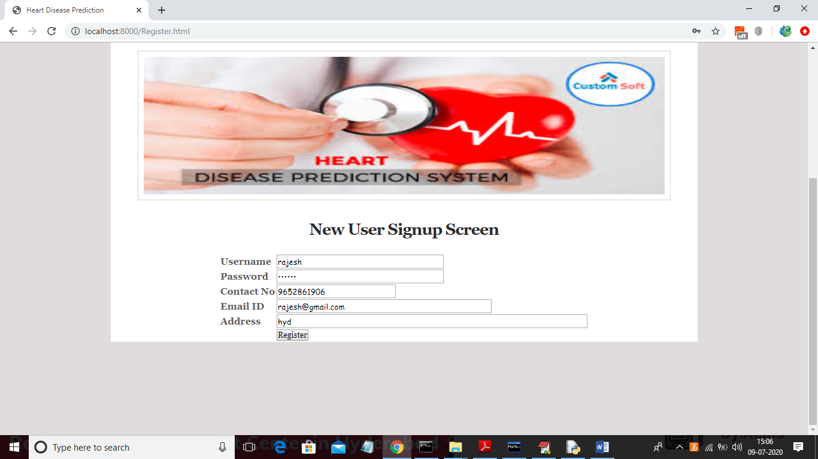

After adding new user will get below screen

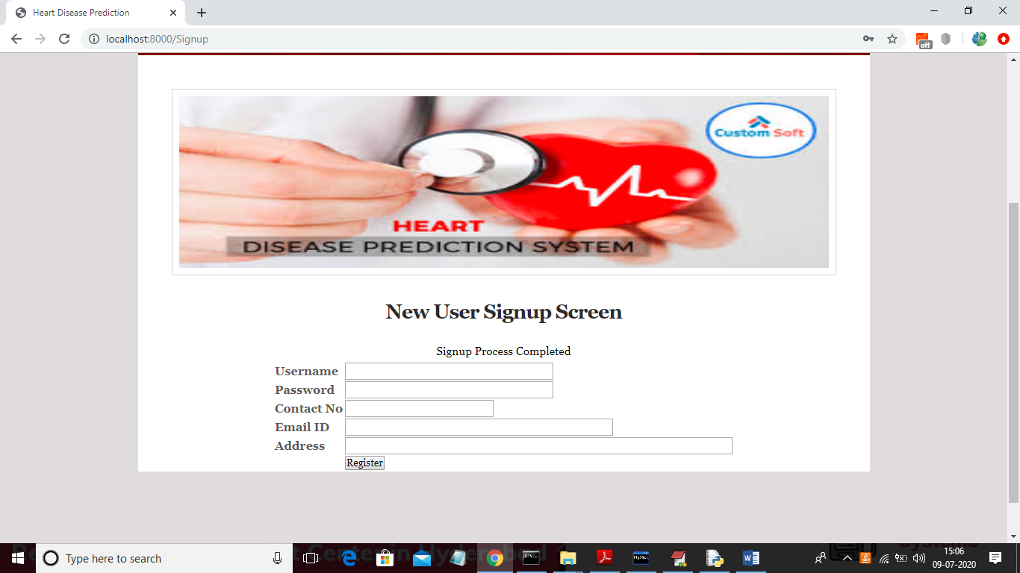

Now click on login link to log user

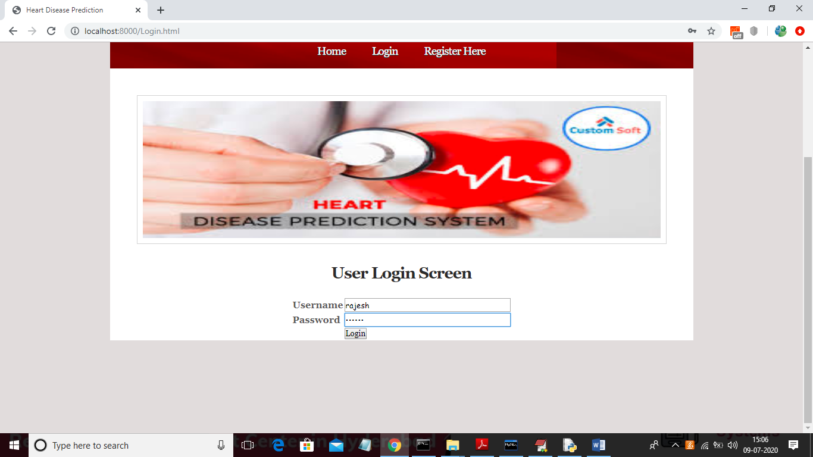

After login will get below screen

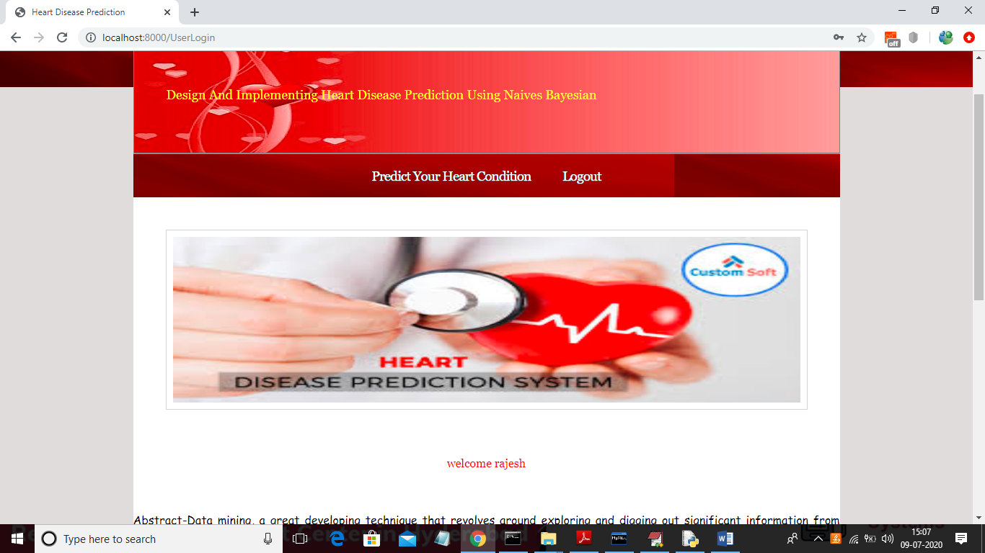

Now click on ‘Predict Your Heart Condition’ link to input details

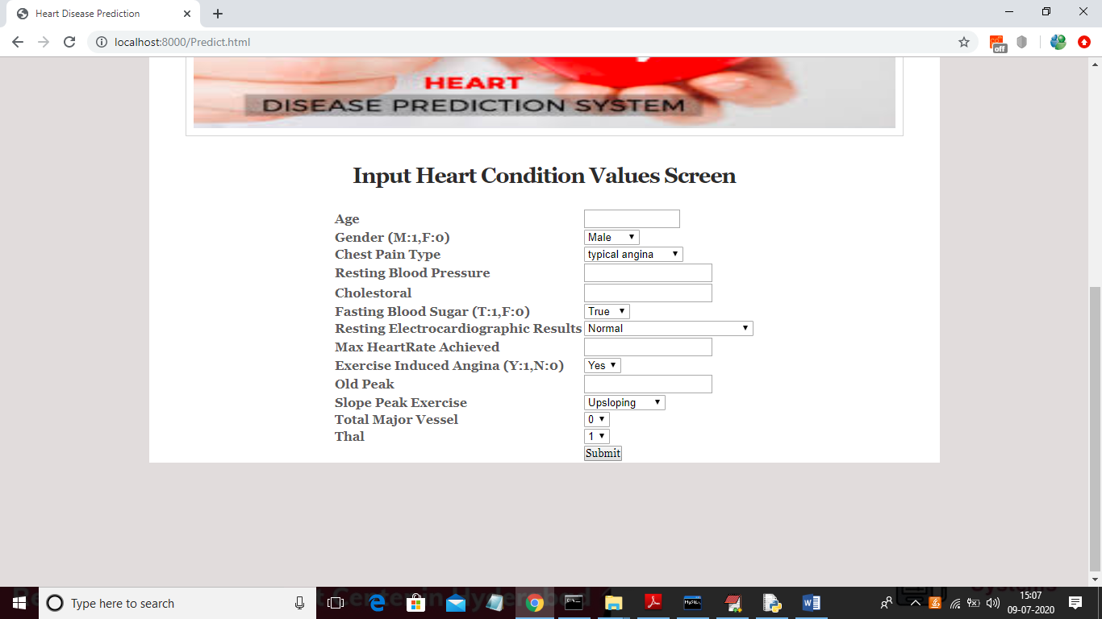

In above screen user will enter details about his heart and application will predict disease

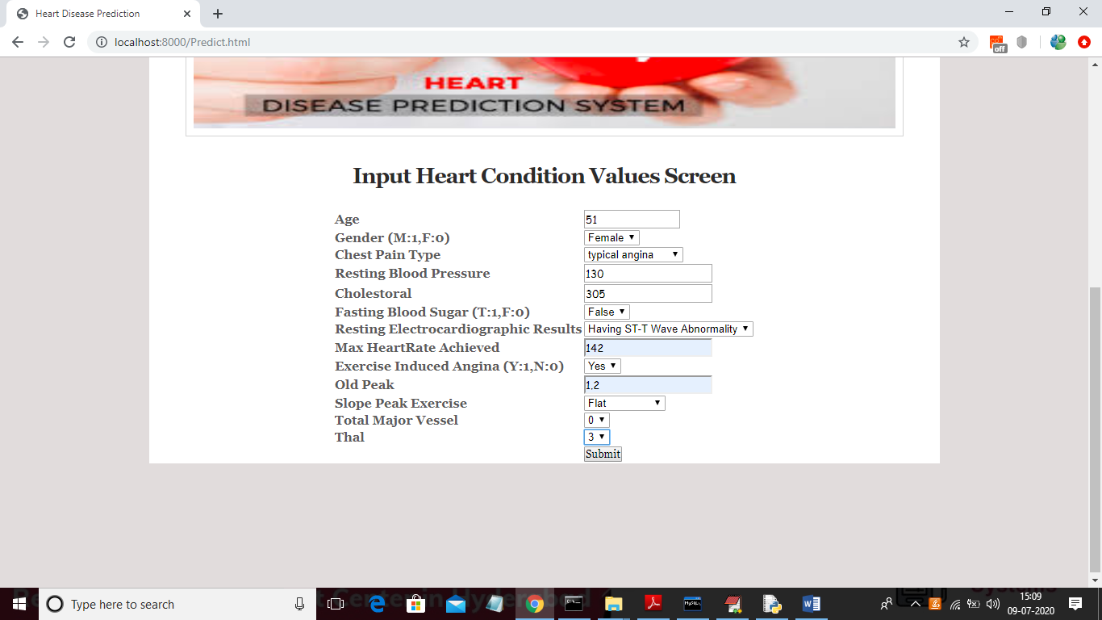

In above screen after entering details will get below screen of prediction

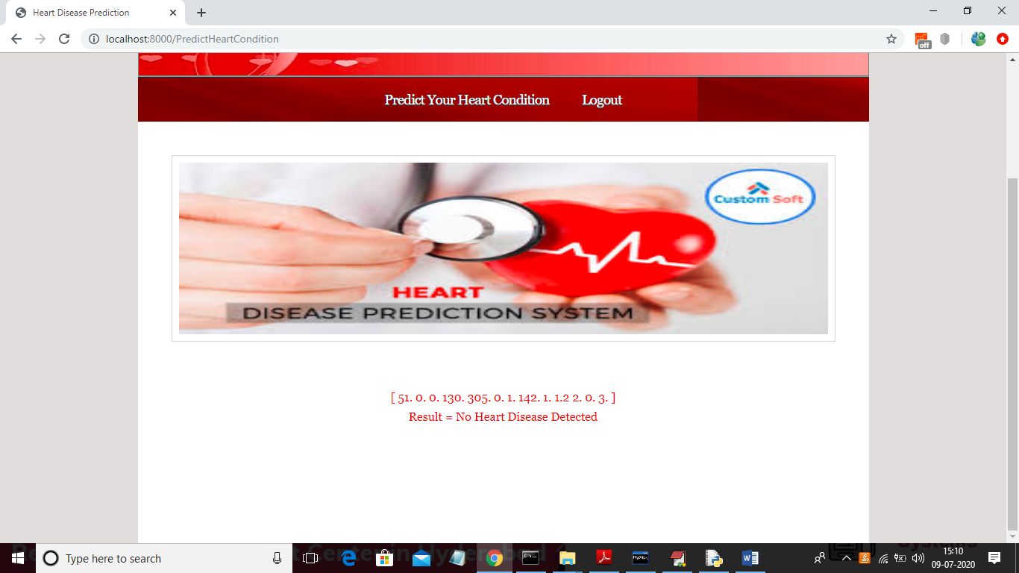

Now below screen with different data

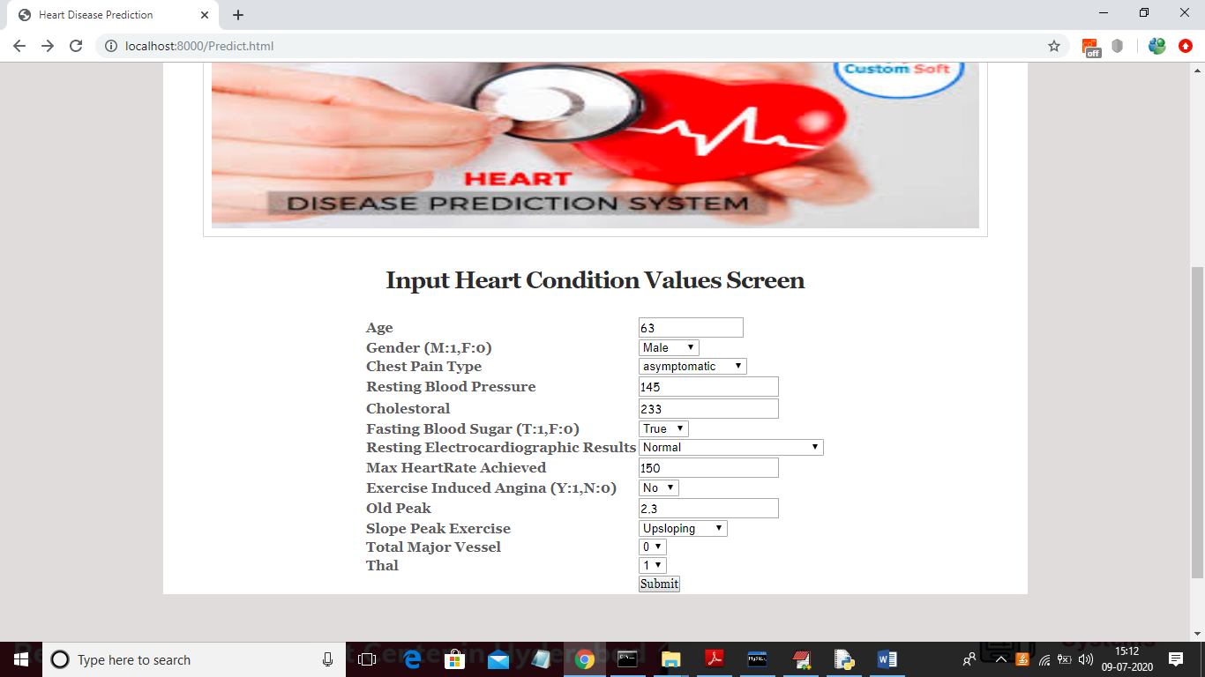

For above screen data will get below result

