# TEAM ID - NM2023TMID19827

# INTRODUCTION

A CRM application for schools/college would be designed to manage interactions with students, parents, and faculty members. It would include a centralized database that stores information about students, courses, grades, attendance, and other relevant data.

Some key features of a CRM application for schools/college include:

1. Lead and Prospect Management: A CRM application can help manage the admissions process, track interested students, and enable lead conversion.

2. Student Lifecycle Management: A CRM application can store information about previous applications, courses taken, grades earned, and other student records in one place.

3. Communication Management: A CRM application can automate emails, track conversations, and manage follow-ups allowing better communication with students or parents.

**Purpose**

A CRM application for schools/college would be designed to manage interactions with students, parents, and faculty members. It would include a centralized database that stores information about students, courses, grades, attendance, and other relevant data.

Some key features of a CRM application for schools/college include:

Lead and Prospect Management: A CRM application can help manage the admissions process, track interested students, and enable lead conversion.

Student Lifecycle Management: A CRM application can store information about previous applications, courses taken, grades earned, and other student records in one place.

Mobile App Compatibility: Given the increasing need for remote learning, a CRM application for schools should be available on mobile platforms like Android and iOS.

**Problem Definition & Design Thinking**

Empathy Map

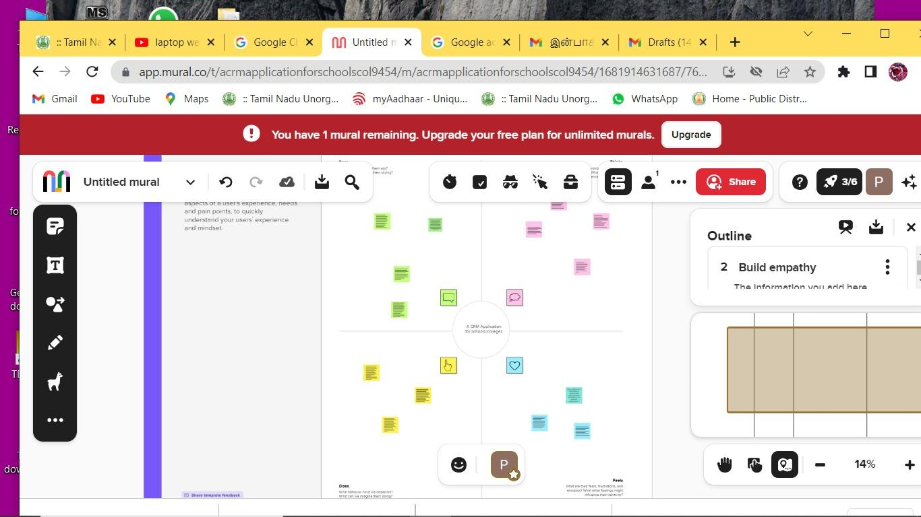

Ideation & Brainstorming Map

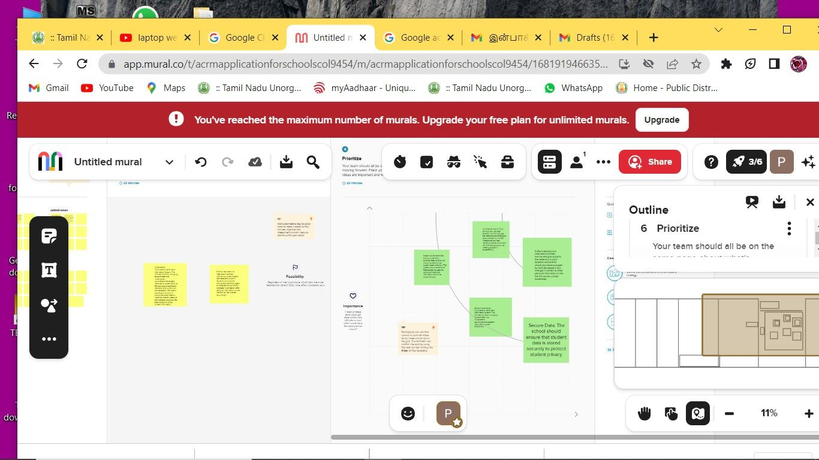

# RESULT

**DATA MODEL**

|  |  |
| --- | --- |
| **OBJECT NAME** | **FIELD IN THE OBJECT** |
| **SCHOOL** | |  |  | | --- | --- | | FIELD LABEL | DATA TYPE | | Address | Text Area | | District | Text Area | | Highest Marks | Roll-up summary  MAX Student | | Number of Student | Roll-up summary  Count student | | Phone Number | Phone | | School Websites | Text Area | | State | Text Area   |  |  | | --- | --- | |  |  | |  |  | |  |  | |  |  | |  |  | | |
| **STUDENT**   |  |  | | --- | --- | |  |  | |  |  | |  |  | | |  |  | | --- | --- | | FIELD LABLE | DATA TYPE | | Class | Number | | Marks | Number | | Phone Number | Phone | | Results | Pick list | |
| **PARENT** | |  |  | | --- | --- | | FIELD LABLE | DATA TYPE | | Parent Address | Text Area | | Parent Number | Phone | |

School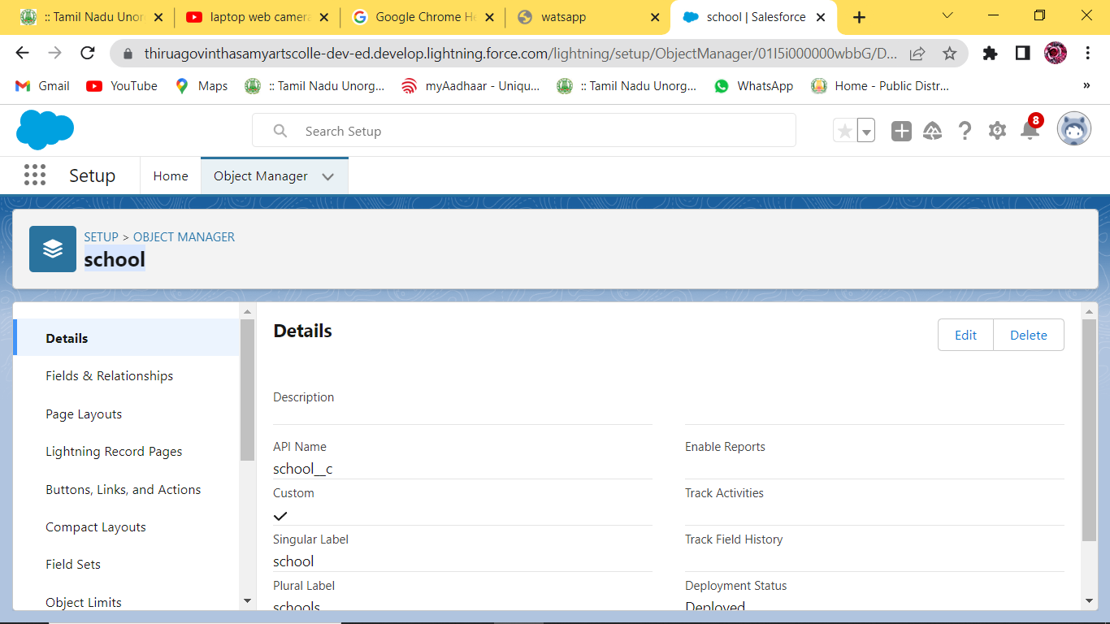

Student

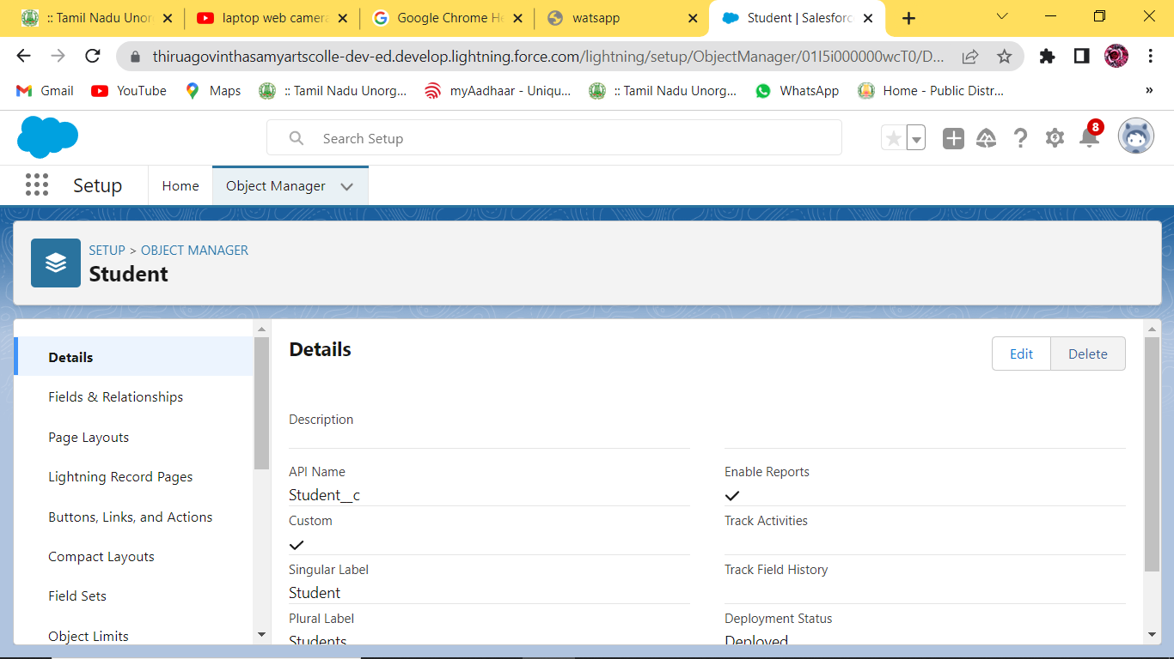

Parent

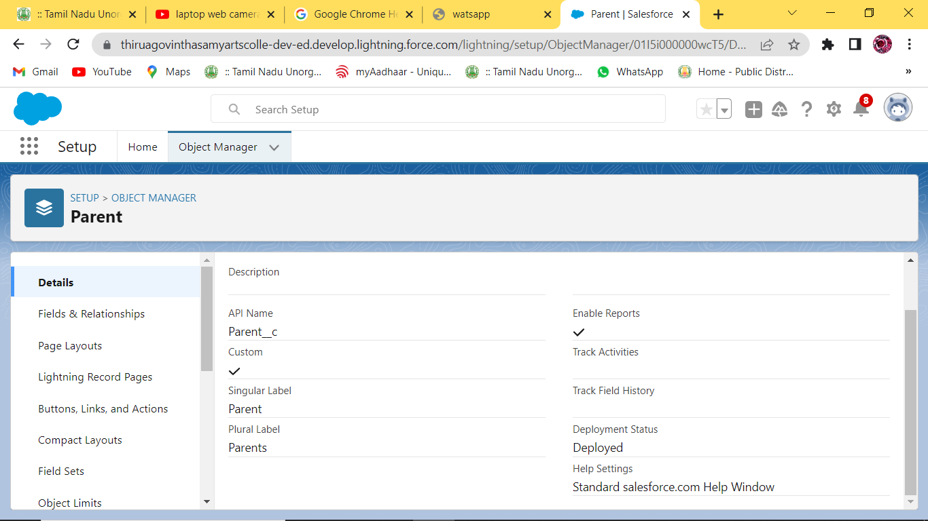

Lightning App

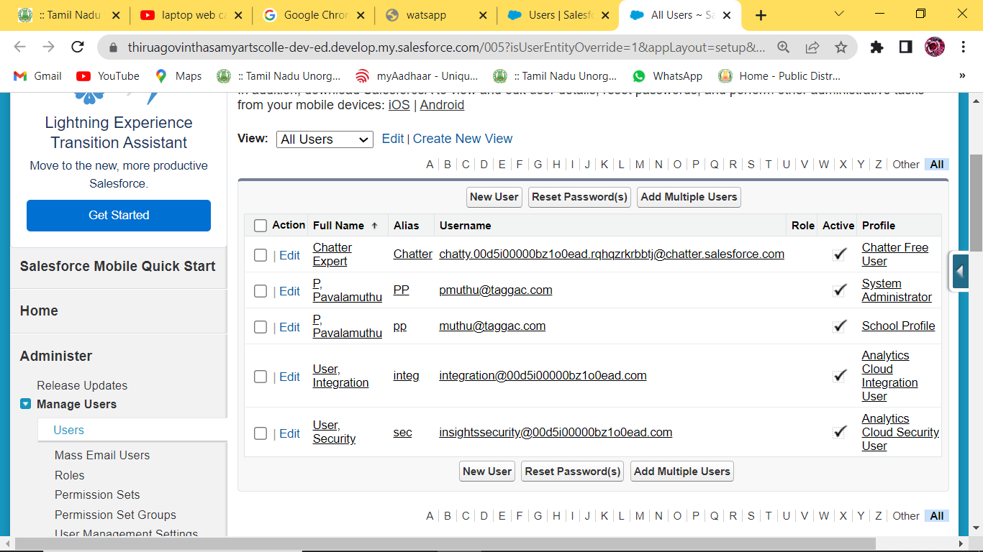

Fields and Relationship

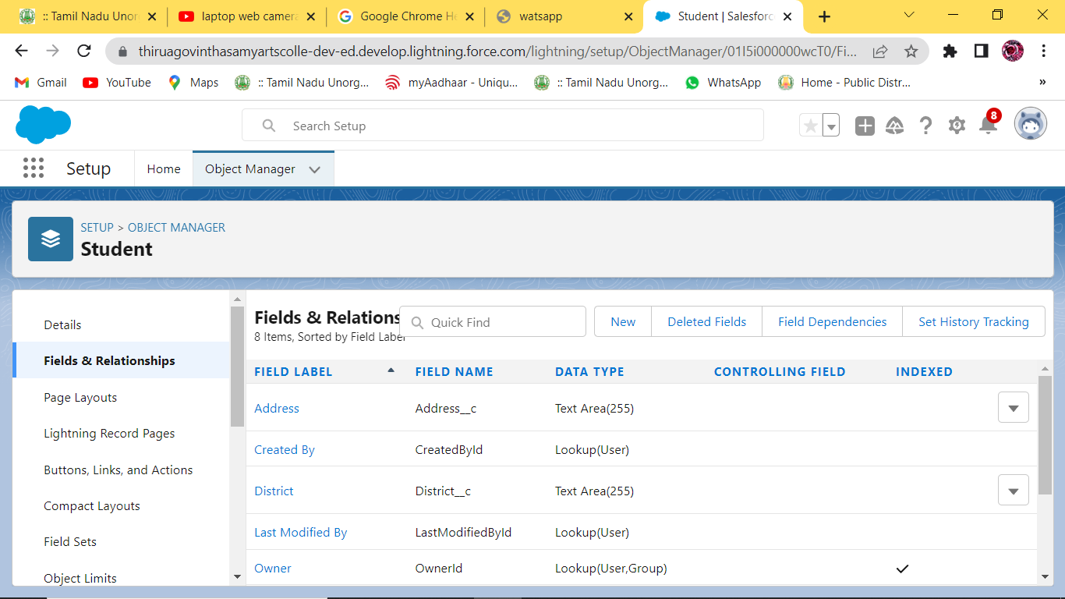

Profiles

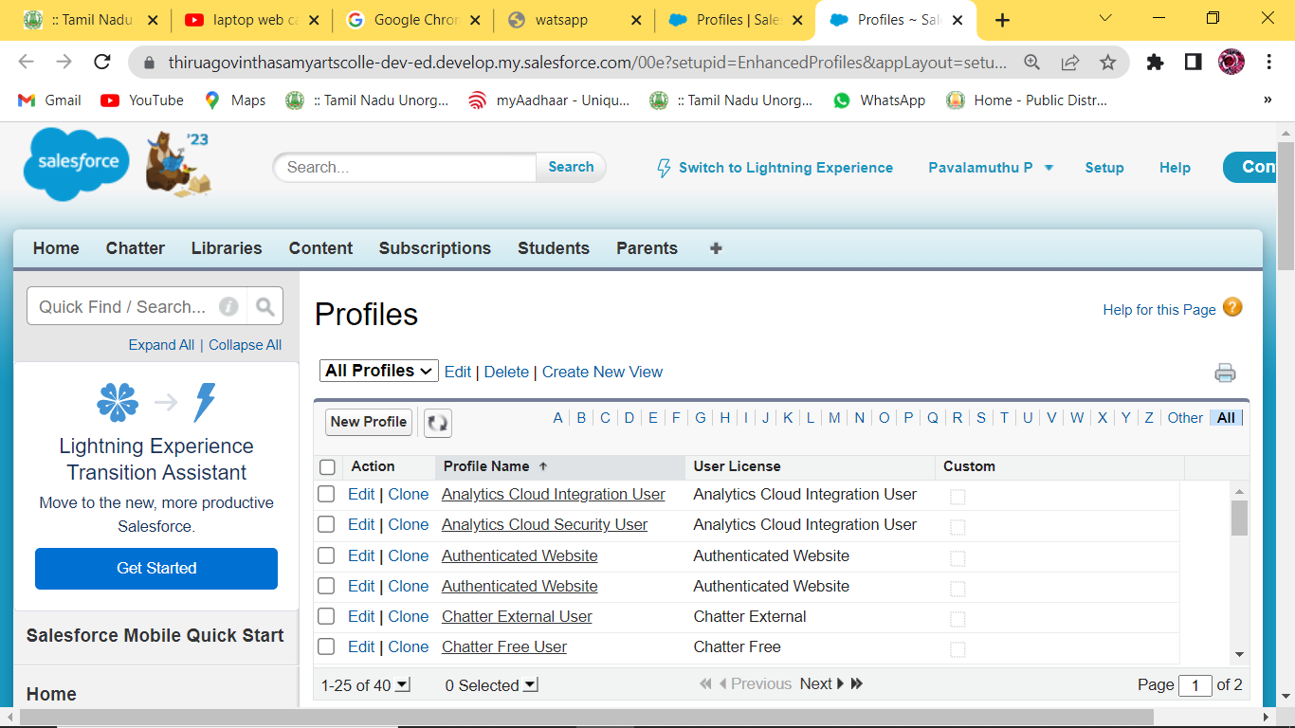

Permission Sets

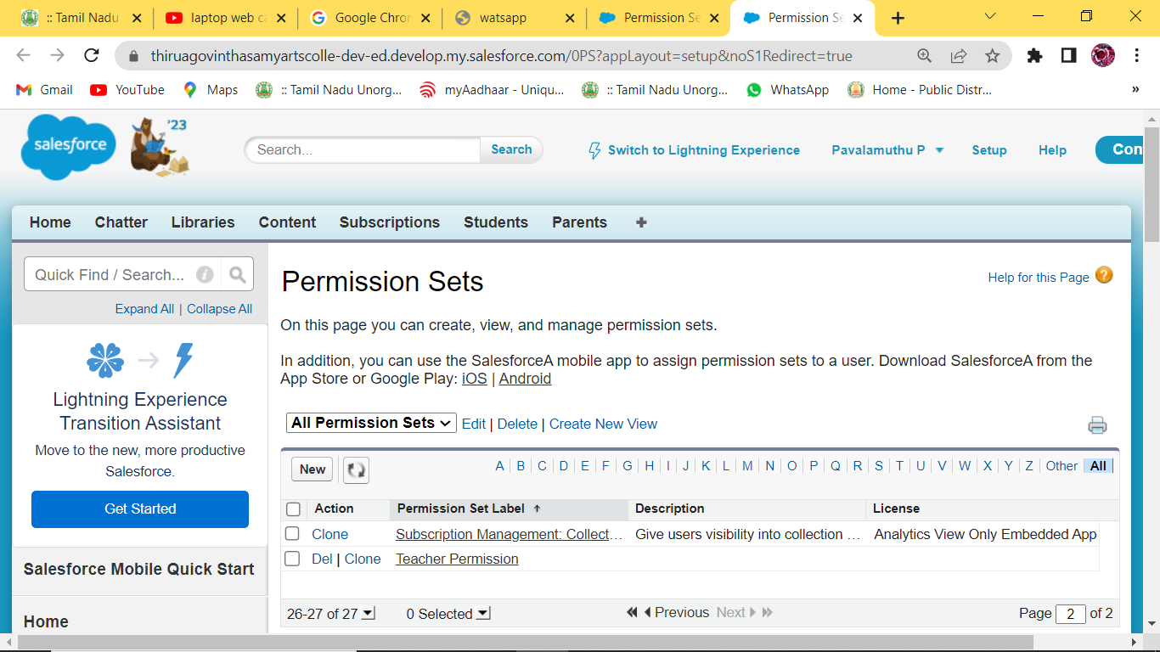

**Teacher Permission**

Team Lead -https://trailblazer.me/id/mdhurairaj

Team Member 1- https://trailblazer.me/id/pmuthu35

Team Member 2 –https://trailblazer.me/id/eerrorgaming

Team Member 3 –https://trailblazer.me/id/vmurugan45

# ADVANTAGES & DISADVANTAGES

# Having huge amounts of data on customer interaction enables an organization to build up a clearer picture of its customers

1. All gathered data is stored and maintained as one centralized location in

CRM ,which can be easily accessible to see the information

1. Not suitable for every business, They are many security issues with CRM such as data costs and data being hacked by someone

# APPLICATIONS

1. This project helps you to maintain and manage the school related problem.
2. This project aim is to provide real-time knowledge for all the student who have basic knowledge of salesforce

# CONCLUSION

To created new object and fields.

It was observed that the presence of effective the level of student report patronage intention

# FUTURE SCOPE

CRM Software helps to generate a progress report on the ongoing tasks in you enterprises.

In future CRM software is used to track all the customers data and records.

# APPENDIX

# A. Source Code

Attach the code for the solution built.